LOGISTICS DATA ANALYSIS USING PYTHON
Task 3 – Exploratory Data Analysis, Visualization and Insights
Hypothetical Logistics Dataset | 500 Shipment Records

1. Objective
The objective of this task is to explore, analyze and visualize a hypothetical logistics dataset using Python. The analysis focuses on shipment volume, transportation mode, distance, delivery time, transportation cost and on-time performance. The purpose is to demonstrate how numerical analysis and visualization can support data-driven logistics decisions.

2. Methodology
A reproducible dataset containing 500 shipment records was simulated using Python and NumPy. Pandas was used for data preparation and exploratory analysis, while Matplotlib was used to create visualizations. A fixed random seed (42) was used so that the same dataset and results can be reproduced.
The workflow followed these stages: (1) data simulation, (2) initial inspection, (3) data-quality checks, (4) descriptive statistics, (5) correlation analysis, (6) visualization, (7) interpretation, and (8) recommendations.

3. Dataset Structure
Variable | Type | Description
Shipment_ID | Text | Unique shipment identifier
Origin | Categorical | Shipment origin city
Destination | Categorical | Shipment destination city
Transport_Mode | Categorical | Road, Rail, Air or Sea
Zone | Categorical | Operational geographic zone
Shipment_Volume_kg | Numeric | Shipment weight/volume proxy in kg
Distance_km | Numeric | Transportation distance
Delivery_Time_days | Numeric | Delivery duration in days
Transportation_Cost_INR | Numeric | Transportation cost in INR
On_Time | Categorical | Whether shipment met its mode-specific target

4. Initial Data Inspection and Cleaning Logic
The dataset contains 500 rows and 10 columns. The initial inspection checked the first records, column types, missing values, duplicate records and basic ranges. The dataset contained no missing values after simulation, so no missing-value imputation was required.
The inspection also guided the cleaning process. Numeric variables were checked for valid non-negative values, categorical variables were checked against the expected categories, and shipment IDs were treated as identifiers rather than analytical measures. Delivery time and transportation cost were checked for unrealistic negative values; the simulation constrained both to positive values. This is important because data inspection should determine the cleaning action instead of applying unnecessary transformations.
For this hypothetical dataset, no records needed to be deleted. In a real logistics dataset, the same checks could identify missing delivery dates, duplicate shipment IDs, impossible distances, negative costs, or inconsistent transport-mode labels.

5. Exploratory Data Analysis Results
Key numerical results from the Python analysis are shown below. The dataset contains 500 shipments with a total simulated shipment volume of 132,961 kg. The average shipment volume is 265.92 kg.
The average delivery time is 5.49 days, while the median is 5.39 days. The standard deviation is 1.85 days. The average transportation cost is ₹2,995.98, with a median of ₹2,394.28. The overall on-time delivery rate is 77.80%.
The difference between the mean and median is useful for identifying skewness. A noticeably higher mean than median would indicate that a smaller number of long or expensive shipments are increasing the average.

6. Transportation Mode Analysis
Mode | Shipments | Avg Delivery (days) | Avg Cost (₹) | Avg Volume (kg) | On-Time %
Road | 287 | 5.24 | ₹2,519.48 | 265.85 | 81.53%
Rail | 101 | 6.33 | ₹1,820.62 | 274.76 | 69.31%
Air | 67 | 3.34 | ₹8,009.79 | 256.45 | 67.16%
Sea | 45 | 8.43 | ₹1,208.05 | 260.64 | 88.89%
The mode-level results show that Road handles the largest number of shipments in the simulated dataset. Air has the highest average transportation cost, while Air has the shortest average delivery time. Sea records the strongest on-time performance. These differences demonstrate the trade-off between speed, cost and service reliability.

7. Visualization 1 – Shipment Count by Transportation Mode
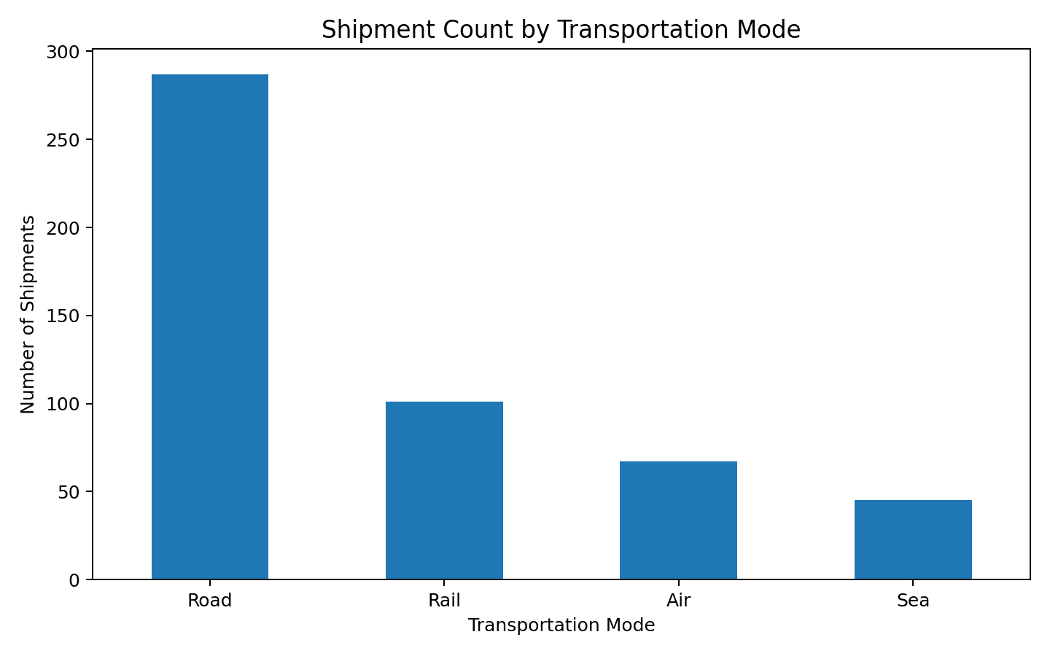
Interpretation: The bar chart compares shipment volumes across transportation modes. Road is the dominant mode in the simulated data. This helps logistics managers identify where most operational capacity is being used and where improvements in fleet or scheduling can have the largest effect.

8. Visualization 2 – Delivery Time Distribution
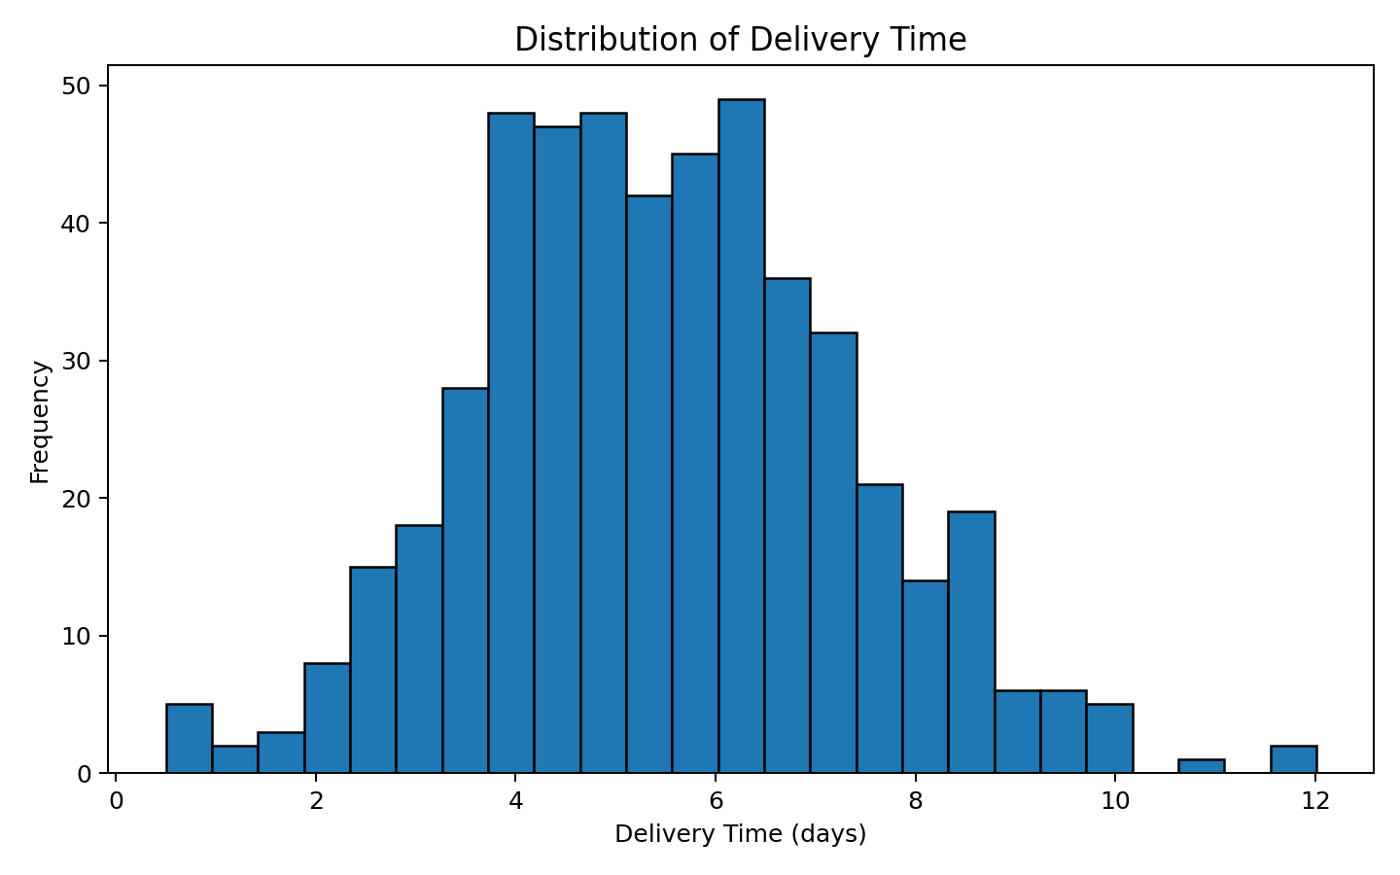
Interpretation: The histogram shows the distribution of delivery durations. The average is 5.49 days and the median is 5.39 days. The spread indicates that not all shipments have the same service experience. Long-duration observations should be investigated by route, mode and distance because they may represent operational bottlenecks.

9. Visualization 3 – Average Transportation Cost by Mode
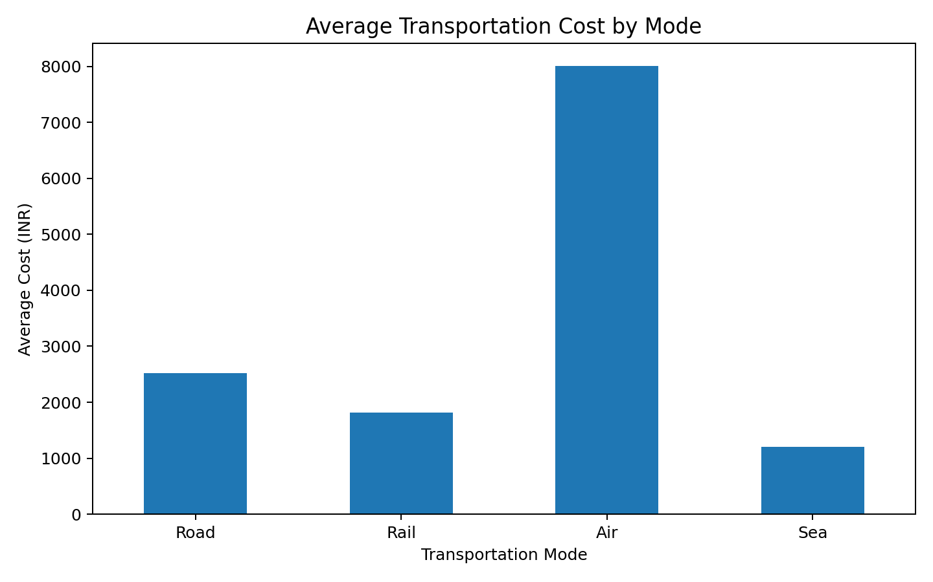
Interpretation: The chart compares average cost by transportation mode. Air has the highest average cost of approximately ₹8,009.79 per shipment. This identifies the mode as an important cost driver. Managers can review whether premium modes are being used only for urgent shipments and whether suitable shipments can be moved through lower-cost alternatives.

10. Visualization 4 – Distance vs Transportation Cost
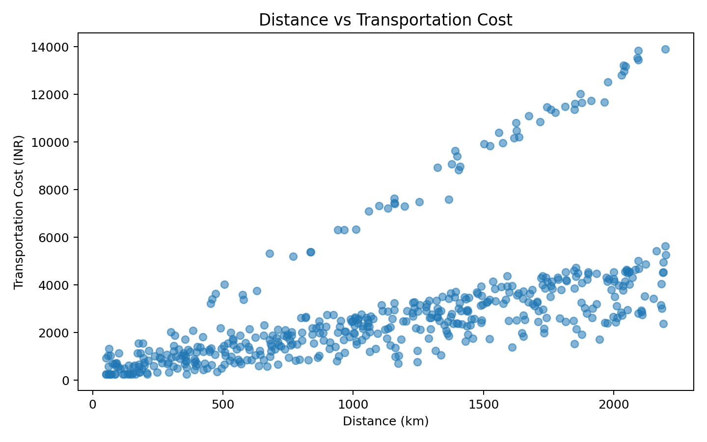
Interpretation: The scatter plot examines the relationship between distance and transportation cost. The calculated correlation is 0.60. A positive relationship means that longer routes generally require higher transportation spending. However, the spread of points shows that distance is not the only cost driver; transportation mode and shipment volume also influence cost.

11. Visualization 5 – Delivery Time by Transportation Mode
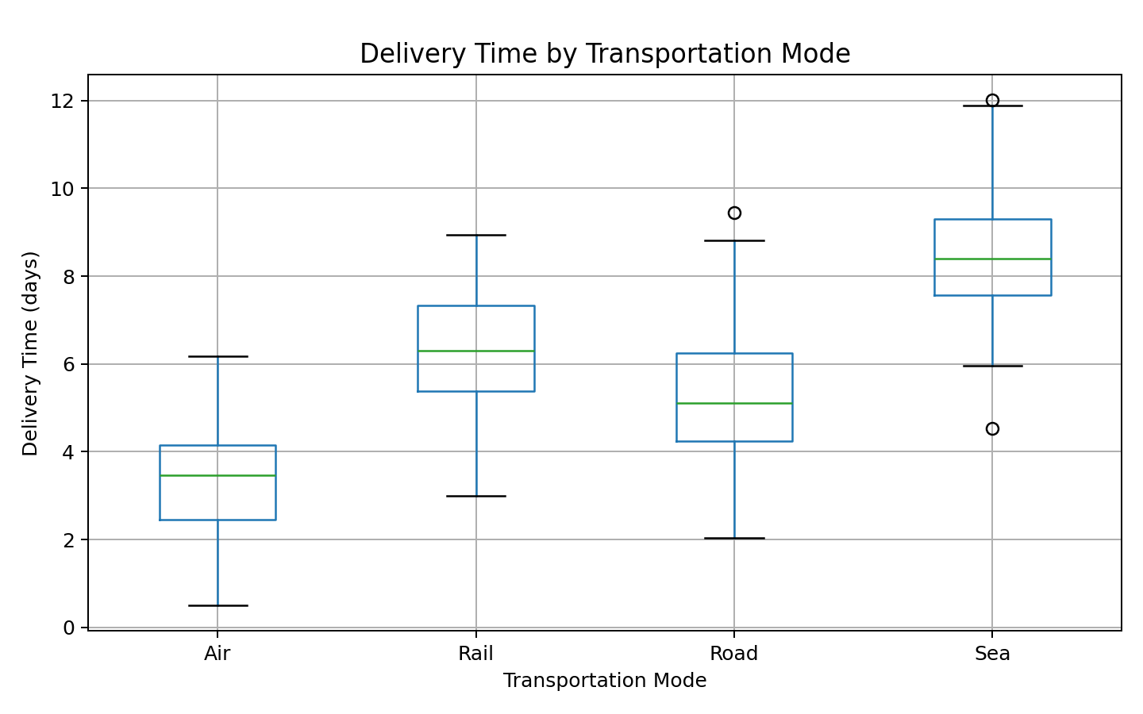
Interpretation: The box plot compares the distribution and variability of delivery time across modes. Air has the lowest average delivery time. The boxes and whiskers also show that some modes have greater variability, which can indicate inconsistent transit performance. This visualization is useful for deciding which modes are appropriate for time-sensitive shipments.

12. Visualization 6 – Correlation Matrix
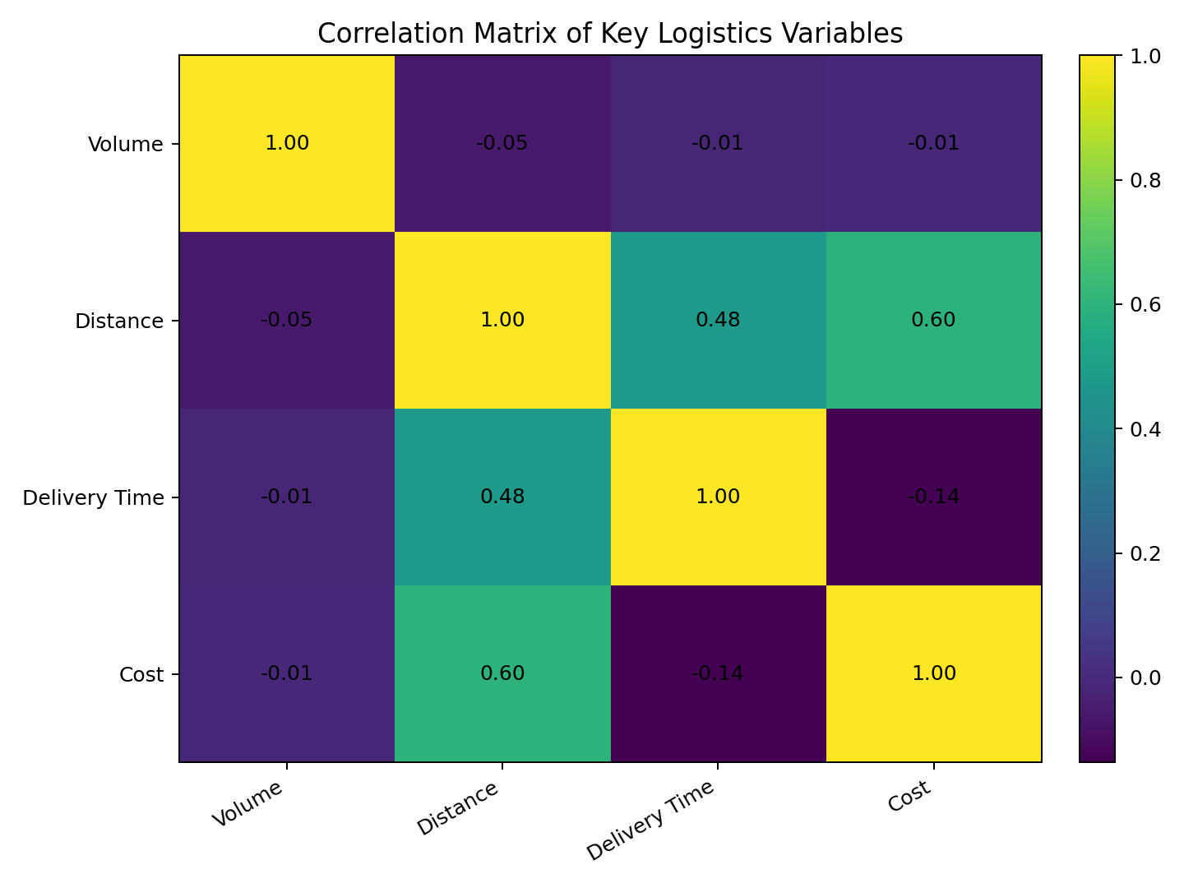
Interpretation: The correlation matrix summarizes linear relationships among key numeric variables. Distance and cost have a correlation of 0.60; distance and delivery time have a correlation of 0.48; and delivery time and cost have a correlation of -0.14. These values help identify variables that move together and can guide deeper route-level analysis.

13. Visualization 7 – On-Time vs Delayed Shipments
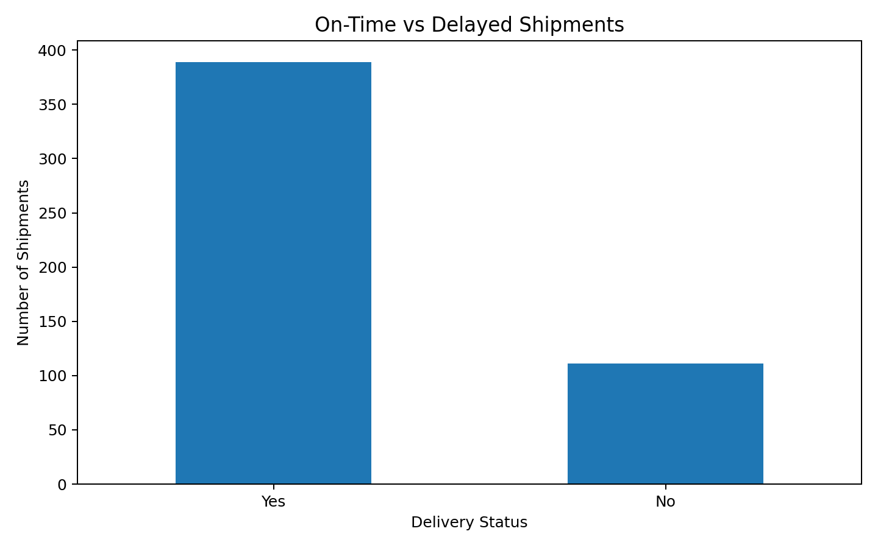
Interpretation: The chart shows 389 on-time shipments and 111 delayed shipments. The overall on-time rate is 77.80%. The delayed shipments should be segmented by mode, destination, distance and shipment volume to determine whether delays are concentrated in particular operational areas.

14. Analytical Insights
- Operational volume: Road carries the highest number of simulated shipments, making it an important area for capacity planning and performance monitoring.
- Cost driver: Air has the highest average transportation cost (approximately ₹8,009.79 per shipment).
- Speed advantage: Air has the shortest average delivery time at approximately 3.34 days.
- Service performance: The overall on-time rate is 77.80%, indicating that a measurable share of shipments requires investigation for delay reduction.
- Distance effect: Distance and cost have a positive correlation of 0.60, supporting the use of route distance as an important cost-planning variable.
- Variability matters: Averages alone can hide unusual delays and high-cost shipments. Histograms, box plots and scatter plots provide additional evidence for operational decisions.

15. Recommendations
- Review high-cost shipments by mode and route before approving premium transportation.
- Use faster transportation modes selectively for urgent or high-priority shipments rather than as the default option.
- Monitor routes with unusually high delivery times and compare them with distance, mode and destination patterns.
- Create a weekly logistics dashboard containing shipment count, average delivery time, average cost and on-time percentage.
- Investigate delayed shipments individually to identify recurring causes such as route congestion, scheduling issues or mode-specific delays.
- Use route-level cost-per-kilometre and cost-per-kg measures in future analysis for more precise cost optimization.

16. Python Tools Used
Tool | Purpose | Application
NumPy | Data simulation | Randomized shipment, distance and delivery variables
Pandas | Data analysis | DataFrame creation, grouping, descriptive statistics and correlation
Matplotlib | Visualization | Bar charts, histogram, scatter plot, box plot and correlation matrix
Python | Overall workflow | Reproducible end-to-end logistics analysis

17. Conclusion
This analysis demonstrates how Python can convert logistics data into measurable operational insights. The simulated 500-shipment dataset produced concrete evidence on shipment volume, delivery performance, transportation cost and relationships between variables. The analysis found an overall on-time rate of 77.80%, an average delivery time of 5.49 days and an average transportation cost of ₹2,995.98. Visualizations make these results easier to interpret and help logistics managers identify cost drivers, capacity priorities and potential bottlenecks. In a real organization, the same workflow can be connected to actual shipment records and extended with route, warehouse, fuel, carrier and customer-level information.

18. Appendix – Sample Python Output
Representative outputs from the executed analysis are included below to provide concrete evidence rather than only describing the proposed methodology.
Dataset shape: (500, 10)
Average delivery time: 5.49 days
Median delivery time: 5.39 days
Average transportation cost: ₹2,995.98
Median transportation cost: ₹2,394.28
Average shipment volume: 265.92 kg
Total shipment volume: 132,961 kg
On-time delivery rate: 77.80%
Distance–cost correlation: 0.60
Distance–delivery-time correlation: 0.48

