1) Javafx.java

PROGRAM:

package com.example.demo2;  
  
import javax.swing.*;  
public class javafx {  
 public static void main(String[] args) {  
 JFrame frame = new JFrame("Button Example");  
 frame.setSize(400, 300);  
 frame.setDefaultCloseOperation(JFrame.*EXIT_ON_CLOSE*);  
 JPanel panel = new JPanel();  
 frame.add(panel);  
 *placeButton*(panel);  
 frame.setVisible(true);  
 }  
 private static void placeButton(JPanel panel) {  
 panel.setLayout(null);  
 JButton button = new JButton("login");  
 button.setBounds(150, 100, 100, 50);  
 JButton button2 = new JButton("close");  
 button2.setBounds(150, 150, 100, 50);  
 button.addActionListener(_ -> *openNewFrame*());  
 panel.add(button);  
 panel.add(button2);  
 }  
 private static void openNewFrame() {  
 JFrame newFrame = new JFrame("New Frame");  
 newFrame.setSize(400, 300);  
 newFrame.setDefaultCloseOperation(JFrame.*DISPOSE_ON_CLOSE*);  
 JPanel newPanel = new JPanel();  
 newFrame.add(newPanel);  
 JLabel label = new JLabel("hyy , this is parameshwari");  
 newPanel.add(label);  
 newFrame.setVisible(true);  
 }  
}

OUTPUT:

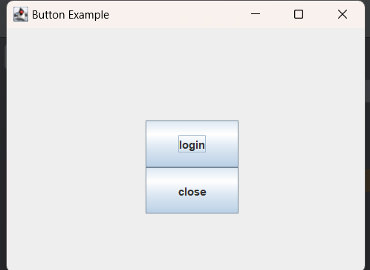

AFTER CLICKING LOGIN:

