**TASK-13**

***File Operation***

***Write a Java program to write data to an Excel file using Apache POI Library.***

***Q1. Create a new Excel Workbook.***

***code:***

**package** com.mavencheck;

**import** java.io.File;

**import** java.io.FileNotFoundException;

**import** java.io.FileOutputStream;

**import** java.io.IOException;

**import** org.apache.poi.ss.usermodel.Cell;

**import** org.apache.poi.ss.usermodel.Row;

**import** org.apache.poi.ss.usermodel.Sheet;

**import** org.apache.poi.ss.usermodel.Workbook;

**import** org.apache.poi.xssf.usermodel.XSSFWorkbook;

**public** **class** FileOperation {

**public** **static** **void** main(String[] args) **throws** IOException {

//Creating an object of file

Workbook wb=**new** XSSFWorkbook();

**try** {

//create a excel file with specified location

FileOutputStream file=**new** FileOutputStream(“F:\\java eclipse\\MavenProject\\src\\com”

+ “\\mavencheck\\TaskExcel.xlsx”);

System.***out***.println(“File successfully created”);

//creating a Sheet in excel

Sheet sheet1=wb.createSheet(“Sheet1”);

System.***out***.println(“Sheets Has been Created successfully”);

wb.write(file);

} **catch** (FileNotFoundException e) {

e.printStackTrace();

}

}

}

code and output :

***File Operation***

***Write a Java program to write data to an Excel file using Apache POI Library.***

***Q1. Create a new Excel Workbook.***

***code:***

**package** com.mavencheck;

**import** java.io.File;

**import** java.io.FileNotFoundException;

**import** java.io.FileOutputStream;

**import** java.io.IOException;

**import** org.apache.poi.ss.usermodel.Cell;

**import** org.apache.poi.ss.usermodel.Row;

**import** org.apache.poi.ss.usermodel.Sheet;

**import** org.apache.poi.ss.usermodel.Workbook;

**import** org.apache.poi.xssf.usermodel.XSSFWorkbook;

**public** **class** FileOperation {

**public** **static** **void** main(String[] args) **throws** IOException {

//Creating an object of file

Workbook wb=**new** XSSFWorkbook();

**try** {

//create a excel file with specified location

FileOutputStream file=**new** FileOutputStream(“F:\\java eclipse\\MavenProject\\src\\com”

+ “\\mavencheck\\TaskExcel.xlsx”);

System.***out***.println(“File successfully created”);

//creating a Sheet in excel

Sheet sheet1=wb.createSheet(“Sheet1”);

System.***out***.println(“Sheets Has been Created successfully”);

wb.write(file);

} **catch** (FileNotFoundException e) {

e.printStackTrace();

}

}

}

code and output :

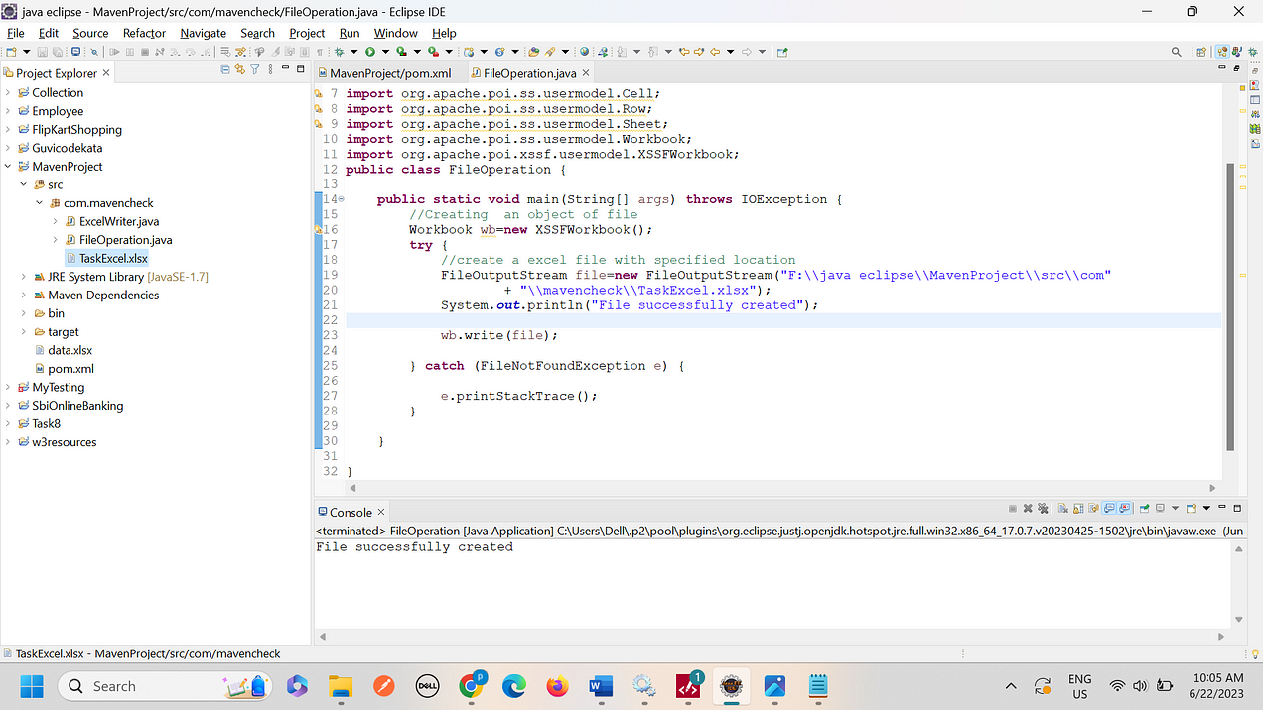

***2.Create a new sheet with name “sheet1”.***

***Code:***

**package** com.mavencheck;

**import** java.io.File;

**import** java.io.FileNotFoundException;

**import** java.io.FileOutputStream;

**import** java.io.IOException;

**import** org.apache.poi.ss.usermodel.Cell;

**import** org.apache.poi.ss.usermodel.Row;

**import** org.apache.poi.ss.usermodel.Sheet;

**import** org.apache.poi.ss.usermodel.Workbook;

**import** org.apache.poi.xssf.usermodel.XSSFWorkbook;

**public** **class** FileOperation {

**public** **static** **void** main(String[] args) **throws** IOException {

//Creating an object of file

Workbook wb=**new** XSSFWorkbook();

**try** {

//create a excel file with specified location

FileOutputStream file=**new** FileOutputStream("F:\\java eclipse\\MavenProject\\src\\com"

+ "\\mavencheck\\TaskExcel.xlsx");

System.***out***.println("File successfully created");

//creating a Sheet in excel

Sheet sheet1=wb.createSheet("Sheet1");

System.***out***.println("Sheets Has been Created successfully");

wb.write(file);

} **catch** (FileNotFoundException e) {

e.printStackTrace();

}

}

}

***Code and output screenshot:***

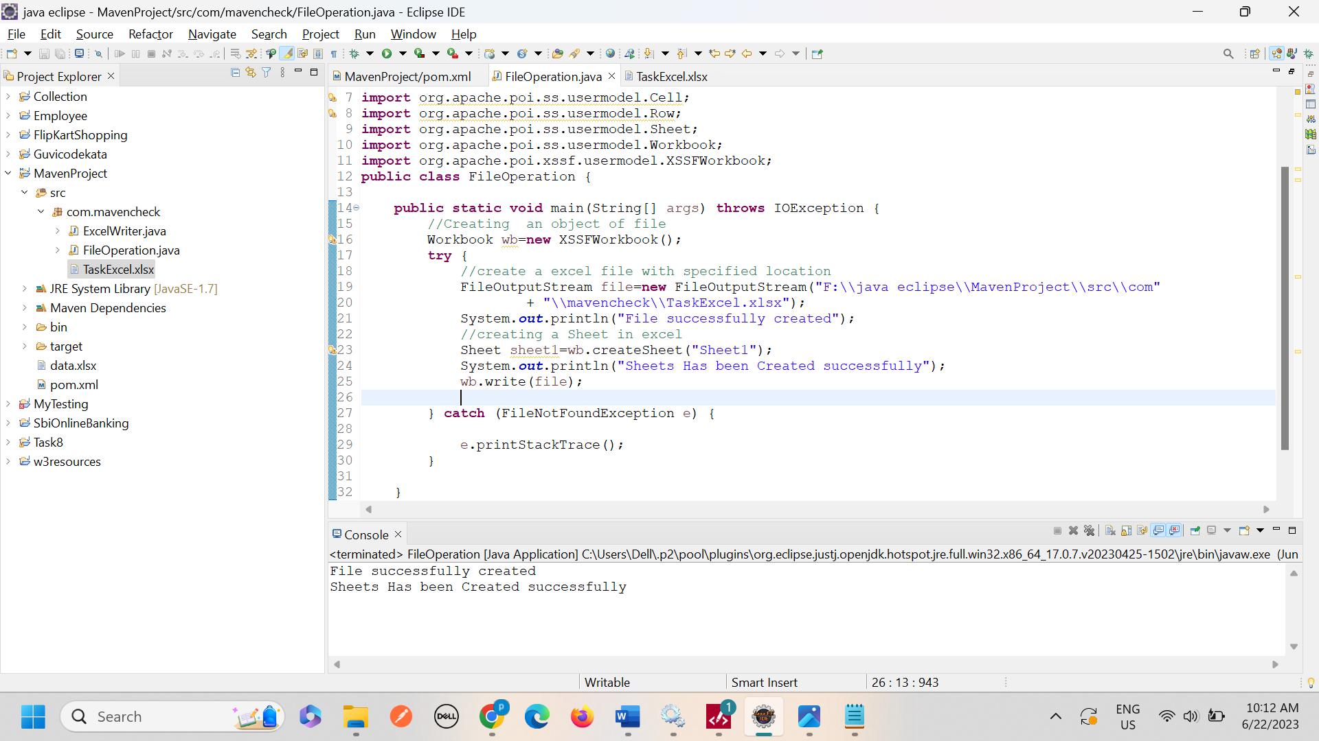

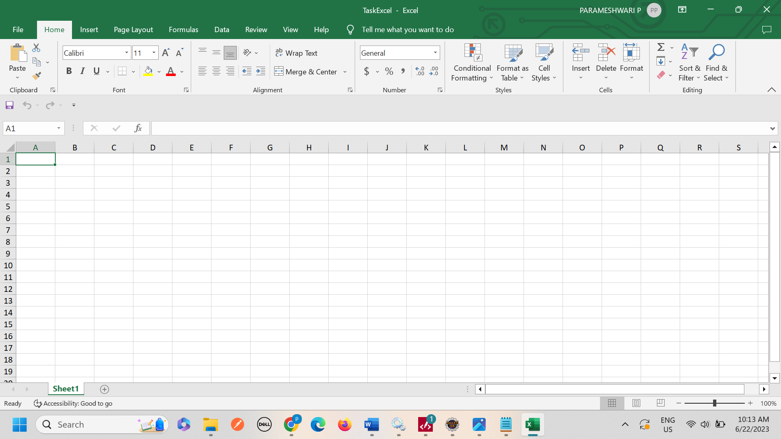

3. Write a following data to the sheet.

Column header: Name, Age, Email.

Row 1: John Doe,30,john@test.com

Row 2: John Doe,28,john@test.com

Row 3: Bob smith,35,jacky@examle.com

Row 4: swapnil,37,joe@example.com

Code:

package com.mavencheck;

import java.io.File;

import java.io.FileNotFoundException;

import java.io.FileOutputStream;

import java.io.IOException;

import org.apache.poi.ss.usermodel.Cell;

import org.apache.poi.ss.usermodel.Row;

import org.apache.poi.ss.usermodel.Sheet;

import org.apache.poi.ss.usermodel.Workbook;

import org.apache.poi.xssf.usermodel.XSSFWorkbook;

public class FileOperation {

public static void main(String[] args) throws IOException {

//Creating an object of file

Workbook wb=new XSSFWorkbook();

try {

//create a excel file with specified location

FileOutputStream file=new FileOutputStream("F:\\java eclipse\\MavenProject\\src\\com"

+ "\\mavencheck\\TaskExcel.xlsx");

System.out.println("File successfully created");

//creating a Sheet in excel

Sheet sheet1=wb.createSheet("Sheet1");

System.out.println("Sheets Has been Created successfully");

Object[][] data= {

{"Name","Age","Email"},

{"John Doe",30,"john@test.com"},

{"John Doe",28,"john@test.com"},

{"Bob smith",35,"jacky@examle.com"},

{"swapnil",37,"joe@example.com"}

};

int rowNum=0;

for(Object[] rowdata:data) {

// Creating a new row in the sheet

Row row =sheet1.createRow(rowNum++);

int colNum=0;

for(Object field:rowdata) {

// This line create a cell in the next column of that row

Cell cell=row.createCell(colNum++);

if(field instanceof String ) {

cell.setCellValue((String)field);

}else if(field instanceof Integer) {

cell.setCellValue((Integer)field);

}

}

}

System.out.println("data added successfully");

wb.write(file);

} catch (FileNotFoundException e) {

e.printStackTrace();

}

}

}

***Code and output:***

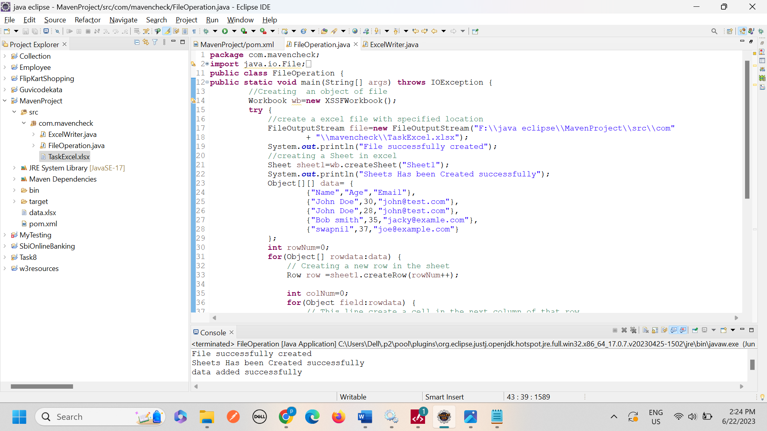

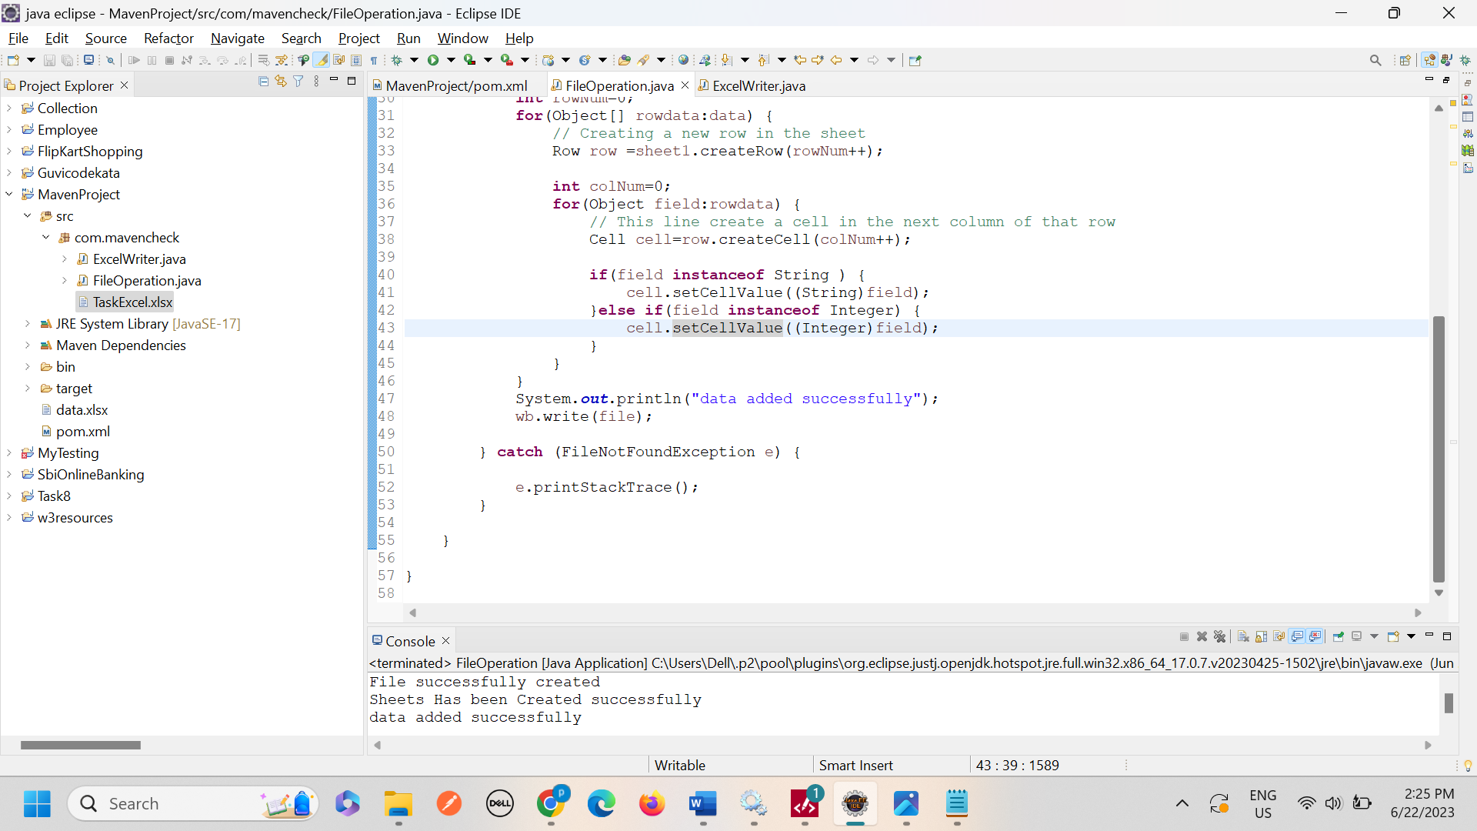

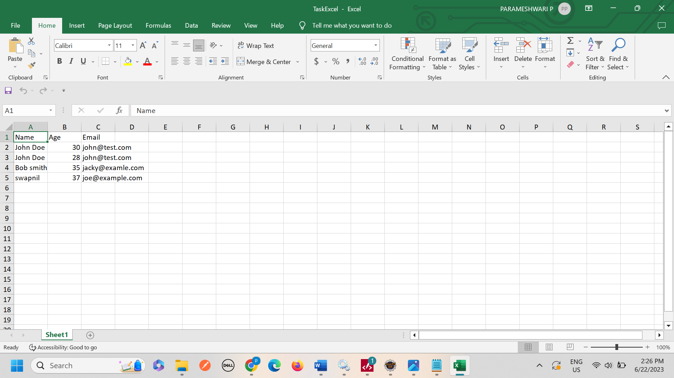

***4. Write a java program to write data to an excel file using apache poi library.***

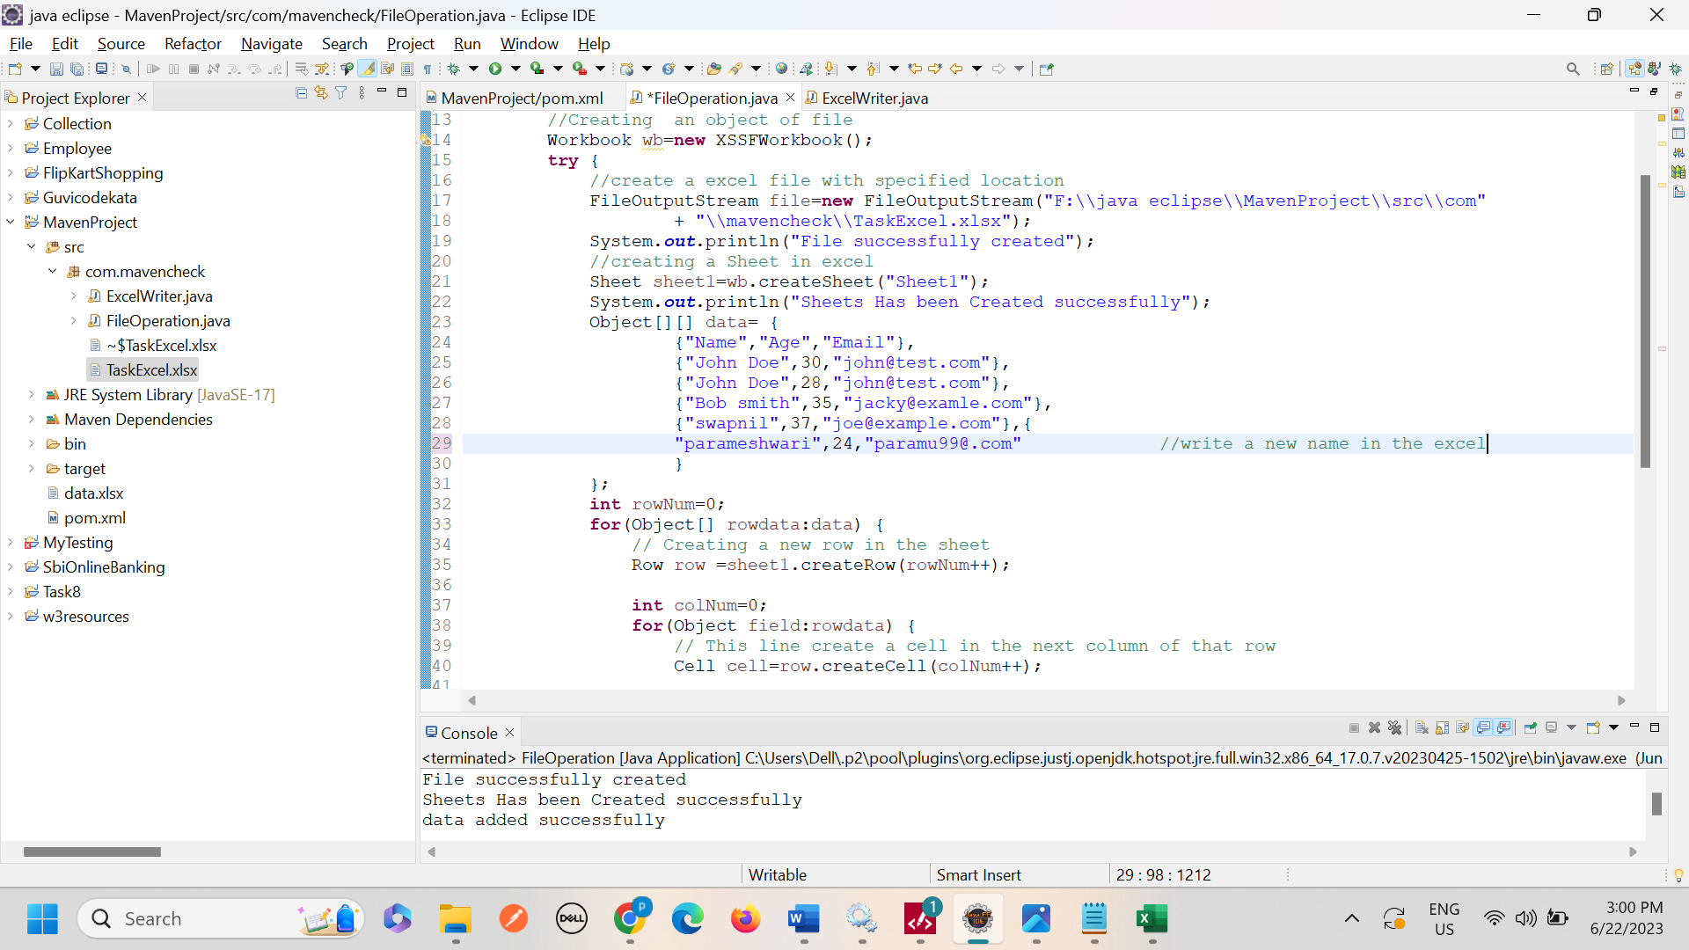

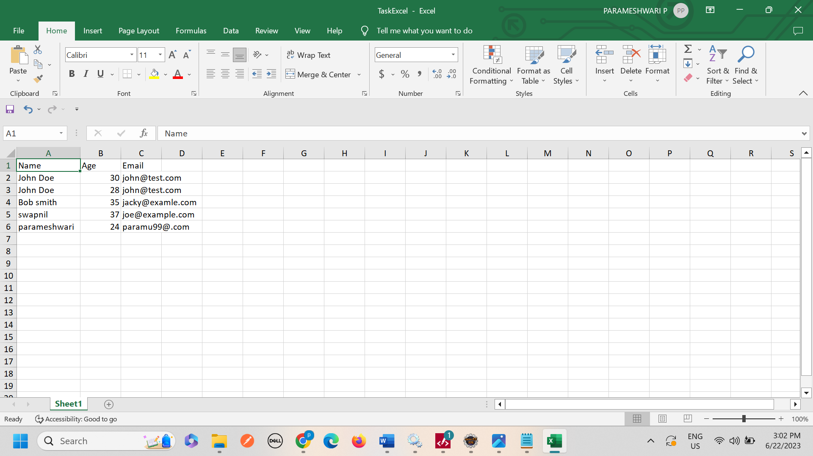

***5. Write a java program to read data to an excel file using apache poi library and print in the console***.

**Code:**

**package** com.mavencheck;

**import** java.io.File;

**import** java.io.FileNotFoundException;

**import** java.io.FileOutputStream;

**import** java.io.FileInputStream;

**import** java.io.IOException;

**import** org.apache.poi.ss.usermodel.Cell;

**import** org.apache.poi.ss.usermodel.CellType;

**import** org.apache.poi.ss.usermodel.Row;

**import** org.apache.poi.ss.usermodel.Sheet;

**import** org.apache.poi.ss.usermodel.Workbook;

**import** org.apache.poi.xssf.usermodel.XSSFWorkbook;

**public** **class** FileOperation {

**public** **static** **void** main(String[] args) **throws** IOException {

//Creating an object of file

Workbook wb=**new** XSSFWorkbook();

**try** {

//create a excel file with specified location

FileOutputStream file=**new** FileOutputStream("F:\\java eclipse\\MavenProject\\src\\com"

+ "\\mavencheck\\TaskExcel.xlsx");

System.***out***.println("File successfully created");

//creating a Sheet in excel

Sheet sheet1=wb.createSheet("Sheet1");

System.***out***.println("Sheets Has been Created successfully");

Object[][] data= {

{"Name", "Age","Email"},

{"John Doe", 30,"john@test.com"},

{"John Doe", 28,"john@test.com"},

{"Bob smith", 35,"jacky@examle.com"},

{"swapnil", 37,"joe@example.com"},{

"parameshwari",24,"paramu99@.com" //write a new name in the excel

}

};

**int** rowNum=0;

**for**(Object[] rowdata:data) {

// Creating a new row in the sheet

Row row =sheet1.createRow(rowNum++);

**int** colNum=0;

**for**(Object field:rowdata) {

// This line create a cell in the next column of that row

Cell cell=row.createCell(colNum++);

**if**(field **instanceof** String ) {

cell.setCellValue((String)field);

}**else** **if**(field **instanceof** Integer) {

cell.setCellValue((Integer)field);

}

}

}

System.***out***.println("data added successfully");

System.***out***.println("_______________________");

wb.write(file);

FileInputStream intputstream=**new** FileInputStream("F:\\java eclipse\\MavenProject\\src\\com"

+ "\\mavencheck\\TaskExcel.xlsx");

XSSFWorkbook workbook=**new** XSSFWorkbook();

**for**(Row row:sheet1) {

**for**(Cell cell:row) {

//to check if cell contains is string or numeric

**if**(cell.getCellType()==CellType.***STRING***) {

System.***out***.print(cell.getStringCellValue()+"\t");

}**else**

System.***out***.print(cell.getNumericCellValue()+"\t");

}

System.***out***.println();

}

} **catch** (FileNotFoundException e) {

e.printStackTrace();

}

}

}

**Code and output:**

