Spatial Mapping Using Time-of-Flight

Paramveer Multani

Dr. Yaser M. Haddara, Dr. Shahrukh Athar, Dr. Thomas Doyle
Department of Electrical and Computer Engineering, McMaster University
April 7th, 2026

As a future member of the engineering profession, the student is responsible for performing the required work in an honest manner, without plagiarism and cheating. Submitting this work with my name and student number is a statement and understanding that this work is my own and adheres to the Academic Integrity Policy of McMaster University and the Code of Conduct of the Professional Engineers of Ontario. Submitted by Paramveer Multani

Table of Contents
Section 1.0 Device Overview 3
1.1 Features 3
1.2 Hardware 4
1.3 Software 5
1.4 General Description 5
1.5 Block Diagram and Data Flow Graph 6
Section 2.0 Device Characteristics Table 7
Section 3.0 Detailed Description 9
3.1 Distance Measurement (Acquisition) 9
3.2 Data Processing (Conversion to XYZ Coordinates) 9
3.3 Displacement 10
3.4 Visualization 10
Section 4.0 Application Example, Instructions, and Expected Output 11
4.1 Hardware Setup Instructions 11
4.2 Software Setup Instructions 12
4.3 Running the System 12
4.4 Coordinate System Definition 12
4.5 Scanned Location 13
4.6 Reference Images 13
4.7 Expected Output (Python Visualization) 14
Section 5.0 Limitations 15
Section 6.0 Circuit Schematic 17
Section 7.0 Programming Logic Flowcharts 19
7.1 Python Visualization Script (ScanCode.py) 20
References 21
Appendix: Campus Location Scan vs. Photograph 22

Section 1.0 Device Overview
This report introduces a compact, cost-effective indoor Light Detection and Ranging (LIDAR) system capable of generating a three-dimensional spatial representation of an enclosed environment. The main component of this system is a Texas Instruments MSP-EXP432E401Y microcontroller, which utilizes a VL53L1X Time-of-Flight (ToF) sensor attached to a 28BYJ-48 stepper motor for a 360° scan. Measurements are taken at a specified angle in the Y-Z plane, with X-axis displacement calculated manually between measurements. All measurement information is sent serially to a host PC, where a Python script translates polar coordinates into Cartesian coordinates and creates a three-dimensional wireframe representation using Matplotlib.

1.1 Features
Visualization and Communication
- 3D spatial map generated using Python (PySerial + Matplotlib) wireframe visualization
- VL53L1X ToF sensor communicates live distance measurements with microcontroller via I2C at 100 kbps
- Microcontroller communicates live data to PC via UART at 115200 bps

Microcontroller
- ARM Cortex-M4F 32-bit CPU with hardware single-precision FPU
- 28 MHz bus speed (PSYSDIV = 16)
- 1 MB Flash, 256 KB SRAM
- Powered via 5 V Micro-USB

I/O and Controls
- PJ0 starts scans via GPIO falling-edge interrupt
- PJ1 pauses and resumes the motor via GPIO falling-edge interrupt
- PN0 (D2) is the measurement status LED
- PF0 (D4) is the UART TX status LED
- PF4 (D3) is the additional status LED

Scanning Behaviour
- 64 distance measurements per 360° scan at 5.625° angular resolution
- Alternating CW and CCW motor direction between scans to prevent cable tangling
- Long-range mode supports up to 4 m

1.2 Hardware
Hardware | Image | Datasheet | Price
MSP-EXP432E401Y Microcontroller | 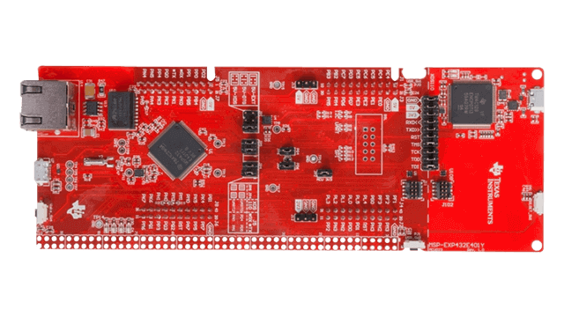 | TISLAU748B  Datasheet | $47.99
28BYJ-48 Stepper Motor | 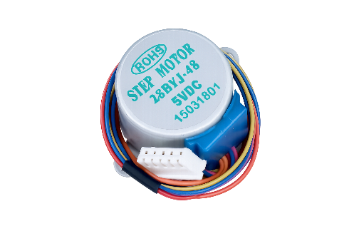 | 28BYJ-48 Datasheet | $11.73
Pololu VL53L1X ToF Sensor | 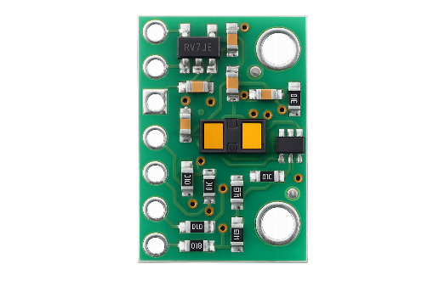 | VL53L1X Datasheet | $18.95
ULN2003 Stepper Motor Driver | 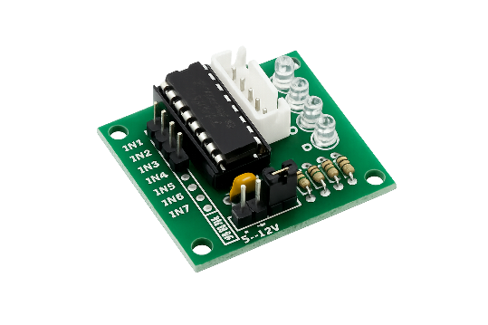 | ULN2003AN Datasheet | $1.35
 |  | Total: | $80.02

Table 1: Hardware Components

1.3 Software
Software Package | Job
Keil MDK (C) | Microcontroller firmware (communication, GPIO, interrupts, motor control)
Python 3.13.5 | PC-side visualization, coordinate conversion, serial reception
PySerial | Serial port communication library
Matplotlib | 3D plotting and wireframe rendering
Table 2: Software Packages

1.4 General Description
Peripheral coordination is carried out using the MSP-EXP432E401Y LaunchPad, consisting of a 120 MHz ARM Cortex-M4F core equipped with a hardware floating-point unit, with 1 MB of on-chip flash memory and 256 KB of SRAM. Based on project specifications and student number, the frequency of the system clock is adjusted to 28 MHz through PLL divider PSYSDIV = 16.
The initial start of the system occurs when the user pushes the onboard button PJ0 (SW1) to start a scan. Both buttons utilize falling-edge GPIO interrupts and set flag variables that are used by the main loop. Pressing PJ0 initiates a 360° rotation of the stepper motor. During the scanning procedure, PJ1 (SW2) can be pushed to temporarily stop or resume motor rotation.
Distance detection is performed using a Pololu VL53L1X board, which consists of an ST VL53L1X ranging sensor. Distance measurement is performed by emitting a 940 nm invisible Class 1 laser and recording the time taken for the light to reflect off a surface and return to the onboard single photon avalanche diode (SPAD) receiver array. All signal processing and analog-to-digital conversion is done inside the module, and the result is sent to the controller in mm through the I2C interface, which operates at 100 kbps on pins PB2 (clock) and PB3 (data) with open-drain configuration. The sensor supports a voltage range from 2.6 V to 5.5 V and operates under 3.3 V provided by the MSP432E401Y voltage regulator.
Rotation is carried out by a 28BYJ-48 geared stepper motor with a ULN2003 Darlington driver attached to GPIO Port H (PH0–PH3). The motor uses an internal gear reduction system to convert 64 internal half-steps into a single external step of 5.625°. For the current configuration, one increment of measurement equals 32 full-step rotations, giving 64 measurements per full revolution. The rotation direction switches every other scan to prevent tangling of the sensor and motor wires.
Once a distance measurement is complete, the data is sent through UART at 115200 bps using the onboard Micro-USB connector to a computer. Python code processes the serial stream, translates polar coordinates (distance, angle) into Cartesian coordinates (x, y, z), and creates a 3D wireframe representation using Matplotlib. Data is also stored in .xyz and .csv file formats.

1.5 Block Diagram and Data Flow Graph
The block diagram below shows the interconnection of all hardware components. The PC sits at the top of the data flow, receiving processed measurements via UART. The MSP432E401Y microcontroller is the central piece.
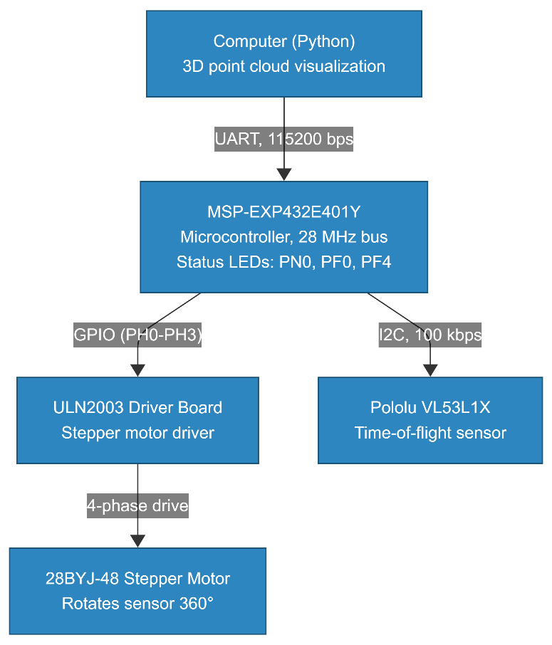

Figure 1: System Component Block Diagram
The data flow graph below shows the signal path from sensor acquisition through I2C transfer, microcontroller processing, UART transmission, and finally PC-side visualization.

Figure 2: Data Flow Graph

Section 2.0 Device Characteristics Table
Component | Operating Voltage
MSP-EXP432E401Y Microcontroller | +5 V through Micro-USB
ULN2003 Stepper Motor Driver | +5 V from microcontroller
28BYJ-48 Stepper Motor | +5 V from ULN2003 driver
Pololu VL53L1X ToF Sensor | +3.3 V from microcontroller (range: 2.6–5.5 V)
Table 3: Component Power Requirements
Pin | Signal | Description
PH0–PH3 | GPIO Output | Stepper motor coil drive (4-phase full-step via ULN2003)
PJ0 | GPIO Interrupt | SW1: Start scan (falling-edge interrupt)
PJ1 | GPIO Interrupt | SW2: Pause/Resume motor (falling-edge interrupt)
PB2 | SCL | I2C0 clock line to VL53L1X
PB3 | SDA | I2C0 data line to VL53L1X (open-drain)
PG0 | XSHUT | VL53L1X hardware reset control
PN0 | LED D2 | Distance measurement status (flashes per reading)
PF0 | LED D4 | UART transmission status (flashes on TX)
PF4 | LED D3 | Additional status: ON = idle/ready, OFF = scanning
Micro-USB | UART | Serial data to PC at 115200 bps
Table 4: MSP-EXP432E401Y Pin Assignments

Parameter | Value
I2C Frame | 1 start bit, 7-bit address, 1 R/W bit, 1 ACK, 8 data bits, 1 ACK/NACK, 1 stop bit
I2C Clock Speed | 100 kbps (standard mode the ToF supports up to 400 kbps fast mode)
I2C Slave Address | 0x29 (VL53L1X default)
UART Frame | 1 start bit, 8 data bits, 1 stop bit (8N1, no parity)
UART Baud Rate | 115200 bps
Table 5: Communication Protocol Parameters
Parameter | Value
MSP-EXP432E401Y Bus Speed | 28 MHz (PSYSDIV = 16)
Timing Budget | 50 ms per measurement
Inter-Measurement Period | 60 ms
Distance Mode | Long range (mode 2, up to 4 m)
Points per Scan | 64 (5.625° per point)
Motor Steps per Point | 32 full steps
Total Motor Steps per Revolution | 2048
Number of Scans | 10
X-Axis Offset Between Scans | 100 mm (simulated)
Motor Step Delay | 20 ms per step

Table 6: Timing and Scan Parameters

Section 3.0 Detailed Description

3.1 Distance Measurement (Acquisition)
The VL53L1X Time-of-Flight sensor runs on the principle of measuring the full round-trip time of a 940 nm infrared laser pulse. The sensor emits a short burst of photons from its VCSEL emitter, which reflect off the target surface and return to the SPAD receiver array. The sensor’s onboard microcontroller measures the time it takes and computes the distance in millimetres using the speed of light. The measurement is returned as a 16-bit unsigned integer in units of millimetres.

$$d = c × \frac{Δt}{2}$$

c is the speed of light (3 × 10⁸ m/s)
Δt is the round-trip flight time of the laser pulse

The sensor communicates with the MSP432E401Y microcontroller through the I2C protocol at 100 kbps. The microcontroller acts as the I2C master with the VL53L1X at slave address 0x29. I2C is initialized on Port B where PB2 serves as SCL and PB3 as SDA (configured as open-drain per the I2C specification). The I2C0 Timer Period Register (I2C0_MTPR_R) is configured to achieve the desired 100 kHz clock rate at the 28 MHz system clock.
The sensor is configured in long-range distance mode (mode 2), supporting measurements up to approximately 4 metres. The timing budget is set to 50 ms and the inter-measurement period to 60 ms. Continuous ranging is enabled with VL53L1X_StartRanging(dev).
Each scan collects 64 distance measurements across a full 360° rotation, producing an angular resolution of 5.625°. For each measurement point, the stepper motor first advances 32 steps via spinOnePoint(), after which the microcontroller polls VL53L1X_CheckForDataReady() until data is available. The distance is read using VL53L1X_GetDistance() and the sensor interrupt is cleared with VL53L1X_ClearInterrupt(). The PN0 LED (D2) flashes once per measurement to provide a visual status indication.

3.2 Data Processing (Conversion to XYZ Coordinates)
The ToF sensor captures measurements in polar form where each reading consists of a distance (mm) at an angular position θ within the Y-Z scan plane. The X-axis represents displacement between scan planes. Conversion from polar to Cartesian coordinates is performed on the PC side by the Python script using the following equations:
$$x = x_offset$$
$$y = d × cos(θ)$$
$$z = d × sin(θ)$$
d is the measured distance in mm, θ is the angle in radians converted from millidegrees, and x_offset is the simulated displacement for the current scan.
Example
Consider point 9 of scan 2, with raw UART data:
Point 9, Offset: 100 mm, Angle: 50625 mdeg, Distance: 350 mm

  - Convert millidegrees to degrees: θ = 50625 / 1000 = 50.625°
  - Convert to radians: θ_rad = 50.625 × (π / 180) = 0.8836 rad
  - Compute Cartesian coordinates:

x = 100.0 mm
y = 350 × cos(0.8836) = 350 × 0.6347 = 222.1 mm
z = 350 × sin(0.8836) = 350 × 0.7730 = 270.6 mm

(x, y, z) = (100.0, 222.1, 270.6) mm

3.3 Displacement
In this implementation, displacement along the X-axis is simulated in software. The system performs 10 scans at the same physical position but assigns a virtual 100 mm offset between each scan plane:

$$x_offset = scanNum × 100 mm$$

This produces scan planes at x = 0, 100, 200, …, 900 mm. In the firmware, this is transmitted through a formatted UART string. Between every other scan, the motor direction alternates to prevent cable tangling around the motor shaft.

3.4 Visualization
The Python script (ScanCode.py) handles the visualization process using PySerial and Matplotlib. The PySerial module opens the COM port at 115200 baud, reads incoming UART data line by line, and parses three structured message types: SCAN_INDEX lines set the active scan number, X_MM lines set the displacement offset, and Point lines carry individual measurement data.
To handle data conversion, the math module is used within the convert_to_xyz() function, employing math.radians(), math.cos(), and math.sin() to convert polar coordinates into Cartesian coordinates. For visualization, Matplotlib’s plot_wireframe() function creates a 3D plot where each scan is rendered as a closed polygon with a distinct color. Adjacent scans are connected using black lines in the wireframe model. For CCW scans, the point order is reversed before connecting to ensure correct angular alignment.
All data is exported in two formats: .xyz lists the x, y, and z coordinates as space-separated values; .csv contains columns for scan number, x_mm, angle_deg, distance_mm, and the Cartesian coordinates. The final plot is exported as scan_3d.png at 150 DPI.

Section 4.0 Application Example, Instructions, and Expected Output
This section outlines an exemplar scan using this spatial mapping system. Provided below are setup instructions for initializing the system and acquiring measurements, followed by expected outputs. The instructions assume the required software (Keil MDK, Python 3.13.5 with PySerial and Matplotlib) is installed and the hardware is wired as described in Section 6.0.

4.1 Hardware Setup Instructions
- Mount the VL53L1X ToF sensor onto the 28BYJ-48 stepper motor shaft using a custom 3D-printed bracket. Ensure the sensor faces outward (perpendicular to the rotation axis) and that the protective liner has been removed from the sensor IC.
- Connect the ULN2003 stepper motor driver to Port H: PH0 to IN1, PH1 to IN2, PH2 to IN3, PH3 to IN4. Supply the ULN2003 board with +5 V from the microcontroller.
- Connect the VL53L1X sensor: VIN to 3.3 V, GND to GND, SDA to PB3, SCL to PB2, XSHUT to PG0.
- Connect the MSP432 to the PC via the onboard Micro-USB cable. This provides both power and UART communication.
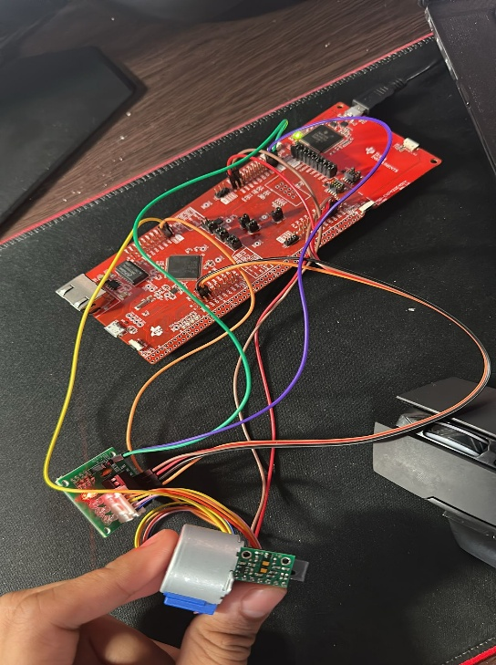

Figure 3: Hardware Assembly and Mounting Configuration

4.2 Software Setup Instructions
- Open the Keil project. Make sure the target is set to the MSP432E401Y. Click Translate, then Build, and finally Download to flash the firmware.
- After flashing, press the Reset button on the board. All onboard LEDs should flash briefly, confirming the firmware is running.
- Determine the COM port: open Windows Device Manager and find XDS110 Class Application/User UART (COM #).
- Open ScanCode.py and set SERIAL_PORT to your COM port (e.g., SERIAL_PORT = "COM6"). Verify BAUD_RATE = 115200.
- Run the Python script: python ScanCode.py. The script starts listening for serial data.

4.3 Running the System
- The terminal displays System ready. Press PJ0 (SW1) to start scan 1. The PF4 LED (D3) turns ON indicating the system is idle and ready.
- Press PJ0 (SW1) to start scan 1. The PF4 LED turns OFF during scanning. The motor rotates 360° CW, stopping 64 times. PN0 (D2) flashes per measurement; PF0 (D4) flashes per UART transmission.
- When scan 1 completes, the system prints Press PJ0 for scan 2. Press PJ0 again. The motor now rotates CCW.
- During any scan, pressing PJ1 (SW2) pauses the motor. Pressing PJ1 again resumes it.
- After all scans are complete, the firmware retransmits all stored data (bracketed by START/END) and prints All scans complete.
- The Python script detects the completion message, saves scan_points.xyz and scan_points.csv, and displays the 3D wireframe. The plot can be rotated interactively.

4.4 Coordinate System Definition
X-axis (Displacement/Depth): Represents the offset between scan planes. Scan 1 at x = 0 mm, Scan 2 at x = 100 mm, and so on.

Y-axis (Width): Horizontal component of the ToF distance in the scan plane: y = d × cos(θ).

Z-axis (Height): Vertical component of the ToF distance in the scan plane: z = d × sin(θ).

The ToF sensor begins at 0° (pointing in the +Y direction) and rotates through 360°. Ten scan slices in the Y-Z plane are spaced 100 mm apart along the X-axis.

4.5 Scanned Location
Based on student number 400586406, the assigned scanning location is Section G on the second floor of McMaster’s Engineering Technology Building (ETB). A floor plan of the second floor of ETB is provided below, with the assigned scanning location highlighted, along with real-life reference photographs of the scanned area.

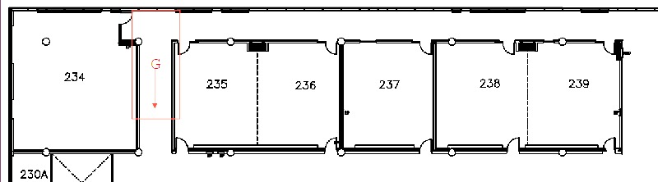

Figure 4: Engineering Technology Building Second Floor Section G

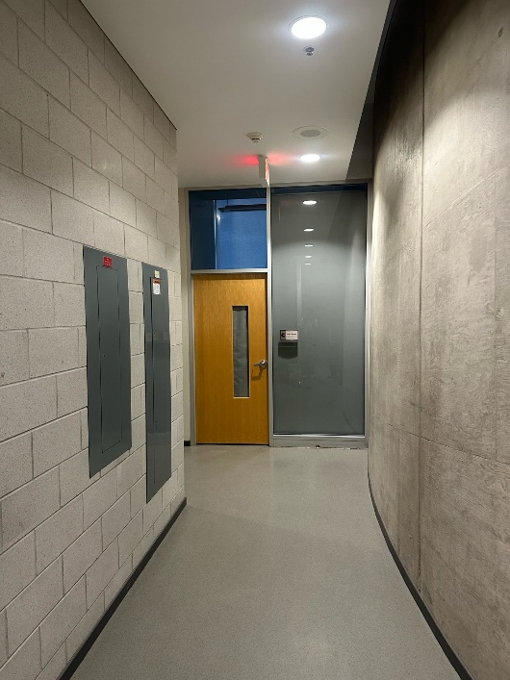
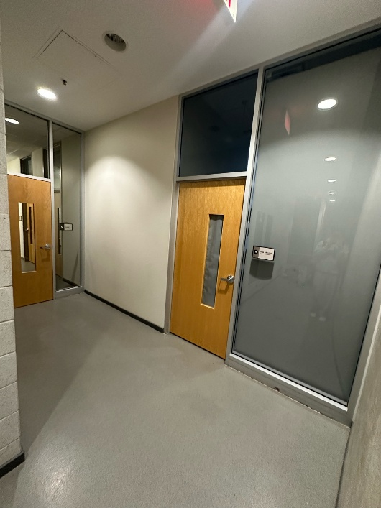
4.6 Reference Images

Figure 5: Reference Photographs of the Scanned Location ETB Section G

4.7 Expected Output (Python Visualization)
As shown in the images below, the system captured the overall geometry of the hallway in Section G of ETB. The top view gives a clear representation of the hallway’s length and width, along with its two open ends and the general wall boundaries throughout the scanned region. The side view shows the vertical structure of the space, including the ceiling height and the recessed alcove present in the ceiling. The isometric view combines the perspectives to show the full three-dimensional layout of the hallway, giving a clearer understanding of both the corridor shape and the overhead ceiling feature.
Note that the measurements taken by the ToF sensor are in the vertical Y-Z plane, while the X-axis represents the manually incremented displacement between scans.

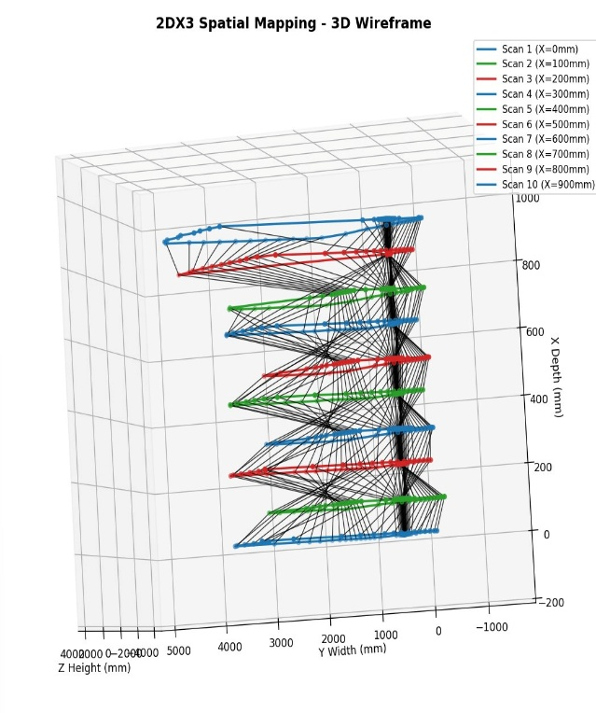
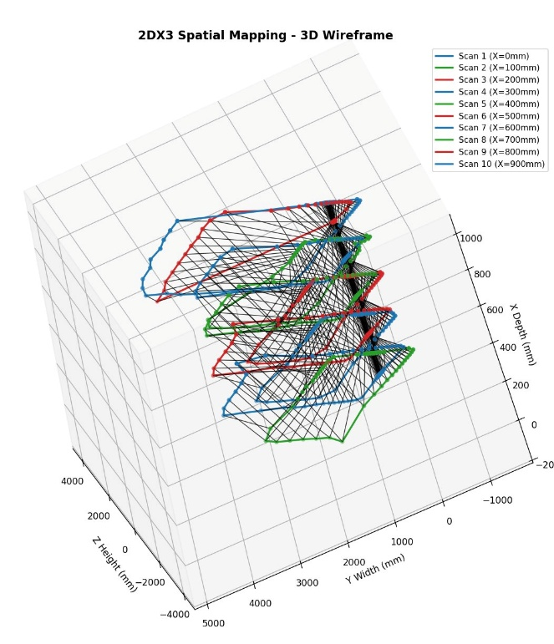
Figure 6: Bird’s Eye View
Figure 7: Side View

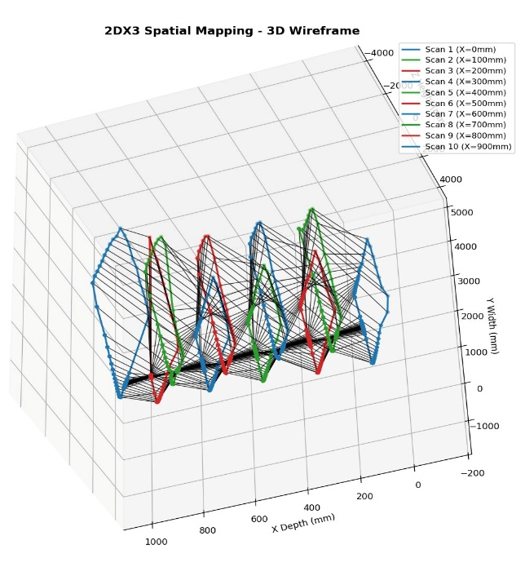
Figure 8: Angled Perspective View

Section 5.0 Limitations
This section addresses each of the seven questions from Section 5 of the project specification. All values are specific to this build (28 MHz clock, 64 points/scan, Python-based visualization).

Microcontroller Floating-Point and Trigonometric Precision
The Cortex-M4F chip embedded within the MSP432E401Y has a hardware floating point module, which allows single precision arithmetic only (32-bit IEEE 754), which limits the number of precise digits to seven decimal places. Unlike basic operations such as addition or division, the FPU does not have dedicated hardware instructions for trigonometric functions. As a result, calls to sin() and cos() are handled entirely in software by the compiler's math library using polynomial approximations, which introduce rounding errors on the order of 10⁻⁶ to 10⁻⁷.
The two limitations, when combined, work together to increase any errors. A trigonometric function rounding error will be clearer depending on the distance and the proximity of the angle to zero, since a coordinate displacement due to a small trigonometric rounding error might be measured in fractions of millimetres (for example, d = 4000 mm). In this project, the risk with this limitation is reduced by calculating all the trigonometric functions using the Python interpreter (64-bit double, 15 – 16 digits).

ToF Module Quantization Error
The VL53L1X outputs distance as a 16-bit unsigned integer. In long-range mode (mode 2) the ceiling is 4000 mm. Using the standard quantization formula:

$$Q_{max} = \frac{Full-Scale Range}{2^{n}} = \frac{4000 mm}{65536}= 0.061 mm$$

Since the API delivers whole-millimetre integers, the effective step size is 1 mm (±0.5 mm worst-case). The datasheet-rated accuracy of about ±25 mm under normal indoor conditions far exceeds this quantization floor.

Maximum Serial Communication Rate with the PC
Despite this, the XDS110 USB bridge attached to the board limits the transmission speed. It restricts the highest achievable baud rate, which according to the Windows Device Manager port settings is 128000 bps. In the current project, a baud rate of 115200 bps is used with 8N1 framing. How accurate the data is was checked by running RealTerm as a serial terminal alongside the Python script and confirming that all 64 measurement strings per scan were transmitted successfully with no errors or missing data.

Microcontroller-to-Sensor Communication Method and Speed
The VL53L1X is reached exclusively over I2C, clocked at 100 kbps (standard mode) on PB2/PB3. The sensor datasheet permits up to 400 kbps fast-mode operation. At address 0x29, a typical register read transfers 4–6 bytes and completes in roughly 0.5 ms.

Primary System Speed Bottleneck
Two stages take up nearly all of each scan’s duration. Motor travel takes 32 steps $×$ 20 ms per step = 640 ms per measurement point which across 64 points is roughly 41 seconds. Sensor ranging contributes 60 ms × 64 points = 3.8 s. Because the motor already waits 640 ms per point, the sensor is always ready before the motor finishes moving.
I2C overhead is about 32 ms total and UART throughput is similarly negligible. The motor delay clearly is majority of the scans duration. This was confirmed by timing a complete scan with a stopwatch and the measured result tracked the 41-second theoretical value.

Bus Speed Configuration and Verification (PSYSDIV Calculation)
From Table 1 of the Project Specification Requirement, my LSD was set to 6, which assigned 28 MHz. The PLL VCO runs at 480 MHz (from the 25 MHz crystal). The PSYSDIV field divides this down:
$$f_{sys} = \frac{480 MHz}{PSYSDIV + 1}$$

$$PSYSDIV = \frac{480}{28} - 1 =16.14$$
$$PSYSDIV = 16$$
$$Actual clock = \frac{480}{17} = 28.24 MHz$$

SysTick is loaded with 280000 counts for a 10 ms tick. This was verified through a GPIO pin that was toggled inside the SysTick handler, and the resulting waveform was captured on an Analog Discovery 3 to confirm the expected period.

Status LED Assignments and Meaning

From Table 2 of the Project Specification Requirement, my second LSD was 0, which was assigned:

- PN0 (D2) Measurement Indicator: Blinks each time the firmware captures a distance sample which gives user a visual pulse of sensor activity.
- PF0 (D4) Transmission Indicator: Blinks when a block of data leaves the board over UART, confirming bytes are reaching the PC.
- PF4 (D3) Ready/Idle Indicator: Stays lit while the system and waits for a button press and turns off during an active scan.

Additional Hardware Constraints
There are several real-life limitations on the working of the system. For instance, to avoid the cable wrapping around the motor, there should be an alternation between CW and CCW motion of the motor for every single scan. According to the data sheet, the 28BYJ-48 stepper motor is characterized by non-accumulative step accuracy of ±5%. The field of view of the VL53L1X sensor is equal to 27°, which limits its ability to detect objects at certain angles. In addition, highly reflective or absorbing surfaces at 940 nm might provide inaccurate results.

Section 6.0 Circuit Schematic
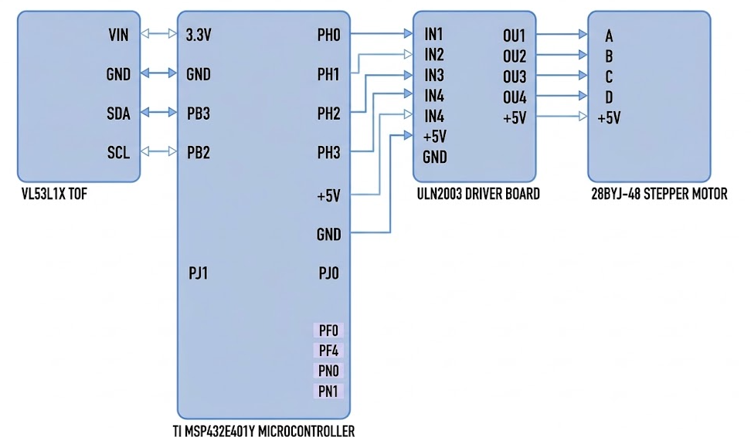
The circuit schematic below shows the complete wiring of all system components connected to the MSP-EXP432E401Y microcontroller.

Figure 6: Circuit Schematic of the Spatial Mapping System
Push Buttons: SW1 on PJ0, SW2 on PJ1 (active-low with internal pull-up resistors)
LEDs: D2 on PN0 (measurement), D4 on PF0 (UART TX), D3 on PF4 (ready/idle)
UART to PC: Via onboard Micro-USB connector (XDS110 bridge) at 115,200 bps

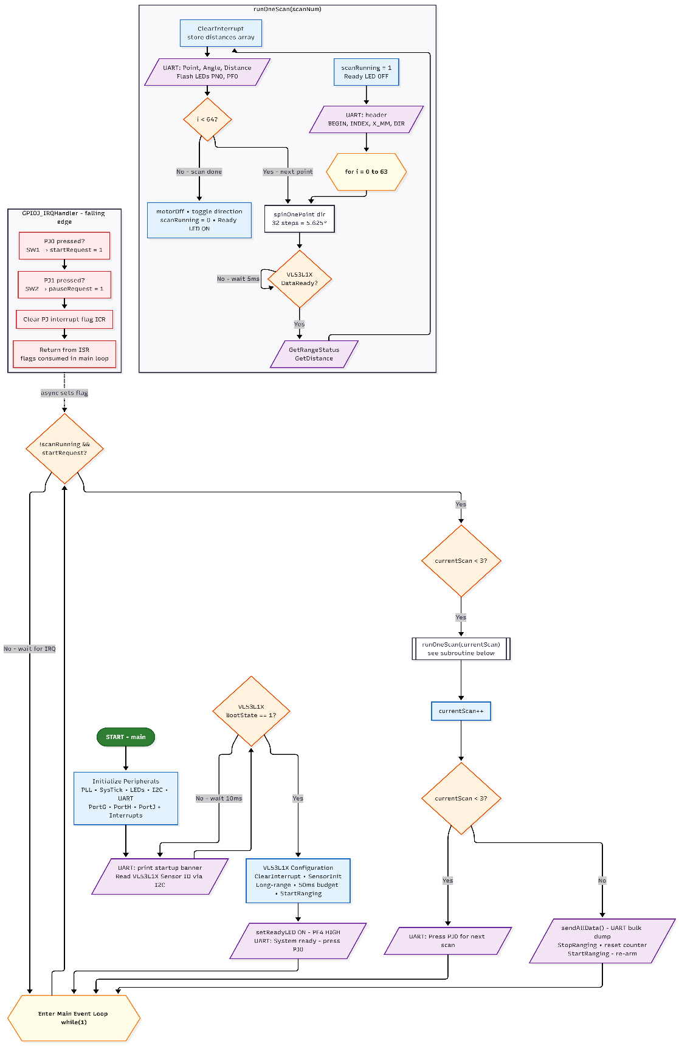
Section 7.0 Programming Logic Flowcharts

Figure 7: Microcontroller Firmware Logic Flowchart

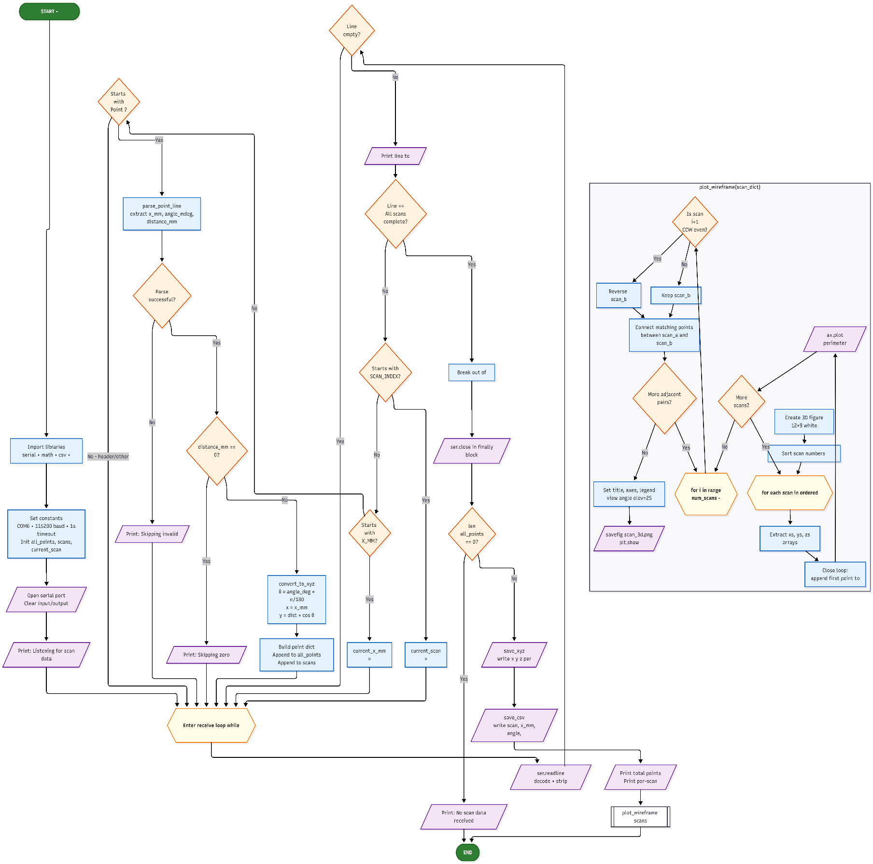
7.1 Python Visualization Script (ScanCode.py)

Figure 8: Python Visualization Script Logic Flowchart

References
[1] STMicroelectronics, “VL53L1X World’s Smallest Time-of-Flight Ranging Sensor Datasheet,” 2018. [Online]. Available: https://www.pololu.com/file/0J1506/vl53l1x.pdf
[2] Texas Instruments, “MSP-EXP432E401Y SimpleLink Ethernet LaunchPad Development Kit User’s Guide,” SLAU748B, 2018.
[3] Texas Instruments, “TM4C1294NCPDT Microcontroller Data Sheet,” SPMS433, 2014.
[4] “28BYJ-48 Stepper Motor Datasheet,” available from multiple distributors.
[5] Texas Instruments, “ULN2003A Darlington Transistor Arrays Datasheet,” SLRS027T.
[6] Python Software Foundation, “PySerial Documentation.” [Online]. Available: https://pyserial.readthedocs.io/
[7] Matplotlib Development Team, “Matplotlib 3D Plotting Documentation.” [Online]. Available: https://matplotlib.org/stable/gallery/mplot3d/
[8] McMaster University, “COMPENG 2DX3 Project Specification: Observe, Reason, Act — Winter 2026,” Feb. 2026.

