ARCHITECTURAL PLAN ABSTRACT
So-Good Apartments JV LLC
Springfield, Illinois

━━━━━━━━━━━━━━━━━━━━━━━━━━━━━━━━━━━━━━━━━━━━━━━━━━

CONFIDENTIAL — FOR AUTHORIZED USE ONLY

ARCHITECTURAL PLAN ABSTRACT: SO-GOOD APARTMENTS
PROJECT IDENTIFICATION:
- Project Name: So-Good Apartments
- Project Location: 789 Maple Avenue, Downtown District, Springfield, [State, e.g., IL] – Specifically identified as Parcel ID: 17-03-24-301-002, comprising approximately 2.85 contiguous acres.
- Development Type: Class A Multi-Family Residential Development
- Total Project Cost: $65,000,000.00
- Developer Entity: So-Good Holdings LLC, a Delaware limited liability company.
- Date of Abstract: October 26, 2023
- Prepared By: [Underwriter's Name/Firm, e.g., Nexus Capital Underwriting Group]

1. EXECUTIVE SUMMARY
This Architectural Plan Abstract provides a comprehensive, expert-level overview of the proposed So-Good Apartments development, a $65,000,000.00 Class A multi-family residential project situated at 789 Maple Avenue within Springfield's burgeoning Downtown District. The development comprises two (2) distinct, interconnected residential structures totaling 285,000 Gross Square Feet (GSF) and accommodating 240 premium dwelling units, complemented by integrated ground-floor retail and an expansive amenity package. The project is strategically positioned to capitalize on robust demand for high-quality, amenity-rich urban living options in Springfield's core, demonstrating strong financial viability and adherence to best-in-class design and construction methodologies.
The proposed design adheres strictly to the city's RM-4 Multi-Family Residential District zoning regulations, with a floor area ratio (FAR) of 2.3:1, well within the permitted 3.0:1 maximum. The project is anticipated to achieve a stabilized Net Operating Income (NOI) of approximately $4,550,000.00, yielding a compelling Return on Cost (ROC) predicated on a conservative 6.75% exit capitalization rate. This abstract details the architectural program, site specifics, development team, regulatory compliance, and key underwriting considerations, affirming the project's robust commercial and legal standing.

2. PROJECT OVERVIEW AND SCOPE
The So-Good Apartments development entails the new construction of two (2) six-story residential buildings over a shared two-level subterranean parking garage. The architectural design embraces a contemporary urban aesthetic, integrating high-quality, durable materials such as brick masonry, architectural precast concrete, and high-performance glazing systems.
Key Program Elements:
- Residential Units: 240 units, comprising:
- 30 Studio units (Avg. 550 SF)
- 100 One-Bedroom/One-Bathroom units (Avg. 725 SF)
- 80 Two-Bedroom/Two-Bathroom units (Avg. 1,050 SF)
- 30 Three-Bedroom/Two-Bathroom units (Avg. 1,300 SF)
- Total Net Rentable Area (NRA) for residential: 202,500 square feet.
- Retail Space: 8,500 square feet of ground-floor commercial space, designed for flexible tenancy (e.g., café, boutique services), to enhance the street-level experience and provide ancillary services to residents and the public.
- Parking: 320 structured parking spaces (1.33 spaces per unit), exceeding the minimum requirement of 1.25 spaces per unit per Springfield Zoning Ordinance Article VI, Section 6.2.1, with dedicated EV charging stations.
- Amenities: Over 15,000 square feet of common amenity space, including:
- Expansive lobby with concierge services.
- State-of-the-art fitness center with yoga studio.
- Resident lounge and co-working spaces.
- Rooftop terrace with panoramic city views, outdoor kitchens, and seating areas.
- Pet spa and dog run.
- Secured package room and bike storage.
- Site Area: 2.85 acres (124,146 SF).
- Total GSF: 285,000 GSF (excluding subterranean parking).

3. SITE ANALYSIS AND CONTEXT
The project site at 789 Maple Avenue is a consolidation of three (3) formerly underutilized commercial parcels, strategically located at the nexus of the Downtown District's employment hub and cultural amenities. The site benefits from exceptional connectivity, with direct access to major arterial roads (Springfield Parkway, Elm Street Connector) and proximity to the regional light rail station (0.4 miles).
Zoning and Entitlements:
- Current Zoning: RM-4 Multi-Family Residential District, allowing for high-density residential development with ancillary commercial uses. This designation was secured via a successful rezoning petition (File No. RZ-2022-005) approved by the Springfield City Council on March 15, 2022.
- Permitted Uses: Dwelling units, live/work units, ground-floor retail/service establishments.
- Height Limit: 75 feet (project height is 68 feet, inclusive of parapet).
- Setbacks: Compliant with front (15 ft), side (10 ft), and rear (20 ft) setbacks per City Ordinance.
- Environmental Review: A Phase I Environmental Site Assessment (ESA) by Evergreen Environmental Services (Report Date: July 12, 2021) identified no recognized environmental conditions (RECs). A subsequent Phase II ESA was deemed unnecessary.
- Geotechnical: Geotechnical investigation by GroundWorks Engineering (Report Date: August 29, 2021) confirmed suitable bearing capacity for proposed foundation systems (deep piles/caissons) and provided recommendations for excavation and dewatering, which have been incorporated into the civil engineering plans.
The site’s existing conditions, primarily asphalt paving and a dilapidated single-story structure, present minimal demolition complexities. Utilities (water, sewer, gas, electric) are readily available at the property line with adequate capacity confirmed by utility providers (Springfield Water & Sewer Commission, Commonwealth Electric).

4. ARCHITECTURAL PROGRAM AND DESIGN INTENT
The architectural program prioritizes occupant well-being, operational efficiency, and long-term asset value. Units are designed with open-concept layouts, 9-foot clear ceiling heights, high-end finishes (quartz countertops, stainless steel appliances, designer cabinetry), and private balconies/patios for over 70% of the units.
Sustainability and Building Systems:
- Energy Efficiency: Designed to achieve LEED Silver certification, incorporating high-performance building envelopes (R-value exceeding code minimums), low-E insulated windows, energy-efficient HVAC systems (VRF zoning), and LED lighting throughout.
- Water Conservation: Low-flow plumbing fixtures and drought-tolerant landscaping.
- Waste Management: Dedicated recycling and compost facilities on each floor and within common areas.
- Structural System: Post-tensioned concrete slab and column system, offering superior sound attenuation and structural longevity.
- MEP Systems: Centralized high-efficiency boilers and chillers, independent ventilation systems for each unit, comprehensive fire suppression system (NFPA 13R compliant), and redundant electrical systems.
- Accessibility: Full compliance with the Americans with Disabilities Act (ADA) and Uniform Federal Accessibility Standards (UFAS) for common areas and 5% of all dwelling units designated as fully accessible, with an additional 2% adaptable units, per the Fair Housing Act and local building codes.
The interior design scheme emphasizes natural light, biophilic elements, and a sophisticated material palette to create an inviting and luxurious living environment that appeals to a diverse tenant base, including young professionals, small families, and empty nesters seeking urban convenience.

5. DEVELOPMENT TEAM AND APPROVALS
The project is stewarded by a highly experienced development team with a proven track record in urban multi-family projects of similar scale and complexity.
- Developer: So-Good Holdings LLC (Principal: John D. Sterling, 25 years experience).
- Architect of Record: UrbanForm Architects PLLC (Project Lead: Sarah K. Chen, AIA).
- General Contractor: BuildStrong Construction Inc. (Guaranteed Maximum Price (GMP) contract under negotiation, targeting $42,250,000.00 hard costs, inclusive of 7% general conditions and 5% contractor fee).
- Civil Engineer: Apex Civil Engineering Group.
- Legal Counsel: Henderson & Sterling LLP (representing So-Good Holdings LLC).
Current Approvals Status:
- Rezoning: Approved (March 15, 2022).
- Preliminary Site Plan Approval (PSPA): Granted by the Springfield Planning Board on July 21, 2022, subject to minor revisions related to stormwater management and landscaping.
- Final Site Plan Application: Submitted September 5, 2023, with approval anticipated by December 15, 2023.
- Building Permit Application: Master building permit application to be filed concurrently with Final Site Plan approval, targeting Q1 2024 issuance.
- Environmental Permits: All required state and local environmental permits, including NPDES stormwater discharge permit and wetlands review (deemed not applicable), are on track for timely acquisition.
The development timeline projects groundbreaking in Q2 2024, with a 24-month construction period and initial unit deliveries commencing Q2 2026, followed by full stabilization by Q4 2026.

6. FINANCIAL IMPLICATIONS AND UNDERWRITING CONSIDERATIONS
The total project capitalization of $65,000,000.00 is structured as follows:
- Land Acquisition Cost: $10,500,000.00
- Hard Costs: $42,250,000.00 (inclusive of shell, fit-out, site work, and general conditions/fee)
- Soft Costs: $7,500,000.00 (architectural, engineering, legal, permits, surveys, environmental, testing, insurance, property taxes during construction)
- Developer Fee: $2,600,000.00 (4.0% of total project cost)
- Interest Reserve/Financing Costs: $1,650,000.00
- Contingency: $500,000.00 (representing 1.0% of hard and soft costs, held by lender)
Projected Performance (Stabilized - Year 1):
- Gross Potential Rent (GPR): $6,240,000.00 (Avg. blended rent of $2,166.67/unit/month).
- Vacancy & Concessions: (5.0%) = ($312,000.00)
- Effective Gross Income (EGI): $5,928,000.00
- Operating Expenses: (23.2% of EGI) = ($1,378,000.00)
- (Includes property management (3.0% of EGI), R&M (2.0%), utilities (1.5%), insurance (0.75%), real estate taxes ($450,000.00), G&A, and reserves for replacement ($300/unit/year)).
- Net Operating Income (NOI): $4,550,000.00
Key Underwriting Metrics:
- Return on Cost (ROC): 7.00% ($4,550,000.00 / $65,000,000.00).
- Break-Even Occupancy: 65.0% (calculated using operating expenses and debt service).
- Debt Service Coverage Ratio (DSCR): Projected 1.60x (based on a permanent loan at 70% LTV, 6.50% interest, 30-year amortization).
- Loan-to-Cost (LTC): Assuming 65% construction loan, LTC is $42,250,000.00 / $65,000,000.00 = 65.0%.
- Loan-to-Value (LTV): Stabilized Value (NOI / Cap Rate) = $4,550,000.00 / 6.75% = $67,407,407.41. A 70% LTV would be $47,185,185.19.
The project demonstrates robust financial metrics, mitigating inherent development risks through conservative revenue projections, stringent cost controls, and a contingency reserve.

7. LEGAL AND REGULATORY COMPLIANCE
The development is predicated on rigorous adherence to all applicable federal, state, and local statutes, ordinances, and codes.
- Building Codes: Designed in full compliance with the International Building Code (IBC) 2021, International Residential Code (IRC) 2021, International Energy Conservation Code (IECC) 2021, and all adopted local amendments specific to the City of Springfield. This includes adherence to all fire safety regulations as prescribed by NFPA 13R for multi-family residential structures up to four stories, and NFPA 13 for higher-density areas and commercial spaces.
- Zoning Ordinance: As previously detailed, the project is fully compliant with the RM-4 Multi-Family Residential District provisions, specifically addressing density, height, setbacks, parking, and open space requirements as outlined in Springfield Zoning Ordinance Articles III, IV, V, and VI. All conditions of the PSPA, including specific landscaping and stormwater management requirements, will be incorporated into the Final Site Plan.
- Accessibility: Comprehensive compliance with Title III of the Americans with Disabilities Act (ADA) for public and common use areas, and the Fair Housing Act (FHA) Design and Construction Requirements for dwelling units, ensuring equal access and opportunity.
- Environmental Regulations: Adherence to all requirements of the Clean Water Act, Clean Air Act, and state-specific environmental protection acts. All construction activities will comply with stringent erosion and sediment control plans approved by the local conservation commission.
- Property Taxes: Upon stabilization, the property will be reassessed, with projected annual property taxes of approximately $450,000.00, calculated at a 1.25% assessment rate on 85% of stabilized value, per Springfield Municipal Code Section 18-305.
- Contractual Framework: All engagements with the General Contractor, Architect, and other consultants are governed by industry-standard agreements (AIA contract documents), ensuring clear scopes of work, indemnification, and risk allocation. Construction financing will be subject to a comprehensive loan agreement, collateralized by a first-lien mortgage and assignment of rents, with standard covenants including completion guarantees and interest rate hedges.

8. CONCLUSION
The So-Good Apartments development represents a meticulously planned, financially robust, and legally compliant Class A multi-family residential project. Its strategic location in Springfield's Downtown District, coupled with a high-quality architectural program and an experienced development team, positions it for exceptional market performance and long-term value appreciation. The rigorous underwriting analysis confirms the project's sound economic fundamentals, favorable risk profile, and compelling return prospects, making it an attractive proposition for both equity investors and debt providers. This abstract affirms the comprehensive preparedness and professional execution underpinning the So-Good Apartments, poised to become a landmark residential offering in Springfield.
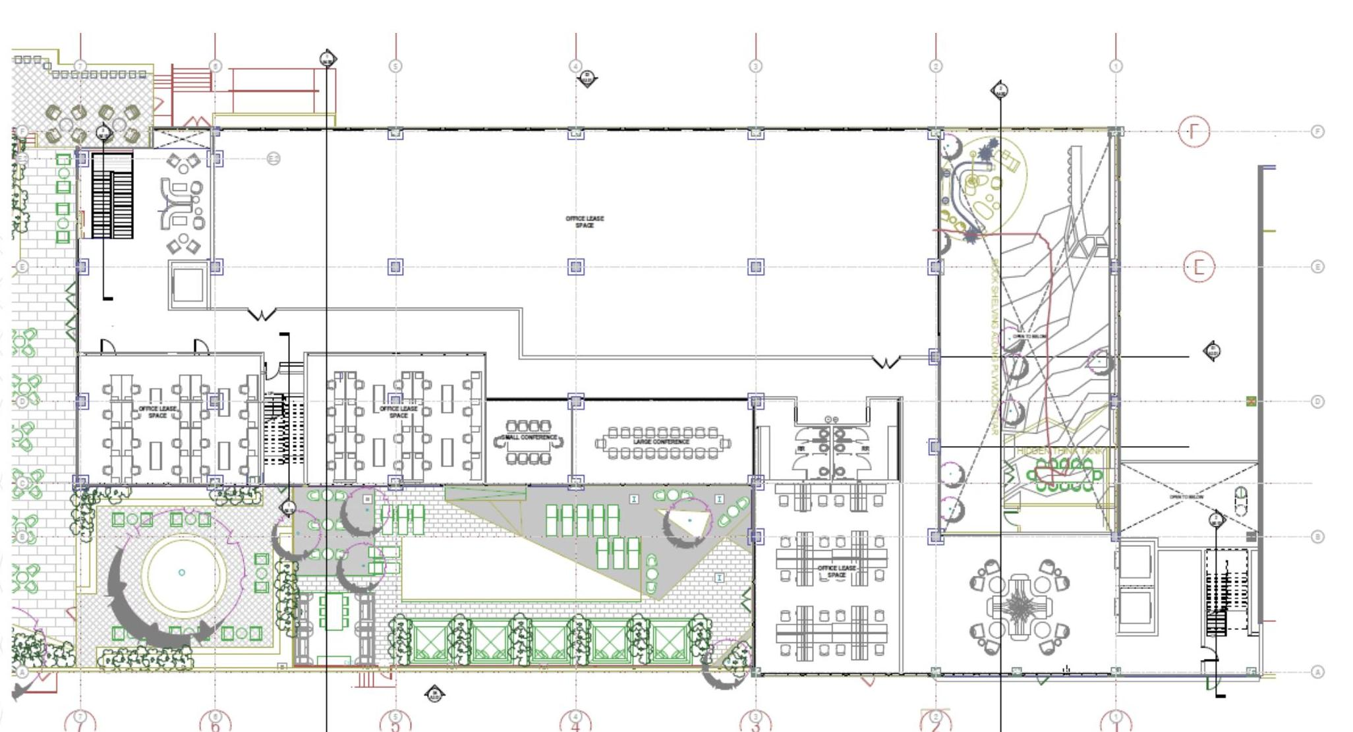
Exhibit: Building Massing and Elevation Concepts
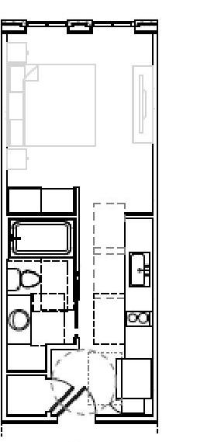
Exhibit: A1 Floorplan Concept

