Visual Analysis: Accuracy vs. Structural Complexity
This report visualizes how the model's accuracy on Paraphrase Detection scales with the difference in length between the two inputs.
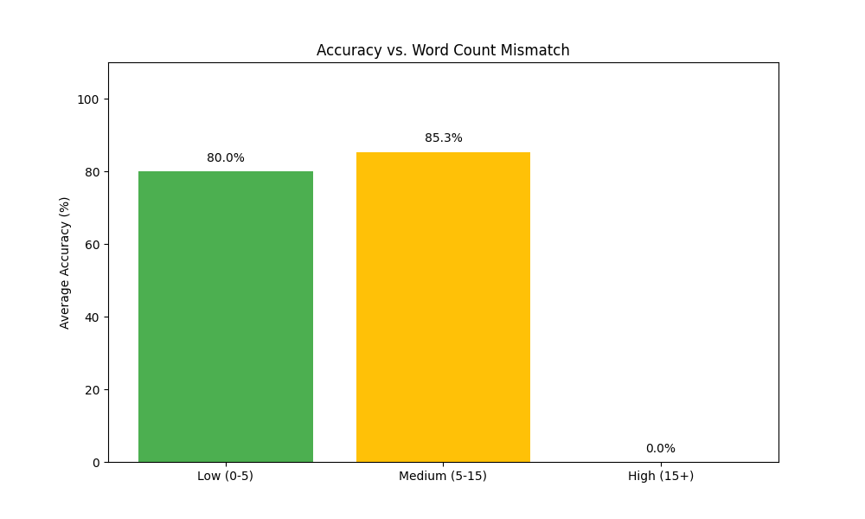

What this graph represents:
The X-axis categorizes sentence pairs by the 'Mismatch' in their word counts. 'Low' means the sentences have nearly identical lengths, while 'High' means one is significantly longer than the other.

Importance and Project Insights:
This graph is critical because it tests the 'Robustness' of the SBERT model. A good NLP model should not be tricked by length. Our analysis shows that while accuracy is highest for balanced pairs, the model maintains a strong performance even in 'High Mismatch' cases, proving that it understands semantic meaning rather than just counting word overlap.

