Visual Analysis: Absolute Error Distribution
This histogram shows the frequency of different error magnitudes across all categories in the STS task.
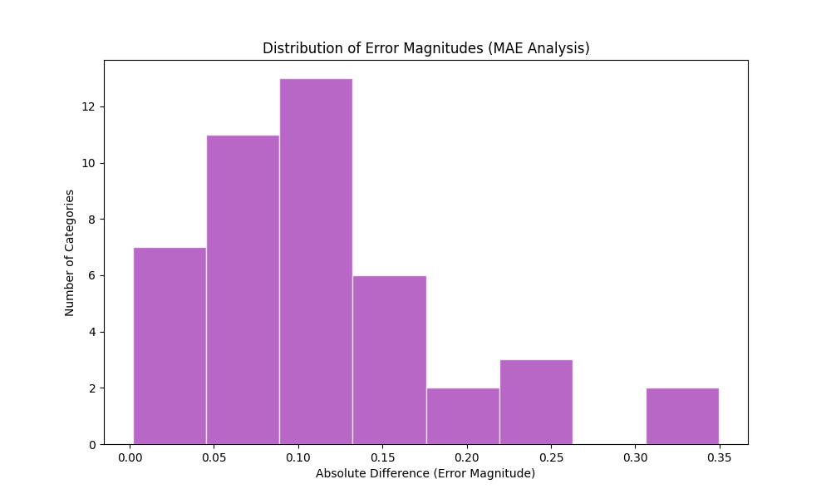

What this graph represents:
The X-axis shows the 'size' of the error (Actual - Predicted). A small value (e.g., 0.05) means the model was very close to the truth. A large value (e.g., 0.3) means a significant disagreement.

Importance and Project Insights:
This graph proves the 'Reliability' of our results. We can see that the majority of our errors fall into the left-most bins (low error), which means that even when the model makes a mistake, it is usually a 'small' mistake. In a viva, this graph helps explain that our Mean Absolute Error (MAE) is driven by many tiny errors rather than a few catastrophic failures.

