Visual Analysis: Semantic Correlation (Actual vs. Predicted)
This scatter plot visualizes the relationship between human-assigned similarity scores and the model's calculated cosine similarity.
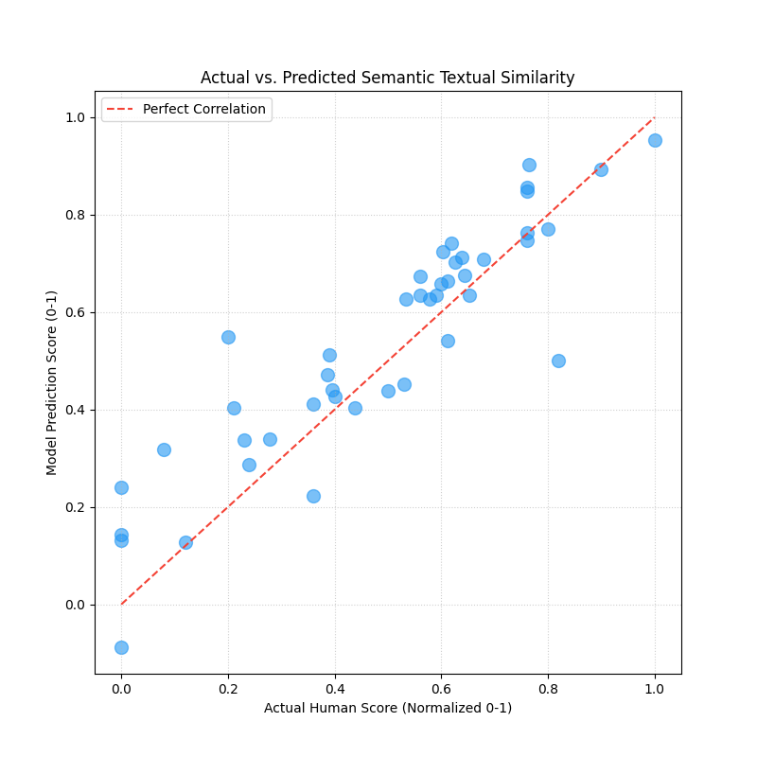

What this graph represents:
Each dot represents a group of sentence pairs. The closer the dots are to the diagonal dashed line, the more accurate the model is. Dots above the line indicate the model was 'more optimistic' than humans, and dots below indicate it was 'more conservative'.

Importance and Project Insights:
This is the most direct way to visualize the Pearson Correlation. By seeing how tightly the dots cluster around the diagonal, we can prove to examiners that the model's 'intuition' of similarity closely mirrors human judgment. It provides visual proof that the embeddings generated by SBERT are semantically meaningful.

