Tutorial-1: Spotify Web Application Testing Report

Aim
To understand SDLC and STLC phases for a real-world software project and identify testing activities performed during each development stage.

Description
This practical demonstrates manual testing of the Spotify Web Application using SDLC and STLC concepts.

Problem Statement
Perform functional testing of the Spotify Web Application and document the results.

Implementation Details
Project Name | Spotify Web Application
Application/Software | Spotify
Module Name | Spotify Web
SDLC Model | Waterfall
Programming Language | JavaScript, HTML, CSS
IDE/Tool Used | Google Chrome
Input/Test Data | Spotify Test Account

TC_01 - Home Page
Test Case ID | TC_01
Tester Name | Aakash Parangi
Scenario | Home Page
Test Steps | 1. Open the Spotify Web Application in Google Chrome.  2. Observe the Home Page and verify the displayed sections.  3. Check Trending songs, Popular artists and Popular albums and singles.  4. Record the observed result.
Test Data | Spotify Home Page
Expected Result | Home Page loads correctly and the available music sections are displayed.
Actual Result | Home Page loaded successfully and the displayed music sections were visible as expected.
Status | Pass
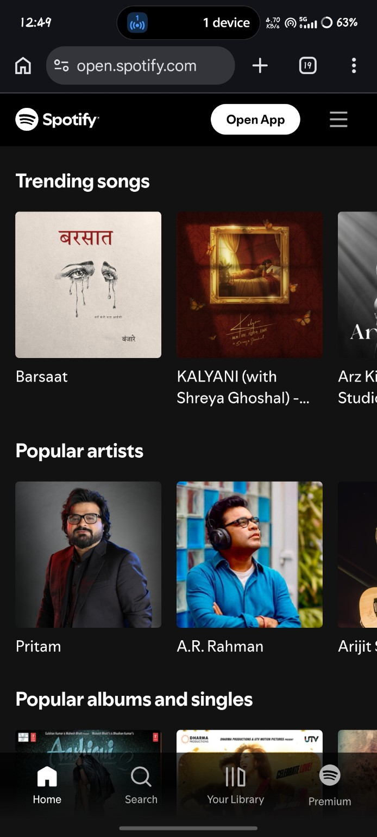

TC_02 - Login Page
Test Case ID | TC_02
Tester Name | Aakash Parangi
Scenario | Login Page
Test Steps | 1. Open the Spotify Login Page.  2. Verify that the Email field and Continue button are displayed.  3. Verify the available phone number, Google, Facebook and Apple login options.  4. Record the observed result.
Test Data | Spotify Login Page
Expected Result | Login Page displays all required login fields and options correctly.
Actual Result | Login Page displayed the Email field, Continue button and available login options correctly.
Status | Pass
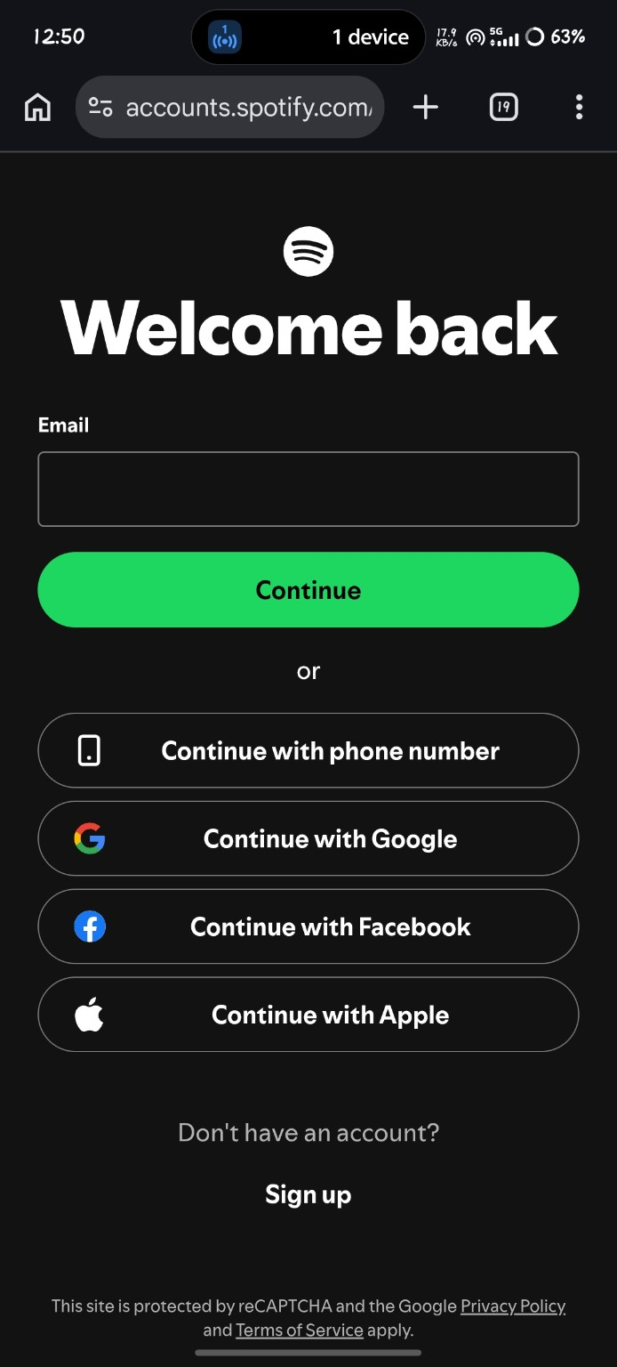

TC_03 - Invalid Login
Test Case ID | TC_03
Tester Name | Aakash Parangi
Scenario | Invalid Login
Test Steps | 1. Open the Spotify Login Page.  2. Enter the test email shown in the screenshot.  3. Click the Continue button.  4. Verify the error message and record the result.
Test Data | Unlinked email: parangiakd@gmail.com
Expected Result | An appropriate error message is displayed when the email is not linked to a Spotify account.
Actual Result | The message 'Email isn't linked to a Spotify account' was displayed, so the invalid-login condition was handled correctly.
Status | Pass
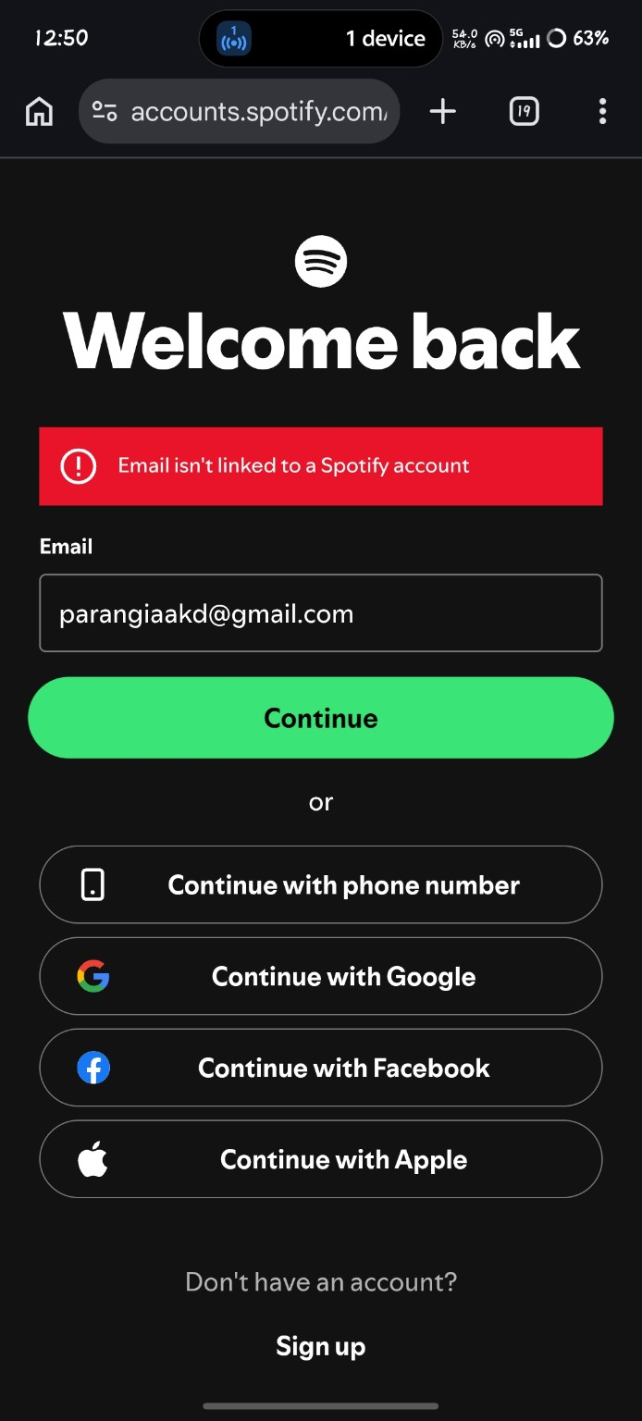

TC_04 - Search Song
Test Case ID | TC_04
Tester Name | Aakash Parangi
Scenario | Search Song
Test Steps | 1. Open the Search section of Spotify.  2. Enter 'Believer' in the search field.  3. Verify that search categories and matching results are displayed.  4. Record the observed result.
Test Data | Search keyword: Believer
Expected Result | The search feature accepts the song name and displays relevant search results.
Actual Result | The search for 'Believer' was performed successfully and matching song and related results were displayed.
Status | Pass
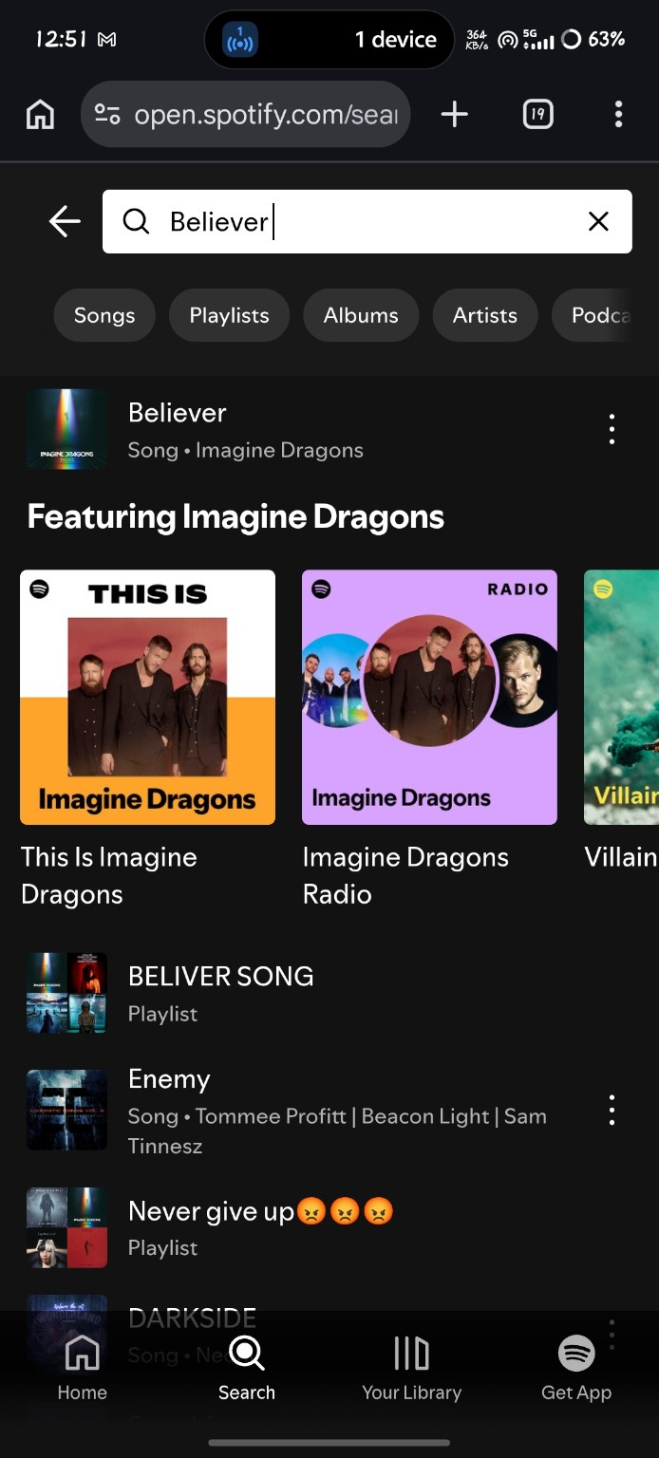

TC_05 - Search Result
Test Case ID | TC_05
Tester Name | Aakash Parangi
Scenario | Search Result
Test Steps | 1. Select the 'Believer' search result.  2. Verify the song page and album artwork.  3. Check the song title, artist name and playback controls.  4. Record the observed result.
Test Data | Selected song: Believer
Expected Result | The selected song opens with its details and playback controls correctly.
Actual Result | The 'Believer' song page opened successfully with the album artwork, song details and playback controls.
Status | Pass
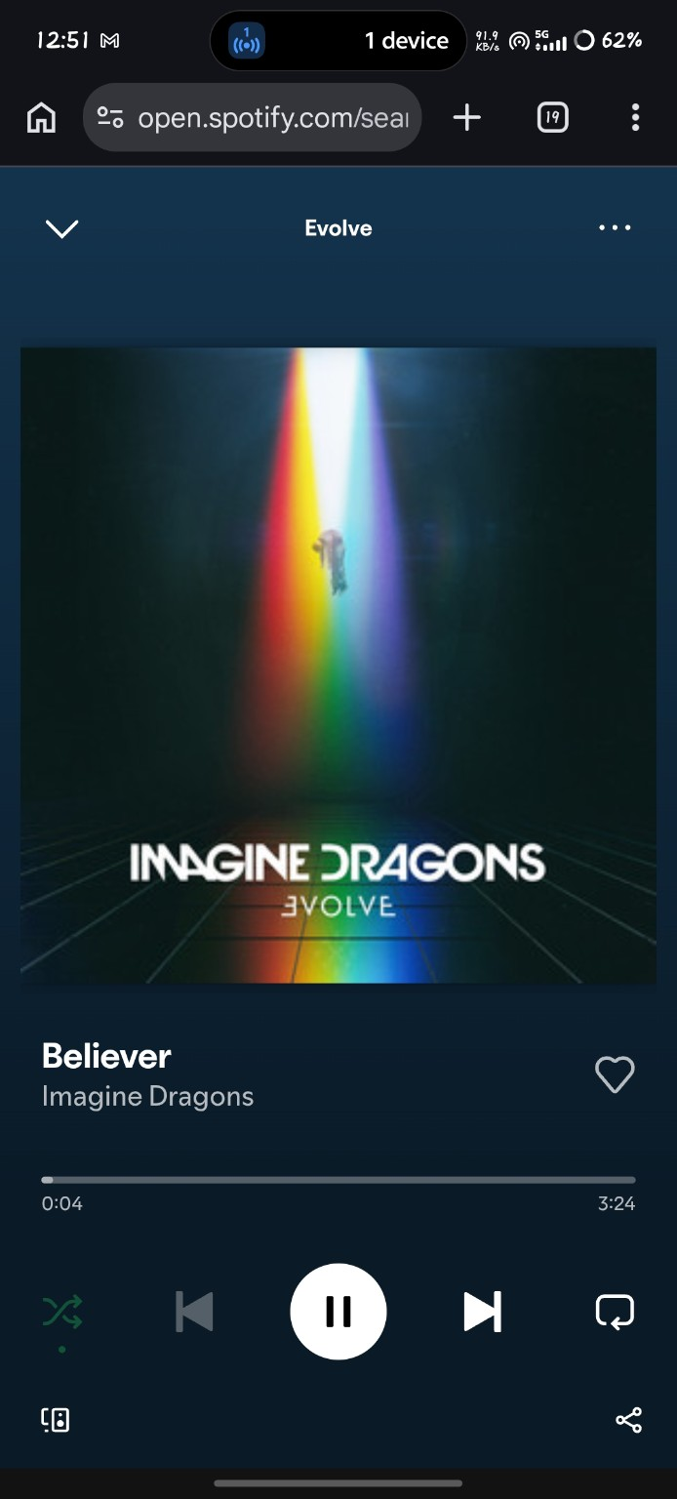

TC_06 - Music Player
Test Case ID | TC_06
Tester Name | Aakash Parangi
Scenario | Music Player
Test Steps | 1. Open the playlist creation/player flow shown in the screenshot.  2. Enter the playlist name 'My playlist #8'.  3. Verify the Cancel and Create buttons.  4. Record the observed result.
Test Data | Playlist name: My playlist #8
Expected Result | The playlist naming screen accepts a playlist name and provides options to cancel or create it.
Actual Result | The playlist naming screen displayed 'My playlist #8' with Cancel and Create options correctly.
Status | Pass
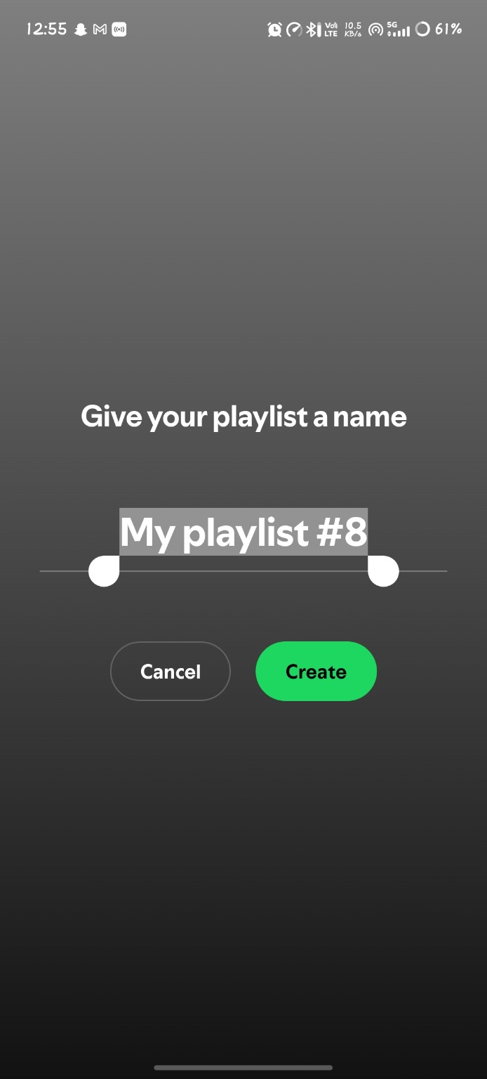

TC_07 - Create Playlist
Test Case ID | TC_07
Tester Name | Aakash Parangi
Scenario | Create Playlist
Test Steps | 1. Create the playlist using the Create option.  2. Open the newly created playlist.  3. Verify the playlist name, owner, song list and playlist controls.  4. Record the observed result.
Test Data | Playlist: My playlist #8; Song: Haseen
Expected Result | The playlist is created successfully and its details and controls are displayed.
Actual Result | The playlist was created successfully and the playlist page displayed its name, owner, song and controls.
Status | Pass
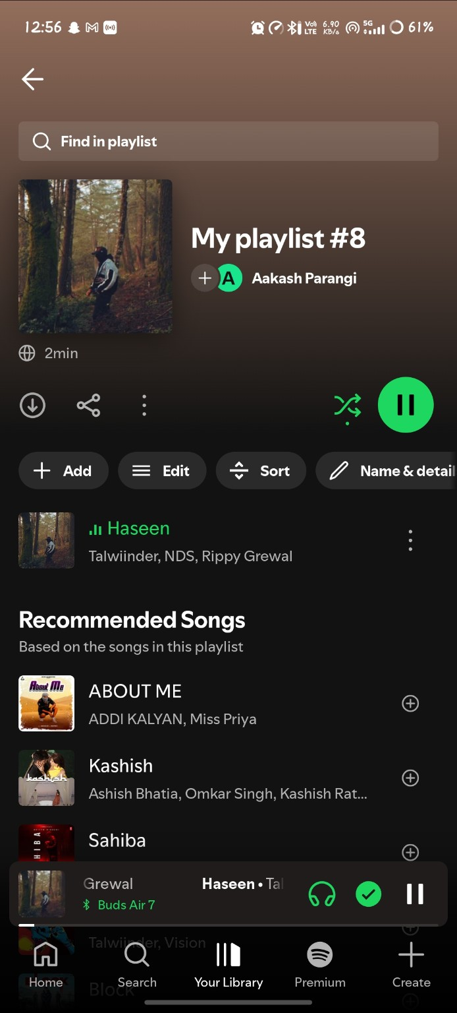

TC_08 - Playlist
Test Case ID | TC_08
Tester Name | Aakash Parangi
Scenario | Playlist
Test Steps | 1. Open the Spotify account/profile menu.  2. Verify the profile name and account options.  3. Check the Add account, Recents, Your Updates and Settings and privacy options.  4. Record the observed result.
Test Data | Spotify profile/account menu
Expected Result | The profile menu opens and displays the available account options correctly.
Actual Result | The profile menu opened successfully and displayed the listed account options.
Status | Pass
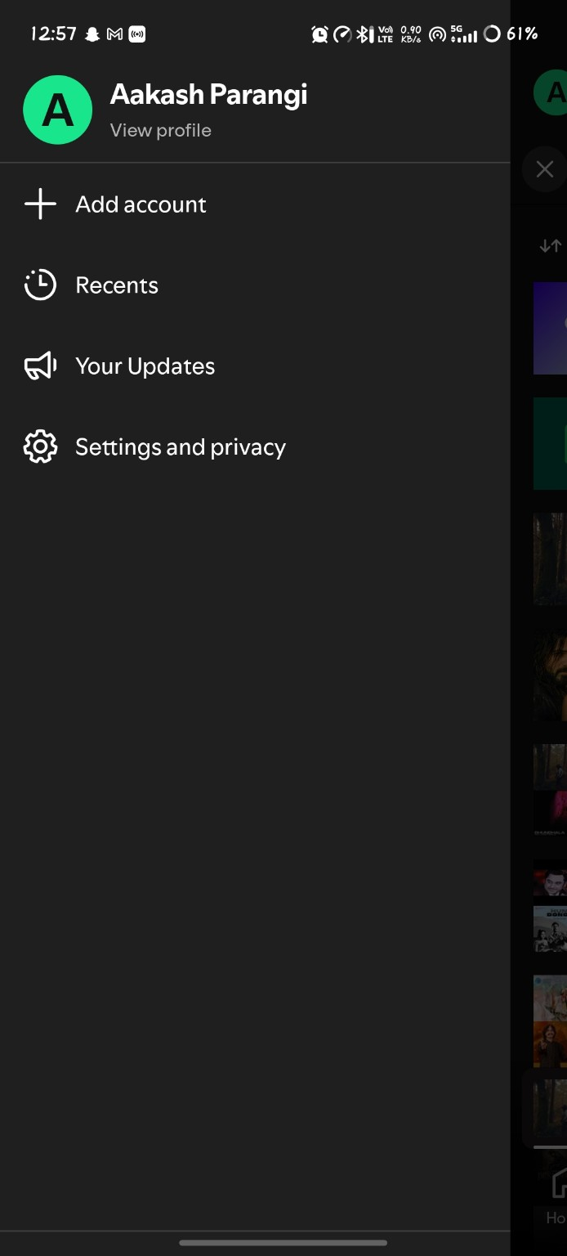

TC_09 - Profile Menu
Test Case ID | TC_09
Tester Name | Aakash Parangi
Scenario | Profile Menu
Test Steps | 1. Open Settings and privacy from the profile menu.  2. Verify the Settings page and its available categories.  3. Check Content and display, Privacy and social, Playback, Notifications, Apps and devices and other settings.  4. Record the observed result.
Test Data | Settings and privacy
Expected Result | The Settings page opens and displays the available settings categories correctly.
Actual Result | The Settings page opened successfully and the available settings categories were displayed.
Status | Pass
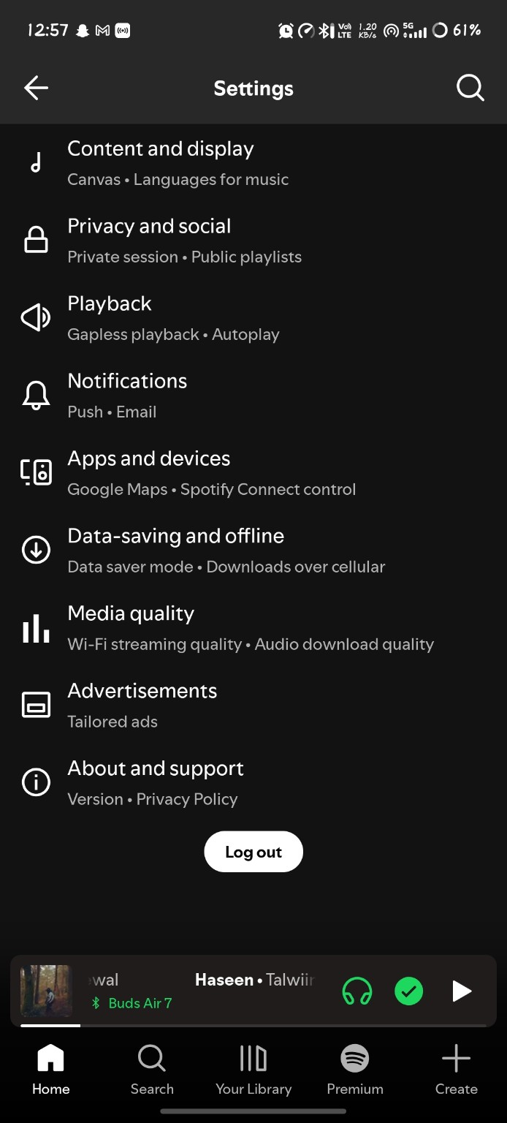

TC_10 - Logout
Test Case ID | TC_10
Tester Name | Aakash Parangi
Scenario | Logout
Test Steps | 1. Open the Spotify account/profile menu.  2. Locate the Log out option.  3. Select Log out and verify that the account session is ended.  4. Record the observed result.
Test Data | Spotify account/session logout
Expected Result | The user is logged out successfully and the account session is ended.
Actual Result | The logout operation completed as expected and the account session was ended.
Status | Pass

Testing Activities Performed
Sr. | SDLC Phase | STLC Phase | Activity
1 | Requirement Analysis | Requirement Analysis | Requirement Gathering
2 | Design | Test Planning | Prepare Test Cases
3 | Development | Test Case Development | Create Test Data
4 | Testing | Test Execution | Execute Test Cases
5 | Deployment | Test Closure | Smoke Testing
6 | Maintenance | Regression Testing | Bug Verification

Observation
All executed test cases behaved as expected.

Conclusion
Spotify Web Application testing was completed successfully.

