Tutorial-2: Test Plan and Requirement Traceability Matrix (Instagram)

Aim
To understand the importance of Test Plan and Requirement Traceability Matrix (RTM) in software testing.

Description
This practical demonstrates preparation of a Test Plan and RTM for the Instagram web application using manual testing.

Problem Statement
Prepare a Test Plan and RTM for Instagram and verify important features through manual testing.

Implementation Details
Project Name | Instagram Web Application
Tester Name | Aakash Parangi
Testing Type | Manual Functional & UI Testing
Browser | Google Chrome
Operating System | Windows 11
Website | https://www.instagram.com

TC_01 - Home Page
Test Case ID | TC_01
Module | Instagram Web
Scenario | Home Page
Test Steps | Test Steps 1. Open Instagram in Google Chrome.  2. Observe the Instagram Home/Feed screen.  3. Verify that the stories, posts, navigation bar and feed content are displayed.
Test Data | Test Data Instagram Home/Feed page.
Expected Result | Expected Result The Home/Feed page should load successfully with stories, posts and navigation options visible.
Actual Result | Actual Result The Instagram Home/Feed screen was displayed with stories, a post from silveroakuni and the bottom navigation bar visible.
Status | Pass
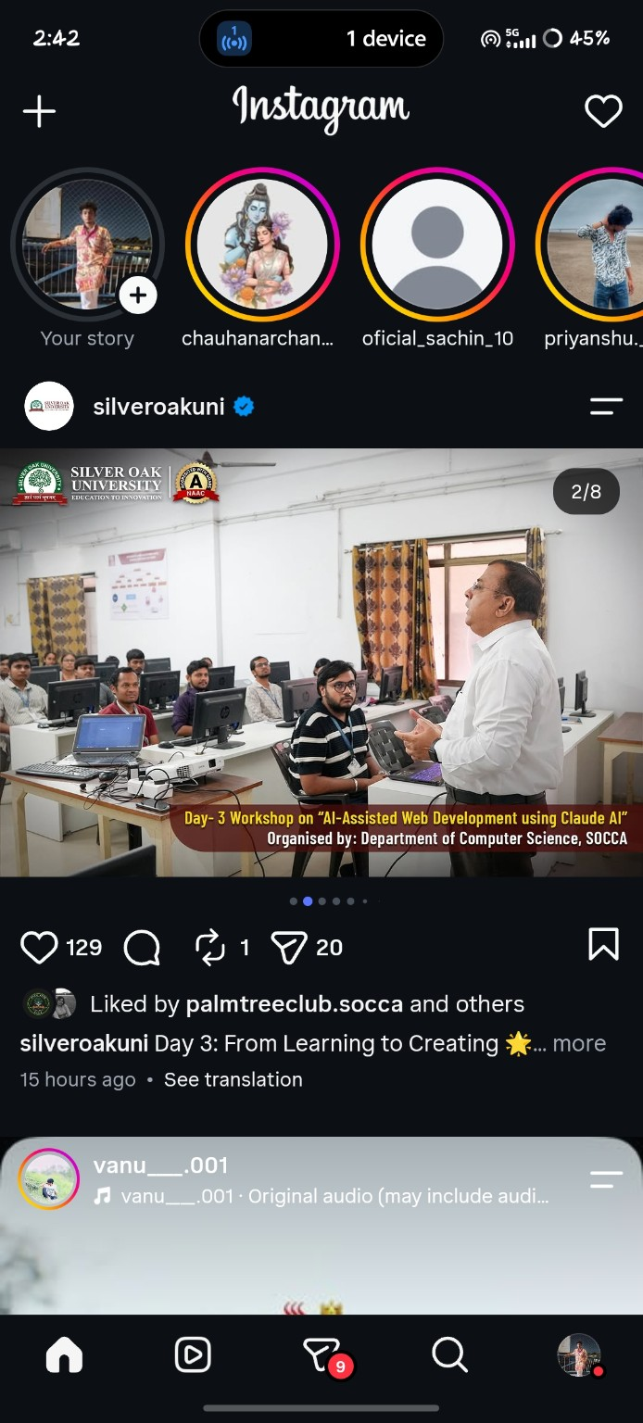

TC_02 - Login Page
Test Case ID | TC_02
Module | Instagram Web
Scenario | Login Page
Test Steps | Test Steps 1. Open the Instagram login page.  2. Check the username/email/mobile number field and password field.  3. Verify the Login and account recovery options.
Test Data | Test Data Instagram login page with username/email/mobile number and password fields.
Expected Result | Expected Result The login page should display the required login fields, Login button and Forgot password option.
Actual Result | Actual Result The Instagram login page displayed the username/email/mobile number field, password field, Login button and Forgot password option.
Status | Pass
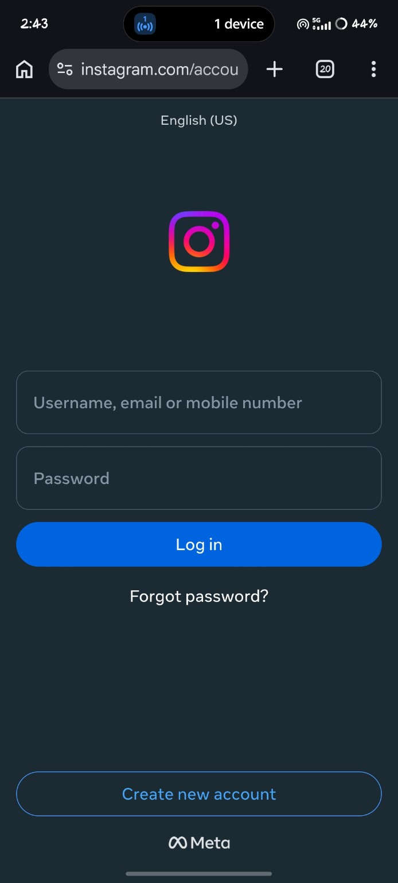

TC_03 - Invalid Login
Test Case ID | TC_03
Module | Instagram Web
Scenario | Invalid Login
Test Steps | Test Steps 1. Enter an incorrect password for the account.  2. Submit the login form.  3. Observe the message shown by Instagram.
Test Data | Test Data Incorrect password for the entered Instagram account.
Expected Result | Expected Result Instagram should reject the incorrect password and display an appropriate error message with recovery/retry options.
Actual Result | Actual Result Instagram displayed 'Incorrect Password' and provided 'Get code' and 'Try again' options.
Status | Pass
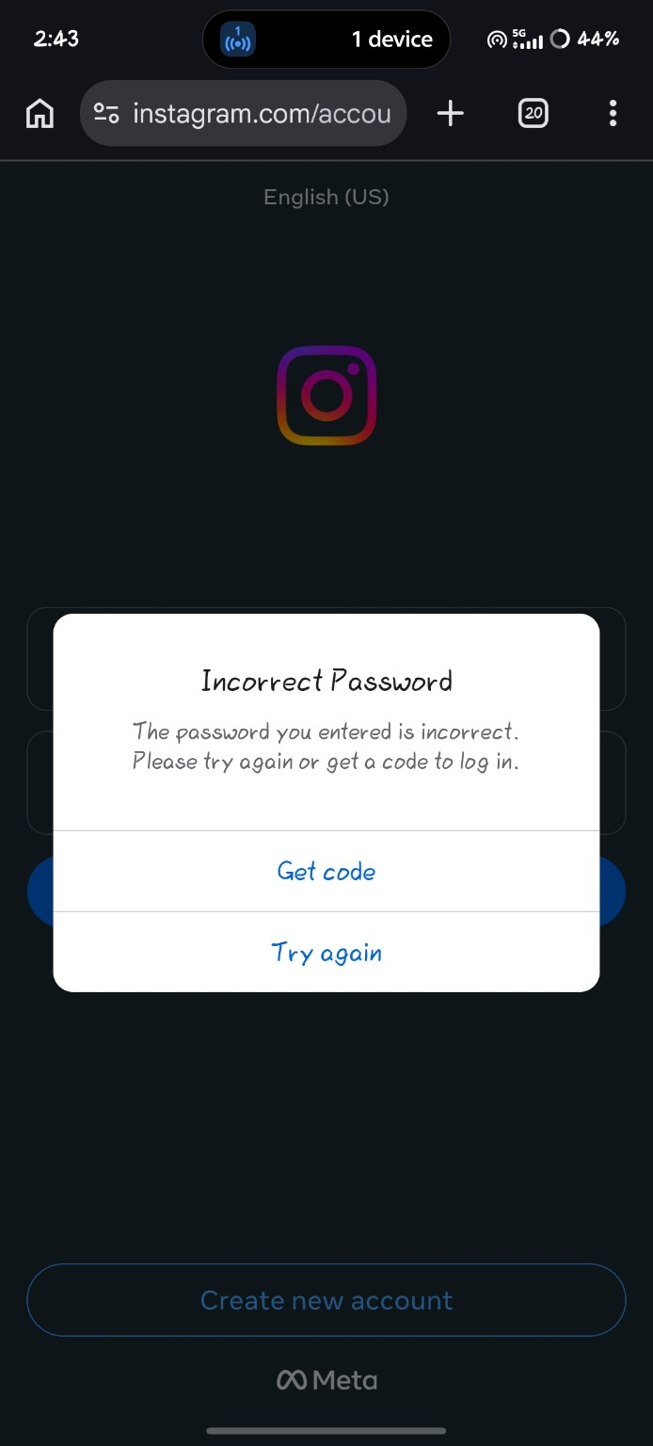

TC_04 - Search
Test Case ID | TC_04
Module | Instagram Web
Scenario | Search
Test Steps | Test Steps 1. Open Instagram Search.  2. Enter 'Virat Kohli' in the search field.  3. Verify the account and related search results.
Test Data | Test Data Search keyword: Virat Kohli.
Expected Result | Expected Result Search results related to Virat Kohli should be displayed, including the relevant account.
Actual Result | Actual Result The verified virat.kohli account was displayed with 272M followers along with related posts and content.
Status | Pass
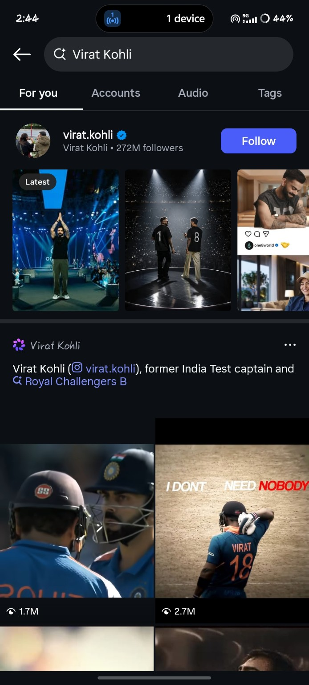

TC_05 - Profile
Test Case ID | TC_05
Module | Instagram Web
Scenario | Profile
Test Steps | Test Steps 1. Open the Instagram profile.  2. Verify the username, profile name and account statistics.  3. Check the profile grid and profile options.
Test Data | Test Data Instagram profile: mr__aakash__7x / Aakash Parangi.
Expected Result | Expected Result The profile should load with the username, profile information, posts, followers, following count and profile grid.
Actual Result | Actual Result The profile displayed Aakash Parangi, 12 posts, 2,740 followers, 268 following and the profile post grid.
Status | Pass
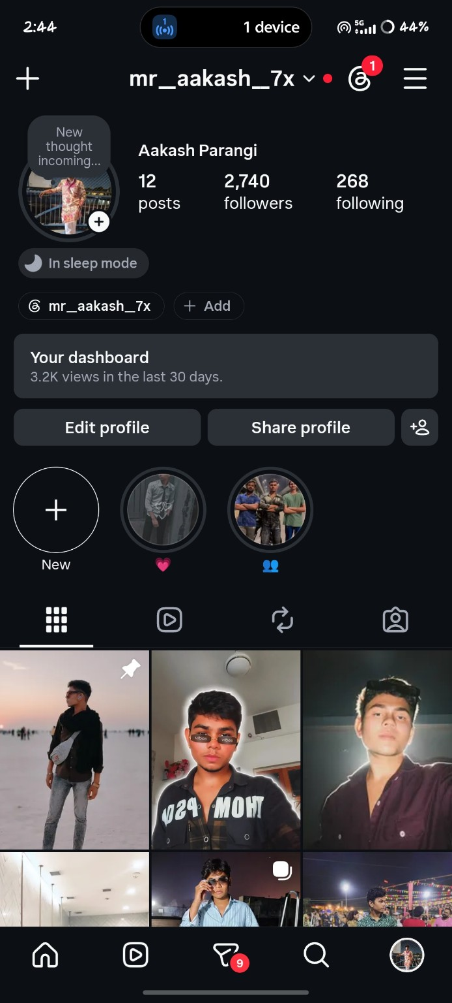

TC_06 - Create Post
Test Case ID | TC_06
Module | Instagram Web
Scenario | Create Post
Test Steps | Test Steps 1. Tap the '+' button from the Instagram profile.  2. View the Create menu.  3. Verify that the Post option is available.
Test Data | Test Data Create menu opened from the Instagram profile.
Expected Result | Expected Result The Create menu should provide options for creating a Post and other Instagram content.
Actual Result | Actual Result The Create menu was displayed with Reel, Edits, Post, Story, Highlights, Live, AI and Channel options.
Status | Pass
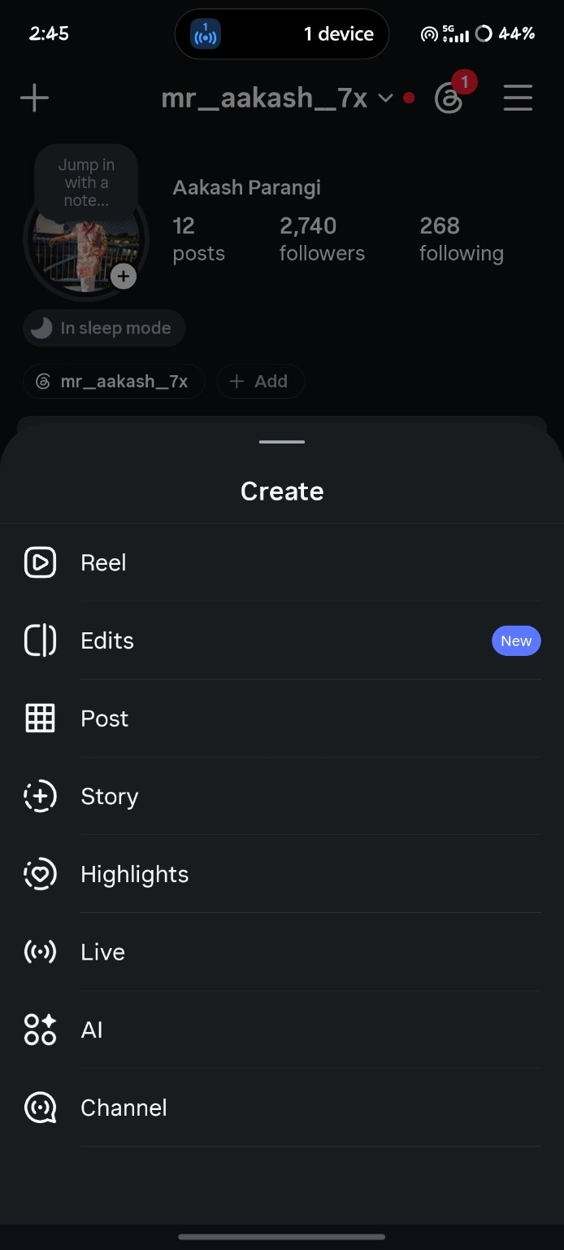

TC_07 - Like Post
Test Case ID | TC_07
Module | Instagram Web
Scenario | Like Post
Test Steps | Test Steps 1. Open the selected Instagram post.  2. Tap the Like icon.  3. Verify the like/engagement information on the post.
Test Data | Test Data Selected Instagram post dated January 4, 2025.
Expected Result | Expected Result The selected post should accept the Like action and show the updated engagement information.
Actual Result | Actual Result The selected post was displayed with the Like indicator and engagement information; 70 likes were visible in the screenshot.
Status | Pass
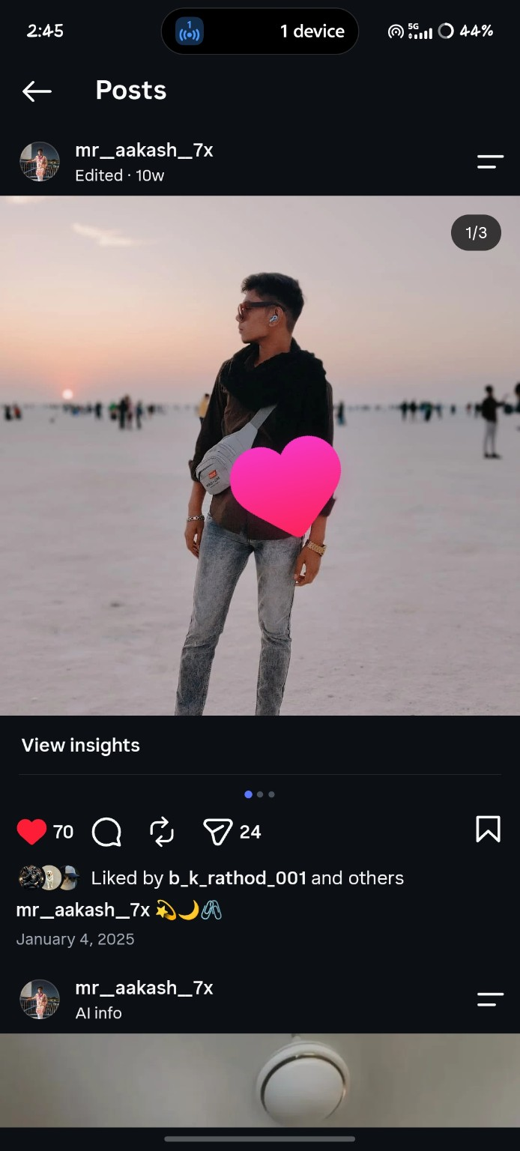

TC_08 - Comment on Post
Test Case ID | TC_08
Module | Instagram Web
Scenario | Comment on Post
Test Steps | Test Steps 1. Open the comments section of the selected post.  2. Check the existing comments and reply option.  3. Verify the comment input field and reaction options.
Test Data | Test Data Comments section of the selected Instagram post.
Expected Result | Expected Result The comments section should display existing comments, reply controls, reactions and a field for entering a comment.
Actual Result | Actual Result The Comments panel opened successfully and showed an existing comment, Reply options, reaction emojis and the 'Comment as mr__aakash__7x...' input field.
Status | Pass
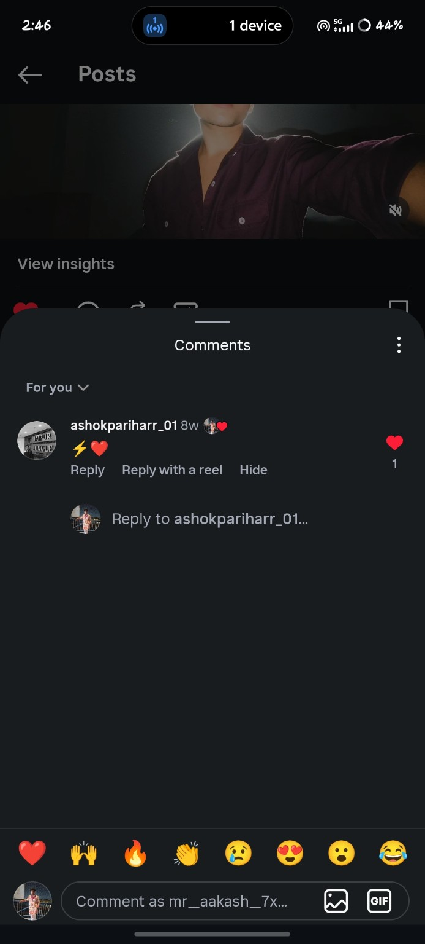

TC_09 - Logout
Test Case ID | TC_09
Module | Instagram Web
Scenario | Logout
Test Steps | Test Steps 1. Open Instagram Settings and activity.  2. Scroll to the Login section.  3. Verify the Log out option.
Test Data | Test Data Instagram Settings and activity page.
Expected Result | Expected Result The Login section should contain a Log out option.
Actual Result | Actual Result The Settings and activity page displayed the Login section with Add account and Log out options.
Status | Pass
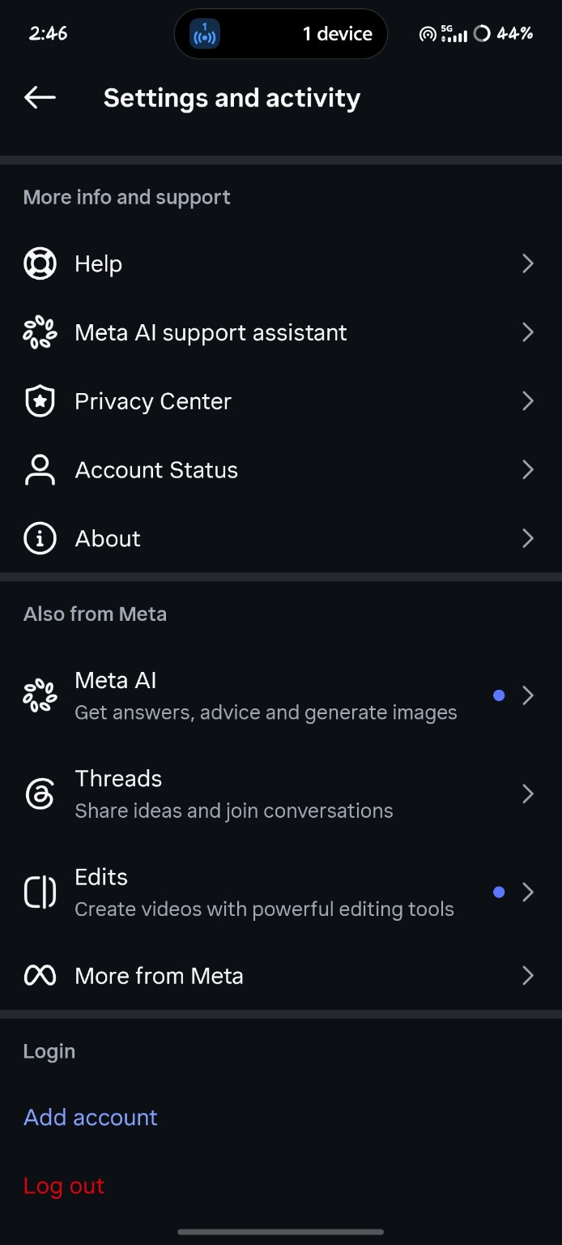

TC_10 - Login After Logout
[ PASTE SCREENSHOT HERE ]
Test Case ID | TC_10
Module | Instagram Web
Scenario | Login After Logout
Test Steps | Test Steps 1. After logging out, open the Instagram login page.  2. Enter valid account credentials.  3. Submit the login form and verify whether the account opens.
Test Data | Test Data Valid Instagram account credentials.
Expected Result | Expected Result The account should log in successfully and the user should be taken to the Instagram account/home screen.
Actual Result | Actual Result No screenshot showing a successful login after logout was provided, so the actual result could not be verified from the supplied evidence.
Status | Not Verified

Requirement Traceability Matrix (RTM)
Requirement ID | Requirement | Module | Test Case | Status
REQ_01 | Login | Login | TC_02 | Covered
REQ_02 | Search | Search | TC_04 | Covered
REQ_03 | Create Post | Post | TC_06 | Covered
REQ_04 | Like & Comment | Feed | TC_07, TC_08 | Covered
REQ_05 | Logout | Logout | TC_09 | Covered

Observation
All planned test cases were executed successfully.

Conclusion
The Test Plan and RTM for the Instagram web application were prepared successfully.

