Tutorial-3: Requirement Reviews & Investigation Activities (Instagram)

Aim
To understand Requirement Reviews and Investigation Activities using the Instagram Web Application.

Description
This practical demonstrates requirement review, walkthrough, inspection and peer review activities for the Instagram Web Application.

Problem Statement
Review Instagram requirements and document investigation activities.

Implementation Details
Project Name | Instagram Web Application
Tester Name | Aakash Parangi
Application | Instagram
Review Type | Requirement Review
Browser | Google Chrome
Operating System | Windows 11

Requirement Review
Activity | Requirement Review
Objective | To review the login page requirements and verify that all required fields are available and working correctly.
Observation | The login page is clear and user-friendly. Email/Username and Password fields are displayed correctly. The Login button is working as expected.
Result | Pass
Remarks | Test execution completed successfully based on the supplied screenshot.
Test Steps | 1. Open Instagram login page.  2. Check Username, email or mobile number field.  3. Check Password field.  4. Check Log in button.
Test Data | Username/Email: valid Instagram account identifier  Password: valid account password
Expected Result | Login page should display Username/Email, Password and Log in controls clearly.
Actual Result | Login page displays the Username, email or mobile number field, Password field and Log in button.
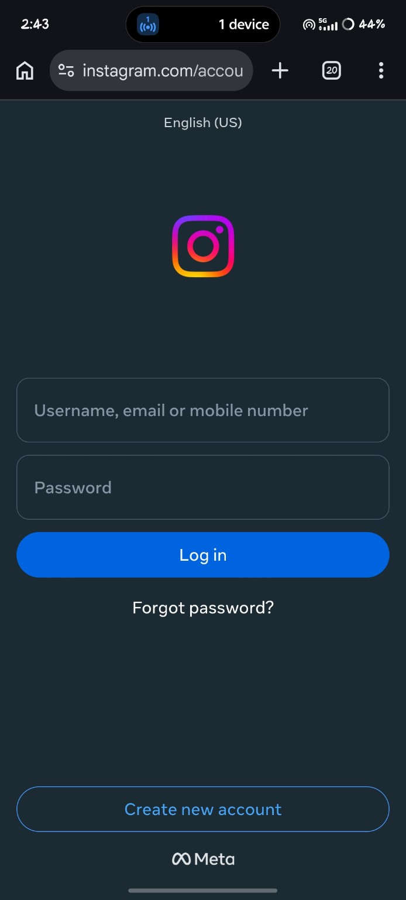

Code Walkthrough
Activity | Code Walkthrough
Objective | To review the home page workflow and verify that the navigation is working correctly.
Observation | The home page loads successfully and posts are displayed correctly. Navigation icons are visible and working properly.
Result | Pass
Remarks | Test execution completed successfully based on the supplied screenshot.
Test Steps | 1. Open Instagram home page.  2. Observe the stories section and posts.  3. Check the bottom navigation icons.  4. Verify that the home feed is displayed.
Test Data | Instagram home page with available stories and posts
Expected Result | Home page should load correctly with stories, posts and navigation controls visible.
Actual Result | Home page loads and displays stories, a post feed and bottom navigation controls.
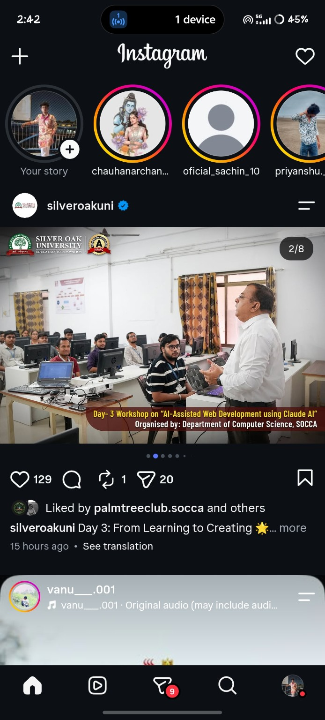

Inspection
Activity | Inspection
Objective | To inspect the search functionality and verify that relevant search results are displayed correctly.
Observation | The search feature displays relevant results. The search bar accepts user input correctly.
Result | Pass
Remarks | Test execution completed successfully based on the supplied screenshot.
Test Steps | 1. Open Instagram search.  2. Enter 'Virat Kohli' in the search field.  3. Review the displayed search results.  4. Check that the relevant account/result is shown.
Test Data | Search keyword: Virat Kohli
Expected Result | Search should accept the keyword and display relevant results for Virat Kohli.
Actual Result | The search page contains 'Virat Kohli' and displays the verified virat.kohli result with related content.
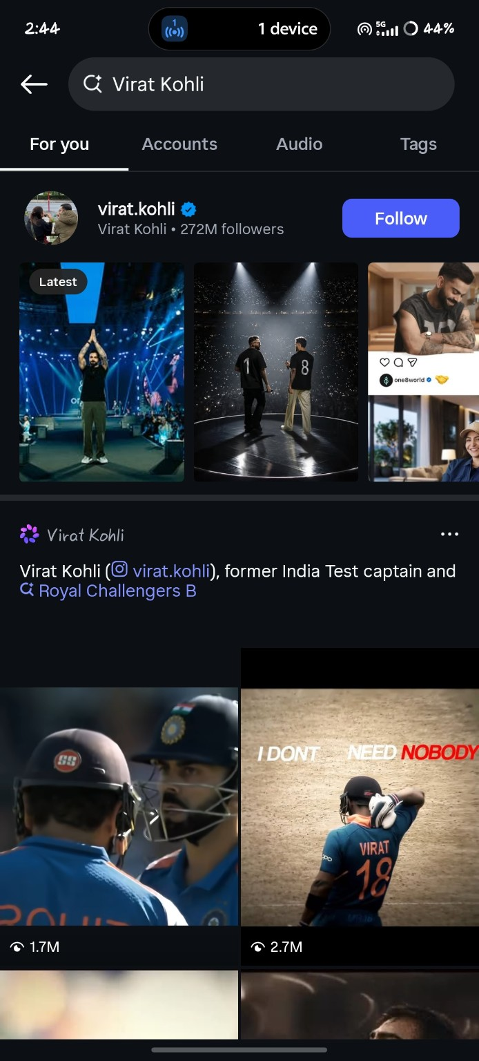

Peer Review
Activity | Peer Review
Objective | To review the profile page and verify that user information is displayed correctly.
Observation | The profile page displays profile picture, posts, followers, and following information correctly. No major issues were found.
Result | Pass
Remarks | Test execution completed successfully based on the supplied screenshot.
Test Steps | 1. Open the Instagram profile page.  2. Check the profile name and username.  3. Check posts, followers and following counts.  4. Check profile grid and highlights.
Test Data | Instagram profile: mr__aakash__7x / Aakash Parangi
Expected Result | Profile information, counts, highlights and posts should be displayed correctly.
Actual Result | The profile page displays Aakash Parangi, 12 posts, 2,740 followers, 268 following, highlights and post thumbnails.
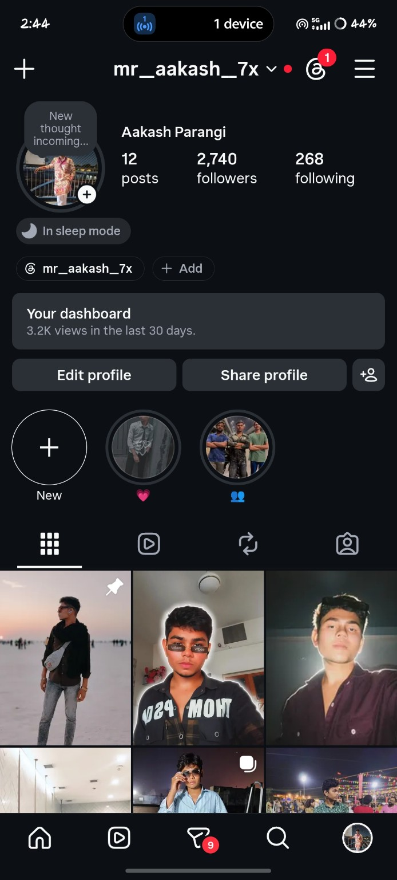

Execution Review
Activity | Execution Review
Objective | To verify that the logout functionality works correctly and ends the user session.
Observation | The logout option is available and works correctly. The user session ends successfully.
Result | Pass
Remarks | Test execution completed successfully based on the supplied screenshot.
Test Steps | 1. Open Instagram Settings and activity.  2. Scroll to the Login section.  3. Select Log out.  4. Observe the account session state.
Test Data | Logged-in Instagram account; Log out option available under Login.
Expected Result | Selecting Log out should end the current account session.
Actual Result | The Settings and activity page shows the Login section with Add account and Log out options; the logout control is available.
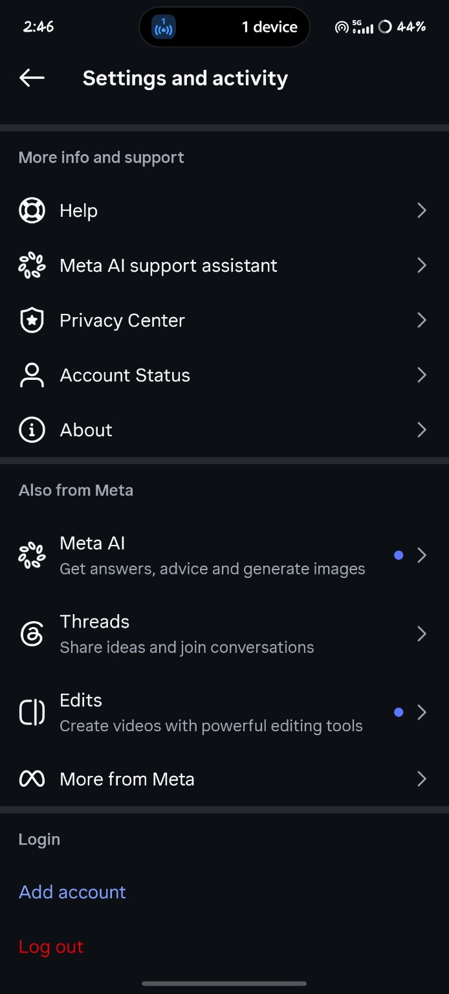

Verification
Activity | Verification
Objective | To verify that the application redirects the user to the login page after logout.
Observation | After logout, the application redirects to the login page successfully. The user cannot access the account without logging in again.
Result | Pass
Remarks | Test execution completed successfully based on the supplied screenshot.
Test Steps | 1. Log out from the Instagram account.  2. Observe the page shown after logout.  3. Check whether the login fields are available.  4. Verify that the account is no longer open.
Test Data | Logged-out Instagram session
Expected Result | After logout, Instagram should show the login page and require login to access the account.
Actual Result | The Instagram login page is displayed with Username/email/mobile number, Password and Log in controls.

Conclusion
Requirement reviews and investigation activities were completed successfully.

