Tutorial-4: Functional Testing (Flipkart)

Description
Perform functional testing of Flipkart features such as Login, Search, Product Details, Cart, Address and Payment using positive and negative scenarios.

Problem Statement
Verify the functional behaviour of Flipkart Mobile Application by executing positive and negative test cases.

Implementation Details
Project Name | Flipkart Mobile Application
Tester Name | Aakash Parangi
Testing Type | Functional Testing
Browser | Android App
Operating System | Android
Application | Flipkart

TC_01 - Home Page
Test Case ID | TC_01
Module | Flipkart App
Scenario | Home Page
Test Steps | 1. Open the Flipkart application.  2. Wait for the home page to load.  3. Verify banners, categories and search bar are displayed.
Test Data | Flipkart Home Page
Expected Result | Home page should load successfully.
Actual Result | Home page loaded successfully.
Status | Pass
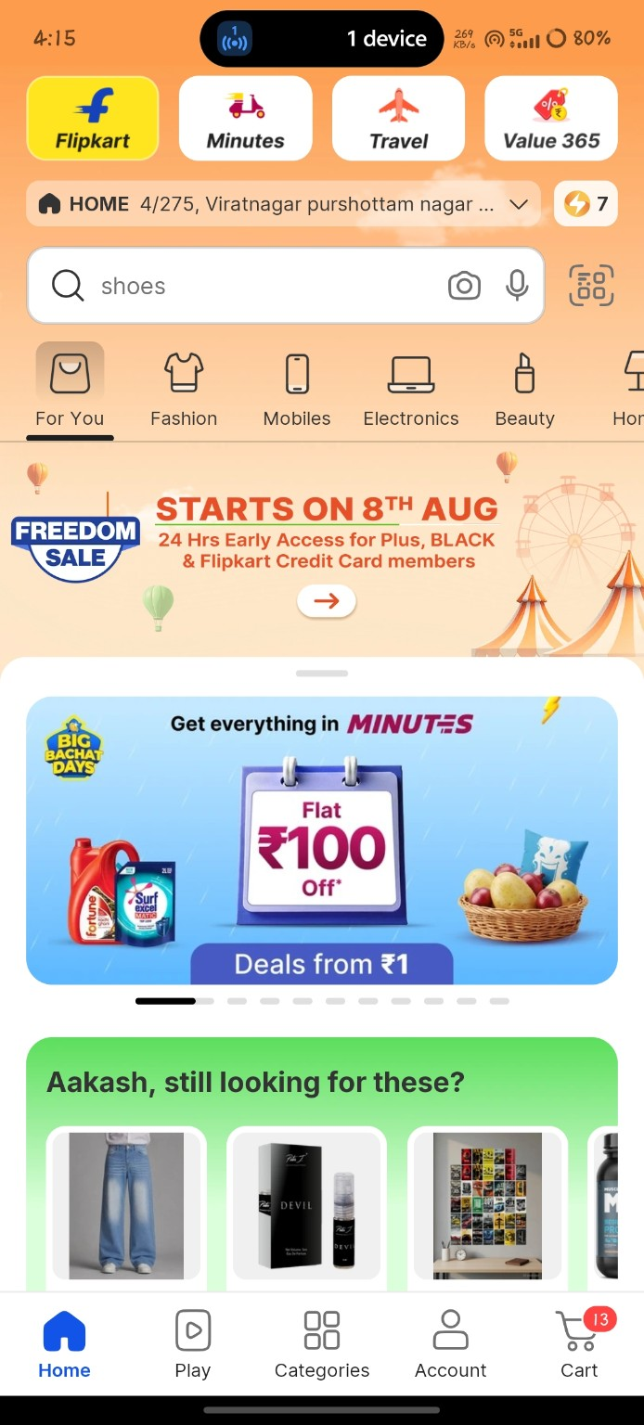

TC_02 - Login Screen
Test Case ID | TC_02
Module | Flipkart App
Scenario | Login Screen
Test Steps | 1. Tap Login.  2. Enter a valid mobile number.  3. Enter OTP.  4. Tap Continue.
Test Data | Valid mobile number and OTP
Expected Result | User should log in successfully.
Actual Result | User logged in successfully.
Status | Pass
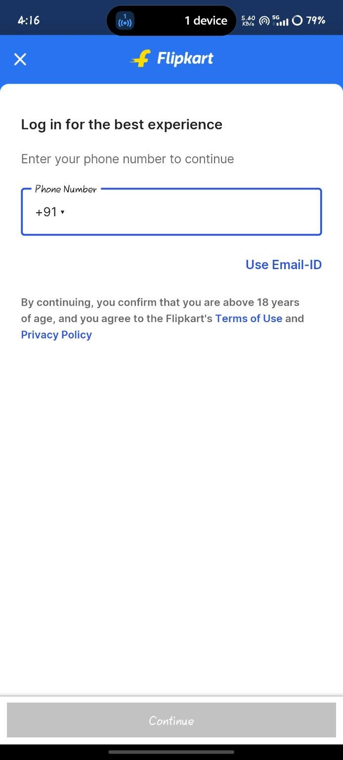

TC_03 - Search Product
Test Case ID | TC_03
Module | Flipkart App
Scenario | Search Product
Test Steps | 1. Tap Search.  2. Enter product name.  3. Tap Search.
Test Data | Baggy for men
Expected Result | Matching products should be displayed.
Actual Result | Relevant products displayed.
Status | Pass
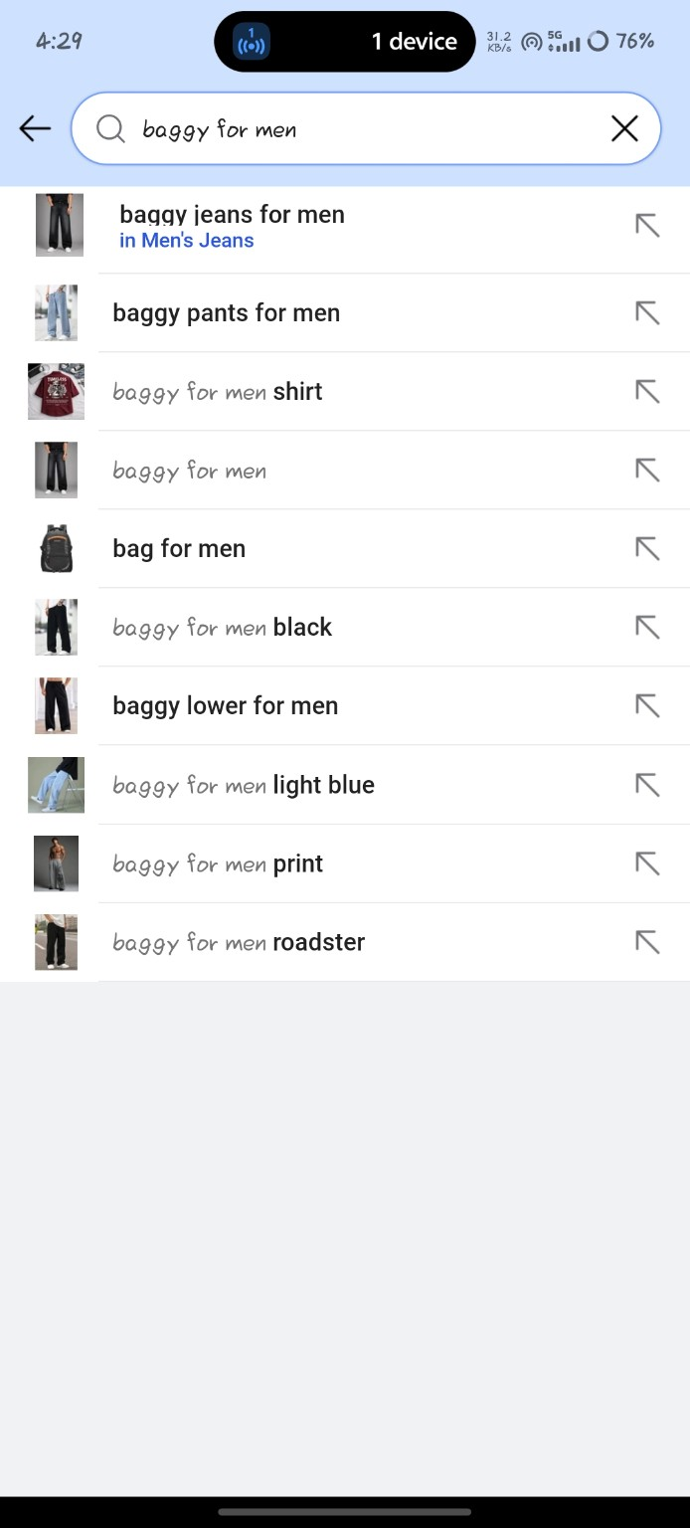

TC_04 - Product Details
Test Case ID | TC_04
Module | Flipkart App
Scenario | Product Details
Test Steps | 1. Open a product.  2. Verify product information.
Test Data | Selected product
Expected Result | Product details should be displayed.
Actual Result | Product details displayed.
Status | Pass
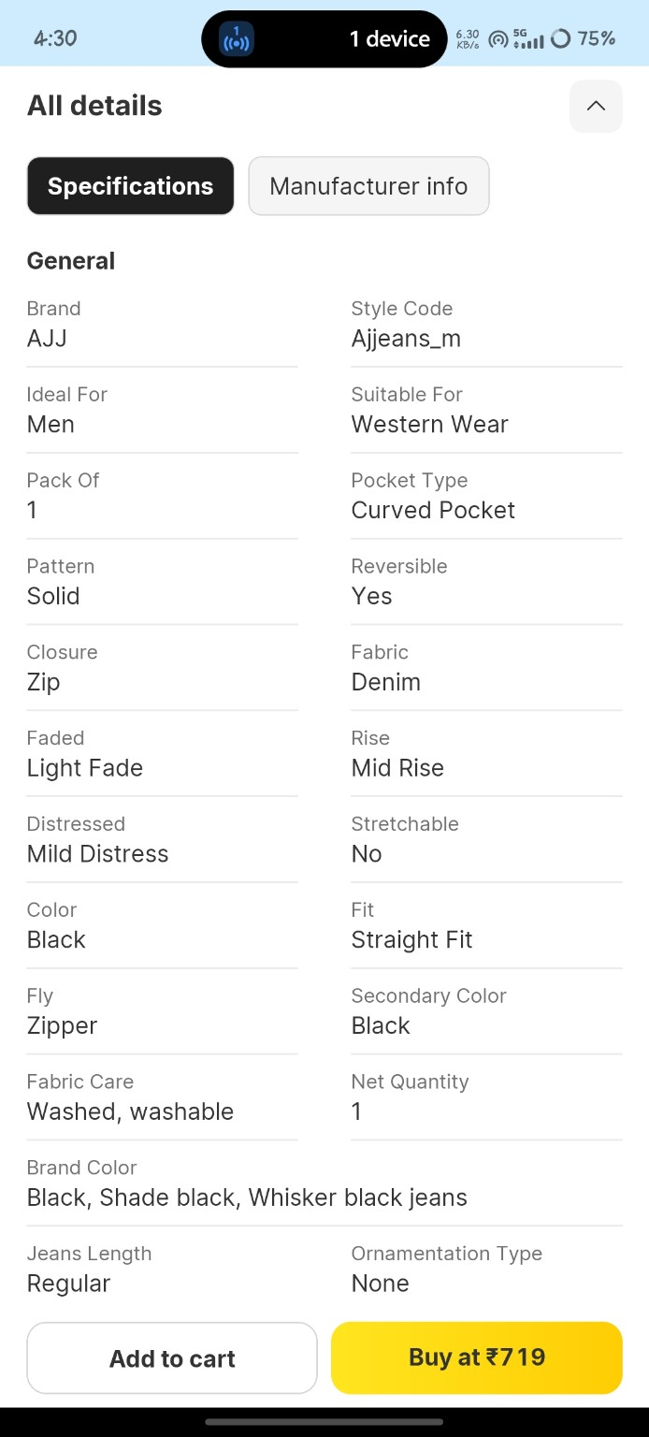

TC_05 - Cart
Test Case ID | TC_05
Module | Flipkart App
Scenario | Cart
Test Steps | 1. Tap Add to Cart.  2. Open Cart.
Test Data | Selected product
Expected Result | Product should be added to cart.
Actual Result | Product added to cart.
Status | Pass
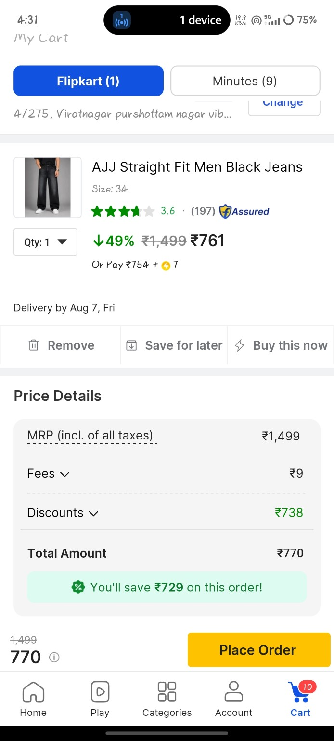

TC_06 - Price Details
Test Case ID | TC_06
Module | Flipkart App
Scenario | Price Details
Test Steps | 1. Open Cart.  2. Verify total amount.
Test Data | Cart items
Expected Result | Price should be calculated correctly.
Actual Result | Price calculated correctly.
Status | Pass
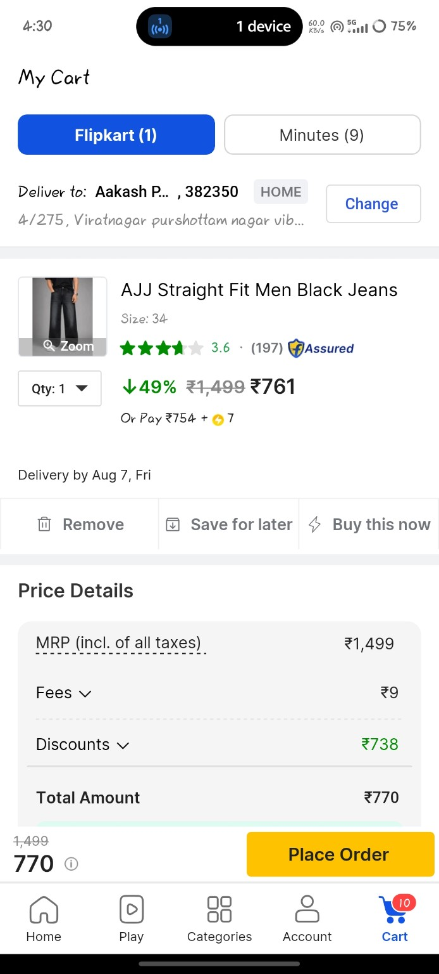

TC_07 - Delivery Address
Test Case ID | TC_07
Module | Flipkart App
Scenario | Delivery Address
Test Steps | 1. Open Address page.  2. Select/Add address.
Test Data | Delivery address
Expected Result | Address should be accepted.
Actual Result | Address accepted successfully.
Status | Pass
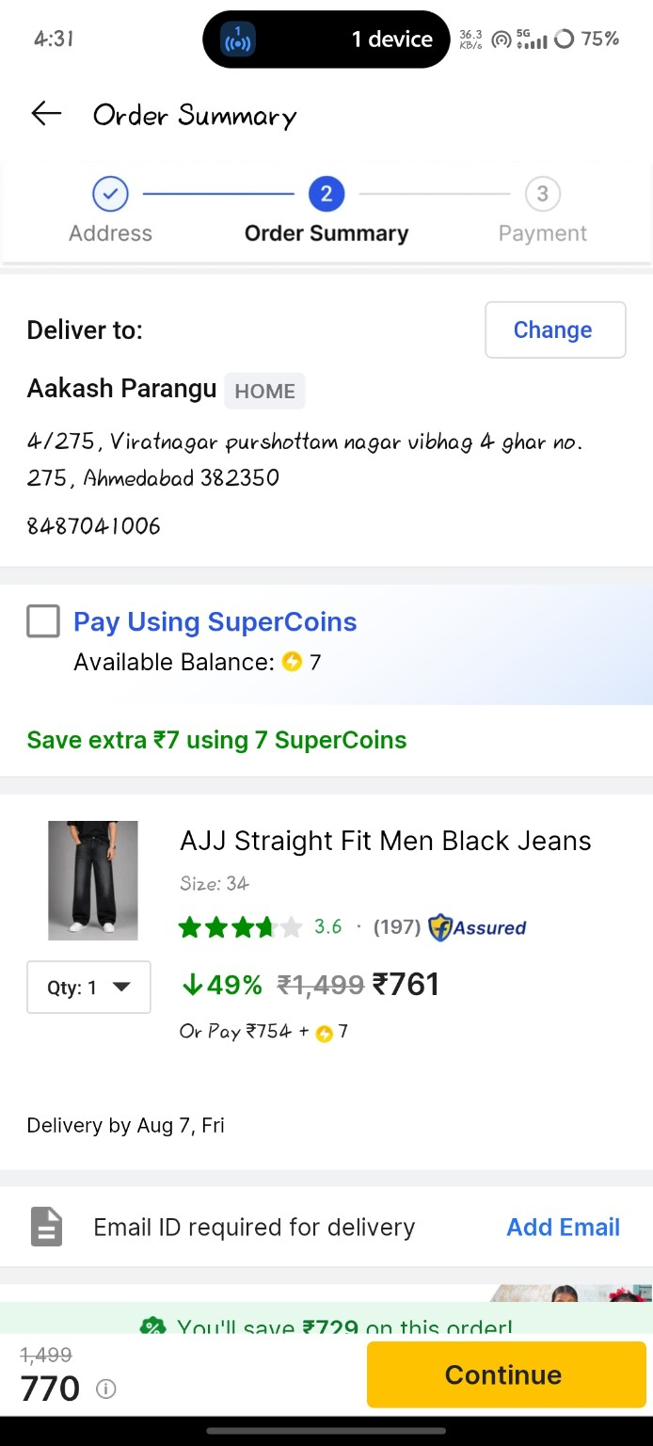

TC_08 - Payment Page
Test Case ID | TC_08
Module | Flipkart App
Scenario | Payment Page
Test Steps | 1. Proceed to Checkout.  2. Open Payment page.
Test Data | COD/UPI
Expected Result | Payment options should be displayed.
Actual Result | Payment options displayed.
Status | Pass
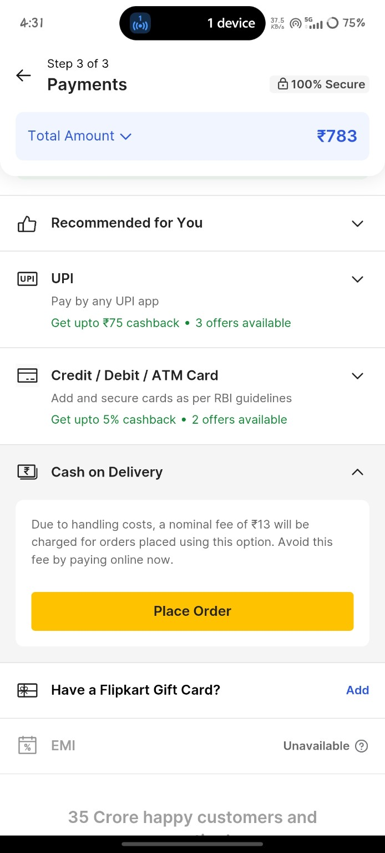

TC_09 - Invalid OTP Validation
Test Case ID | TC_09
Module | Flipkart App
Scenario | Invalid OTP Validation
Test Steps | 1. Enter invalid OTP.  2. Tap Verify.
Test Data | Invalid OTP
Expected Result | Validation message should appear.
Actual Result | Validation message displayed.
Status | Pass
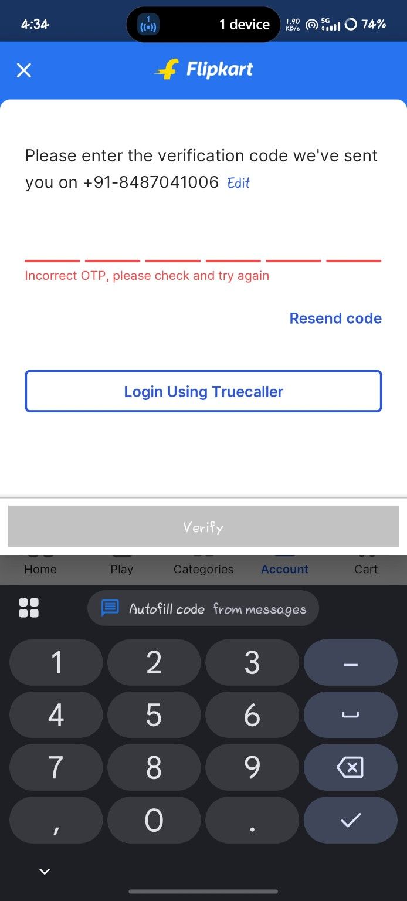

TC_10 - Empty Address Validation
Test Case ID | TC_10
Module | Flipkart App
Scenario | Empty Address Validation
Test Steps | 1. Leave address fields blank.  2. Tap Save.
Test Data | Blank address
Expected Result | Validation message should appear.
Actual Result | Validation message displayed.
Status | Pass
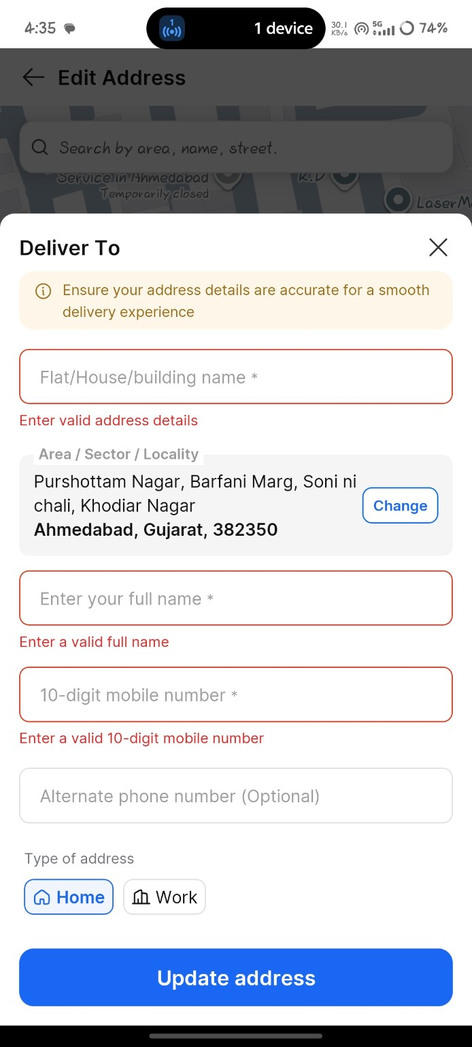

Requirement Traceability Matrix (RTM)
Requirement ID | Requirement | Module | Test Case | Status
REQ_01 | Login | Login | TC_02,TC_09 | Covered
REQ_02 | Search Product | Search | TC_03 | Covered
REQ_03 | Product Details | Product | TC_04 | Covered
REQ_04 | Cart | Cart | TC_05,TC_06 | Covered
REQ_05 | Checkout & Payment | Payment | TC_07,TC_08,TC_10 | Covered

Conclusion
Functional testing of the Flipkart mobile application was completed successfully.

