SILVER OAK UNIVERSITY
TUTORIAL – 5 : DEFECT REPORTING
Pinterest Web Application Testing

Aim | Apply defect identification and prepare professional bug reports including severity, priority, screenshots and reproduction steps.
Application Tested | Pinterest
Screenshots Used | 1, 2, 3, 4, 5, 6, 7 and 8
Steps | 1. Open Pinterest  2. Home  3. observe pins and navigation.

Testing Note: The supplied screenshots are used as evidence. No unsupported defect has been invented; a confirmed defect requires observable failure evidence.

SCREENSHOT 1 – Pinterest Home Feed
Test ID | PTR-01
Module | Home / Feed
Steps | 1. Open login/signup  2. observe email field, Continue and sign-in options.
Test Data | Pinterest home feed with visible pins, tabs (All / Gt 650) and bottom navigation.
Expected Result | Home feed should load with pins, tabs and navigation.
Actual Result | Home feed, All/Gt 650 tabs, pins and bottom navigation are visible.
Status | No clear defect observed
Evidence Screenshot
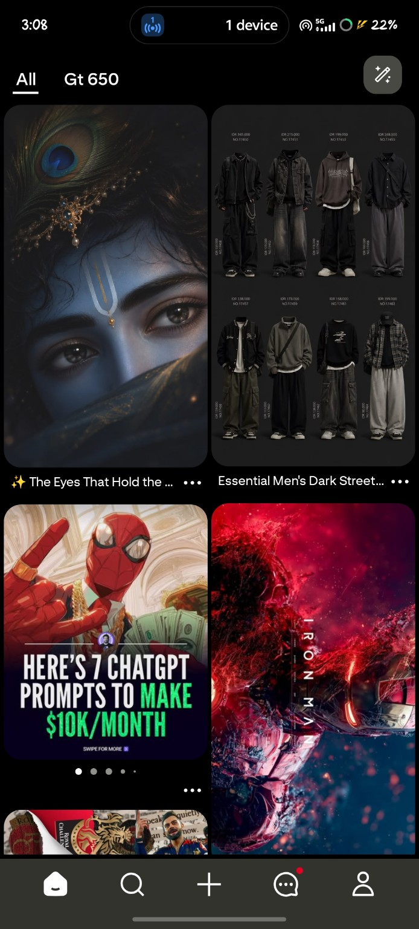

SCREENSHOT 2 – Login / Signup Screen
Test ID | PTR-02
Module | Login / Signup
Steps | 1. Open Search  2. enter “spiderman wallpaper”  3. observe query field.
Test Data | Blank email field; Continue button before input; Google sign-in option.
Expected Result | Authentication options and validation should be clear.
Actual Result | Email field, disabled Continue button, Google option and Facebook-unavailable message are visible.
Status | No clear defect observed
Evidence Screenshot
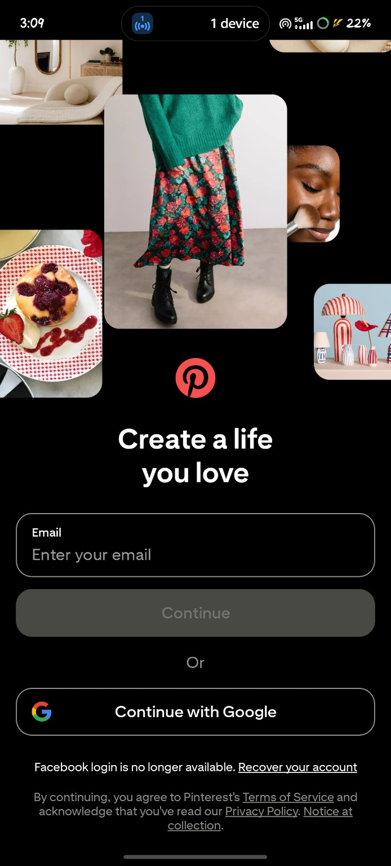

SCREENSHOT 3 – Search Input
Test ID | PTR-03
Module | Search
Steps | 1. Search “spiderman wallpaper”  2. wait for results  3. observe cards and filters.
Test Data | Search query = “spiderman wallpaper”.
Expected Result | The entered search query should remain visible.
Actual Result | The entered query “spiderman wallpaper” remains visible in the search field.
Status | No clear defect observed
Evidence Screenshot
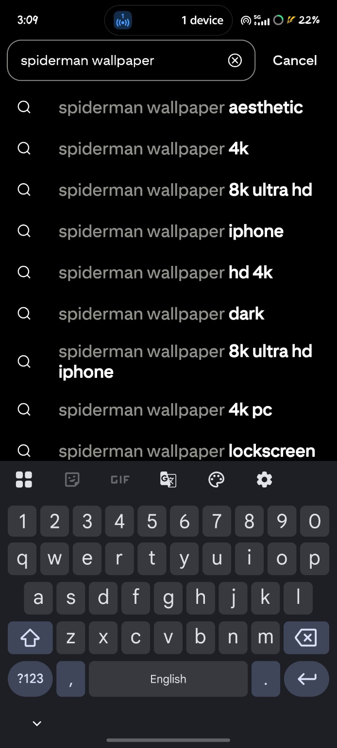

SCREENSHOT 4 – Search Results Display
Test ID | PTR-04
Module | Search Results
Steps | 1. Open a pin  2. open action menu  3. observe available actions.
Test Data | Search query = “spiderman wallpaper”; wait for results and filter chips.
Expected Result | Search results should load in a readable layout with filters.
Actual Result | Search results, filter chips and multiple Spider-Man pins are displayed.
Status | No clear defect observed
Evidence Screenshot
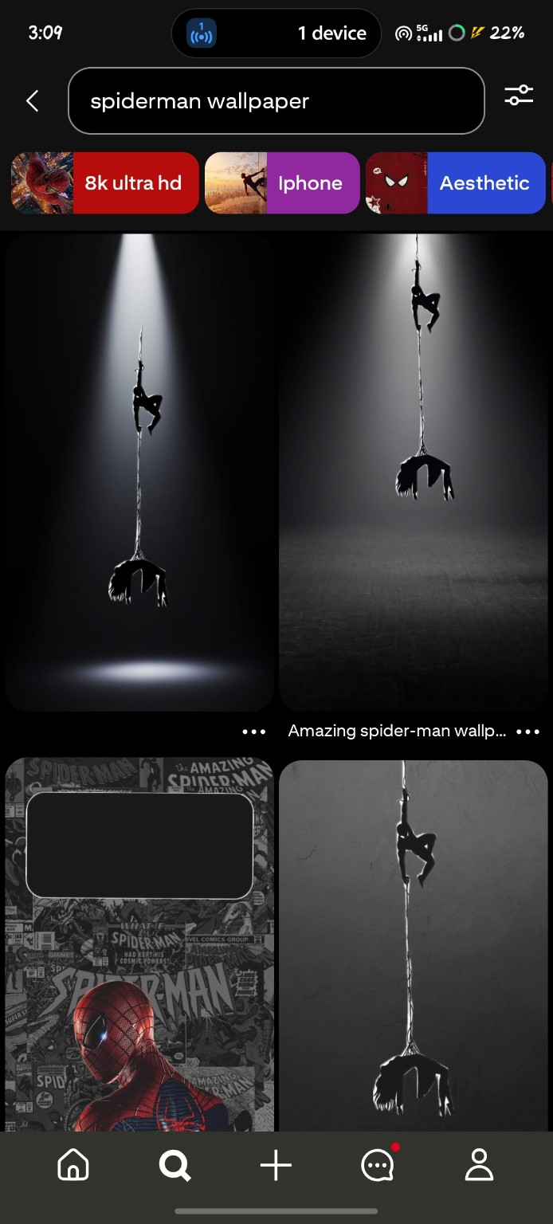

SCREENSHOT 5 – Pin Action Menu
Test ID | PTR-05
Module | Pin Actions
Steps | 1. Save/open the board  2. observe board name and pin count.
Test Data | Selected Spider-Man pin; open the pin action menu.
Expected Result | Pin actions should be clearly available.
Actual Result | See more, See less, Save, Share, Download image and Report actions are displayed.
Status | No clear defect observed
Evidence Screenshot
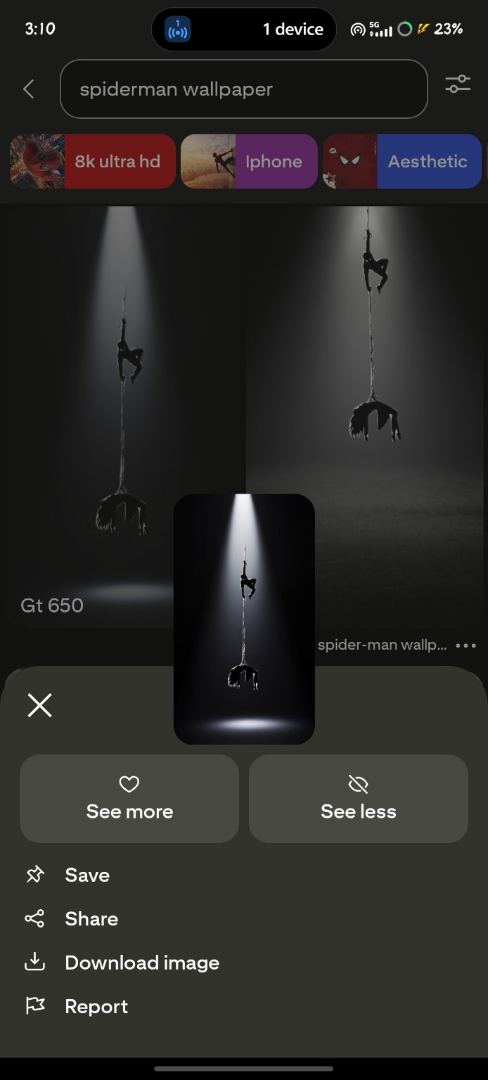

SCREENSHOT 6 – Saved Board
Test ID | PTR-06
Module | Board / Saved Pins
Steps | 1. Open profile  2. observe profile, Saved tab and boards.
Test Data | Board name = “Gt 650”; saved pin count = 4.
Expected Result | Saved pins should appear in the selected board with the correct count.
Actual Result | Board “Gt 650” is visible with 4 saved pins.
Status | No clear defect observed
Evidence Screenshot
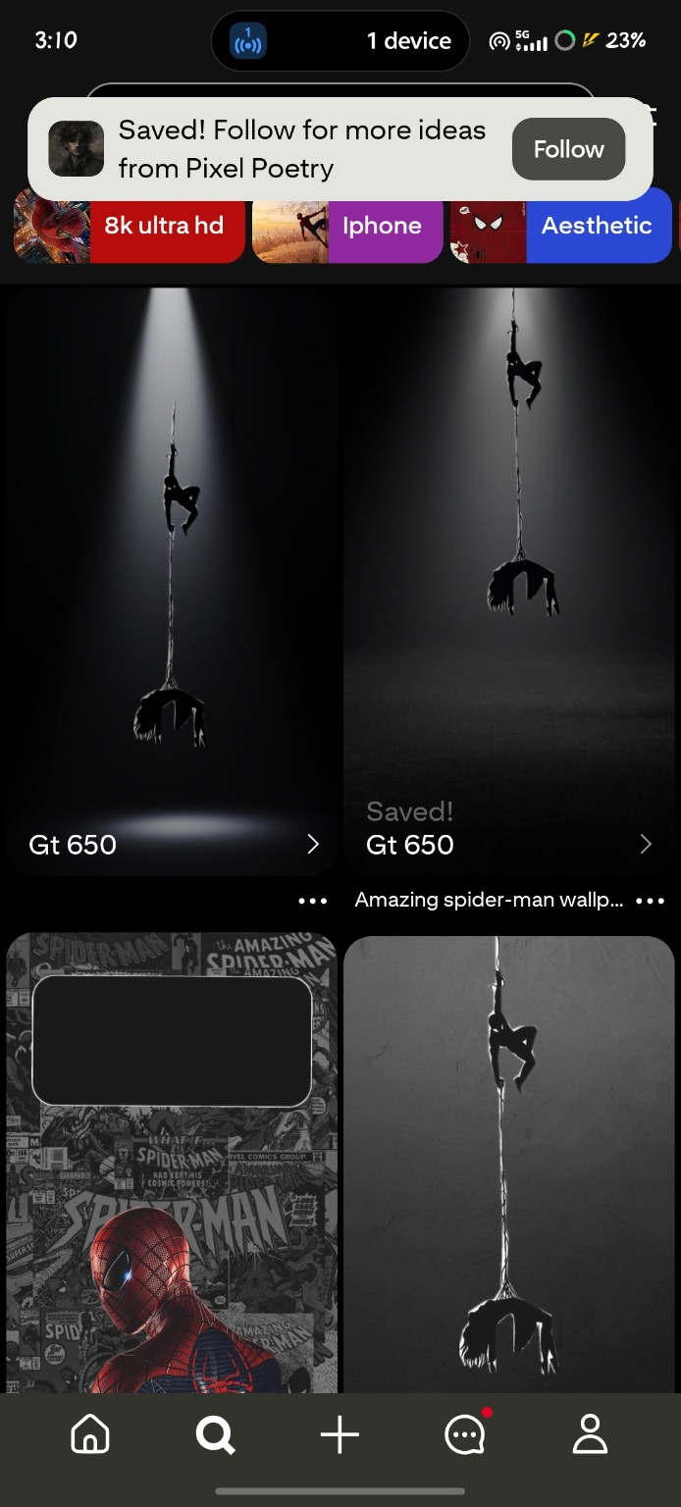

SCREENSHOT 7 – User Profile
Test ID | PTR-07
Module | Profile
Steps | 1. Open account settings  2. observe notifications, privacy, security and logout.
Test Data | Profile = Aakash; Saved tab selected; board “Gt 650” visible.
Expected Result | Profile and saved content should display consistently.
Actual Result | Aakash profile, Saved tab, boards and saved content are visible.
Status | No clear defect observed
Evidence Screenshot
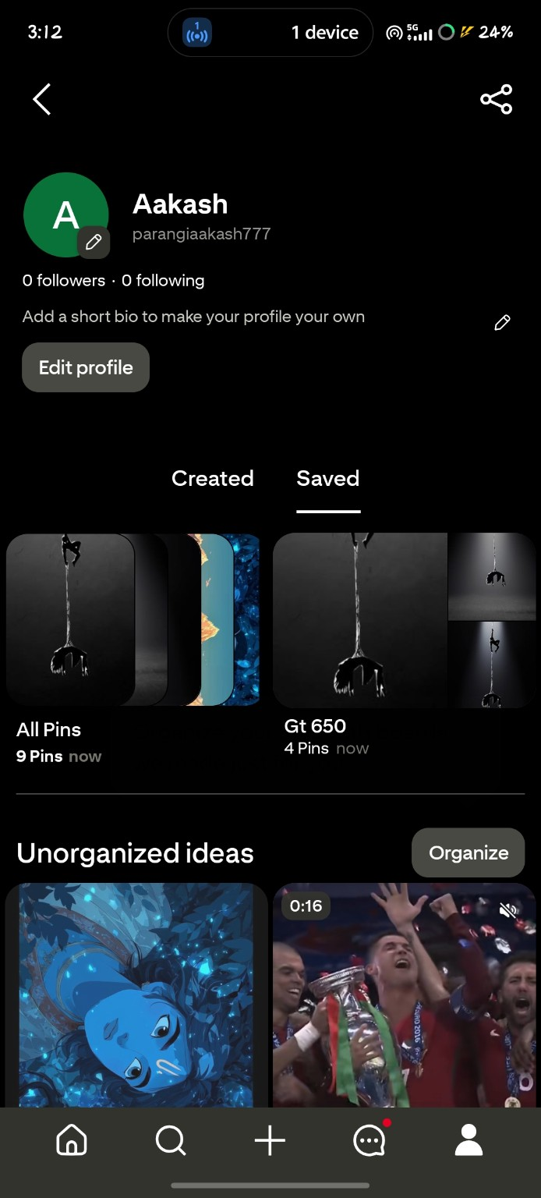

SCREENSHOT 8 – Logout
Test ID | PTR-08
Module | Logout
Acceptance | Account settings clearly provide Security and Log out options.
Test Data | Account settings page; verify Security and Log out options.
Expected Result | Account settings should clearly present Security and Log out options.
Actual Result | Account settings show Security and Log out along with other settings categories.
Status | No clear defect observed
Evidence Screenshot
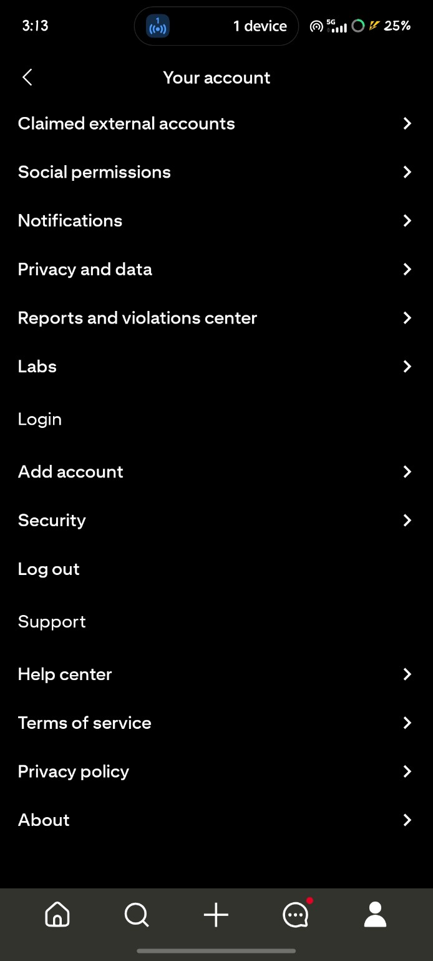
TUTORIAL 5 – SUMMARY
Application | Pinterest
Evidence Reviewed | Screenshots 1, 2, 3, 4, 5, 6, 7 and 8
Confirmed defects | None clearly demonstrable from the supplied screenshots alone
Conclusion | The supplied screens were reviewed according to the defect-reporting aim. Additional interaction evidence would be needed to raise a confirmed reproducible defect.

