TUTORIAL - 6
Manual Test Execution
Web Application: Pinterest

Aim | Apply manual test cases using multiple input conditions and prepare detailed test execution and summary reports.
Description | Manual testing is performed on Pinterest using search, login validation, saved pins and account/logout scenarios. Each selected test case includes steps, expected result, actual result, status and screenshot evidence.

Module | Pinterest
Test Case No. | 1
Status | PASS
Steps to Execute | 1. Open Pinterest.  2. Tap the Search icon.  3. Enter "spiderman wallpaper" in the search field.  4. Execute the search.

Expected Result | Relevant Spiderman wallpaper/image results should be displayed.
Actual Result | Pinterest displayed multiple relevant Spiderman wallpaper results with search suggestions/categories.

Screenshot 1
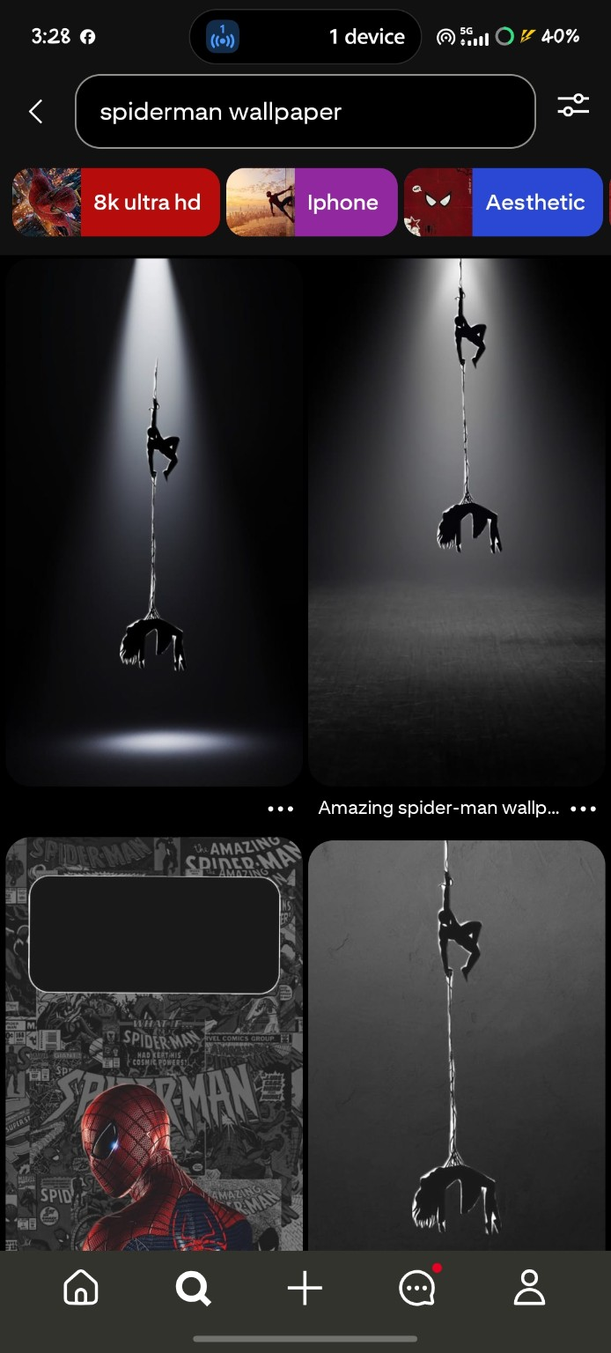

Module | Pinterest
Test Case No. | 2
Status | PASS
Steps to Execute | 1. Open the Search section.  2. Enter "shoes men" in the search field.  3. Execute the search.

Expected Result | Relevant men's shoe results should be displayed.
Actual Result | Pinterest displayed men's shoe images, categories and related results.

Screenshot 2
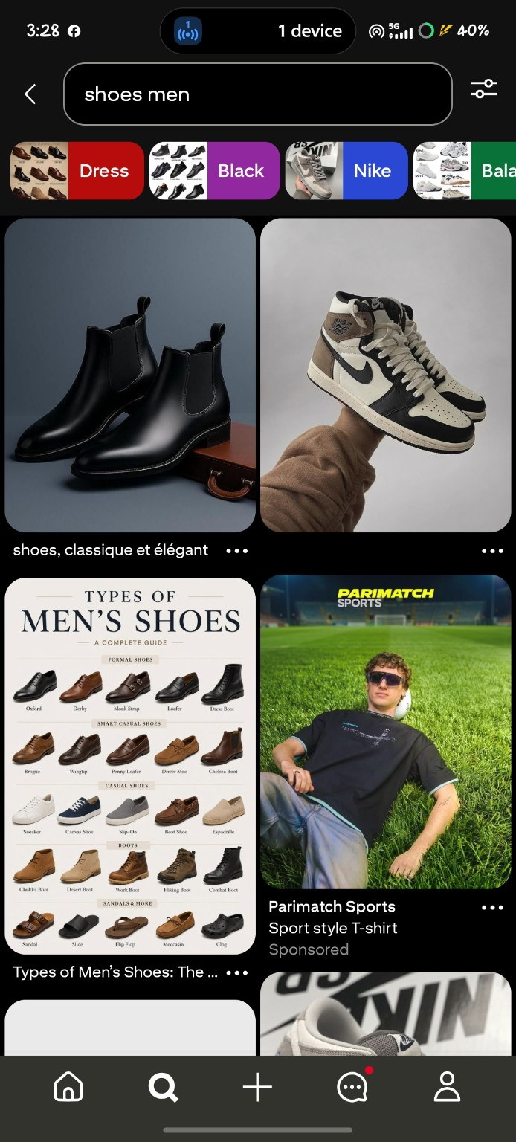

Module | Pinterest
Test Case No. | 3
Status | PASS
Steps to Execute | 1. Open the Search option.  2. Leave the search field empty.  3. Observe the search screen.

Expected Result | The application should keep the search field empty and should not perform a search without a query.
Actual Result | The search screen remained open with the placeholder "Search for ideas" and no search query entered.

Screenshot 3
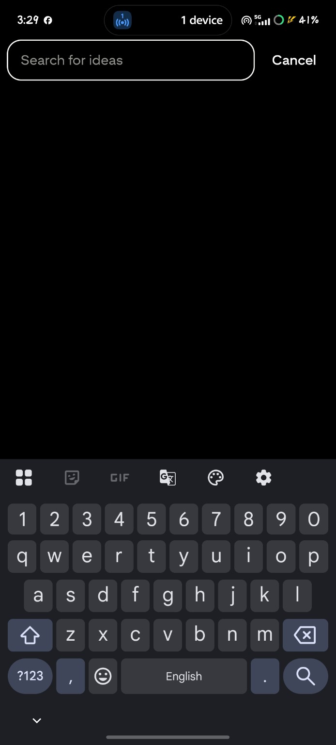

Module | Pinterest
Test Case No. | 4
Status | PASS
Steps to Execute | 1. Open the Pinterest login screen.  2. Leave the Email field empty.  3. Observe the Continue button and login form.

Expected Result | The application should not continue with an empty email field.
Actual Result | The Email field remained empty and the Continue button was disabled.

Screenshot 4
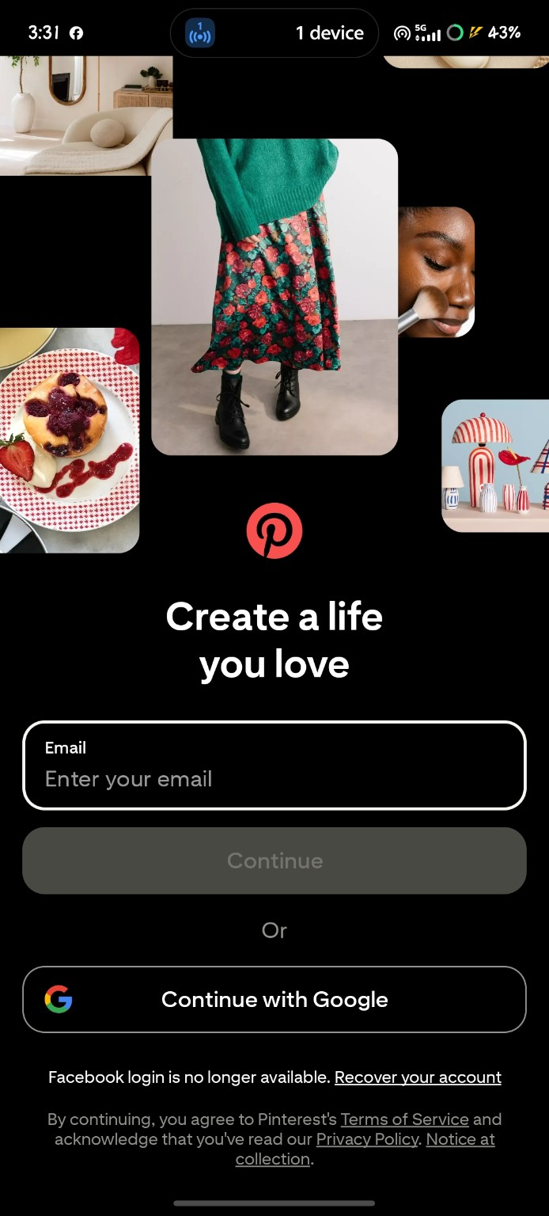

Module | Pinterest
Test Case No. | 5
Status | PASS
Steps to Execute | 1. Open the Pinterest login screen.  2. Enter an invalid email format.  3. Observe the validation message.

Expected Result | The application should show an email validation error and prevent valid continuation.
Actual Result | A validation message "Sorry, this doesn't look like a valid email" was displayed below the email field.

Screenshot 5
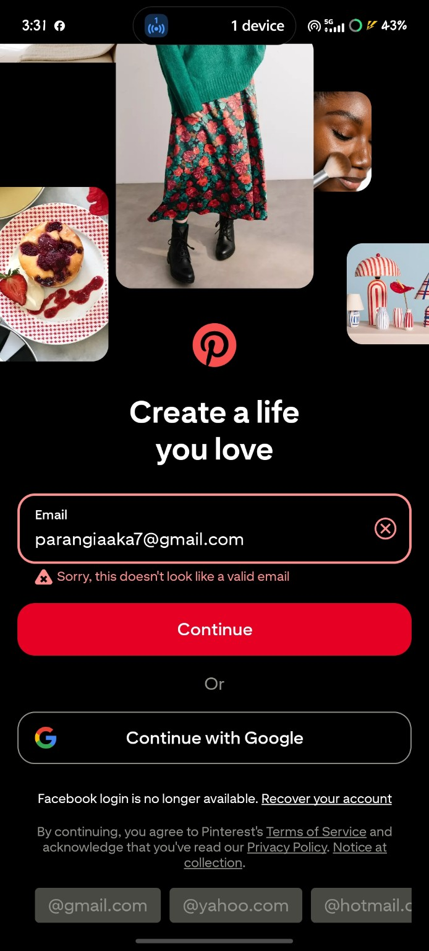

Module | Pinterest
Test Case No. | 6
Status | PASS
Steps to Execute | 1. Open the user profile.  2. Select the Saved section.  3. Observe the saved boards/pins.

Expected Result | The Saved section should display the user's saved pins/boards.
Actual Result | The Saved section displayed the board "Gt 650" with 4 pins and the All Pins section with 9 pins.

Screenshot 6
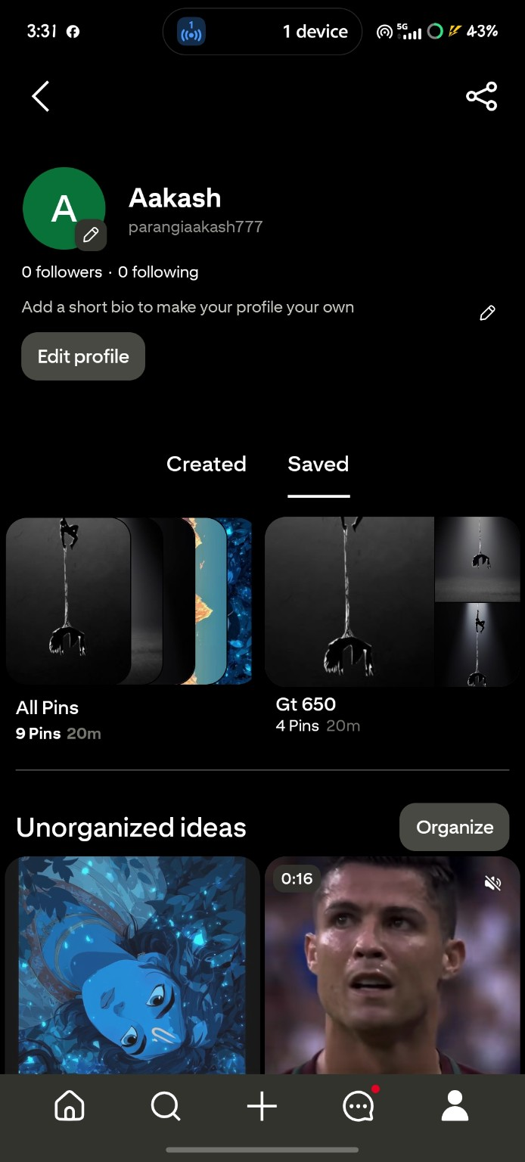

Module | Pinterest
Test Case No. | 7
Status | PASS
Steps to Execute | 1. Open the account/profile menu.  2. Scroll to the account options.  3. Locate the "Log out" option.

Expected Result | A Log out option should be available in the account menu.
Actual Result | The account menu displayed the "Log out" option at the bottom of the list.

Screenshot 7
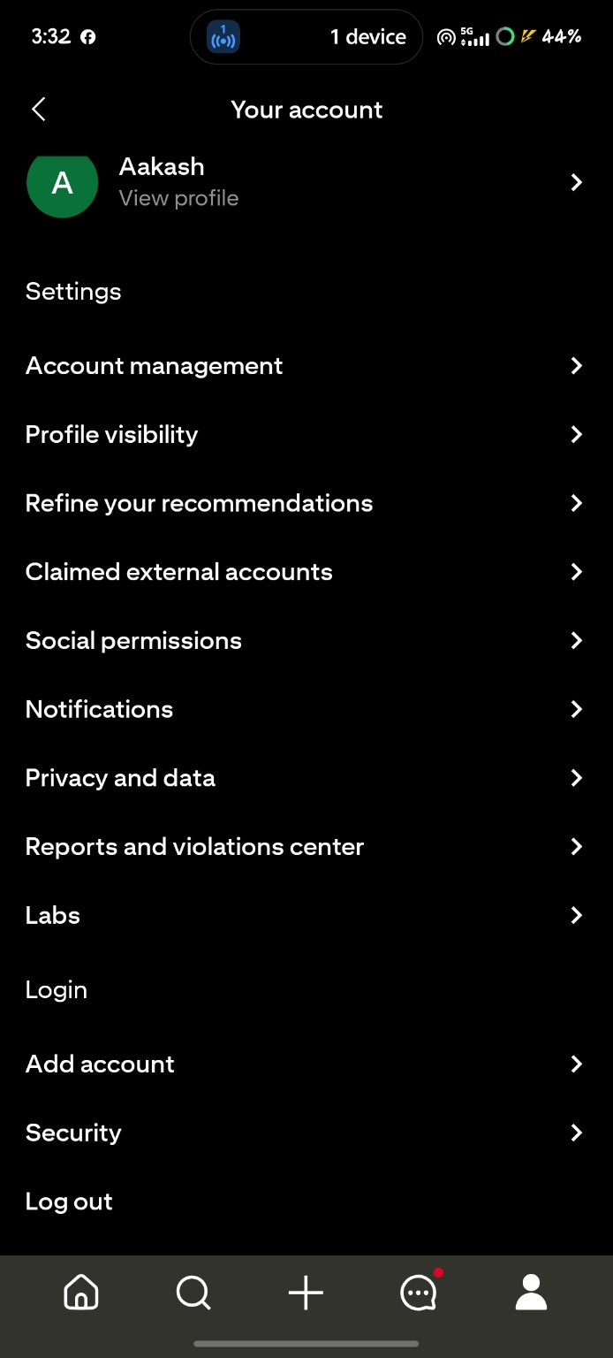

Test Execution Summary
Test Case | Scenario | Result | Status
1 | Search for Spiderman Wallpaper | Pinterest displayed multiple relevant Spiderman wallpaper results with search suggestions/categories. | PASS
2 | Search for Men's Shoes | Pinterest displayed men's shoe images, categories and related results. | PASS
3 | Blank Search | The search screen remained open with the placeholder "Search for ideas" and no search query entered. | PASS
4 | Login with Blank Email | The Email field remained empty and the Continue button was disabled. | PASS
5 | Login with Invalid Email | A validation message "Sorry, this doesn't look like a valid email" was displayed below the email field. | PASS
6 | View Saved Pins | The Saved section displayed the board "Gt 650" with 4 pins and the All Pins section with 9 pins. | PASS
7 | Logout Option | The account menu displayed the "Log out" option at the bottom of the list. | PASS

Total Test Cases Executed: 7
Passed: 7
Failed: 0

