1) Consider n-by-n grid of cells where each cell (aka site) is a person with or without an infectious disease. Each person is directly connected to either 2 or 3 or 4 persons. If p is the probability of a person being infectious then 1-p is the probability that the person is not infectious. How many persons need to be infectious for the infection to get transferred from the top row to the bottom row? If p is low (0.4) we can say for sure that the infection will not get transferred from the top row to the bottom row. If p is very high (0.8) we can say for sure that the infection will get transferred from the top row to the bottom row. But if p is medium (0.6) we cannot say for sure. The task is to find the threshold value of p when the infection will get transferred from the top row to the bottom row.

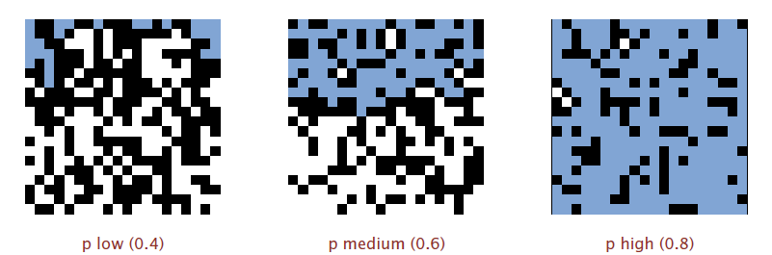

In this diagram a black cell denotes a person with no infection (not in contact with any of its immediate neighbor), a white cell denotes a person with infection (in contact with 1 or more of its immediate neighbor) but not connected to the top and blue cell denotes a connection to the top.

To re-iterate when n is sufficiently large, there is a threshold value p* such that when p < p* a random n-by-n grid almost will never cause the infection to percolate from top to bottom, and when p > p*, a random n-by-n grid almost always percolates. As of this day there is no mathematical formula to find the percolation threshold p*. Your task is to estimate p* using an appropriate data structure and algorithm.

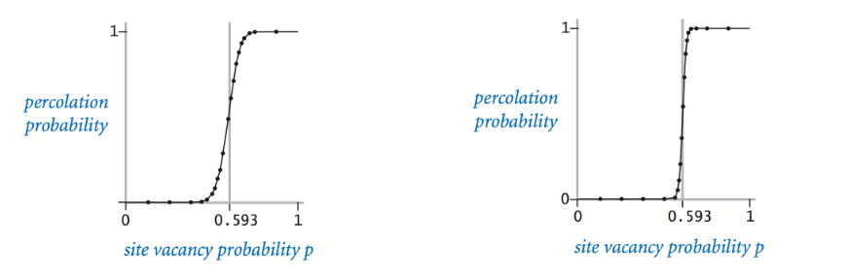

2) The time complexity of binary search tree is O(1.39 log2N) (average case) and Φ(N) (worst case). Your task is to make changes to the binary search tree to bring down the worst case to either logarithmic (log2N) or linearithmic (N * log2N).

|  |  |
| --- | --- |
| **Average Case** | **Worst Case** |
|  |  |

3) Your task is to write a sorting algorithm to sort a file of size 1 GB containing n numbers with either logarithmic (log2N) or linearithmic (N * log2N) time complexity. The constraint is the heap memory available to the java process is only 1024 MB. In other words you cannot load the entire file in memory at the same time.

Instructions:

1. You can pick any 1 of the 3 problems. But you are welcome to pick more.
2. You need to submit the working code within 8 hours.
3. Do let us know if you have any queries on any of these problems.
4. Do let us know if need any hint or help to make progress.