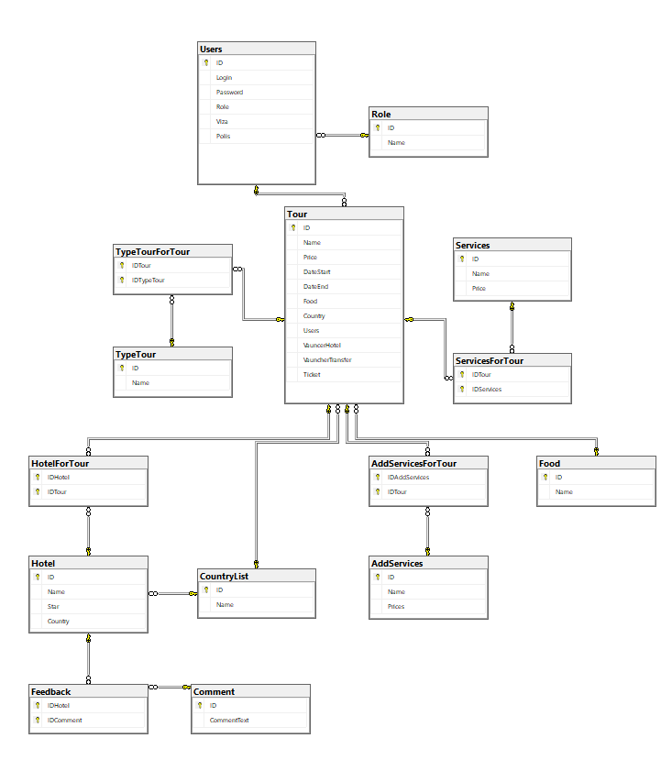

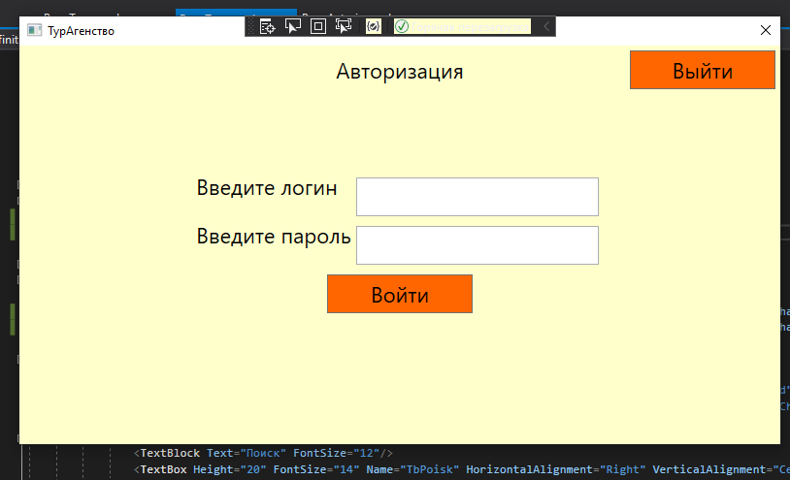

Код:

using System.Linq;

using System.Windows;

using System.Windows.Controls;

using System.Windows.Navigation;

namespace UP.Pages

{

/// <summary>

/// Логика взаимодействия для PageAvtoriz.xaml

/// </summary>

public partial class PageAvtoriz : Page

{

public PageAvtoriz()

{

InitializeComponent();

}

private void BtnEnter_Click(object sender, RoutedEventArgs e)

{

if (TbLogin.Text.Length == 0 || TbPassword.Password.Length == 0)

{ MessageBox.Show("Заполните поля", "Error", MessageBoxButton.OK, MessageBoxImage.Error); }

else

{

var a = App.Context.Users;

if (a.Where(p => p.Login == TbLogin.Text && p.Password == TbPassword.Password).Count() == 1)

{

App.UserContext = a.FirstOrDefault(p => p.Login == TbLogin.Text && p.Password == TbPassword.Password);

NavigationService.Navigate(new Pages.PageTour());

}

else

MessageBox.Show("Пользователь не найден", "Error", MessageBoxButton.OK, MessageBoxImage.Error);

}

}

}

}

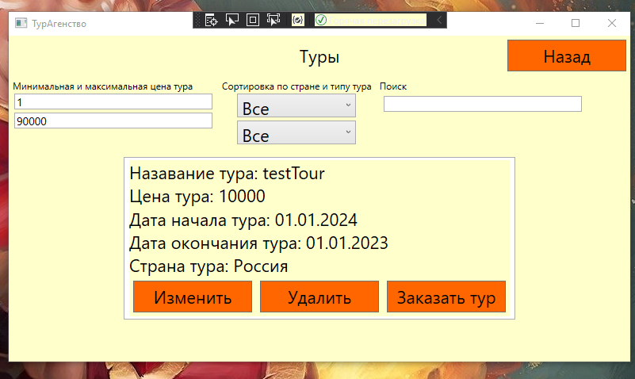

Код:

using System;

using System.Linq;

using System.Windows;

using System.Windows.Controls;

namespace UP.Pages

{

/// <summary>

/// Логика взаимодействия для PageTour.xaml

/// </summary>

public partial class PageTour : Page

{

public PageTour()

{

InitializeComponent();

var Type = App.Context.TypeTours.Select(p => p.Name).ToList();

Type.Insert(0, "Все");

CBTypeTour.ItemsSource = Type.ToList();

var Country = App.Context.CountryLists.Select(p => p.Name).ToList();

Country.Insert(0, "Все");

CBCountryTour.ItemsSource = Country.ToList();

CBCountryTour.SelectedIndex = 0;

CBTypeTour.SelectedIndex = 0;

CBCountryTour.FontSize = 8;

CBTypeTour.FontSize = 8;

Update();

}

public void Update()

{

try

{

var a = App.Context.Tours.ToList();

int CostMax = 1000;

int CostMin = 0;

if (Int32.TryParse(TbCostMax.Text, out CostMax) && Int32.TryParse(TbCostMin.Text, out CostMin))

{

if (CostMax < CostMin)

{

MessageBox.Show("Не верное значение цены", "Error", MessageBoxButton.OK, MessageBoxImage.Error);

return;

}

else

a = a.Where(p => p.Price >= CostMin && p.Price <= CostMax).ToList();//сортировка по цене

}

else

{

MessageBox.Show("Не соответствующий тип данных", "Error", MessageBoxButton.OK, MessageBoxImage.Error);

return;

}

if (TbPoisk.Text != null)

a = a.Where(p => p.Name.ToLower().Contains(TbPoisk.Text.ToLower())).ToList();//поиск по названию

if (CBCountryTour.SelectedItem.ToString() != "Все")

a = a.Where(p => p.CountryList.Name.ToLower().Contains(CBCountryTour.SelectedItem.ToString().ToLower())).ToList();//фильтр по стране

if (CBTypeTour.SelectedItem.ToString() != "Все")

a = a.Where(p => p.TypeTours.Select(j => j.Name.ToLower()).Contains(CBTypeTour.SelectedItem.ToString().ToLower())).ToList();//фильтр по типу тура

LVTour.ItemsSource = a;

}

catch (Exception e)

{

MessageBox.Show(e.Message);

}

}

private void TbCostMin_TextChanged(object sender, TextChangedEventArgs e)

{

Update();

}

private void TbCostMax_TextChanged(object sender, TextChangedEventArgs e)

{

Update();

}

private void TbPoisk_TextChanged(object sender, TextChangedEventArgs e)

{

Update();

}

private void Edit_Click(object sender, RoutedEventArgs e)

{

Update();

}

private void Zakaz_Click(object sender, RoutedEventArgs e)

{

Update();

}

private void Delete_Click(object sender, RoutedEventArgs e)

{

Update();

}

private void CBTypeTour_SelectionChanged(object sender, SelectionChangedEventArgs e)

{

Update();

}

private void CBCountryTour_SelectionChanged(object sender, SelectionChangedEventArgs e)

{

Update();

}

private void Page_Loaded(object sender, RoutedEventArgs e)

{

Update();

}

}

}

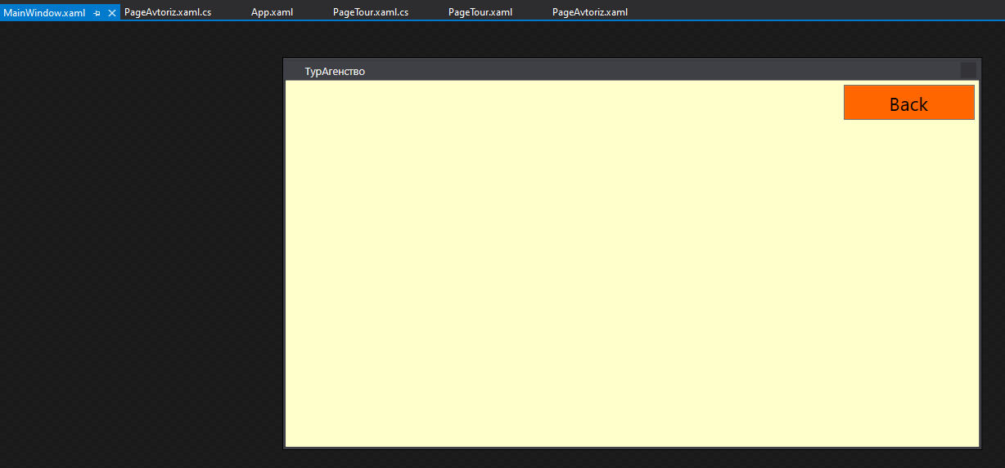

Код:

using System;

using System.Windows;

namespace UP

{

/// <summary>

/// Логика взаимодействия для MainWindow.xaml

/// </summary>

public partial class MainWindow : Window

{

public MainWindow()

{

InitializeComponent();

MainFrame.Navigate(new Pages.PageAvtoriz());

}

private void BtnBack_Click(object sender, RoutedEventArgs e)

{

if (MainFrame.CanGoBack)

MainFrame.GoBack();

if (BtnBack.Content.ToString() == "Выйти")

{

this.Close();

}

}

private void Window_ContentRendered(object sender, EventArgs e)

{

if (MainFrame.CanGoBack)

{

ResizeMode = ResizeMode.CanResize;

BtnBack.Content = "Назад";

}

else

{

ResizeMode = ResizeMode.NoResize;

Width = 800;

Height = 450;

BtnBack.Content = "Выйти";

}

}

}

}

Партиал класс:

using System;

using System.Collections.Generic;

using System.Linq;

using System.Text;

using System.Threading.Tasks;

namespace UP.DB

{

public partial class Tour

{

public string NameView { get { return $"Назавание тура: {Name}"; } }

public string PriceView { get { return $"Цена тура: {Price}"; } }

public string DateStartView { get { return $"Дата начала тура: {DateStart}"; } }

public string DateEndView { get { return $"Дата окончания тура: {DateEnd}"; } }

public string FoodView { get { return $""; } }

public string CountryView { get { return $"Страна тура: {CountryList.Name}"; } }

public string UsersView { get { return $""; } }

public string VauncerHotelView { get { return $""; } }

public string VauncherTransferView { get { return $""; } }

public string TicketView { get { return $""; } }

public string btnRole

{

get

{

if (App.UserContext.Role1.ID == 1)

{

return "Visible";

}

else

return "Hidden";

}

}

}

}

USECASE

