BinaryCoven
User Manual

A Web-Based Quest-Oriented Learning System for Introductory Programming
with Instructor Management Features

Version 1.0
April 2026

Gordon College
College of Computer Studies
Olongapo City, Zambales, Philippines

TABLE OF CONTENTS
PART I: STUDENT GUIDE
1. Getting Started
1.1 Creating Your Account
1.2 Joining a Session
1.3 Logging In Again
1.4 Forgot Your Password?
2. Navigating the World
2.1 Basic Controls
2.2 The HUD
3. The Quest System
3.1 Finding Quests
3.2 Quest Phases and Objectives
3.3 Cancelling and Restarting
4. The Programming Terminal
4.1 Opening the Editor
4.2 Writing and Running Code
4.3 Built-in Commands
4.4 Creating Your Own Functions
4.5 Preset Templates
4.6 Energy Management
4.7 Drones
5. Saving Your Progress

PART II: INSTRUCTOR / ADMIN GUIDE
6. Getting Started (Admin)
6.1 Logging In
6.2 The Dashboard
7. Managing Sessions
7.1 Creating a Session
7.2 Session Lifecycle
8. Monitoring Students
8.1 Student List
8.2 Individual Student View
8.3 Viewing Student Code
9. Admin User Management
10. Quick Reference Tables

PART I
Student Guide

Welcome to BinaryCoven, aspiring coder. Your robot companion Qubit awaits your instructions. This guide will teach you how to command it.

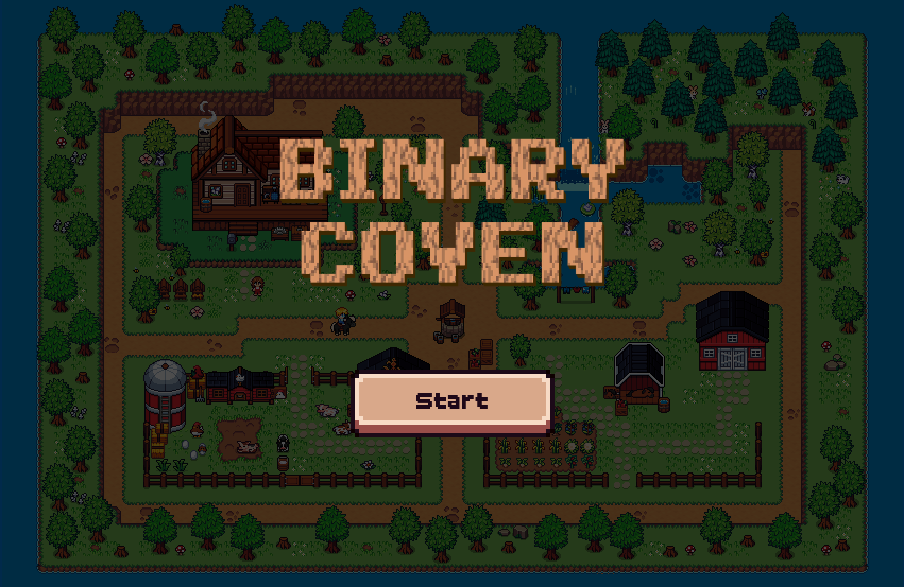

1. Getting Started
Before you can explore the world of BinaryCoven and start commanding Qubit, you will need an account and a session code from your instructor. Think of the session code as your ticket into the classroom.

1.1 Creating Your Account
Open the student portal in your browser. You will see the login modal titled "Binary Coven -- Student Portal." To create a new account:
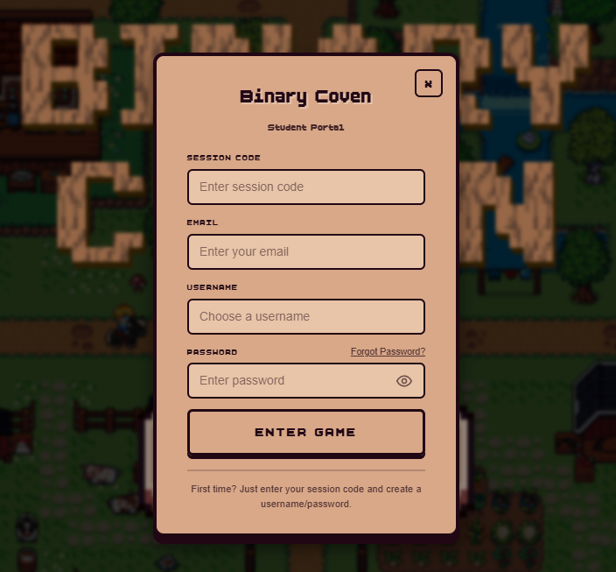
Step 1. Enter the Session Code your instructor provided. The system validates it in real time -- a green check mark means you are good to go, a red X means the code is invalid or expired.
Step 2. Fill in your Email, Username, and Password. Your password must contain at least one uppercase letter, one number, and one special character. The form enforces these as you type.

Step 3. Click Submit. If the username is new, the system automatically switches to the OTP verification step.
Step 4. Check your email for a 6-digit verification code and enter it. If you do not see it, wait 60 seconds and click "Resend code."
Step 5. Once verified, your account is created, your game state syncs from the database, and you enter the game. You are in.
Tip: Your account works across sessions. If your instructor gives you a new session code next week, just log in with your existing username and password plus the new code. The system links it automatically.

1.2 Joining a Session
Your instructor will give you a session code at the start of class. Sessions have time windows (scheduled, active, or expired) and may have a maximum student cap. If the code is expired, inactive, or the session is full, the system will tell you. Just ask your instructor for a valid code.

1.3 Logging In Again
Already have an account? Enter your username, password, and the current session code. No OTP needed the second time around. If you are joining a new session with an existing account, the system detects this and links your account to the new session automatically.

1.4 Forgot Your Password?
It happens to the best of us. On the login screen:
Step 1. Enter your username and session code.
Step 2. The system sends a reset OTP to your registered email (shown partially masked for privacy).
Step 3. Enter the code and set a new password.

2. Navigating the World
BinaryCoven is a pixel-art world built on a grid. You move around by clicking, using arrow keys, or (eventually) by writing code that tells Qubit where to go. The world contains interactive tiles like mining terminals, dynamos, wallets, and farming plots.

2.1 Basic Controls

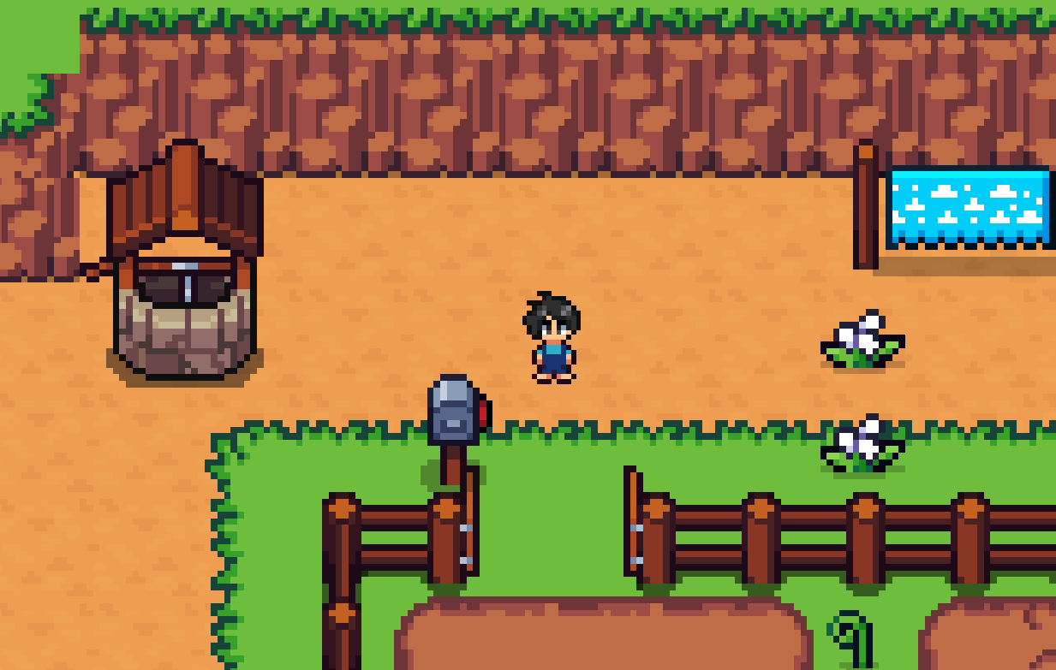
Input | What It Does
Click on Qubit | Opens the status / programming interface
Click on a tile | Shows tile info and available actions (mine, crank, plant, etc.)
Arrow keys | Manual movement for testing
Drag | Move code windows and floating panels around the screen
Corner handles | Resize code windows and panels

2.2 The HUD
The heads-up display sits at the edges of your screen. The buttons available are:
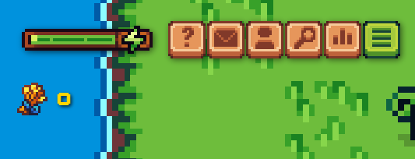
Button | What It Opens
Quests | Your quest log -- available, active, and completed quests
Glossary | Reference for all available commands and syntax
Status | Qubit's current stats (energy, position, inventory)
Explore | World navigation and points of interest
Map Editor | Available in certain contexts for editing the grid

Toast notifications pop up for events (quest updates, errors, achievements). Errors also appear in a dedicated Error Display panel.

3. The Quest System
Quests are how you learn in BinaryCoven. Each quest teaches a programming concept -- sequencing, conditionals, loops, functions, or optimization -- through hands-on tasks where you write code to make Qubit do things in the world.

3.1 Finding Quests
Open the Quests modal from the HUD. You will see three tabs:
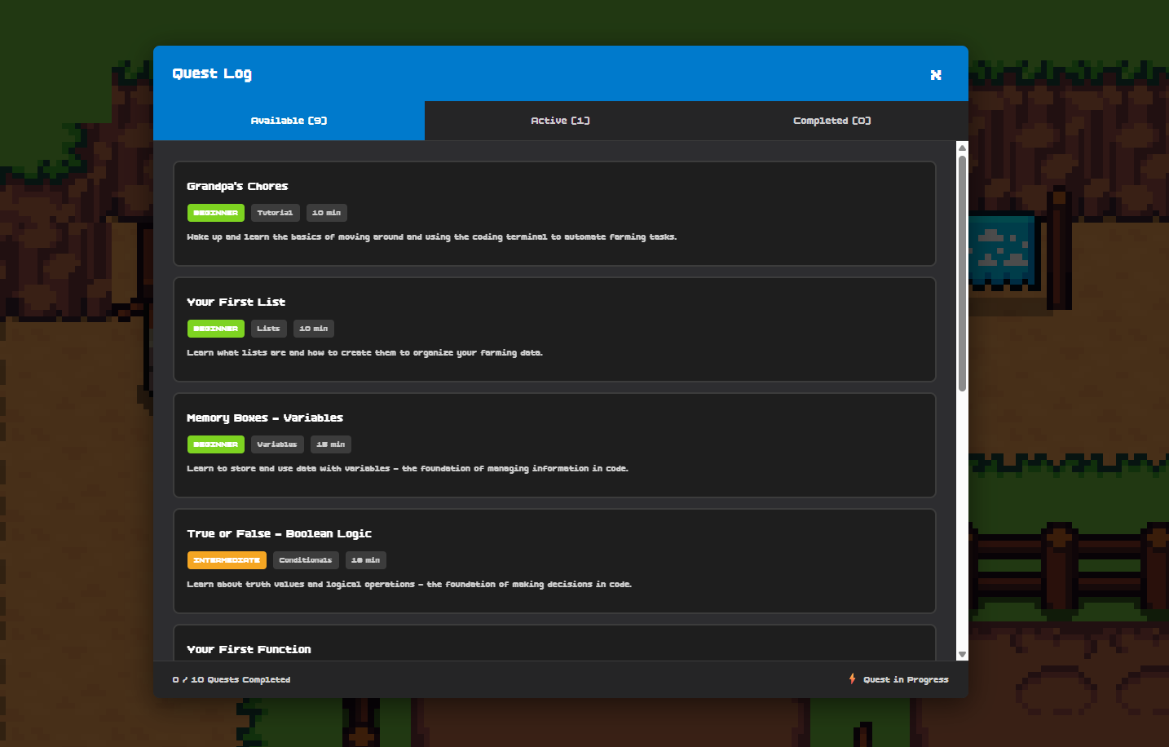
Available -- quests you can start right now.
Active -- the quest you are currently working on (only one at a time).
Completed -- quests you have finished. You can revisit and restart these.
Each quest card shows its title, description, difficulty (color-coded: beginner, intermediate, advanced), category, estimated time, the programming concepts it teaches, and any prerequisites.
Note: If your instructor has enabled prerequisite enforcement for the session, some quests will be locked until you complete the required earlier quests. This is by design -- the concepts build on each other.

3.2 Quest Phases and Objectives
Quests are broken into phases, and each phase has objectives. As you complete objectives, the quest modal updates in real time. When all objectives in a phase are satisfied, the phase completes, post-phase dialogue plays, and the next phase begins. When the final phase completes, the quest is marked done and any dependent quests are unlocked.
If your code runs but does not satisfy the objectives (Qubit moves the wrong way, for example), the world resets to the phase's starting condition and you can try again. There is no penalty for retrying. Experiment freely.

3.3 Cancelling and Restarting
You can cancel an active quest from the Active tab if you want to try a different one. You can also restart any completed or active quest from the beginning to practice again. Your progress is saved to the database and persists across logins.

4. The Programming Terminal
This is the heart of BinaryCoven. The programming terminal is a Monaco-based code editor (the same engine that powers VS Code) with syntax highlighting, autocomplete, and multi-cursor support. This is where you write the code that controls Qubit.
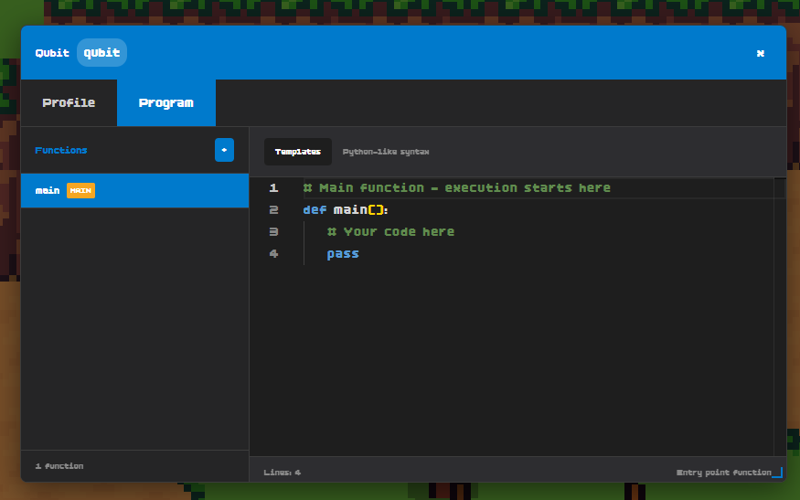

4.1 Opening the Editor
Click on Qubit, then switch to the Program tab. The left sidebar lists all your functions. The main editor area shows whichever function you have selected. Your entry point is always the main() function -- execution starts there.

4.2 Writing and Running Code
BinaryCoven uses a Python-like syntax. If you have never written code before, do not worry -- the quest system will teach you step by step. When you are ready, press the Run button and watch Qubit execute your commands in real time on the grid.
If your code has errors (syntax mistakes, undefined variables, invalid commands), they appear in the Error Display panel with line numbers so you know exactly what to fix.

4.3 Built-in Commands
The following commands are available to you from the start:
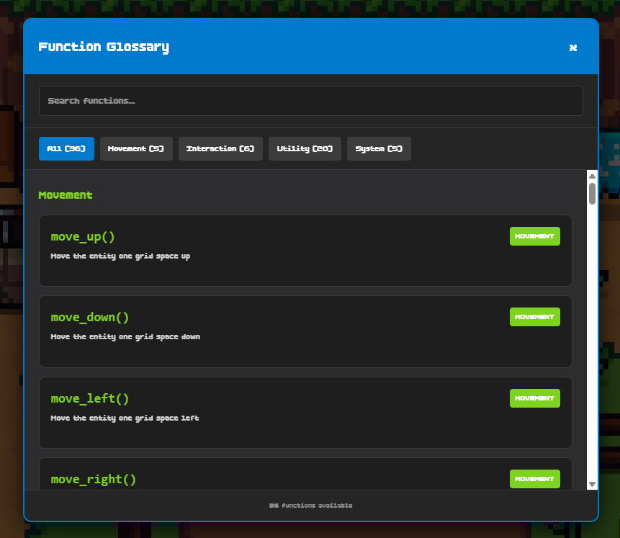

Movement
Command | What It Does
move_up() | Moves Qubit one tile up
move_down() | Moves Qubit one tile down
move_left() | Moves Qubit one tile left
move_right() | Moves Qubit one tile right
move_to(x, y) | Moves Qubit to a specific grid coordinate

Utilities
Command | What It Does
get_position() | Returns Qubit's current (x, y) position
get_current_grid() | Returns info about the tile Qubit is standing on
get_energy() | Returns Qubit's current energy level
get_inventory() | Returns a list of items Qubit is carrying
wait(seconds) | Pauses execution for the specified duration
print(...) | Prints a message to the terminal output

Tile-Bound Actions
These commands only work when Qubit is standing on the matching tile:
Command | Requires Tile
mine_initiate() / collect() | Mining terminal
crank() | Dynamo (refills energy)
store(amount) | Wallet
plant() / harvest() / can_harvest() | Farming plot

4.4 Creating Your Own Functions

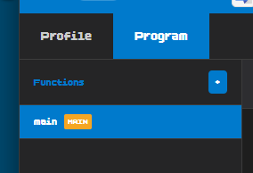
As you progress, you will want to organize your code into reusable functions. In the terminal's left sidebar:
Step 1. Click the + button to add a new function.
Step 2. Enter a unique name. Duplicates are rejected.
Step 3. A new tab opens with a stub: def your_name(): pass
Step 4. Write the function body, then call it from main() or other functions just like you would in Python.
You can delete non-main functions using the trash icon. The main() function cannot be deleted -- it is your entry point.

4.5 Preset Templates
Not sure where to start? The preset menu offers ready-made code templates you can load into the editor:
Template | What It Demonstrates
Basic Movement | Simple directional commands
Plant & Harvest Loop | Farming with while loops and conditionals
Movement Loop | Using for...in range() for repeated movement
Energy Management | Checking energy and refilling at a dynamo
Smart Farming | Combining conditionals, loops, and tile actions
Patrol Pattern | Multi-step movement sequences with functions

Note: Loading a preset replaces your current code. The system asks for confirmation before overwriting.

4.6 Energy Management


Every action Qubit takes costs energy. Moving, mining, planting, harvesting -- they all drain the battery. When energy hits zero, Qubit stops. To refill, move to a dynamo tile and run crank(). Good energy management is itself a programming lesson: plan your routes efficiently.

4.7 Drones

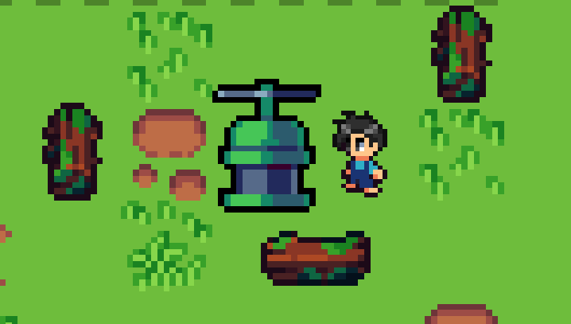
Later in the game, you may encounter drones. Drones are separate programmable entities with their own code windows. When you program a drone, you are editing the drone's functions, not Qubit's. The "Set as Main" option is not available for drones -- they always run their own main function.

5. Saving Your Progress

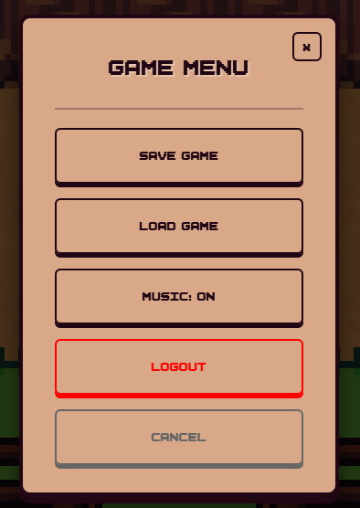
BinaryCoven uses a two-tier save system. During gameplay, your state (position, energy, code, quest progress, inventory) is stored locally in your browser for speed. When you explicitly click Save, everything is synced to the server database. When you click Load, your most recent server-side save is pulled down and restored.
Your quest progress (which phases and objectives you have completed) is also saved to the database and persists across logins. If you close the browser and come back tomorrow, your quests pick up right where you left off.
Tip: Save often. Browser storage can be cleared if you clear your cache. The server save is permanent.

PART II
Instructor / Admin Guide

This section is for instructors and administrators who manage sessions, monitor student progress, and curate learning content through the admin panel.

6. Getting Started

6.1 Logging In
Navigate to /admin/login in your browser. Admin accounts are completely separate from student accounts -- you cannot use a student username to access the admin panel, and vice versa.
There are two admin roles:
Admin -- can manage sessions, view students, and monitor progress.
Super Admin -- everything above, plus the ability to create, edit, and remove other admin accounts.
The system checks your session on every page. If your session expires or you are not authenticated, you are redirected to the login screen.

6.2 The Dashboard

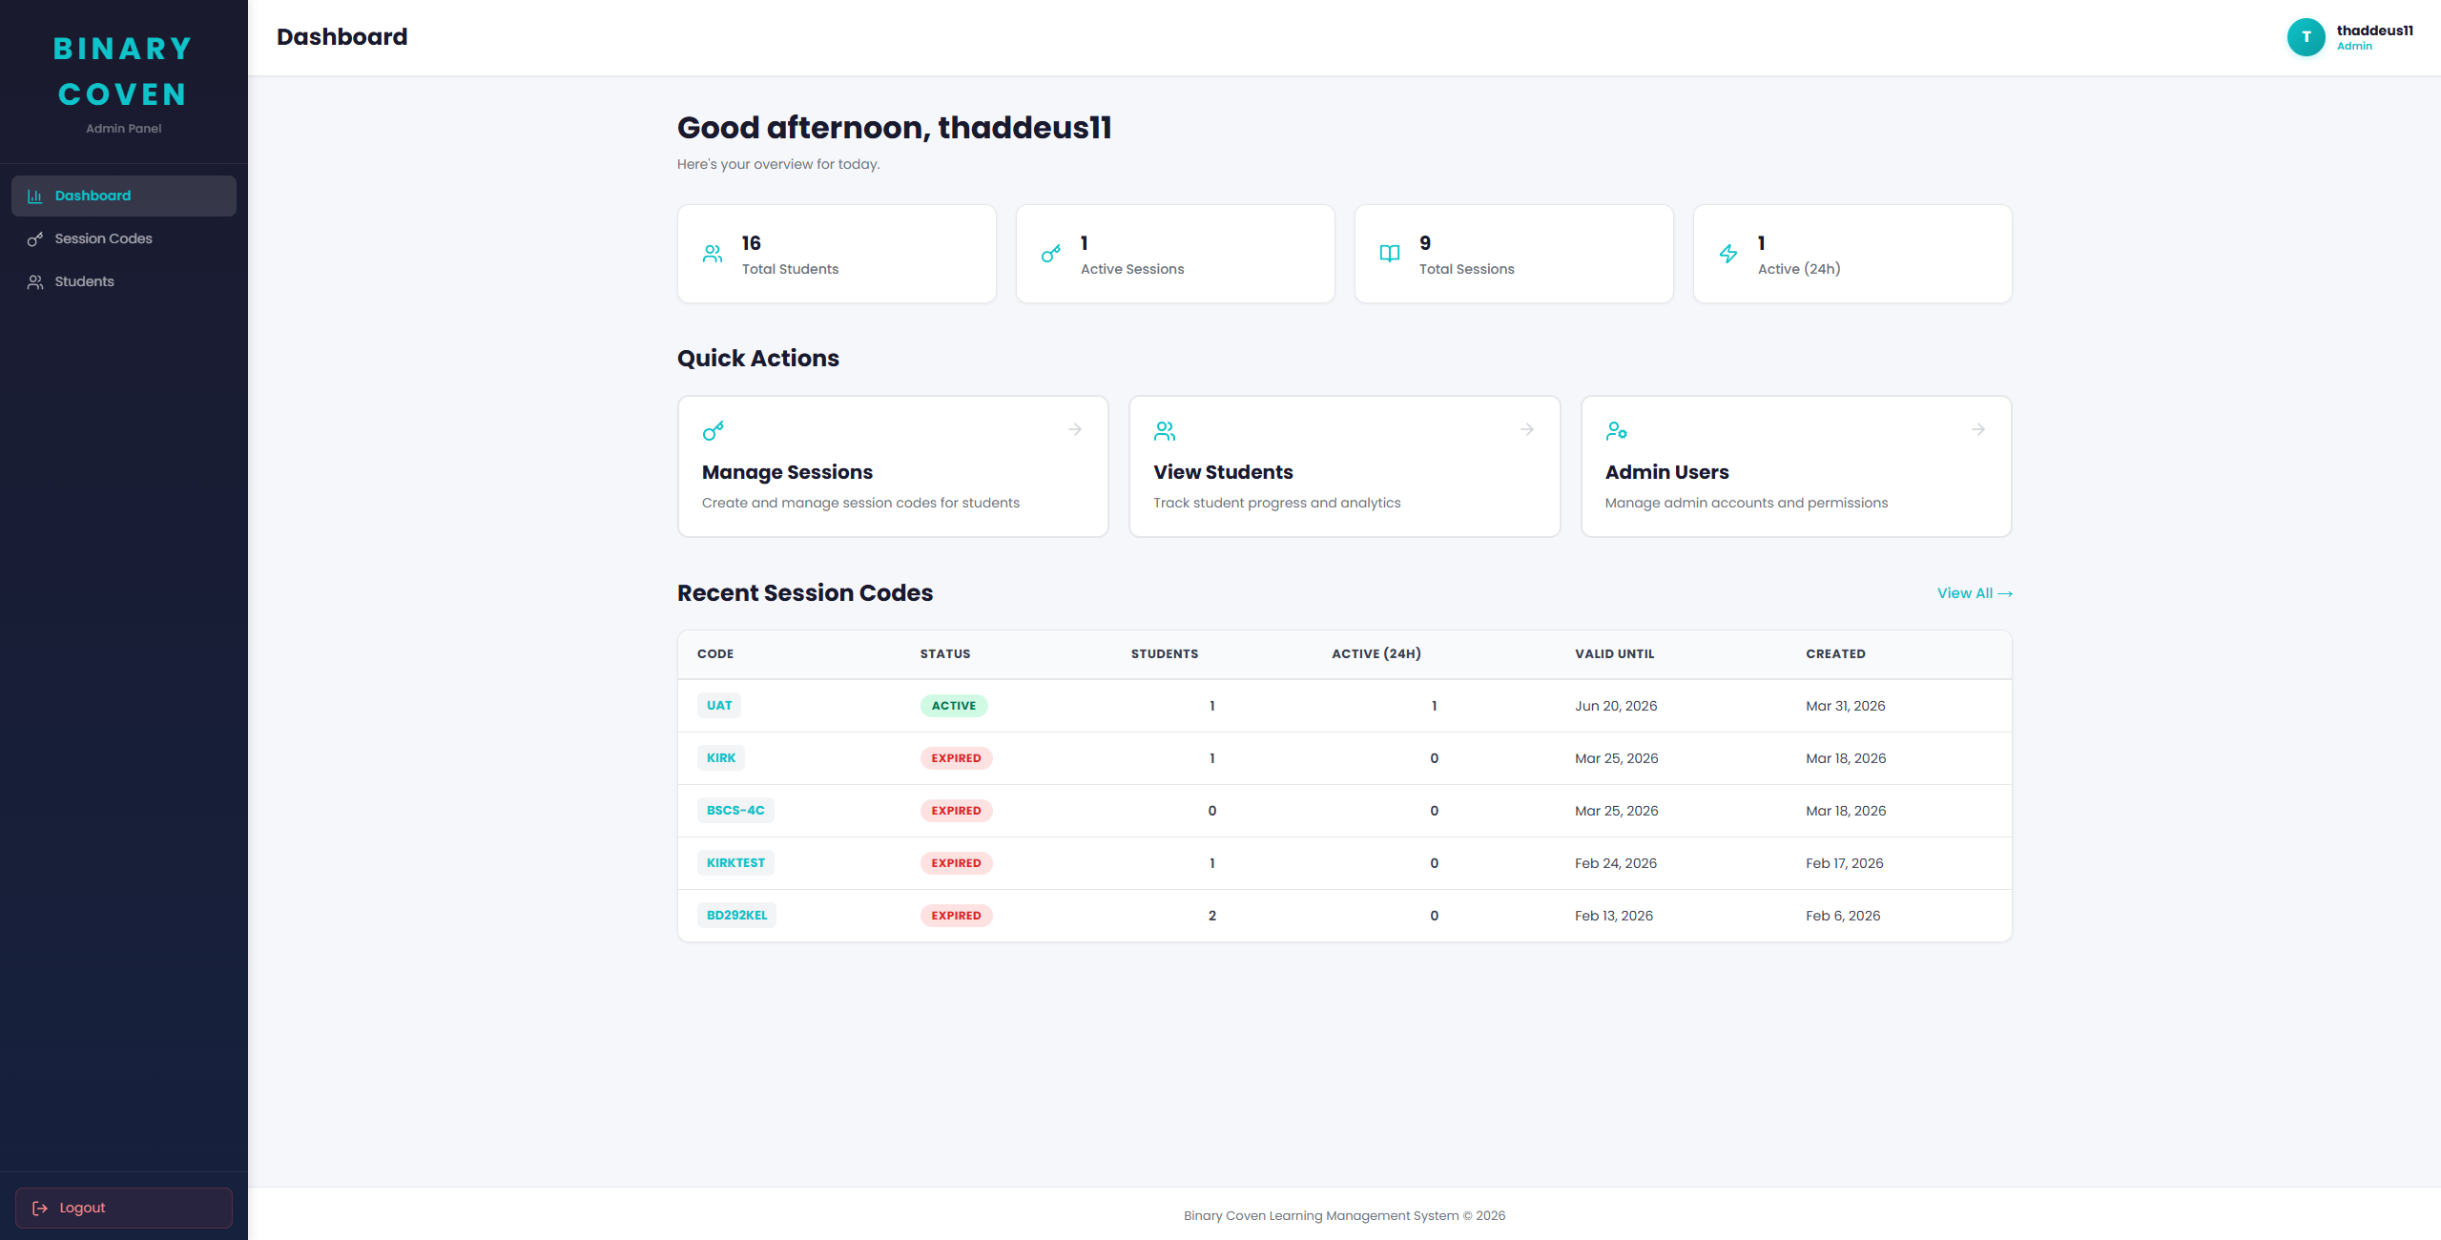
After logging in, you land on the admin dashboard (/admin). Here you will see at a glance:
Metric | Description
Total Students | Number of registered student accounts across all sessions
Active Sessions | Sessions currently within their validity window
Total Sessions | All sessions ever created (active + expired + scheduled)
Recent Activity | Student logins and activity within the last 24 hours

Below the stats, the five most recent sessions are listed with quick links to their detail pages.

7. Managing Sessions

7.1 Creating a Session

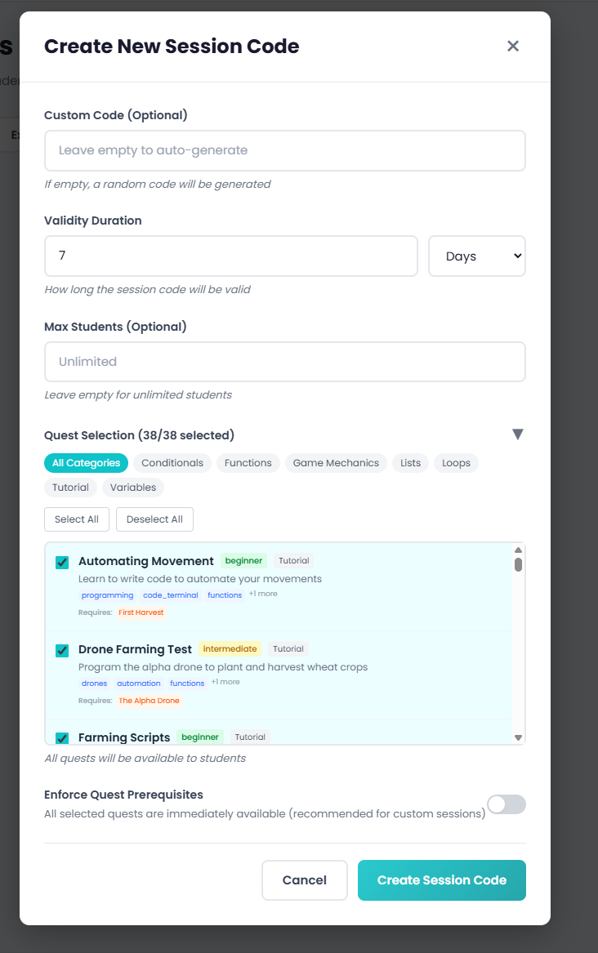
Go to /admin/sessions and click "Create Session." The creation modal asks for:
Step 1. Session Code -- enter a custom code (e.g., "CS101-W3") or leave it blank to auto-generate one.
Step 2. Duration -- set the validity window in hours or days. The default is 7 days.
Step 3. Max Students (optional) -- set a cap on how many students can join. Leave blank for unlimited.
Step 4. Quest Selection -- the system loads all available quests. You can filter by category, use "Select All," or pick individual quests. By default, all quests are selected.
Step 5. Enforce Prerequisites -- toggle this on if you want students to complete prerequisite quests before unlocking dependent ones. Toggle it off to let students attempt any quest in any order.
Tip: For a structured lesson plan, enable prerequisites and select only the quests relevant to this week's topic. Students will progress through them in order.

7.2 Session Lifecycle
Sessions move through the following states:
Status | What It Means
Scheduled | Created but not yet within its validity window. Students cannot join yet.
Active | Within its validity window. Students can join and play.
Expired | Past its validity window. Students can no longer join.
Inactive | Manually deactivated by an admin. Students cannot join.

You can search sessions by code, filter by status, and deactivate sessions from the list view. Each session card shows its code, validity window, student count, recent activity, max capacity, quest count, and status badge.

8. Monitoring Students

8.1 Student List

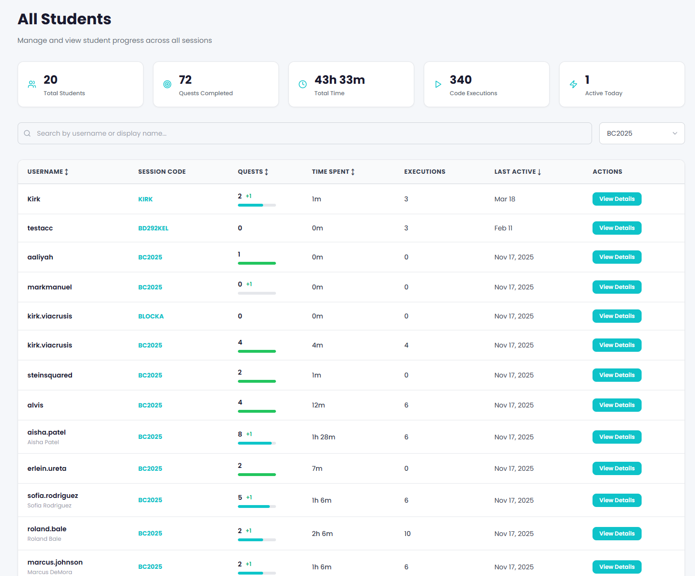
Browse all students at /admin/students, or filter to a specific session at /admin/sessions/[code]/students. The list shows each student's username, linked sessions, and last activity.

8.2 Individual Student View

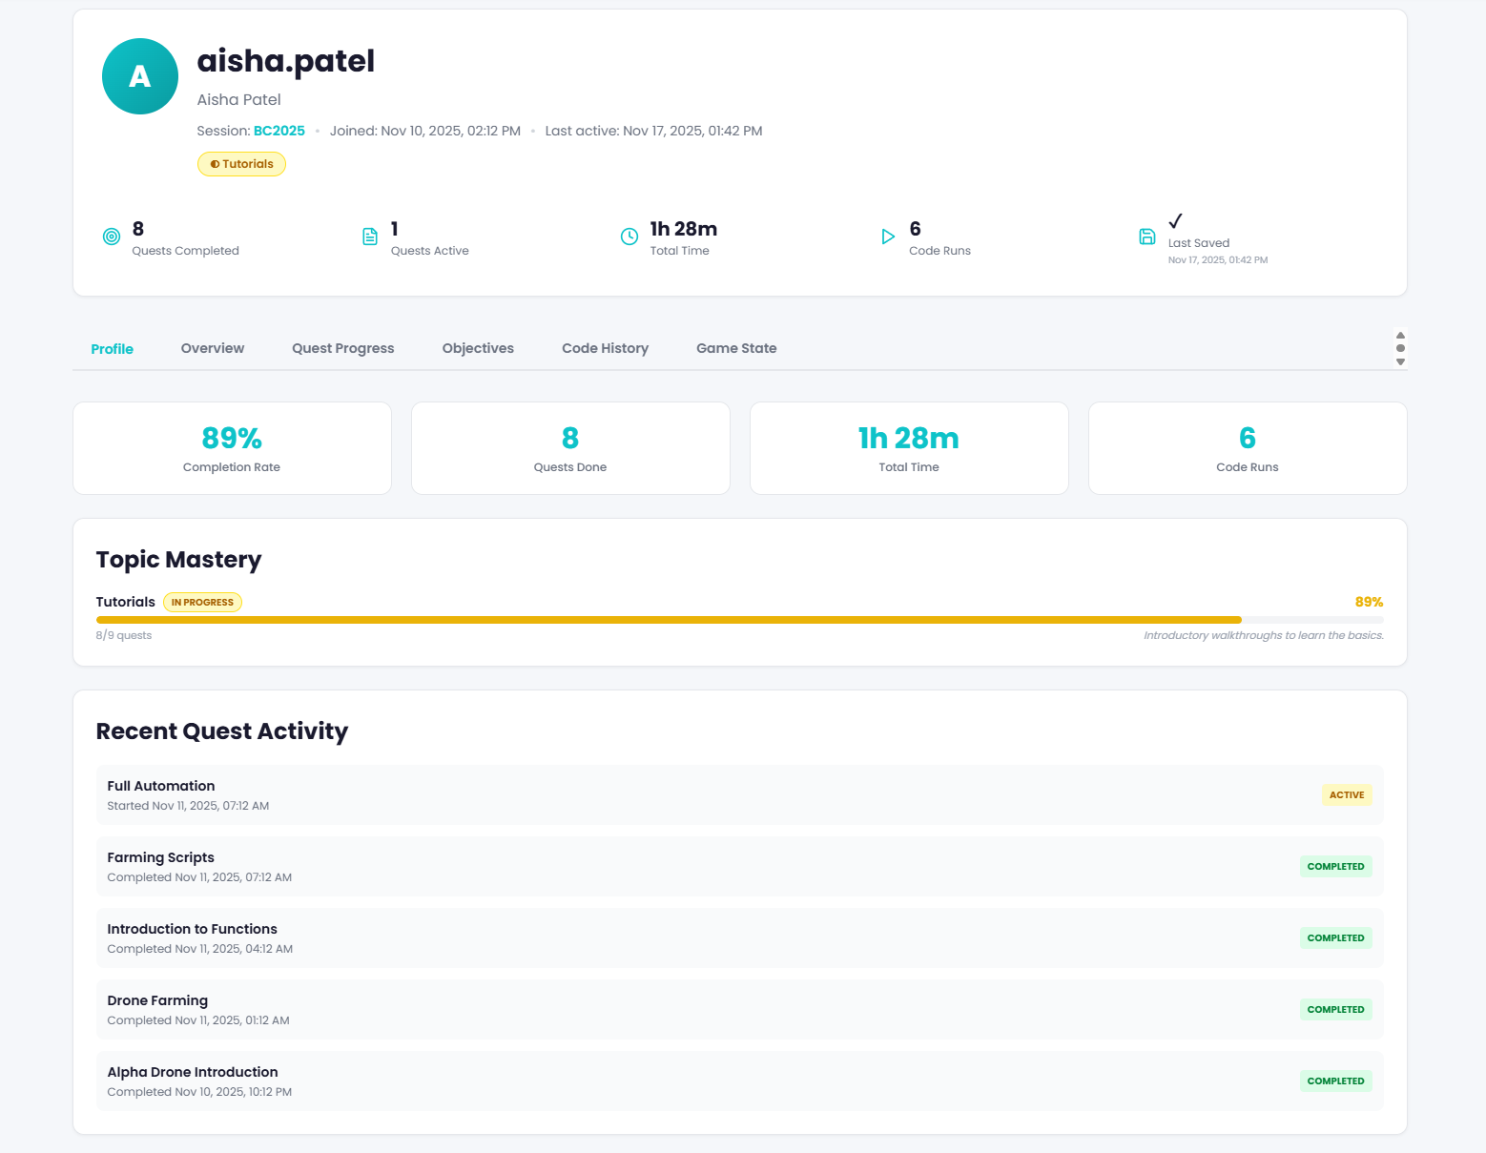
Click on any student to open their detail page (/admin/students/[id]). Here you can see:
Profile -- username, email, linked sessions.
Quest Progress Chart -- a visual breakdown of completed, active, and available quests.
Objective Progress List -- drill into individual phases and objectives to see exactly where the student is stuck.
Game State Viewer -- inspect the student's persisted game state including position, inventory, energy, code windows, and drones.

8.3 Viewing Student Code

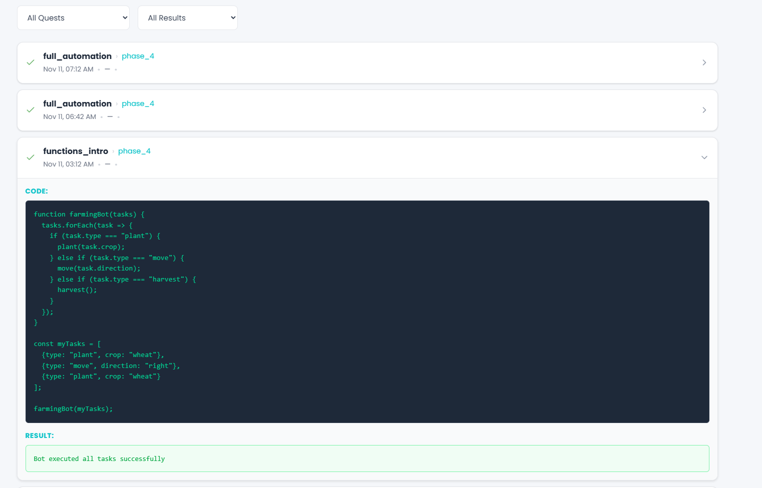
The Code Execution Viewer shows every piece of code a student has run, organized by session. You can review their submissions chronologically, see which quest and phase each submission was associated with, and check whether the execution succeeded or produced an error. This is valuable for identifying common mistakes, understanding student problem-solving approaches, and providing targeted feedback.
Tip: Look at the attempt count on quest objectives. If a student has 15 attempts on one objective, they probably need help. If the class average on a particular quest is high, the quest might need clearer instructions.

9. Admin User Management
This section is only available to Super Admin accounts, accessible at /admin/users.
From this page, you can create new admin accounts, edit existing ones (change passwords, update roles), and remove admin accounts. When creating a new admin, you assign them either the Admin or Super Admin role.
Note: Be thoughtful about Super Admin access. Super Admins can create and delete other admin accounts, including other Super Admins.

10. Quick Reference

Student Commands -- Complete List
Command | Category | Requires Tile
move_up() | Movement | No
move_down() | Movement | No
move_left() | Movement | No
move_right() | Movement | No
move_to(x, y) | Movement | No
get_position() | Utility | No
get_current_grid() | Utility | No
get_energy() | Utility | No
get_inventory() | Utility | No
wait(seconds) | Utility | No
print(...) | Utility | No
mine_initiate() | Tile Action | Mining Terminal
collect() | Tile Action | Mining Terminal
crank() | Tile Action | Dynamo
store(amount) | Tile Action | Wallet
plant() | Tile Action | Farming Plot
harvest() | Tile Action | Farming Plot
can_harvest() | Tile Action | Farming Plot

Admin URL Reference
URL | Purpose
/admin/login | Admin login page
/admin | Dashboard with stats overview
/admin/sessions | Session list, search, create
/admin/students | All students across sessions
/admin/sessions/[code]/students | Students in a specific session
/admin/students/[id] | Individual student detail page
/admin/users | Admin account management (Super Admin only)

