Dear readers, were the fascinating occurrences I describe below a case of SUPER ESP, PK or ITC? I will let you decide.

The incredible story of my jet ring

By chance, a couple of days ago when I was leafing through some folders in my computer, the article below came into my view. I reread it and thought that I would like to share such a fascinating true story with my readers. I published it in the ITC Journal years ago, in issue 46, June 2013.
As a matter of fact, I published two articles about this extraordinary event in the same issue of the ITCJ. The piece underneath was published in the ‘Personal Testimony’ Section.

A moving and different ITC story

Anabela Cardoso

“Except ye see signs and wonders, ye will not believe” - John 4:48
This was so unexpected, so extremely interesting that although I am used to strange occurrences – and the anomalous electronic voices above all – I almost could not believe it! It happened yesterday, June 8, 2013 and I gladly share this lovely personal story with my readers although I will keep names, other than my own, private.
I had been extremely sad and depressed all day because my little female dog Nina, seventeen and a half years old, died a short time, just a few weeks, ago. I know that nobody dies because the voices repeat it over and over again but, unfortunately, that fact does not prevent grief. My day had been bad and the terrible sensation of loss, due to Nina’s absence that I had been feeling since getting out of bed, was aggravated by a rainy, grey and dark atmosphere throughout the day.
In the afternoon I listened to the 6th of June recording of Rio do Tempo’s voices and, as usual, the voices greatly cheered me up. A loud masculine voice had identified itself as my father’s, as it happens often. The effect the voices can have on us is unsurpassed. A voice yelling from the radio “This is your father João Cardoso speaking”, in reply to my direct call for identification of the speaker, can dramatically change our state of mind even if we are used to these extraordinary experiences. But as I became progressively happier and more relaxed, I was far from knowing that the day would finish on an even brighter note.
Searching randomly for a different file in my computer, I saw two jpg images labelled “Yoga” in ‘My Documents’ folder. I knew what they were because they had been sent to me December last, but exactly because they are a cheerful remembrance of a nice time spent with my Yoga companions at the Yoga class I used to attend, I opened the files. I had seen them when I received them in an e-mail from my Yoga friend who had taken them but it had been during a very busy time and I only looked at them without much attention and saved them to my computer.
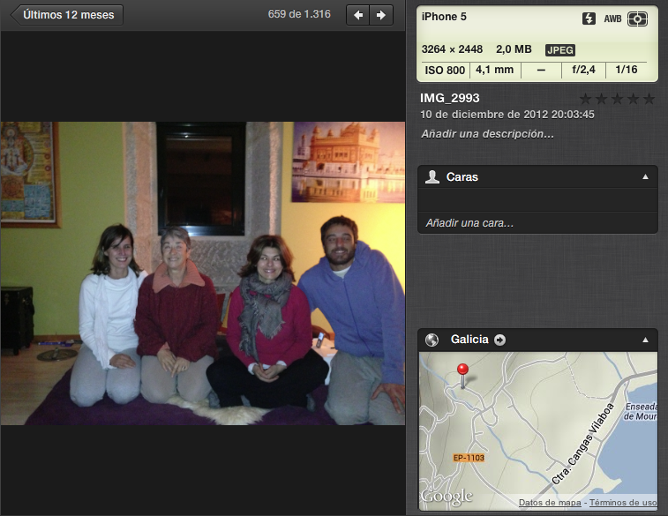
The colour photo taken by my Yoga colleague Jose Ramon on an iPhone 5 in December 2012
But yesterday, when I opened the images again I looked at the photos more attentively. And then to my great surprise, I saw a ring on a finger of my left hand! I was stunned because it has been years since I have worn a ring. Even when I was married for a number of years I never wore a ring. I like to work in the garden, play with the dogs, bring wood in for the fire and so on and a ring can become a nuisance.
These photographs were taken with an iPhone 5 and are not so sharp because it was at night after we finished the class. But the ring is unmistakable and very visible especially in the close-up photo; there is a ring on the third finger of my left hand which I was not wearing! A ring I have not worn for years.
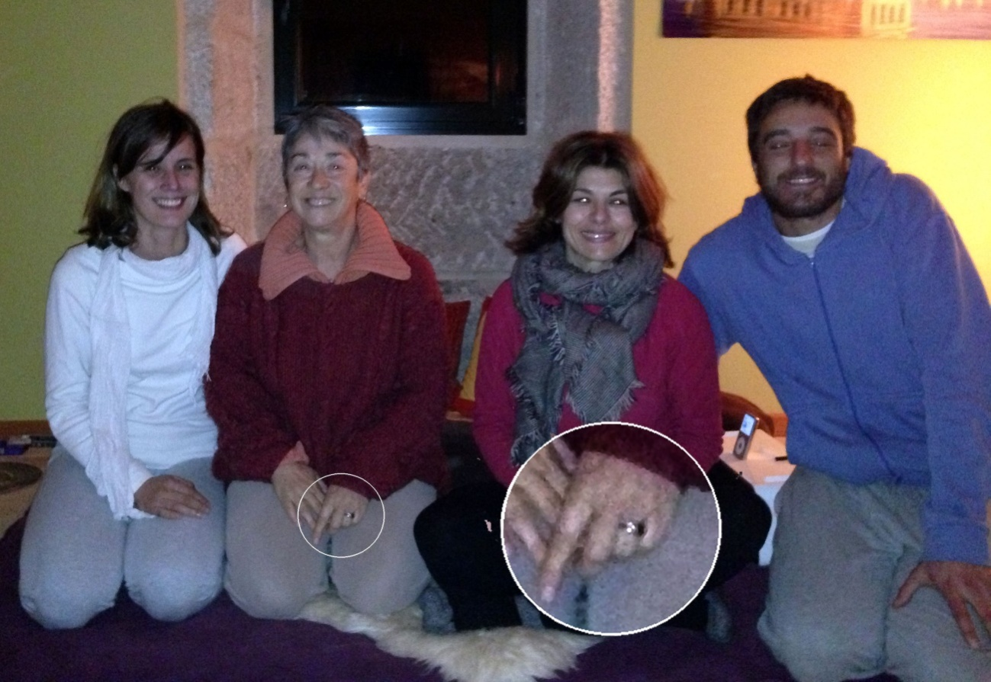
The original photo with the detail of the hand inserted
The few pieces of jewellery I possess are in a safe at the Bank because in the difficult times of delinquency we are doomed to live in it makes me feel more secure not to have them with me. Besides, I am a person who never really liked to wear jewellery although, as I said, I own a few beautiful pieces.
Presently I have only that one ring at home which, as I said above, I have not worn for several years. This ring was a gift to me from someone very dear whom I lost a few years ago. Because it was bought in Santiago de Compostela it is of gold and silver in the antique style with a mounted black stone called ‘azabache’ emblematic of this city. Since my beloved friend died I have not worn the ring, which I keep in a box somewhere in a drawer. When I looked more attentively at the photo and enlarged the area where the ring is on my finger, it became obvious that the ring on my hand, which I was not wearing, is the very ring that I have just described. I had difficulty in finding it because I didn’t know exactly where I had kept it but finally did find it, compared it to the photo, and it looks the same- the very unusual ring that my beloved deceased friend gave me a number of years ago.
I think this is a truly remarkable event which I treasure even more because almost every day I turn my radios on, since his death, I ask my communicators, as well as my greatly missed friend, to send me a message from, or about, him. Until this day nothing came directly from him, only a few short comments from my communicators about the possibility of further information in the future. Seeing the ring in the photo for the first time on a day when my little Nina’s loss was so dramatically poignant, made me rejoice and, suddenly, all was well again. I say “seeing the ring in the photo for the first time” because I cannot guarantee that it was there when I first received the photo as an email attachment. Maybe it was or maybe it was not. For lack of time, I did not check the photo in detail as I did yesterday.
Also incredible, in the scope of signs, symbols and meaningful coincidences, which is the field associated with my story, is what happened today, June 11, three days later when I received my text back from our dear friend Ann Harrison who carefully checks the English in all the papers before they are sent out to the printers. It came to my mind to check the spelling of the word ‘azabache’, of which I was not sure because I am not Spanish and do not know the word, having heard it only in the shop pronounced by the man who sold my friend the ring.
And thus I went into Google to search for it. I confirmed the spelling, the translation ‘jet’ and found the description below about it.
“Healing Properties:
Mystically, jet is considered a stone of sympathy, as it will provide great support and help alleviate the pain and suffering associated by separation of the death of a loved one.”
http://www.shimmerlings.com/gemstones/jet.htm
Nothing could have been more pertinent! I thank life for these extraordinary contacts and sincerely wish everybody could experience them because they completely change our perspective. The impossible becomes reality and although we do not know how, as with the electronic voices, it does not really matter!
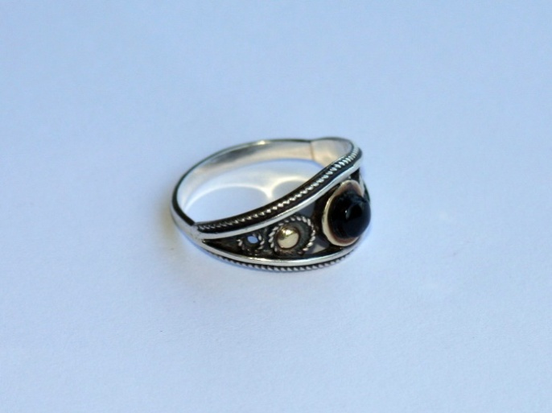
The ‘azabache’ ring

Note: I am certainly aware of the fact that more sceptical readers will think, for example, ‘well she forgot that she was wearing the ring’ and so on. Above I have given the details of this incredible story. Only I and my housemaid, who always sees me off to the Yoga classes and knows exactly what I wear on those days, know for certain that I was not wearing the ring. There is nothing else I can add except perhaps that, since it all happened, I am again wearing the ring…

And the story continues…
The other article published in the same issue of the ITCJ was my editorial and it reads:
The first issue of the ITC Journal for the year 2013 will be more varied in content than our journals usually are and this is because besides the ITC papers, in this issue we publish on a wide variety of topics. I must say that I find this number 46 very interesting and wish to acknowledge the valuable contributions of our dear collaborators and thank them for their help and important work. A number of difficult translations were done by Yanis Arencibia and, from the German, one by Prof Uwe Hartmann. I would like to especially show our appreciation to Professor Ernst Senkowski, who is always available and happy to put his research and respective articles at the disposal of the Journal and his materials and experiences are truly irreplaceable.
One of the most amazing experiences I have lived through since I started receiving the Direct Radio Voices in 1998 is described in this issue. This story is told in the paper published in the Testimony section under the title ‘A moving and different ITC story’ but I would like to add a few observations about what happened and describe some significant coincidences related to this case.
The last time I saw my beloved friend, who gave me the jet ring, in person, was in England. We were together at several events and finally said good-bye at Paddington Station in London where I took the train to Heathrow Airport. I was in England for a few days and surprisingly all the clothes I took with me for this trip were black. I have no idea why I chose them; they were randomly picked up. There was only one exception- a short summer dress with green and black figures that I wore with black pants.
Black, as my readers certainly know, is the colour of mourning in many places in the world. When we had to depart, at the Station, I felt extremely moved and could not stop crying for no precise reason. The whole thing looked so dramatic –my friend standing still on the platform while the train moved away and I, all dressed in black, my eyes red and swollen, waving my hand until I could no longer see him. While I looked back at him on the platform a strange feeling that I would not see him again invaded me and a recurrent idea came into my head which said “this (departure) is a good-bye”. It was not a certainty of course, just a presentiment. And I also felt a kind of constriction in my solar plexus.
But my friend was not ill or anything like that then. Time passed and I forgot about it. When rather unexpectedly he died, suddenly the whole scene came to my mind and I thought how extraordinary it was that I had taken with me black clothes for that trip and had felt such intense and sad feelings at Paddington. It was the first time that I had chosen all black clothes for travelling. Never before had I taken only black clothes on a trip. Moreover, although I have coloured my hair very seldom throughout my life, I had been to the hairdresser’s shortly before the trip and had asked her to dissimulate some patches of grey with the colour of my natural hair, auburn chestnut. She did but for some unknown reason, certainly a miscalculation on her part (the first ever in my experience of her work), she coloured my grey patches with such dark brown tint that it looked more like black than brown. I disliked it but there was no remedy.
When Nina recently died I felt so extremely depressed that I feared I would enter a real pathological depression. I could not stop crying and nothing alleviated my sorrow. After all she had an important role in my life for almost twenty years and the last couple of years, when she became deaf and practically blind, she needed full-time attention. She was the permanent centre of my worries and of my thoughts. When suddenly she was no longer around, I felt as if a piece of flesh had been ripped from my chest. And to those who are reading this and think that the love one feels for a non-human, animal, companion must be different and less intense than the love one feels for a human one, I will say that they are certainly wrong. I have truly loved a few people in my life. Some of them intensely and a couple of others passionately but I have never felt such tender and delicate love, such total love, as the love I felt (and still feel) for some of my non-human companions. Love is a state of the soul. It knows no boundaries, no differences of gender, species or any other. Love should not be appraised, measured or quantified. Such things do not pertain to its essential nature. You either feel it or you don’t and when you really feel it you know what it is.
Going back to our story. It was under these, for me, heart-breaking circumstances that the ring appeared on my finger in the Yoga photo taken in December last. Although I often think of him, I was not particularly thinking of my deceased friend during these days of grief for Nina. But the ring he gave me has a black stone, jet, and that stone is supposed to “…alleviate the pain and suffering associated by separation of the death of a loved one”! What could be more pertinent? I must confess that when my friend bought me the ring many years ago, I found the black stone, the meaning of which I had no clue at, a bit sombre although I was the one who chose it. And I chose it because in the shop we went to there was only jet jewellery, and the ring is beautiful. I didn’t want to say that I found the black stone a bit depressing. Besides, practically all the shops in Santiago de Compostela sell that same jewellery as it is typical of the city.
I was far from knowing then that the jet ring would be involved years later in such extraordinary happening. Another British friend of mine, himself a knowledgeable psychical researcher, said when he read the draft of my testimony: “Until now, I have only read about such instances; this is the first time I have also seen the photographic proof. It is absolutely remarkable and I am so pleased you have been chosen for this ‘communication’….”.
But still another highly meaningful coincidence happened two or three days ago, on June 18th. I received from a Spanish friend, who has no idea of this story because I have not told him anything, as the story is not yet published and anyway he does not understand English, a beautiful Power Point presentation, one of those the Internet is always flooding us with, this time about the fourth finger (in English known as the third finger but in Europe the fourth finger of the hand), also called in Europe ‘the ring finger’.
In the scope of my testimony, Ann Harrison and I had been discussing precisely the terminology used for this finger in Great Britain and the rest of Europe the day before. It was a real beautiful presentation with the title: “A Chinese Legend: Do you know why the engagement ring is worn on the fourth finger?” it said, and exemplified through an ingenious and intricate photographic design, that the fourth finger, the ring finger, is the only finger in the hand that is inseparable from the same finger in the other hand because the fourth finger is the one that represents the partners for life! Of all the many Power Point presentations I have received (from this and other friends) this was the only one about the fourth finger and the inseparability that comes with it.
The Power Point presentation ends with: “A true friend is the one that stretches out his hand and touches your heart.” What can I say? I was stunned. It seemed another remarkable coincidence, one of those that Jung called synchronicities. But what are these coincidences? Do they really carry a special meaning? And here comes the difficult issue. Subjectively of course they do. That is unquestionable but in themselves they carry no meaning at all. This is what sceptics will argue.
But we can make an exercise of dialectics and analyse the ring that I was not wearing and appeared in the photo, my grief because of Nina’s death and the Power Point presentation which I received while all this was going on. Firstly, the ring – the photo was taken by a Yoga colleague whom I do not know well because I only know him from the Yoga classes. He decided to take photos that evening for no apparent reason. A few days later he sent us all the two photos he had taken and I did not see the ring in my hand but I did not look very attentively.
Thus, we may ask another question: was the ring in the photo when I received it and did not see it or was it not? The screen capture that my friend sent me, at my request, in June, when I was writing the report for the ITC Journal after noticing the ring which I was not wearing, also shows the ring. But the screen capture was taken on June 10th, 2013 not in December 2012. The ring was certainly visible when I needed to see it and next read the message about the meaning of jet, i.e. for alleviating the pain associated with grief. I could have taken the apparition of the ring on my hand as a sign from my deceased friend whom I have tried unsuccessfully to contact and actually I did take it as such.
I must say that my friend knew Nina very well. So seeing that ring, which I was not wearing, on my hand in the photo would convey several messages to me – firstly that my deceased friend knew exactly what was going on and that he was with me in my sorrow. But it would also tell me that they (the deceased) are able to make things like these happen, as they do with the electronic voices and that I should not worry because for some, to us, unknown reason he could not speak to me through ITC.
In the field of parapsychology my deceased friend had great interest in ITC but his main interest had been the physical phenomena associated with mediumship. This occurrence seems to associate both disciplines with predominance for ITC. If we analyse the events in this marvellous story, we will see that the ring which appeared in the photo is the only objective evidence of the anomalies in this case. All the other episodes – the jet stone and the fact that I randomly picked up a website that describes the mystical properties of jet to alleviate grief in a period when I am suffering the pain of Nina’s passing and the email about the ‘ring finger’ I received from my Spanish friend Tino – are highly meaningful coincidences, albeit meaningful for me when put together on a certain special occasion, but not meaningful by themselves.
Certainly I could also interpret Tino’s email as carrying a special message of love from my deceased friend about the meaning of the ring he offered me. But we cannot be sure of anything except that the ring which I was not wearing appeared in a photo I did not take. Nevertheless, the only real proof of this lies in my testimony. I am no parapsychologist and, therefore, I will not be able to debate the pros and cons of the PK hypothesis, so much beloved of parapsychologists, adequately.
But we can recap on what happened. As I said I did not take the photo, the person who took it knows nothing of this story and the photo was taken six months before the events took place. Under these circumstances, could I unconsciously have provoked through PK the whole set of amazing occurrences of this story? It seems highly unlikely to say the least although I know that some of those obstinate parapsychologists, who so much like the SUPER ESP and PK explanation, will say that it is possible.
From my side I would say that perhaps it is theoretically possible but totally unverifiable and much more abstruse than the survival hypothesis, which has a good background of evidence built throughout the centuries behind it. Anyhow, this seems an excellent case for further study. As Professor Hans Bender is quoted as saying, “…. [we] will have to face the difficulty that the phenomena apparently elude a critical grasp. The impression almost suggests that the intelligent forces mock the observer and produce a phenomenon just there where one cannot get hold of it” (Bender, 1979; Cardoso 2012).
What a real pity! But perhaps this is the price we must pay for being the recipients of such extraordinary contacts. And while they cannot be fully grasped by our minds, they undoubtedly touch our hearts and change our lives. Maybe this is all that matters.

References: Bender H. Die Gleichförmigkeit von "Spuk"-Mustern in: ZeitschriftfürParapsychologie und Grenzgebiete der Psychologie 1979; 21: 133-139.
Cardoso, A. (2012). A two-year investigation of the allegedly anomalous Electronic Voices or EVP. NeuroQuantology | September 2012 | Volume 10 | Issue 3 | Page 492-514.

Ann Harrison is the Production Editor of the ITC Journal.
Note: the website I quoted in my article no longer exists. This is the current one that says practically the same thing: https://www.healing-crystals-for-you.com/jet-stone.html

