The soul of the cat
Anabela Cardoso

I found the photo below by chance, while looking at postings on my Facebook account. It jumped to my screen for a brief moment and it disappeared. Surprised but not very sure of what I had seen and what it was about, I searched and found it again.

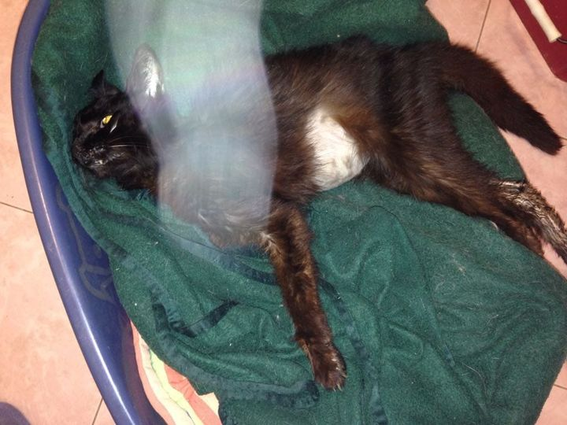

Now, I could see the image properly and that’s when it really struck me. I read the caption underneath and it said that the photo was of Oscar, the cat, at the moment of his death.
I was flabbergasted because it seemed that something was coming out of the little cat’s dead body, something like a cloud or vapour, a misty energy in any case.
Underneath the photo its author had written (translation from the Italian text on Facebook):
Rosanna Capozzi
September 1, 2021 12.52PM
Good morning everyone...this is a photo just taken when my black cat died at the age of 17...the white spot is his companion (a female white cat in fact) who passed away a month earlier who came to pick him up to accompany him. I think it's the sweetest scene I've seen...I took the photo with a normal cell phone…
Rosanna mentioned the “white spot” that can be seen on the photo. But I didn’t share her opinion about the content of the photograph. I was puzzled and suddenly, information I had seen many years ago about a French Professor who had photographed his wife’s, his son’s and several little animals’ dead bodies came to my mind. I even remembered his name - it was Dr Hippolyte Baraduc!
A respected scientist with a remarkable career, Dr Baraduc claimed that the vapour, a kind of misty cloud leaving their bodies, which appeared on his photos taken shortly after death, was the soul or spirit, in any case the vital energy that sustains life.
That energy, called Prana (Sankskrit for breath) in Ayurveda ancient traditions or Qi in Chinese teachings, is considered by many the universal life force.
I am not a specialist in Oriental wisdom but it is not necessary to be one to notice the difference between a dead and a living body… Something is missing in that dead body, there is no doubt about it. And this is what Dr Baraduc claimed that he could photograph.
Mainstream scientists dismissed his claims but they couldn't rule him out because, after all, he was not an esoteric dreamer with scientific aspirations as some would like to imply. On the other hand, he was a talented, respected, prestigious scientist with a great career. He was an accepted member of the famous Salpêtriêre Hospital staff, and his photographic experiments were not a secondary parascientific activity but a constant continuation of his medical practice.

My quest to investigate further about the dead cat’s photograph
My surprise and excitement were such that I turned Facebook upside down to find out more about such extraordinary, unusual testimony, one that I had never seen before except in Dr Baraduc’s chronicles a long time ago.
By chance, I found out that the owner of the dead cat, Rosanna, was a friend of a dear friend of mine, Lorenza Aimone, also a successful ITC experimenter and, through the latter, I got in contact with her. Rosanna reiterated her impressions to my friend Renza, although I told her that I didn’t share her opinion about what was visible on the photo. Rosanna and Lorenza live in Turin and my friend told me that Rosanna is a sensitive who has had anomalous experiences since childhood.
When I asked her, via my friend, for more details and the reason why she had taken the photo, she replied in an email to Lorenza, which I translate below;
Renza’s email about the black cat 7/02/2024:
“Here I am with what I learned. The photo is not recent but Rosanna published it on FB three years ago even if in reality it dates back to 2016 and the one published now is that of a "memory" that FB occasionally suggests republishing. At the time she also had unpleasant comments such as that the photo was manipulated or that she was disgusted to see the dead cat.
Anyway, here are the answers to your [my] questions:
The cat's name is Oscar
The date of death dates back to the beginning of October 2016 (she doesn't remember the exact day)
Time of death approximately 5pm
Age and illness 17 years old pancreatitis
The photo was taken 5/10 minutes after death to be sent to the vet who was treating him
Photo taken at home without artificial light
Via a Samsung phone without flash
Given her assumption, she also communicates the name of the little white cat who was called Mila and who died in August, again in 2016.
The photo exists only in this format and she guarantees that there has been no manipulation of any kind.” (translation from the Italian).
In another email of the same day and in reply to still another
question from me, my friend told me: “Meanwhile, I asked her and she told me that the vet was very impressed by the photo, it seemed incredible to him and he could see it well, also. However, she had given him her version, that is, the little white female cat who had come to pick up her partner.”
I don't have the address or contact of the vet but I'm sure the information could be easily obtained.
Rosanna was very kind and easily agreed when I asked her permission to write an article about the occurrence.

The concept of soul
Because I called this testimony The Soul of the Cat, I wish to explain what I mean by “Soul” before continuing with the story.

We all know that there is a fundamental difference between a dead body and a living body. However, to my knowledge, science has not yet satisfactorily defined what makes the difference, at least by isolating it and giving it a name. There is no proper and universal definition of what we are dealing with, the energy, the element that produces the change between a living and a dead body. Science knows some of the reasons why the living body stops living and becomes dead but that’s all.
From my side, when I use the word “soul” speaking of humans, other animals and plants, perhaps minerals also but I don't know enough about their vitality to include them in the list, I mean the life force or life energy if that's what we want to call it, the Prana of ancient times. I think this is an important clarification because soul is a dangerous word. More often than not, it is used as an anthropomorphic concept with religious connotations. Yet, it is nothing of the sort. This was invented by different religions and appropriated by humans.
Soul is the non-material essence of a living being as Wikipedia puts it. The energy, whatever that energy is that maintains a body alive. Others call it spirit although the word has also religious implications which are undesirable because they diminish and distort the scope of the term.
When I say soul, I usually mean organic life but I believe that inorganic life, such as minerals, must have a correspondent principle which I don’t know about. I could also say consciousness instead of soul or spirit. Consciousness must be a field that pervades all the universes. And we are all part of it.
Professor Sir Jagadish Chandra Bose - India’s first modern biologist, who departed boldly from mainstream botany by claiming that plants possess “nerves” and “pulsating cells” that function respectively much like the nerve and heart cells of animals - studied and investigated also metals (J.C. Bose, 1902). Naturally, minerals will respond according to their own nature not according to the nature of biological organisms. And we know so very little about their true nature…
But as the Indian genius put it, “We are at one both in the East and in the West for the spread of knowledge and the removal of ignorance. We shall pass away, nations will disappear; Truth alone will survive, for it is beyond the reach of time and is eternal.” (Bose, 1920).
In more recent times, Professor Stefano Mancuso, a renowned vegetal neurobiologist, Director of the International Laboratory of Plant Neurobiology (LINV) in Florence, Italy, a founder of the International Society for Plant Signalling and Behaviour, experimentally proved the complexity of plant life and sensitivity. His world famous book, Brilliant Green: The Surprising History and Science of Plant Intelligence revolutionized the paradigm in relation to the understanding of plant life.
But we have also information originated in the higher spheres of life that we should take into account. In my book Electronic Contact with the Dead (2017, pp 18-19), I quote some of the extraordinary anomalous computer texts received by Adolf Homes in Germany on the subject we are discussing:
“... All that lives, and everything lives, is part of creation. Concepts live, the dead live, computers live, everything lives. Every life is fulfilled through transformation. Every life in the worlds, even the most diverse, searches [for] unlimited perfection ...”
And specifically about minerals: “... Every life – animal, plant, mineral, and all kinds of coarse matter as well as subtle matter – consists solely and absolutely of information.” (Senkowski, 1999, German orig. p. 49; Italian translation p. 132).
Interestingly, the same superior beings avowed about the different
forms of life: “.... we do not need your electromagnetic technique
to switch your instruments on because silicon, nerve cell and consciousness are absolutely the same thing for us...” (Senkowski, ibid, German original p. 19; Italian translation p. 40, 1999).
And, again on page 38 of the original and 61 of the Italian edition,
“Our request to you is that of identifying yourselves with your planet and all life in it because everything of you is formed of identical elementary particles. To us silicon, nerve cell and consciousness are absolutely identical...”
From their side, my Rio do Tempo communicators told me “All beings in the world are conscious” when I asked them about plant consciousness.

Going back to our story
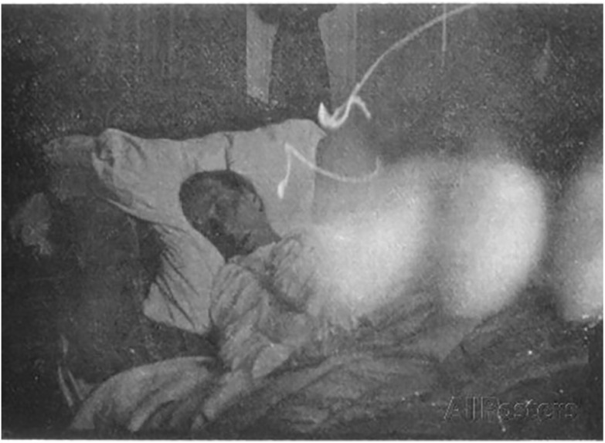
The photo above is a copy of Dr Baraduc’s photograph of his wife’s body a few minutes after death.
Apparently, the soul or spirit leaving the body is what Dr Baraduc, a scientist of excellence, captured on camera. And it very much resembles what the owner of Oscar, the cat, captured with her mobile phone at the moment of his death.

The little cloud leaving the body witnessed by my cleaning woman
Perhaps there are similar stories to the one I heard many years ago when I lived near Lisbon in my house and property where I founded Abrigo, Associação de Proteção à Fauna e à Flora, https://abrigoassociacao.pt/en/ an organization for the protection of animals.
A lady who used to come to my house to clean, Maria Zulmira, told me that the day her mother died she was outside of their modest house in the country when, suddenly, she saw a little whitish cloud come out of her mother’s bedroom window. Surprised, she went inside and asked how the mother was. Tearful, her brother came out of the bedroom and told her that the mother had just died. Very upset, she thought that the mist she had seen coming out of the bedroom window was perhaps related to her mother’s death.
We continued talking and she confessed, “I think that I saw my mother’s soul going away…” When I asked her what the cloud looked like, she replied that it looked like a little transparent cloud, a kind of mist. That was all.

Other scientists developed the same concept
In the 19th century other scientists defended the concept of a vital force that animates all beings.
Baron Carl von Reichenbach, a renowned scientist of his time, was
the proponent of a force, a supposed field of energy combining electricity, magnetism and heat, emanating from all living things, which he called the Odic force.[
He described the Odic force (also called Od) as a hypothetical vital energy or vital force that became popular in the mid-19th century. The name was coined by him in 1845 in reference to the Germanic god Odin.
Others promoted similar discoveries in different historical times, the latest and most advanced being the brilliant Wilhelm Reich and his “0rgone”. As it had happened with his peers, his discovery was labelled by mainstream science as “a pseudoscientific concept variously described as an esoteric energy or a hypothetical universal life force.” However, his claims were validated through several successful experiments that he carried out. And impressive opinions and evaluations of his work were also published against the grain. I transcribe one of those.
From Joseph Nazzaro Ph.D., former President at NewTech Hardware (1984–1996):
“…. Like Tesla he was able to harness energy. His Orgone accumulator sits abandoned by Lake Rangely.
His reputation has been maligned. He was persecuted by the FDA. His books may have the distinction of being the only ones burned by the government.
it’s said that his work was destroyed and he was maligned because it focused on human sexuality and the orgasm using his Orgone box. Rather, it may have been because of his ability to harness cosmic energy and his investigation of this energy.
It is known that our bodies are energy fields. When those energy fields depart our perfect body, no matter how perfect our body is, it is dead. We are not just affected by the energy fields which surround our bodies, we are part of them. These fields always have a biological and psychological impact on us, as does the rest of our physical world. It’s highly likely that Reich found a way to manipulate these fields. It seems that his manipulation provided health benefits. Investigation of the causation of the mechanism has been halted. How sexual energy and the Human orgasm fits into this cosmological field of energy is fascinating” (Quora, Was Wilhelm Reich’s Orgone Generator a hoax?).
For Reich the Orgone energy has a sexual basis and it is present everywhere in the universe. He called it the creative force of life which is diminished in diseased organisms. Regrettably, both Nazis and the American authorities burned his books and equipment. He was the victim of persecution at many scientific levels. After several successful experiences and few not so successful, he was arrested by U. S. authorities and died miserably in jail.
Actually, I and other ITC operators are live witnesses of the energy depletion we feel after an ITC session. In my case, and since I can remember in my adult life, I never felt so debilitated as after having had Covid-19. In result of this, I could not experiment with ITC (Instrumental Transcommunication) for a long time and the mere idea of carrying out an experiment made me unwell.
Some ITC communicators of a higher level who spoke to us from another dimension, are adamant in this respect. In Luxembourg, the famous operators, Maggy and Jules Harsch-Fischbach, asked Timestream what kind of energy they worked with and Swejen Salter, presumably a deceased scientist of another physical world and one of the most active members at Timestream station replied: “We work with Orgone energy. Ask Professor Senkowski to explain it to you. We use also ‘energy residues’ but they are pure positive energies deprived of human influences”.
At Adolf Homes’ the communicators referred to ‘Od energy’ – the
life force experimented with and demonstrated by Baron Carl von Reichenbach, very similar to Reich’s Orgone energy, as we saw above.
Below are excerpts of what they informed.
At Homes’: “...The contact connections can be prevented by a too feeble radiating energy on the part of those who receive them. You call it force of Od. As you know, the totality of the human body possesses an energy, which you understand as electrophysiological energy. During a transcontact we influence the physical fields known to you using the following energies and their respective fields: unstable electrostatic – electrophysiology – mystical – radar – telepathy. Your measurements of them are not correct. The radar energy has nothing to do with yours.
In regard to tachyons, we are dealing with pure forms of energy ...”
(Senkowski, Transkommunikation, Special issue, Vol. IV, Sonderheft
1999, Italian translation pp. 26 and 43 respectively; Cardoso, 2017, pp 25-26).

Dr Baraduc’s followers
Much later, in the scope of advanced Kirlian research, a prestigious Russian scientist with an impressive curriculum, Dr Konstantin Korotkov, Professor at the St. Petersburg Federal University of Informational Technologies, Optics, and Mechanics, created a very interesting method. He developed a technique called "gas discharge visualization".
Korotkov's GDV camera system consists of hardware and software to directly record, process and interpret GDV images with a computer. Professor Korotkov claimed to have photographed the soul leaving the body at the moment of death.
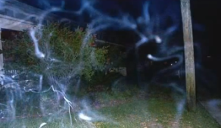
The image taken using the gas discharge visualization method, an advanced technique of Kirlian photography shows in blue the life force (in this case of a person) leaving the body gradually. The scientist captured the image with a bioelectrographic camera.
The electrical component in these experiments reminded me of the sensation I had when my beloved female dog Michi died. I wrote: “When one of my Doberman puppies, Michi, was dying, I stayed by her throughout the whole process keeping my hand on her chest/tummy. Almost simultaneously with her expiring I felt a kind of tickling electrical vibration coming through my hand as if something had crossed it for a moment and then disappeared.
This was the only time in my life I felt this sensation that had
never happened before in any kind of electrical occurrences and
which I, therefore, cannot compare with anything else. It was
similar to an electrical shock but finer, lighter and much more
pleasant” (Cardoso, 2010, p 29; Cardoso, 2017, p. 56).
Interestingly, while watching one of Dr Korotkov’s interviews (unfortunately I don’t remember which one), I found the following comment in the respective section:
“@debraguerrero4542
7 years ago
I received a static shock when my brother's spirit left his body, has anyone ever experienced that. I was surprised”.
I would not call what I felt when my Michi died a static shock because I have experienced several of those but it was definitely electrical in nature as I said above.
Dr Korotkov established important international companies dedicated to the advancement of medicine based on his discoveries . Regrettably, his research was not properly followed in the West and has even been ridiculed in less knowledgeable circles but his claims have not been disproven.
Possibly, there are similar pieces of evidence in this field but, to my knowledge, they are not within the reach of Western psychical researchers. Unfortunately, prejudice, a totally anti-scientific posture, has become widespread and is disastrous to all areas of human knowledge and understanding.
To conclude the story of Oscar the cat, I must say that in my opinion, what Rosanna Capozzi, Dr Hippolyte Baraduc, Dr Konstantin Korotkov and perhaps others I don’t know about, captured on their cameras was the soul, the spirit, consciousness or Prana, Chi, Qi, in any case the life force.

References
Baraduc, H., 1897, La Force vitale, par M. le Dr Hippolyte Baraduc,...
Baraduc, H., 2021, The Human Soul: Its Movements, Its Lights, and the Iconography of the Fluidic Invisible. USA: Legare Street Press.
Boadella, D., 1988, Wilhelm Reich: The Evolution of His Work, USA: Penguin Books
Bose, J. C., 1902, Response in the living and non-living, Longmans, Green, and Co.
Bose, J. C., 1920, Plant and animal response. Proc R Soc Med.;13(Gen_Rep):1–17. doi: 0.1177/003591572001300505. [PMC free article] [PubMed] [CrossRef] [Google Scholar].
Cardoso, A., 2010, Electronic Voices, Contact with Another Dimension? O’
Books/John Hunt Publishing, Ltd. UK: Ropley, Hants.
Cardoso, A., 2012, A Two-Year Investigation of the Allegedly Anomalous
Electronic Voices or EVP. NeuroQuantology, September 2012, Volume 10, Issue
3, pp. 492-514.
Cardoso, A., 2017, Electronic Contact with the Dead, What Do the Voices Tell
us? White Crow Books. UK: Hove.
Cardoso, A., 2021, Glimpses of Another World, Impressions and Reflections of
an EVP Operator. White Crow Books. UK: Hove.
Cardoso, A., 2023, Friedel’s Conversations with the Dead: The Fascinating Story of Friedrich Jürgenson, Pioneer of EVP. White Crow Books. UK: Hove.
Mancuso, S., 2015, Brilliant Green: The Surprising History and Science of Plant Intelligence.
Reich, W., 1927, 1971, The Function of the Orgasm: The Discovery of the Orgone. USA: World Publishing Company.
Reichenbach, K., 2014, Researches On Magnetism, Electricity, Heat, Light, Crystallization And Chemical Attraction In Relation To The Vital Force.

Sensitiva a Cuneo | Blocchi Energetici a Cuneo | Energie in Armonia
https://publicdomainreview.org/collection/baraduc-soul/
Imaging Inscape: *The Human Soul* (1913) — The Public Domain Review
https://www.ncbi.nlm.nih.gov/pmc/articles/PMC4904334/
Researches on Magnetism, Electricity, Heat, Light, Crystallization, and ... - Karl Freiherr von Reichenbach - Google Libros
Von Reichenbach and his Odic Force - Egely Wheel
Wilhelm Reich - Wikipedia
https://www.academia.edu/35704258/History_of_the_Bioelectrography_UPD_2018
Academia.edu/2002_Human_Energy_Field_book_Korotkov.pdf
https://holistic.global/conference-p2.php

