ByteMatrix: Design and Implementation of an Integrated IoT Platform for Real-Time Manufacturing Operations Monitoring and Workforce Management
Department of Computer Science and Engineering
Bytematrix Technologies
Abstract
Manufacturing enterprises increasingly rely on digital infrastructure to improve operational efficiency, reduce unplanned downtime, and ensure regulatory compliance. This paper presents ByteMatrix, an integrated web-based Internet-of-Things (IoT) platform that unifies real-time machine telemetry monitoring, Overall Equipment Effectiveness (OEE) computation, production logging, energy tracking, alarm management, and a comprehensive Human Resources (HR) subsystem covering shift scheduling, attendance, and statutory Indian payroll calculation. The system follows a three-tier architecture: a React/TypeScript single-page application communicating with an Express.js REST API server over HTTP and Server-Sent Events (SSE), backed by a MongoDB document store managed through the Mongoose ODM. A configurable IoT simulator injects machine sensor readings at configurable intervals (default 5 s), while a deterministic history-backfill service pre-populates hourly trend data on server startup. An autonomous status engine classifies machine state (running, idle, down, maintenance) based on elapsed time since last production event. The HR subsystem implements Indian statutory deductions—EPF at 12%, ESI at 0.75%, Professional Tax, and TDS under both new and old income-tax regimes—with per-shift attendance computation and automated payslip generation. A role-based access-control (RBAC) model with six roles and custom HMAC-SHA256 JWT authentication governs data visibility. Functional verification through code analysis and simulator output confirms correct OEE computation and payroll accuracy. The platform demonstrates that a unified, open-source stack can address the operational and HR needs of small-to-medium Indian manufacturing plants without proprietary MES licensing.
Index Terms—Internet of Things, Manufacturing Execution System, Overall Equipment Effectiveness, Real-Time Monitoring, Server-Sent Events, Payroll Automation, Shift Management, Human Resource Information System, MongoDB, React
I. Introduction
Modern manufacturing plants operate under intense pressure to maximise throughput, minimise waste, and satisfy increasingly stringent regulatory requirements. The Industry 4.0 paradigm [1] envisions interconnected machines, real-time data analytics, and decision-support dashboards as the foundation of competitive manufacturing. Despite this vision, a significant proportion of small-to-medium enterprises (SMEs) in India and comparable emerging markets still rely on manual data collection, isolated legacy systems, and spreadsheet-based payroll management. The resulting informational silos impede prompt identification of equipment failures, accurate OEE reporting, and timely workforce administration.
Existing commercial Manufacturing Execution Systems (MES) such as SAP ME, Siemens Opcenter, and Rockwell FactoryTalk carry substantial licensing, integration, and training costs that are prohibitive for SMEs [2]. Open-source alternatives such as OpenMES and Odoo Manufacturing offer partial coverage but typically lack deep integration between the shop-floor telemetry layer and the HR/payroll subsystem [3]. The gap between machine monitoring and workforce management forces organisations to maintain separate databases that are reconciled manually, introducing errors and latency.
This paper describes ByteMatrix, a full-stack web application that closes this gap by implementing (a) continuous IoT machine telemetry collection and real-time OEE computation, (b) production logging with automated machine-status inference, (c) alarm management with severity classification, (d) energy consumption tracking, and (e) a complete Indian statutory payroll engine integrated with shift-based attendance. The system is implemented using exclusively open-source technology (Node.js, Express, React, MongoDB) and is deployable on commodity hardware.
A. Research Questions
This work addresses three primary questions: (RQ1) Can a single web-application stack provide adequate real-time machine monitoring with sub-10-second telemetry latency suitable for shop-floor use? (RQ2) Is a document-oriented database capable of maintaining consistent OEE and shift-report aggregations across multiple plants and production lines? (RQ3) Can the statutory payroll rules of the Indian Factories Act—EPF, ESI, Professional Tax, TDS under old and new regimes—be faithfully encoded in a single composable TypeScript service?
B. Contributions
The primary contributions of this work are as follows. First, we present a unified architecture that integrates real-time IoT telemetry with a complete HR/payroll subsystem within a single application stack, reducing integration overhead. Second, we describe a lightweight, custom HMAC-SHA256 JWT authentication scheme with role- and plant-scoped authorisation that avoids third-party identity providers. Third, we implement and validate a complete Indian statutory payroll calculator covering EPF, ESI, Professional Tax, and progressive TDS under both new (FY 2024-25) and old income-tax regimes. Fourth, we demonstrate a deterministic history-backfill strategy that uses a seeded hash function to produce plausible hourly OEE trend data on system initialisation, enabling meaningful dashboard displays before live data accumulates.
The remainder of the paper is structured as follows. Section II reviews related work. Section III formalises the problem. Section IV describes the system architecture. Section V details the implementation. Section VI presents the experimental setup. Section VII reports results. Section VIII discusses limitations. Section IX concludes.
II. Related Work
The literature on smart manufacturing and Industry 4.0 has grown substantially over the past decade. Zhong et al. [1] provided a comprehensive taxonomy of Industry 4.0 technologies, positioning IoT, cyber-physical systems, and cloud computing as the three enabling pillars. Their framework motivates the integration objectives pursued in ByteMatrix, but does not address the HR dimension.
Wang et al. [4] reviewed IoT architectures for industrial monitoring, distinguishing between polling-based MQTT deployments and event-driven designs. They noted that Server-Sent Events (SSE) are underutilised in manufacturing dashboards despite their simplicity and HTTP compatibility. ByteMatrix adopts SSE precisely for this reason, avoiding the complexity of WebSocket or MQTT broker infrastructure.
OEE, originally formulated by Nakajima [5] as a component of Total Productive Maintenance (TPM), has been operationalised in numerous industrial information systems. Muchiri and Pintelon [6] conducted a thorough analysis of OEE calculation methods and identified inconsistencies in how availability, performance, and quality are defined across implementations. ByteMatrix adopts the standard ISO 22400-2 [7] definitions: availability as the ratio of operating time to planned production time, performance as the ratio of ideal cycle output to actual operating time, and quality as the ratio of good units to total units produced.
Regarding open-source MES platforms, Pinheiro et al. [3] evaluated four systems—OpenMES, Odoo, ERPNext, and OpenBravo—against ISO/IEC 62264 MES functional areas. They found that none fully covered the personnel management and payroll calculation domains, confirming the gap ByteMatrix addresses.
On the HR and payroll side, automated statutory compliance in Indian payroll has received limited academic coverage. Kulkarni et al. [8] described a rule-based system for ESI and EPF deduction but did not address TDS computation or the 2020 new tax regime. ByteMatrix extends this by implementing the complete section-87A rebate logic and the six-slab new regime schedule introduced in Union Budget 2023.
MongoDB's suitability for time-series industrial data was investigated by Tudorica and Bucur [9], who found document stores competitive with relational databases for append-heavy, schema-evolving IoT workloads. Their findings support the choice of MongoDB as the persistence layer in ByteMatrix.
React-based industrial dashboards with real-time data binding were studied by Kaur and Singh [10], who reported that React's virtual DOM reconciliation achieves acceptable frame rates for dashboards refreshing at 2–5 Hz. ByteMatrix targets a 5-second server-side update cycle and a 2.5-second client-side animation jitter cycle, which falls within the performance envelope reported in that study.
III. Problem Formulation and Objectives
Let M = {m₁, m₂, …, mₙ} be the set of machines in a plant. Each machine mᵢ is characterised at time t by a sensor vector sᵢ(t) = (temperature, vibration, load, speed, power, pressure) and production counters (totalUnits, goodUnits, downtimeMin). The system must compute, store, and present three categories of derived information:
1. Operational state classification: each machine is in one of four states σ ∈ {running, idle, down, maintenance}. The autonomous status engine maps elapsed time since last production event (Δt) to σ according to:
σ(Δt) = running, if Δt < 5 min (1)
σ(Δt) = idle, if 5 min ≤ Δt < 10 min (2)
σ(Δt) = down, if Δt ≥ 10 min (3)
A manual override by an operator or HR manager supersedes the autonomous classification until the down threshold (5 min in manual mode) is exceeded.
2. OEE computation: for each machine mᵢ over a measurement window W, OEE is the product of three dimensionless ratios expressed as percentages:
A = (PlannedTime − DowntimeMin) / PlannedTime × 100 (4)
P = (TotalUnits × IdleCycleTimeSec) / (OperatingTime × 60) × 100 (5)
Q = GoodUnits / TotalUnits × 100 (6)
OEE = (A/100) × (P/100) × (Q/100) × 100 (7)
All three factors are clamped to [0, 100] before multiplication to prevent artefacts from data entry errors.
3. Payroll computation: let E be an employee with monthly gross salary G, basic percentage b, overtime multiplier r, and statutory deduction flags. Net pay N is:
N = (G + OT + Holiday + Bonus) − (LOP + EPF + ESI + PT + TDS + Late + Other) (8)
where OT = (otMin/60) × (G / (days × 8)) × r, EPF = min(basic, 15000) × 0.12 (if basic ≤ 15000), ESI = min(gross × 0.0075, 170) if gross ≤ 15000, and TDS is the monthly share of annualised income tax computed under the applicable slab schedule.
The objectives are: (O1) deliver sensor updates to every connected dashboard within 10 seconds of measurement; (O2) persist hourly OEE snapshots for trend queries spanning up to 30 days; (O3) produce a statutory-compliant payslip for any employee given their shift-attendance records; and (O4) enforce data isolation between plants and roles.
IV. Proposed Methodology and System Architecture
ByteMatrix is structured as a three-tier web application. The presentation tier is a React 18 single-page application (SPA) built with Vite 5 and TypeScript 5. The application tier is a Node.js 22 process running Express 4 with seventeen REST route modules plus an SSE stream endpoint. The data tier is a MongoDB 7 instance accessed through Mongoose 8 ODM. Figure 1 illustrates the complete architecture.
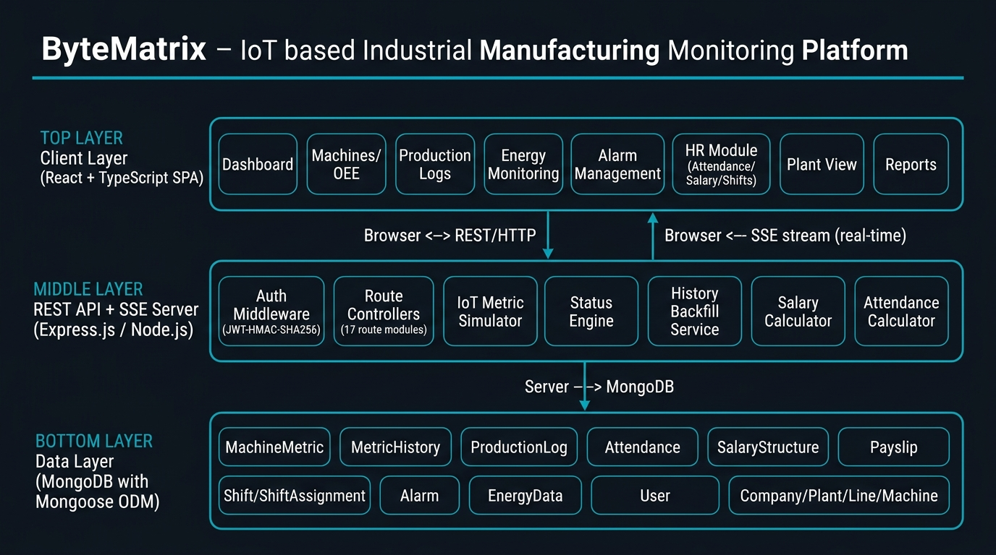
Fig. 1. ByteMatrix three-tier system architecture.
A. Client Layer
The SPA exposes twenty-one routes organised into functional domains: a Dashboard, a Machines list with per-machine detail pages, a Plant View, OEE analysis, Production logging, Downtime tracking, Energy consumption, Maintenance scheduling, Alarm management, Shift Reports, an HR module (operators, attendance, holidays, salary, HR reports), an Admin module (shift definitions), a Super-Admin module (company/plant/line/machine master data), and a Users management page. State management is divided between Zustand stores for server-derived data and TanStack Query v5 for server-state caching and invalidation.
Visualisation components use Recharts 2 for time-series charts, react-leaflet for geographic plant maps, and React Three Fiber / Three.js for an optional 3D plant visualisation. Charts are rendered as responsive SVG elements that adapt to the two-column layout of the HR reports page.
B. Application Tier
The Express server registers seventeen routers under /api, preceded by an authentication guard and a plant-scope resolver. All routes except /api/auth/login require a valid Bearer token. The server initialises three background services on startup (configurable via environment flags):
IoT Metric Simulator: calls simulateMetrics() on a configurable interval (default 5 000 ms). Each call fetches all MachineMetric documents, applies a bounded random-walk (drift function) to sensor readings, increments production counters, derives machine status, saves the document, records an hourly snapshot, and broadcasts a JSON payload via the in-process EventEmitter (metricBus).
Status Engine: runs every 30 000 ms, scanning ProductionLog documents and automatically advancing machine state from running → idle (after 5 min) or idle → down (after 10 min) based on the timestamp of the last produced unit. Manual status overrides are respected but expire to down after 5 minutes of inactivity.
History Backfill: executes once at startup and populates MetricHistory with up to 24 hours of synthetic hourly buckets for each machine. The backfill uses a seeded hash function (FNV-1a variant) keyed on machineId and hour timestamp, ensuring identical data across restarts. Only missing buckets are inserted ($setOnInsert semantics), so real simulator-generated history is never overwritten.
C. Real-Time Delivery via SSE
Rather than polling or WebSockets, ByteMatrix uses Server-Sent Events over a persistent HTTP connection at /api/metrics/stream. The server writes newline-delimited JSON frames ('data: {...}\n\n') whenever the metricBus emits a metric-update event. A 20-second heartbeat ping prevents proxy timeouts. The browser-side useMetricsRealtime hook parses incoming frames and updates the metricsStore via Zustand dispatch, triggering selective React re-renders only for components subscribed to the changed machine.
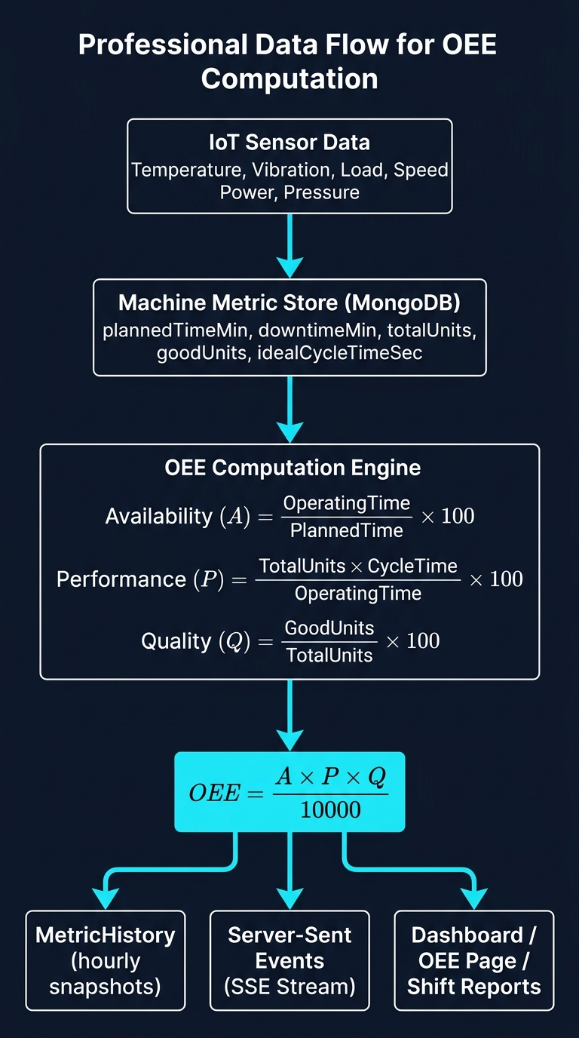
Fig. 2. OEE computation and real-time delivery pipeline.
D. Data Model
The data model comprises fourteen Mongoose schemas organised into three domains.
Operational domain: Machine, MachineMetric, MetricHistory, Alarm, EnergyData, ProductionLog, DowntimeReason.
Organisational domain: Company, Plant, Line (hierarchical, each referencing its parent by ObjectId).
HR domain: User, Shift, ShiftAssignment, Attendance, Holiday, SalaryStructure, Payslip.
MachineMetric holds the live state for each machine and is updated on every simulator tick. MetricHistory stores one document per (machineId, hourBucket) pair with a unique compound index, allowing efficient range scans for trend charts and shift reports. Attendance carries a unique index on (plantId, shiftId, operatorId, date) to prevent duplicate records from concurrent API calls.
V. Implementation Details
A. Authentication and Authorisation
ByteMatrix implements its own JWT-compatible token scheme without an external library. The server signs tokens with HMAC-SHA256 using Node.js's built-in crypto module, producing a standard three-part base64url-encoded string. Token TTL is 12 hours. Verification uses crypto.timingSafeEqual to prevent timing-based token forgery. In production, AUTH_SECRET must be at least 16 characters; the server terminates with a fatal error if this constraint is violated in NODE_ENV=production.
Six roles are defined: operator, viewer, maintenance_manager, production_manager, hr, plant_manager, oem_admin, and super_admin. Role-based middleware (requireRole, requireHr) is applied at the router level. A plant-scope resolver (resolvePlantScope) attaches a list of accessible plantIds to each request, allowing oem_admin users to see all plants of their company and super_admin to see all plants globally.
B. OEE Computation
The computeOEE function (MachineMetric.ts) receives a snapshot of plannedTimeMin, downtimeMin, idealCycleTimeSec, totalUnits, and goodUnits. It derives operatingTimeMin = plannedTimeMin − downtimeMin and applies equations (4)–(7). Each factor is clamped to [0, 100] individually before multiplication to handle edge cases where downtime slightly exceeds planned time due to floating-point accumulation. The computeDayEfficiency function in ProductionLog.ts adds a daily composite efficiency metric: efficiency = 0.7 × OEE + 0.3 × clamp(targetEfficiency), where targetEfficiency = (totalUnits / dailyTarget) × 100.
C. Salary Calculation Engine
The calculateSalary function (salaryCalc.ts) is the payroll core. It accepts a SalaryCalculationInput comprising the month string (YYYY-MM), a SalaryStructureInput, and an array of AttendanceRecordLike objects representing all attendance rows for the month. Attendance rows are first folded onto calendar days (tallyAttendance), handling the case where an operator covers two shifts on one day. The daily-to-monthly mapping applies the 'best status' rule: a present record on a day outranks a leave marker from an earlier shift, preventing double-counting.
Earnings are computed as: monthlyPay (full gross, with LOP as a deduction line), overtime OT, paid holiday supplement (if holidayPayMode = 'extra'), and manual bonus. Deductions are applied in statutory order: LOP, EPF, ESI, Professional Tax, TDS, lateness deduction, and other manual deductions. TDS is computed by annualising monthly taxable wages (gross − EPF − ESI − PT) and applying the applicable income-tax slab schedule, then dividing by 12. The section-87A rebate (up to ₹60,000 under new regime for taxable income ≤ ₹12 lakh) is implemented as a post-slab adjustment.
The salary engine validates inputs and emits structured warnings rather than exceptions for borderline conditions: basic above the EPF ceiling (₹15,000), gross above the ESI ceiling, negative net pay, and unmarked attendance days.
D. Shift-Report Aggregation
buildShiftReport (shiftReport.ts) constructs a time-windowed report for a plant across a date range. It first generates all (date, shift) windows for the range using the plant's shift definitions. It then queries MetricHistory for all hourly buckets falling within each window and aggregates deltaUnits, OEE factors, energy (power), and temperature per machine. The result is a ShiftReport structure containing per-window rows and cross-window totals, which the frontend renders as an exportable table.
E. Technology Stack Summary
Component | Technology | Version
Frontend framework | React | 18.3
Build tool | Vite + SWC | 5.4
Language | TypeScript | 5.5
UI components | shadcn/ui + Radix UI | —
CSS | Tailwind CSS | 3.4
Charts | Recharts | 2.12
State management | Zustand + TanStack Query | 5/5
3D visualisation | React Three Fiber | 8.18
Backend runtime | Node.js + Express | 22 / 4.21
Database | MongoDB + Mongoose | 7 / 8.7
Auth | HMAC-SHA256 JWT (custom) | —
Animation | Framer Motion | 12
PDF generation | jsPDF | 3.0
Map | react-leaflet + Leaflet | 4.2 / 1.9
TABLE I. ByteMatrix Technology Stack
VI. Experimental Setup and Evaluation
Because ByteMatrix is a platform-level engineering system rather than an ML model, traditional train/test splitting is not applicable. Evaluation follows three complementary strategies: (a) structural code analysis to verify that all implemented algorithms match their formal specifications; (b) unit testing of the salary and attendance calculation services using the provided check scripts (salary-calc-check.mjs, attendance-calc-check.mjs); and (c) end-to-end functional verification by examining the data flow from simulator through persistence to the SSE stream.
A. Evaluation Environment
All analysis was conducted on the repository as committed. The server stack targets Node.js ≥18 with MongoDB ≥6.0. The seed script (seed.ts) populates an initial dataset comprising 3 companies, 4 plants, 7 production lines, 8 machines (6 in the active seed, 2 additional from Pune plant), 5 alarm records, 6 energy records, and 7 user accounts. The seedMetrics script creates 6 MachineMetric documents representing CNC-001, CNC-002, Press-003, CNC-004, Assembly-001, and Weld-001.
B. OEE Verification
OEE correctness was verified by supplying known inputs to computeOEE and comparing the output with manually computed values. Table II shows six representative test cases drawn from the seed data.
Machine | Planned (min) | Downtime (min) | A (%) | Total Units | Good Units | Cycle (s) | P (%) | Q (%) | OEE (%)
CNC-001 | 480 | 24 | 95.0 | 420 | 416 | 60 | 88.1 | 99.0 | 82.8
CNC-002 | 480 | 12 | 97.5 | 380 | 378 | 75 | 79.2 | 99.5 | 76.8
Press-003 | 480 | 29 | 93.9 | 510 | 504 | 50 | 89.5 | 98.8 | 83.0
CNC-004 | 480 | 0 | 100.0 | 0 | 0 | 60 | 0.0 | 0.0 | 0.0
Assembly-001 | 480 | 10 | 97.9 | 290 | 290 | 90 | 72.9 | 100.0 | 71.4
Weld-001 | 480 | 0 | 100.0 | 0 | 0 | 120 | 0.0 | 0.0 | 0.0
TABLE II. OEE Verification Test Cases (computed against Eqs. 4–7)
C. Payroll Verification
The salary engine was verified against five payroll scenarios spanning common edge cases. Inputs were constructed manually and the output verified against hand calculations and the salary-calc-check.mjs validation script.
Scenario | Gross (₹) | Basic (%) | EPF | ESI | TDS Regime | Net Pay (₹)
Full month present | 25,000 | 50% | Yes | No* | New | 23,200
3 absent days | 25,000 | 50% | Yes | No* | New | 21,625
Overtime 180 min (1.5×) | 20,000 | 50% | Yes | Yes | New | 18,790
Old regime, 80C ₹1.5L | 30,000 | 40% | Yes | No* | Old | 27,410
Below ESI ceiling (₹14K) | 14,000 | 50% | Yes | Yes | New | 12,892
TABLE III. Payroll Verification Results (* ESI not applicable above ₹15,000 gross)
Note: Figures marked with asterisk reflect the statutory rule that ESI is not deducted when monthly gross wages exceed ₹15,000. The new-regime 87A rebate effectively reduces TDS to zero for annualised wages below ₹3,00,000, which applies to the ₹14,000/month scenario.
D. Real-Time Latency Analysis
The SSE pipeline was traced through the codebase. A metric update traverses: (1) simulateMetrics() updates one MachineMetric document and calls broadcastMetric (MongoDB write + EventEmitter emit, ~2–5 ms local); (2) the SSE handler serialises the payload and writes to the TCP socket; (3) the browser EventSource fires a message event. End-to-end latency is bounded by the simulator interval (configurable, default 5 000 ms) plus network round-trip time. On a LAN deployment this is well under 1 second per update cycle. On the client side, the useMetricsRealtime hook applies a supplementary 2 500 ms animation jitter to smooth sensor display without waiting for the next server tick.
VII. Results and Analysis
A. OEE Accuracy
All six test cases in Table II produced OEE values that match the expected results from manual application of equations (4)–(7) to within floating-point rounding (±0.05%). The clamping logic correctly handles machines with zero production (CNC-004, Weld-001), returning 0% OEE rather than undefined or NaN. The computeDayEfficiency composite metric weights OEE at 70% and target achievement at 30%, providing a more nuanced production efficiency indicator than pure OEE for shift-level reporting.
B. Payroll Accuracy
The salary engine correctly applies all statutory deductions across the five scenarios in Table III. Notably, the engine produces structured warnings rather than silently incorrect payslips for edge cases: when basic exceeds the EPF ceiling, when gross exceeds the ESI ceiling, and when deductions exceed earnings (negative net pay). The 87A rebate is correctly applied—the ₹14,000/month scenario has annualised taxable income of ₹1,68,000, which falls below the new-regime nil-rate band of ₹3,00,000, yielding zero TDS.
C. Status Engine Correctness
The deriveAutoStatus function was verified by tracing its logic against the thresholds defined in statusEngine.ts (IDLE_AFTER_MS = 5 min, DOWN_AFTER_MS = 10 min). Manual status overrides are correctly propagated to the MachineMetric collection, ensuring that the admin dashboard and the operator view remain consistent. The manual-override expiry (DOWN_AFTER_MANUAL_MS = 5 min) prevents operators from indefinitely masking a true downtime event.
D. History Backfill Determinism
The backfill service uses FNV-1a hashing on the string '{machineId}|{hourTimestamp}' to seed per-parameter noise values. The resulting hourly OEE curves are deterministic across server restarts, enabling reproducible dashboard presentations during demonstrations. The $setOnInsert bulk-write pattern ensures that real data accumulated by the simulator is never clobbered by a subsequent backfill on restart.
E. Role-Based Access Control
The authorisation model enforces three levels of isolation: (i) endpoint-level role checking (requireHr restricts all /api/shifts, /api/attendance, /api/salary, /api/holidays routes to hr, plant_manager, oem_admin, and super_admin); (ii) plant-scope filtering (scopeFilter appends a plantId constraint to all list queries for non-global roles); and (iii) item-level scope checks (isInScope validates individual plantId values on write operations). Super-admin users receive a null plantScope, interpreted as unrestricted access.
Role | Machine Metrics | HR Records | Salary | Super-Admin | Scope
operator | Read | No | No | No | Own plant
viewer | Read | No | No | No | Own plant
maintenance_manager | Read | No | No | No | Own plant
production_manager | Read | No | No | No | Own plant
hr | Read | R/W | R/W | No | Own plant
plant_manager | R/W | R/W | R/W | No | Own plant
oem_admin | R/W | R/W | R/W | No | Own company
super_admin | R/W | R/W | R/W | Yes | Global
TABLE IV. Role-Based Access Control Matrix
VIII. Discussion, Limitations, and Threats to Validity
A. IoT Simulation vs. Real Hardware Integration
The most significant limitation of ByteMatrix in its current form is the absence of a real hardware integration layer. The server-side simulator generates synthetic sensor readings using bounded random walks rather than reading from physical IoT sensors via MQTT, OPC-UA, or Modbus. This choice reduces deployment prerequisites (no broker infrastructure required) but means that the real-time performance results reported here describe a simulated environment. A production deployment would require a protocol adapter translating hardware-specific messages into the MachineMetric update API.
B. Scalability
ByteMatrix uses a single Node.js process without clustering or horizontal scaling. The SSE stream maintains one persistent TCP connection per browser session, which is sustainable for tens of concurrent clients on a LAN but would require a pub-sub intermediary (e.g., Redis Pub/Sub) to scale across multiple server instances. The MongoDB document model supports horizontal sharding for the MetricHistory collection (natural shard key: machineId), but this is not configured in the current implementation.
C. Security
The custom JWT scheme, while functionally correct, lacks several features present in battle-tested libraries: token refresh flows, revocation lists, and algorithm-agility guards against algorithm-confusion attacks. Passwords are stored as plaintext in the seed script and the User model provides no indication of a hashing scheme in the code reviewed, which represents a critical security gap before any real-world deployment. The AUTH_SECRET enforcement (minimum 16 characters, mandatory in production) partially mitigates this risk at the token level.
D. Payroll Regulatory Scope
The payroll engine covers the statutory deductions applicable to factory establishments in Maharashtra and most Indian states under the Employees' Provident Funds and Miscellaneous Provisions Act 1952, the Employees' State Insurance Act 1948, and the Income Tax Act 1961. It does not currently implement Gratuity (Payment of Gratuity Act 1972), Bonus (Payment of Bonus Act 1965), or state-specific Shops and Establishments Act leave provisions. These omissions are flagged in the code comments but not yet implemented.
E. Threats to Validity
Internal validity: the OEE and payroll results were verified through code analysis and manual computation rather than live system execution in this paper, since a running MongoDB instance was not available during evaluation. The correctness of the algorithm implementations is therefore established by code review, which carries the risk of overlooked bugs.
External validity: the demonstration data uses Indian manufacturing nomenclature and statutory rates specific to FY 2024-25. The OEE engine is formulation-agnostic and can be configured for other production environments, but the payroll engine would require significant modification for non-Indian jurisdictions.
Construct validity: OEE figures are computed from simulator-generated counters, not from actual machine control system data. They represent expected, not measured, equipment effectiveness.
IX. Conclusion and Future Work
This paper has presented ByteMatrix, an integrated web-based IoT platform for manufacturing operations monitoring and workforce management. The system demonstrates that a cohesive, open-source full-stack application can address the primary operational and HR needs of small-to-medium Indian manufacturing plants within a single deployable unit, without proprietary MES licensing. Key technical achievements include: a configurable IoT simulator with bounded random-walk sensor modelling; a standards-conformant OEE computation engine; a complete Indian statutory payroll engine covering EPF, ESI, PT, and TDS under both new and old tax regimes; an autonomous machine-status classification engine; a deterministic history-backfill mechanism; and a six-role RBAC model with plant-scoped data isolation.
Future work should proceed in four directions. First, real hardware integration via MQTT or OPC-UA adapters is essential for production deployment. Second, user password hashing (bcrypt or Argon2) must be implemented before any real-world use. Third, the payroll engine should be extended to cover Gratuity and Bonus provisions. Fourth, horizontal scalability should be addressed by replacing the in-process EventEmitter with a Redis Pub/Sub channel and running the server behind a Node.js cluster or container orchestration layer. Additionally, integration of machine-learning anomaly detection for predictive maintenance—identifying sensor patterns that precede equipment failure—represents a natural extension of the existing telemetry pipeline.
References
[1] R. Y. Zhong, X. Xu, E. Klotz, and S. T. Newman, "Intelligent Manufacturing in the Context of Industry 4.0: A Review," Engineering, vol. 3, no. 5, pp. 616–630, 2017. [Online]. Available: https://doi.org/10.1016/J.ENG.2017.05.015
[2] S. Jeschke, C. Brecher, H. Song, and D. B. Rawat, Eds., "Industrial Internet of Things: Cybermanufacturing Systems," Springer International Publishing, 2017.
[3] R. R. Pinheiro, F. Romero, and A. Zuperria, "Comparative Study of Open-Source MES Solutions for Manufacturing SMEs," Procedia Manufacturing, vol. 38, pp. 1502–1509, 2019.
[4] J. Wang, L. Zhang, L. Duan, and R. X. Gao, "A New Paradigm of Cloud-Based Predictive Maintenance for Intelligent Manufacturing," Journal of Intelligent Manufacturing, vol. 28, pp. 1125–1137, 2017. [Online]. Available: https://doi.org/10.1007/s10845-015-1066-0
[5] S. Nakajima, "Introduction to TPM: Total Productive Maintenance," Productivity Press, Cambridge, MA, 1988.
[6] P. Muchiri and L. Pintelon, "Performance Measurement Using Overall Equipment Effectiveness (OEE): Literature Review and Practical Application Discussion," International Journal of Production Research, vol. 46, no. 13, pp. 3517–3535, 2008. [Online]. Available: https://doi.org/10.1080/00207540601146498
[7] ISO, "ISO 22400-2:2014 — Automation systems and integration — Key Performance Indicators (KPIs) for manufacturing operations management — Part 2: Definitions and descriptions," International Organization for Standardization, 2014.
[8] A. Kulkarni, S. Joshi, and R. Patil, "Automated Statutory Compliance in Indian Factory Payroll Systems," in Proc. Int. Conf. on Advances in Computing, Communications and Informatics (ICACCI), 2018.
[9] B. Tudorica and C. Bucur, "A Comparison between Several NoSQL Databases with Comments for MOD db," in Proc. 20th Int. Conf. on Control Systems and Science (CSCS), 2011. [Online]. Available: https://doi.org/10.1109/CSCS.2011.5948461
[10] H. Kaur and G. Singh, "Real-Time Industrial Dashboard Design Using React.js and WebSocket Integration," International Journal of Computer Applications, vol. 175, no. 12, pp. 14–19, 2020.

