5/19/2021

Jenkins Installation:

[Simple-DevOps-Project/Jenkins_Installation.MD at master · yankils/Simple-DevOps-Project · GitHub](https://github.com/yankils/Simple-DevOps-Project/blob/master/Jenkins/Jenkins_Installation.MD)

**Install Jenkins on AWS EC2**

Jenkins is a self-contained Java-based program, ready to run out-of-the-box, with packages for Windows, Mac OS X and other Unix-like operating systems. As an extensible automation server, Jenkins can be used as a simple CI server or turned into the continuous delivery hub for any project.

**Prerequisites**

1. EC2 Instance
   * With Internet Access
   * Security Group with Port 8080 open for internet
2. Java v1.8.x

**Install Java**

1. We will be using open java for our demo, Get the latest version from <http://openjdk.java.net/install/>
2. yum install java-1.8*

#yum -y install java-1.8.0-openjdk-devel

1. Confirm Java Version and set the java home
2. java -version
3. find /usr/lib/jvm/java-1.8* | head -n 3
4. JAVA_HOME=/usr/lib/jvm/java-1.8.0-openjdk-<Java version which seen in the above output>
5. export JAVA_HOME
6. PATH=$PATH:$JAVA_HOME
7. # To set it permanently update your .bash_profile

vi ~/.bash_profile

JAVA_HOME=/use/lib/jvm/java-`.8.0.*

PATH=$PATH:$HOME/bin:$JAVA_HOME

Logoff and log in to get it effect

Login as a root user

Echo $JAVA_HOME – this will display java path

remove defauly java version: yum remove java-1.7.0*

*The output should be something like this,*

[root@~]# java -version

openjdk version "1.8.0_151"

OpenJDK Runtime Environment (build 1.8.0_151-b12)

OpenJDK 64-Bit Server VM (build 25.151-b12, mixed mode)

**Install Jenkins**

You can install jenkins using the rpm or by setting up the repo. We will set up the repo so that we can update it easily in the future.

1. Get the latest version of jenkins from <https://pkg.jenkins.io/redhat-stable/> and install
2. yum -y install wget
3. sudo wget -O /etc/yum.repos.d/jenkins.repo https://pkg.jenkins.io/redhat-stable/jenkins.repo
4. sudo rpm --import https://pkg.jenkins.io/redhat-stable/jenkins.io.key

yum -y install jenkins

**Start Jenkins**

# Start jenkins service

service jenkins start

# Setup Jenkins to start at boot,

chkconfig jenkins on

**Accessing Jenkins**

By default jenkins runs at port 8080, You can access jenkins at

http://YOUR-SERVER-PUBLIC-IP:8080

**Configure Jenkins**

* The default Username is admin
* Grab the default password
* Password Location:/var/lib/jenkins/secrets/initialAdminPassword
* Skip Plugin Installation; *We can do it later*
* Change admin password
  + Admin > Configure > Password
* Configure java path
  + Manage Jenkins > Global Tool Configuration > JDK
* Create another admin user id

**Test Jenkins Jobs**

1. Create “new item”
2. Enter an item name – My-First-Project
   * Chose Freestyle project
3. Under the Build section Execute shell: echo "Welcome to Jenkins Demo"
4. Save your job
5. Build job
6. Check "console output"

Paran:

Create EC2 instance. Tag it as Jenkins_server. Create new security group called devops_SG and open port 8080 by click on add rules

Download pem file. Use mobaxterm putty to use pem instead of PPK file.

Get into mobaxterm( multitab pully) and enter ip address, select private key and choose user as ec2-user.

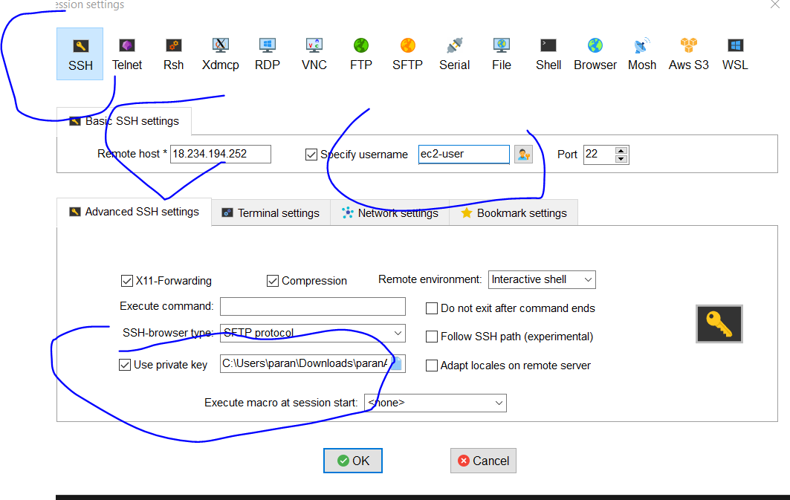

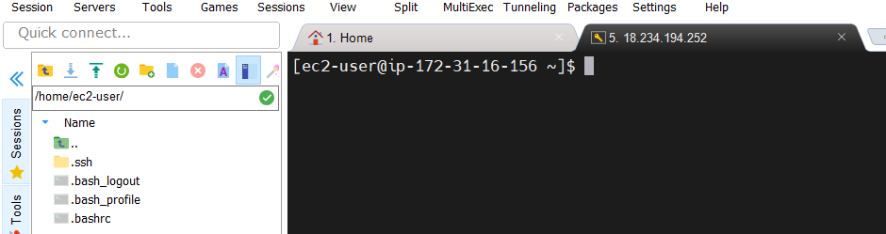

Change to root to install Java.

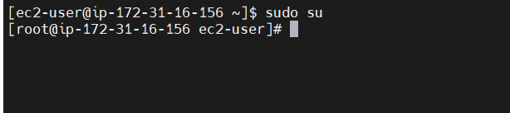

Before installing java version pls check java version. Amazon linux come with 1.7. we need to install 1.8

To remove java 1.7

* + - Java -version
    - Yum remove java -1.7.0*

Install java 1.8

* + - Yum install java-1.8*

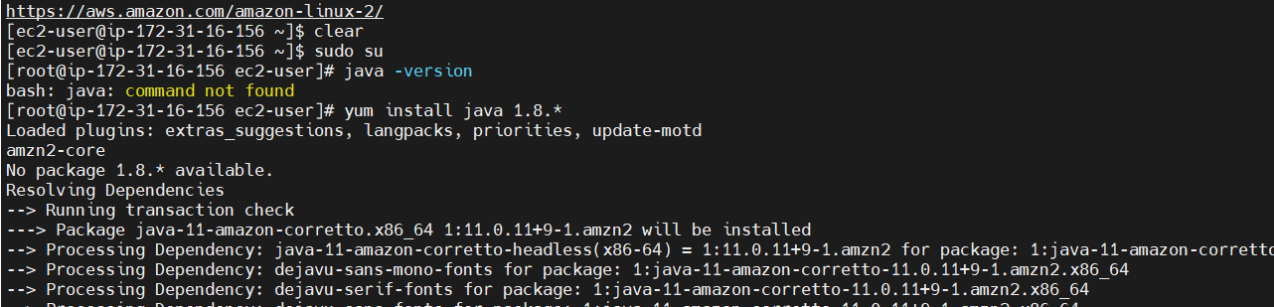

After java installation we need to set home path where jre located.

>find /usr/lib/jvm/java-1.8* | head -n 3