**SSN College of Engineering**

**Department of Information Technology**

**UIT2201 — Programming and Data Structures**

**Exercise — 03**

**Part-A**

**1. Implement a Vector ADT. Write methods to perform arithmetic operations over vector objects and also add methods to make the vector object iterable.**

**Aim:**

**To Implement a Vector ADT.**

**Algorithm:**

**1)Start**

**2)To create a class called Vector.**

**3)To define some super methods namely __init__() , __str__() , __eq__() , etc.**

**4)these special methods will help the vector to add and iterate.**

**Main algorithm:**

**1)to create to vector object and add them.**

**2)Then iterate them in a for loop.**

**Output:**

**Testcases:**

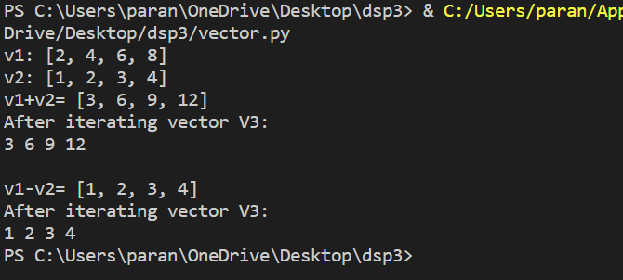

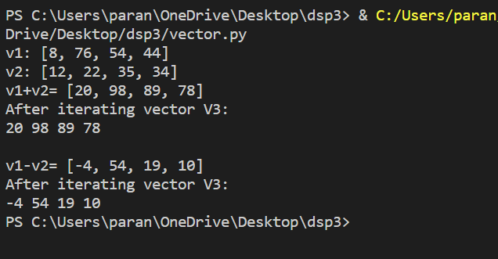

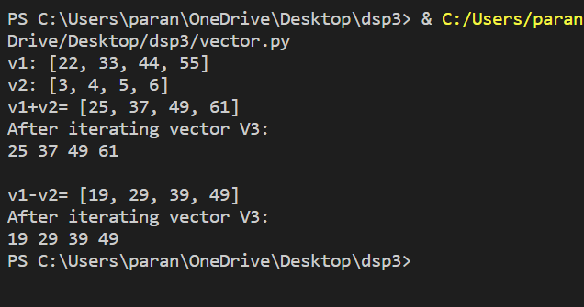

**Part-B**

**2. Implement a Matrix ADT where the instances of Matrix should be able to store a matrix**

**of any size. The ADT takes the number of rows and number of columns as arguments**

**with a default value as (0 & 0) , and sets each matrix entry to zero.Realize the matrix as**

**a list of list.**

**Generate a function to create a matrix with random numbers, a function that multiplies**

**two Matrix objects (checking for conformity) and returns a Matrix.Also provide functions**

**for Addition/Subtraction of two matrices and return the resultant matrix. Provide the**

**function to find the determinant of the Matrix Object.**

**Pay special attention to the way you use the results of the multiplication functions!**

**Unless you’ve written __eq__(self, other), you need to be very careful (i.e., use**

**initialization to get your product matrix back to the calling environment)!**

**Create (and submit) a small Test program to demonstrate your ADT functions.**

**Aim:**

**To create a Matrix ADT to add, sub, multiple and find determinant.**

**Algorithm:  
1) Start**

**2) import randint from random and copy module.**

**3) define a class Matrix in which we define some special methods to add,**

**Sub and multiply two matrix objects and also find the determinant of a**

**Matrix.**

**Main Algorithm:**

**1)To create two matrix with random numbers.**

**2) To add , sub and multiply two Matrix object.**

**3)Also to find the determinant of a matrix.**

**Output:**

**Testcases:**

