DEEP ANALYSIS AND MONITORING OF AIR QUALITY WITH GREENHOUSE GASES USING IoT (INTERNET OF THINGS) UNDER SDG 3.9

1. “Deep analysis and monitoring of air quality and greenhouse gases using Internet of Things (IoT)”, system uses a wide variety of sensor and microcontroller to monitor the quality of air and greenhouse gases in outdoor environment.
2. The system fetches the sensed data from the sensors using DHT-11, MQ-7 & MQ-2 Sensors, Arduino Nano, Node MCU (ESP8266) it stored the sensed data in both excel and cloud storage.
3. Further, the monitored values will be stored locally and exported to .csv format. Then the collected data is pre -processed, it is split into two sets: a training set and a test set.
4. The training set is used to train the model, while the test set is used to evaluate the model performance. The Machine learning algorithm (Decision tree classification algorithm) is used to make predictions and analysis using the sensed data.
5. This process is repeated until IoT sensors senses various greenhouse gases 16 such as carbon dioxide, methane, carbon monoxide etc.
6. The analysis and prediction will be carried out using nonlinear categorical data with ensemble techniques. Performance analysis is calculated and visualized.

**Description**

In this world, there is five elements of nature (air, water, land, etc.) is essential for living organisms (humans, animals and environment). Where air is most important elements which plays in human life. During pandemic time from 2019 the disease spread over an environment through air particles. Air pollution and greenhouse contamination is considered as the prime concern of the industrial age, that affect human health, environment and green house. Air pollution is recognized as a pressing sustainability concern and is directly mentioned in two SDG targets: SDG 3.9 (substantial reduction of health impacts from hazardous substances) and SDG 11.6 (reduction of adverse impacts of cities on people). The air contamination of chemical gases that affect both the air quality and the green house. Hence, the quality of air should be maintained properly to avoid this form of disease spreading and the pollution caused in the air and green house. The harmful gases like Carbon dioxide (Co2), Carbon monoxide (CO), Smoke, Methane (CH3) etc... are affecting the quality of air. To monitor these harmful gases/pollutants, the Internet of Things (IoT) gives a wonderful solution through sensors. This proposed system measures and predicting the quality of air through machine learning classification algorithm and measures the performance metrices. This system uses MQ7, MQ2, LM35 or DHT11 sensor, Arduino microcontroller board and Deep analysis and monitoring of air quality with greenhouse gases using IoT under SDG 3.9 iv ESP8266 NODEMCU for monitoring air, that detects most harmful gases and can measure the gas levels. The prediction accuracy is acquired from the performance metrices.

Objectives:

The objectives of the project “Deep Analysis and Monitoring of air quality With greenhouse gases using Internet of Things (IoT) under SDG 3.9” are,

¬ To identify gases in green house environment.

¬ To monitor the chemical gases in sensors.

¬ To Analyze the monitoring real time gases through machine learning.

¬ To visualize and generate the report for predicted data.

¬ Remote based monitoring from any location through cloud and database.

Challenges:

The challenges of the Project “Deep analysis and monitoring of air quality with greenhouse gases using Internet of Things (IoT) under SDG 3.9” is,

¬ Batteries tends to drain if the power consumption is high.

¬ Environmental disasters affect the deployment of the sensors.

¬ Durability of Micro-controller must be reduced over some period.

¬ Outlier may affect the machine learning algorithm.

**Getting Started**

**Dependencies**

Hardware requirements:

The sensors and micro-controllers to be used for measuring the air quality and greenhouse gases in outdoor environment for the “Deep analysis and monitoring of air quality with greenhouse gases using Internet of Things (IoT) under SDG 3.9” system are follows.

¬ Arduino Nano

¬ ESP8266 Wi-Fi Module (Node MCU)

¬ DHT11 Sensor

¬ MQ-2 Sensor

¬ MQ-7 Sensor

¬ Bread board

¬ System / Desktop

Software requirements:

The Software requirements for implementation of the Arduino Nano, the sensors and for storage are,

¬ Tools: Jupyter notebook or google colab and Arduino IDE

¬ OS: windows 10 and 11

¬ Languages: Python

¬ Cloud environment: Blynk application

Architecture:

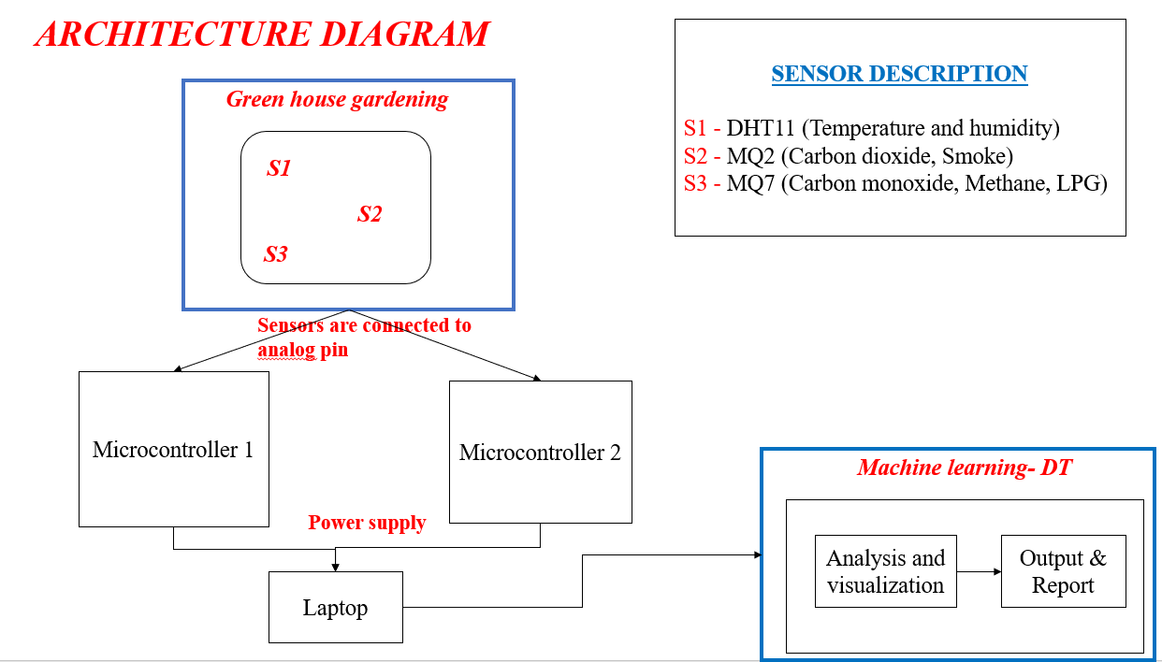

**Installing**

* **Using Anaconda:**  
  Install Python and Jupyter using the Anaconda Distribution, which includes Python, the Jupyter Notebook, and other commonly used packages for scientific computing and data science. To install Anaconda, go through [How to install Anaconda on windows?](https://www.geeksforgeeks.org/how-to-install-anaconda-on-windows/) and follow the instructions provided.
* **Using PIP:**  
  Install Jupyter using the **PIP package manager** used to install and manage software packages/libraries written in Python. To install pip, go through [How to install PIP on Windows?](https://www.geeksforgeeks.org/how-to-install-pip-on-windows/) and follow the instructions provided.

**Installing Jupyter Notebook using Anaconda:**

Anaconda is an open-source software that contains Jupyter, spyder, etc that are used for large data processing, data analytics, heavy scientific computing. Anaconda works for R and python programming language. Spyder (sub-application of Anaconda) is used for python. Opencv for python will work in spyder. Package versions are managed by the package management system called conda.

**Authors**

Author name and contact info

Name: Paranthaman muthu

E.mail: paranthamanm.31@gmail.com

**License**

This project is licensed under the [Paranthaman muthu] License - see the LICENSE.txt file for details