# High Level Design (HLD)

**Credit Card Fraud Detection**

***PARAS DAHIYA***

**ABSTRACT**

In the dynamic landscape of financial risk assessment, the challenge of predicting credit defaults for commercial banks shares conceptual parallels with classification tasks in diverse domains. This project employs classical machine learning techniques encompassing Data Exploration, Cleaning, Feature Engineering, Model Building, and Testing to craft a robust solution. The goal is to predict the probability of credit default based on the distinctive characteristics and payment histories of credit card owners.

**CONTENTS**

Title Page i

Abstract ii

Content iii

|  |  |  |
| --- | --- | --- |
|  | Introduction | 1 |
|  | Why this HlD Documentation? | 1 |
| 1 | Description | 1 |
| 1.1 | Problem Perspective | 1 |
| 1.2 | Problem Statement | 1 |
| 1.3 | Proposed Solution | 1 |
| 1.4 | Technical Requirements | 1 |
| 1.5 | Tools Used | 2 |
| 1.6 | Data Requirements | 2 |
| 1.7 | Constraints | 2 |
| 1.8 | Assumptions | 2 |
| 2 | Design Flow | 3 |
| 2.1 | Modelling Process | 3 |
| 2.2 | Deployment Process | 3 |
| 2.3 | Logging | 3 |
| 2.4 | Error Handling | 3 |
| 3 | Performance Evaluation | 4 |
| 3.1 | Reusablity | 4 |
| 3.2 | Application Compatiblity | 4 |
| 3.3 | Resourse Utilization | 4 |
| 3.4 | Deployment |  |
| Conclusion |  |  |
|  |  |  |

# INTRODUCTION

**Why this High-Level Design Document?**

The main purpose of this HLD documentation is to feature the required details

of the project and supply the outline of the machine learning model and also the

written code. This additionally provides a careful description on how the

complete project has been designed end-to-end.

# 1 Description

## Problem Perspective

Credit Card Default Prediction is a machine learning model which helps us to predict wheter the the person going to default or not.

## Problem Statement

Financial threats are displaying a trend about the credit risk of commercial banks as the

incredible improvement in the financial industry has arisen. In this way, one of the

biggest threats faces by commercial banks is the risk prediction of credit clients. The

goal is to predict the probability of credit default based on credit card owner's

characteristics and payment history.

## Proposed Solution

The solution proposed to take input from the client and process all the provided data to meet the requirements of the machine learning model and finally displaying the output csv file.

# 1.4 Technical Requirements

There are no hardware requirements required for using this application, the user must have an interactive device which has access to the internet and must have the basic understanding of providing the input. And for the backend part the server must run all the software that is required for the processing the provided data and to display the results.

## 1.5 Tools Used

* + - Python 3.9 is used as the programming language and frame works like numpy, pandas, sklearn and other modules for building the model.
    - PyCharm is used as IDE.
    - For visualizations seaborn and parts of matplotlib are being used.
    - For data collection SQl database is being used.
    - Front end development is done using HTML/CSS/JAVASCRIPT.
    - Flask is used for both data and backend deployment.
    - GitHub is used for version control.
    - Heroku is used for deployment.

**1.6 Data Requirement**

The info demand totally supported the matter statement. and also, the information set is accessible on the Kaggle within the type of standout sheet(.xlsx). Because the main theme of the project is to induce the expertise of real time issues, we have a tendency to once more mercantilism {the information into the prophetess database and commerce it into csv format.

**1.7 Constraints**

The Credit Card Default prediction answer should be attainable and also the user should not be needed to understand any of the operations.

**1.8 Assumptions**

The most objective of the project is to implement the utilization cases for the

new dataset that the user provides through the programming. Machine learning

model is employed to process the on top of a computer file. it's additionally

assumed that each one aspect of this project has the flexibility to figure along

within the approach the designer is expecting.

1. **Design Flow**

**2.1 & 2.2 Model Flow & Deployment Process**

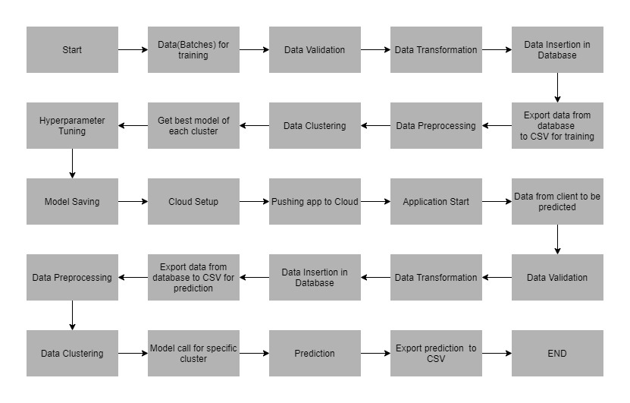

# 2.3 Logging

# Each step is being logged within the system that runs internally, that shows the

# date time and therefore the process that has been performed, work is completed

# in several layers as information, DEBUG, ERROR, WARNINGS. This provides

# the US the perception of the logged info.

# 2.4 Error Handling

# Once a slip has occurred, the reason is logged in its several log files, in order that

# the developer will rectify the error.

**3 Performance analysis**

**3.1 Reusability**

Elements of the code written are accustomed to different applications and

therefore the rest is changed and reused.

**3.2 Application Compatibility**

The various parts for this project are exploitation python as an associate interface

between them. every element can have its own tasks to perform, and it's the work

of the python to make sure the transfer of data.

**3.3 Resource Utilization**

Once any task is performed, it'll doubtless use all the process power offered till

that performance is finished.

**3.4 Deployment**

The model is being deployed on Heroku.

**Conclusion**

The Credit Card Default prediction will predict the worth of the trained knowledge set

within the rule. therefore, the user will recognize the approximate value for his

or her journey