Wireframe

**Credit Card Fraud Detection**

***PARAS DAHIYA***

**ABSTRACT**

In the dynamic landscape of financial risk assessment, the challenge of predicting credit defaults for commercial banks shares conceptual parallels with classification tasks in diverse domains. This project employs classical machine learning techniques encompassing Data Exploration, Cleaning, Feature Engineering, Model Building, and Testing to craft a robust solution. The goal is to predict the probability of credit default based on the distinctive characteristics and payment histories of credit card owners.

**CONTENTS**

Title Page i

Abstract ii

Content iii

Web Interface

User Input

Result Page

|  |  |  |
| --- | --- | --- |
|  |  |  |
|  |  |  |
|  |  |  |
|  |  |  |
|  |  |  |
|  |  |  |
|  |  |  |
|  |  |  |
|  |  |  |
|  |  |  |
|  |  |  |
|  |  |  |
|  |  |  |
|  |  |  |
|  |  |  |
|  |  |  |
|  |  |  |

**1. Web Interface**

-

Our web page is an interface where input is taken from the user and the prediction is displayed.

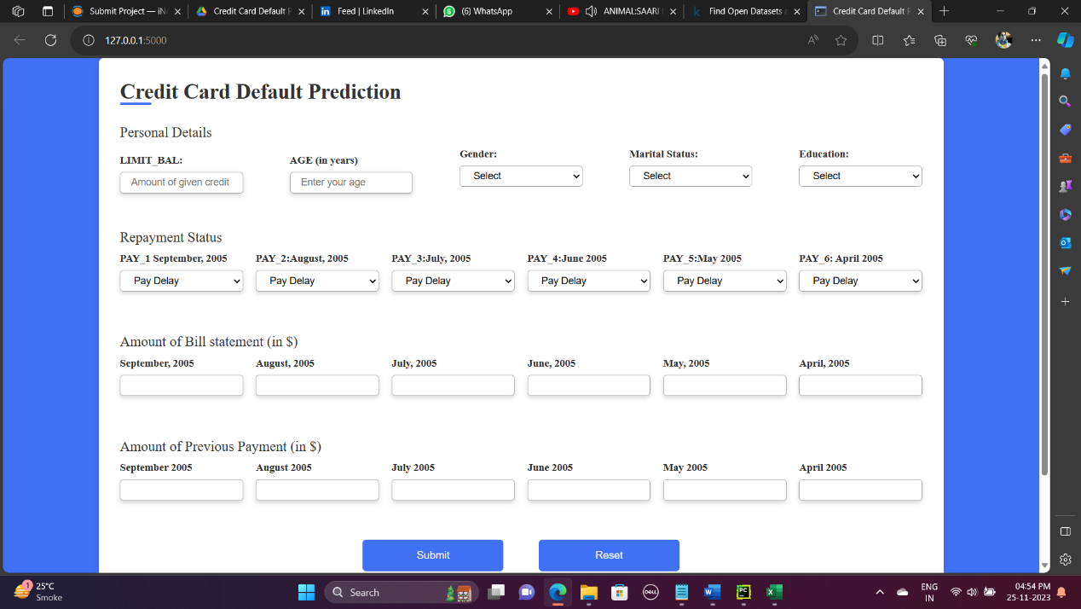

1. **User Input**

Whenever the user hits our url, they first see the user input page here they have to provide the input.

After providing the required input and pressing the submit button, the page refreshes and displays the output.

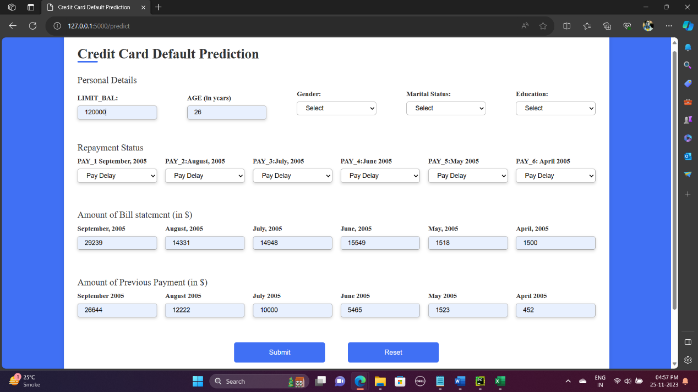

1. **Result Page**

After the user hits one button the page gets refreshed and the results are being displayed in the result area in the above frame.

The user can refill all the inputs in the same page and get the results in the same way.

