Wireframe

**MUSHROOM CLASSIFICATION**

***PARAS DAHIYA***

**ABSTRACT**

Mushrooms can be found extensively in a variety of natural environments and visual identification of mushroom species is well established. Some mushrooms are known because of their nutritional and therapeutical properties. Some species are known all over the world because of their toxicity that causes fatal accidents every year mainly due to misidentification. Some of the edible mushrooms are Ganoderma spp, Cantharellus spp, Agaricus spp, Pleurotus spp, Russula spp, Auricularia spp and Termitomyces spp; but the ornamentals are the beautifully ringed Microporous spp. Amanita spp, Lepiota cristata, Lepiota brunneoincarnata and Inocybe asterospora, C o p r i n u s s p p are among the most important species responsible for mushroom poisoning. Morphological and chemical analyses for mushrooms are occasionally required in forensic science practice. In this work, we will try to predict which mushroom is poisonous & which is edible.

**CONTENTS**

Title Page i

Abstract ii

Content iii

Web Interface

User Input

Result Page

|  |  |  |
| --- | --- | --- |
|  |  |  |
|  |  |  |
|  |  |  |
|  |  |  |
|  |  |  |
|  |  |  |
|  |  |  |
|  |  |  |
|  |  |  |
|  |  |  |
|  |  |  |
|  |  |  |
|  |  |  |
|  |  |  |
|  |  |  |
|  |  |  |
|  |  |  |

**1. Web Interface**

-

Our web page is an interface where input file is taken from the user and the prediction is displayed.

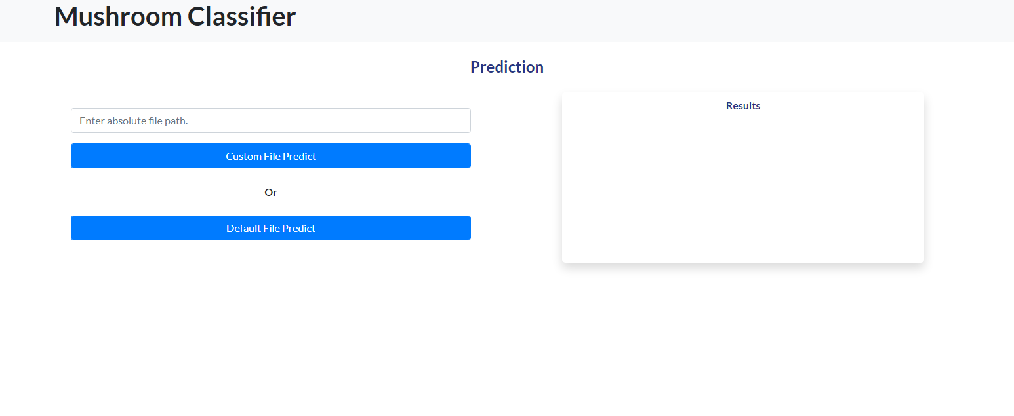

1. **User Input**

Whenever the user hits our url, they first see the user input page here they have to provide the custom prediction file or they can choose default path.

After providing the required input and pressing the submit button, the page refreshes and displays the output.



1. **Result Page**

After the user hits one button the page gets refreshed and the results are being displayed in the result area in the above frame.

The user can refill all the inputs in the same page and get the results in the same way.

