IIT Goa CS 378 (Computer Networks LAB) Name: ParasYadav
Instructor: Neha Karanjkar Roll No.: 170010007

LAB 4: Reliable Transport Protocols

1. (a)
When we set Pc=0.5 , the packet gets corrupted in the channel with 50% probability.
udt_send() is called by the data channel for packet 1. The packet gets corrupted in the data channel.
Then udt_send() is called for packet 2. The receiver correctly receives packet 2, but the receiver was expecting packet 1. So, the simulation is halted.

Attached below is the corresponding output in terminal:

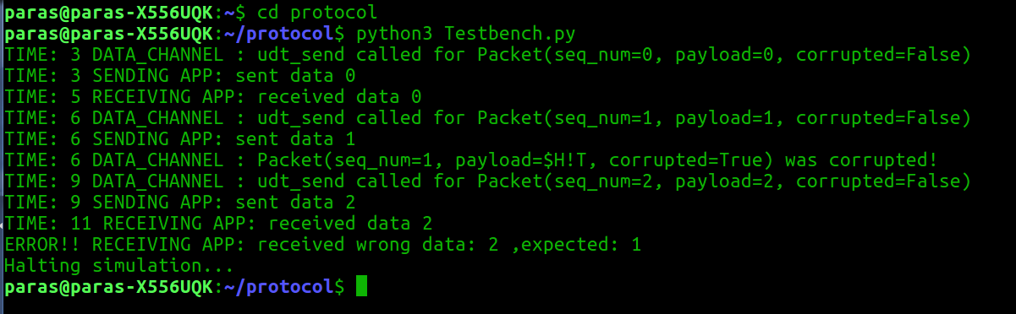

1. (b)
Yes, the protocol works for Pc>0 for the data channel , by sending ACKs and NAKs corresponding to the packet received by the receiver. Whenever the sender receives a NAK, it resends the packet. Whenever the sender receives an ACK, it sends the next packet.

Attached below is the corresponding output in terminal:
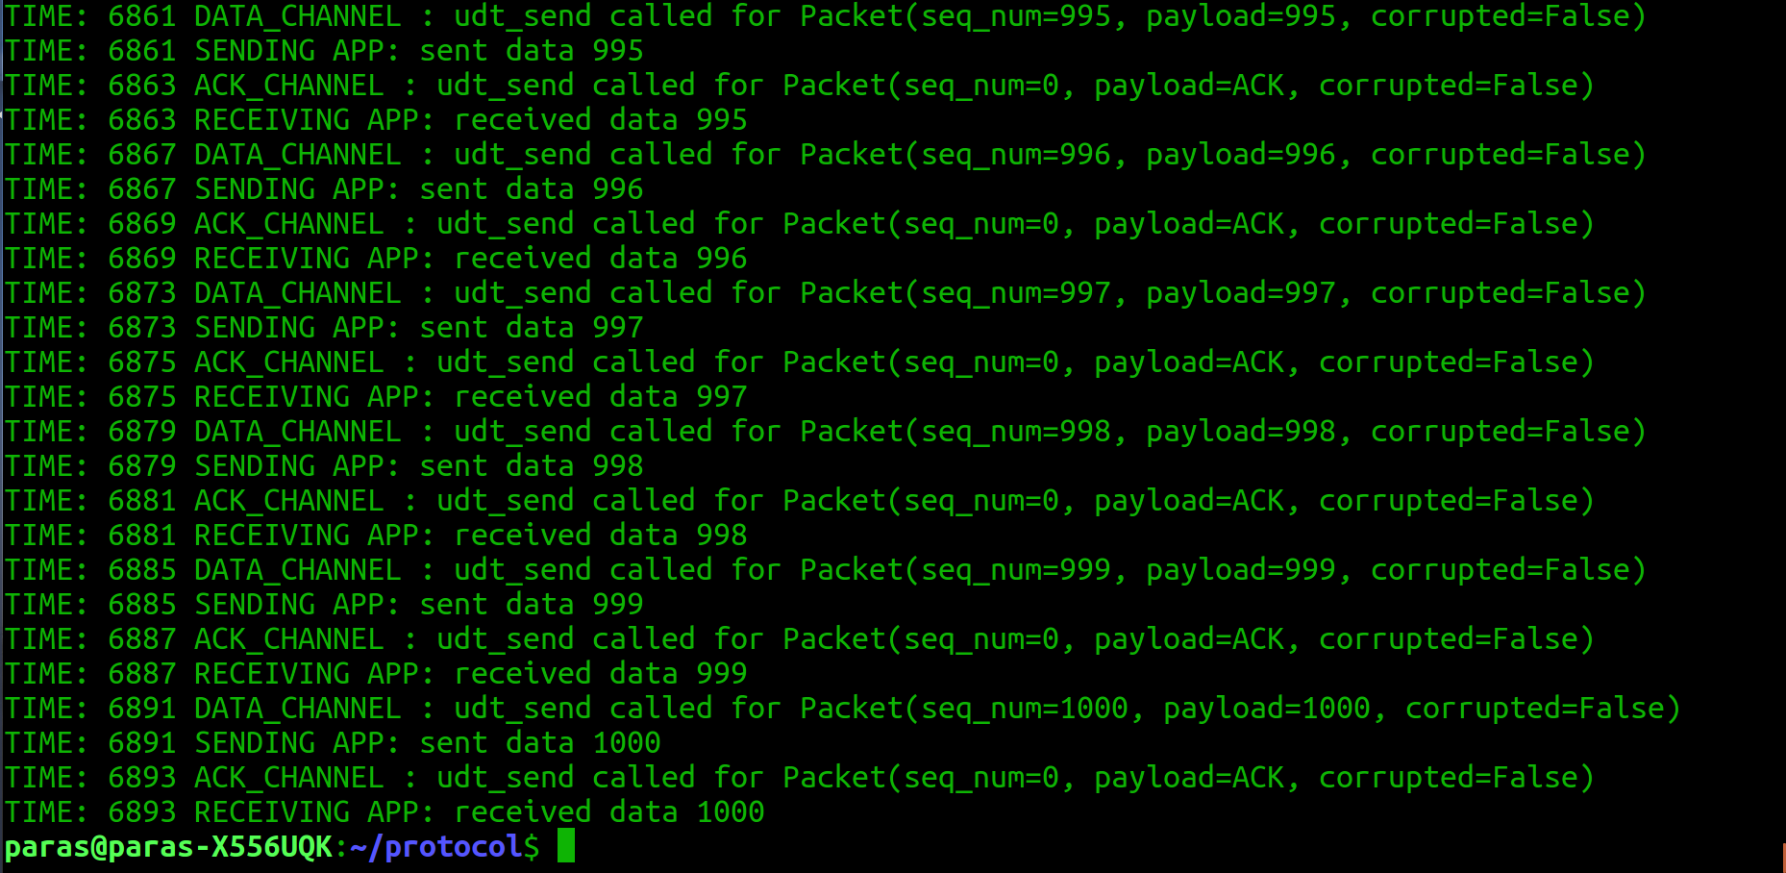
1. (c)

Pc | T_avg
0 | 4.000
0.1 | 4.222
0.2 | 4.472
0.3 | 4.925
0.4 | 5.430
0.5 | 6.247
0.6 | 6.919
0.7 | 9.004
0.8 | 11.575
0.9 | 21.699

If you observe, you’ll notice that the graph is hyperbolic. This is easily justifiable because the simulation takes a constant time, approximately equal to the sum channel delay for the data and ack channels. However, this same time increases as the packets get corrupted and tends to infinity when Pc=1 (i.e. the channel corrupts every packet passing through it), because then the packets gets corrupted every time with probability 1 and the sender never gets an ACK.

1. (d)
Let us assume we’re trying to send packet 1.
udt_send() is called by the data channel for the packet 1. The application sends the data packet.
udt_send() is called by the ack channel for sending ACK, but the ACK gets corrupted on the way.
The sender checks that the payload is neither ACK nor NAK, and the simulation is halted.

Attached below is the corresponding output in terminal:

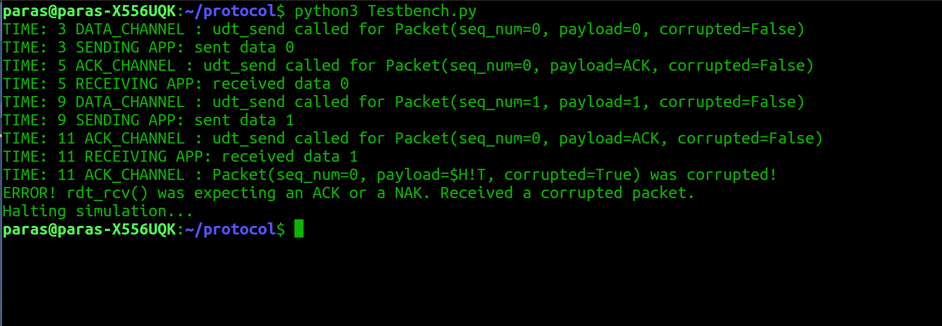

2. Submitted as Protocol_rdt22.py

3. (a)
The sender sends data packet 0, but it gets lost in the data channel. The receiver doesn’t receive anything so it doen’t send any ACK or NAK. The sender does’t receive any ACK or NAK, so it doen’t send the next packet. As there is timeout concept, the whole process comes to a standstill.
Finally the process terminates because of the time constraint in the Testbench.py file, env.run(until=100).

Attached below is the corresponding output in terminal:

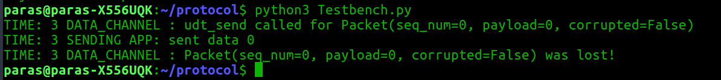

3. (b) Submitted as Protocol_rdt3.py

3.(c)

(Pc=0.2 is fixed for all cases)

Pl | T_avg
0 | 6.008
0.1 | 8.032
0.2 | 10.235
0.3 | 14.668
0.4 | 20.064
0.5 | 30.088
0.6 | 47.817
0.7 | 84.566
0.8 | 192.689
0.9 | 737.306

3. (d)

Channel.py code :

# SimPy model for an unreliable communication channel.
#
# A packet sent over this channel:
# - can get corrupted, with probability Pc
# - can get lost, with probability Pl
# - reaches the other end after "delay" amount of time, if it is not lost.
#
# Author: Neha Karanjkar

import simpy
import random
from Packet import Packet
import copy
class UnreliableChannel(object):

def __init__(self,env,Pc,Pl,delay,name):
# Initialize variables
self.env=env
self.Pc=Pc
self.Pl=Pl
self.delay=delay
self.receiver=None
self.name=name

def udt_send(self,packt_to_be_sent):
# this function is called by the sending-side
# to send a new packet over the channel.
packt=copy.copy(packt_to_be_sent) #!!! BEWARE: Python uses pass-by-reference by default.Thus a copy() is necessary
print("TIME:",self.env.now,self.name,": udt_send called for",packt)
# start a process to deliver this packet across the channel.
self.env.process(self.deliver_packet_over_channel(self.delay, packt))

def deliver_packet_over_channel(self, delay, packt_to_be_delivered):
packt=copy.copy(packt_to_be_delivered)
# Is this packet lost?
if random.random()<self.Pl:
print("TIME:",self.env.now,self.name,":",packt,"was lost!")
else:
# Is this packet corrupted?
if random.random()<self.Pc:
packt.corrupt()
print("TIME:",self.env.now,self.name,":",packt,"was corrupted!")
# Now wait for "delay" amount of time
delay=random.randint(1,9)
yield self.env.timeout(delay)
# deliver the packet by calling the rdt_rcv()
# function on the receiver side.
self.receiver.rdt_rcv(packt)

Output in Terminal :
