Grocyyyy🛒

About :

This website is dedicated to providing information of grocery store. You find the information on this website of the product available in the store and price of the product . Feel free to search the site for specific information about your basic essential needs.

ABSTRACT :

The adoption of online grocery shopping is growing rapidly at the moment. Studies have shown that the adoption of online grocery shopping by consumers differs across categories. In this study, participants were asked to indicate their preferences to buy specific grocery products either in a brick-and-mortar or in an online supermarket. Besides, respondents were asked personal questions to describe different consumer segments. Findings show that consumers prefer to purchase packaged goods in an online supermarket. However, consumers prefer to buy perishable food products with a high need of touch in a brick-and-mortar supermarket. In addition, the products characteristics that determine the decision to buy either in a brick-and-mortar supermarket or in an online supermarket are perishability, need of touch, packaging and speciality. Although consumer segments are hard to describe, consumer segments can be distinguished based on age, whereby millennials are more willing to shop grocery online. This study contributes to the literature about differences in online adoption of grocery categories and provides practical implications for novice online grocery retailers.

Introduction of the Project Online Grocery Ordering System:

The "Online Grocery Ordering System" has been developed to override the problems prevailing in the practicing manual system. This software is supported to eliminate and in some cases reduce the hardships faced by this existing system. Moreover this system is designed for the particular need of the company to carry out operations in a smooth and effective manner.

The application is reduced as much as possible to avoid errors while entering the data. It also provides error message while entering invalid data. No formal knowledge is needed for the user to use this system. Thus by this all it proves it is user-friendly. Online Grocery Ordering System, as described above, can lead to error free, secure, reliable and fast management system. It can assist the user to concentrate on their other activities rather to concentrate on the record keeping. Thus it will help organization in better utilization of resources.

Every organization, whether big or small, has challenges to overcome and managing the information of Customer, Grocery, Stock, Address, Product. Every Online Grocery Ordering System has different Grocery needs, therefore we design exclusive employee management systems that are adapted to your managerial requirements. This is designed to assist in strategic planning, and will help you ensure that your organization is equipped with the right level of information and details for your future goals. Also, for those busy executive who are always on the go, our systems come with remote access features, which will allow you to manage your workforce anytime, at all times. These systems will ultimately allow you to better manage resources.

Objective of Project on Online Grocery Ordering System:

The main objective of the Project on Online Grocery Ordering System is to manage the details of Grocery, Customer, Order, Stock, Product. It manages all the information about Grocery, Address, Product, Grocery. The project is totally built at administrative end and thus only the administrator is guaranteed the access. The purpose of the project is to build an application program to reduce the manual work for managing the Grocery, Customer, Address, Order. It tracks all the details about the Order, Stock, Product.

Functionalities provided by Online Grocery Ordering System are as follows:

* Provides the searching facilities based on various factors. Such as Grocery, Order, Stock, Product Online Grocery Ordering System also manage the Address details online for Stock details, Product details, Grocery. It tracks all the information of Customer, Address, Stock etc.
* Manage the information of Customer
* Shows the information and description of the Grocery, Order • To increase efficiency of managing the Grocery, Customer
* It deals with monitoring the information and transactions of Stock.
* Manage the information of Grocery • Editing, adding and updating of Records is improved which results in proper resource management of Grocery data.
* Manage the information of Stock Integration of all records of Product.

Grocyyyy🛒 Main page :

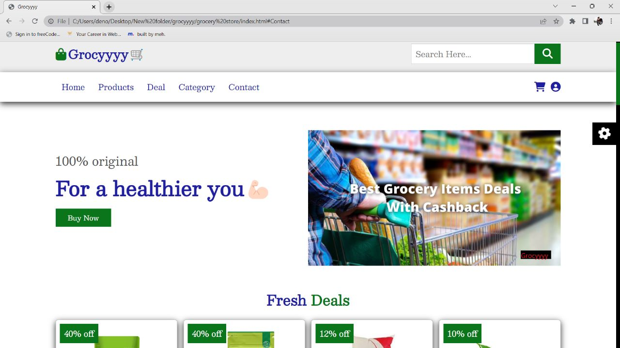

Category Page :

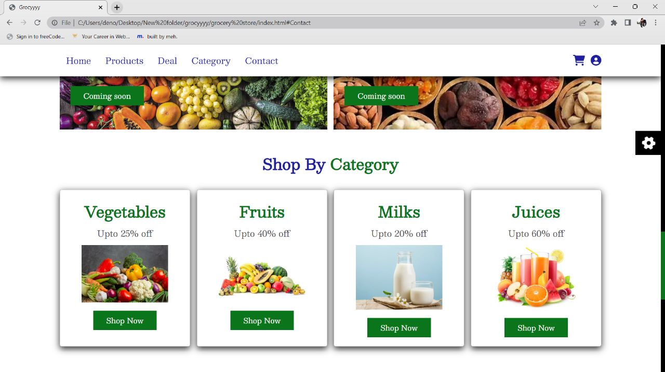

**App Overview :**

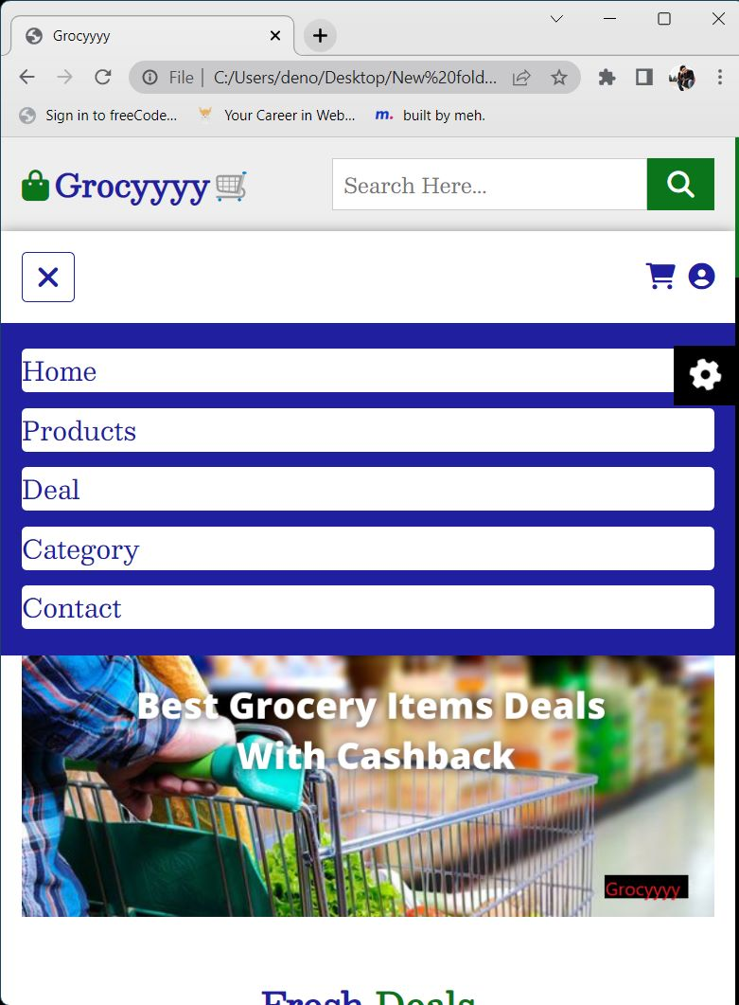

Deals Page :

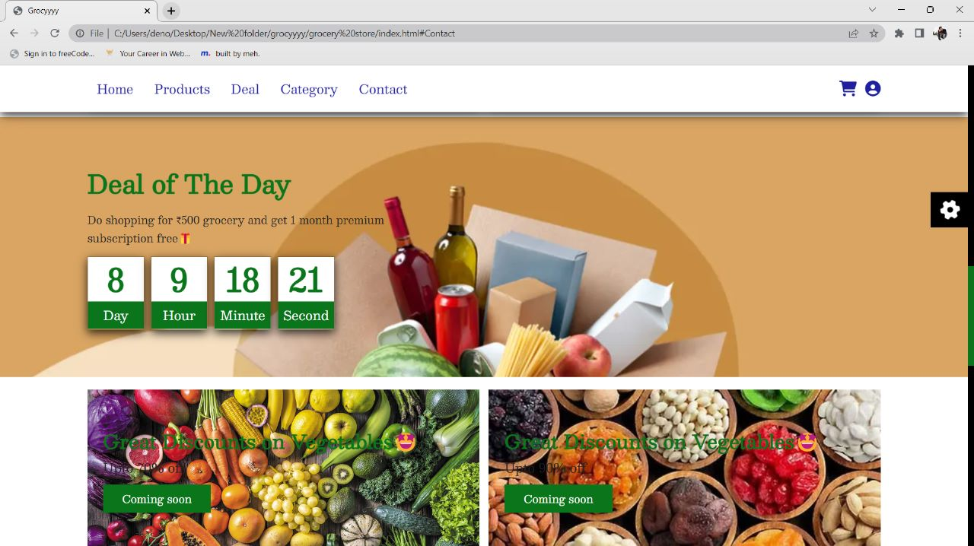

Contact us page :

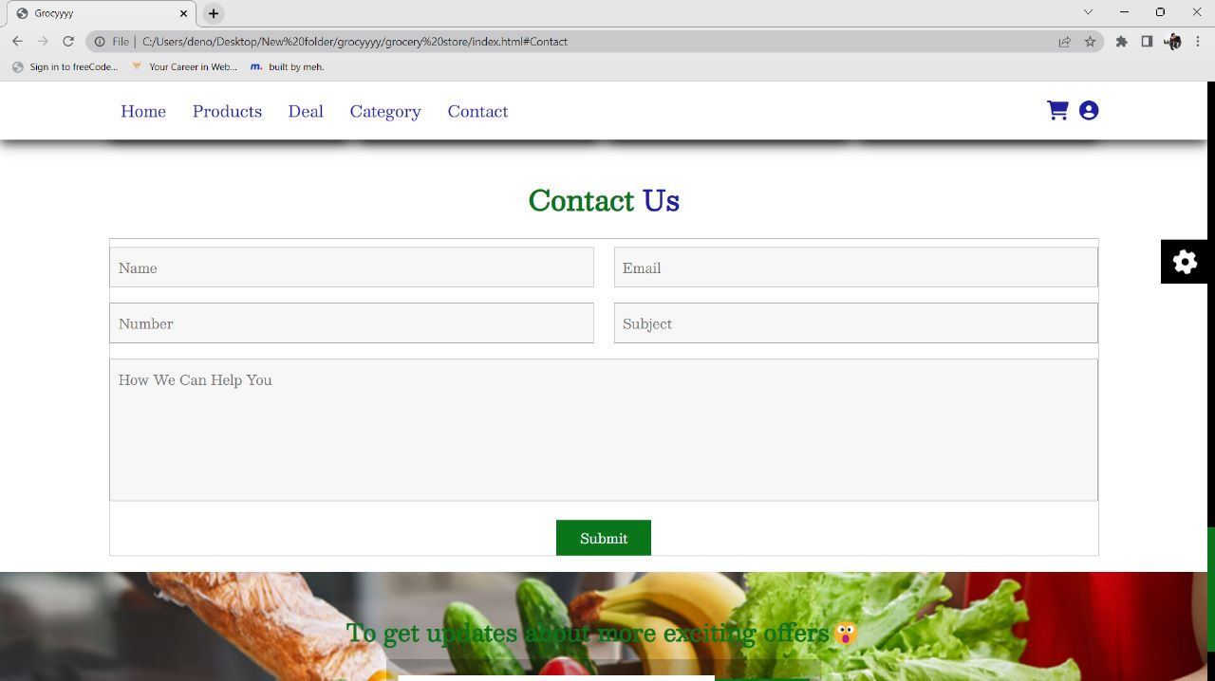

Products page :

Choose the color window :

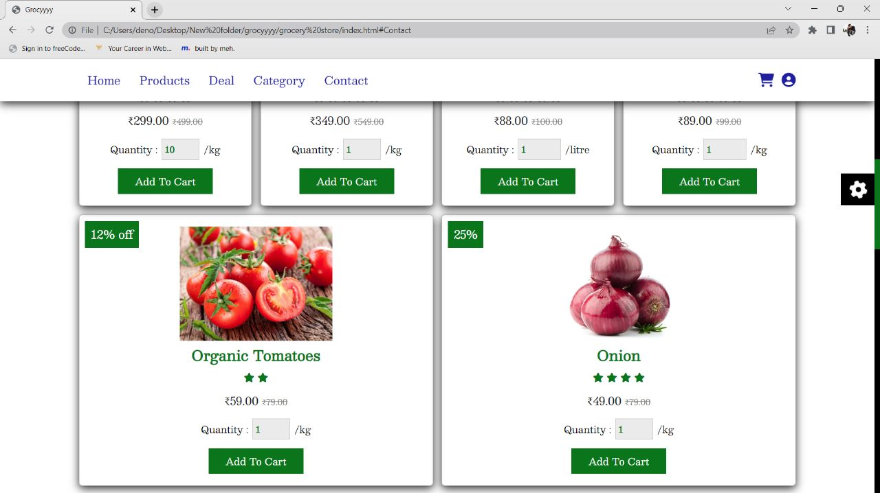

# PROPOSED MODEL:

# Grocyyyy🛒 has a easy to navigate interface and is user friendly. It asks the user to register themselves on the website the first time you visit and the next time you open the website again you can easily login into your account and get your saved data back.

# The website allows you to serve different grocery products over the internet and allows you to easily add them to your cart so that whenever you login again and want to buy the items you have saved in your cart you can whenever you want to. One of the benefits of the website is that it's very easy to use and even a person with no prior knowledge of online shopping can use it to order groceries.