HAND GESTURE RECOGNIZATION USING IMU SENSOR
SHUBHAM SHARMA ,SHUBHAM JAIN,PIYUSH TAYAL AND KARTIK RAJ

Abstract-The main objective of this project C.APPLICATIONS:-
is to create a wearable computer mosuse and By using java.awt.robot script different
keyboard interface.This is accomplished by gesture is assigned with different key
using Inertial Measurement Unit(IMU) sensor press command.The mouse pointer is
which give us the value of Yaw,Pitch and Roll. Controlled by the movement of hand.
The filtered training data is collected in matlab The human computer
for processing.Using the Neural Network interface has been sucessfully formed
Machine Learning Algorithm the 7 different and the system was purely controlled
gestures are recognised and using java.awt.robot by Hand Gestures.
script the interface has been formed through
which different tasks are performed using AKNOWLEDGEMENT
different gestures. We would like to thank our E-club
faculty advisor prof Sahu coordinators
INTRODUCTION Prakhar Jawre and Ayush Shakya and
From the invitation of computers we are using all the students involve in Summer
simply keyboards and mouse for performing Camp 2015-16.Their help,advice and
different tasks.Recently new technologies try guidance helped us develop and carry
to replace this,Hand gestures are very easy way out our research.
to interact so the main aim of this project is to
create human computer interface by using human REFERENCES
gestures. 1)Courseera.org
2)arduino.org
A.INERTIAL MESUREMENT UNIT:- 3)matlab documentation
IMU sensor gives you the value of Yaw,Pitch 4)Complimentary filters
and Roll by the use of Accelorometer,Gyroscope
and Magnetometer.Razor IMU has an arduino pro
mini so that data is directly obtained by
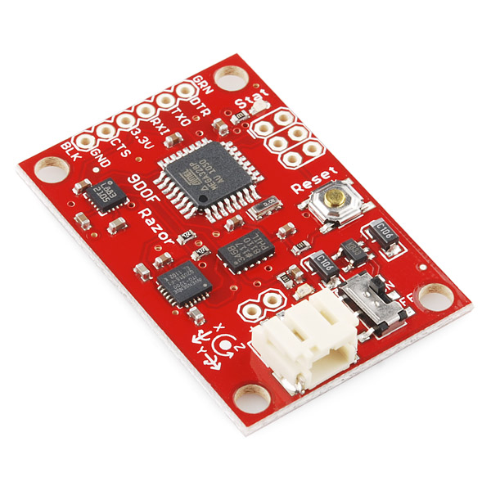
programming in arduino.The data is filtered by
applying complimentary filters to the data.Low pass
filters are applied to Accelorometer angle andy High
pass filters are applied to gyro angle and the value of
alpha is optimised.By choosing an appropriate alpha
value the data is filtered and stable data is obtained.

B.PROGRAMMING:-
The filtered data is collected in matlab by forming
an interface between arduino and matlab.The program
can be divided into two sections,training and testing.
The training portion of the program collect the IMU
data ,extract features,builds the Neural Network
Pattern Recognition Classifier and saves off the
classifier values.The second portion of the program
implement the interface in real time.It collects IMU
data classify IMU data and uses it for prediction

