**Experiment-6**

**Title-  
Write a program using radio button that will select any one of option from movie type(comedy, horror, action, thriller) and toast the message on submit button is clicked.**

**Source code link-https://github.com/ParasJava/RadioButtonApp**

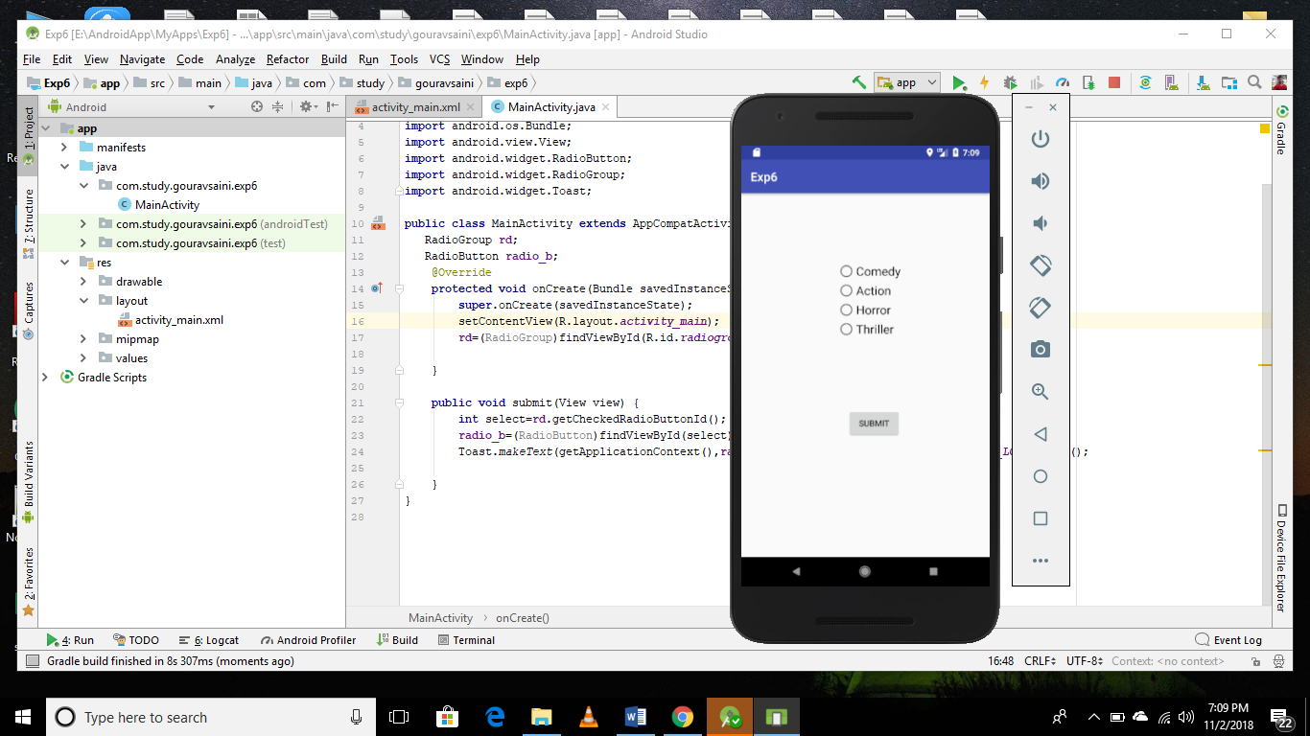 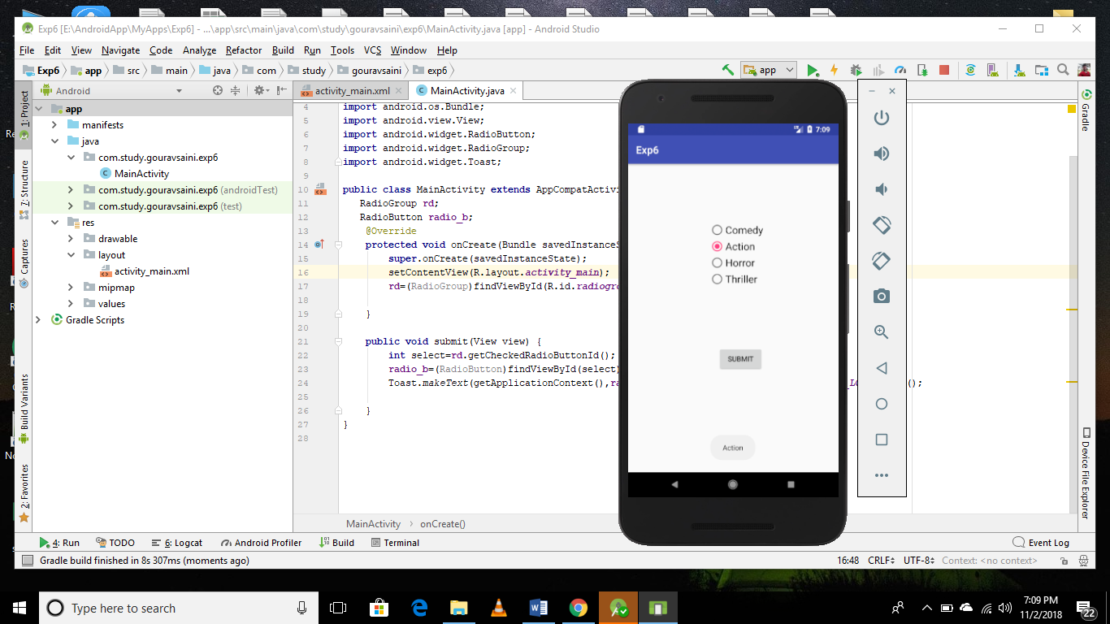

**MainActivity.java**

**public class** MainActivity **extends** AppCompatActivity {  
 RadioGroup **rd**;  
 RadioButton **radio_b**;  
 @Override  
 **protected void** onCreate(Bundle savedInstanceState) {  
 **super**.onCreate(savedInstanceState);  
 setContentView(R.layout.***activity_main***);  
 **rd**=(RadioGroup)findViewById(R.id.***radiogroup***);  
  
 }  
  
 **public void** submit(View view) {  
 **int** select=**rd**.getCheckedRadioButtonId();  
 **radio_b**=(RadioButton)findViewById(select);  
 Toast.*makeText*(getApplicationContext(),**radio_b**.getText().toString(),Toast.***LENGTH_LONG***).show();  
  
 }  
}