**Experiment-7**

**Title-**Write an Android app For Registration Form using Explicit Intent.

Source Code Link-https://github.com/ParasJava/RegistrationFormApp

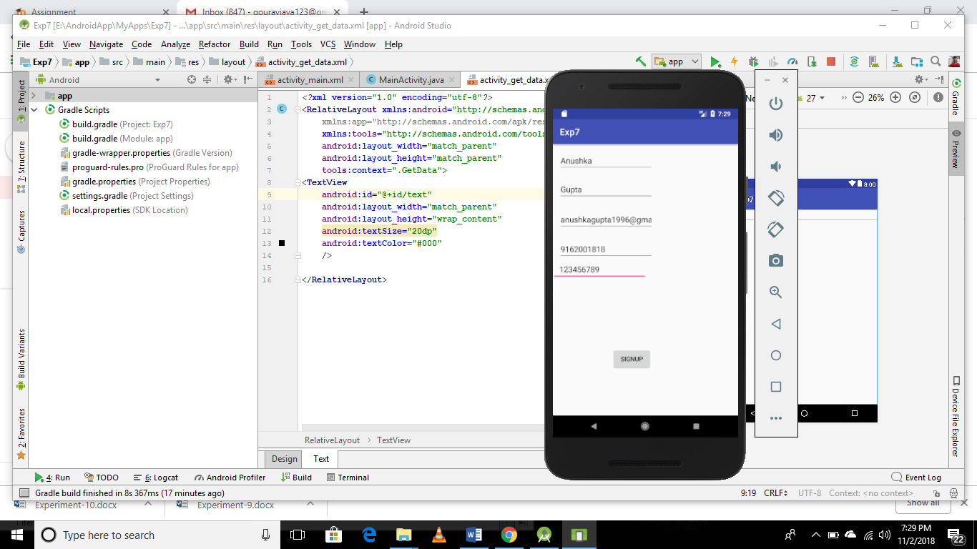 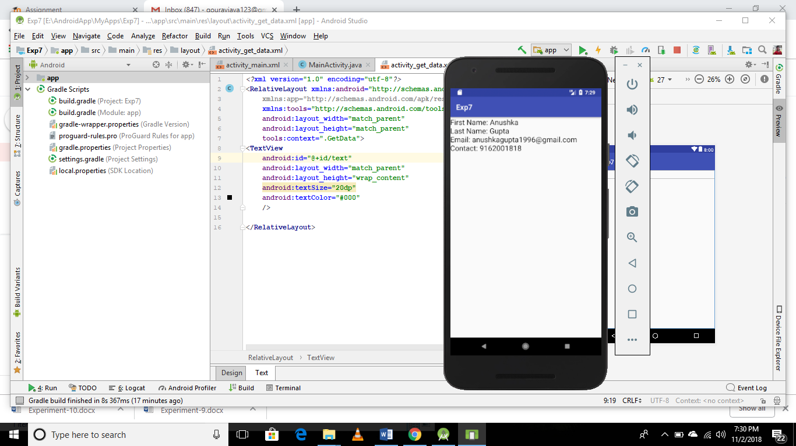

**MainActivity.java**

**public class** MainActivity **extends** AppCompatActivity {  
EditText **f_name**,**l_name**,**email**,**contact**,**password**;  
String **fname**,**lname**,**email_add**,**con**,**pass**;  
  
  
 @Override  
 **protected void** onCreate(Bundle savedInstanceState) {  
 **super**.onCreate(savedInstanceState);  
 setContentView(R.layout.***activity_main***);  
 **f_name**=findViewById(R.id.***fname***);  
 **l_name**=findViewById(R.id.***lname***);  
 **email**=findViewById(R.id.***email***);  
 **contact**=findViewById(R.id.***contact***);  
 **password**=findViewById(R.id.***password***);  
  
 }  
  
 **public void** submit(View view) {  
 **fname**=**f_name**.getText().toString();  
 **lname**=**l_name**.getText().toString();  
 **email_add**=**email**.getText().toString();  
 **con**=**contact**.getText().toString();  
 **pass**=**password**.getText().toString();  
 Intent myIntent = **new** Intent(**this**, GetData.**class**);  
 myIntent.putExtra(**"firstName"**, **fname**);  
 myIntent.putExtra(**"lastName"**, **lname**);  
 myIntent.putExtra(**"email"**,**email_add**);  
 myIntent.putExtra(**"contact"**,**con**);  
 startActivity(myIntent);  
  
 }  
}

**SecondActivity.java**

**public class SecondActivity extends** AppCompatActivity {  
TextView **txt**;  
  
 @Override  
 **protected void** onCreate(Bundle savedInstanceState) {  
 **super**.onCreate(savedInstanceState);  
 setContentView(R.layout.***activity_get_data***);  
 **txt**=findViewById(R.id.***text***);  
 Intent intent = getIntent();  
  
 String fName = intent.getStringExtra(**"firstName"**);  
 String lName = intent.getStringExtra(**"lastName"**);  
 String email=intent.getStringExtra(**"email"**);  
 String contact=intent.getStringExtra(**"contact"**);  
  
 **txt**.setText(**"First Name: "**+fName+**"\nLast Name: "**+lName+**"\nEmail: "**+email+**"\nContact: "**+contact);  
  
 }  
}