**Exprement-1**

**Create a basic Android application to display a string ”Welcome to Android” using strings.xml and  Explore the directory structure and components of the android application.**

**Source Code Link**- https://github.com/ParasJava/WelcomeApp

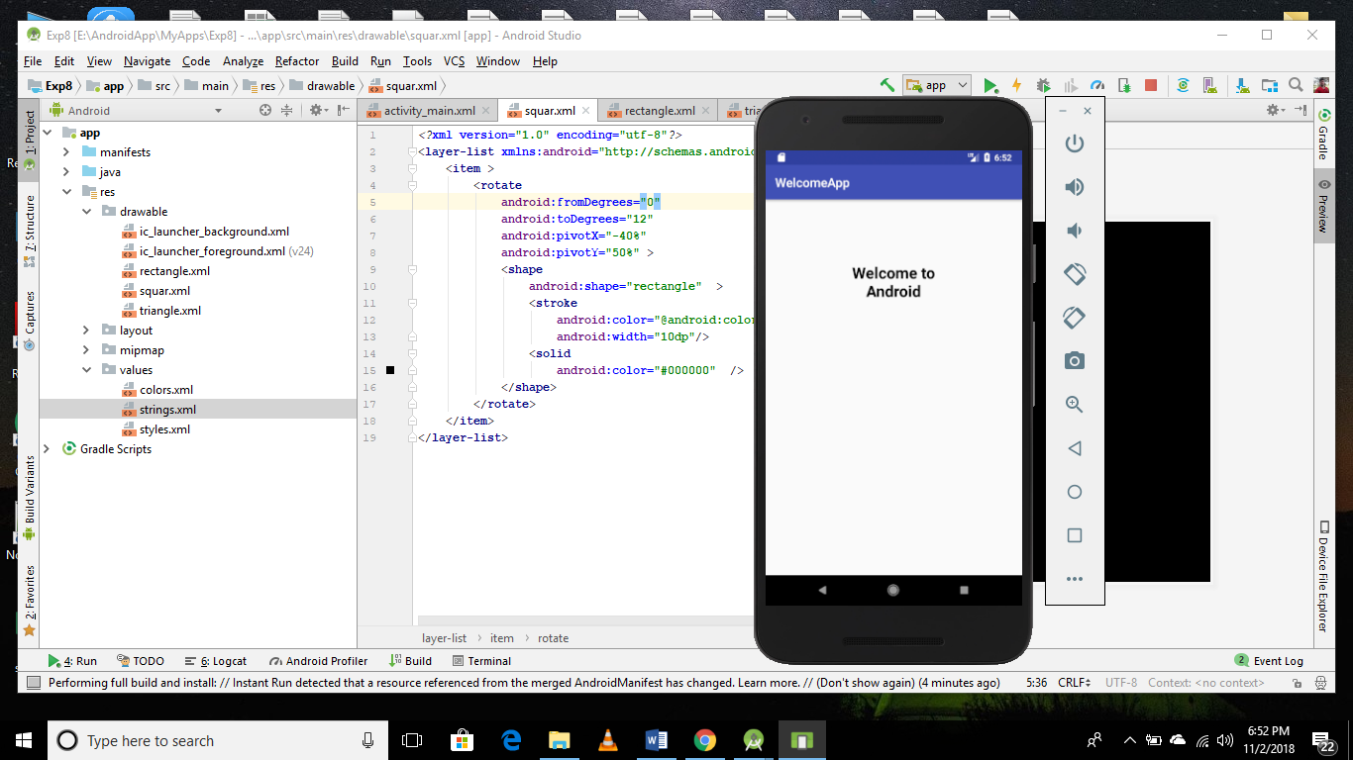

**Activity.xml**

*<?***xml version="1.0" encoding="utf-8"***?>*<**RelativeLayout xmlns:android="http://schemas.android.com/apk/res/android"  
 xmlns:app="http://schemas.android.com/apk/res-auto"  
 xmlns:tools="http://schemas.android.com/tools"  
 android:layout_width="match_parent"  
 android:layout_height="match_parent"  
 tools:context=".MainActivity"**>  
  
 <**TextView  
 android:layout_width="wrap_content"  
 android:layout_height="wrap_content"  
 android:padding="100dp"  
 android:gravity="center"  
 android:text="@string/welcome"  
 android:textColor="#000"  
 android:textSize="25dp"  
 android:textStyle="bold"** />  
  
</**RelativeLayout**>