**Jenkins**

Jenkins is an open source automation server written in Java. It is used to continuously build and test software projects, enabling developers to set up a CI/CD environment. It also supports version control tools like Subversion, Git, Mercurial, and Maven.

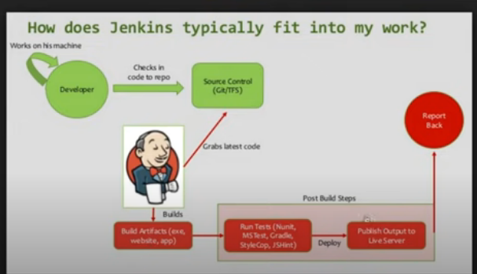

As mentioned in the below screenshot the Jenkins home directory, needs to be changed to place where disk space is more.

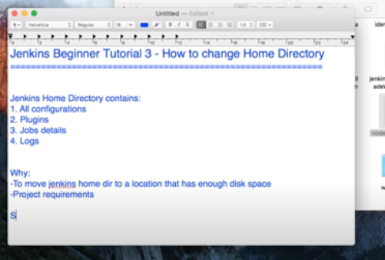

Steps to change home directory:

