Hibernate

Hibernate is a Java framework that simplifies the development of Java application to interact with the database. It is an open source, lightweight, ORM (Object Relational Mapping) tool.

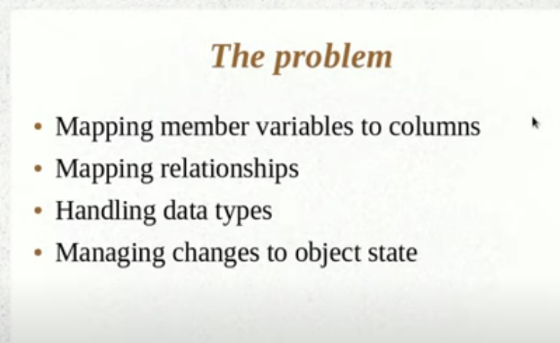

Hibernate internally uses JDBC to connect to the data base.