JavaScript is a dynamically typed language, meaning that variables' data types are determined by the value they hold at runtime and can change throughout the program as we assign different values to them.

**Const object in js can be changed i.e new value/object cannot be assigned but new keys can be added or existing keys can be modified.**

There are 2 methods in js:

1. Alert -> This just displays a string in browser
2. Prompt-> This asks for user input

There are 2 types of data type in javascript:

1. Primitive – null, number, Boolean, bigint, string, symbol, undefined
2. Non – primitive – Object

Object can be accessed by using 2 syntaxes:

1. objectName[‘key’]
2. objectName.key

Delete in array, deletes an array but length of array remains the same.

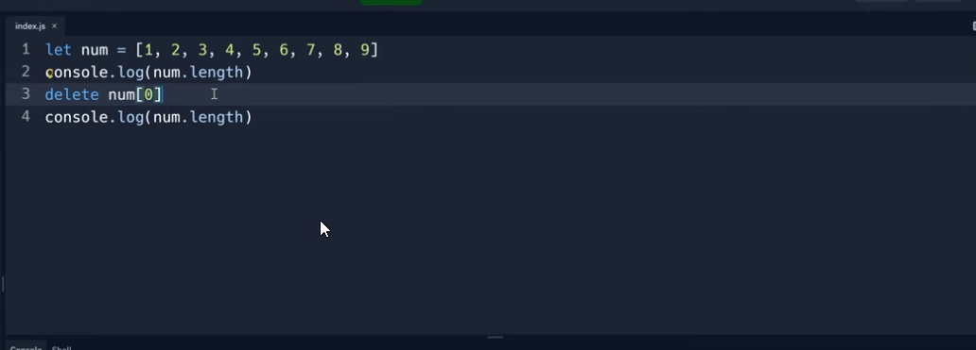

Sort method in array sorts the number alphabetically.

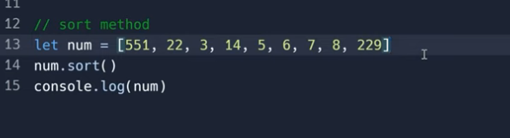

Console functions

time and timeEnd

These methods are used to calculate the execution time of any piece of code

