Typescript

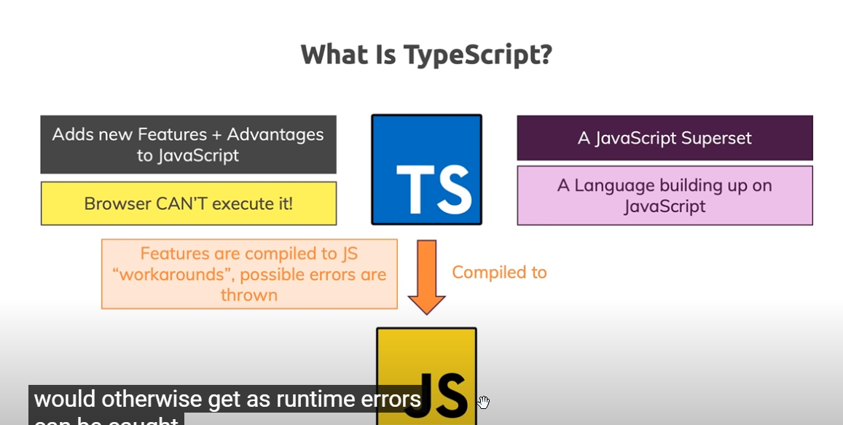

Typescript is built on top of Javascript and at runtime typescript code compiles to javascript.

It adds more features to javascript. It cannot be executed inside the browser. It also helps in detecting and fixing errors at compile time which are usually solved at runtime in javascript.

We can convert string value to number in javascript using + operator (infront of the variable).

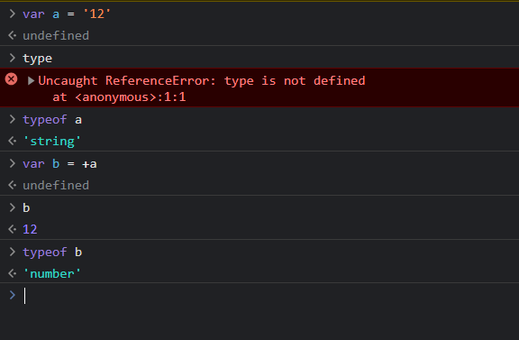

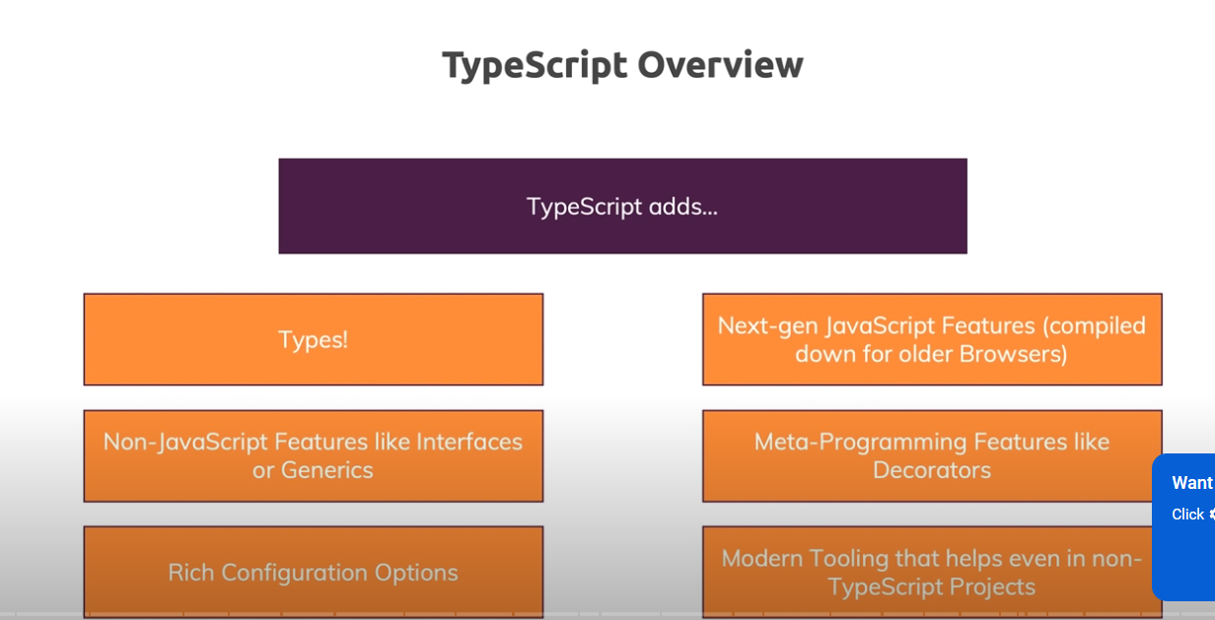

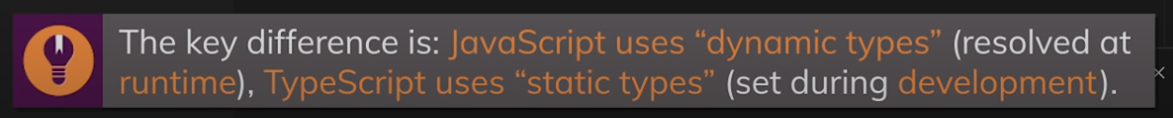

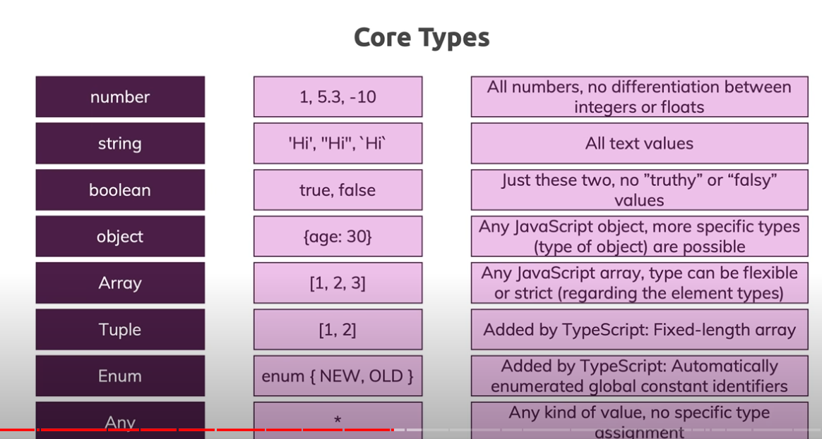

Union types in typescript

This means that value can be of multiple types. For example -

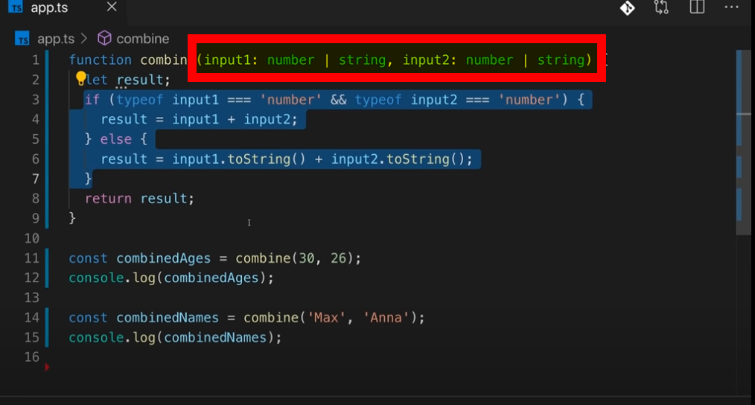

Literal types

Literal types in ts are fixed values which can only be assigned to a variable .For example-

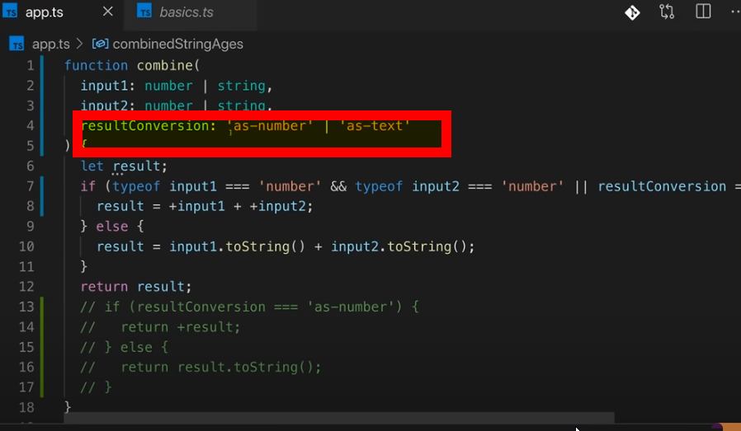

In the above image resultConversion can be either ‘as-number’ or ‘as-text’. It cannot hold any other value other than these 2 values.

Type Alias

Type Aliases allow defining types with a custom name (an Alias).

Type Aliases can be used for primitives like string or more complex types such as objects and arrays

type CarYear = number  
type CarType = string  
type CarModel = string  
type Car = {  
  year: CarYear,  
  type: CarType,  
  model: CarModel  
}  
  
const carYear: CarYear = 2001  
const carType: CarType = "Toyota"  
const carModel: CarModel = "Corolla"  
const car: Car = {  
  year: carYear,  
  type: carType,  
  model: carModel  
};

Unknown Type

It is a type which can hold any unknown value.

**Watch mode in typescript**

This mode helps in compiling all the typescript files whenever some changes has been made into it.

* tsc init

This command helps in initializing the typescript project. It will also create a tsconfig.json file.

* tsc -w

This will start a watch mode in typescript.

In tsconfig.json, we can include or exclude files that are to be included or excluded from the compilation process.

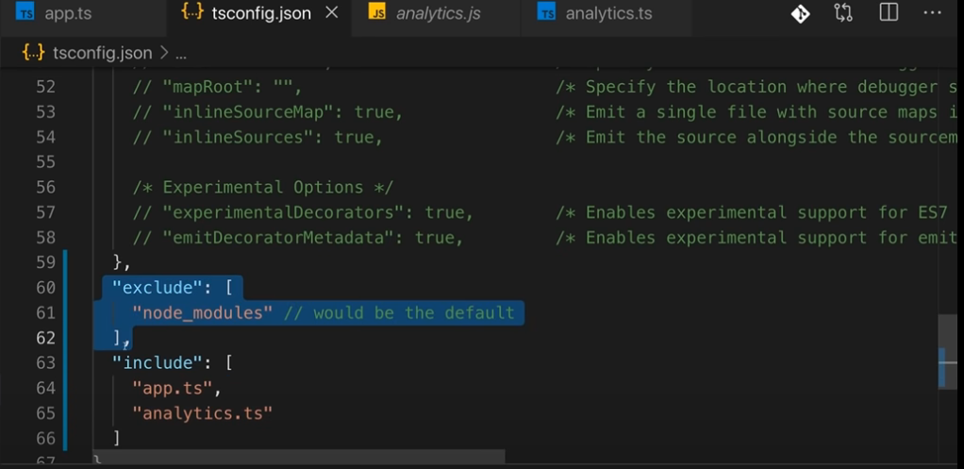

There are some compiler options available inside tsconfig.json file which we may use as per our requirements like :

1. target – In this, you may specify the targeted javascript version.
2. Libs – libraries which are to be included so that it can understand that these functionalities can be used inside typescript files.
3. Sourcemaps – It helps in debugging and development as source files i.e ts files are available inside Sources of the browser which helps us in debugging.
4. Outdir – All the generated files are kept at the path mentioned inside this attribute.
5. RemoveComments – all the comments present in ts file will be removed from generated js file.
6. noEmit – if it is set to true then it will not generate any output file.(js file)