//Final Query Ques 2//

select

J3.User_Name,

J3.Product_Name,

OQ.Ordered_Quantity,

J3.Amount_Paid,

J3.Last_Transaction_Date,

J3.Balance

from

(

(Select

B.Product_ID,

B.User_ID,

User_Name,

B.Product_Name,

B.Ordered_Quantity

from t_user_master

inner join

(Select

t_product_master.Product_ID,

User_ID,

Product_Name,

sum(Transaction_Amount)/Cost_Per_Item as Ordered_Quantity

from t_product_master

left join t_transaction on

t_product_master.Product_ID=t_transaction.Product_ID

and

t_transaction.Transaction_Type="Order"

group by User_ID,t_transaction.Product_ID

) B

on t_user_master.User_ID=B.User_ID

)

OQ

)

inner join

(

(

select

J2.User_Name,

J2.Product_Name,

J2.Product_ID,

J2.User_ID,

Amt.Amount_Paid,

J2.Last_Transaction_Date,

J2.Balance

from

(

(Select

Amp.Product_ID,

Amp.User_ID,

Amp.user_Name,

Product_Name,

Amp.Amount_Paid

from t_product_master

inner join

(

Select

user_Name,

Am.User_ID,

Am.Product_ID,

Am.Amount_Paid

from t_user_master

inner join

(

select

User_ID,

Product_ID,

Payment as Amount_Paid

from transact_pivot_pretty

) Am

on t_user_master.User_ID=Am.User_ID

)Amp

on t_product_master.Product_ID=Amp.Product_ID

)

Amt

)

inner join

(

(select

Lastdt.User_Name,

Lastdt.Product_Name,

Lastdt.Product_ID,

Lastdt.User_ID,

Lastdt.Last_Transaction_Date,

Balan1.Balance

from

(

(Select

Lstdate.Product_ID,

Lstdate.User_ID,

Lstdate.user_Name,

Product_Name,

Lstdate.Last_Transaction_Date

from t_product_master

inner join

(

Select

user_Name,

Ldate.Product_ID,

Ldate.User_ID,

Ldate.Last_Transaction_Date

from t_user_master

inner join

(

select

User_ID,

Product_ID,

max(Transaction_Date) as Last_Transaction_Date

from t_transaction

group by User_ID,Product_ID

) Ldate

on t_user_master.User_ID=Ldate.User_ID

)Lstdate

on t_product_master.Product_ID=Lstdate.Product_ID

) Lastdt

)

inner join

(

(

Select

Balan.Product_ID,

Balan.User_ID,

Balan.user_Name,

Product_Name,

Balan.Balance

from t_product_master

inner join

(

Select

user_Name,

Bal.User_ID,

Bal.Product_ID,

Bal.Balance

from t_user_master

inner join

(

select

User_ID,

Product_ID,

Payment-Orderr as Balance

from transact_pivot_pretty

) Bal

on t_user_master.User_ID=Bal.User_ID

)Balan

on t_product_master.Product_ID=Balan.Product_ID

) Balan1

)

on Lastdt.Product_ID=Balan1.Product_ID

and

Lastdt.User_ID=Balan1.User_ID

) J2

)

on Amt.Product_ID=J2.Product_ID

and

Amt.User_ID=J2.User_ID

)J3

)

on OQ.Product_ID=J3.Product_ID

and

OQ.User_ID=J3.User_ID

//Output//

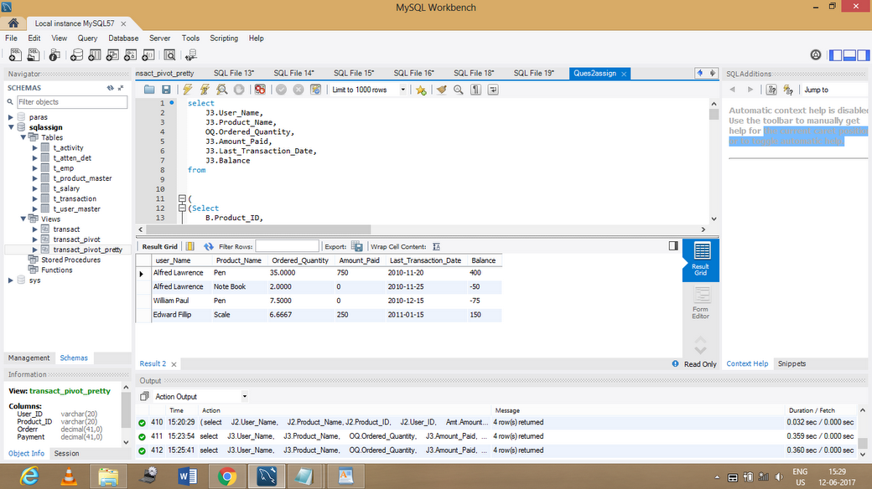

//Query 4.1//

select

Emp_f_name,

Emp_m_name,

Emp_l_name,

Emp_DOB

from t_emp

where Emp_DOB like '%-01-31' or

Emp_DOB like '%-02-28' or

Emp_DOB like '%-03-31' or

Emp_DOB like '%-04-31' or

Emp_DOB like '%-05-31' or

Emp_DOB like '%-06-31' or

Emp_DOB like '%-07-31' or

Emp_DOB like '%-08-31' or

Emp_DOB like '%-09-31' or

Emp_DOB like '%-10-31' or

Emp_DOB like '%-11-31' or

Emp_DOB like '%-12-31' ;

// Query 4.2//

(select N.Year,N.Month,N.Day,N.name,N.Atten_end_hrs,

case when Day = '13' then N.Atten_end_hrs end as "13",

case when Day = '16' then N.Atten_end_hrs end as "16",

case when Day = '17' then N.Atten_end_hrs end as "17",

case when Day = '19' then N.Atten_end_hrs end as "19",

case when Day = '14' then N.Atten_end_hrs end as "14"

from

(select

(year(M.Atten_start_datetime)) as Year,

(monthname(M.Atten_start_datetime)) as Month,

day(M.Atten_start_datetime)as Day,M.name,sum(M.Atten_end_hrs) from

(

select t_atten_det.Emp_id,

Atten_end_hrs,

concat(coalesce(Emp_f_name,""),

" ",

coalesce(Emp_m_name,""),

" ",

coalesce(Emp_l_name,"")) as name,t_atten_det.Atten_start_datetime

from t_atten_det inner join t_emp on t_atten_det.Emp_id=t_emp.Emp_id

group by t_emp.Emp_id,t_atten_det.Atten_start_datetime

)M

group by Year,Month,Day,M.name

) N);