**PG Program in Analytics** 

**Statistics and Probability Exam Questions Time: 2hrs**

**1.** From the pack of 52 cards, three cards are drawn randomly without replacement then what is the probability that one card is a diamond, one card is a heart and one is spade?

**2.** If a twelve-sided fair dice is rolled (with numbers from 1 to 12), what is the probability that the result would either be an odd number or a perfect square.

**3.** A bag *A* contains 3 red and 5 black balls and bag *B* contains 4 white and 7 black balls. A bag is selected randomly and a ball is drawn from it. A drawn ball is observed to be black. Find the probability that bag ‘*B’* was selected.

**4.** Ten percent of screws produced in a certain factory turn out to be defective. Find probability that in a sample of 10 screws chosen at random exactly 2 will be defective. Data follows binomial distribution

### **5.** Assume mean height of soldiers to be 68.22 inches with a variance of 10.8 inches square. Data is normally distributed. How many soldiers in a regiment of 1000 would you expect to be over 6 feet tall? (1 feet = 12inches)

**6.** Suppose prices of new flats in Manchester are normally distributed with an average of $350870 and a standard deviation of $12405. Find the 75th percentile of prices among new homes in Manchester.

#### 7. If 10% of bolts manufactured by a machine are defective. Data follows binomial distribution. Determine the probability that out of 10 bolts

a) 1 bolt chosen at random is defective.  
b) None of the bolts are defective  
c) At most 2 bolts are defective

**8.** Annual project of university done by three groups of students with equal sample sizes. Each group was given a different task. After the final presentation students get the marks. The summary statistics are given below:



Using One-Way ANOVA, calculate F – statistics and SST

**9.** The number of pizzas sold per day by a food zone "Pizza per Pizza" follows a Poisson distribution at a rate of 76 pizzas per day. What is the probability that the number of pizza sales exceeds 80 in a day? Write Python code to calculate the probability.

**10.** In the population, the mean weight is 82. A team of dietitians wants to test a new protein supplier to see if it has either a positive or negative effect on diet, or no effect at all. A sample of 25 participants who have taken the protein supplier has a mean of 95 with standard deviation is 20. Test the claim where alpha=0.05 and critical value is 2.064.

**11.** A food services manager for a baseball park wants to know if there is a relationship between gender (male or female) and the preferred condiment on a hot dog. The following table summarizes the results. Test the hypothesis using Chi Square Test of independence with a significance level of 5%.

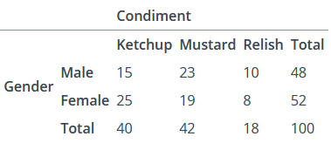

### **12.** An online medicine shop claims that the mean delivery time for medicines is less than 120 minutes with a standard deviation of 30 minutes. Is there enough evidence to support this claim at a 0.05 significance level if 49 orders were examined with a mean of 100 minutes? Critical value is -1.645

### **13.** The National Transportation Safety Board (NTSB) wants to examine the safety of compact cars, midsize cars, and full-size cars. It collects a sample of three for each of the treatments (cars types). Using the hypothetical data provided below, test whether the mean pressure applied to the driver’s head during a crash test is equal for each types of car. Use One Way Anova test at α = 5%. f_crit=5.1433. Also determine SSR, SSE, SST, MSR, MSE and f-stat

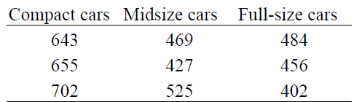

### **14.** By using NLP, spam e-mails can be detected. Assume that the word ‘offer’ occurs in 80% of the spam messages in the inbox. Also, let’s assume ‘offer’ occurs in 10% of the desired e-mails. 30% of the received e-mails are considered as a spam. If the new mail received contains ‘offer’, what is the probability that it is spam? (Note - Desired mails are non-spam mails)