
DATA STRUCTURES AND ALGORITHMS -- 23CSE203
Submitted by
Name | S. Siva Karthikeya
Roll No | AV.SC.U4CSE25050
Year/sem/section | 2ND year/sem-3/CSE-A
Credits | 5

Submitted to

Name | DR. RAJKUMAR BATCHU
Department | School of computing
Designation | Asst. professor(SI. Grade)

s.no | title | Page no | remarks
1 | WEEK 1: 1a. Recursive countdown from n to Launch. 1b. Recursive calculation of compound growth factor. 1c. Recursive search for employee ID in list. 1d. Recursive factorial calculation for parcel arrangements. 1e. Recursive Fibonacci series generation.
2 | WEEK 2: 2a. Write a python program to perform linear search on the give input. 2b. Write a python program to perform binary search on the given. Verify by taking sorted array as an input. 2b. Write a python program to perform binary search on the given. Verify by taking unsorted array as an input.
3 | WEEK 3: 3a.write a python program to perform  Bubble sort. Verify by taking unsorted array as an input. 3b. Write a python program to perform Insertion sort on the given. Verify by taking unsorted array as an input. 3c. Write a python program to perform Selection sort on the given. Verify by taking unsorted array as an input.

WEEK-1
1A.AIM:A Rocket launch system displays a countdown before launch. Instead of suing a loop, implement the countdown using recursion. Write a recursive python program to display a countdown from n to 1 followed by “launch”.
Code:
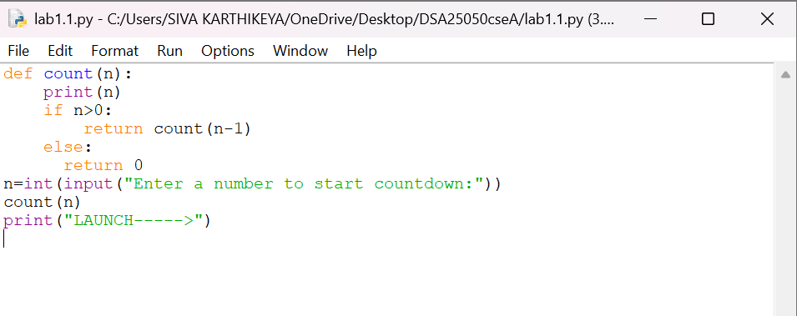

OUTPUT:
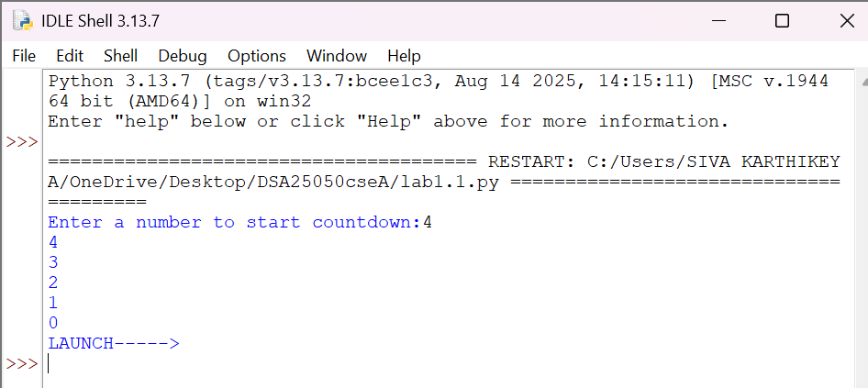
Explanation
Condition 1: Positive Input (n > 0)
- The function checks whether n == 0.
- Since n is positive, the condition is False.
- It executes:
- print(n) → prints the current value of n.
- countdown(n-1) → calls the same function again with n-1.
- This process continues until n becomes 0.
- When n == 0, the condition becomes True.
- It prints launch.
- The return statement stops that function call.
- Then the recursive calls return one by one.
- Since there is no value returned by the function, it returns None.
Condition 2: Zero Input (n == 0)
- The function checks if n == 0.
- The condition is immediately True.
- It prints launch.
- The return statement stops the function.
- No recursive call takes place.
- The function returns None.
Condition 3: Negative Input (n < 0)
- The condition n == 0 is False.
- It prints the negative value.
- Then it calls itself with n-1, making the value even more negative.
- Therefore, it will never reach 0.
- The recursion continues indefinitely.
- Eventually, Python raises a RecursionError because the maximum recursion depth is exceeded
SNO: | Error obtained | Rectification
1. | Negative input in countdown | Add a condition to handle negative numbers before recursion.

1B. Aim: Banks calculate the growth of an investment using compound interest. The formula requires calculating powers, which can be implemented recursively. Write a recursive program to calculate p(n) where p=principal growth, n= no. of years.
Code:
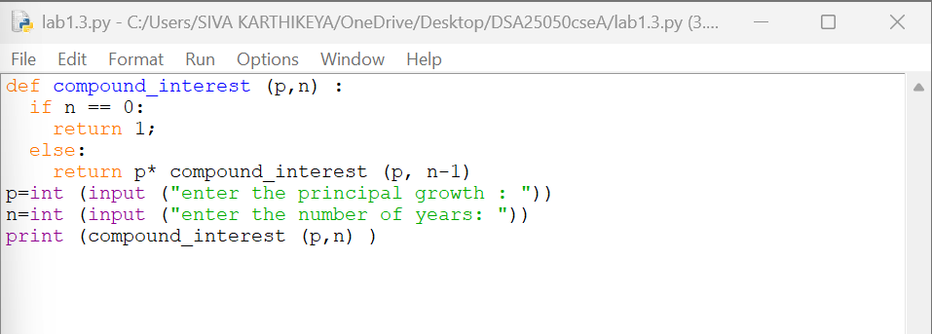
OUTPUT:
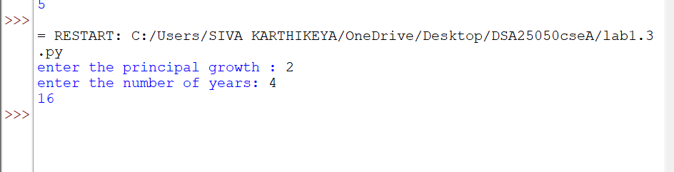

Explanation
Condition 1: n > 0
- The function compound_interest(p, n) is called with the principal amount p and number of years n.
- The function checks whether n == 0.
- Since n is greater than 0, the condition is False.
- It executes the else block.
- It calculates:
- p * compound_interest(p, n-1)
- The function calls itself recursively with n-1.
- This process continues until n becomes 0.
- Each recursive call multiplies p one more time.
- Therefore, the function calculates pⁿ.
Condition 2: n == 0
- When n becomes 0, the condition n == 0 becomes True.
- The function returns 1.
- This 1 acts as the base case for the multiplication.
- The recursive calls then return one by one.
- Each returned value is multiplied by p.
- Finally, the result is printed using print(compound_interest(p,n))
Error table:
Sno: | Error | Rectification
1 | Wrong recursive value | Updated the recursive value correctly

1C. AIM . An Hr department stores employee IDs in a list .Develop a recursive program to search for a given employee ID write a recursive function to search for an employee ID in a list.
Code:
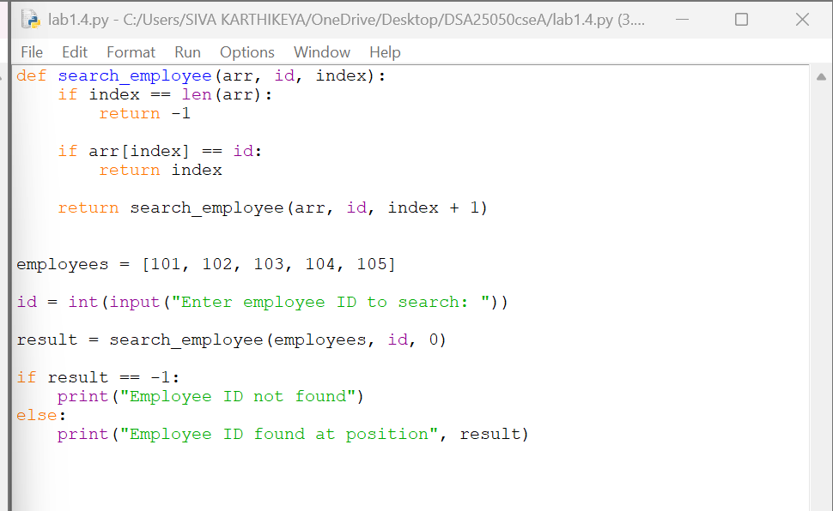
OUTPUT:
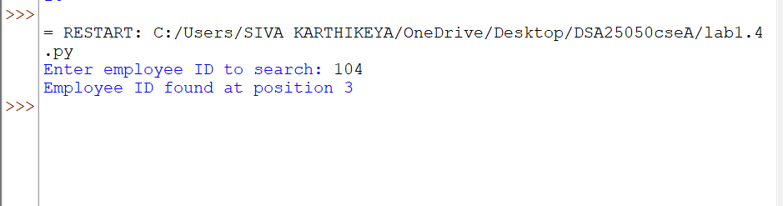
Explanation
Condition 1: index == len(emp_list)
- The function checks whether index has reached the length of the employee list.
- If index == len(emp_list), it means we have checked all employee IDs.
- The employee ID was not found.
- The function returns False.
- No further recursion takes place.
Condition 2: emp_list[index] == emp_id
- The function checks whether the current employee ID is equal to the ID we are searching for.
- If both IDs are equal, the condition becomes True.
- The function returns True.
- The recursion stops because the employee ID has been found.
Condition 3: Employee ID does not match
- If the current employee ID is not equal to emp_id, the condition is False.
- The function calls itself recursively with:
- index + 1
- This moves to the next employee ID in the list.
- The process continues until:
- The employee ID is found, or
- The entire list is checked.
Error table:
Sno: | Error | Rectification
1 | Missing return statement | Add the required return statement

1D. AIM. In a logistics company , the no . of possible ways to arrange in different parcels is calculated using the factorial formula (n!). Develop a recursive program to calculate the factorial of a given number.
Code:
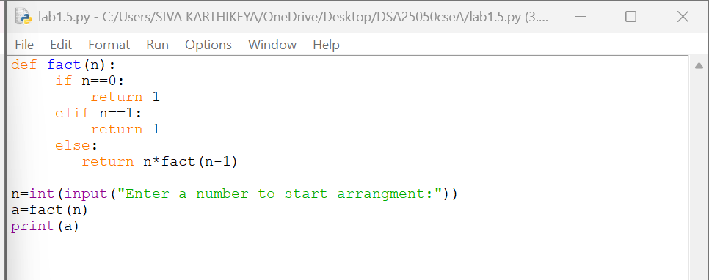
OUTPUT:
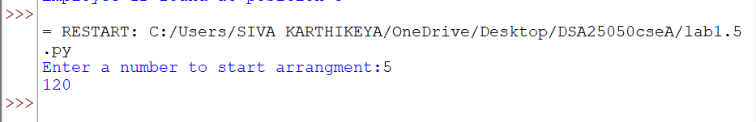
Explanation
Condition 1: Negative Input (n < 0)
- The program first checks whether n < 0.
- If n is negative, the condition is True.
- Factorial is not defined for negative numbers.
- It prints:
Factorial is not defined for negative numbers.
- The factorial() function is not called.
Condition 2: Base Case (n == 0 or n == 1)
- Inside the factorial() function, it checks:
n == 0 or n == 1
- If n is 0 or 1, the condition is True.
- The function returns 1.
- This is the base case of the recursion.
- It stops further recursive calls.
Condition 3: n > 1
- If n is greater than 1, the condition n == 0 or n == 1 is False.
- The else block is executed.
- It returns:
n * factorial(n - 1)
- The function calls itself with n - 1.
- This continues until n becomes 1.
- Then the returned values are multiplied together
Error table:
Sno: | Error | Rectification
1 | Wrong recursive value | Updated the recursive value correctly

1E. AIM. Write a recursive program to print the first n terms of the fibonacci series
Code:
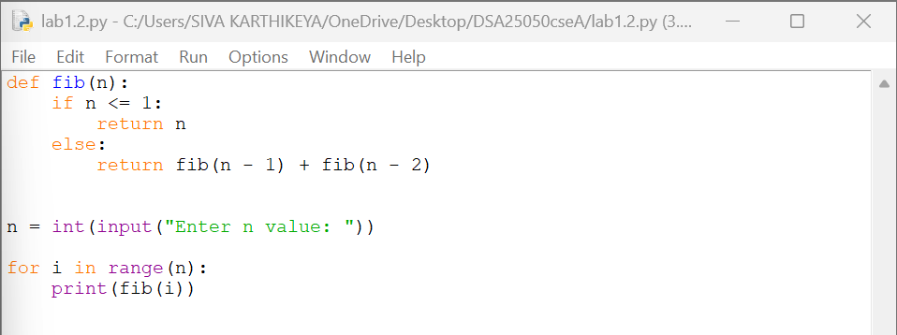
OUTPUT:
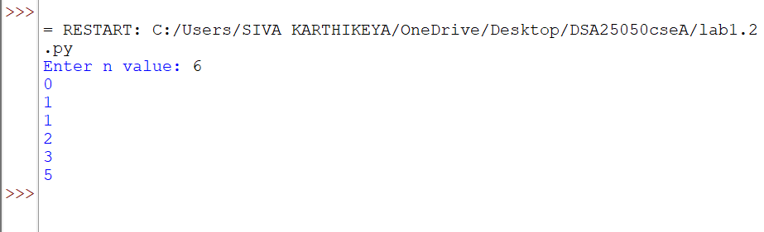
Explanation
Condition 1: n == 0
- The function checks whether n == 0.
- If the condition is True, the function returns 0.
- This is the first base case.
- No further recursive call takes place.
Condition 2: n == 1
- If n is not 0, the function checks whether n == 1.
- If the condition is True, the function returns 1.
- This is the second base case.
- No further recursive call takes place
Condition 3: n > 1
- If n is neither 0 nor 1, both conditions are False.
- The else block is executed.
- The function calls itself two times:
- fibonacci(n - 1)
- fibonacci(n - 2)
- The two returned values are added together.
- This process continues until the base cases n == 0 and n == 1 are reached.

Error table:
S.NO | Error obtained | Rectification
1 | Wrong recursive value | Updated the recursive value correctly

Week-2
2a. AIM: Write a python program to perform linear search on the give input.
Code:
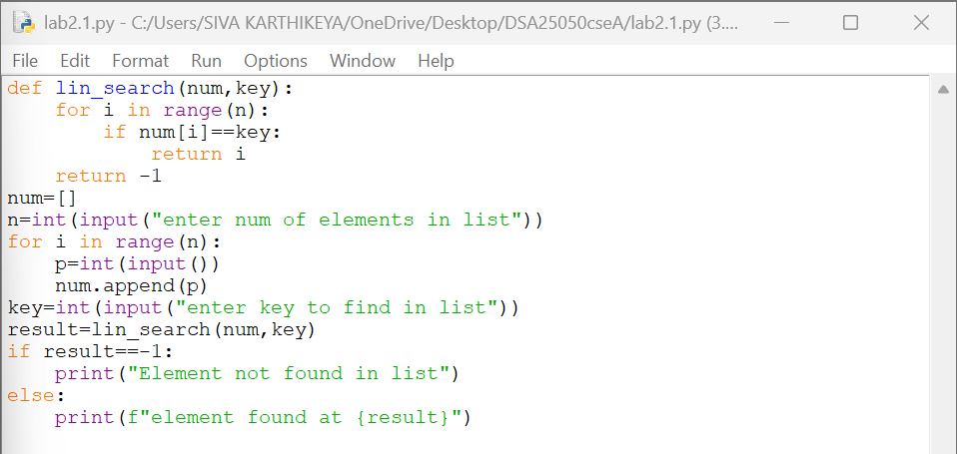
OUTPUT:
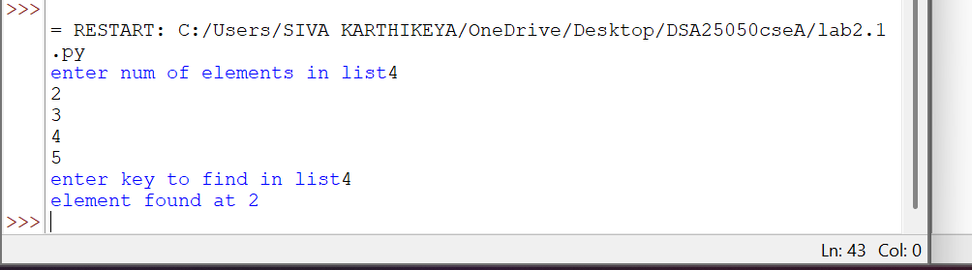
Explanation
Condition 1: Element is Found (arr[i] == k)
- The function linear_search(arr, k) receives the array arr and the search element k.
- The for loop starts from the first element of the array.
- It checks each element one by one using:
arr[i] == k
- If the current element is equal to k, the condition becomes True.
- The function immediately returns the index i.
- Since the function returns the index, the loop stops immediately.
- The remaining elements are not checked.
Condition 2: Element is Not Found
- The loop checks every element in the array.
- If none of the elements is equal to k, the if condition is always False.
- After the loop finishes, the statement return -1 is executed.
- -1 indicates that the search element is not present in the array.
Error table:
Sno: | Error | Rectification
1 | infinite loop because i never incremented. | I valued incremented in while loop.

2b. AIM: Write a python program to perform binary search on the given. Verify by taking sorted array as an input.
Code:
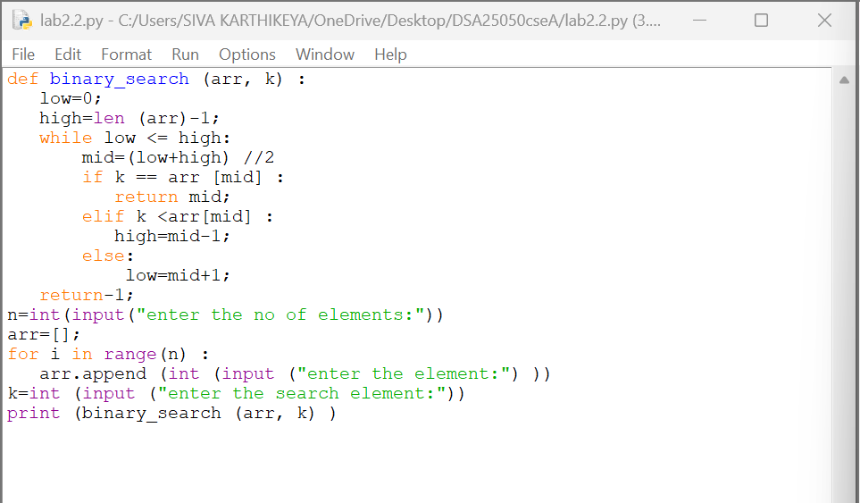
OUTPUT:
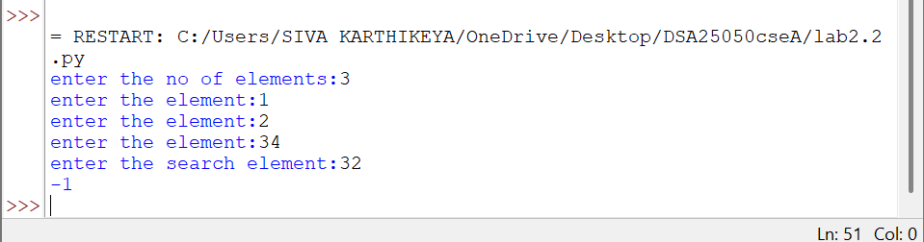
Explanation
Condition 1: k == arr[mid] — Element Found
- The function binary_search(arr, k) receives the array and the search element.
- low is initialized to 0, which represents the first index.
- high is initialized to len(arr)-1, which represents the last index.
- The while loop runs as long as low <= high.
- mid is calculated using:
mid = (low + high) // 2
- The middle element is compared with the search element k.
- If k == arr[mid], the element is found.
- The function returns the index mid and stops searching.
Condition 2: k < arr[mid] — Search Left Half
- If k is smaller than the middle element, the condition is True.
- This means the search element can only be present in the left half.
- Therefore:
high = mid - 1
- The right half is eliminated.
- The process continues with the remaining left half
Condition 3: k > arr[mid] — Search Right Half
- If k is greater than the middle element, the elif condition is False.
- The else block is executed.
- This means the search element can only be present in the right half.
- Therefore:
low = mid + 1
- The left half is eliminated.
- The process continues with the remaining right half.
Condition 4: low > high — Element Not Found
- The while loop continues until low <= high becomes False.
- When low > high, there are no elements left to search.
- This means the search element is not present in the array.
- The function returns -1.
Error table:
Sno: | Error | Rectification
1 | Writing high = len(arr) | Writing high = len(arr)-1

WEEK-3:
- Write a Python Program to implement Bubble-Sort, where the Input Elements are taken by the User

Input code: -
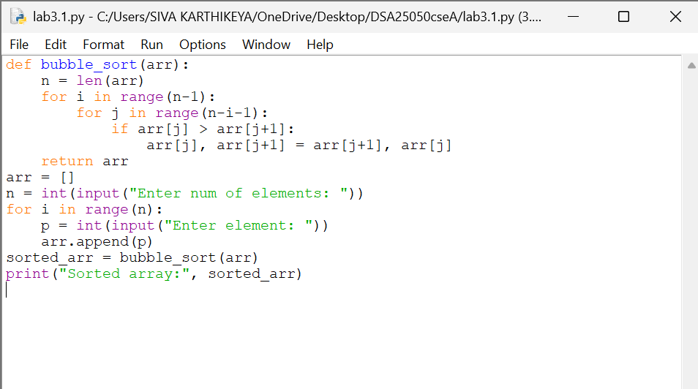

Output : -
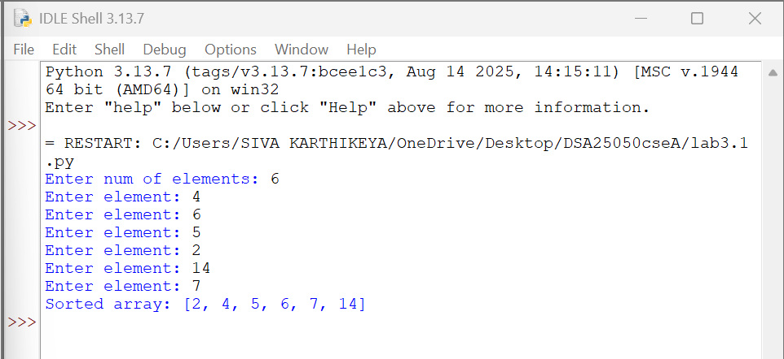

Explanation: -

- Read the size and elements of the list from the user and store them in arr.
- The outer for loop runs through the list multiple times to sort all the elements.
- The inner for loop compares two adjacent elements, arr[j] and
arr[j+1].
- The comparison is made between the current element and the next element to check whether they are in the correct order.
- If the first element is greater than the second, they are swapped using:
arr[j], arr[j+1] = arr[j+1], arr[j]
- After each pass, the largest unsorted element moves towards the end of the list.
- The inner loop compares fewer elements in each subsequent pass because the elements at the end are already in their correct positions.
- After all the passes, the elements are arranged in ascending order, and
return arr returns the sorted list.

Error table:
Sno: | ERROR | RECTIFICATION
1 | Invalid Syntax. | By keeping the colon (:) in the if loop the error solved

- Write a Python Program to implement Insertion-Sort, where the Input Elements are taken by the User.

Input code:
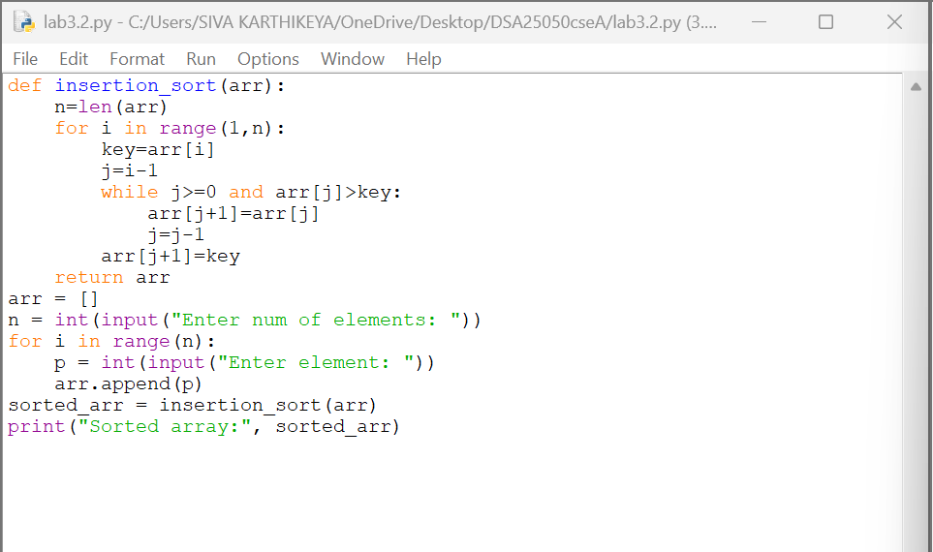

Output : -
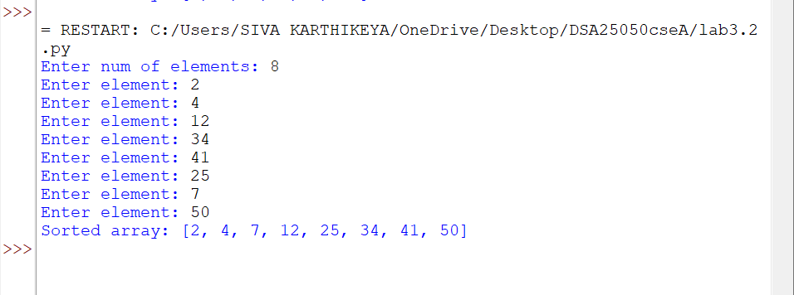
Explanation: -
- Read the size and elements of the list from the user and store them in arr.
- The for loop starts from the second element, considering the first element as already sorted.
- The current element is stored in a variable called key, which is the element that needs to be placed in its correct position.
- A variable called j is used to point to the element just before the key.
- The while loop compares the key with the previous elements of the sorted part of the list.
- If a previous element is greater than the key, it is shifted one position to the right, and j is moved one position to the left.
- This shifting continues until a smaller element is found or the beginning of the list is reached. Then, the key is inserted into its correct position.
- The process is repeated for all elements, and after all iterations, return arr returns the sorted list in ascending order.

ERROR TABLE:

SNO | ERROR | RECTIFICATION
1 | Accesses invalid array position  Using a[i-1] when i = 0 | Initializing  i=1.

- Write a Python Program to implement Selection-Sort, where the Input Elements are taken by the User.

Input code: -
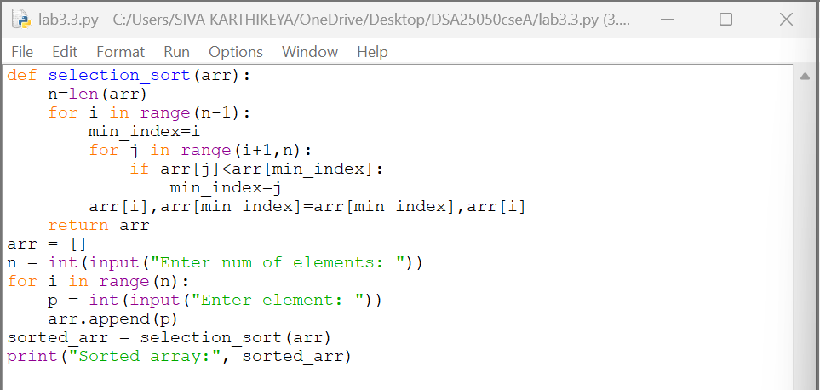

output : -
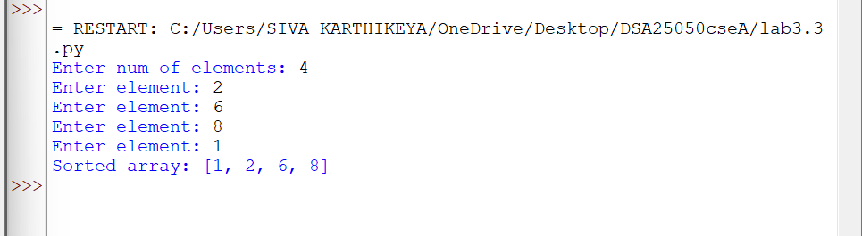
Explanation: -
- Read the size and elements of the list from the user and store them in arr.
- The outer for loop selects each position of the array one by one, starting from the first position.
- A variable called min_index is used to store the index of the smallest element found.
- The inner for loop compares the current minimum element with the remaining elements of the list.
- If a smaller element is found, its index is stored in min_index.
- After finding the smallest element, it is swapped with the element at the current position using:
arr[i], arr[min_index] = arr[min_index], arr[i]
- This process is repeated until the entire list is sorted and return arr
returns the sorted list in ascending order.
ERROR TABLE:

SNO | ERROR | RECTIFICATION
1 | Using invalid array index | Rectified runtime/undefined behavior.
- Write a Python Program to implement merge-Sort, where the Input Elements are taken by the User.

Input code:
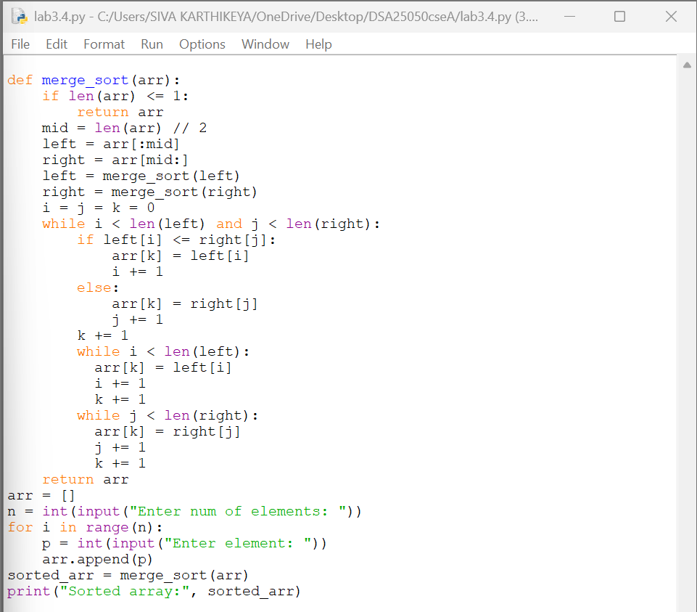
Output:
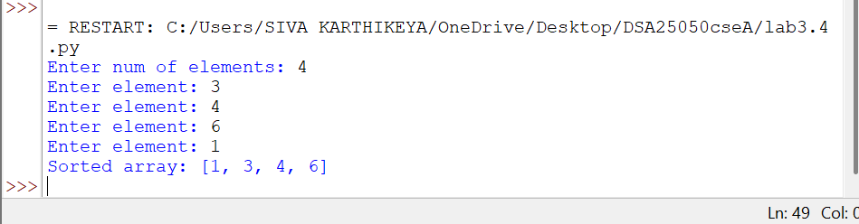
EXPLANATION:
1. Read the size and elements of the list from the user and store them in arr.
2.The merge_sort() function checks the length of the list. If the list contains zero or one element, it is already sorted and is returned.
•3.The middle position of the list is calculated using mid = len(arr) // 2.
•4.The list is divided into two parts, called left and right, using slicing.
5. The merge_sort() function is recursively called for both left and right until each part contains only one element.
6.Three variables i, j, and k are used to keep track of the current positions in the left list, right list, and original arr respectively.
7.The while loop compares the elements of left and right. The smaller element is placed into the original arr.
8.The remaining elements of left or right are copied into arr after one of the lists becomes empty.
9.This process continues until all the divided parts are merged in sorted order.
10.Finally, return arr returns the sorted list in ascending order.

ERROR TABLE:

SNO | ERROR | RECTIFICATION
1 | Comparison Error: | if left[i] <= right[j]:

5.Write a Python Program to implement merge-Sort, where the Input Elements are taken by the User.
Input code:

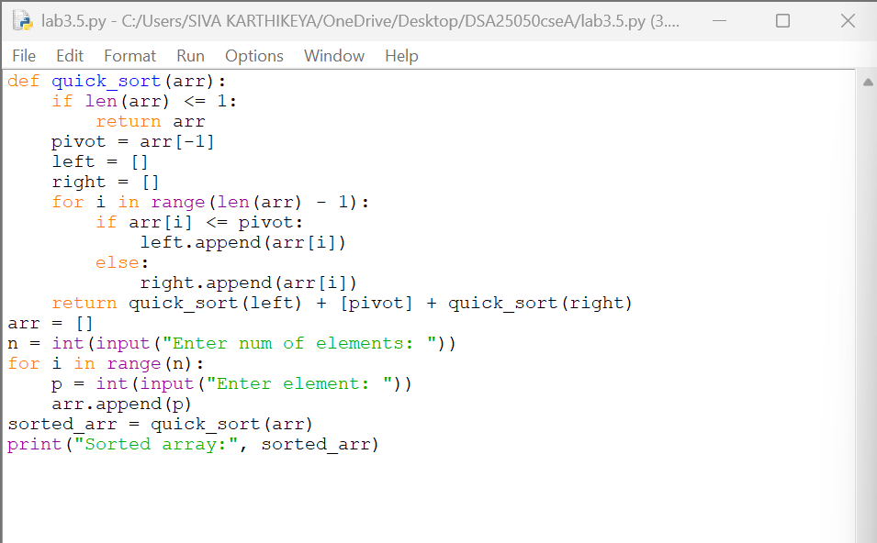
Output:
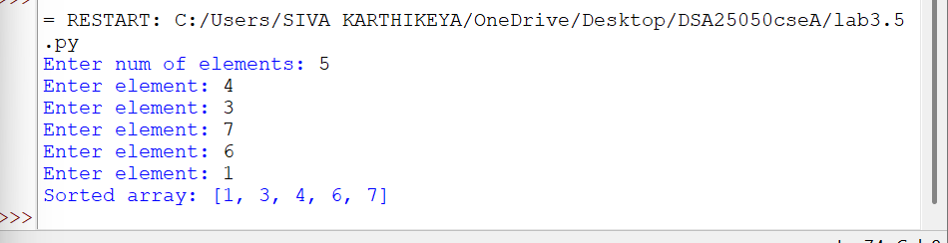
EXPLANATION:
1. Read the size and elements of the list from the user and store them in arr.
2. The quick_sort() function checks the length of the list. If the list contains zero or one element, it is already sorted and is returned.
3. The last element of the list is selected as the pivot using pivot = arr[-1].
4. Two empty lists called left and right are created to store elements smaller than or equal to the pivot and elements greater than the pivot.
5. The for loop compares each element with the pivot. If the element is smaller than or equal to the pivot, it is added to left.
6. If the element is greater than the pivot, it is added to right.
7. The quick_sort() function is recursively called for both left and right to sort the two parts
8. The sorted left list, pivot, and sorted right list are combined using:
return quick_sort(left) + [pivot] + quick_sort(right)
9. This process is repeated until every part contains zero or one element.
10. Finally, the function returns the sorted list in ascending order.
ERROR TABLE:

SNO | ERROR | RECTIFICATION
1 | Pivot Selection Error | pivot = arr[-1]

