
DATA STRUCTURES AND ALGORITHMS -- 23CSE203
Submitted by
Name | S. Siva Karthikeya
Roll No | AV.SC.U4CSE25050
Year/sem/section | 2ND year/sem-3/CSE-A
Credits | 5

Submitted to

Name | DR. RAJKUMAR BATCHU
Department | School of computing
Designation | Asst. professor(SI. Grade)

s.no | title | Page no | Date
1 | WEEK 1: 1a. Recursive countdown from n to Launch. 1b. Recursive calculation of compound growth factor. 1c. Recursive search for employee ID in list. 1d. Recursive factorial calculation for parcel arrangements. 1e. Recursive Fibonacci series generation. | 4-12 | 23-07-26
2 | WEEK 2: 2a. Write a python program to perform linear search on the give input.  2b. Write a python program to perform binary search on the given. Verify by taking sorted array as an input. 2c. Write a python program to perform binary search on the given. Verify by taking unsorted array as an input. | 13-16 | 30-07-26
3 | Lab3:- 3a) Write a Python program to bubble sort the elements, taking input from the user. 3b) Write a Python program to insertion sort the elements, taking input from the user.  3c) Write a Python program to selection sort the elements, taking input from the user.  3d) Write a Python program to merge sort the elements, taking input from the user.  3e) Write a Python program to quick sort the elements, taking input from the user. | 17-24 | 6-08-26
4 | Lab-4: A.write a python program to implement a single linked list which could perform the below operations, by taking an input from the user A. Create linked list B. Insert beginning C. Insert end D. Insert at index E. Delete by value F. Delete first node G. Delete last node H. Count number of nodes I. Display J. Exit | 26-53 | 13-08-26
5 | Lab-5 write a python program to implement a stack which could perform the below operations, by taking an input from the user A. Stack using arrays push( ).  B. Stack using arrays pop( ). C. Stack using arrays combined code. D. Stack using LinkedList push( ). E. Stack using LinkedList pop( ). F. Stacks using LinkedList combined code. G. infix to postfix | 54-64 | 27-08-26
6 | Lab-6:- 6A) write a python program to implement a queue which could perform the below operations, by taking an input from the user, using both array and linked list A. Enqueue B. Dequeue C. Peek D. Display 6B) write a python program to implement a circular queue which could perform the below operations, by taking an input from the user, using both array and linked list A. Enqueue B. Dequeue C. Peek D. Display | 64-77 | 03-09-26
7 | 7A.1).AIM: Write a Python Program to implement a binary tree using an array with all of its operations.  7A.2).AIM: Write a Python Program to implement a binary tree using an linked list with all of its operations. | 78-91 | 24-07-26
8 | 8)Write a Python Program to implement Binary Search Tree with it's operations Transversals also. | 92-95 | 08-10-26
9 | 9)Write a Python Program to implement AVL Tree with it's operations Transversals also. | 96-103 | 22-10-26
10 | Week-10:  Write a python program to implement hashing using separate chaining linear and quadratic probing in python | 104-107 | 29-10-26

WEEK-1
1A.AIM:A Rocket launch system displays a countdown before launch. Instead of suing a loop, implement the countdown using recursion. Write a recursive python program to display a countdown from n to 1 followed by “launch”.
Code:
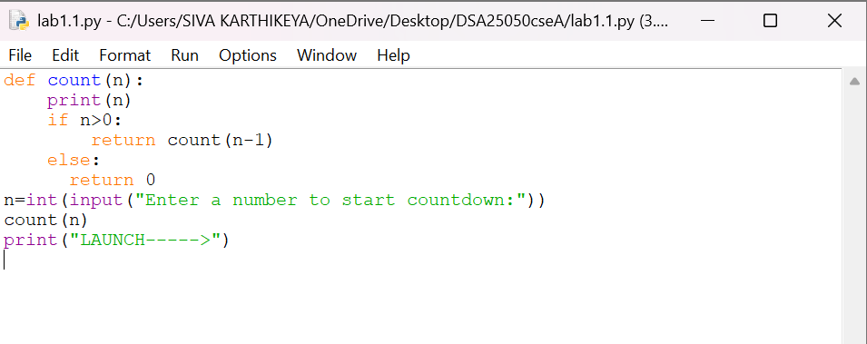

OUTPUT:
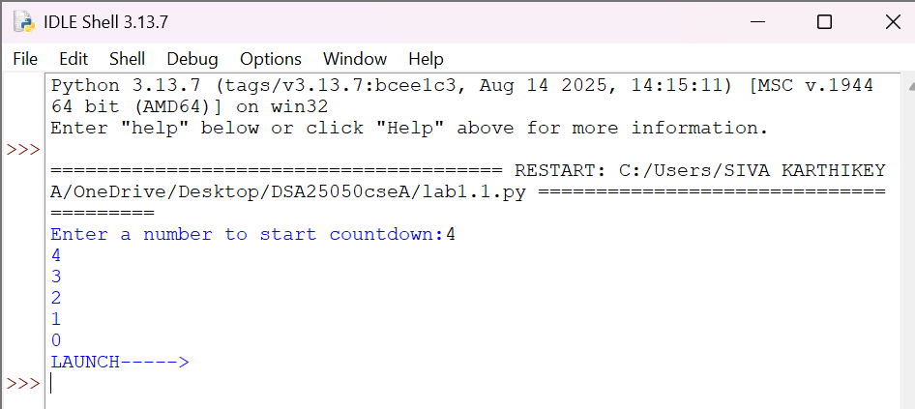
Explanation
Condition 1: Positive Input (n > 0)
- The function checks whether n == 0.
- Since n is positive, the condition is False.
- It executes:
- print(n) → prints the current value of n.
- countdown(n-1) → calls the same function again with n-1.
- This process continues until n becomes 0.
- When n == 0, the condition becomes True.
- It prints launch.
- The return statement stops that function call.
- Then the recursive calls return one by one.
- Since there is no value returned by the function, it returns None.
Condition 2: Zero Input (n == 0)
- The function checks if n == 0.
- The condition is immediately True.
- It prints launch.
- The return statement stops the function.
- No recursive call takes place.
- The function returns None.
Condition 3: Negative Input (n < 0)
- The condition n == 0 is False.
- It prints the negative value.
- Then it calls itself with n-1, making the value even more negative.
- Therefore, it will never reach 0.
- The recursion continues indefinitely.
- Eventually, Python raises a RecursionError because the maximum recursion depth is exceeded
SNO: | Error obtained | Rectification
1. | Negative input in countdown | Add a condition to handle negative numbers before recursion.

1B. Aim: Banks calculate the growth of an investment using compound interest. The formula requires calculating powers, which can be implemented recursively. Write a recursive program to calculate p(n) where p=principal growth, n= no. of years.
Code:
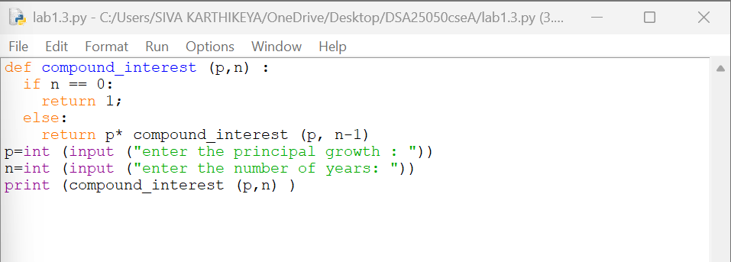
OUTPUT:
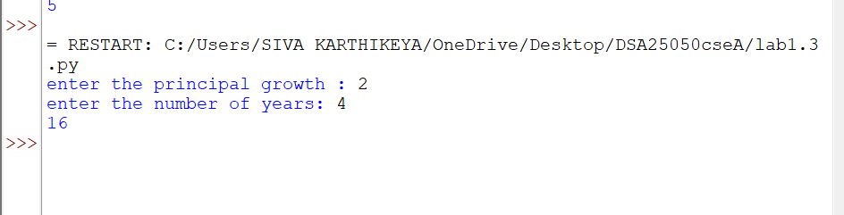

Explanation
Condition 1: n > 0
- The function compound_interest(p, n) is called with the principal amount p and number of years n.
- The function checks whether n == 0.
- Since n is greater than 0, the condition is False.
- It executes the else block.
- It calculates:
- p * compound_interest(p, n-1)
- The function calls itself recursively with n-1.
- This process continues until n becomes 0.
- Each recursive call multiplies p one more time.
- Therefore, the function calculates pⁿ.
Condition 2: n == 0
- When n becomes 0, the condition n == 0 becomes True.
- The function returns 1.
- This 1 acts as the base case for the multiplication.
- The recursive calls then return one by one.
- Each returned value is multiplied by p.
- Finally, the result is printed using print(compound_interest(p,n))
Error table:
Sno: | Error | Rectification
1 | Wrong recursive value | Updated the recursive value correctly

1C. AIM . An Hr department stores employee IDs in a list .Develop a recursive program to search for a given employee ID write a recursive function to search for an employee ID in a list.
Code:
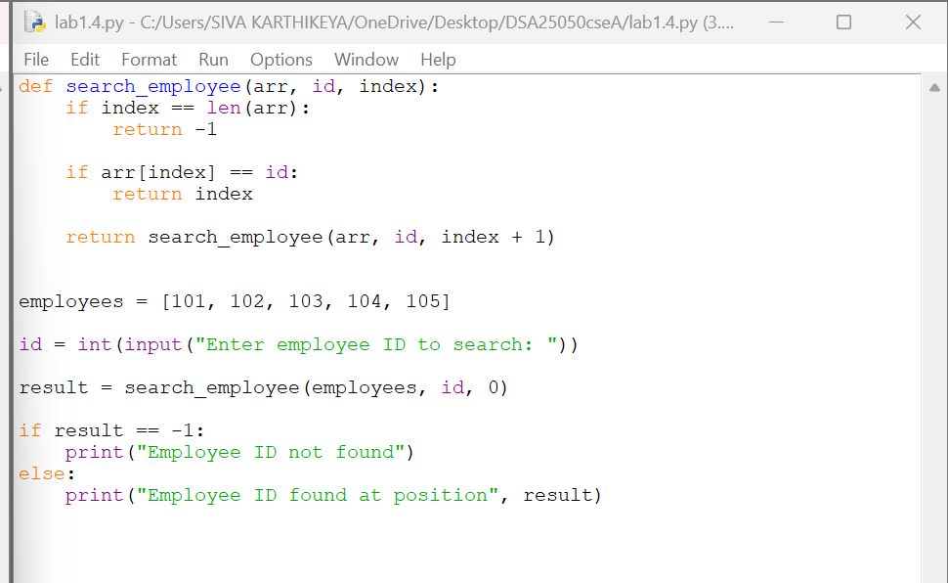
OUTPUT:
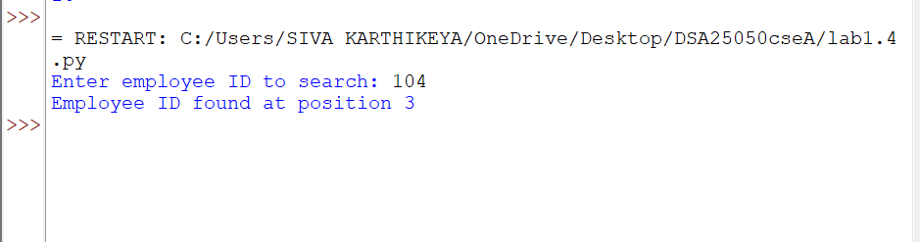
Explanation
Condition 1: index == len(emp_list)
- The function checks whether index has reached the length of the employee list.
- If index == len(emp_list), it means we have checked all employee IDs.
- The employee ID was not found.
- The function returns False.
- No further recursion takes place.
Condition 2: emp_list[index] == emp_id
- The function checks whether the current employee ID is equal to the ID we are searching for.
- If both IDs are equal, the condition becomes True.
- The function returns True.
- The recursion stops because the employee ID has been found.
Condition 3: Employee ID does not match
- If the current employee ID is not equal to emp_id, the condition is False.
- The function calls itself recursively with:
- index + 1
- This moves to the next employee ID in the list.
- The process continues until:
- The employee ID is found, or
- The entire list is checked.
Error table:
Sno: | Error | Rectification
1 | Missing return statement | Add the required return statement

1D. AIM. In a logistics company , the no . of possible ways to arrange in different parcels is calculated using the factorial formula (n!). Develop a recursive program to calculate the factorial of a given number.
Code:
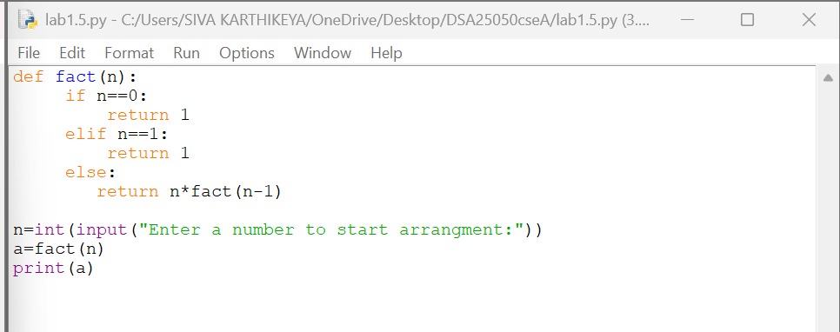
OUTPUT:
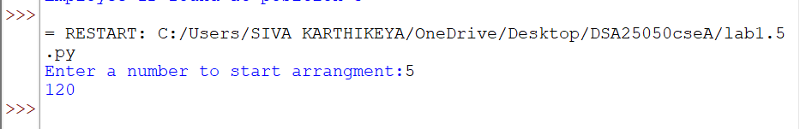
Explanation
Condition 1: Negative Input (n < 0)
- The program first checks whether n < 0.
- If n is negative, the condition is True.
- Factorial is not defined for negative numbers.
- It prints:
Factorial is not defined for negative numbers.
- The factorial() function is not called.
Condition 2: Base Case (n == 0 or n == 1)
- Inside the factorial() function, it checks:
n == 0 or n == 1
- If n is 0 or 1, the condition is True.
- The function returns 1.
- This is the base case of the recursion.
- It stops further recursive calls.
Condition 3: n > 1
- If n is greater than 1, the condition n == 0 or n == 1 is False.
- The else block is executed.
- It returns:
n * factorial(n - 1)
- The function calls itself with n - 1.
- This continues until n becomes 1.
- Then the returned values are multiplied together
Error table:
Sno: | Error | Rectification
1 | Wrong recursive value | Updated the recursive value correctly

1E. AIM. Write a recursive program to print the first n terms of the fibonacci series
Code:
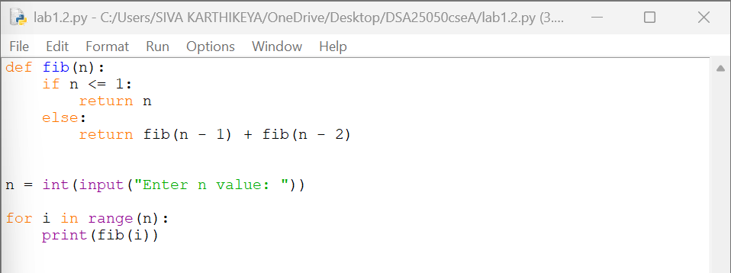
OUTPUT:
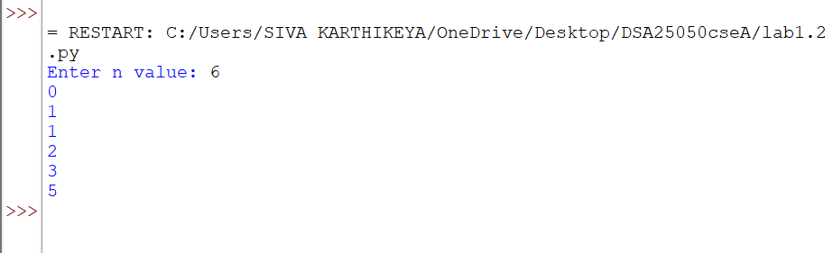
Explanation
Condition 1: n == 0
- The function checks whether n == 0.
- If the condition is True, the function returns 0.
- This is the first base case.
- No further recursive call takes place.
Condition 2: n == 1
- If n is not 0, the function checks whether n == 1.
- If the condition is True, the function returns 1.
- This is the second base case.
- No further recursive call takes place
Condition 3: n > 1
- If n is neither 0 nor 1, both conditions are False.
- The else block is executed.
- The function calls itself two times:
- fibonacci(n - 1)
- fibonacci(n - 2)
- The two returned values are added together.
- This process continues until the base cases n == 0 and n == 1 are reached.

Error table:
S.NO | Error obtained | Rectification
1 | Wrong recursive value | Updated the recursive value correctly

Week-2
2a. AIM: Write a python program to perform linear search on the give input.
Code:
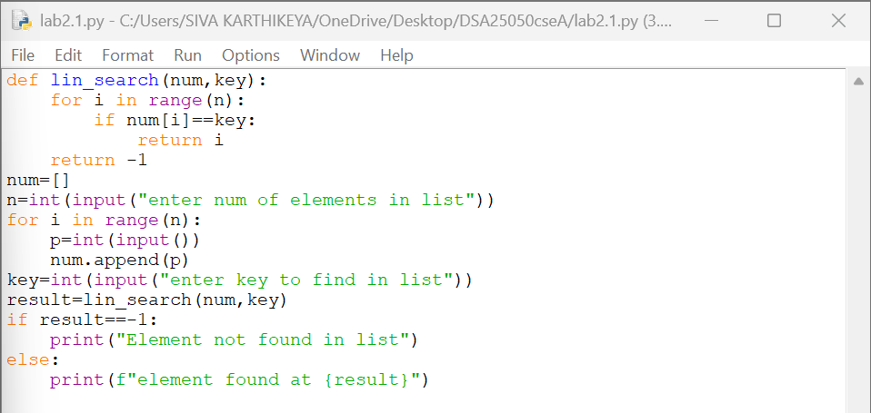
OUTPUT:
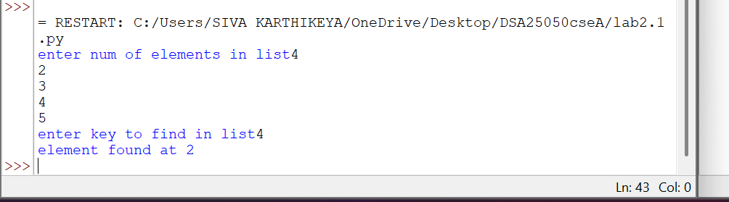
Explanation
Condition 1: Element is Found (arr[i] == k)
- The function linear_search(arr, k) receives the array arr and the search element k.
- The for loop starts from the first element of the array.
- It checks each element one by one using:
arr[i] == k
- If the current element is equal to k, the condition becomes True.
- The function immediately returns the index i.
- Since the function returns the index, the loop stops immediately.
- The remaining elements are not checked.
Condition 2: Element is Not Found
- The loop checks every element in the array.
- If none of the elements is equal to k, the if condition is always False.
- After the loop finishes, the statement return -1 is executed.
- -1 indicates that the search element is not present in the array.
Error table:
Sno: | Error | Rectification
1 | infinite loop because i never incremented. | I valued incremented in while loop.

2b. AIM: Write a python program to perform binary search on the given. Verify by taking sorted array as an input.
Code:
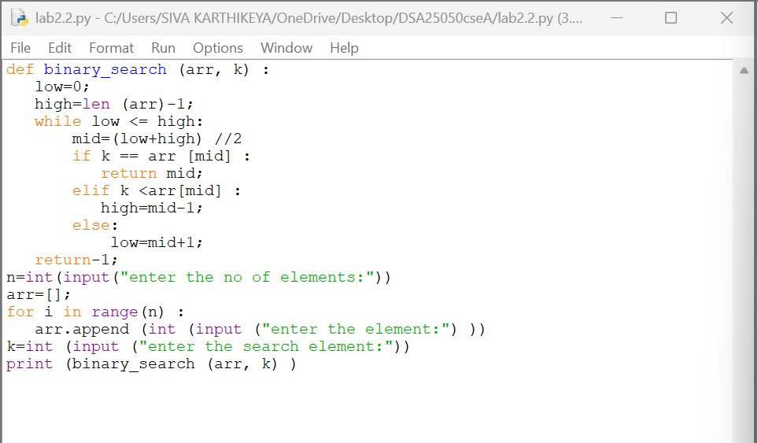
OUTPUT:
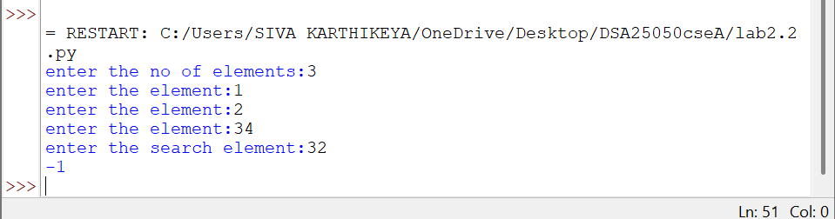
Explanation
Condition 1: k == arr[mid] — Element Found
- The function binary_search(arr, k) receives the array and the search element.
- low is initialized to 0, which represents the first index.
- high is initialized to len(arr)-1, which represents the last index.
- The while loop runs as long as low <= high.
- mid is calculated using:
mid = (low + high) // 2
- The middle element is compared with the search element k.
- If k == arr[mid], the element is found.
- The function returns the index mid and stops searching.
Condition 2: k < arr[mid] — Search Left Half
- If k is smaller than the middle element, the condition is True.
- This means the search element can only be present in the left half.
- Therefore:
high = mid - 1
- The right half is eliminated.
- The process continues with the remaining left half
Condition 3: k > arr[mid] — Search Right Half
- If k is greater than the middle element, the elif condition is False.
- The else block is executed.
- This means the search element can only be present in the right half.
- Therefore:
low = mid + 1
- The left half is eliminated.
- The process continues with the remaining right half.
Condition 4: low > high — Element Not Found
- The while loop continues until low <= high becomes False.
- When low > high, there are no elements left to search.
- This means the search element is not present in the array.
- The function returns -1.
Error table:
Sno: | Error | Rectification
1 | Writing high = len(arr) | Writing high = len(arr)-1

WEEK-3:
- Write a Python Program to implement Bubble-Sort, where the Input Elements are taken by the User

Input code: -
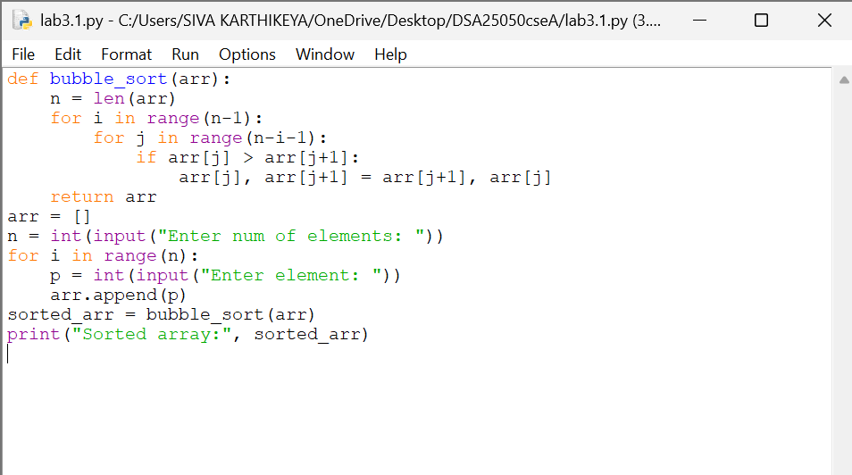

Output : -
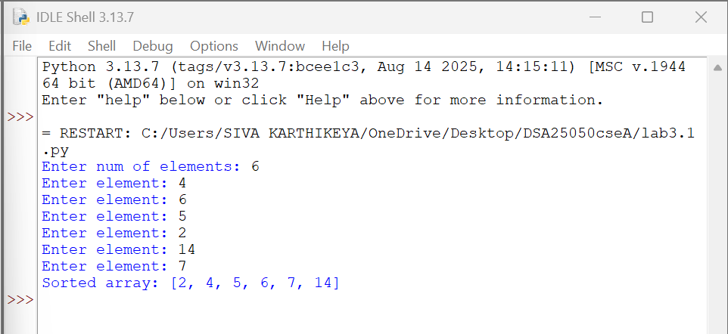

Explanation: -

- Read the size and elements of the list from the user and store them in arr.
- The outer for loop runs through the list multiple times to sort all the elements.
- The inner for loop compares two adjacent elements, arr[j] and
arr[j+1].
- The comparison is made between the current element and the next element to check whether they are in the correct order.
- If the first element is greater than the second, they are swapped using:
arr[j], arr[j+1] = arr[j+1], arr[j]
- After each pass, the largest unsorted element moves towards the end of the list.
- The inner loop compares fewer elements in each subsequent pass because the elements at the end are already in their correct positions.
- After all the passes, the elements are arranged in ascending order, and
return arr returns the sorted list.

Error table:
Sno: | ERROR | RECTIFICATION
1 | Invalid Syntax. | By keeping the colon (:) in the if loop the error solved

- Write a Python Program to implement Insertion-Sort, where the Input Elements are taken by the User.

Input code:
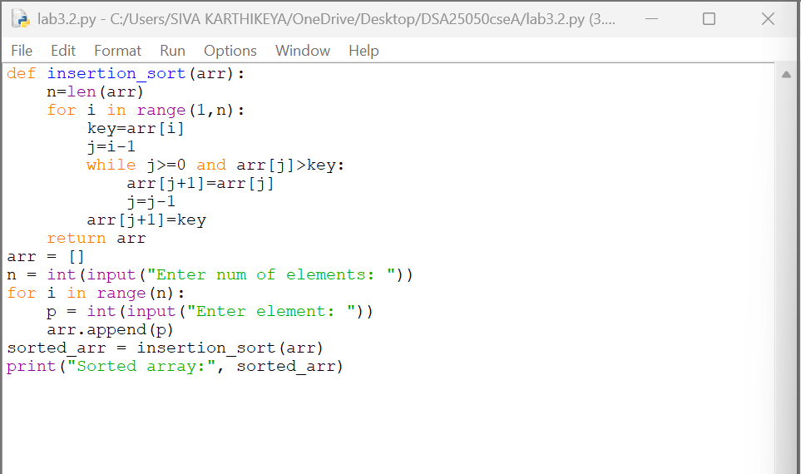

Output : -
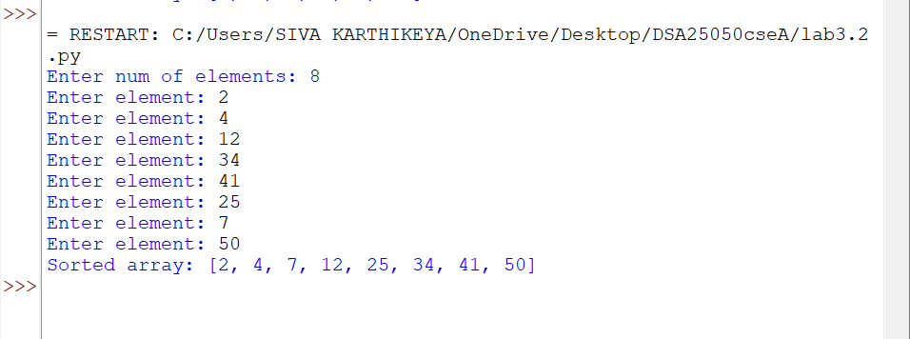
Explanation: -
- Read the size and elements of the list from the user and store them in arr.
- The for loop starts from the second element, considering the first element as already sorted.
- The current element is stored in a variable called key, which is the element that needs to be placed in its correct position.
- A variable called j is used to point to the element just before the key.
- The while loop compares the key with the previous elements of the sorted part of the list.
- If a previous element is greater than the key, it is shifted one position to the right, and j is moved one position to the left.
- This shifting continues until a smaller element is found or the beginning of the list is reached. Then, the key is inserted into its correct position.
- The process is repeated for all elements, and after all iterations, return arr returns the sorted list in ascending order.

ERROR TABLE:

SNO | ERROR | RECTIFICATION
1 |  | Initializing  i=1.
  Accesses invalid array position
  Using a[i-1] when i = 0

- Write a Python Program to implement Selection-Sort, where the Input Elements are taken by the User.

Input code: -
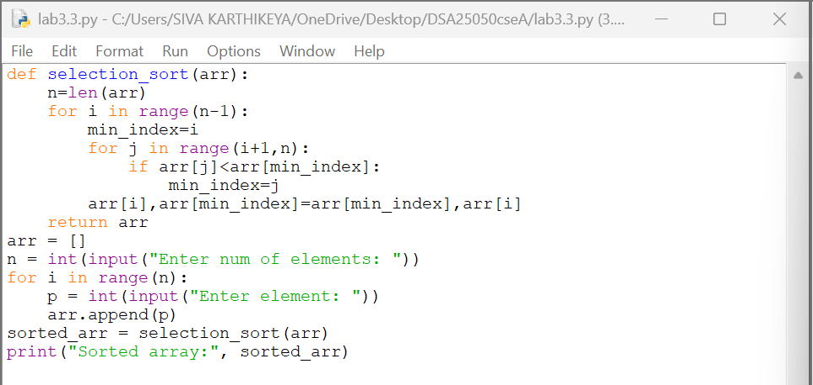

output : -
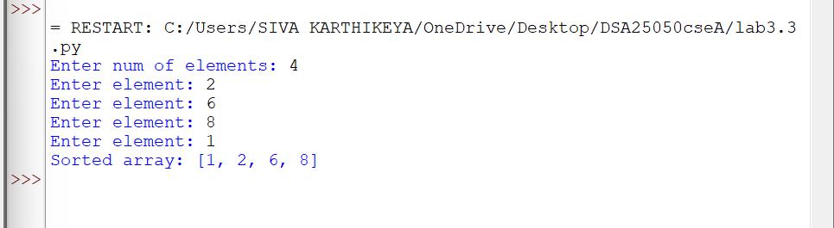
Explanation: -
- Read the size and elements of the list from the user and store them in arr.
- The outer for loop selects each position of the array one by one, starting from the first position.
- A variable called min_index is used to store the index of the smallest element found.
- The inner for loop compares the current minimum element with the remaining elements of the list.
- If a smaller element is found, its index is stored in min_index.
- After finding the smallest element, it is swapped with the element at the current position using:
arr[i], arr[min_index] = arr[min_index], arr[i]
- This process is repeated until the entire list is sorted and return arr
returns the sorted list in ascending order.
ERROR TABLE:

SNO | ERROR | RECTIFICATION
1 | Using invalid array index
  Rectified runtime/undefined behavior.
- Write a Python Program to implement merge-Sort, where the Input Elements are taken by the User.

Input code:
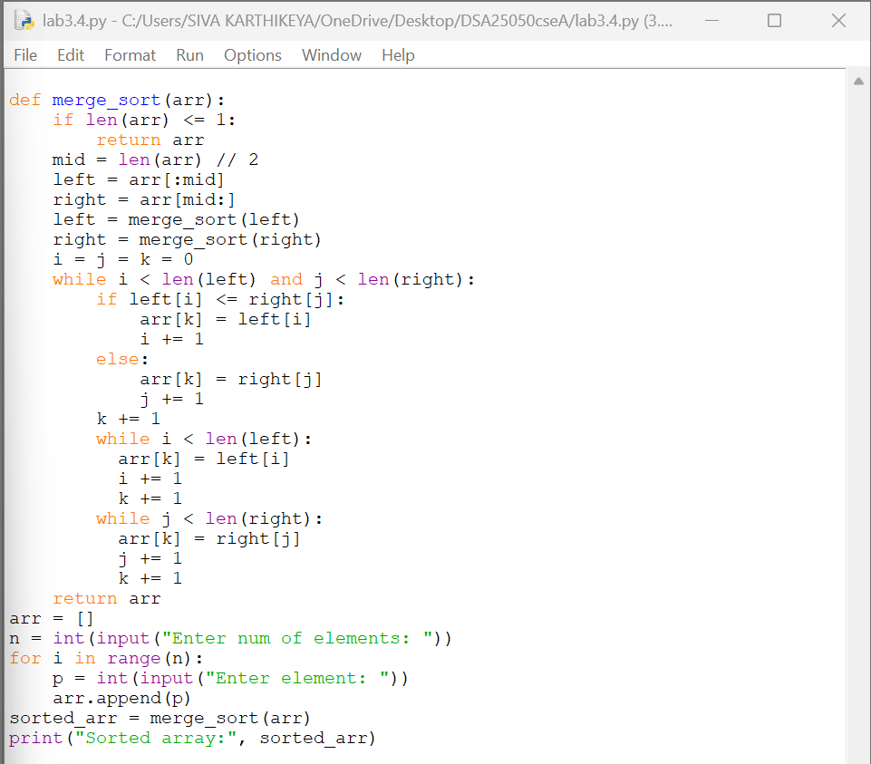
Output:
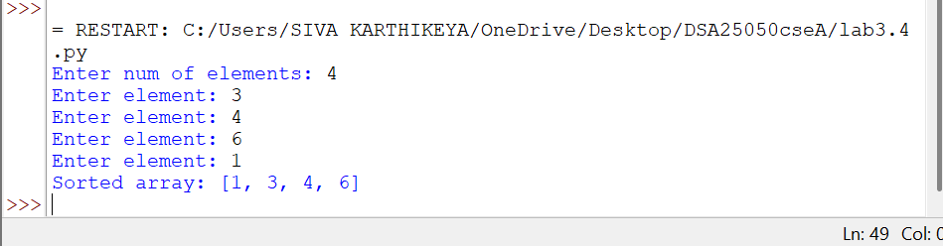
EXPLANATION:
1. Read the size and elements of the list from the user and store them in arr.
2.The merge_sort() function checks the length of the list. If the list contains zero or one element, it is already sorted and is returned.
•3.The middle position of the list is calculated using mid = len(arr) // 2.
•4.The list is divided into two parts, called left and right, using slicing.
5. The merge_sort() function is recursively called for both left and right until each part contains only one element.
6.Three variables i, j, and k are used to keep track of the current positions in the left list, right list, and original arr respectively.
7.The while loop compares the elements of left and right. The smaller element is placed into the original arr.
8.The remaining elements of left or right are copied into arr after one of the lists becomes empty.
9.This process continues until all the divided parts are merged in sorted order.
10.Finally, return arr returns the sorted list in ascending order.

ERROR TABLE:

SNO | ERROR | RECTIFICATION
1 | Comparison Error:
  if left[i] <= right[j]:

5.Write a Python Program to implement merge-Sort, where the Input Elements are taken by the User.
Input code:

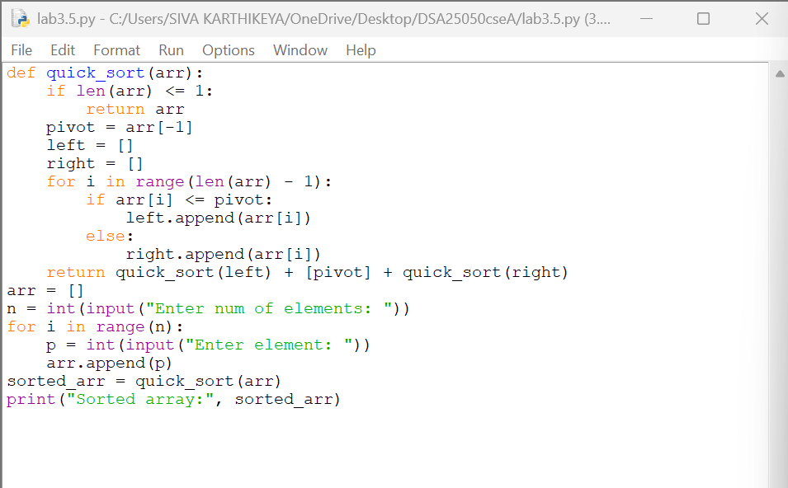
Output:
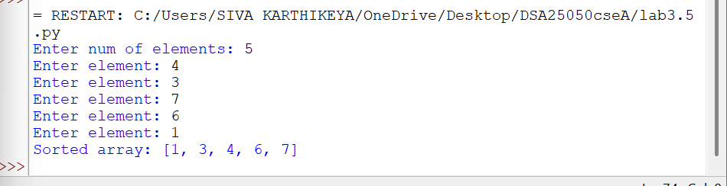
EXPLANATION:
1. Read the size and elements of the list from the user and store them in arr.
2. The quick_sort() function checks the length of the list. If the list contains zero or one element, it is already sorted and is returned.
3. The last element of the list is selected as the pivot using pivot = arr[-1].
4. Two empty lists called left and right are created to store elements smaller than or equal to the pivot and elements greater than the pivot.
5. The for loop compares each element with the pivot. If the element is smaller than or equal to the pivot, it is added to left.
6. If the element is greater than the pivot, it is added to right.
7. The quick_sort() function is recursively called for both left and right to sort the two parts
8. The sorted left list, pivot, and sorted right list are combined using:
return quick_sort(left) + [pivot] + quick_sort(right)
9. This process is repeated until every part contains zero or one element.
10. Finally, the function returns the sorted list in ascending order.
ERROR TABLE:

SNO | ERROR | RECTIFICATION
1 | Pivot Selection Error | pivot = arr[-1]

WEEK-4
AIM
Write a Python program to implement a singly linked list which will perform the following operations by taking input from the user:
- Create linked list
- Insert at beginning
- Insert at specified index
- Insert at end
- Delete by value
- Delete first node
- Delete last node
- Count number of nodes
- Display / Traverse
- Exit

CODE:
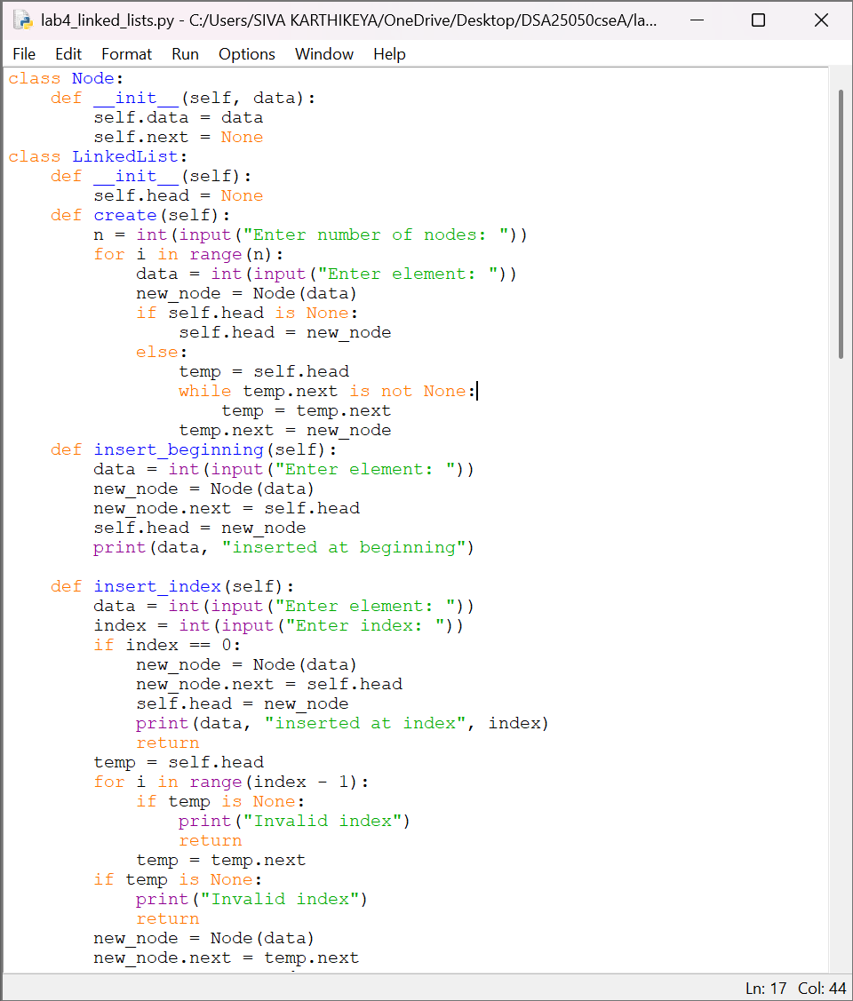
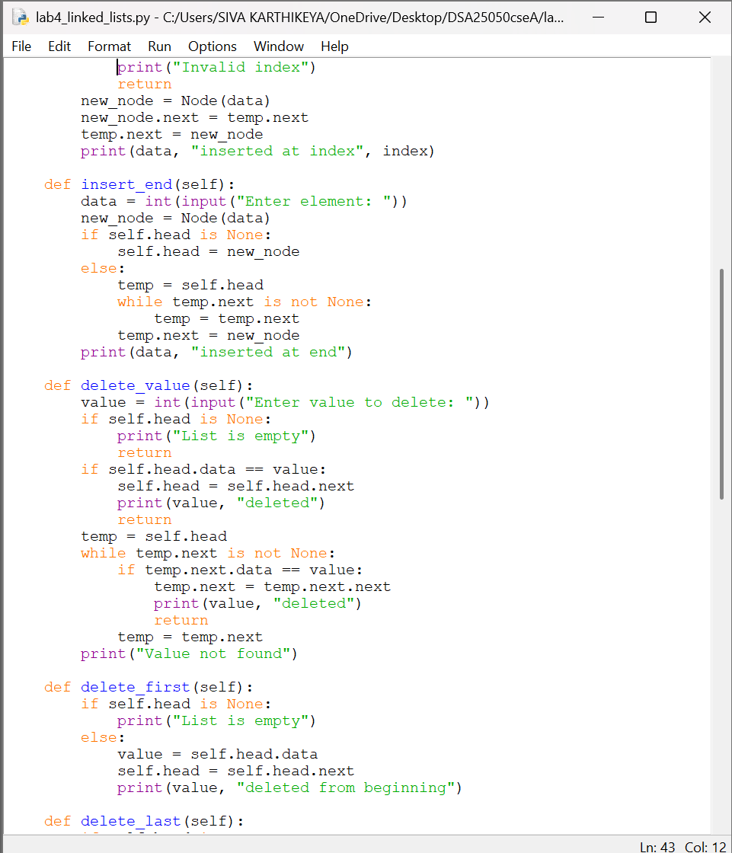
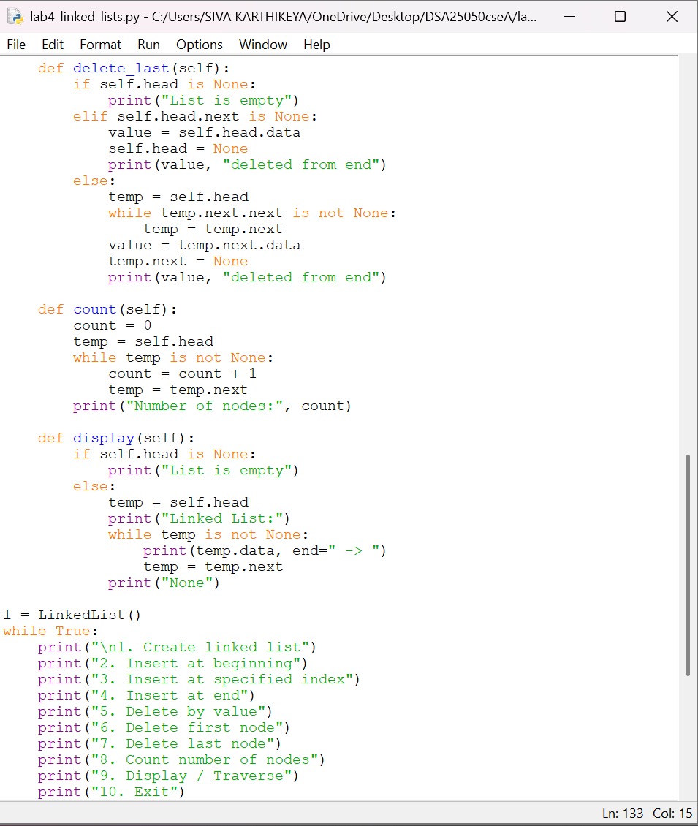
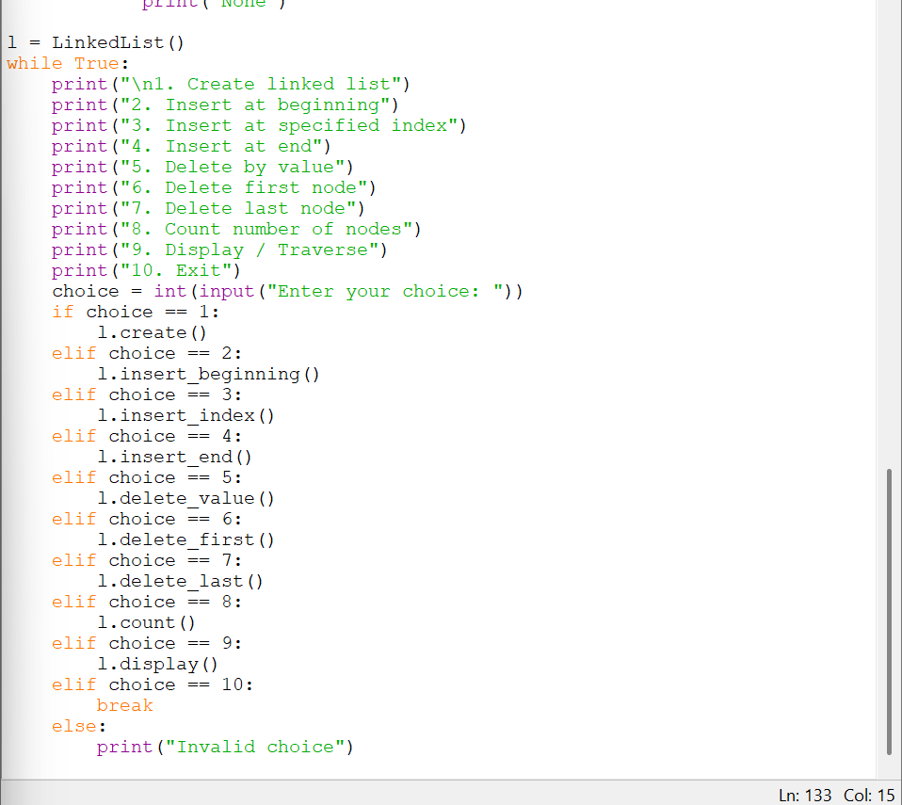
Output:
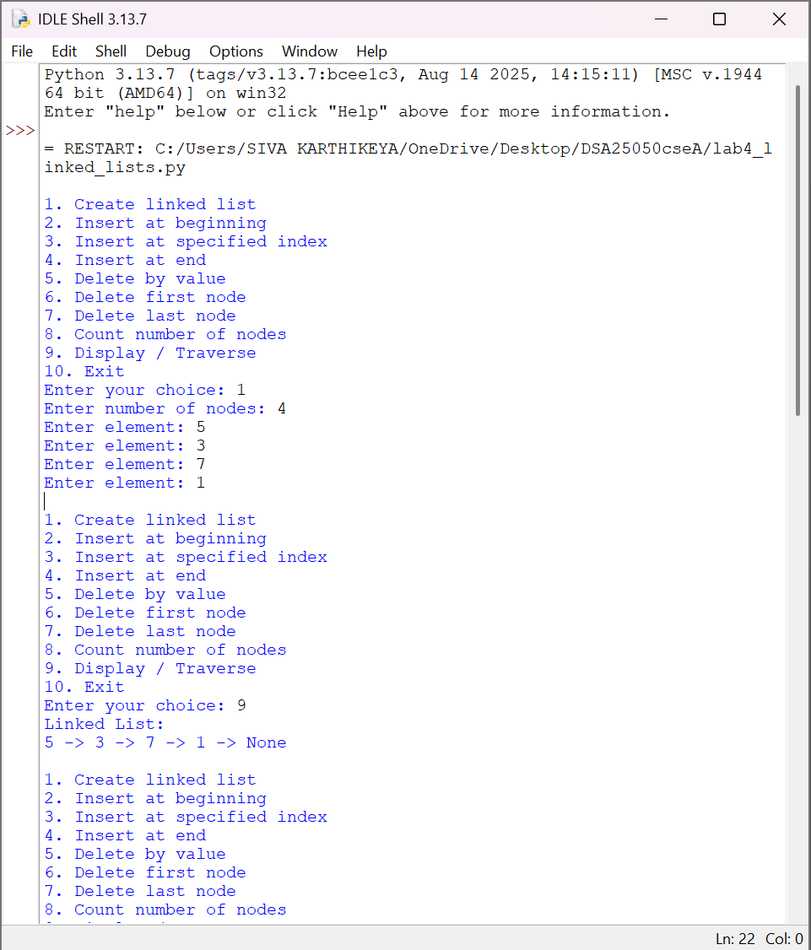
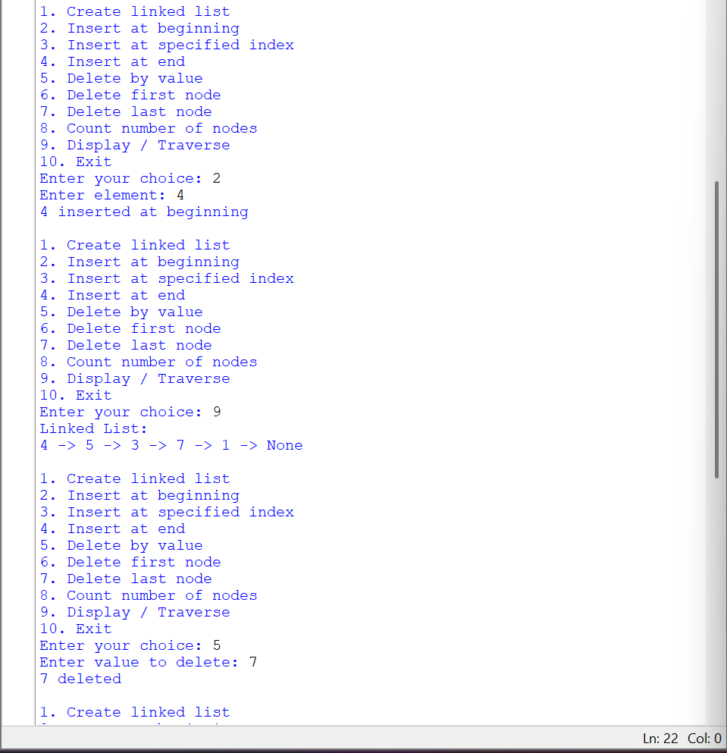
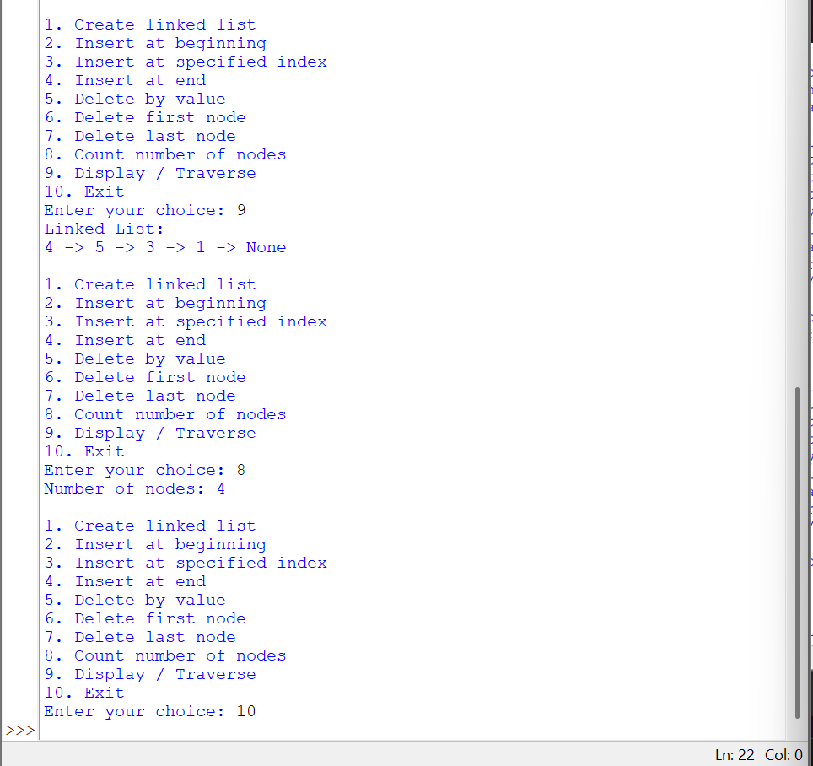

Explanation
1. Create Linked List
- The create() function takes the number of nodes and their data from the user.
- For every element, a new node is created using new_node = Node(data).
- If self.head is None, the new node becomes the first node.
- Otherwise, temp starts from self.head and moves through the list using temp = temp.next.
- When temp reaches the last node, the new node is connected using temp.next = new_node.
2. Insert at Beginning
- A new node is created using new_node = Node(data).
- The new node is connected to the existing list using new_node.next = self.head.
- Then self.head = new_node makes the new node the first node of the linked list.
3. Insert at Specified Index
- The program takes the element and the required index from the user.
- If the index is 0, the new node is inserted before self.head.
- Otherwise, temp traverses the list until the node before the required index.
- The new node is connected using:
- new_node.next = temp.next
temp.next = new_node
- Thus, the new node is inserted between two existing nodes.
4. Insert at End
- A new node is created using Node(data).
- If self.head is None, the new node becomes the head.
- Otherwise, temp starts from self.head and moves until temp.next becomes None.
- The new node is then connected using temp.next = new_node.
5. Delete by Value
- The program takes the value to be deleted.
- First, it checks whether self.head is None.
- If the value is present in the first node, self.head is moved to the next node.
- Otherwise, temp traverses the list and checks temp.next.data.
- When the value is found, the node is skipped using:
temp.next = temp.next.next
- This removes the required node from the linked list.
6. Delete First Node
- The program first checks whether the list is empty.
- If the list is not empty, self.head is moved to the next node:
self.head = self.head.next
- Therefore, the previous first node is removed.
7. Delete Last Node
- If self.head is None, the list is empty.
- If there is only one node, self.head is set to None.
- Otherwise, temp traverses the list until it reaches the second-last node.
- The last node is removed by setting:
temp.next = None
8. Count Number of Nodes
- A variable count is initialized to 0.
- temp starts from self.head.
- While temp is not None, count is increased by 1.
- temp = temp.next moves to the next node.
- Finally, count gives the total number of nodes.
9. Display / Traverse
- temp is initialized with self.head.
- The while loop continues as long as temp is not None.
- temp.data is displayed.
- After displaying each node, temp = temp.next moves to the next node.
- Traversal ends when temp becomes None.
10. Exit
- When the user selects option 10, the break statement terminates the while loop.
- The program execution ends.
This terminology closely follows the structure of your existing lab record, where the explanations describe what each variable and condition does rather than giving only a general definition.

ERROR TABLE:

SNO | ERROR | RECTIFICATION
1 | New node not connected to the list | Used new_node.next to connect the node
2 | Empty list not handled | Added self.head is None condition
3 | First node deletion not handled
  Used self.head = self.head.next

EXPERIMENT 4b — DOUBLY LINKED LIST
AIM
Write a Python program to implement a Doubly Linked List and perform create, insertion, deletion, counting and display operations by taking input from the user.
CODE
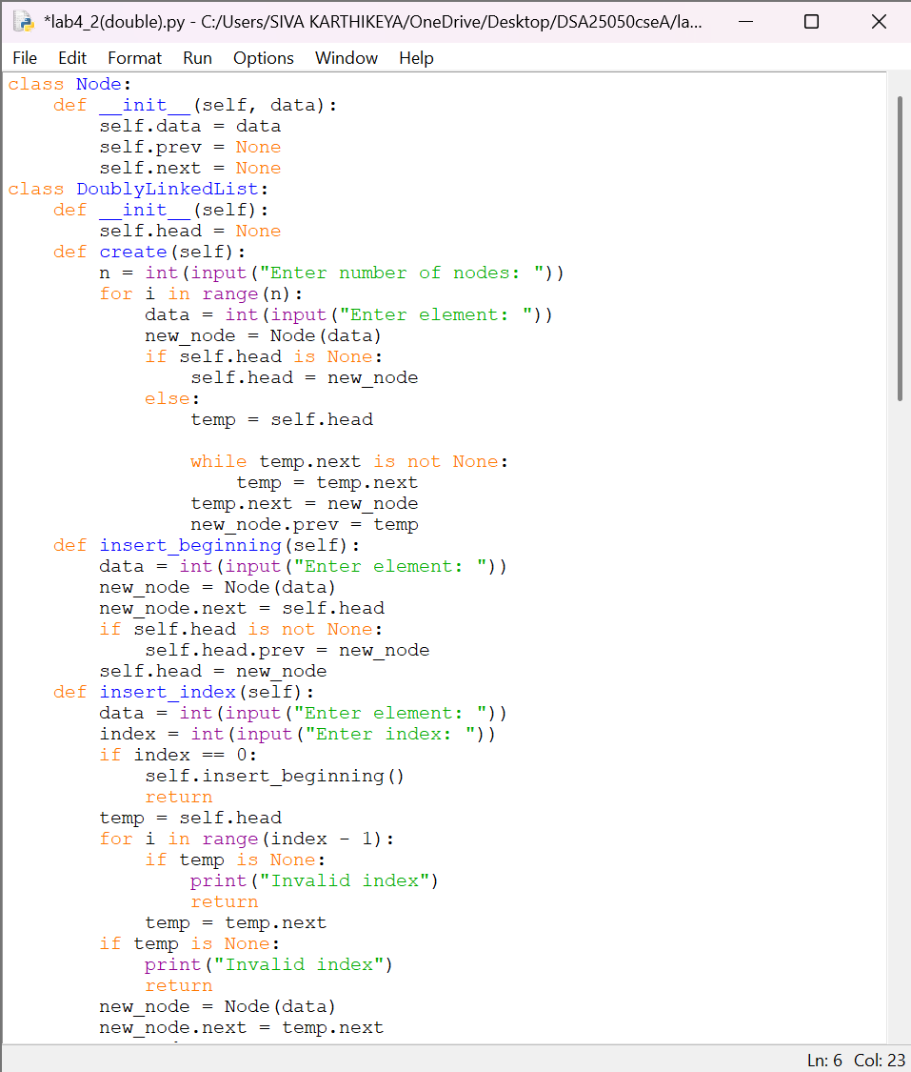
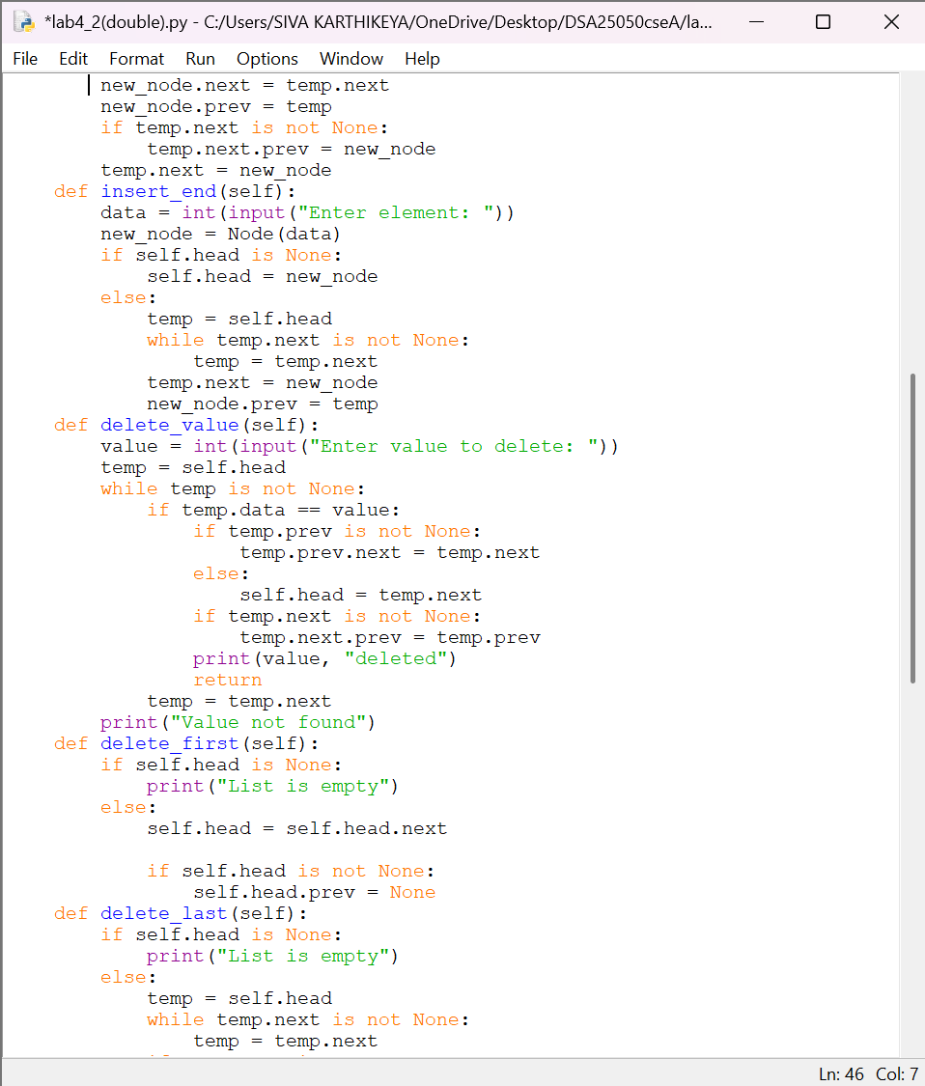
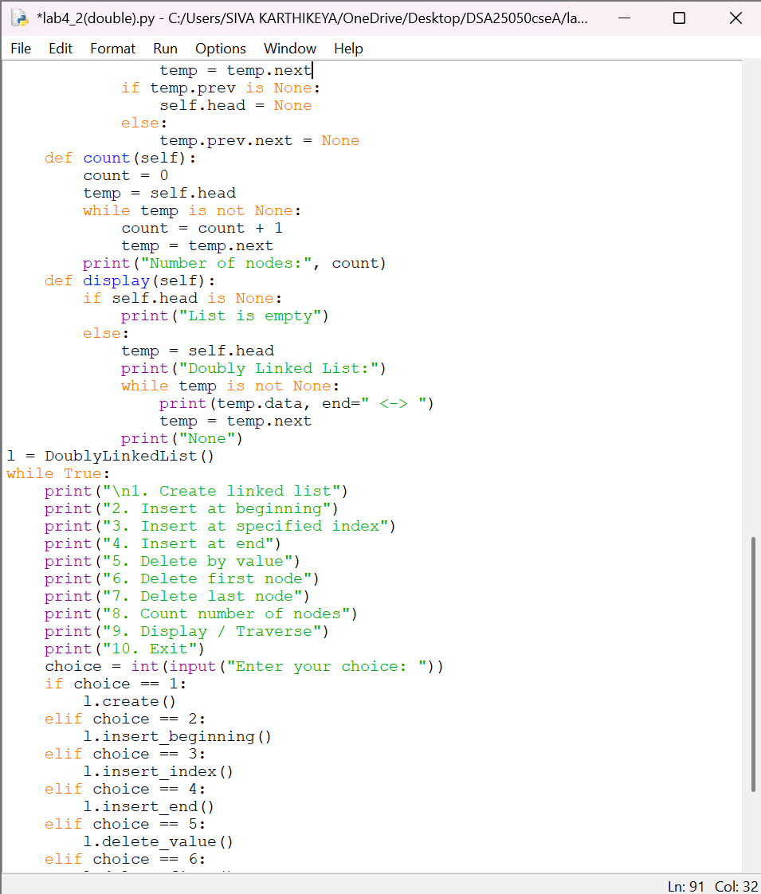
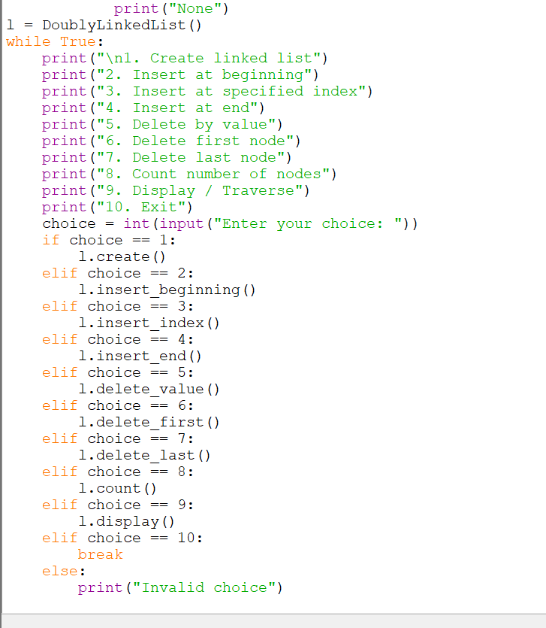
OUTPUT:
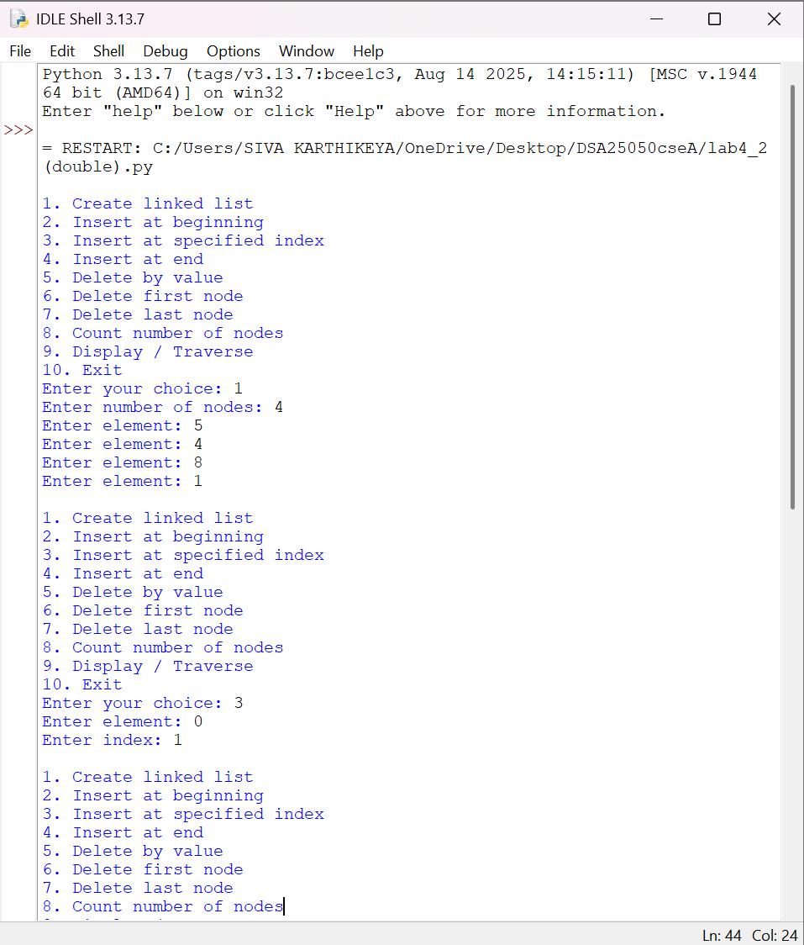
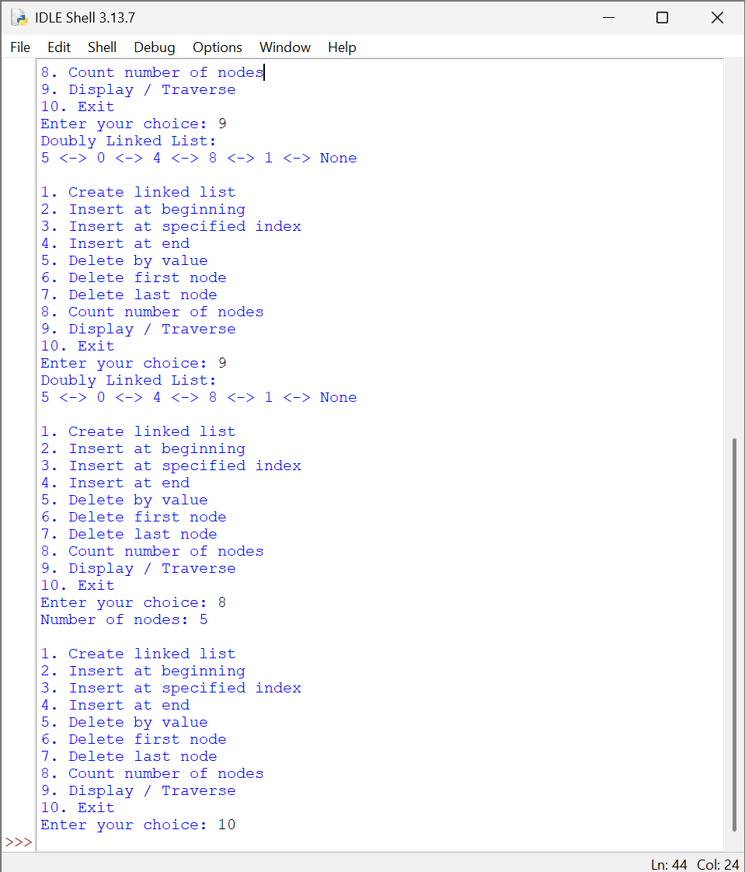
EXPLANATION
1. Create Linked List
- A Node contains three parts: data, prev and next.
- self.head stores the first node.
- temp is used to traverse the list.
- When a new node is added at the end:
- temp.next = new_node
new_node.prev = temp
- Therefore, every node has links in both directions.
None <- 10 <-> 20 <-> 30 -> None
↑
head
2. Insert at Beginning
- new_node.next is connected to self.head.
- If the list is not empty, the old head's prev is connected to new_node.
- Finally, self.head = new_node.
new_node.next = self.head
self.head.prev = new_node
self.head = new_node
3. Insert at Specified Index
- temp traverses until the node before the required index.
- The new node is connected in both directions:
- new_node.next = temp.next
new_node.prev = temp
- The surrounding nodes are then connected to the new node.
4. Insert at End
- temp traverses until temp.next becomes None.
- The new node is connected using:
- temp.next = new_node
new_node.prev = temp
5. Delete by Value
- temp traverses the list and searches for the given value.
- When the value is found, the previous node is connected to the next node:
temp.prev.next = temp.next
- The next node's prev is also updated:
temp.next.prev = temp.prev
6. Delete First Node
- self.head is moved to the next node:
self.head = self.head.next
- The new head's prev is set to None.
7. Delete Last Node
- temp moves to the last node.
- The previous node is accessed using temp.prev.
- Its next is set to None.
8. Count Nodes
- temp starts from self.head.
- Every time temp moves to temp.next, count is increased.
- When temp becomes None, the total count is displayed.
9. Display / Traverse
- temp starts from self.head.
- temp.data is displayed.
- temp = temp.next moves forward through the list
- ERROR TABLE:

SNO | ERROR | RECTIFICATION
1 | prev link not updated | Set new_node.prev = temp
2 | Traversal does not stop
  Check temp is not None

EXPERIMENT 4c — CIRCULAR LINKED LIST
AIM
Write a Python program to implement a Circular Linked List and perform create, insertion, deletion, counting and display operations by taking input from the user.
CODE:
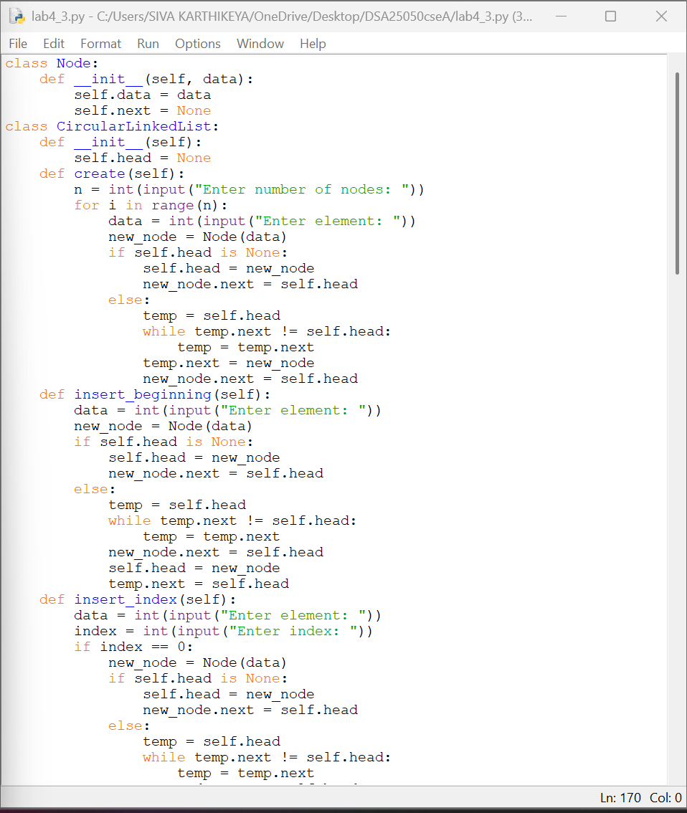
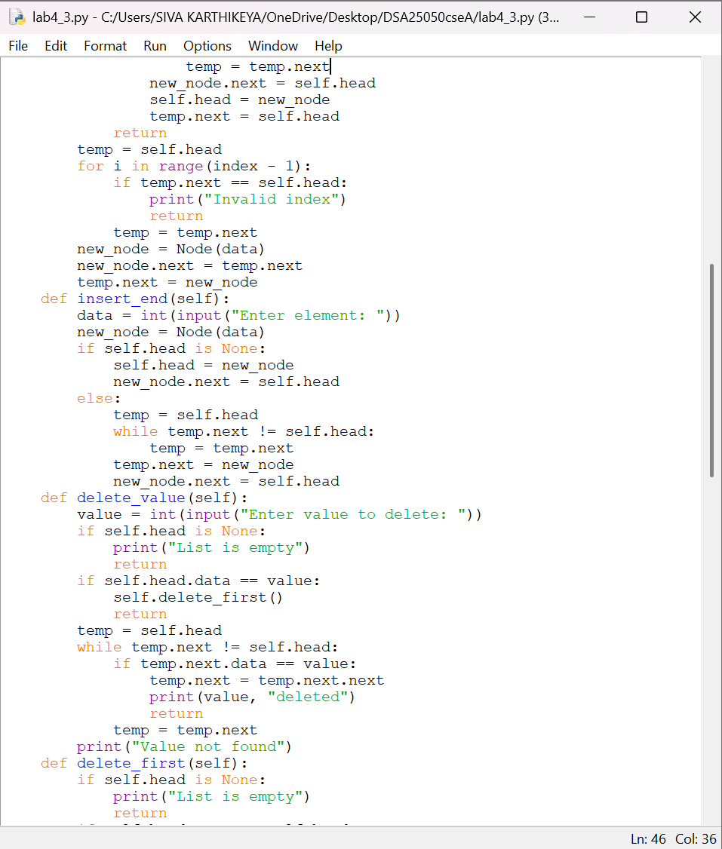
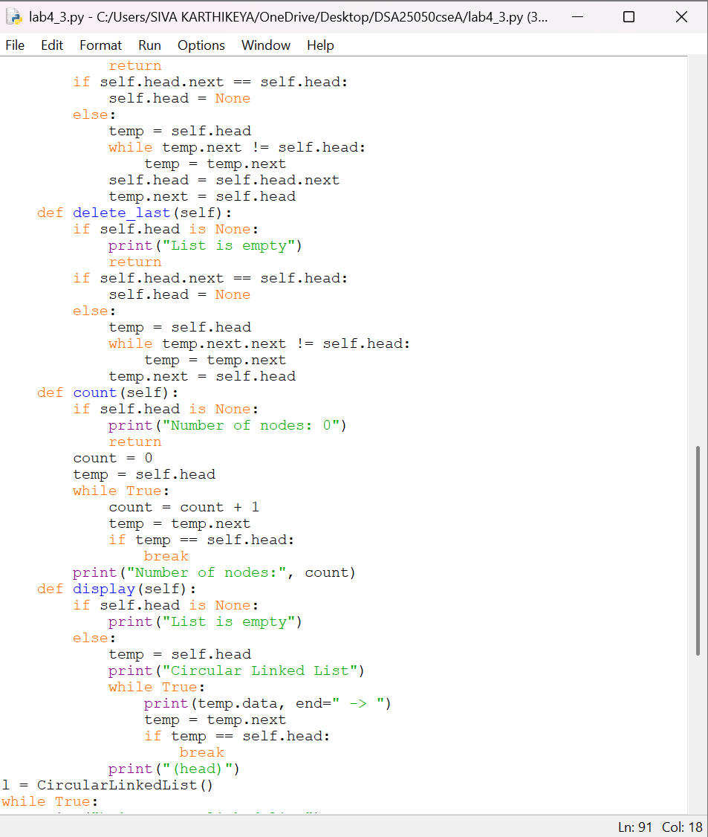
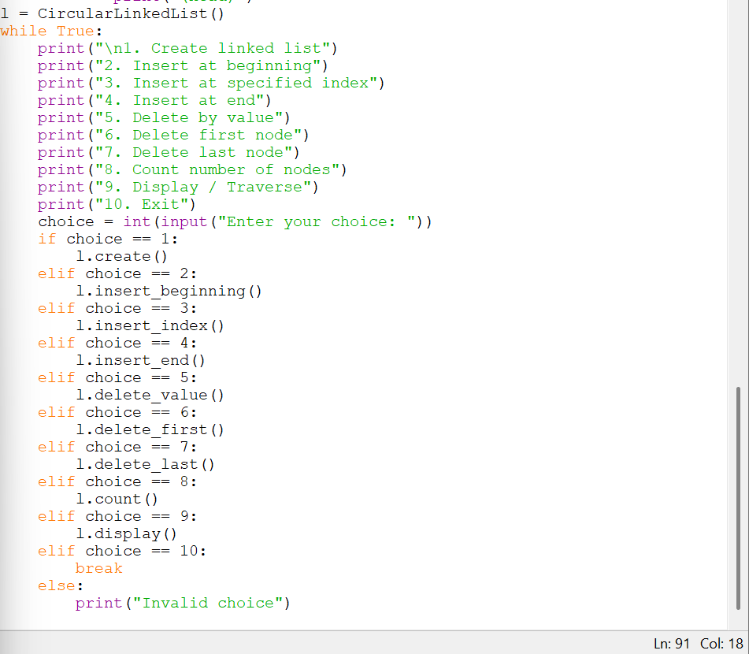

OUTPUT:
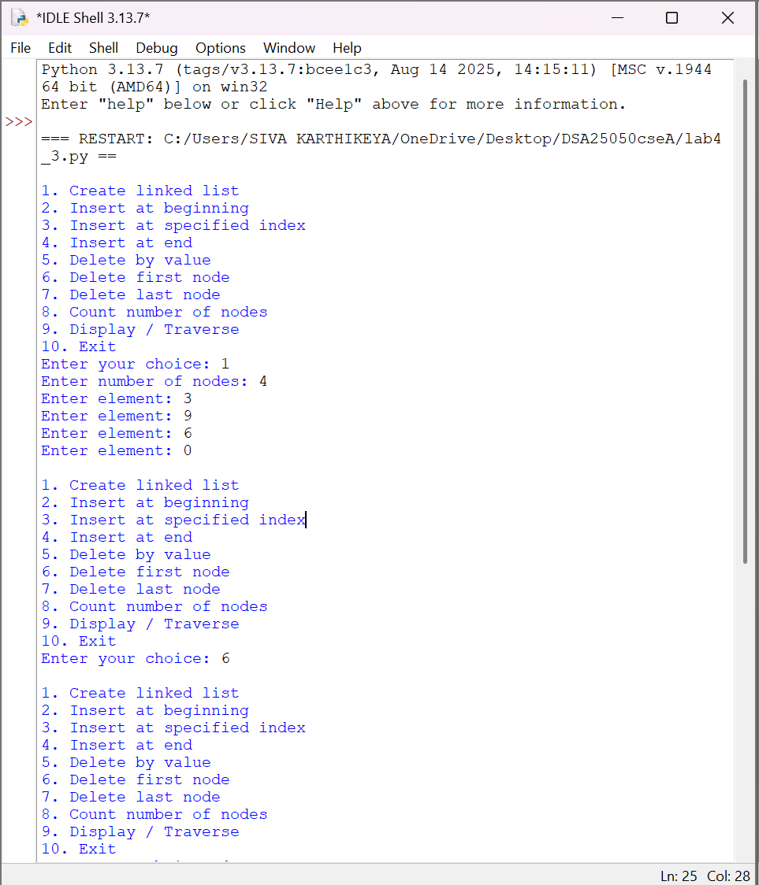
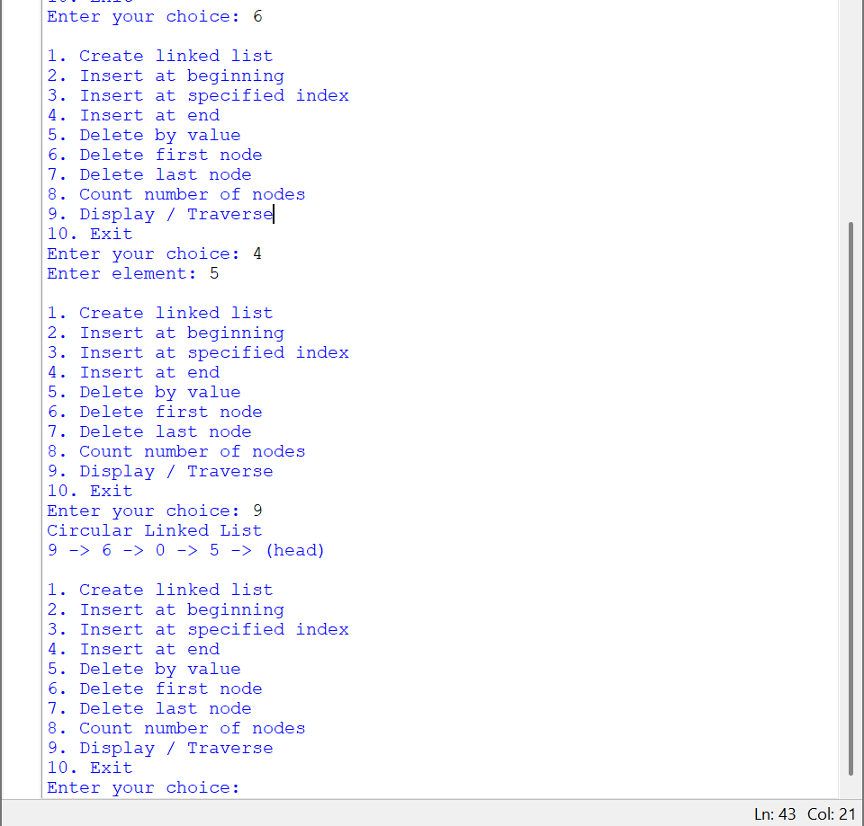
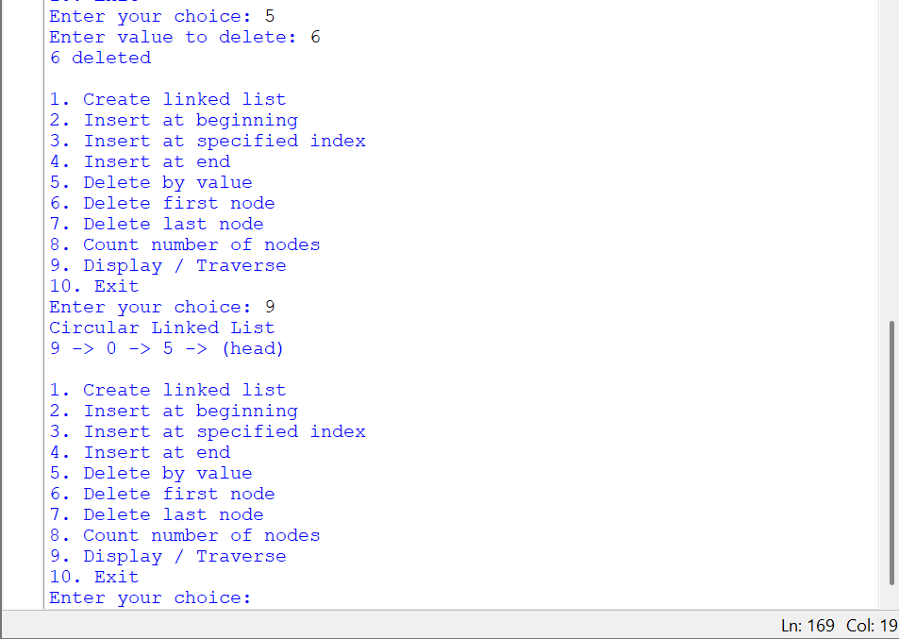
EXPLANATION
1. Create Linked List
- A Node contains data and next.
- self.head stores the first node.
- In a circular linked list, the last node does not contain None.
- Instead, its next points back to self.head:
new_node.next = self.head
┌───────────────┐
↓ │
10 → 20 → 30 ──────────┘
↑
head
2. Insert at Beginning
- temp traverses until the last node.
- The new node points to the current self.head.
- self.head is changed to the new node.
- The last node's next is updated to the new head.
3. Insert at Specified Index
- temp moves to the node before the required index.
- The new node points to temp.next.
- temp.next is then changed to the new node.
- The circular connection is maintained.
4. Insert at End
- temp traverses until:
temp.next == self.head
- This identifies the last node.
- The new node is inserted after it.
- The new node's next points back to self.head.
5. Delete by Value
- temp traverses the circular list.
- The condition temp.next.data == value checks the next node.
- When the value is found:
temp.next = temp.next.next
- The unwanted node is skipped.
6. Delete First Node
- If there is only one node:
self.head.next == self.head
so self.head is set to None.
- Otherwise, temp finds the last node.
- self.head is moved to the next node.
- The last node's next is updated to the new head.
7. Delete Last Node
- temp traverses until the second-last node.
- The last node is removed by:
temp.next = self.head
- Thus, the second-last node directly points to the head.
8. Count Nodes
- temp starts from self.head.
- Unlike a normal linked list, we cannot check temp is not None.
- We continue until temp becomes equal to self.head again:
- if temp == self.head:
break
- This counts every node exactly once.
9. Display / Traverse
- temp starts from self.head.
- Each node's data is displayed.
- temp = temp.next moves to the next node.
- Traversal stops when temp reaches self.head again.
10. Exit
- When choice 10 is selected, break terminates the menu loop.
ERROR TABLE:
SNO | ERROR | RECTIFICATION
1 |  | Stop when temp == self.head
  Infinite loop during traversal
2 | Last node deletion breaks circular link
  Set temp.next = self.head

WEEK-5
5A. AIM
Write a Python program to implement a Stack using Array. Also implement the stack operations such as PUSH, POP, PEEK and display the stack elements.
Code:
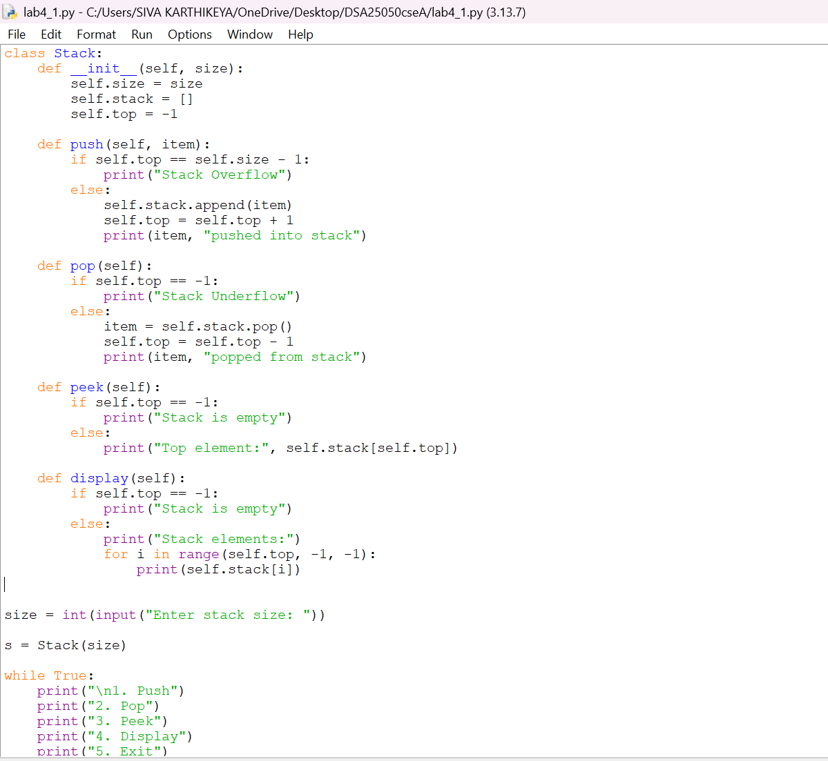

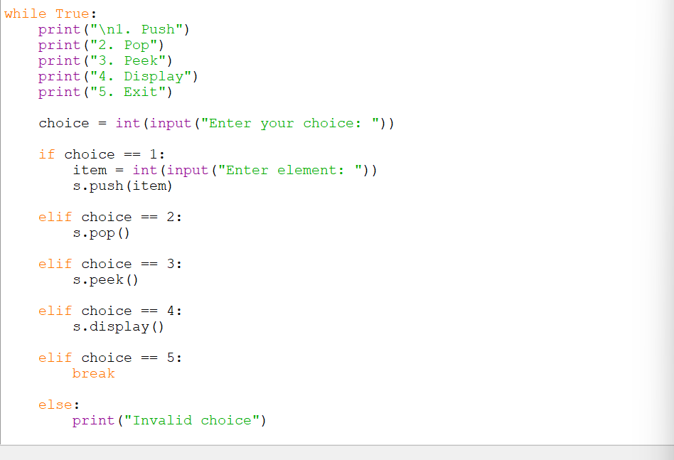
Output:
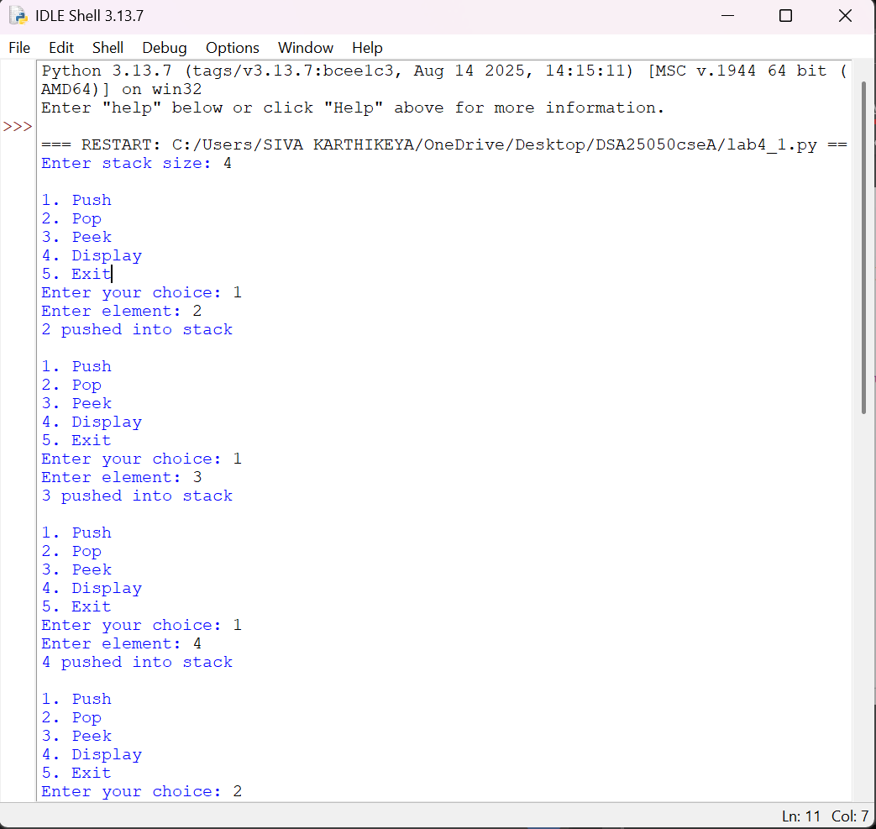

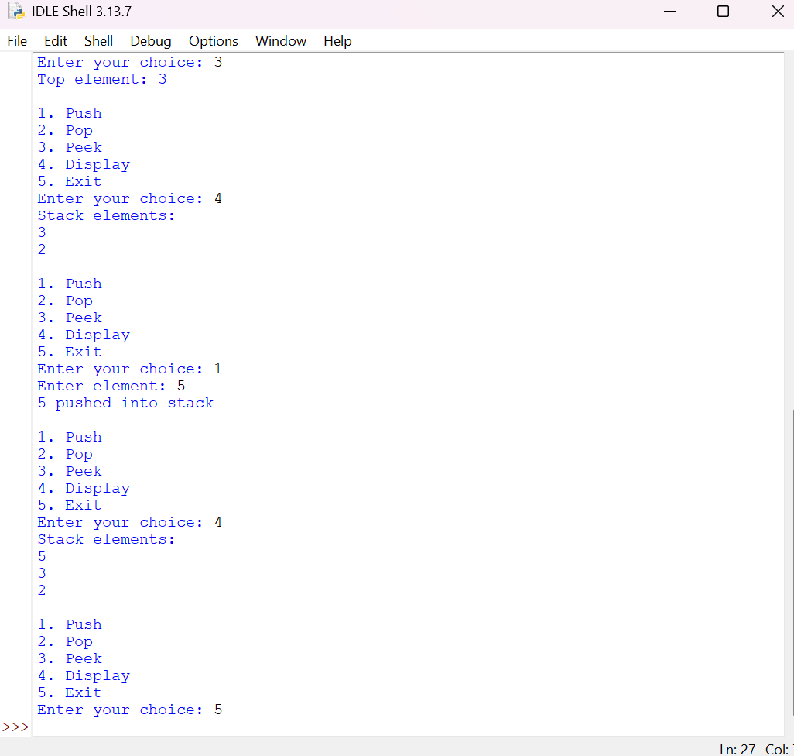
EXPLANATION:
Condition 1: PUSH Operation
- The push() function receives the element to be inserted.
- It first checks whether the stack is full using:
self.top == self.size - 1
- If the condition is True, the stack is full.
- Therefore, Stack Overflow is displayed.
- Otherwise, the element is added using:
self.stack.append(item)
- The top value is increased by 1.
- The new element becomes the top element of the stack.
Condition 2: POP Operation
- The pop() function removes the top element.
- It first checks:
self.top == -1
- If the condition is True, the stack is empty.
- Therefore, Stack Underflow is displayed.
- Otherwise, the top element is removed using:
item = self.stack.pop()
- The top value is decreased by 1.
Condition 3: PEEK Operation
- The peek() function displays the top element without removing it.
- It checks whether:
self.top == -1
- If True, the stack is empty.
- Otherwise:
self.stack[self.top]
- displays the top element.
Condition 4: DISPLAY Operation
- The display() function displays all the elements of the stack.
- If top == -1, the stack is empty.
- Otherwise, the for loop starts from top and moves towards 0.
- Therefore, the elements are displayed from TOP to BOTTOM.

ERROR TABLE:
SNO | ERROR | RECTIFICATION
1 | Stack Overflow condition written incorrectly | Used self.top == self.size – 1

5B. AIM
Write a Python program to implement a Stack using Linked List. Also implement the stack operations such as PUSH, POP, PEEK and display the stack elements.
Code:
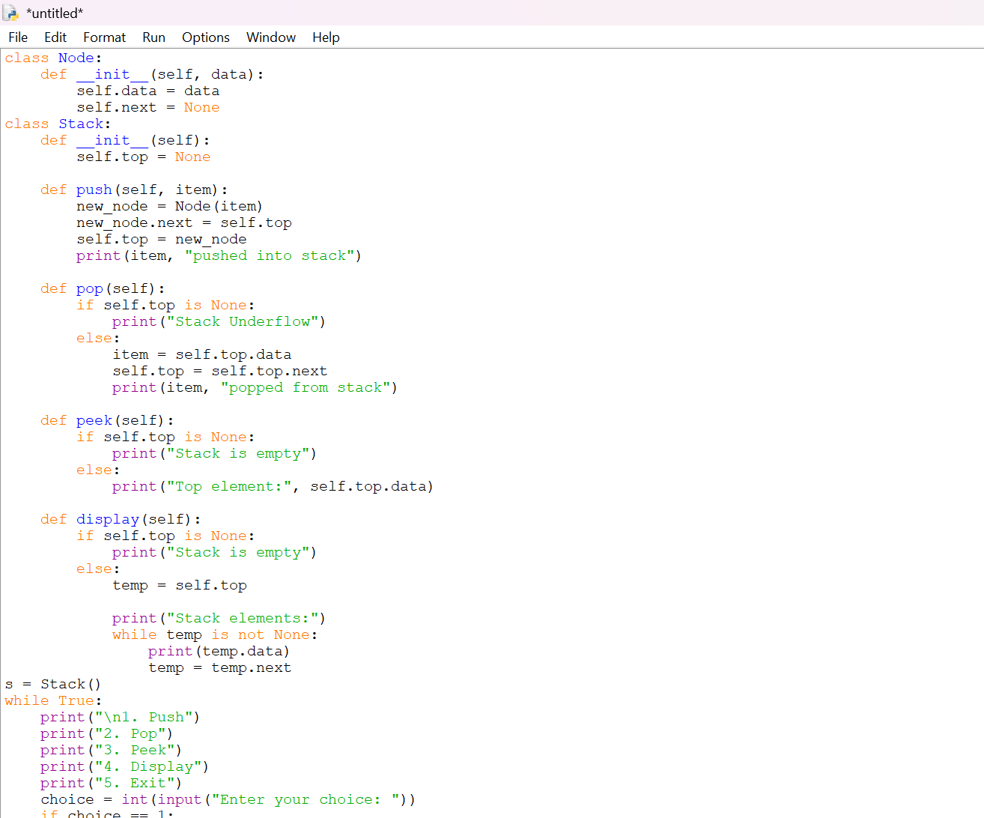
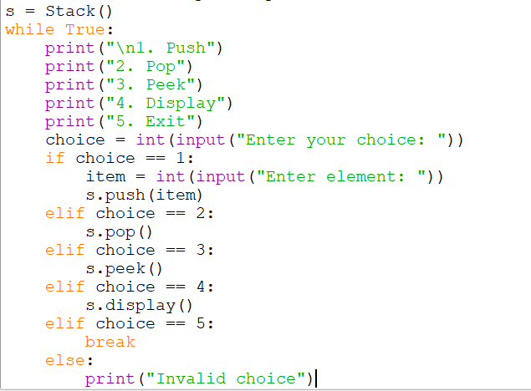
Output:
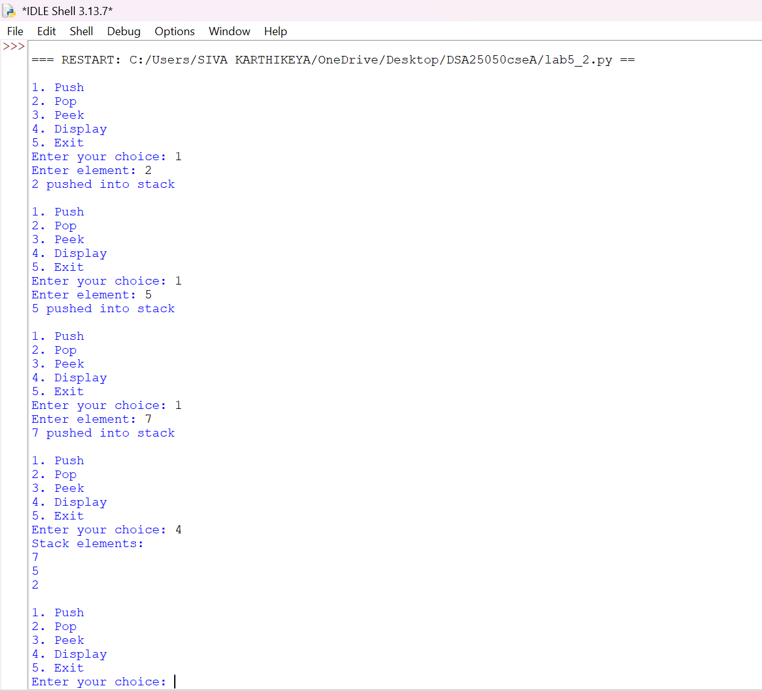
EXPLANATION
Condition 1: PUSH Operation
- A new node is created using:
new_node = Node(item)
- The new node is connected to the current top using:
new_node.next = self.top
- The new node is then made the top:
self.top = new_node
For example, initially:
TOP → 20 → 10 → None
After pushing 30:
TOP → 30 → 20 → 10 → None
Condition 2: POP Operation
- The program first checks:
self.top is None
- If True, the stack is empty and Stack Underflow is displayed.
- Otherwise, the top element is stored:
item = self.top.data
- The top is moved to the next node:
self.top = self.top.next
For example:
Before POP:

TOP → 30 → 20 → 10 → None
After POP:
TOP → 20 → 10 → None
Therefore, 30 is removed.
Condition 3: PEEK Operation
- The peek() function does not remove the element.
- It checks whether self.top is None.
- If the stack is not empty, it displays:
self.top.data
- Thus, it displays the top element without changing the stack.
Condition 4: DISPLAY Operation
- The display() function uses a temporary variable:
temp = self.top
- The while loop traverses the linked list.
- Each node's data is displayed.
- After displaying one node, temp moves to the next node:
temp = temp.next
- The process continues until temp becomes None.

ERROR TABLE:
SNO | ERROR | RECTIFICATION
1 | New node not connected to existing stack | Used new_node.next = self.top
2 | Top not updated after PUSH | Used self.top = new_node
3 | Infinite traversal during DISPLAY | Used temp = temp.next

WEEK-6:
AIM: QUEUE USING ARRAY
Write a Python program to implement a Queue using an Array and perform the operations Enqueue and Dequeue using a menu-driven program.
CODE:
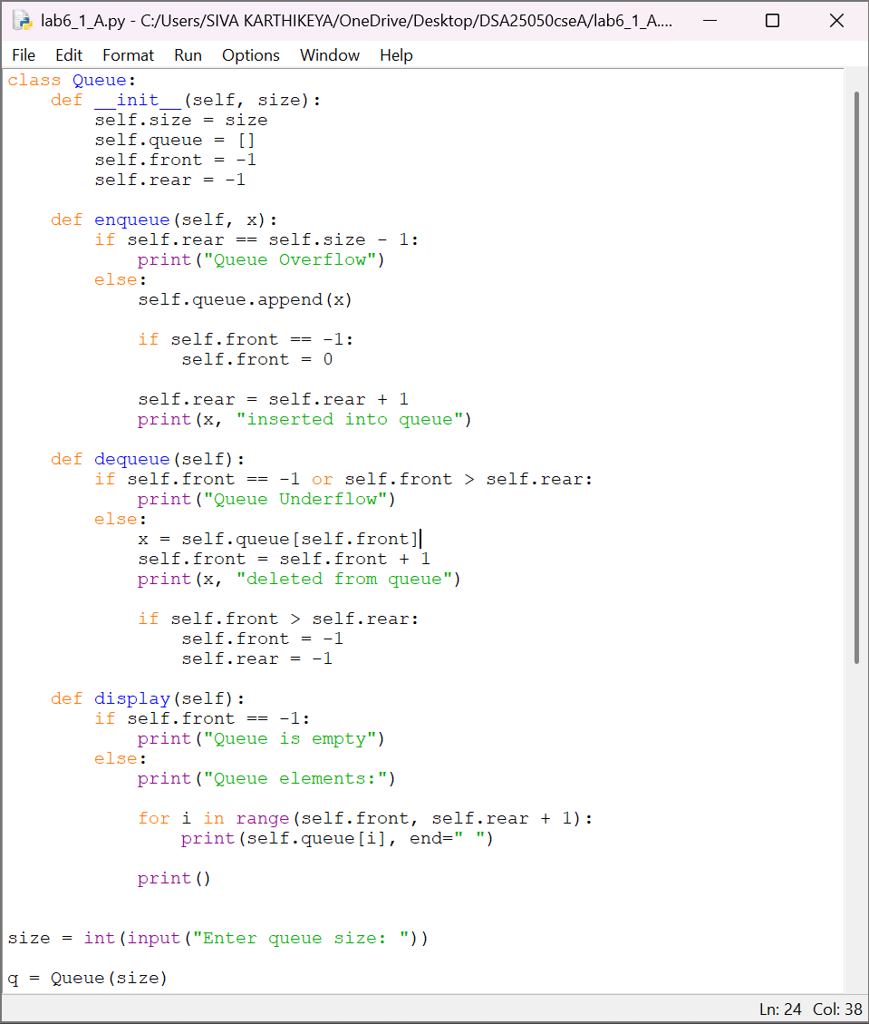

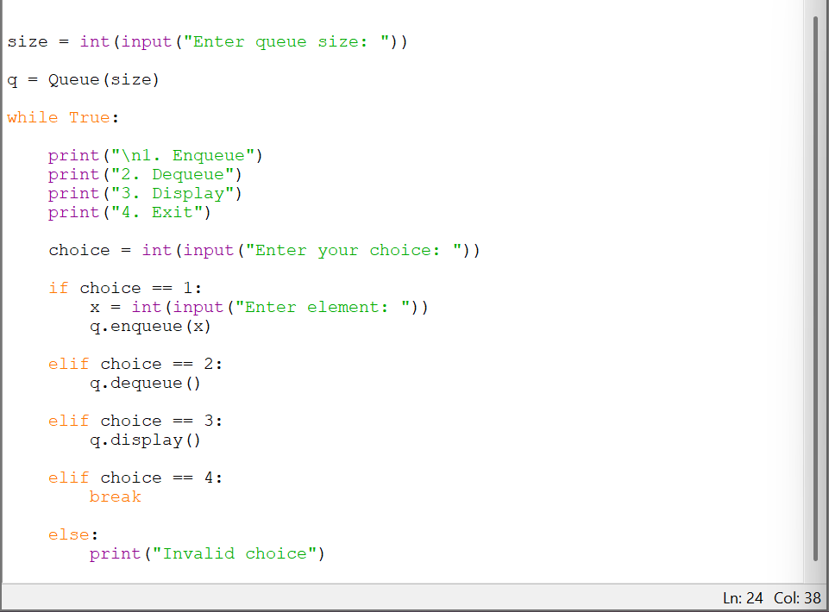
OUTPUT:
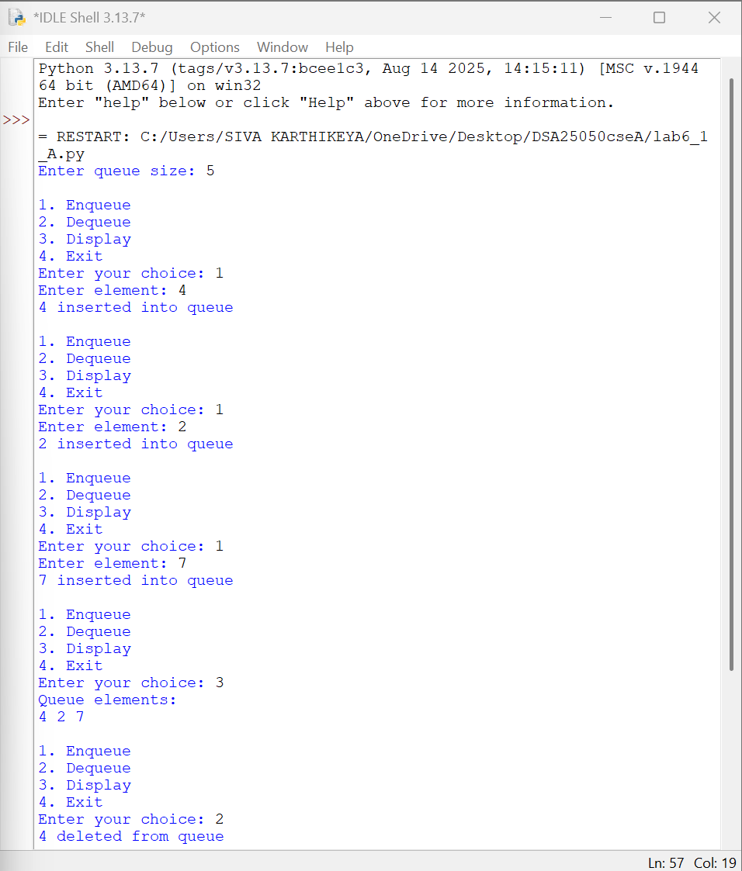
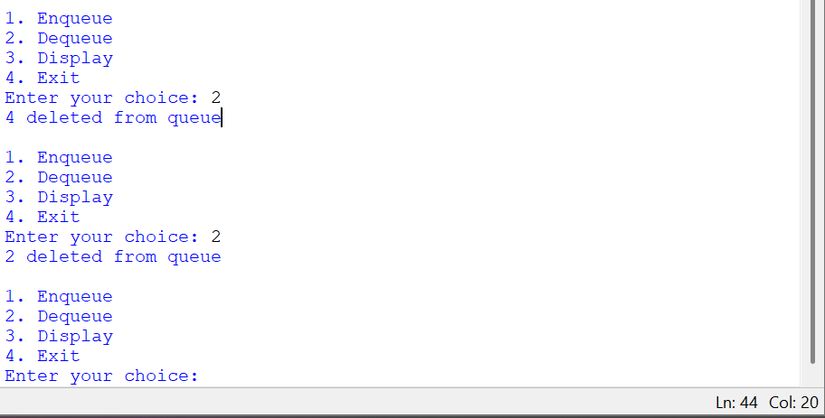
EXPLANATION
1. Enqueue Operation
- The enqueue() function is used to insert an element into the queue.
- First, rear is checked to determine whether the queue is full:
self.rear == self.size - 1
- If the condition is true, Queue Overflow is displayed.
- Otherwise, the element is added to queue.
- If the queue is initially empty, front is set to 0.
- rear is then incremented to point to the newly inserted element.
2. Dequeue Operation
- The dequeue() function removes an element from the front of the queue.
- The queue is empty when:
self.front == -1
or
self.front > self.rear
- The element at self.front is stored in x.
- front is then incremented:
self.front = self.front + 1
- If front goes beyond rear, both front and rear are reset to -1.
3. Display Operation
- The program checks whether front == -1.
- If the queue is not empty, a for loop starts from front and goes up to rear.
- Each queue element is displayed.
4. Exit
- When the user selects 4, the break statement terminates the menu loop.
ERROR TABLE:
SNO | ERROR | RECTIFICATION
1 | Queue overflow condition incorrect | Used rear == size - 1
2 | Front not updated after dequeue | Used front = front + 1
3 | Queue state not reset after last deletion | Set front = rear = -1

AIM: QUEUE USING LINKED LIST
Write a Python program to implement a Queue using a Linked List and perform Enqueue and Dequeue operations using a menu-driven program.
CODE:

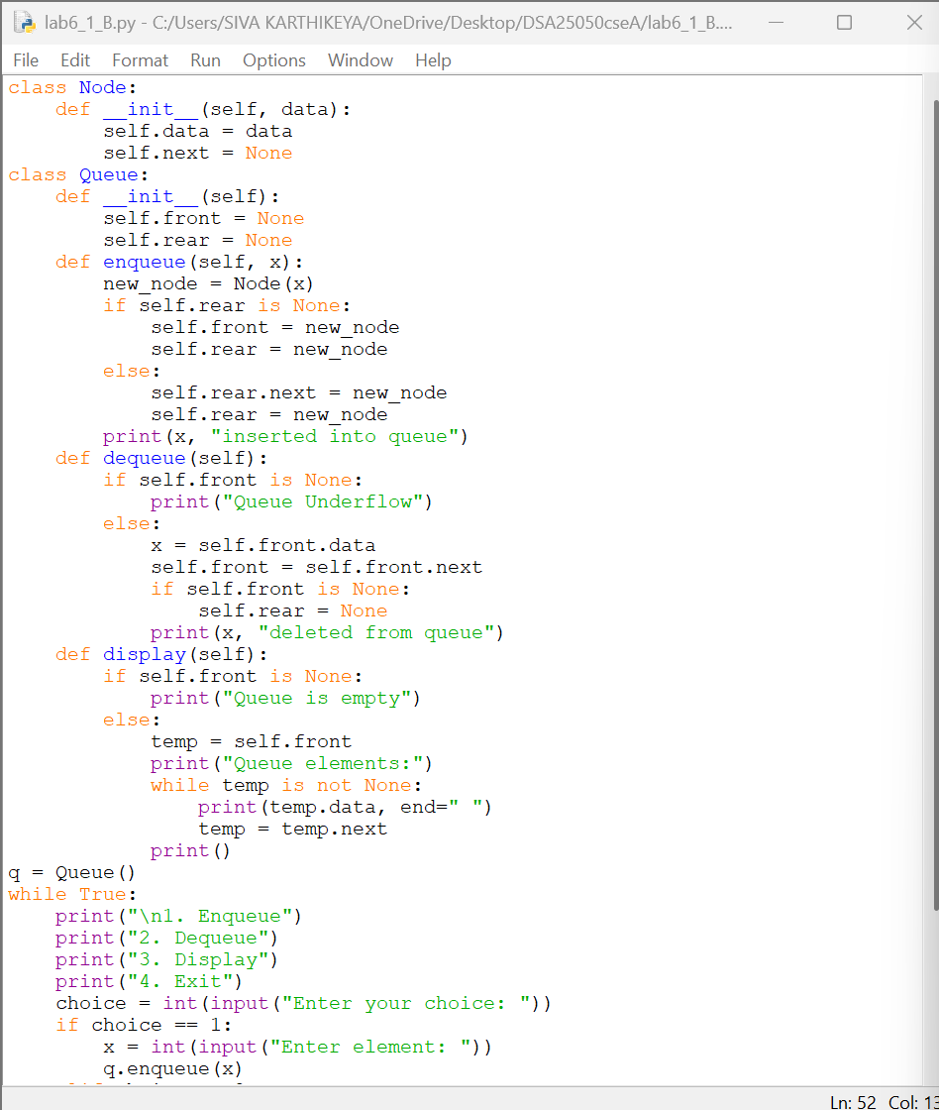
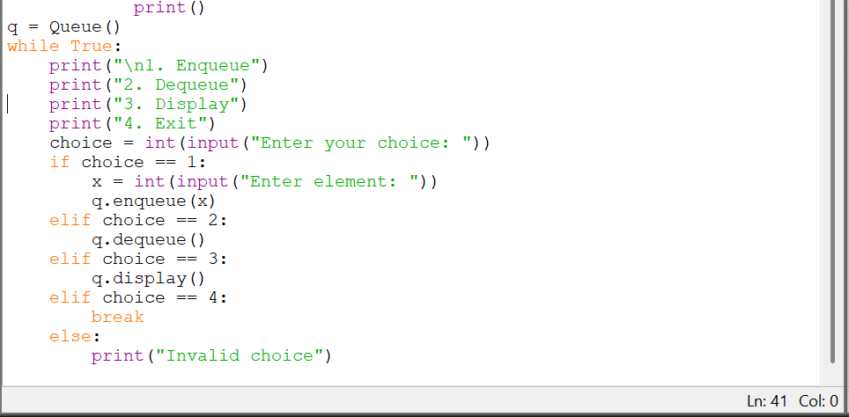
OUTPUT:
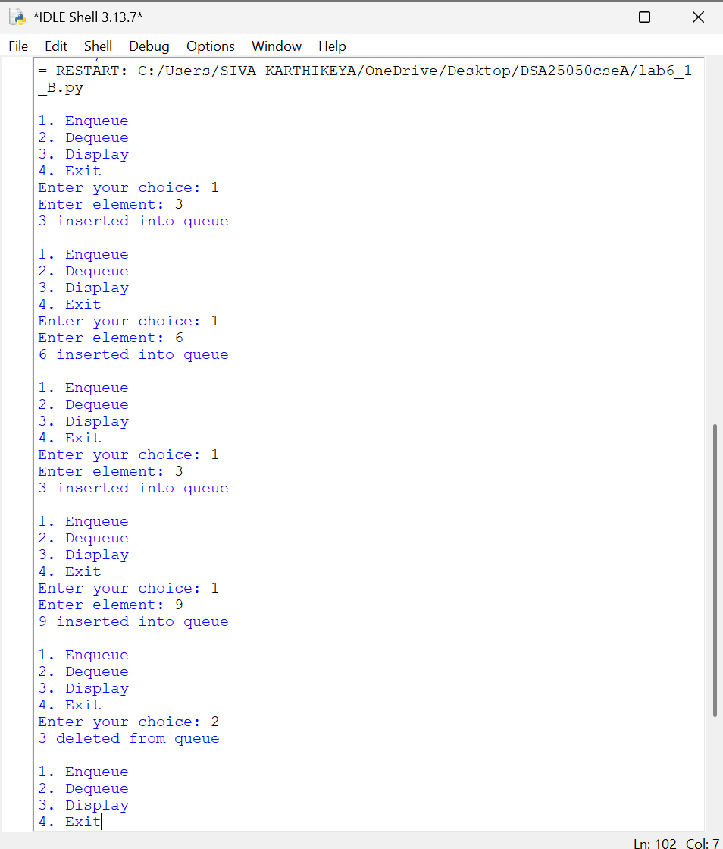
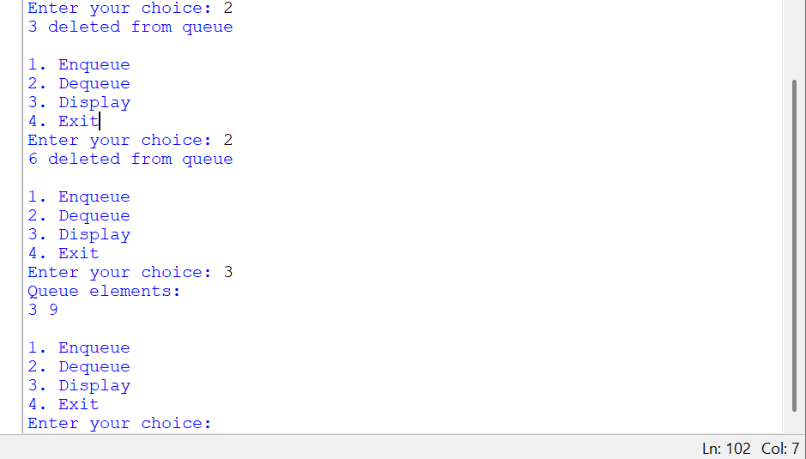
EXPLANATION
1. Enqueue Operation
- A new node is created using:
new_node = Node(x)
- If self.rear is None, the queue is empty.
- Therefore, both self.front and self.rear point to the new node.
- Otherwise, the new node is connected after the current rear:
self.rear.next = new_node
- Then self.rear is updated:
self.rear = new_node
2. Dequeue Operation
- The program checks whether self.front is None.
- If it is None, the queue is empty and Queue Underflow is displayed.
- Otherwise, the data of the front node is stored in x.
- self.front is moved to the next node:
self.front = self.front.next
- If the queue becomes empty, self.rear is also set to None.
3. Display Operation
- temp starts from self.front.
- The while loop traverses the queue.
- temp.data is displayed.
- temp = temp.next moves to the next node.
- Traversal ends when temp becomes None.
ERROR TABLE:
SNO | ERROR | RECTIFICATION
1 | rear not updated during enqueue | Used self.rear = new_node
2 | front not updated during dequeue | Used self.front = self.front.next
3 | Rear remains after deleting last node | Set self.rear = None

6(B)
AIM: QUEUE USING CIRCULAR LINKED LIST
Write a Python program to implement a Queue using a Circular Linked List and perform Enqueue and Dequeue operations using a menu-driven program.
CODE:
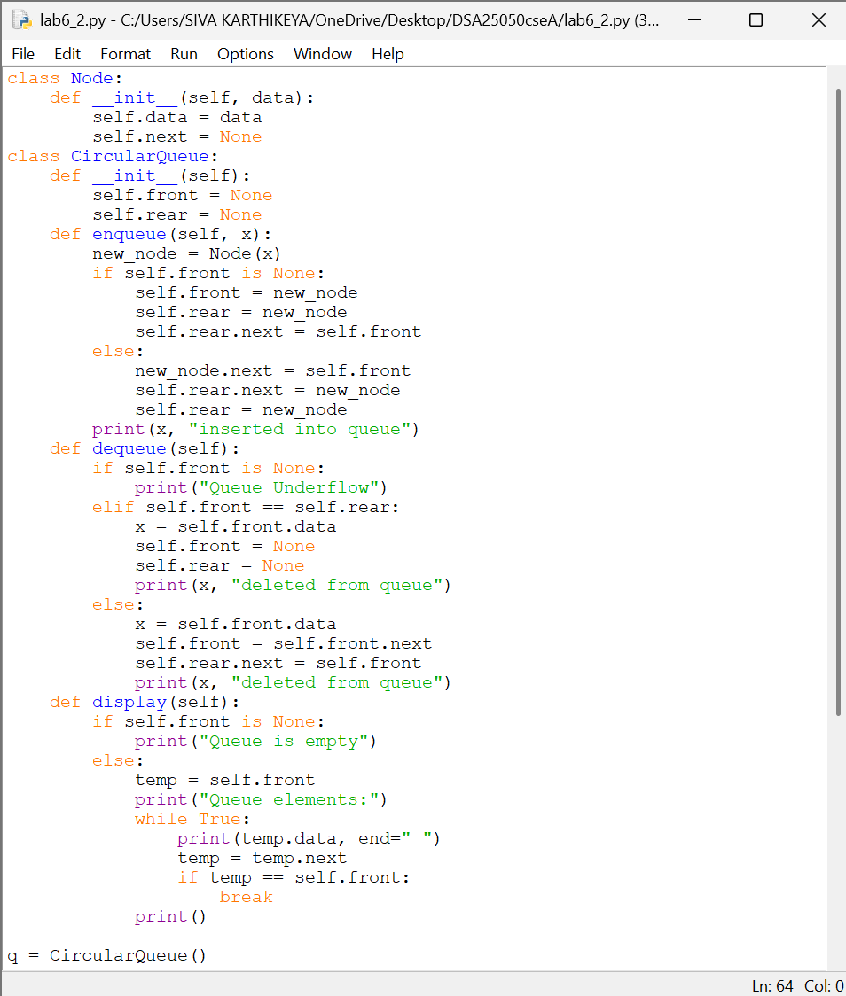
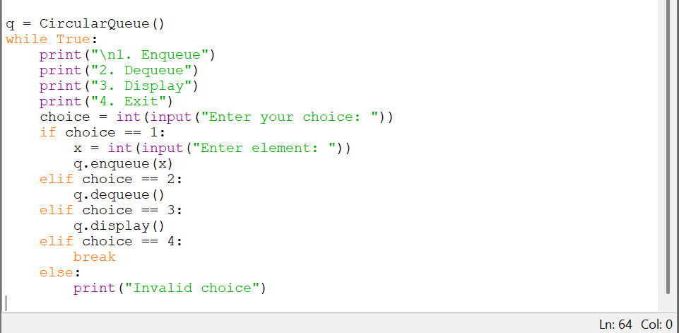
OUTPUT:
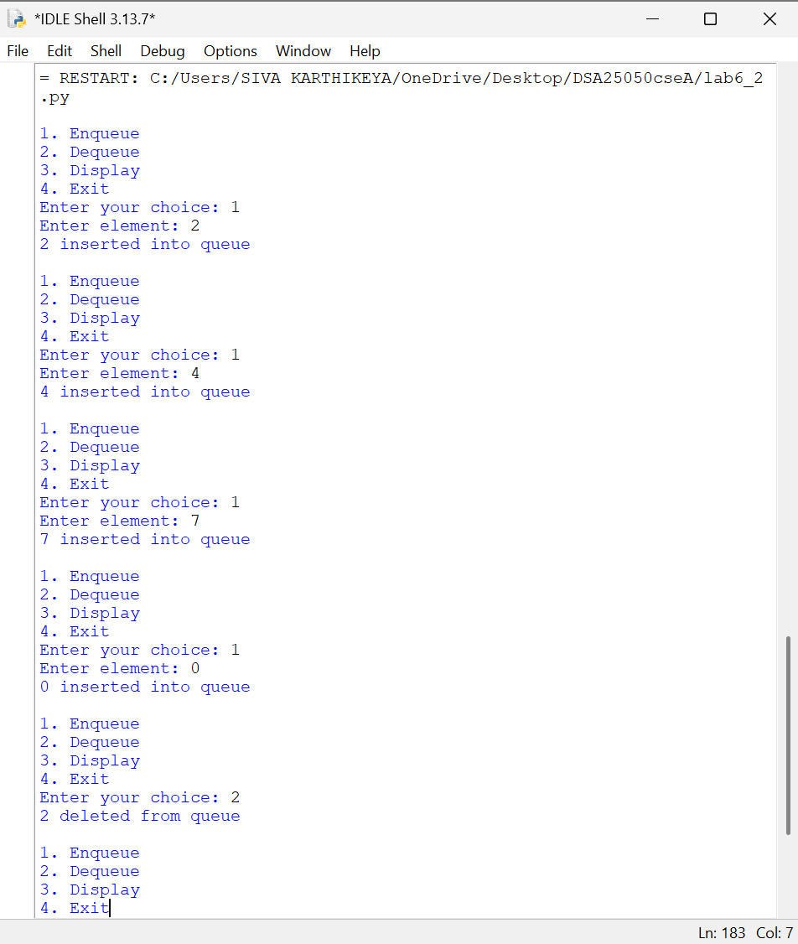
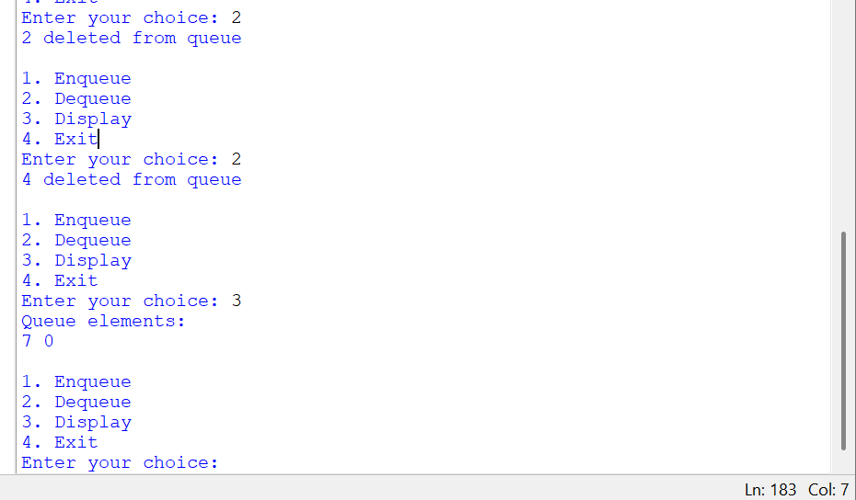
EXPLANATION
1. Enqueue Operation
- A new node is created using:
new_node = Node(x)
- If self.front is None, the queue is empty.
- Both self.front and self.rear point to the new node.
- Since it is a circular queue:
self.rear.next = self.front
- For an existing queue, the new node is connected after self.rear.
- The new node points back to self.front.
- Finally, self.rear is updated to the new node.
2. Dequeue Operation
- First, the program checks whether self.front is None.
- If true, the queue is empty and Queue Underflow is displayed.
- If self.front == self.rear, there is only one node.
- Both front and rear are then set to None.
- Otherwise, self.front moves to the next node:
self.front = self.front.next
- The circular connection is restored using:
self.rear.next = self.front
3. Display Operation
- temp starts from self.front.
- Since the queue is circular, temp does not become None.
- Therefore, a while True loop is used.
- After moving through the nodes, the loop stops when:
temp == self.front
- This prevents infinite traversal.
4. Exit
- When the user selects 4, break terminates the menu loop.
- ERROR TABLE:
SNO | ERROR | RECTIFICATION
1 | Circular connection not maintained | Set rear.next = front
2 |  | Set self.front = self.front.next
  Front not updated during dequeue
3 | Infinite loop during display | Check front == rear

WEEK – 7
7A.1).AIM: Write a Python Program to implement a binary tree using an array with all of its operations
PROGRAM:
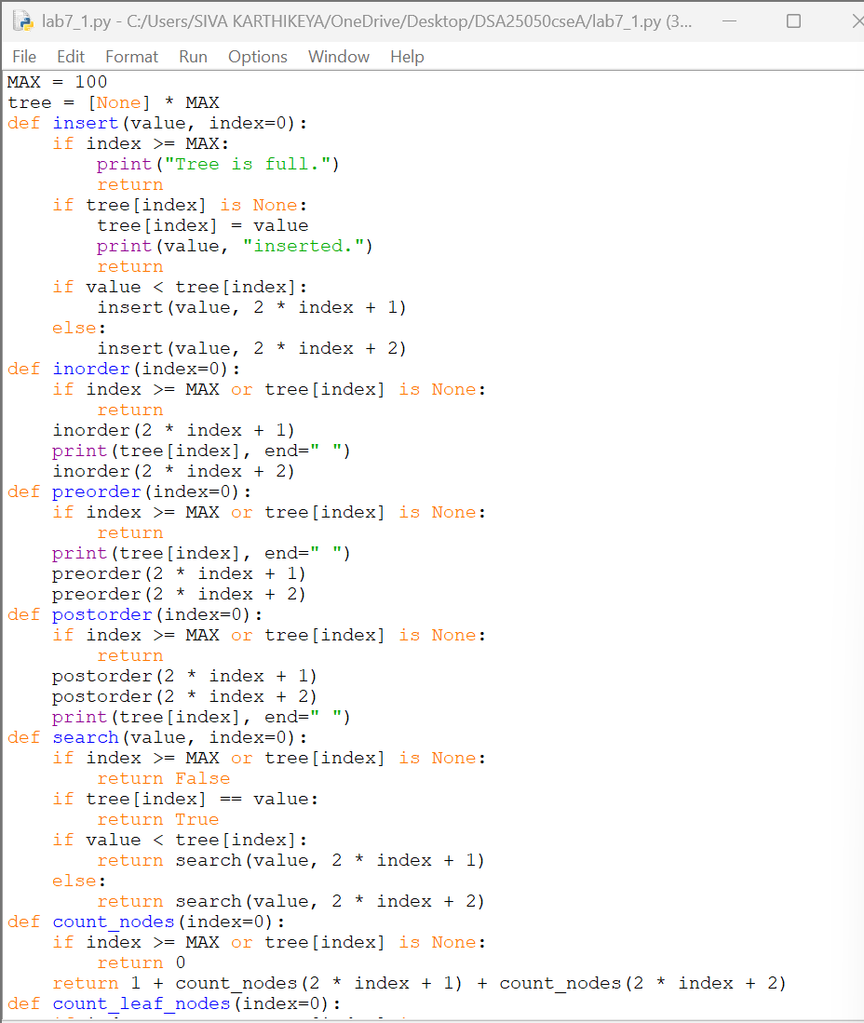
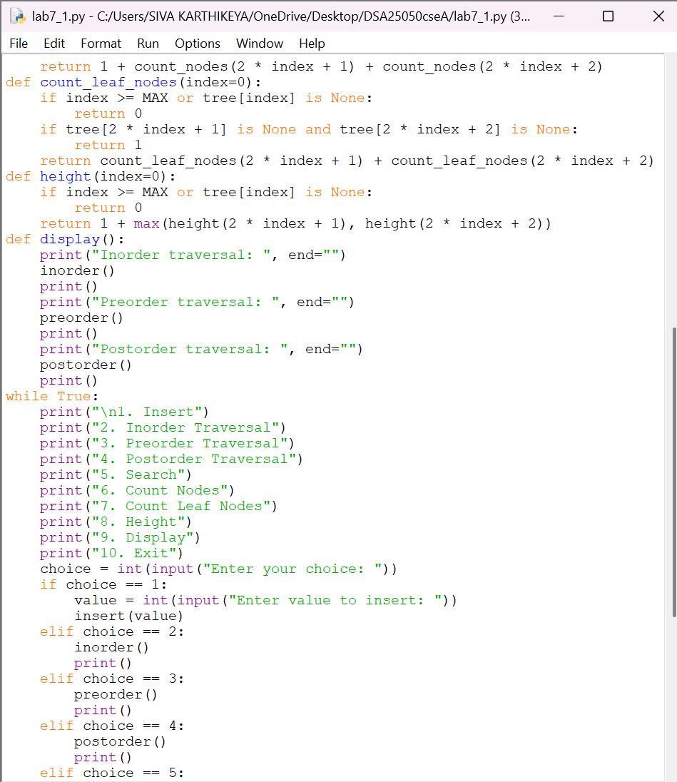
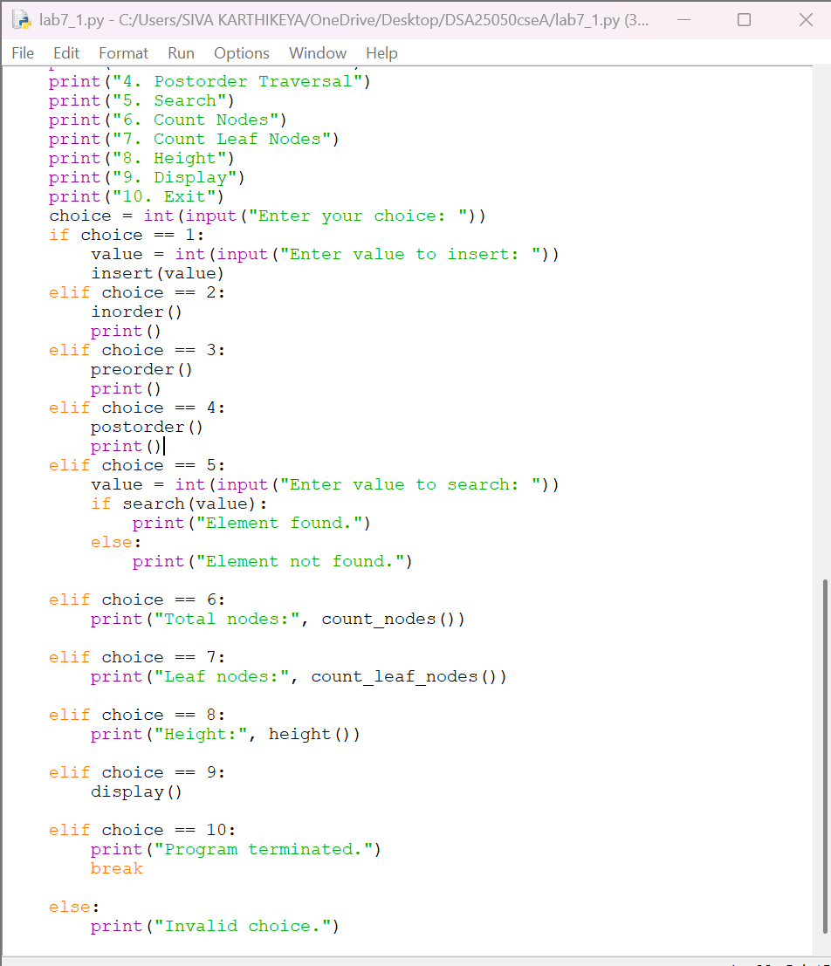
Output:
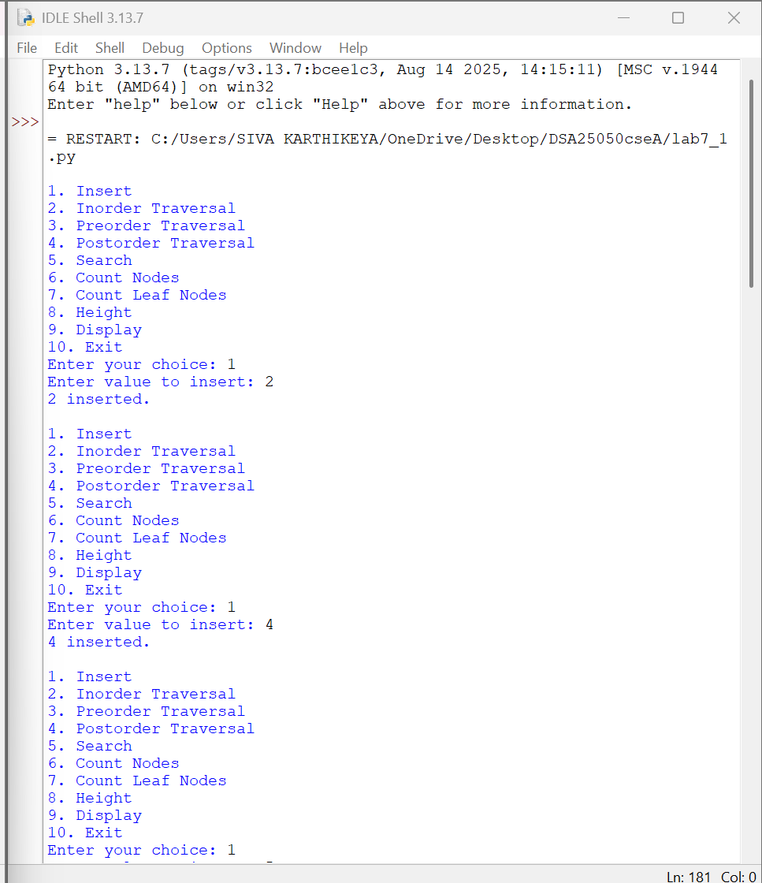

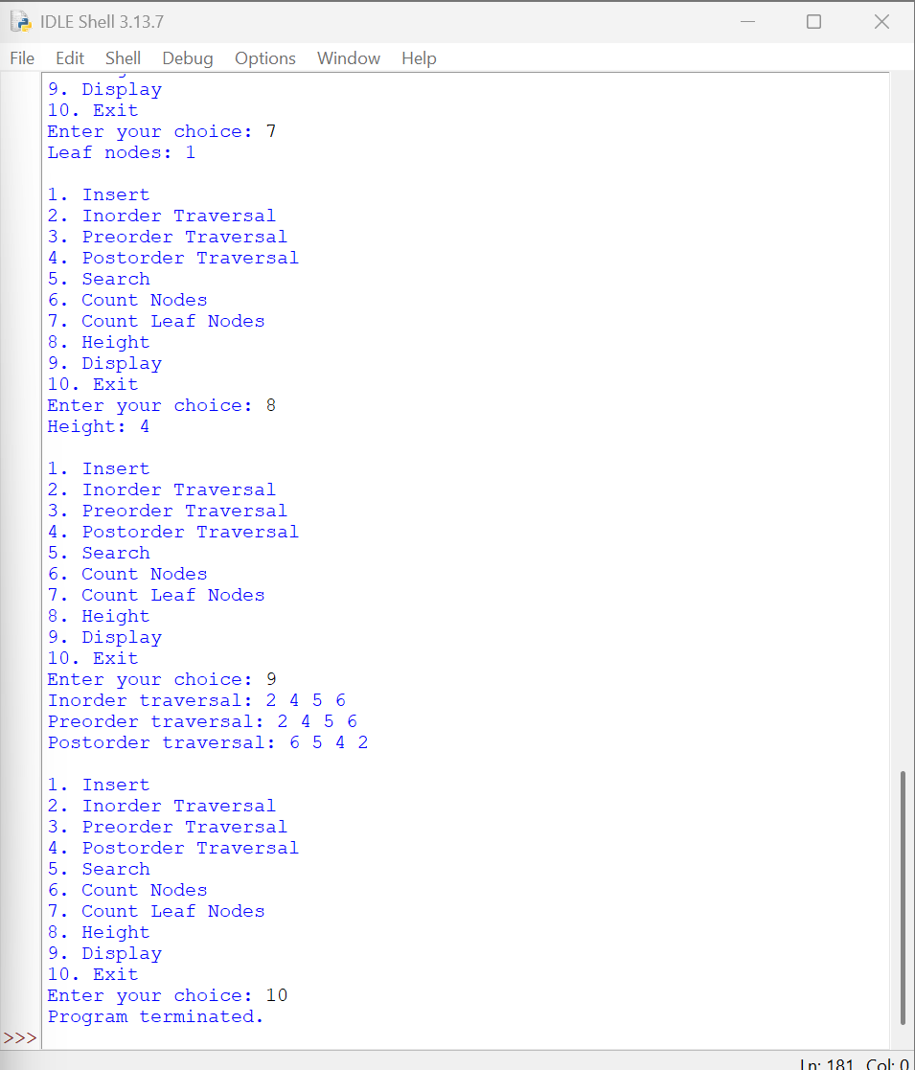
EXPLANATION:
A binary tree is a non-linear data structure in which each node contains at most two children, called the left child and the right child.
In this program, a binary search tree (BST) is implemented using an array of fixed size. The root node is stored at index 0. For any node at index i, its left child is stored at index 2*i + 1 and its right child is stored at index 2*i + 2.
The following operations are performed in the program:
- Insertion: Inserts an element into the binary search tree. Smaller values are placed in the left subtree, and greater or equal values are placed in the right subtree.
- Inorder Traversal: Visits the left subtree, root node, and right subtree. It displays elements in ascending order.
- Preorder Traversal: Visits the root node, left subtree, and right subtree.
- Postorder Traversal: Visits the left subtree, right subtree, and root node.
- Searching: Searches for a particular element in the tree by comparing it with the root node and moving to the appropriate subtree.
- Counting Nodes: Calculates the total number of nodes present in the binary tree.
- Counting Leaf Nodes: Counts the nodes that do not have any children.
- Finding Height: Calculates the height of the tree by finding the longest path from the root node to a leaf node.
- Displaying the Tree: Displays the elements of the tree using inorder, preorder, and postorder traversals.
Error table:
SNO | ERROR | RECTIFICATION
1 | Using the wrong index for the left child. | Use 2 * index + 1 for the left child.
2 |  | Use 2 * index + 2 for the right child.
  Using the wrong index for the right child.
3 | Forgetting to initialize the array. | Initialize it using tree = [None] * MAX

7.B.) AIM: Write a Python Program to implement a binary
tree using an linked list with all of its operations.
INPUT:
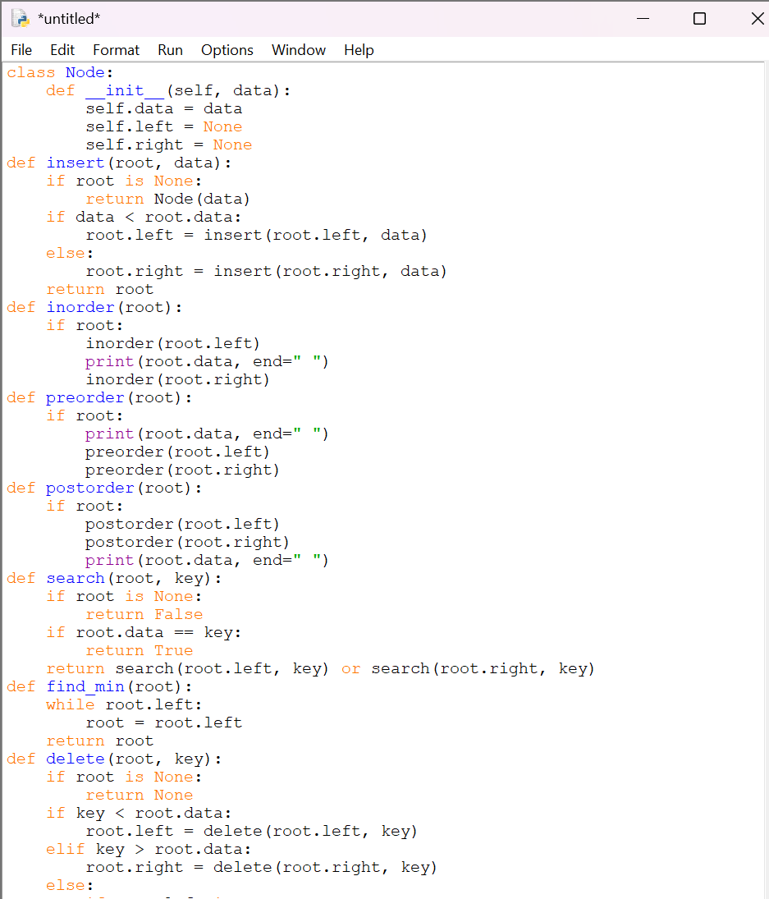
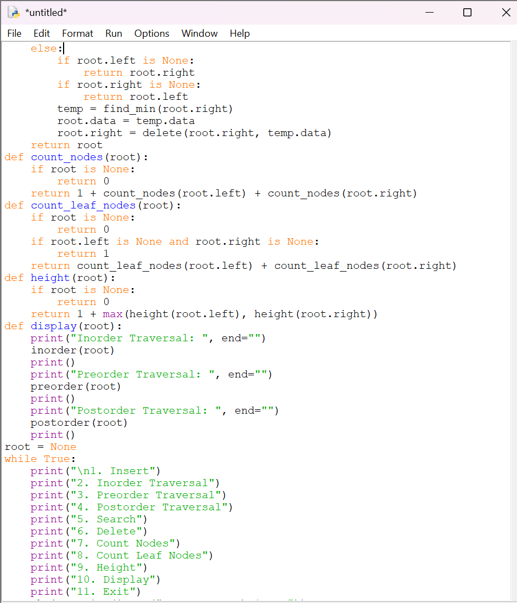
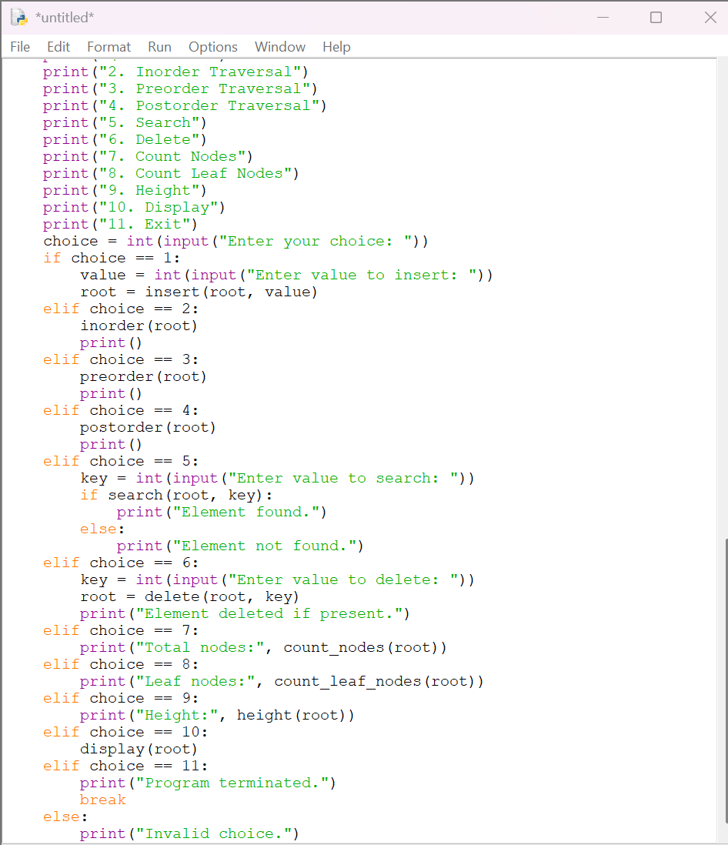
OUTPUT:
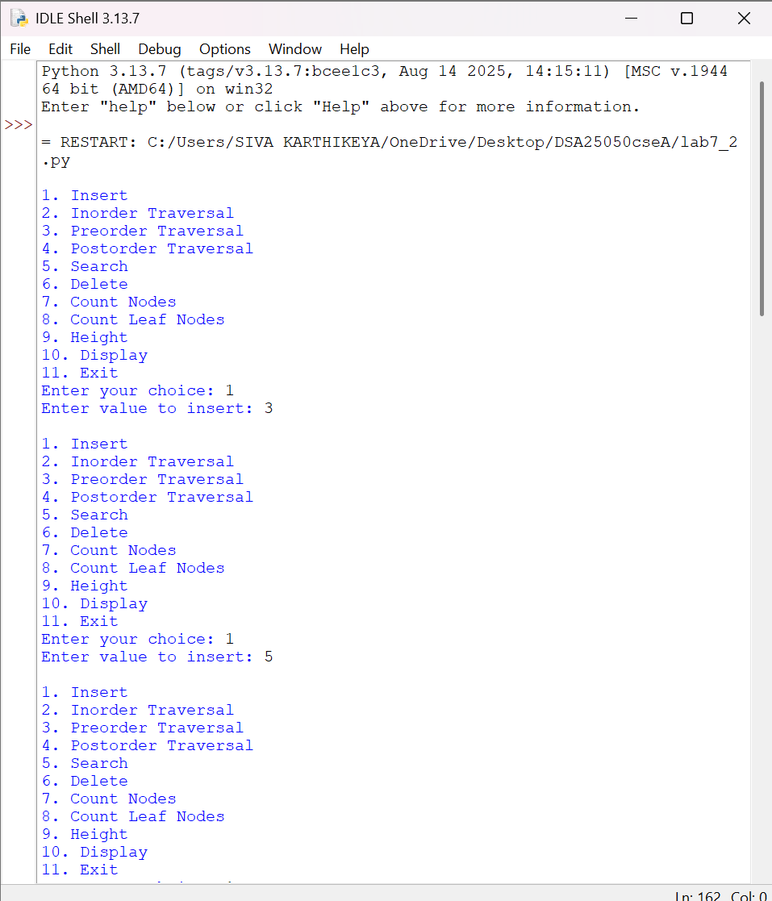
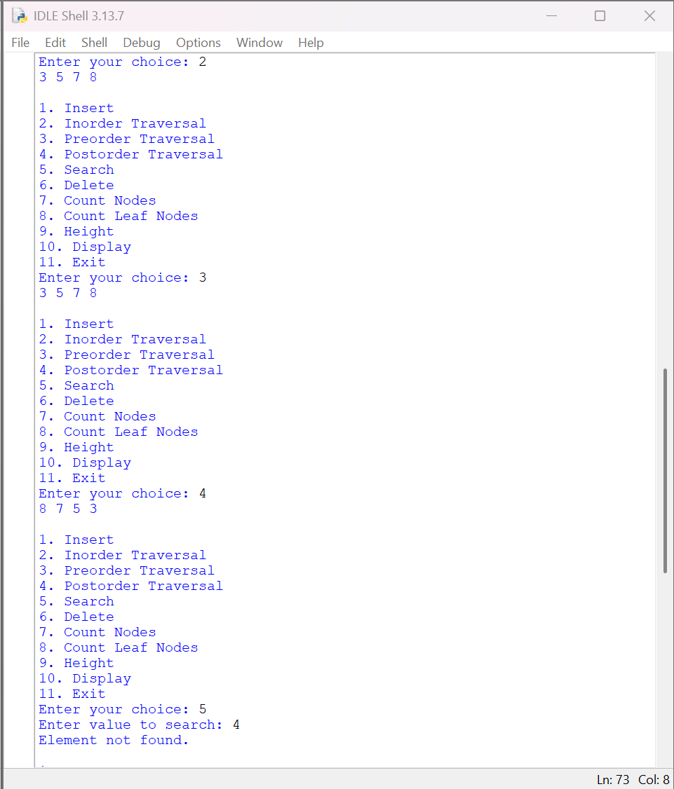
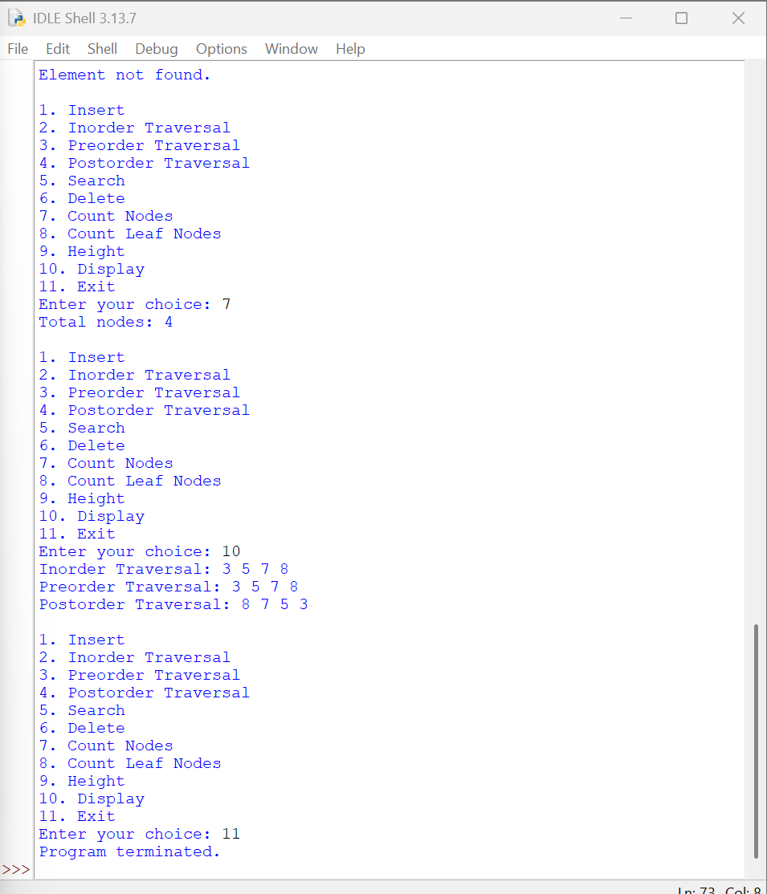
EXPLANATION
A binary tree is a non-linear data structure in which each node contains data and references to at most two children, called the left child and the right child.
Each node is created dynamically using a class and contains three fields: data, left, and right. The left and right references connect the nodes to form the tree.
The following operations are performed:
- Insertion: Inserts a new node into the tree. Smaller values are inserted into the left subtree, while greater or equal values are inserted into the right subtree.
- Inorder Traversal: Visits the left subtree, root node, and right subtree.
- Preorder Traversal: Visits the root node, left subtree, and right subtree.
- Postorder Traversal: Visits the left subtree, right subtree, and root node.
- Searching: Searches for a particular element by traversing the tree.
- Deletion: Removes a specified node from the tree. It handles nodes with no children, one child, or two children.
- Counting Nodes: Counts the total number of nodes present in the tree.
- Counting Leaf Nodes: Counts nodes that do not have any children.
- Finding Height: Calculates the height of the tree by finding its longest path from root to leaf.

Error table:
SNO | ERROR | RECTIFICATION
1 | AttributeError | Use __init__()
2 |  | Maintain proper indentation
  IndentationError
3 | RecursionError | Add proper base conditions

WEEK-8
8).AIM: Write a Program to implement Binary Search Tree with it's operations Transversals also
Program:
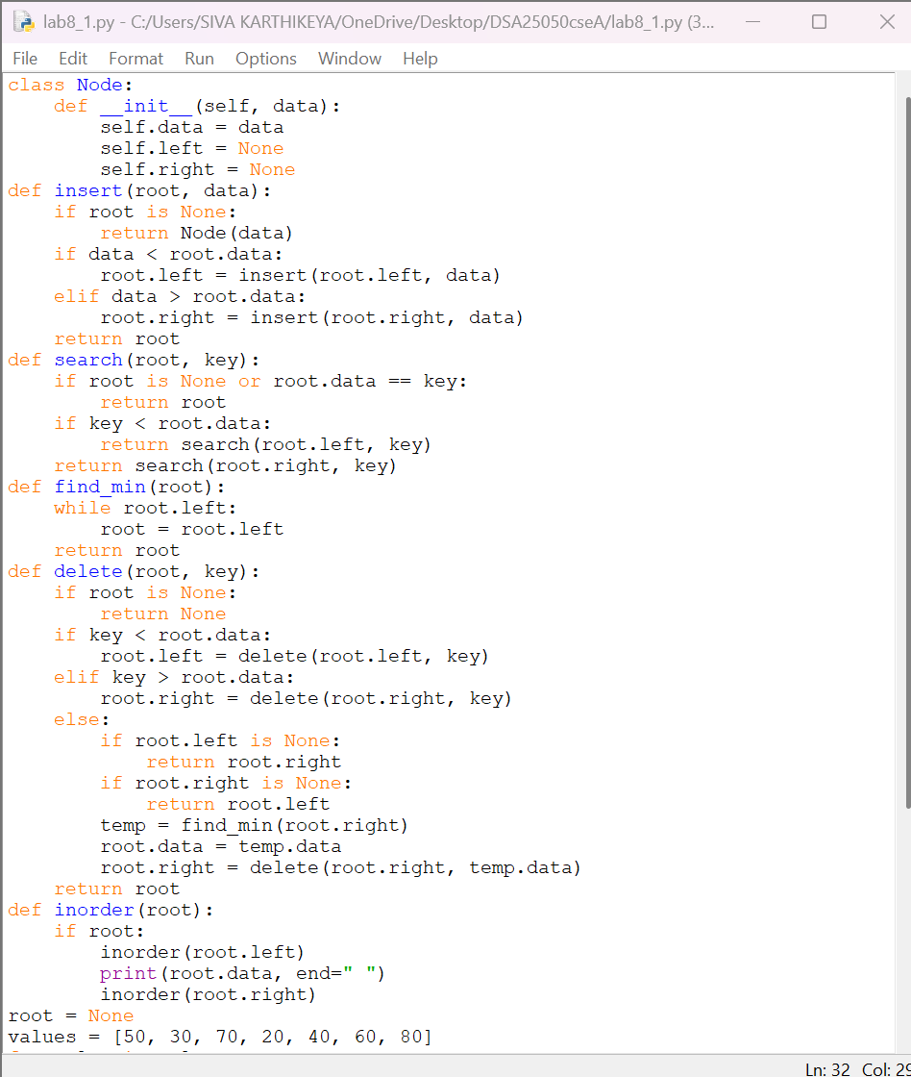
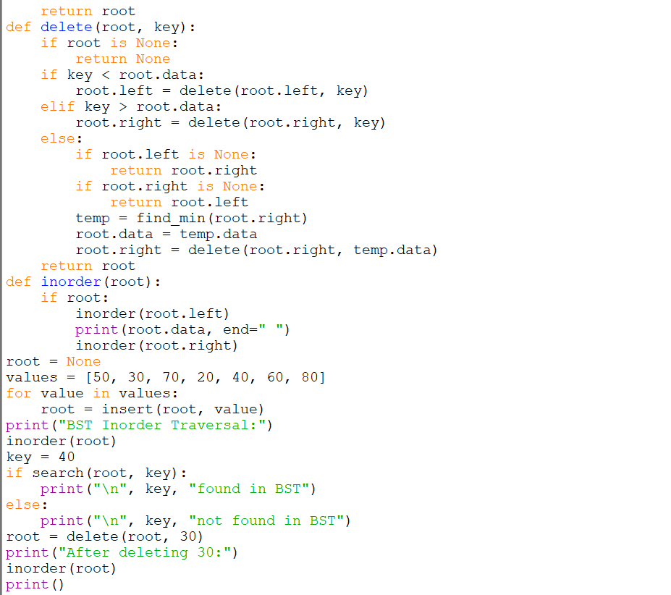
Output:
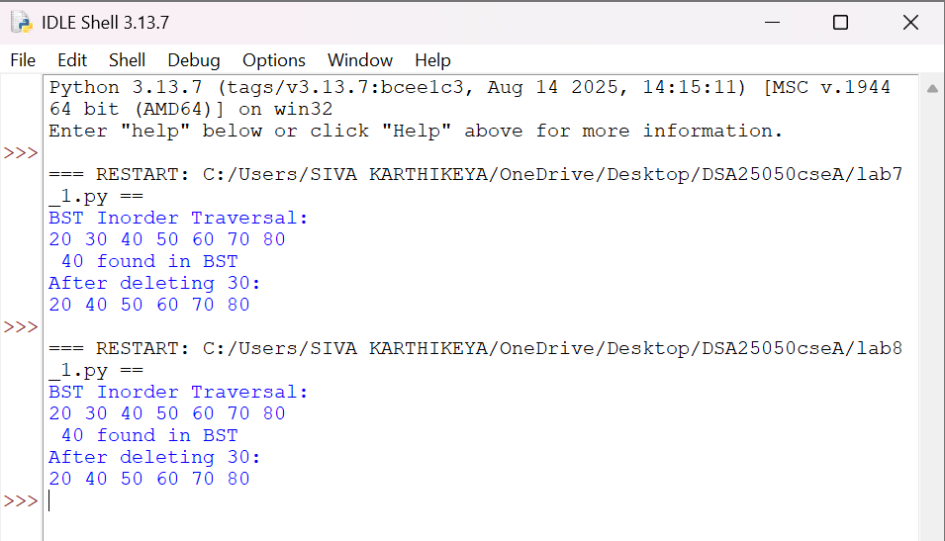
EXPLANATION
A Binary Search Tree (BST) is a non-linear data structure in which each node contains data and references to its left and right children.
In a BST, all elements in the left subtree are smaller than the root node, and all elements in the right subtree are greater than the root node.
Each node is created dynamically using a class and contains three fields: data, left, and right.
The following operations are performed:
- Insertion: Inserts a new element in its correct position according to BST properties.
- Searching: Searches for an element by comparing it with the root and moving to the left or right subtree.
- Deletion: Deletes a node from the BST. It handles three cases: node with no children, one child, or two children.
- Inorder Traversal: Visits left subtree → root → right subtree. It displays elements in ascending order.
- Preorder Traversal: Visits root → left subtree → right subtree.
- Postorder Traversal: Visits left subtree → right subtree → root.
- Counting Nodes: Counts the total number of nodes in the tree.
- Counting Leaf Nodes: Counts nodes that have no children.
- Finding Height: Calculates the longest path from the root to a leaf.
- Displaying: Displays all three traversals of the BST.

Error table:
SNO | ERROR | RECTIFICATION
1 | Not updating root | Always use root = insert(root, value) and root = delete(root, key) because these functions may return a new root.
2 |  | Simply removing the node could break the BST structure. Your code correctly uses find_min() to find its inorder successor
  Deleting a node with two children.

Week-9
9)Write a Python Program to implement AVL Tree with it's operations Transversals also
Input:
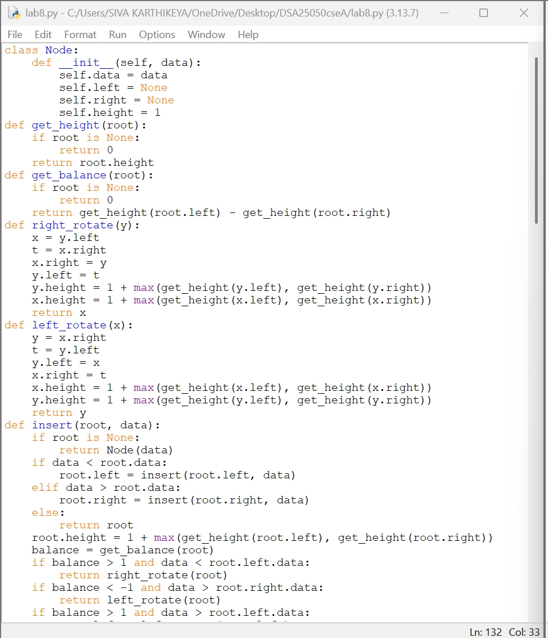
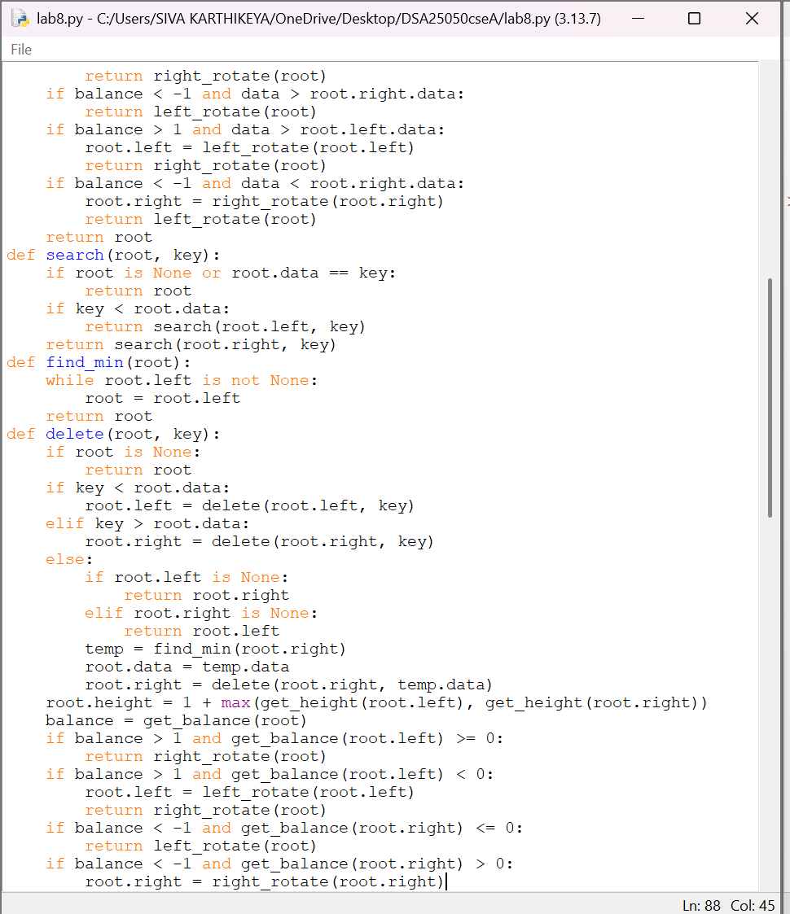
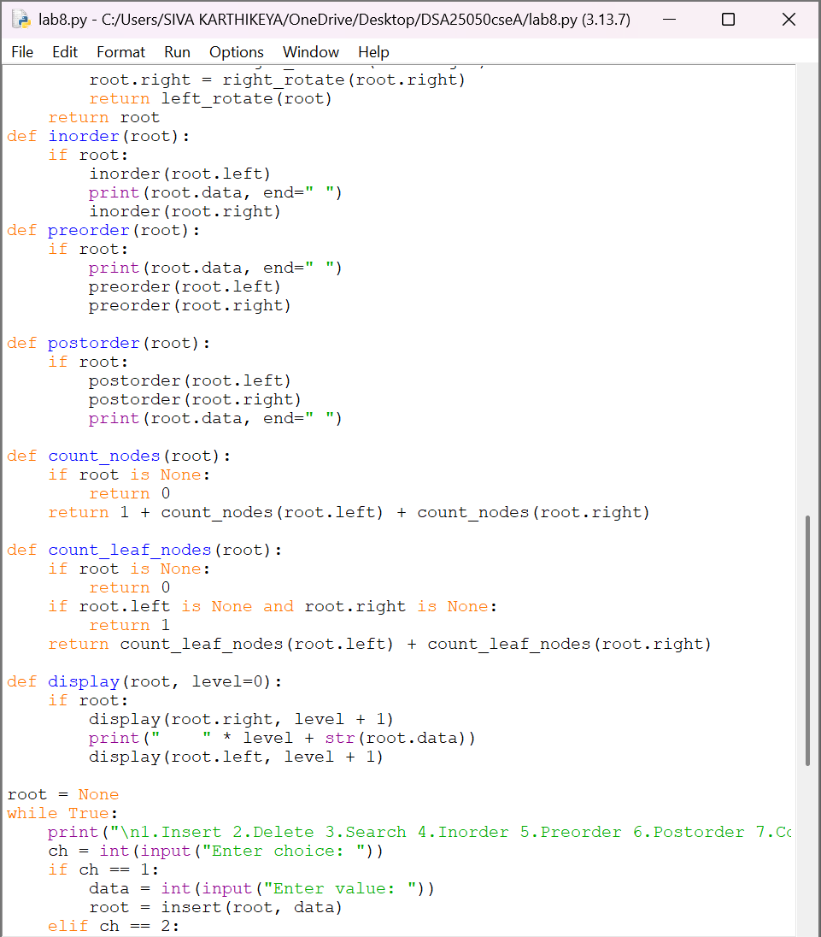
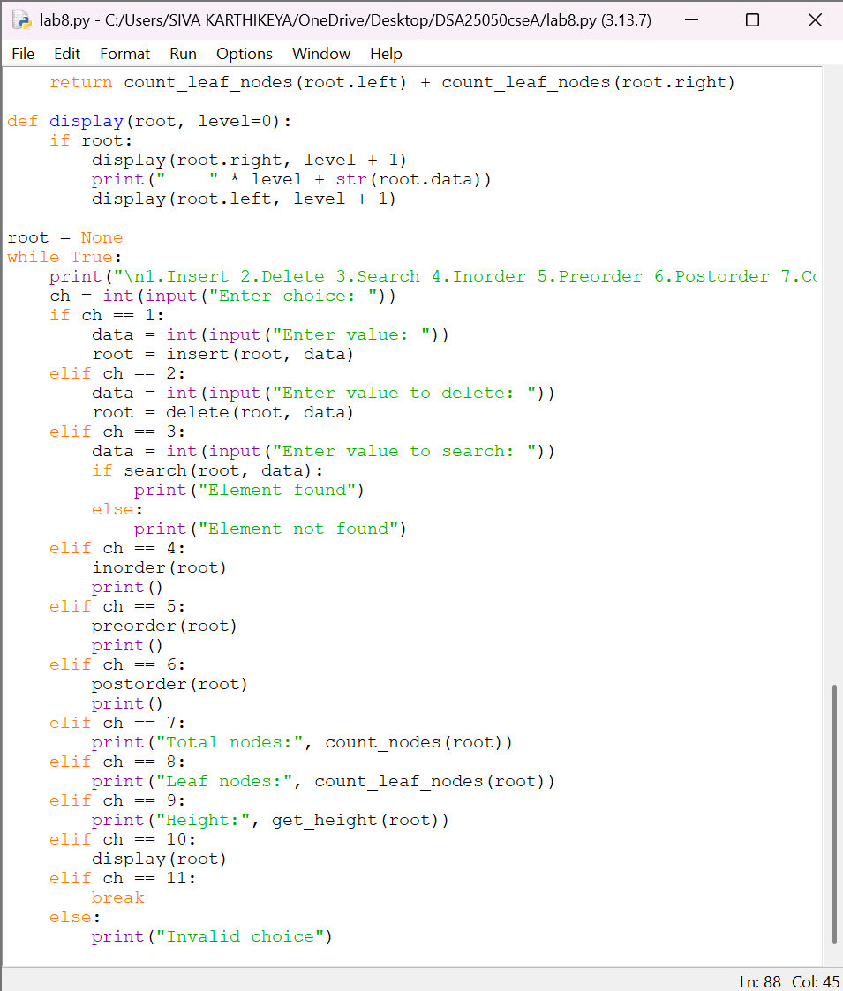
Output:
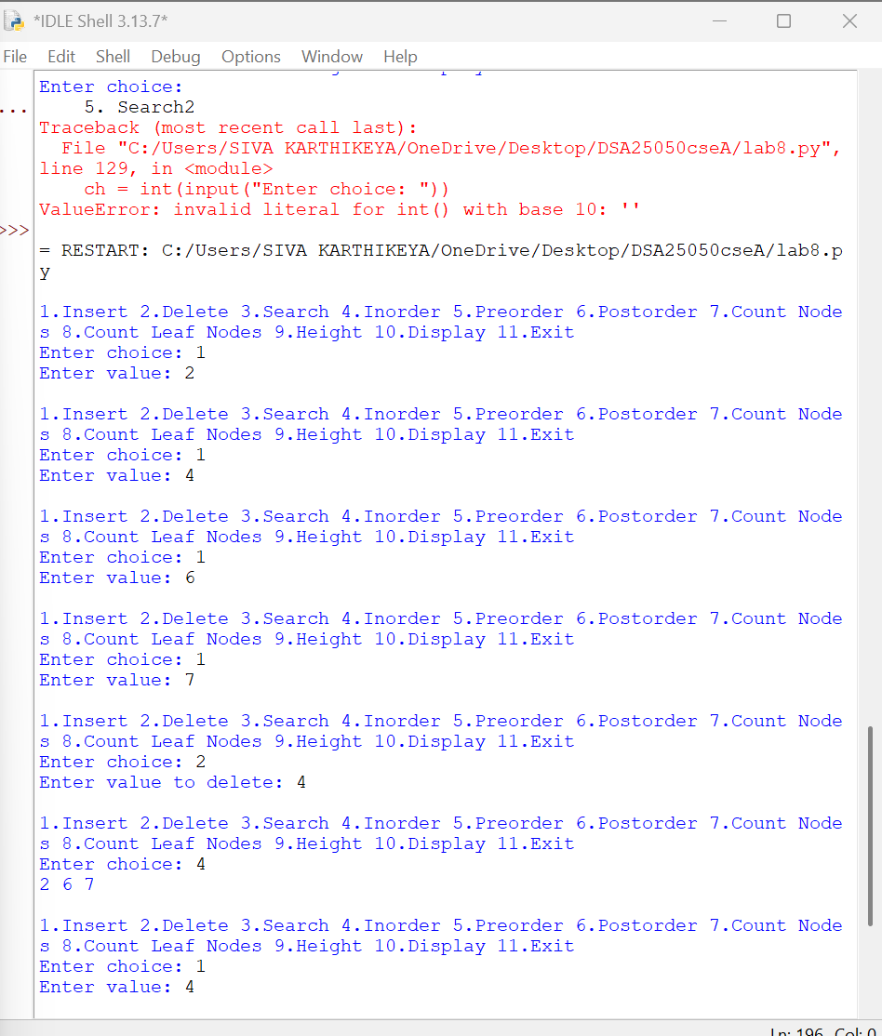
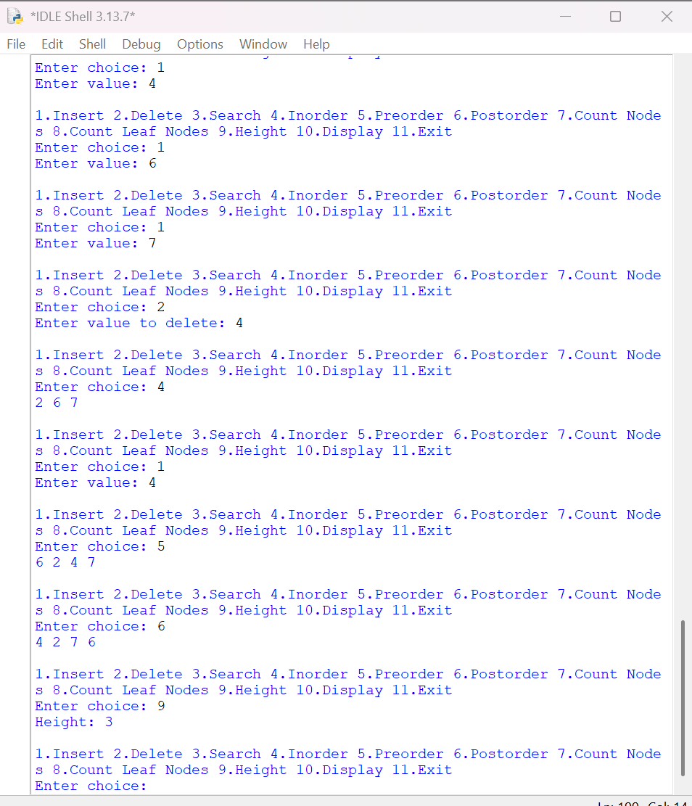
EXPLANATION
An AVL Tree is a self-balancing Binary Search Tree (BST) in which the difference between the heights of the left and right subtrees of every node is at most 1.
The Balance Factor (BF) is calculated as:
$$BF=Height\left(Left Subtree\right)-Height\left(Right Subtree\right)$$
For an AVL tree, the balance factor must be -1, 0, or +1.
The following operations are performed:
- Insertion: Inserts a new node according to BST properties and updates the height of each node.
- Balance Factor: Calculates the difference between the heights of the left and right subtrees.
- Right Rotation: Performs a right rotation to balance the tree when necessary.
- Left Rotation: Performs a left rotation to balance the tree when necessary.
- LL Rotation: A right rotation is performed when insertion occurs in the left subtree of the left child.
- RR Rotation: A left rotation is performed when insertion occurs in the right subtree of the right child.
- LR Rotation: First performs a left rotation on the left child, followed by a right rotation on the root.
- RL Rotation: First performs a right rotation on the right child, followed by a left rotation on the root.
- Searching: Searches for an element using BST properties.
- Deletion: Deletes a node and rebalances the tree using rotations.
- Traversals: Inorder, preorder, and postorder display the elements in different orders.
- Counting Nodes: Counts the total number of nodes in the tree.
- Counting Leaf Nodes: Counts nodes that have no children.
- Finding Height: Returns the height of the AVL tree.
Error table:
SNO | ERROR | RECTIFICATION
1 | Rotations may return a new root node. | Always use root = insert(root, value) and root = delete(root, key) because these functions may return a new root.
2 |  | Use get_balance(root) = get_height(root.left) - get_height(root.right).
  Left and right subtree heights are calculated incorrectly.
3 |  | Update height using 1 + max(get_height(root.left), get_height(root.right)).
  Node height remains incorrect after insertion or deletion.

Week-10:
Write a python program to implement hashing using separate chaining linear and quadratic probing in python
Input:
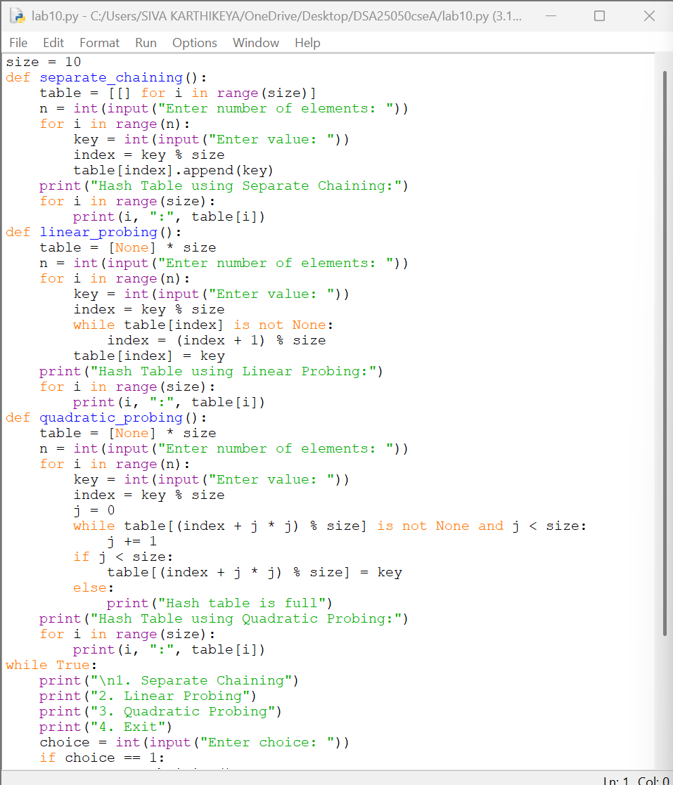
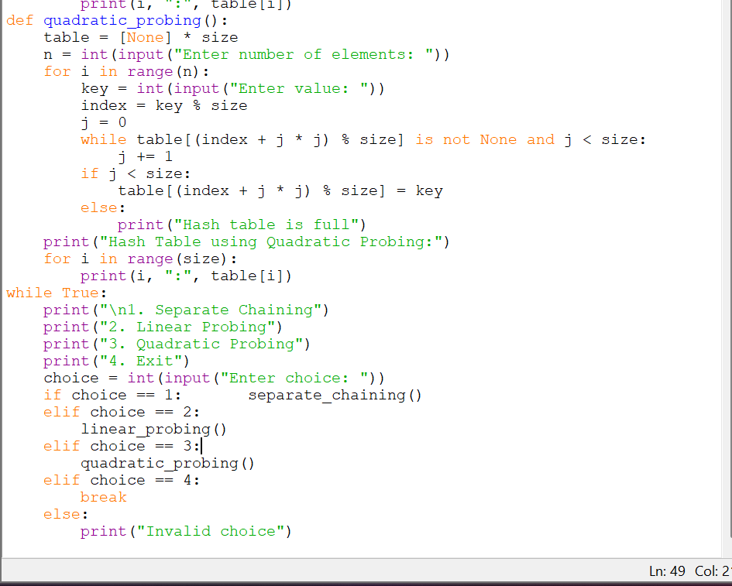
Output:
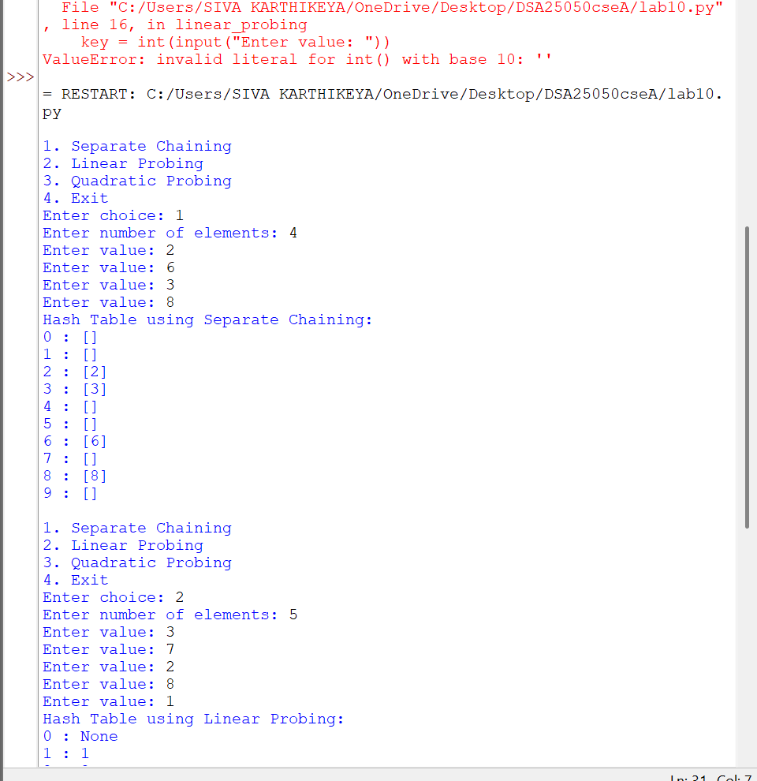
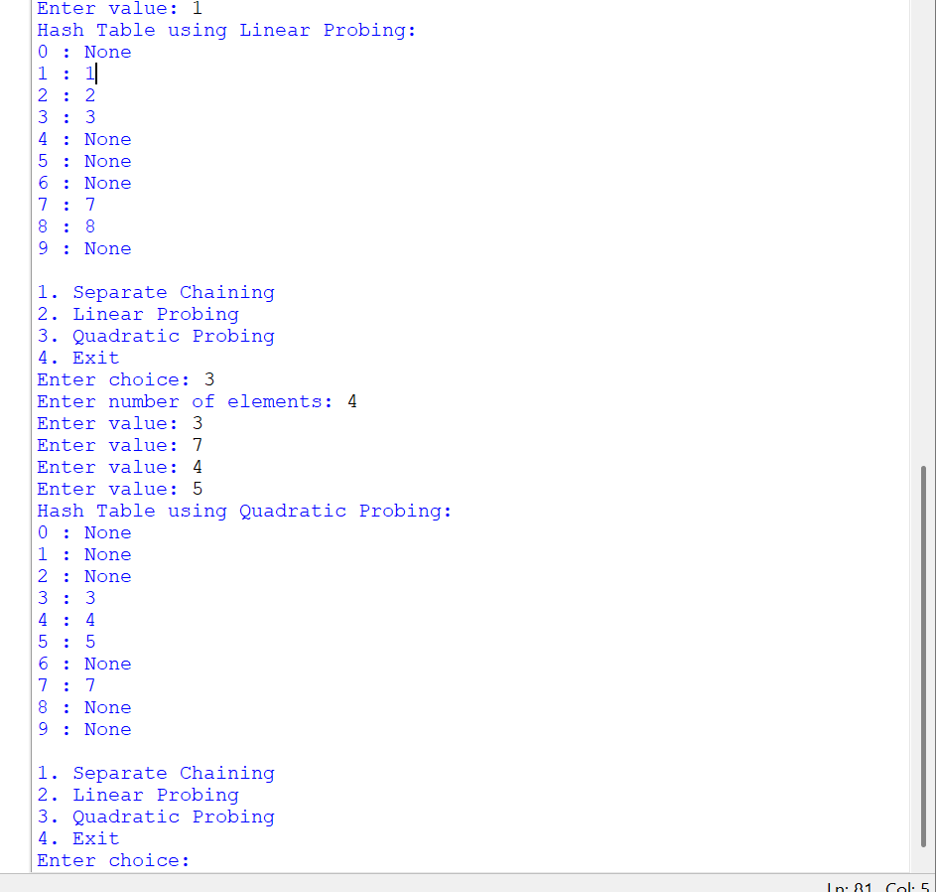
EXPLANATION
1. Separate Chaining
- Each index of the hash table contains a list.
- If two keys have the same hash value, both are stored in the same list.
- Collision is handled using linked-list-like chaining (here, Python lists).
2. Linear Probing
- If a collision occurs, the next available location is searched.
- Formula: h(k, i) = (h(k) + i) % m
3. Quadratic Probing
- If a collision occurs, locations are searched using squares of increments.
- Formula: h(k, i) = (h(k) + i²) % m
Common Hash Function
h(k) = k % m
Where:
- k = key
- m = size of hash table

Error table:
SNO | ERROR | RECTIFICATION
1 | Index out of range
  Use modulo % size
2 |  | Use key % size
  Incorrect hash function
3 |  | Convert input using int()
  Type error

