

**Indian Institute of Information Technology**, **Date**: 21-Aug-2022

**Design and Manufacturing Kurnool Scribe**: CS303T Theory of Computation Paras Yadav,

Instructor Dr. R. Kabaleeshwaran. Mallela Nitesh Raj

# Non Deterministic Finite Automata

## Definition

Non Deterministic Finite Automata (also know as the *NFA*) is a five tuple -

NFA = (*Q,* Σ*, δ, q*0*, F* )

* + - *Q* is the set of finite states.
    - Σ is the set of finite input symbols. For example - {*a, b, ...*}*,* {0*,* 1*, ...*}*,* etc.
    - *δ* is the transition function. A transition function defines the movement of the automation from one state to another state by treating the current state and current input symbol as an ordered pair. For each pair of ”current state” and ”current input symbol” (the function input), the transition function produces as output the next state in the automaton.

*δ* : *Q* × Σ ∪ {*ϵ*} → *P* (*Q*)

* + - *q*0 is the starting state of the automation where the condition *q*0 ∈ *Q* should hold.
    - *F* is the final state of the automation, where the condition *F* ⊆ *Q* should hold.

## Example

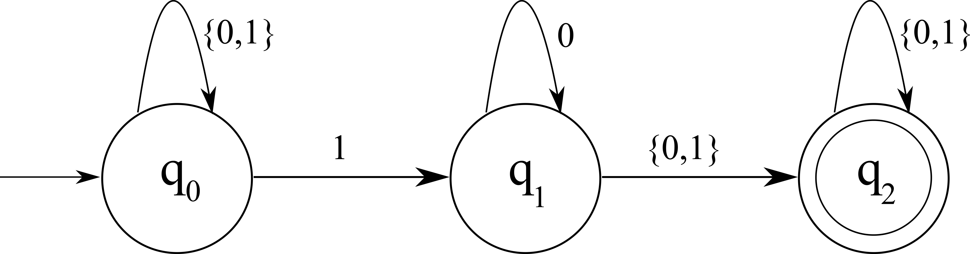

Figure 1: *N*1

* + - An **NFA** for the language of strings that contains the substring 10 or 11.

|  |  |  |
| --- | --- | --- |
| *δ* | **0** | **1** |
| *q*0 | *q*0 | {*q*0*, q*1} |
| *q*1 | {*q*1*, q*2} | *q*2 |
| *q*2 | *q*2 | *q*2 |

Table 1: Transition Table

The formal description of *N*1 is *N*1 = (*Q,* Σ*, δ, q*0*, F* ), where - 1. *Q* = {*q*0*, q*1*, q*2}

2. Σ = {0*,* 1}

1. *δ* is the transition table which is shown in the previous page.
2. *q*0 represents the starting state.
3. *F* = *q*2 represents the accepting state(s).

## Example of NFA (with Epsilon)

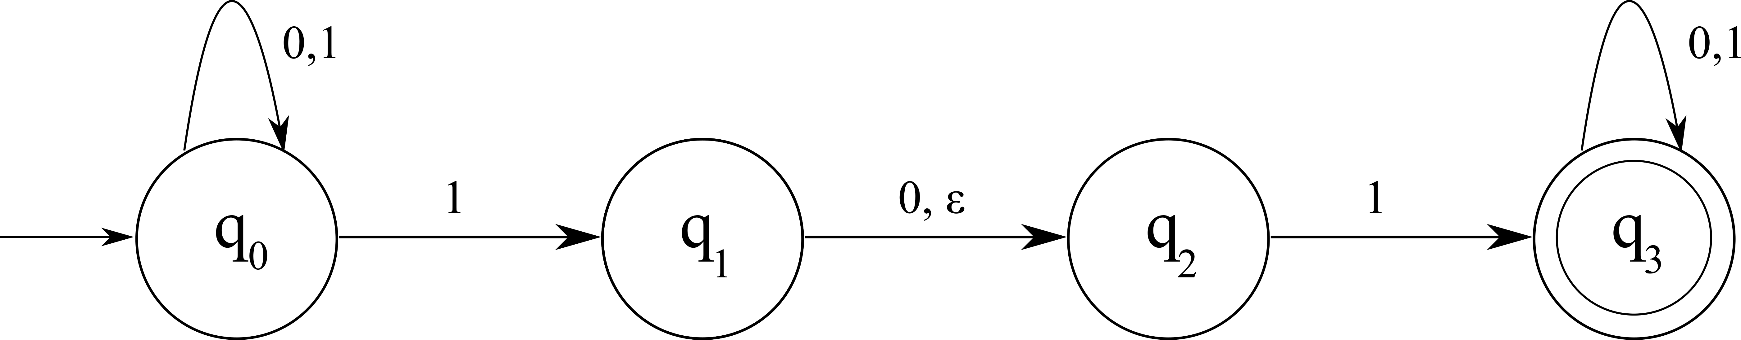

Figure 2: *N*2

* + - An **NFA** for the language of strings that contains at least 2 one’s.

|  |  |  |  |
| --- | --- | --- | --- |
| *δ* | **0** | **1** | *ϵ* |
| *q*0 | *q*0 | {*q*0*, q*1} | *ϕ* |
| *q*1 | *q*2 | *ϕ* | *q*2 |
| *q*2 | *ϕ* | *q*3 | *ϕ* |
| *q*3 | *q*3 | *q*3 | *ϕ* |

Table 2: Transition Table

The formal description of *N*2 is *N*2 = (*Q,* Σ*, δ, q*0*, F* ), where - 1. *Q* = {*q*0*, q*1*, q*2*, q*3}

2. Σ = {*ϵ,* 0*,* 1}

1. *δ* is the transition table which is shown in the previous page.
2. *q*0 represents the starting state.
3. *F* = *q*3 represents the accepting state(s).

## Language to NFA

### Question 1: Construct NFA that represents all binary strings whose 2*nd* last digit is 1

**Answer:**

From the above question, we can make the following conclusions -

* + - Alphabet Set (Σ) is {0*,* 1}
    - Number of states should be at least 3.
    - Minimum length of the sub string is 2, where the second last position should be 1.
    - The trivial substrings are - 1. 10

2. 11

* + - Some other examples may be - 1. 10010

2. *...*11111

3. *...*00010

One of the possible NFA for the above questions is -

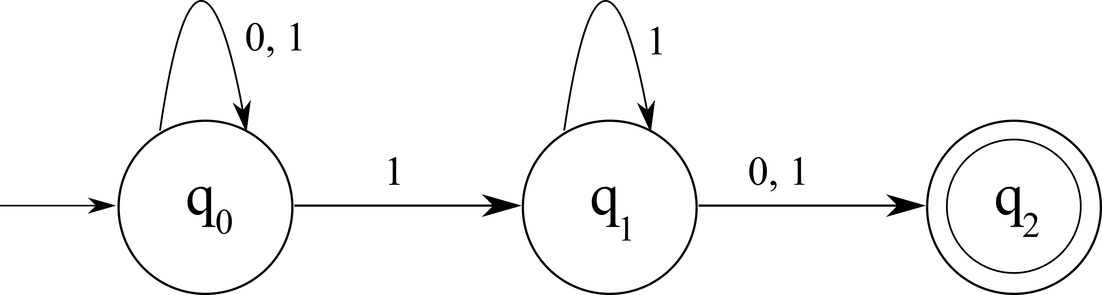

Figure 3: NFA for all binary strings whose second last digit is 1

|  |  |  |
| --- | --- | --- |
| *δ* | **0** | **1** |
| *q*0 | *q*0 | {*q*0*, q*1} |
| *q*1 | *q*2 | {*q*1*, q*2} |
| *q*2 | *ϕ* | *ϕ* |

Table 3: Transition Table

### Question 2: Construct NFA for the language {*ϵ*} with one state. Answer:

From the above question, we can make the following conclusions -

* + - Alphabet Set (Σ) is {*ϵ*}
    - Number of states should be exactly 1.
    - The trivial string is - {*ϵ*}

The corresponding NFA looks like

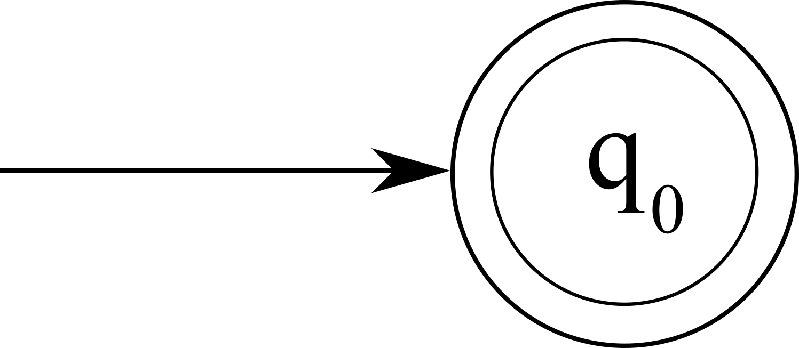

Figure 4: NFA for the language {*ϵ*} with one state.

### Question 3: Construct NFA for the language 0∗1∗00∗ with at least states. Answer:

From the above question, we can make the following conclusions -

* + - Alphabet Set (Σ) is {*ϵ,* 0*,* 1}
    - Number of states should be exactly 3.
    - The trivial string is - {0}
    - Some other examples can be - 1. 0100

2. 0*...*011*...*110000*...*

The corresponding NFA looks like

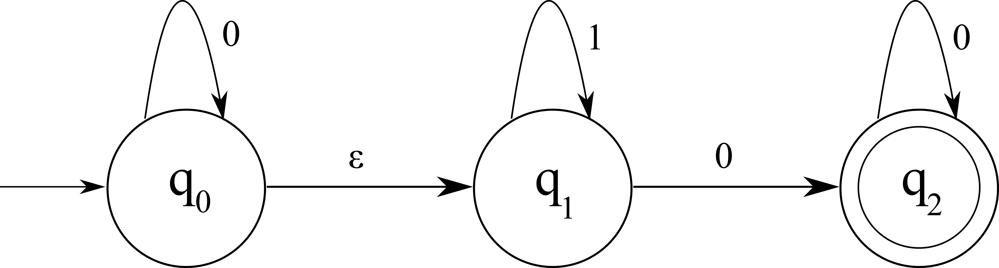

Figure 5: NFA for the language 0∗1∗00∗

## NFA to Language

### Question 1: Determine the language that is accepted by the NFA diagram show below

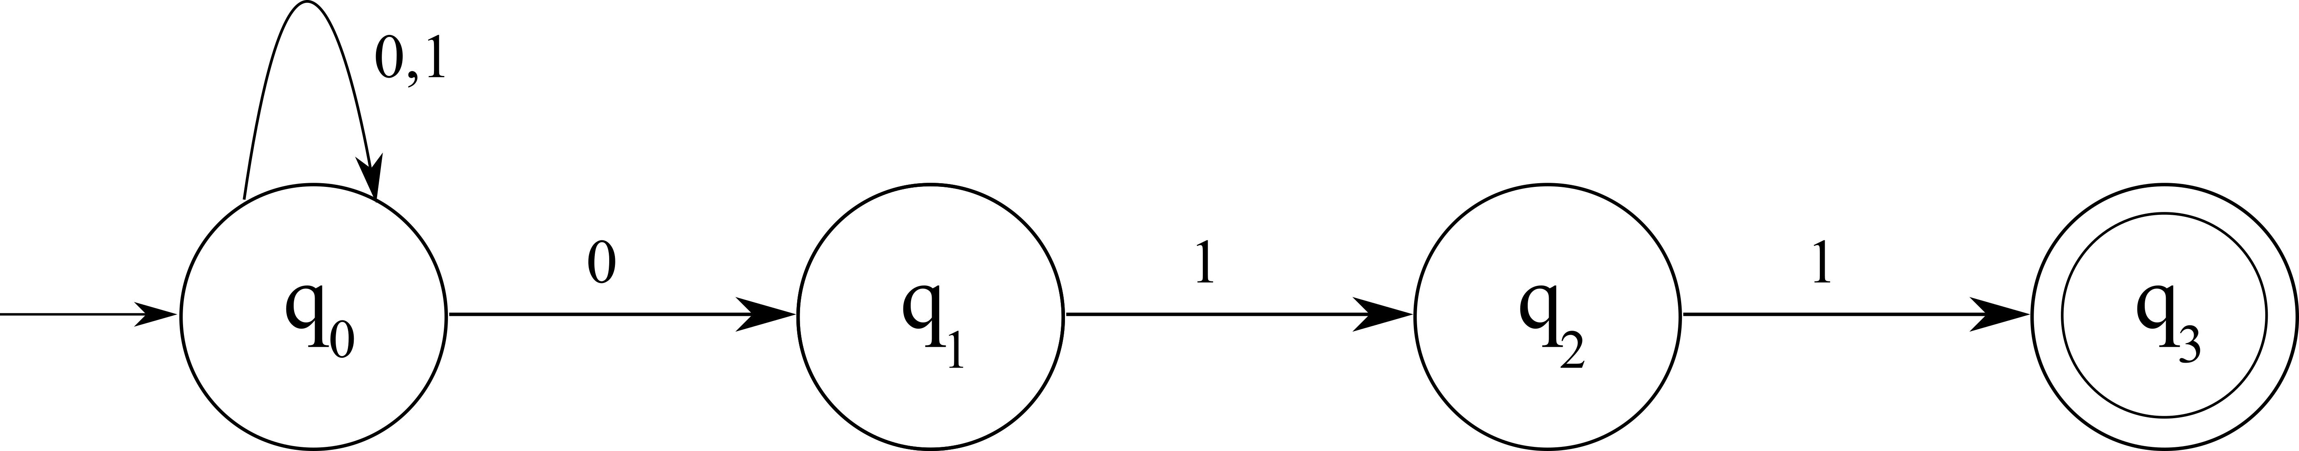

Figure 6: Given NFA

### Answer

From the above diagram, we can draw the following conclusions

1. Length of the substring will be at least three.
2. The substring must end with 011
3. Any number of one or zeros can be there before the substring 011.

### From the above observations, we can conclude the answer to be -

(0 + 1)∗ 011

### Question 2: Determine the language that is accepted by the NFA diagram show below

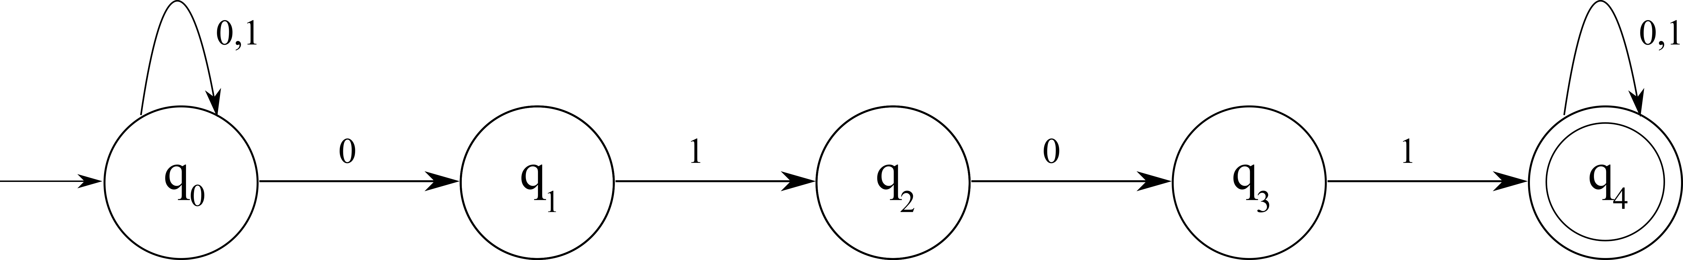

Figure 7: Given NFA

### Answer

From the above diagram, we can draw the following conclusions

1. Length of the substring will be at least four.
2. The substring must contain the substring 0101 somewhere in the middle.
3. Any number of one or zeros can be there before the 0101 and after 0101.

### From the above observations, we can conclude the answer to be -

(0 + 1)∗0101(0 + 1)∗

# Clousre Properties

Nondeterministic finite automata are also closed under -

* Reversal
* Concatenation
* Kleene Star

## Reversal

Closure under reversal is very using, specially when using *ϵ NFA*. Let’s assume we are using a NFA (say *N* ), then by performing the following we can change it to *NRev*

−

1. Reverse all the arc.
2. Changing old start state to the new accepting state.
3. Add a new state and an *ϵ* − arc to all the previous final states. Here is the example show the above process -

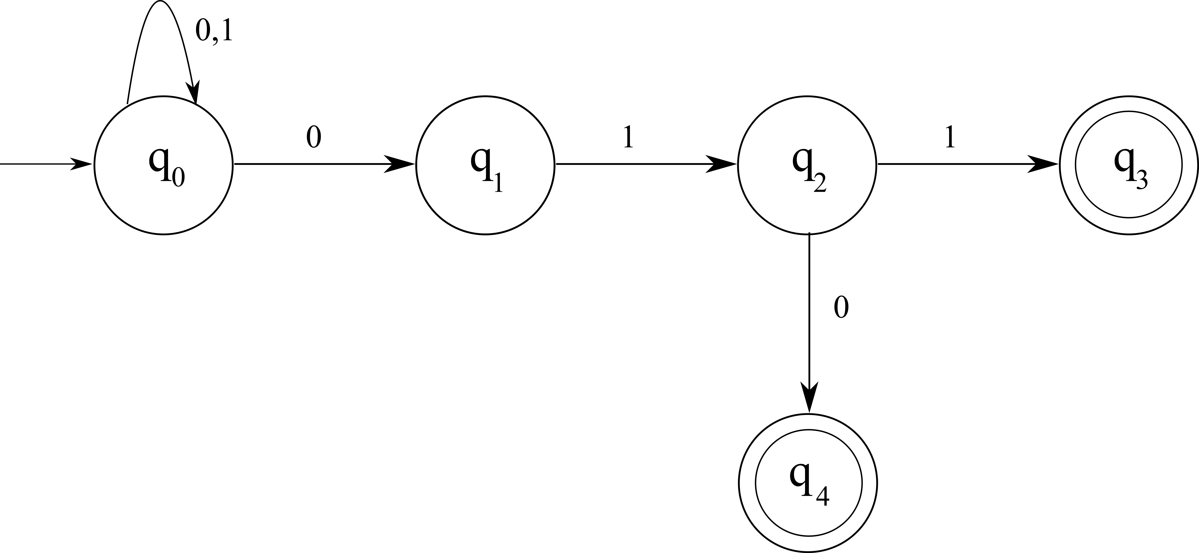

Figure 8: Original NFA

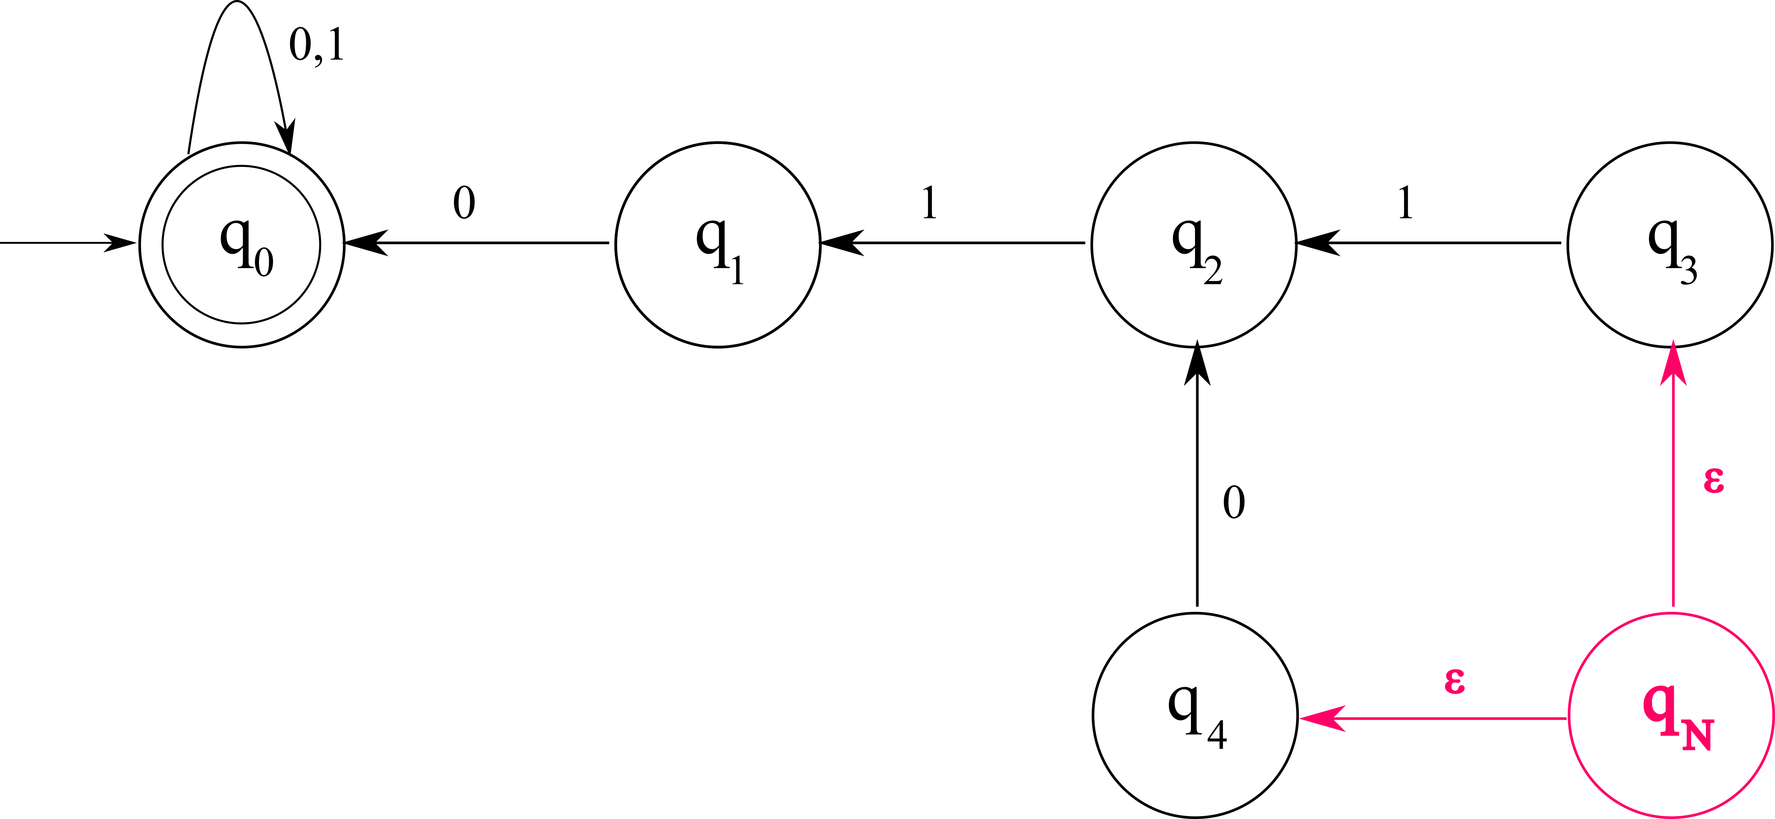

Figure 9: Reversed NFA

## Concatenation

Let *X* and *Y* be the two individual NFAs, now to concatenate them, we must do the following -

1. Union both of them.
2. Add an *ϵ* transition form each accepting state of *X* to the starting state of *Y* .

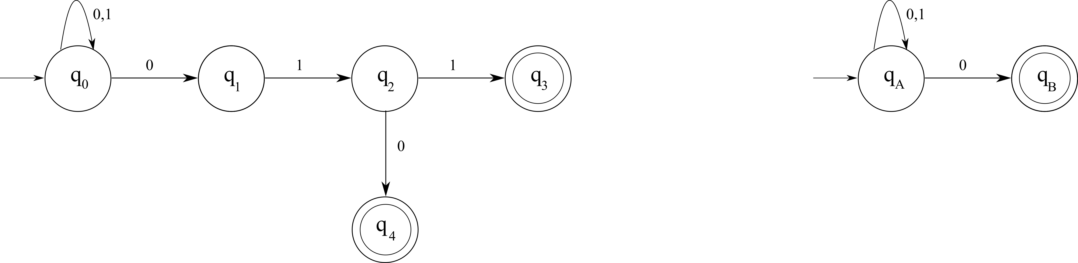

Figure 10: Original NFAs X and Y

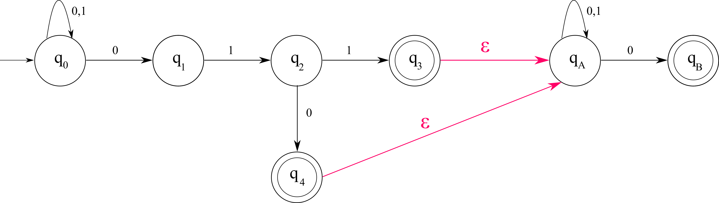

Figure 11: Concatenated NFA XY

## Kleene Star

To do Kleene star of a NFA *N* we must do the following steps -

1. Add a new state and let it be the new starting state.
2. Add *ϵ* arc from this new state to the old start state.
3. Add *ϵ* arcs from all accepting state(s) to this new start state. Example of the Kleene Star is given below -

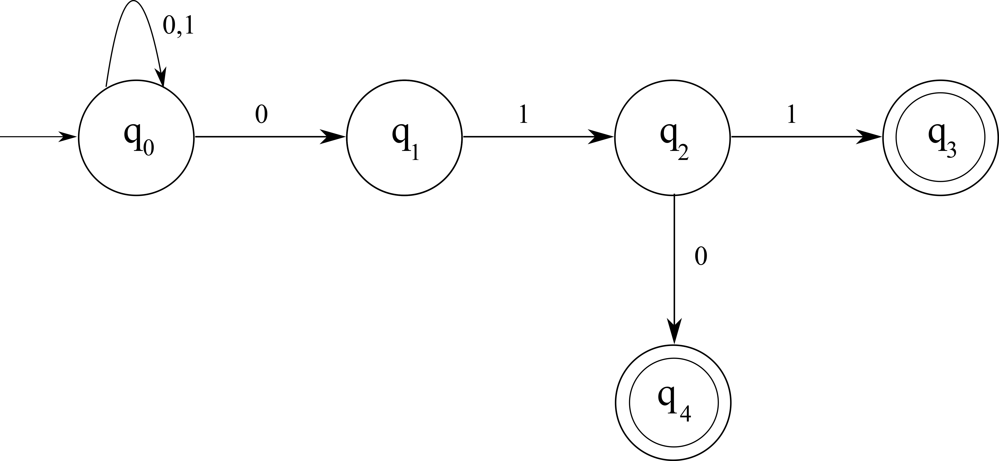

Figure 12: Original NFA

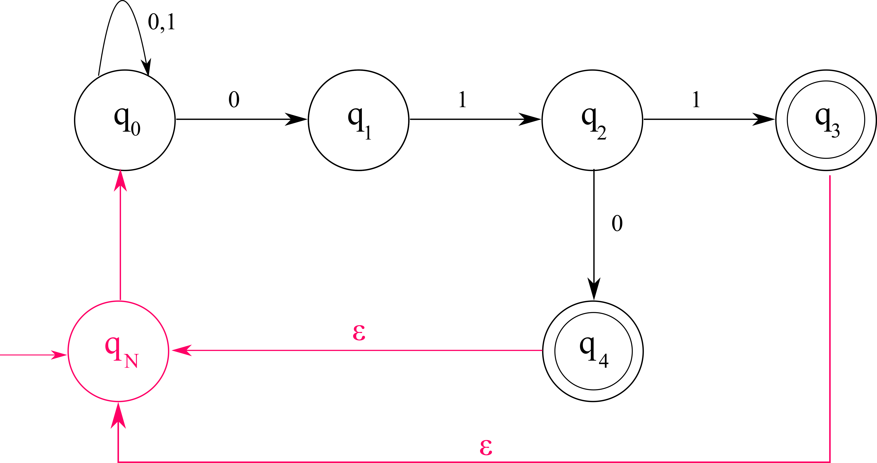

Figure 13: Kleene NFA