SM- SOEN 6611
Software Measurements
Summer 2017


Deliverable 1
(DESCRIPTIVE-STATISTICS)

Declaration

We, the members of the team, have read and understood the Fairness Protocol and the Communal Work Protocol, and agree to abide by the policies therein, without any exception, under any circumstances, whatsoever.

Team A
Ali Afzal
Paras Dhawan

//Abhi isko nhi chedenge ye last mei update hoga
Table of Contents
1 Introduction 4
2 Challenges in the Problem Domain 4
3 Application Requirements 4
3.1 Functional Requirements 4
3.1.1 Quadratic Solver 4
3.1.2 Cubic Solver 4
3.1.3 Prime Number Identification 5
3.2 Non-Functional Requirements 5
4 Use Case Model 5
4.1 Fully Dressed Use Cases 5
4.2 Use Case Diagram 8
5 Effort Estimation 8
5.1 Use Case Points 9
5.1.1 Unadjusted Use Case Points 9
5.1.2 Unadjusted Actor Weight 9
5.1.3 Unadjusted Use Case Weight 9
5.1.4 Calculating the Unadjusted Use Case Points 10
5.1.5 Technical Complexity Factor 10
5.1.6 Environment Complexity Factor 11
5.1.7 Calculating the Use Case Points 11
5.2 Effort Estimate 11
6 Selected Algorithms 12
6.1 Solving a Quadratic Equation 12
6.2 Solving a Cubic Equation 13
6.3 Identifying Primality 15
6.3.1 Fermat’s Test 15
6.3.2 Optimized Trial Division 16
7 Test Cases and Test Data 17
7.1 Quadratic Solver Test Cases 17
7.2 Cubic Solver Test Data 19
7.3 Cubic Solver Test Cases 20
7.4 Cubic Solver Test Data 22
7.5 Prime Identifier Test Cases 23
7.6 Prime Identifier Test Data 25
8 Cyclomatic Complexity 26
9 Quality Attributes 27
9.1 Efficiency 27
9.2 Generality 27
9.3 Maintainability 27
9.4 Portability 27
9.5 Usability 27
10 Glossary 28
11 References 29
12 Source Code Repository 32

DESCRIPTIVE-STATISTICS

Introduction
The Descriptive-Statistics application finds the minimum (m), maximum (M), mode (o), median (d), arithmetic mean (μ) and standard deviation (σ). The application takes an input of data values of random number and output its descriptive statistics. The purpose of the project is to create a set of interrelated artifacts for conducting certain measurements related to Descriptive-Statistics.
Descriptive-Statistics is an application designed for exploring numeric and symbolic programming, aiming for quality and accuracy. The results obtained from Descriptive-Statistics should be analyzed quantitatively and qualitatively.

Challenges in the Problem Domain

Application Requirements

Use Case Model (Descriptive Statistics)

4.1 Fully Dressed Use Cases

Id: | UC 01
Use Case: | Find Minimum Value
Description: | This use case describes the scenario of using the system to find the minimum value in a list of integers.
Level:
Primary Actor:
Supporting Actors:
Pre-conditions:
Post-conditions:
Main Success Scenarios:
Extensions:

Id: | UC 02
Use Case: | Find Maximum Value
Description: | This use case describes the scenario of using the system to find the maximum value in a list of integers.
Level:
Primary Actor:
Supporting Actors:
Pre-conditions:
Post-conditions:
Main Success Scenarios:
Extensions:

Id: | UC 03
Use Case: | Find Median Value
Description: | This use case describes the scenario of using the system to find the median value in a list of integers.
Level:
Primary Actor:
Supporting Actors:
Pre-conditions:
Post-conditions:
Main Success Scenarios:
Extensions:

Id: | UC 04
Use Case: | Find Arithmetic Mean Value
Description: | This use case describes the scenario of using the system to find the arithmetic mean value in a list of integers.
Level:
Primary Actor:
Supporting Actors:
Pre-conditions:
Post-conditions:
Main Success Scenarios:
Extensions:

Id: | UC 05
Use Case: | Find Standard Deviation Value
Description: | This use case describes the scenario of using the system to find the arithmetic mean value in a list of integers.
Level:
Primary Actor:
Supporting Actors:
Pre-conditions:
Post-conditions:
Main Success Scenarios:
Extensions:

Id: | UC 06
Use Case: | Generate Random Numbers
Description: | This use case describes the scenario of using the system to generate a list of integers between 0 and 100 with each having the same probability of occurrence.
Level:
Primary Actor:
Supporting Actors:
Pre-conditions:
Post-conditions:
Main Success Scenarios:
Extensions:

4.2 Use Case Diagram
//Replace the diagram
Figure 1 Use Case Diagram

1. User is the primary actor who interacts with web application
2. Web Application Interacts with a standalone Web Service Application which is a secondary actor.

//Diagram needs to be updated as it needs exclude and include relationships
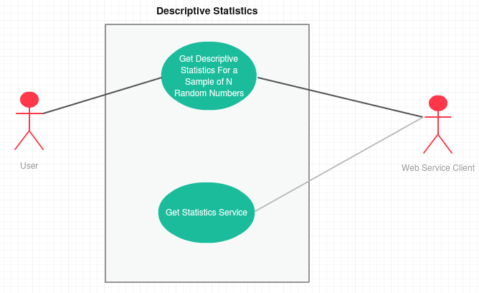

Effort Estimation

5.1 Effort Estimation Using COCOMO 81

The number of use case points in a project is a function of the following:
- The number and complexity of the use cases in the system.
- The number and complexity of the actors on the system.
- Various non-functional requirements (such as portability, performance, maintainability) that are not written as use cases.
- The environment in which the project will be developed (such as the language, the team’s motivation, and so on).

The effort estimate based on the UCP approach depends upon the calculations obtained from a number of equations. The process used to calculate the total UCP is as follows:
- Determine and Calculate UUCP.
- Determine and Calculate TCF.
- Determine and Calculate ECF.
- Determine PF.
- Calculate UCP.
- Calculate the Estimated Number of Person-Hours.

These sequences of steps in the effort estimation process are based on the UCP approach. The equation for effort estimation consists of two variables, the Use Case Points (UCP), the Productivity Factor of the development team (PF). The equation for effort estimate is given by:

Effort Estimate = UCP * PF

5.1.1 Use Case Points
The UCP calculation consists of three variables:
- Unadjusted Use Case Points (UUCP)
- Technical Complexity Factor (TCF)
- Environment Complexity Factor (ECF)

These variables are defined and calculated separately using weighted and subjective values, and constraining constants. The UCP equation is given by:

UCP = UUCP * TCF * ECF

5.1.2 Unadjusted Use Case Points
The calculation of UUCP is based on the sum of:
- Unadjusted Actor Weight (UAW)
- Unadjusted Use Case Weight (UUCW)

The UAW based on the aggregated complexity of all the actors in all the use cases, and the UUCW is based on the aggregated complexity of all of the use case scenarios in the system. The UUCP equation is given by:

UUCP = UAW + UUCW

5.1.3 Unadjusted Actor Weight
The UCP calculation is based on the acknowledgement that the actors in a use case model are not all equal. As our system has only one human actor, the sole actor is a complex actor which is weighed at a value of 3. The calculation for UUAW is shown below:

UUAW = 1 * 3 = 3

5.1.4 Unadjusted Use Case Weight
The UCP calculation is based on the acknowledgement that the use cases in a use case model are not all equal. Our system has four use cases,

UC 01: Solve Quadratic Equation is a simple use case, as it has 1 transaction or 2 steps, thus the weight considered is 5.
UC 02: Solve Cubic Equation is a simple use case, as it has 1 transaction or 2 steps. Thus the weight considered is 5.
UC 03: Identify a prime number is a simple use case, as it has 1 transaction or 2 steps, thus the weight considered is 5.
UC 04: Perform Operation with invalid inputs, is a simple use case, thus weight considered is 5.

The calculation for UUCW is as follow:

UUCW = 4 * 5 = 20

5.1.5 Calculating the Unadjusted Use Case Points
As mentioned earlier, the UUCP is calculated as the sum of UUAW and UUCW. With these values, UUCP can be calculated:

UUCP = UUAW + UUCW = 3 + 20 = 23

3.1 Effort Estimation Using UCP Approach

- We have 1 complex actor in our use case model that is the user who is interacting through GUI. We have 1 simple actor as well that is web service client which has a well defined API.

- We have assumed our two use cases to be complex. User requesting for Descriptive Statistics via GUI and web application requesting the web service client to process the request and send back the response are two complex use cases. This assumption has been made under the overestimation category as both the use case involves more than 7 classes in their implementation even though the transaction processed is one. After all overestimation is always better than underestimation.

- Productivity Factor is assumed to be 20 as this is a new project for our team.

- For TCF calculation our system is not a distributed system so we have assumed the perceived impact factor to be 0 for that. In terms of performance we have tried to eliminate memory leaks so as to get the acceptable performance. We have applied JVM tuning to ensure that acceptable performance is achieved to send the request and get the response, thus assuming the perceived factor to be 3 as this has average influence on the system. In terms of user efficiency and easy to use technical factors we have tried to make the application interactive and quite simple so user can have the feedback without any difficulty so we have made the use of web designing for that matter, hence assuming the perceived impact factor to be 5 for the complexity in both the factors as they have a strong influence on the system. As we have developed a web service which can be consumed by any client externally or internally to get the statistics in terms of json response, we can deploy it on a central server and users can get the statistics easily, for the matter we have more complexity and we have assumed the perceived factor to be 5. We have two applications one standalone web service API and the other web app. Both these apps need to be deployed on a web server with a defined set of configurations, hence we have assumed the perceived factor to be 5 for portability and easy to install factors. Rest of the factors are not influencing our application, thus they are incurring a zero impact.

- For ECF calculation, both the developers were familiar with the use case domain which as a strong, positive influence on the software project. We have no part time workers, hence part time workers has zero influence on the environment complexity. Both developers are well motivated and experienced with Java, Web, OOP concepts and analytical problem solving , hence we have assumed that analyst capability, object oriented experience, motivation and application experience to have strong, positive influence thus assuming the perceived factor to be 5. As the requirements are clearly given by the professor which are not changing at all. This also has a strong,positive influence on the project.

- Detailed Calculation is shown in figure 3.1.1.

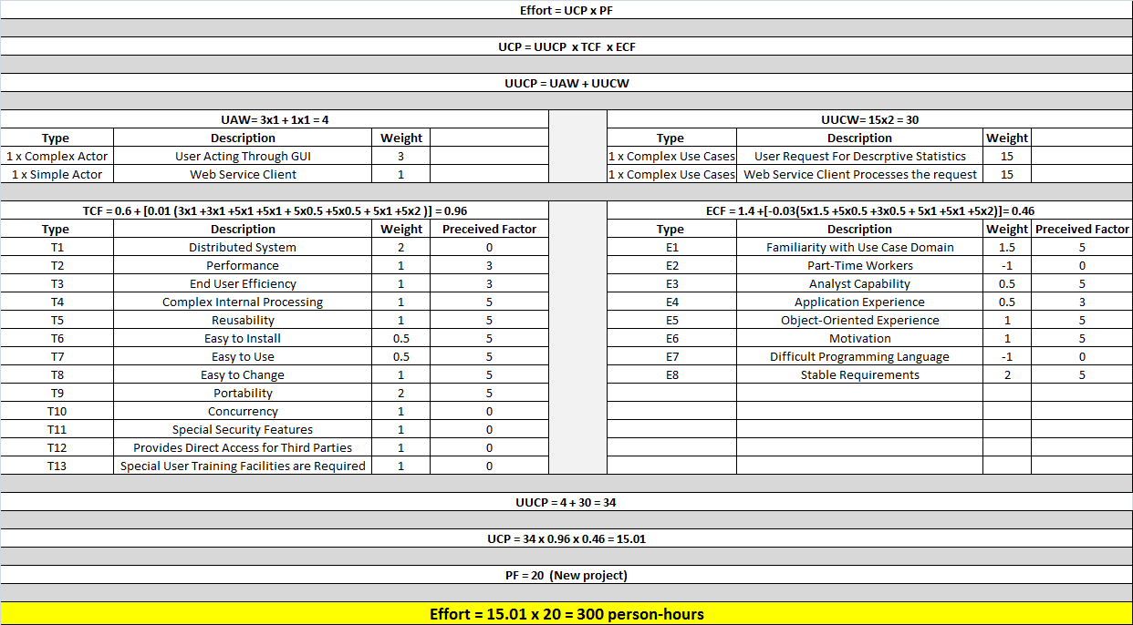

Figure 3.1.1

3.2 Effort Estimation Using COCOMO 81

- LOCMetrics Tool has been used to find out the Physical-SLOC of Java Code. Figure 3.2.1 shows the physical SLOC of Java code in Web Application and Figure 3.2.2 shows physical SLOC of Java Code in Web Service Application.

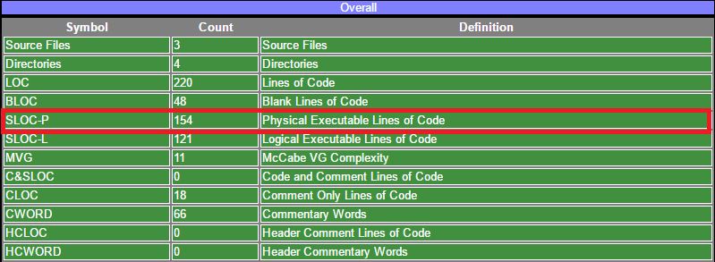

Figure 3.2.1

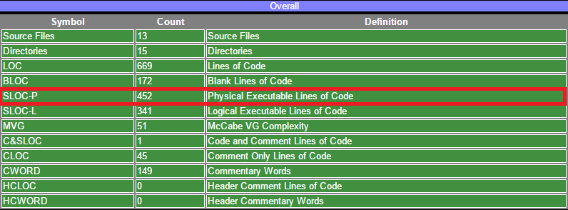

Figure 3.2.2

- Github has been used to find out the Physical-SLOC of HTML, CSS and Java Script. Figure 3.2.3 shows the physical SLOC of HTML + Java Script in Web Application and Figure 3.2.4 shows physical SLOC of CSS in Web Service Application.

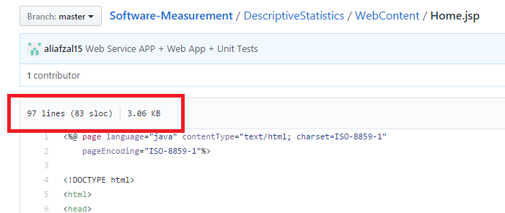

Figure 3.2.3

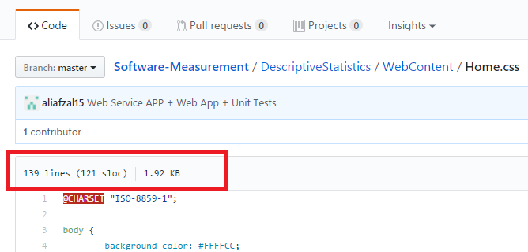

Figure 3.2.4

- Project Type for COCOMO 81 calculation is assumed to be Organic as the team of our project is small and is quite familiar with the Java application development environment.

- Result for the Calculation is given below in the figure 3.2.5.

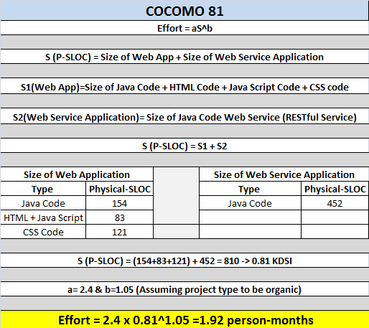

Figure 3.2.4

3.3 Difference In COCOMO 81 and UCP Estimate

The basic COCOMO81 is intended for quick, early and rough estimates when little
knowledge is available at the beginning of the software development. It does not
take into account the cost drivers such as hardware, personnel and product attributes.
While in UCP approach we consider all the cost drivers to calculate the estimate. Therefore,
the value of estimate obtained in COCOMO 81 is higher as compared to the value in UCP
estimate. The degree of overestimation is higher in COCOMO 81 as compared to UCP as
no adjustment factor is being incorporated in estimate calculation.

Quality Attributes
As much as possible, good software engineering principles were used in an attempt to achieve the following quality attributes: efficiency, generality, maintainability, portability, and usability.

Efficiency
Efficiency depends on the runtime complexity and space complexity of an algorithm. When researching and selecting algorithms to be implemented as part of MINSK, attention was paid to the runtime complexity so that the fastest runtime can be achieved that balances without compromising other attributes such as maintainability, complexity, and correctness.

Generality
In MINSK’s implementation the highest degree of generality was aimed for. For the quadratic and cubic solvers, any real number is acceptable as an input. This increases the generality as the set of real numbers includes the set of integers. Where outputs are concerned, an abstraction over arithmetic dealing with the sets of real numbers and complex numbers is provided so that real numbers and complex numbers may be manipulated in a unified fashion. This implementation allows the solver to solve quadratic and cubic equations where both real and complex roots are involved.

Maintainability
As much as possible, some key design principles were used to minimize maintenance costs. The key principles which were adhered to are:
Separation of Concerns: MINSK is divided into modules with as little overlap as possible. Common functionality is refactored into separate utility classes to avoid duplicated code.
Single Responsibility Principle: Each module is responsible for only a specific feature or cohesive functionality set.

Portability
To maximize portability, two primary things were done. Firstly, MINSK was implemented in Java and runs in the Java Virtual Machine. This aspect allows the application to run on multiple platforms with no modifications to the source code as no platform dependent APIs were used. Secondly, the application does not depend on any IDE to be compiled and run. The Gradle build system was used as a tool to manage building the application in a platform independent manner. This tool allows the application to be built, tested and run. It is not required to install Gradle on a PC for use, it is included as a JAR file with the application so that as long as a developer has the source code, they have access to the tools used to build and test that code.

Usability
Usability was taken into account when designing the user interface. All user facing messages have been designed to be clear and instructive as to minimize any doubts the user may have when using the application. The user interface is also designed to be error tolerant so that the user is informed when they have provided an invalid input and what kind of input is expected by the system.

Glossary
Complex Numbers: The set of complex numbers is the set of all numbers which have a real component and an imaginary component.

Cubic Equation: A cubic equation is a univariate to the third degree, polynomial with 4 terms. A cubic equation is commonly seen in the form ax3+bx2+cx+d=0where the coefficients a, b, c, and d are real or complex numbers, and a0.

Integers: The set of integers is the set of all numbers which do not have a fractional component or imaginary component.

Overflow: A term used when the calculation results in a value that is greater than the largest floating point number

Prime Number: A prime number is a positive integer greater than 1 which is only divisible by 1 and itself.
Composite Number: A composite number is a positive integer and is not prime which means it has factors other than 1 and itself.

Quadratic Equation: A quadratic equation is a univariate to the second degree, trinomial equation. The standard form of a quadratic equation is ax2+bx+c=0where the coefficients a, b and c are real or complex numbers, and a0.

Real Numbers: The set of real numbers is the set of all numbers, positive and negative, including 0, which can be plotted on a number line. Real numbers can be whole or include a fractional component.
Underflow: The condition where the calculation result in a value smaller in magnitude that the minimum allowable in the storage space

References
Some reference………………….!!

Source Code Repository

Address of the Github repository containing Source Code:

https://github.com/parasdhawan21/Software-Measurement

Table of Contents
(Generated Automatically)

New Page
(Details of Deliverable #)
(Sections)
(Paragraphs; Uniform Typeface Throughout; Captioned Figures/Tables)

(Address of the Table of Group/Team/Unit Member-Responsibilities [*] on the Wiki Hosting Service or Alternate)

[*] (Table of Group/Team/Unit Member-Responsibilities ≡ Two-Column Table: First Column: Name of Group/Team/Unit Member, Second Column: Details of Responsibilities)

New Page
(Contributions on Deliverable #)

(Two-Column Table: First Column: Name of Group/Team/Unit Member, Second Column: List of Details of Contributions)

Group/Team/Unit Member | Contributions
OK: Johannes Chrysostomus Wolfgangus Theophilus Mozart  Not OK: Wolf 12345678 | OK:  - Registered Wiki Hosting Service, . . .  - Searched and Documented References on Prometheus, . . .  - Reviewed Figure 2, . . .  Not OK:  - Communicated with Team, . . .  - Prepared and Reviewed Glossary, . . .

