PROJECT REPORT
CAMPUS BUS PASS
MANAGEMENT SYSTEM
A Java-Based Campus Transportation Management Application

Submitted for | VITyarthi Project Review
Student Name | Paras Dwivedi
Registration No. | 25BAI10621
Technology | Java
Project Type | Console / Core Java Application
Main Package | com.campusbuspass
University | VIT Bhopal University

Abstract
The Campus Bus Pass Management System is a Java-based console application for basic campus transportation pass management. It provides a menu-driven workflow for adding student details, adding bus routes, generating monthly bus passes, and verifying pass validity. A generated pass is associated with a student registration number and a selected route and receives a unique pass ID. The implementation is separated into model, DAO, service, database, and utility packages.
The current implementation validates student and route existence before issuing a pass, uses the fee stored for the selected route, assigns validity dates, and handles invalid console input. The included execution screenshots demonstrate the main menu, student creation, route creation, pass generation, and pass verification.

1. Introduction
Campus transportation requires a simple way to maintain student information, route information, and bus-pass validity. Manual handling can make these operations less organized. This project applies Java programming and object-oriented design to implement a small console-based campus bus pass management application.
The application uses a numbered menu. The available operations are Add student, Add route, Generate pass, Verify pass, and Exit.

2. Problem Statement
A campus bus service needs a systematic method to maintain student details, maintain route details, issue bus passes, and verify whether a supplied pass is valid. The project addresses this need by linking a student to a selected route through a generated pass ID and providing a verification operation.

3. Objectives
- Maintain basic student registration information.
- Maintain campus bus route information including source, destination, and fee.
- Generate a unique bus pass ID for a valid student and route.
- Assign validity dates to a generated monthly pass.
- Verify a supplied pass ID.
- Validate student and route existence before issuing a pass.
- Use the actual fee configured for the selected route.
- Apply modular and object-oriented Java programming concepts.

4. Scope of the Project
- Student creation and lookup by registration number.
- Route creation and lookup by route ID.
- Monthly bus pass generation.
- Unique pass ID generation.
- Pass verification.
- Console-based interaction.
- Persistence through the project's local data/storage classes.
The current menu exposes the four core operations listed above plus Exit. The project also contains dedicated classes for pass, route, student, verification-log, storage, and input handling.

5. Requirements

5.1 Functional Requirements
ID | Requirement | Implementation
FR-01 | Add student | Store student details and reject duplicate registration numbers.
FR-02 | Add route | Create a route with an automatically assigned ID and store its fee.
FR-03 | Generate pass | Validate student and route, create a unique pass ID, and save the pass.
FR-04 | Verify pass | Accept a pass ID and return the verification result.
FR-05 | Route fee | Use the actual fee stored for the selected route.
FR-06 | Date validation | Reject an expiry date earlier than the start date.

5.2 Non-Functional Requirements
- Maintainability: responsibilities are separated across packages and classes.
- Readability: descriptive class and method names are used.
- Usability: a simple numbered console menu guides the operator.
- Validation: invalid student or route references are rejected during pass generation.
- Extensibility: the layered structure allows future interface or storage improvements.

6. System Architecture
The project follows a layered structure. Main handles the menu and coordinates user actions. Model classes represent application data. DAO classes provide data operations. Service classes contain business logic. DB and Schema provide the data/storage abstraction, while Input centralizes console input handling.
Layer / Package | Responsibility
Main | Entry point, menu, and user interaction coordination
model | Student, Route, Pass, and VerificationLog entities
dao | StudentDAO, RouteDAO, PassDAO, and VerificationLogDAO data operations
service | PassIdGenerator, PassService, and VerificationService business logic
db | DB and Schema data/storage setup
util | Input.java for console input

7. Final Repository Structure
Campus-Bus-Pass-Management-System/
├── .vscode/
├── src/
│ └── com/
│ └── campusbuspass/
│ ├── Main.java
│ ├── dao/
│ │ ├── PassDAO.java
│ │ ├── RouteDAO.java
│ │ ├── StudentDAO.java
│ │ └── VerificationLogDAO.java
│ ├── db/
│ │ ├── DB.java
│ │ └── Schema.java
│ ├── model/
│ │ ├── Pass.java
│ │ ├── Route.java
│ │ ├── Student.java
│ │ └── VerificationLog.java
│ ├── service/
│ │ ├── PassIdGenerator.java
│ │ ├── PassService.java
│ │ └── VerificationService.java
│ └── util/
│ └── Input.java
├── screenshots/
│ ├── main-menu.png
│ ├── add-student.png
│ ├── add-route.png
│ ├── generate-pass.png
│ └── verify-pass.png
├── report/
│ └── Campus_Bus_Pass_Management_System_Final_Report.docx
├── TERMINAL OUTPUT/
│ └── terminal output.pdf
├── .gitignore
├── README.md
└── campus_bus_passes.dat (local ignored data file)
The compiled out/ directory is generated locally for execution and is excluded from source control through .gitignore. The local campus_bus_passes.dat file is also ignored so runtime data changes are not committed to the repository.

8. Module Description

8.1 Student Module
Student and StudentDAO represent and manage student information. StudentDAO supports adding, finding, listing, updating, and deleting students, with registration-number lookup performed case-insensitively and duplicate registration numbers rejected.

8.2 Route Module
Route and RouteDAO represent and manage bus routes. A route contains an ID, route name, source, destination, distance, and fee. RouteDAO assigns an ID when required and provides lookup and CRUD operations.

8.3 Pass Module
PassService generates a monthly pass after checking the date range, student existence, and route existence. It reads the selected route's actual fee, generates a unique pass ID, creates a Pass object, and stores it through PassDAO.

8.4 Verification Module
VerificationService accepts a pass ID and checks its validity/status. The project also contains VerificationLog and VerificationLogDAO classes for verification-log support.

8.5 Input Utility Module
Input.java centralizes console input operations so that menu and data-entry code does not repeat scanner handling.

9. Core Algorithms

9.1 Pass Generation Algorithm
- Start pass generation.
- Read the student's registration number and route ID.
- Set the pass validity dates.
- Find the student using StudentDAO.
- If the student does not exist, display an error and stop.
- Find the route using RouteDAO.
- If the route does not exist, display an error and stop.
- Read the actual fee from the selected Route object.
- Generate a unique pass ID using PassIdGenerator.
- Create the Pass object with student, route, fee, dates, and active status.
- Save the pass using PassDAO.
- Display the generated pass ID.

9.2 Pass Verification Algorithm
- Read the pass ID from the user.
- Search for the pass.
- Check pass validity/status and applicable expiry information.
- Return the verification result.
- Record verification information through the verification-log mechanism.

10. Implementation Details
The application is written in Java under the com.campusbuspass package. The implementation uses classes and objects, encapsulation, constructors, methods, lists, exception-based validation, LocalDate for validity dates, and separation of business logic from data-access operations.
Main provides the menu. PassService contains pass-issuance business rules. StudentDAO and RouteDAO provide lookup and storage operations. Pass represents an issued pass, while PassIdGenerator creates unique pass identifiers.

11. Validation and Error Handling
- Duplicate student registration numbers are rejected.
- A pass cannot be issued for a registration number that does not exist.
- A pass cannot be issued for a route ID that does not exist.
- An expiry date earlier than the validity start date is rejected.
- Invalid menu input is handled by the console input utility.

12. Testing
Testing was performed through the console interface using the main application workflow. The execution evidence supplied with the project demonstrates successful student creation, route creation, pass generation, pass verification, and program exit.
Test ID | Test Case | Expected / Observed Result | Status
TC-01 | Start application | Menu displayed | Passed
TC-02 | Add student | Student added | Passed
TC-03 | Add route | Route added with generated ID | Passed
TC-04 | Generate pass | Pass generated with unique ID and validity dates | Passed
TC-05 | Verify pass | Valid pass returns successful verification | Passed

13. Execution Screenshots
The following screenshots are included in the repository under /screenshots. They show the working console application and the five main user-facing operations.
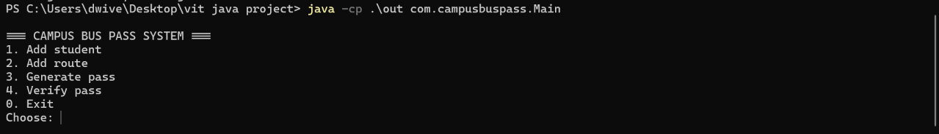
Figure 1. Main menu
Figure 2. Student creation
Figure 3. Route creation
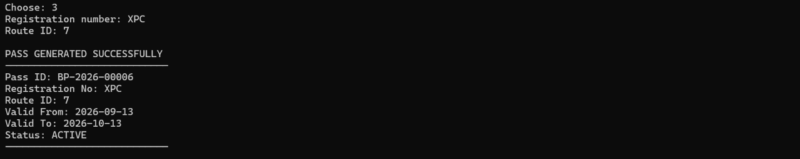
Figure 4. Pass generation
Figure 5. Pass verification

14. Expected User Workflow
- Launch the application.
- Select 1 to add a student.
- Select 2 to add a bus route and enter its fee.
- Select 3 to generate a pass using an existing student and route.
- Receive a unique pass ID and validity dates.
- Select 4 and enter the pass ID to verify it.
- Select 0 to exit.

15. Advantages
- Simple menu-driven console interface.
- Clear separation of concerns through layered packages.
- Unique pass identification.
- Student and route validation before pass issuance.
- Actual route fee is used for the pass.
- Verification is available directly from the main menu.
- Structure is suitable for future extension.

16. Limitations and Future Enhancements
The following are future enhancements and are not claimed as current menu features:
- Add a graphical user interface using Java Swing or JavaFX.
- Add dedicated screens for listing, updating, and deleting students and routes.
- Add richer pass details and printable pass output.
- Use stronger database storage such as SQLite or MySQL if required.
- Add automated unit tests for service and DAO classes.
- Add role-based access for transport administrators.
- Add reporting for active, expired, and blocked passes.

17. Learning Outcomes
The project demonstrates practical application of Java concepts including classes and objects, encapsulation, packages, modular design, collections, exception handling, date handling, and separation of business logic from data-access operations. It also demonstrates a structured development approach from problem identification through implementation and testing.

18. Conclusion
The Campus Bus Pass Management System provides a focused solution for basic campus bus-pass management. Its menu-driven workflow covers student entry, route entry, pass generation, and verification. The layered Java structure improves maintainability, while validation of student and route references improves the correctness of pass generation. The included execution screenshots and project evidence demonstrate the core workflow.

19. References and Project Evidence
- VITyarthi project assignment instructions supplied for the project review.
- Campus Bus Pass Management System source project.
- TERMINAL OUTPUT.pdf containing execution evidence.

Appendix A – Sample Console Workflow
=== CAMPUS BUS PASS SYSTEM ===
1. Add student
2. Add route
3. Generate pass
4. Verify pass
0. Exit
Choose: 1
Registration number: XPA
Name: PARAS
Category: 1
Phone: 7979
Student added.
Choose: 2
Route name: COLLEGE
Source: BUS
Destination: SATNA
Fee: 1000
Route added with ID: 5
Choose: 3
Registration number: XPA
Route ID: 5
PASS GENERATED SUCCESSFULLY
Pass ID: BP-2026-00003
Registration No: XPA
Route ID: 5
Valid From: 2026-09-13
Valid To: 2026-10-13
Status: ACTIVE
Choose: 4
Pass ID: BP-2026-00001
VALID: OK

Appendix B – Final Submission Checklist
☐ GitHub repository created and project source files pushed.
☐ README.md included at the repository root.
☐ screenshots/ directory contains the five project screenshots.
☐ TERMINAL OUTPUT/ contains the execution evidence PDF.
☐ Compiled output is excluded from source control where appropriate.
☐ campus_bus_passes.dat is kept as a local ignored runtime data file.
☐ Project report is prepared for review/submission according to the course instructions.

