**Q-1:**

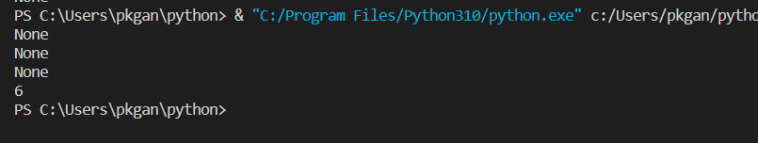

When you run first print (b ())-🡪it adds +2 in a=0🡪0+2=2,

When you run second print (b ())🡪 it again adds +2 in a=2🡪 2+2=4

When you run third print (b ())🡪 it again adds +2 in a=4🡪 4+2=6

When you run print (a)🡪 it prints value of a, which is a=6

**Q-2:**

When you run print(“midterm.py”):



when you run print(“idtern.py”):

To print a message if file not found.



**Q-3:**

**Q-4:**

**Q-5:**

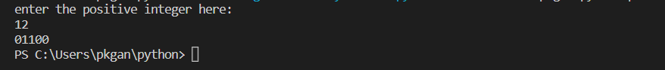



**Q-6:**

**Q-9:**

