CS 494/594 Internetworking Protocols: Homework 1 (Winter 2022) Portland State University

**Due Date: 1/18/2022, 11:59 pm PST, ONLINE**

Name (please print): **Harshvardhan Rajiv Bindage** Circle One: 494 594

Instructions:

594 Students:

The papers:

Please embed your homework answers in the space provided below. Submit a PDF on Canvas.

Please DO NOT email your homework to the instructor or TA.

Do not slip your homework in the instructor’s mailbox or under her office door.

*Late submissions are not accepted for this homework. Your homework score for your final grade will be the mean of your top 4 HW scores (out of 5 HWs).*

Please review the following papers in addition to submitting the homework. Please see the links provided on the course page on John Ousterhout’s Guidelines for Paper Reviews, as well as some excellent sample reviews.

* “The Design Philosophy of the DARPA Internet Protocols”, David Clark, ACM SIGCOMM 1988.
* "End-to-end arguments in system design", Saltzer, Reed and Clark, ACM TOCS, 1984.
* “The Internet Governance Ecosystem”, Vint Cerf, CACM, April 2014.

1. **(20 points) Packet Switching Vs. Circuit Switching**

**Consider an Internet audio chat application which transmits data at a fixed rate of 320 kbps (e.g., the sender generates anywhere 320,000 bits of data every second). Also, when such an application starts, it will stay on for an hour. Is this application more suited to run over a packet- switched network, or a circuit-switched network? Briefly explain your answer.**

Ans) This internet audio chat application uses the concept of Circuit Switching.

Circuit Switching establishes a physical communication connection between two nodes before there is any communication between them.

Packet Switching does not have any physical connection between the nodes. The data is transferred in packets via the network and then received by the receiving node.

In this case, Circuit Switching is preferred because: -

-Circuit Switching was mainly used for communication via audio.

-It creates a fixed path of communication between the nodes so the application. won’t face any issue.

-In-Circuit Switching the resources aren’t wasted because we know that the application won’t sleep for an hour without any interruption. The data flow remains continuous.

-In Packet Switching the packets don’t always arrive in the same order which will cause improper communication and will create a problem in the audio chats. Circuit Switching does not have to face any of these issues.

1. **(20 points) Internet Design**

In his SIGCOMM 1988 paper, David Clark describes the design goals that guided the development of the Internet protocols. Can you describe a positive artifact that is a result of the priority accorded to different design goals at the inception? Can you describe a negative artifact that is a result of the priority accorded to different design goals at the inception? How could this problem be addressed?

Ans) -The United States Government had introduced the concept of TCP/IP.DARPA was created on this concept which is now used both in the military and for commercial purposes as well.

-DARPA’s internet architecture focused more on building an effective technique for multiplexing utilization of existing interconnecting networks. These techniques were used on Circuit Switching.

-In the military there is a possibility of hostile environment, and it was built in such a way that survivability was of the utmost importance and then accountability was considered.

-The data transfer should take without any interruption and cost effectiveness was not taken into consideration. They had to mask all the transient features if there were any.

-The internet has become very useful and vast because it can support multiple types of networks. The internet will keep on working if gateways and network stop working.

-The Internet Architecture has been very successful, and the protocols are being used for both military and commercial purposes. Because of this the accountability is being considered and there is a study being done on that. Proper agencies can be there who can keep a track on these and make sure no misuse of the facilities is done.

1. (20 points) Network Delays
2. (10 points) Suppose two hosts, *Jupiter* and *Pluto*, are separated by 4.5 x 103 km and are connected by a direct link of rate *R = 10 Mbps*. Suppose the propagation speed over the link is *2.5*

*× 108* m/s. Consider sending a file of 10000 Mbytes from *Jupiter* to *Pluto*. Suppose the file is sent

continuously as one large message. What is the maximum number of bits that will be in the link at any given time? Note: *1 Mbps = 1,000,000 bps* & *1 Mbyte = (1024)*2 *bytes*.

ANS) The distance between Jupiter and Pluto =4.5 x 103km

=4.5 x 106 m

Link Rate=10 Mbps

=10 x 106 bps

=107 bps

Speed of Propagation=2.5 x 108 m/s

Length of the message=10000 Mbytes

=10000 x 1024 x1024 x8

=80000 x1024 x 1024 bits

=8388608 x 103 bits

Transmission Rate=8388608 x 103/107

= 838.8608 sec

Propagation Delay=4.5 x 106/2.5 x 108

=0.018 sec

Time required =838.8608 + 0.018

=838.8788 sec

1. (10 points) Consider a router buffer preceding an outbound link. In this problem, you will use Little’s formula, a famous formula from queueing theory. Let *N* denote the average number of packets in the buffer plus the packet being transmitted. Let a denote the rate of packets arriving at the link. Let *d* denote the average total delay (i.e., the queueing delay plus the transmission delay) experienced by a packet. Little’s formula is *N = A × d.* Suppose that on average, the buffer contains *20* packets, and the average packet queueing delay is *20* milliseconds. The link’s transmission rate is *200 packets/sec.*

Using Little’s formula, compute the average packet arrival rate, assuming there is no packet loss.

ANS)

We know that N=A x d

Average Number of Packets(N) =20

Link Transmission Rate(L)=200 packets/sec

=0.005 sec

Queueing Delay(Q)=20 milliseconds

=0.02 sec

Average Delay=L+Q

=0.005 + 0.02

=0.025 sec

Average Packet Queueing=20/0.025

=800 packets/sec

1. (20 points) Network Tools: traceroute

The program traceroute allows you to find out the path (i.e., a sequence of routers) that a packet will follow to a specific destination. The routers along the path are often identified by name. Use traceroute to find the number of hops from your host computer to the following destinations. (Attach your trace route printouts to the end of this homework).

|  |  |
| --- | --- |
| **Destination** | **Number of Hops** |
| **A Consumer Internet Company** | 11 hops |
| **A Government Agency** | 15 hops |
| **A Site in Europe** | 10 hops |
| **A Site in Australia** | 15 hops |

**A Consumer Internet Company**

**A Government Agency**

**A Site in Europe**

A site in Australia

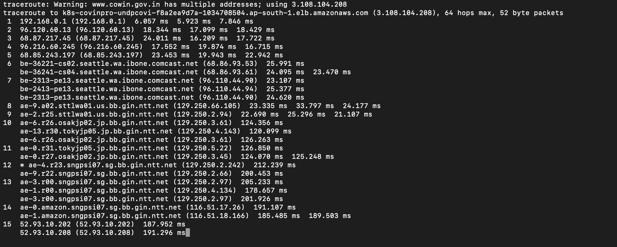

**5)Wireshark Labs: Getting Started**

ANS)

1) Three Protocols are:

-HTTP

-TCP

-DNS

2)



The time taken between HTTP Get and HTTP OK message is=

3)We can see from the above image that the internet address <http://gaia.cs.umass.edu> is 128.119.242.12 and the IP address of my computer is 192.168.0.112.

4) GET message

5) OK message

