A PROJECT REPORT
As partial requirement for the degree of
Bachelor Of Computer Application
Advance Web Designing
ON
ONLINE MOBILE PURCHASING &
DISTRIBUTING SYSTEM
SUBMITTED BY : | University / Enrollment No:
1. __________________________________ | ____________________
2. __________________________________ | ____________________
3. __________________________________ | ____________________

UNDER GUIDANCE OF
________________________________________
Project Guide

COMPUTER SCIENCE DEPARTMENT,
Dolat-Usha Institute Of Applied Sciences And
Dhiru-Sarla Institute of Management & Commerce, Valsad
Affiliated with
Veer Narmad South Gujarat University, Surat
* 2025 - 2026 *

Computer Department
CERTIFICATE
This is to certify that the project work is satisfactorily carried out on "Online Mobile Purchasing & Distributing System" is a work done by Mr. / Ms. ___________________________________________________________________________________ in partial fulfillment of the requirement for the award of the degree of Bachelor of Computer Applications during the academic year 2025 - 2026.
I appreciate their hard work, honesty and discipline during the training for the concerned project in our organization. The project work was carried out under our supervision and guidance of internal guide.
________________________  Project Guide | ________________________  I/C Principal & HOD

Project Certified Date : ____________________
At T.Y.B.C.A Examination
Examiners:
1. ___________________________________
2. ___________________________________

DOLAT-USHA INSTITUTE OF APPLIED SCIENCES AND
DHIRU-SARLA INSTITUTE OF MANAGEMENT & COMMERCE, VALSAD
Project Assessment Detail (internal)
Roll No : - __________________________________________________
Project Title : - Online Mobile Purchasing & Distributing System
Internal Guide: - __________________________________________________
Student Name : - 1. __________________________________________________
2. __________________________________________________
3. __________________________________________________
Week  No. | Week From –  Week To | Date of  Report | Topic / Milestone | Task Schedule for  Next Week | Remarks of  Internal Guide | Signature of  Guide
Week 1 | Week 1 |  | Project Definition / Requirement Analysis | System Design & Modeling
Week 2 | Week 2 |  | Requirement Analysis / System Design | ER Modeling & DFD
Week 3 | Week 3 |  | System Design & DFD Architecture | Database Schema Design
Week 4 | Week 4 |  | System Design / Form Design | Backend Coding Setup
Week 5 | Week 5 |  | Form Design / Backend Coding | Core Business Modules
Week 6 | Week 6 |  | Coding & Concurrency Stock Lock | Mock Payment & Billing
Week 7 | Week 7 |  | Coding & System Documentation | System Testing & QA
Week 8 | Week 8 |  | Documentation, Testing & Final Report | Final Submission / Viva

Project Documentation / Index
SR. No | Topics / Chapter Title | Page No
1 | Chapter 1: Project Introduction, Goal & Objectives | 6
2 | Chapter 2: Hardware and Software Environment | 9
3 | Chapter 3: System Requirement Analysis & RBAC | 11
4 | Chapter 4: System Design, Flowcharts, DFD & ER Modeling | 15
5 | Chapter 5: Database Design & Storage Architecture | 22
6 | Chapter 6: Database Data Dictionary (Tables 1 to 20) | 24
7 | Chapter 7: System Module Descriptions (Modules 1 to 14) | 38
8 | Chapter 8: User Interface & Form Design | 43
9 | Chapter 9: System Implementation & Source Code Documentation | 57
10 | Chapter 10: Form Validation & Business Logic | 62
11 | Chapter 11: Testing & Quality Assurance (30 Test Cases) | 64
12 | Chapter 12: System Security Architecture | 67
13 | Chapter 13: Results & System Output | 69
14 | Chapter 14: System Limitations & Constraints | 70
15 | Chapter 15: Future Scope & Roadmap | 71
16 | Chapter 16: Project Conclusion | 72
17 | Bibliography & References | 73
18 | Appendices (Schema, Sample Data, XAMPP Guide) | 74

CHAPTER 1: PROJECT INTRODUCTION & OBJECTIVES
1.1 Industry Background & Domain Context
The retail smartphone ecosystem in India has experienced exponential growth over the past decade, driven by rapid technological innovation, the nationwide rollout of high-speed 5G mobile broadband networks, and expanding digital financial inclusion. Mobile devices are no longer mere communication instruments; they represent the central computing hub for personal productivity, enterprise collaboration, digital entertainment, banking, and e-governance. Consequently, the demand for flagship, mid-range, and budget smartphones is immense, with consumers seeking high-performance processors, superior multi-lens optical camera setups, extended battery life, and modern display technologies.
However, despite this surging consumer demand, the conventional retail and distribution supply chain for smartphones remains plagued by inefficiencies, multi-tiered middleman markups, manual inventory reconciliation errors, and fragmented stock visibility. Retail brick-and-mortar stores frequently suffer from inventory stockouts of popular flagship models, while consumers face geographic constraints, opaque pricing structures, and lack of comprehensive technical specifications during their decision-making process. The need for a centralized, modern, web-driven smartphone procurement and multi-tier distribution platform is evident.
1.2 Problems with Traditional Mobile Purchasing & Distribution
An in-depth analysis of the traditional smartphone distribution pipeline reveals several critical bottlenecks that hamper operational efficiency and degrade customer satisfaction:
- Manual Stock Reconciliation & Phantom Inventory: In physical retail environments, stock quantities are updated manually at the end of business days or weekly cycles. During high-demand flash sales or product launch windows, multiple orders placed simultaneously lead to overselling and phantom stockouts, causing cancellations and consumer frustration.
- Fragmented Multi-Tier Supply Chains: Regional wholesalers, authorized master distributors, and retail franchise outlets operate on disconnected software silos. Suppliers lack real-time visibility into consumer purchase trends, resulting in either overstocking depreciating devices or severe inventory droughts for trending models.
- Manual Billing & Taxation Bottlenecks: Manual calculation of complex Indian Goods and Services Tax (GST) rates (18% for mobile phones under HSN 85171300, bifurcated into 9% Central GST and 9% State GST) frequently introduces arithmetic discrepancies, delayed invoicing, and compliance penalties.
- Opaque Consignment Tracking: Traditional parcel delivery relies on disconnected courier telephone calls or delayed manifests. Buyers lack granular, transparent visibility into warehouse picking, packaging verification, transit routing, and doorstep delivery schedules.
1.3 Proposed Solution: Online Mobile Purchasing & Distributing System
To decisively overcome these traditional supply chain obstacles, the "Online Mobile Purchasing & Distributing System" has been engineered as a robust, database-driven, 3-tier web platform developed utilizing PHP 8.2+ and MySQL 8.4. The system acts as a unified digital bridge connecting Retail Customers, Verified Regional Suppliers, and Super Administrators within an integrated software environment. By automating catalog discovery, concurrency-safe inventory locking, simulated secure financial settlements, automated GST tax billing, and 7-stage consignment tracking, the application guarantees data consistency, high transactional integrity, and operational transparency.
1.4 Project Goal
PRIMARY PROJECT GOAL
The paramount goal of the Online Mobile Purchasing & Distributing System is to design, develop, and demonstrate a reliable, user-friendly, and comprehensive web-based e-commerce and distribution platform that automates the end-to-end smartphone procurement lifecycle—enabling seamless mobile browsing, dynamic price/tax calculation, 15-minute concurrency stock reservation, safe mock gateway authentication, instant GST invoice generation, and real-time shipment milestone tracking.

1.5 Detailed Project Objectives
To realize the primary project goal, fourteen specific, measurable technical and functional objectives were established and fulfilled during the system's development lifecycle:
- Simplify Smartphone Procurement: Deliver an intuitive, responsive web interface that empowers retail consumers to browse flagship and budget devices, review technical specifications, and purchase smartphones within a streamlined 4-step workflow.
- Centralized Multi-Brand Catalog: Structure a normalized database catalog featuring categorized smartphones across leading manufacturers (Apple, Samsung, OnePlus, Xiaomi, Google, Realme) with verified technical specifications.
- Multi-Attribute Filtering & Discovery: Implement dynamic search and multi-criteria filtering engines allowing customers to filter devices simultaneously by operating system, 5G connectivity, RAM, internal storage, camera megapixels, battery capacity, and price bands.
- Multi-Vendor Distribution Architecture: Provide regional mobile suppliers with dedicated, authenticated vendor portals to upload smartphone inventories, manage batch allocations, set competitive pricing, and monitor assigned purchase orders.
- Automated Low-Stock Threshold Alarms: Incorporate an automated inventory audit daemon that alerts suppliers and administrators whenever stock levels for any mobile model drop below a critical threshold (minimum 5 units).
- Concurrency-Safe Stock Reservation (P1.3.3): Engineer an optimistic concurrency lock holding temporary stock reservations in the database for 15 minutes during checkout to eliminate double-selling and race conditions during flash demand.
- Safe Mock Bank Payment Simulation (P1.4.2): Implement an academic demonstration payment gateway simulating Credit Card, Debit Card, UPI, and Net Banking settlements with cryptographic HMAC-SHA256 signature verification.
- Automated GST Tax Invoicing (P1.4.3): Automate statutory tax computation compliant with Indian GST laws (HSN Code 85171300), generating print-ready tax invoices with itemized taxable amounts, 9% CGST, 9% SGST, and sequential numbering.
- End-to-End 7-Stage Consignment Tracking (P1.5): Design a transparent fulfillment lifecycle tracking consignments across 7 discrete milestones: Order Placed, Payment Verified, Processing, Packed with IMEI Barcode, Shipped via Express Courier, Out for Delivery, and Doorstep OTP Delivery.
- Role-Based Access Control (RBAC): Establish strict credential authentication and session-level authorization separating Customer, Supplier, and Super Administrator privileges to guarantee system security.
- Executive Supply Chain Analytics: Furnish super administrators with a real-time command dashboard featuring interactive KPI metric cards, monthly revenue distribution charts, product volume audits, and customer growth trends.
- Full ACID Relational Data Integrity: Architect a 3rd Normal Form (3NF) relational database utilizing MySQL's InnoDB storage engine with cascading foreign key constraints guaranteeing referential integrity.
- Cross-Device Responsive Web Presentation: Leverage Bootstrap 5.3 fluid grid layouts and responsive viewports ensuring optimal usability across smartphones, tablets, laptops, and desktop workstations.
- Elimination of Paperwork & Administrative Overheads: Transition traditionally manual paper-based order slips, inventory logbooks, and tax invoices into automated, queryable electronic records.
1.6 Scope and Boundaries of the Academic Project
This project is developed as an academic capstone software engineering project. The software encompasses all foundational business workflows of an enterprise mobile distribution portal. However, certain external enterprise services are simulated to maintain academic feasibility: payment settlements are conducted through an internal cryptographically-verified Mock Bank Gateway rather than live banking APIs; courier tracking logs are managed via an internal fulfillment database rather than live third-party logistics API webhooks; and all smartphone prices and supplier profiles are treated as realistic academic demonstration data.

CHAPTER 2: HARDWARE AND SOFTWARE ENVIRONMENT
2.1 Hardware Configuration
The Online Mobile Purchasing & Distributing System is designed to operate efficiently on standard commodity hardware without requiring expensive high-performance computing clusters. The minimum and recommended hardware environments for development, local hosting, and client access are specified below:
Development & Server Hardware Configuration
- Central Processing Unit (CPU): Intel Core i3 10th Generation or AMD Ryzen 3 equivalent (Quad-Core, 3.0 GHz or higher)
- System Memory (RAM): 8.00 GB DDR4 SDRAM (16.00 GB recommended for concurrent IDE, Apache, and MySQL services)
- Secondary Storage: 240 GB Solid State Drive (SSD) with at least 20 GB free storage for database tables and product assets
- Display Resolution: 1920 x 1080 Full HD color display monitor for multi-window web development and UI auditing
- Network Interface: Broadband Internet connection (minimum 10 Mbps) for external CDN assets (Bootstrap, Font Awesome, Chart.js)
Client Hardware Requirements
- Client Devices: Standard modern personal computer, laptop, tablet, or smartphone equipped with a modern web browser
- Client Memory & CPU: Minimum 2 GB RAM and dual-core processor capable of rendering modern HTML5/CSS3 web pages
- Display Compatibility: Minimum 360 x 640 mobile screen resolution up to 4K ultra-high-definition desktop displays
2.2 Software Environment
The software architecture leverages proven, open-source, industry-standard web engineering tools ensuring zero licensing costs, high portability, and widespread community support:
- Operating System: Microsoft Windows 10 / Windows 11 (64-bit Professional / Home Edition). Windows provides a stable, user-friendly environment for XAMPP development, command-line utilities, and web browser debugging.
- Web Server: Apache HTTP Server 2.4.x (administered via XAMPP Local Development Suite). Apache handles incoming HTTP/HTTPS requests, virtual hosting, directory routing, and PHP module execution via mod_php.
- Backend Programming Engine: PHP 8.2+ (Hypertext Preprocessor). Employs modular object-oriented and procedural programming principles, PDO (PHP Data Objects) for database abstraction, and native session management.
- Relational Database Management System: MySQL 8.4 Community Server (InnoDB Engine). Provides enterprise-grade relational database persistence, full ACID transaction compliance, foreign key constraint enforcement, and B-tree indexing.
- Database Administration Tool: phpMyAdmin 5.2.x. A web-based graphical interface for managing MySQL databases, executing SQL queries, managing user privileges, and performing database backup/restore operations.
- Frontend Markup & Styling: HTML5 semantic markup for structural layout; CSS3 for custom typography, transitions, and media queries; and Bootstrap 5.3.3 framework for responsive navigation bars, modal dialogs, and utility classes.
- Client-Side Scripting: Vanilla JavaScript (ECMAScript 2022) for client-side form validation, asynchronous AJAX fetch requests (live cart counter, price calculation), and interactive DOM manipulation.
- Iconography & Visual Assets: Font Awesome 6.5.1 vector icon library delivering crisp, scalable iconography for mobile specifications, cart actions, status badges, and dashboard navigation.
- Data Visualization Engine: Chart.js 4.4.2 client-side charting library utilized within the administrative portal to render dynamic monthly revenue line charts and inventory distribution bar graphs.
- Source Code Editor: Microsoft Visual Studio Code (VS Code) equipped with PHP Intelephense, Prettier, and MySQL extensions for efficient syntax highlighting, debugging, and code formatting.
- Target Web Browsers: Google Chrome 120+, Microsoft Edge 120+, and Mozilla Firefox 120+ with full support for modern CSS Flexbox, Grid, and ES6 JavaScript features.

CHAPTER 3: SYSTEM REQUIREMENT ANALYSIS
3.1 Stakeholder Analysis & Role Hierarchy
System requirement analysis forms the fundamental bedrock of the software development lifecycle. In the Online Mobile Purchasing & Distributing System, three distinct operational user roles interact with the platform, each possessing defined permissions, data handling boundaries, and functional responsibilities:
3.1.1 Super Administrator Role
The Super Administrator possesses supreme governance authority over the entire platform. The administrator does not engage in direct commercial smartphone selling, but rather oversees catalog integrity, audits multi-depot warehouse inventories, evaluates vendor performance, reviews financial payment reconciliations, and monitors security logs.
- Login / Authentication: Administrative credential authentication with encrypted password verification and session fixation protection.
- Permissions: Global read/write/delete privileges across all database tables (users, suppliers, products, orders, payments, invoices, shipments, logs).
- Core Functions: Approve or reject newly registered mobile suppliers; activate, deactivate, or suspend customer accounts; audit low-stock alerts; override fulfillment statuses; inspect system error logs.
- Data Handled: Sensitive administrative records, user personal identifiable information (PII), total revenue aggregates, system audit trails, and global configuration flags.
- Expected Output: Executive KPI metric widgets, printable audit reports, revenue breakdown charts, and synchronized inventory tables.
3.1.2 Supplier / Distributor Role
Suppliers represent authorized regional smartphone distributors and wholesale warehouse operators. They are responsible for listing smartphone models, maintaining available stock units, updating unit prices, and fulfilling assigned purchase orders.
- Registration & Login: Dedicated supplier registration requiring business company name, GSTIN number, contact person, and secure password; subsequent authenticated login.
- Permissions: Read and update access strictly restricted to products and order items associated with their unique supplier_id.
- Core Functions: Add new smartphone models with technical specs; restock existing mobile quantities; view allocated purchase orders; update dispatch stages; assign carrier tracking IDs.
- Data Handled: Company profile data, product specifications (RAM, storage, processor, display, camera), stock quantities, batch purchase orders, and shipment airway bill numbers.
- Expected Output: Supplier inventory status tables, restock confirmation alerts, dispatch manifests, and supplier sales summaries.
3.1.3 Retail Customer Role
Retail Customers represent the end consumers purchasing mobile phones for personal or business use. They expect an intuitive, responsive, and transparent digital shopping experience.
- Registration & Login: Self-service registration capturing name, email address, 10-digit mobile number, delivery address, and password; subsequent authenticated login.
- Permissions: Read access to active product catalogs; full management of own shopping cart; creation and tracking of own orders; download of personal tax invoices.
- Core Functions: Search and filter smartphones; view detailed hardware specifications; add devices to cart; execute 15-minute stock reservation checkout; complete mock payment; track parcel milestones; submit product reviews.
- Data Handled: Personal profile details, delivery addresses, cart line-items, payment tokens, order numbers, and product ratings.
- Expected Output: Instant order confirmation receipts, official GST tax invoices (PDF/Print), and real-time 7-stage consignment delivery timelines.
3.2 Functional Requirements Specification
Functional requirements define the specific operational behaviors and business capabilities implemented within the system:
- FR-01: User Authentication & RBAC: The system must authenticate users via encrypted BCRYPT password hashes and enforce strict role-based route guards across Customer, Supplier, and Admin spaces.
- FR-02: Smartphone Catalog Browsing: The system must present an organized catalog of active smartphones displaying device names, brand logos, high-resolution imagery, and current pricing.
- FR-03: Multi-Criteria Search & Filter: The system must enable simultaneous multi-attribute filtering by brand, 5G support, RAM capacity, storage capacity, operating system, and price range.
- FR-04: Technical Spec Sheet Display: The system must render comprehensive hardware specifications (processor, display resolution, rear/front cameras, battery capacity, fast charging, OS version) for every smartphone.
- FR-05: Shopping Cart Management: The system must allow users to add items, modify quantities, remove line items, and dynamically compute item subtotals without manual page reloads.
- FR-06: 15-Minute Concurrency Stock Lock (P1.3.3): The system must temporarily lock requested stock quantities in the stock_reservations table for 15 minutes during checkout to prevent double-selling.
- FR-07: Automated Stock Release Daemon: The system must automatically release expired stock reservations if checkout is abandoned or payment is cancelled within the 15-minute TTL.
- FR-08: Mock Payment Gateway Simulation (P1.4.2): The system must provide an academic payment sandbox supporting Card, UPI, and Net Banking with cryptographic HMAC-SHA256 signature verification.
- FR-09: Order Confirmation & Persistence: On successful payment verification, the system must create an immutable order record in D3, commit stock deductions permanently, and assign a unique order number.
- FR-10: Automated GST Tax Invoicing (P1.4.3): The system must compute 18% GST (9% CGST + 9% SGST) compliant with HSN 85171300 and produce a formal, printable tax invoice (INV-YYYY-XXXX).
- FR-11: 7-Stage Consignment Tracking (P1.5): The system must track consignments across 7 discrete milestones: Order Placed, Payment Verified, Processing, Packed, Shipped, Out for Delivery, and Delivered.
- FR-12: Supplier Inventory Management: The system must empower authenticated suppliers to restock quantities, add new models, and review assigned purchase orders.
- FR-13: Low-Stock Automated Warning: The system must generate visual dashboard alerts whenever product inventory drops to or below the minimum threshold (5 units).
- FR-14: Administrative KPI Analytics: The system must aggregate and render total revenue, order volumes, active customer counts, and warehouse unit metrics via interactive charts.
- FR-15: Customer Review & Rating Engine: The system must allow verified buyers to submit 1-to-5 star ratings and textual reviews for purchased smartphone models.
3.3 Non-Functional Requirements Specification
Non-functional requirements dictate the operational qualities, performance characteristics, and security standards enforced by the system:
- NFR-01: Usability & User Experience: The user interface must adhere to clean, modern e-commerce UI/UX standards, requiring no more than 3 clicks to navigate from homepage to checkout with intuitive visual feedback.
- NFR-02: Performance & Response Time: Catalog search queries and page rendering must execute in under 1.2 seconds under standard local server loads; database queries must leverage indexes for sub-50ms execution.
- NFR-03: Concurrency & ACID Reliability: The system must maintain 100% database ACID compliance during simultaneous checkouts, ensuring zero inventory discrepancies or negative stock quantities.
- NFR-04: Security & Data Protection: Passwords must be salted and hashed via BCRYPT (cost factor 10); all SQL queries must utilize PDO prepared statements; user inputs must be sanitized against XSS and CSRF attacks.
- NFR-05: Maintainability & Code Modularity: Source code must adhere to clean modular PHP separation of concerns, isolating database configurations, authentication guards, business logic, and presentation templates.
- NFR-06: Scalability & Growth: The relational schema must support vertical and horizontal scaling, accommodating tens of thousands of products and order records without architectural refactoring.
- NFR-07: Availability & Fault Tolerance: The application must handle database disconnection gracefully, rendering informative user-facing error notices rather than unhandled fatal stack traces.
- NFR-08: Cross-Platform Responsiveness: The web interface must dynamically adapt to all screen form factors (desktops, laptops, tablets, and smartphones) with zero horizontal overflow.

CHAPTER 4: SYSTEM DESIGN & ARCHITECTURE
4.1 System Flowchart & Operational Lifecycle
The system flow diagram illustrates the sequential operational lifecycle traversed by a retail customer from initial storefront discovery through stock reservation, mock financial settlement, warehouse packing, and doorstep fulfillment. Figure 4.1 maps this comprehensive workflow:
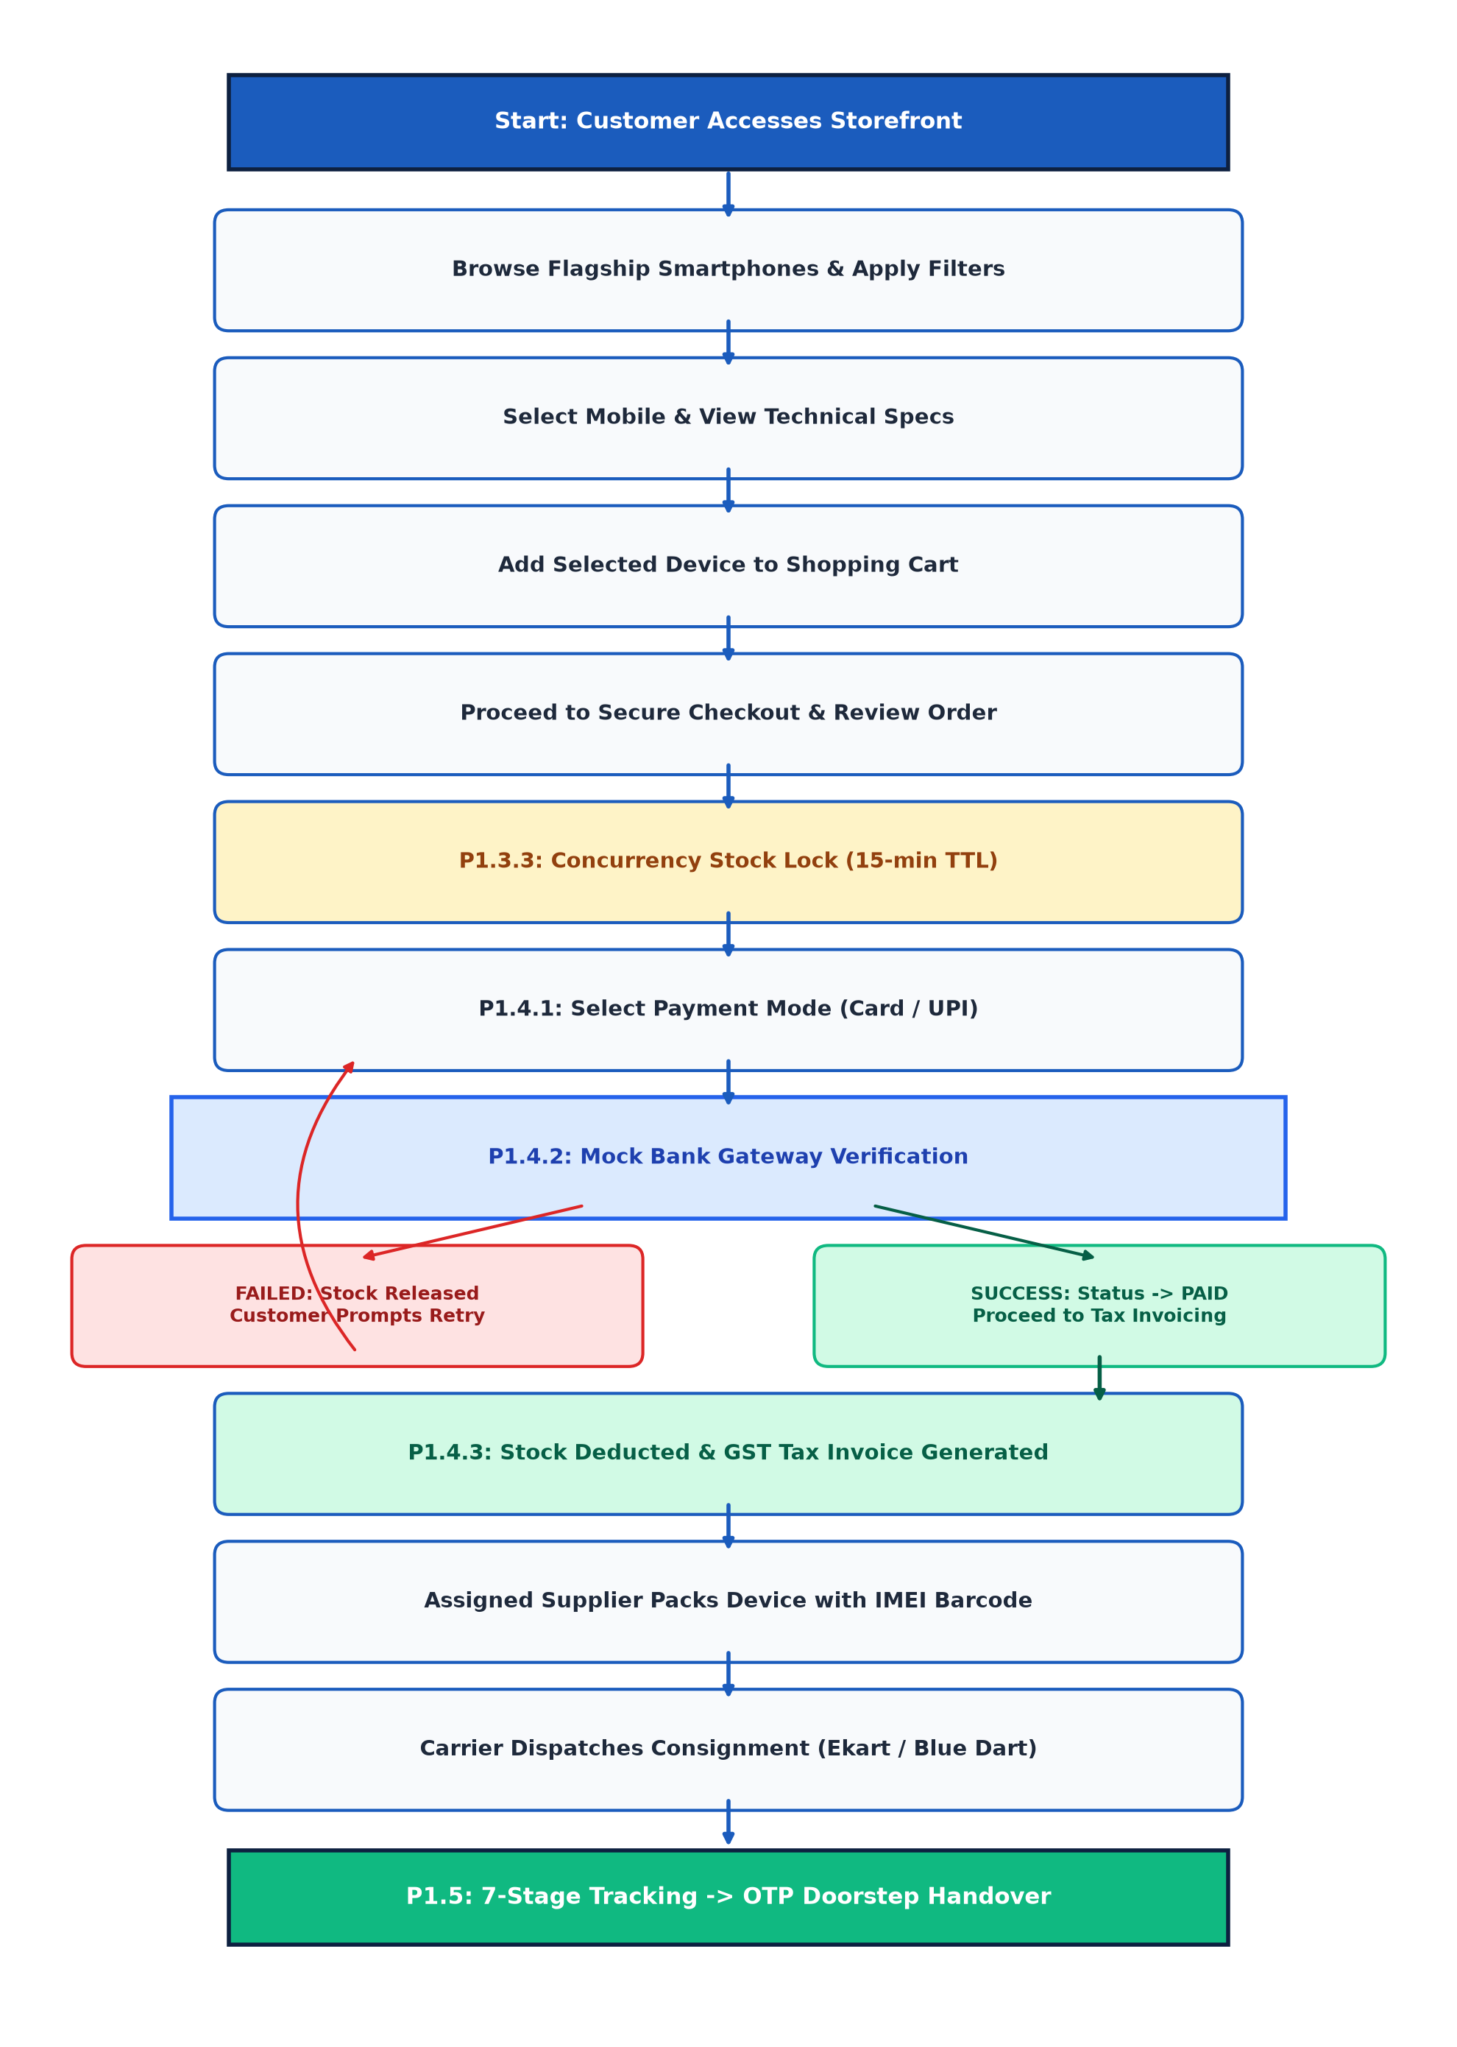
Figure 4.1 — End-to-End Smartphone Order & Distribution Lifecycle Flowchart
As depicted in Figure 4.1, the operational sequence proceeds through thirteen discrete phases:
- Phase 1 (Storefront Access): The customer accesses the home storefront and authenticates via email/password credentials or browses as a guest.
- Phase 2 (Catalog Discovery): The user browses the smartphone catalog, applying filters for brand (Samsung, Apple, OnePlus), 5G capability, RAM, storage, and price bands.
- Phase 3 (Product Specification): The customer inspects detailed hardware specifications, warranty terms, and high-resolution product imagery.
- Phase 4 (Cart Management): The user adds selected smartphone models and quantities to the dynamic shopping cart.
- Phase 5 (Checkout Initiation): The customer proceeds to checkout, verifying delivery contact details and shipping address.
- Phase 6 (Stock Reservation Hold): The system executes Process P1.3.3, locking the required units in stock_reservations with a 15-minute TTL to prevent concurrent double-booking.
- Phase 7 (Payment Method Selection): The user selects a payment mode (Credit/Debit Card, UPI, Net Banking) and submits payment intent.
- Phase 8 (Mock Gateway Authentication): The system transmits a cryptographically signed HMAC token to the Mock Bank Gateway sandbox for validation.
- Phase 9 (Payment Branching Logic): If payment fails, reserved stock is released back into inventory and the customer is prompted to retry. If payment succeeds, order status transitions to PAID.
- Phase 10 (Invoice Generation & Stock Commit): The system deducts stock permanently and generates an official GST Tax Invoice (INV-YYYY-XXXX) compliant with HSN 85171300.
- Phase 11 (Supplier Packaging): The assigned regional supplier inspects the smartphone, scans the unique IMEI barcode, and packs the unit in a security-sealed box.
- Phase 12 (Carrier Dispatch): The package is handed over to the express logistics carrier (Ekart / Blue Dart Air) and assigned an Airway Bill (AWB) tracking number.
- Phase 13 (OTP Doorstep Handover): The customer monitors live transit milestones until the delivery executive verifies an OTP at the customer doorstep to complete delivery.
4.2 Data Flow Diagram (DFD) Architecture
The Data Flow Diagram represents the authoritative architectural foundation governing all information exchanges between external entities, functional processes, and relational data stores. Figure 4.2 presents the complete, unaltered project DFD architecture:
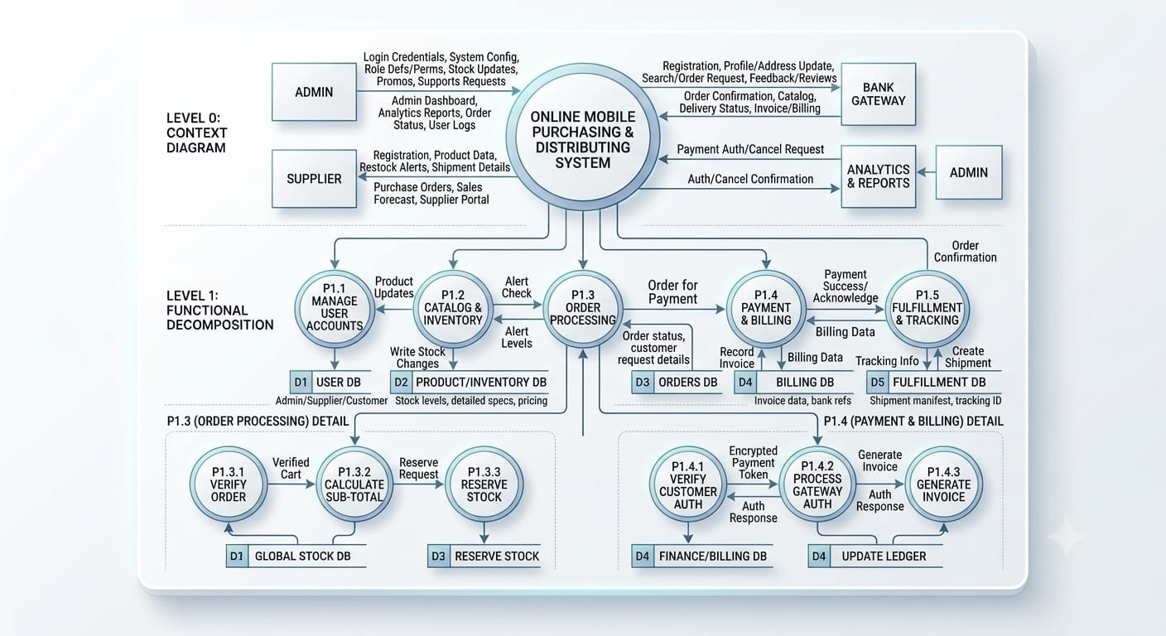
Figure 4.2 — Project Data Flow Diagram (Authoritative Architecture: Level 0 & Level 1)
4.2.1 Level 0: Context Analysis Diagram
At the Level 0 Context Analysis layer, the entire web platform is conceptualized as a single centralized process—"Online Mobile Purchasing & Distributing System"—interacting with five primary external entities:
- 1. Administrator Entity: Transmits system configuration parameters, role definitions, stock updates, promotional discount codes, and customer support ticket resolutions. Receives administrative command dashboards, real-time analytics reports, order statuses, and system audit logs.
- 2. Supplier Entity: Transmits supplier onboarding credentials, product specifications, inventory restock notices, and shipment handover details. Receives allocated purchase orders, regional sales forecasts, and vendor portal metrics.
- 3. Customer Entity: Transmits customer registration data, shipping addresses, search queries, cart modifications, order requests, and device reviews. Receives order confirmation receipts, smartphone catalogs, delivery tracking updates, and GST tax invoices.
- 4. Bank Gateway Entity: Receives encrypted payment authorization requests containing transaction amounts and order IDs; returns authorization callbacks and settlement status confirmations.
- 5. Analytics & Reports Entity: Consumes multi-table transactional streams to compute financial metrics, sales velocity, and inventory turnover reports for executive review.
4.2.2 Level 1: Functional Decomposition & Core Processes
The Level 1 Functional Decomposition expands the core system into five sequential, coordinated processes (P1.1 through P1.5) interfacing with five normalized relational data stores (D1 through D5):
- Process P1.1 (Manage User Accounts): Handles credential verification, session management, RBAC authorization guards, user profile maintenance, and supplier GSTIN business approvals. Reads and writes from D1: USER DB.
- Process P1.2 (Catalog & Inventory): Maintains the smartphone product catalog, technical specification attributes, brand and category relationships, and warehouse stock levels. Emits low-stock alert signals to P1.3 when stock <= 5 units. Interfaces with D2: PRODUCT/INVENTORY DB.
- Process P1.3 (Order Processing): Orchestrates cart aggregation, shipping address verification, subtotal/tax computation, and temporary concurrency stock locking. Reads from D2, communicates with P1.4, and persists orders to D3: ORDERS DB.
- Process P1.4 (Payment & Billing): Manages customer payment method selection, communicates with the Mock Bank Gateway sandbox via signed tokens, verifies HMAC signatures, and generates official GST tax invoices. Updates D4: BILLING DB.
- Process P1.5 (Fulfillment & Tracking): Coordinates warehouse packing, IMEI barcode verification, carrier dispatch handover, AWB tracking ID creation, and 7-stage milestone status updates. Persists shipment events into D5: FULFILLMENT DB.
4.3 Order Processing Sub-Pipeline (P1.3 Decomposition)
Process P1.3 (Order Processing) is further decomposed into three critical sub-processes that enforce business validation and concurrency protection during customer checkout:
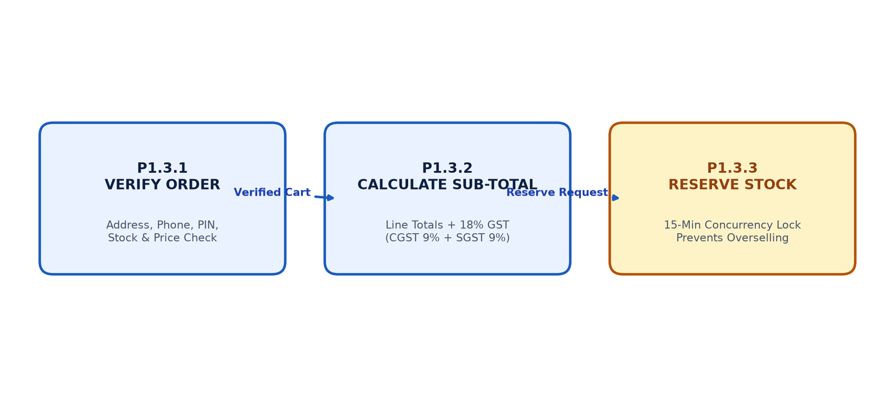
Figure 4.3 — Subprocess Decomposition: P1.3 Order Processing Pipeline
- P1.3.1 Verify Order Details: Validates customer delivery address completeness, 10-digit telephone contact formatting, PIN code serviceability, and ensures the selected mobile model is active and physically in stock.
- P1.3.2 Calculate Sub-Total & Tax: Aggregates line items by multiplying unit selling price by quantity, calculates applicable 18% GST (9% CGST + 9% SGST) under HSN 85171300, determines free or flat shipping charges, and outputs the final payable grand total.
- P1.3.3 Reserve Stock: Places an optimistic concurrency reservation lock in the stock_reservations table with a 15-minute Time-To-Live (TTL). This decrements available inventory temporarily, preventing other concurrent shoppers from purchasing the same units during flash sales.
4.4 Payment & Billing Sub-Pipeline (P1.4 Decomposition)
Process P1.4 (Payment & Billing) coordinates the financial settlement and statutory invoicing lifecycle:
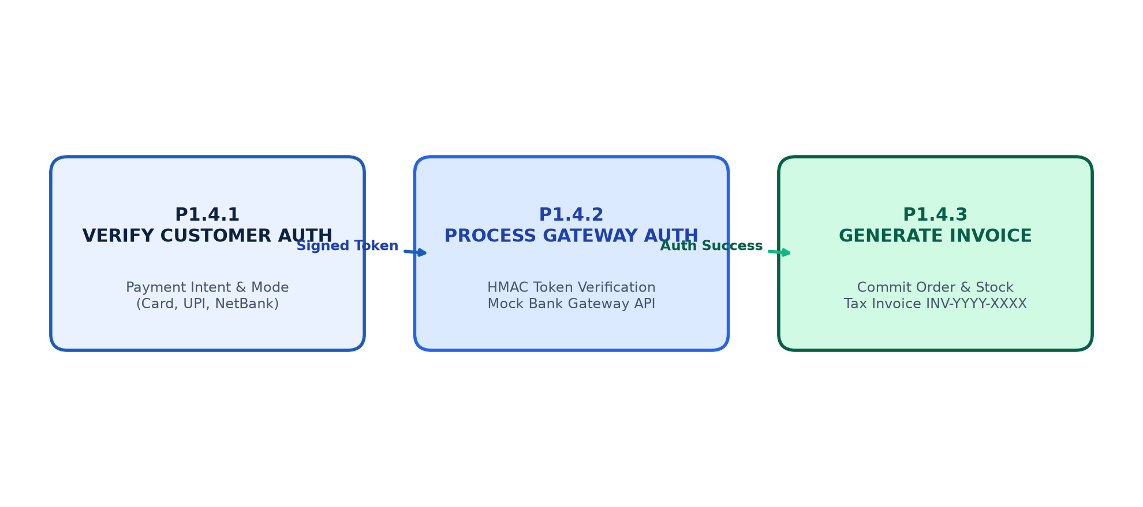
Figure 4.4 — Subprocess Decomposition: P1.4 Payment & Billing Pipeline
- P1.4.1 Customer Payment Auth: Collects the customer's chosen payment instrument (Credit/Debit Card, UPI ID, Net Banking) and prepares a base64-encoded payment intent token packaging order ID, customer ID, and amount.
- P1.4.2 Process Gateway Auth: Transmits the payment token to the Mock Bank Gateway sandbox. Verifies tamper-proof HMAC-SHA256 signatures, simulates bank authorization, captures transaction IDs, and returns a verified success/failure callback.
- P1.4.3 Generate Tax Invoice: Upon receiving gateway authorization, commits order status to PAID, permanently reduces warehouse stock, and generates a formal GST Tax Invoice (INV-YYYY-XXXX) with complete tax bifurcation and customer download access.
4.5 5-Tier System Architecture
The system is architected as an enterprise-grade 5-Tier software hierarchy separating client presentation, styling, controller logic, business domain engines, and relational persistence. Figure 4.5 details this multi-tier structure:
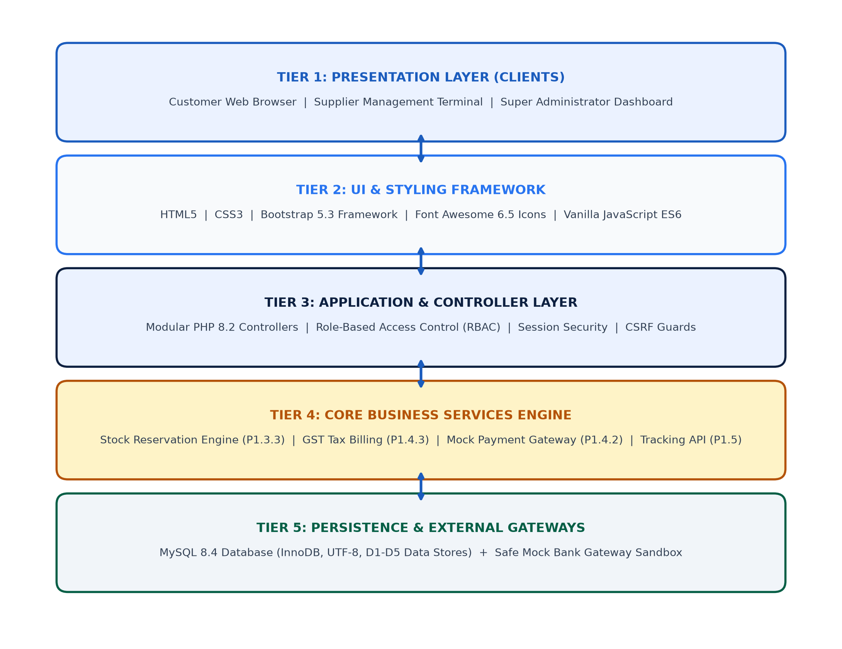
Figure 4.5 — 5-Tier Enterprise Software Architecture
- Tier 1 (Presentation Layer): Delivers responsive web interfaces for Retail Customers, Regional Suppliers, and Super Administrators across standard web browsers.
- Tier 2 (UI & Styling Framework): HTML5 semantic tags, custom CSS3 responsive styles, Bootstrap 5.3 fluid grid, Font Awesome 6.5 iconography, and Chart.js analytics visuals.
- Tier 3 (Application & Controller Layer): Modular PHP 8.2 controllers implementing strict RBAC guards, session fixation defense, CSRF tokens, and input sanitization.
- Tier 4 (Business Services Engine): Dedicated business logic services: 15-minute Concurrency Stock Reservation Engine, Automated GST Tax Calculator, Mock Payment Gateway Sandbox, and 7-Stage Tracking API.
- Tier 5 (Persistence & Gateway Layer): MySQL 8.4 Community Server executing the InnoDB storage engine with strict foreign key constraints across D1-D5 relational data stores.
4.6 Entity-Relationship (ER) Modeling
The Entity-Relationship diagram defines the relational data structures, primary keys, foreign keys, and cardinalities governing all persistent domain entities. Figure 4.6 illustrates the normalized ER model:
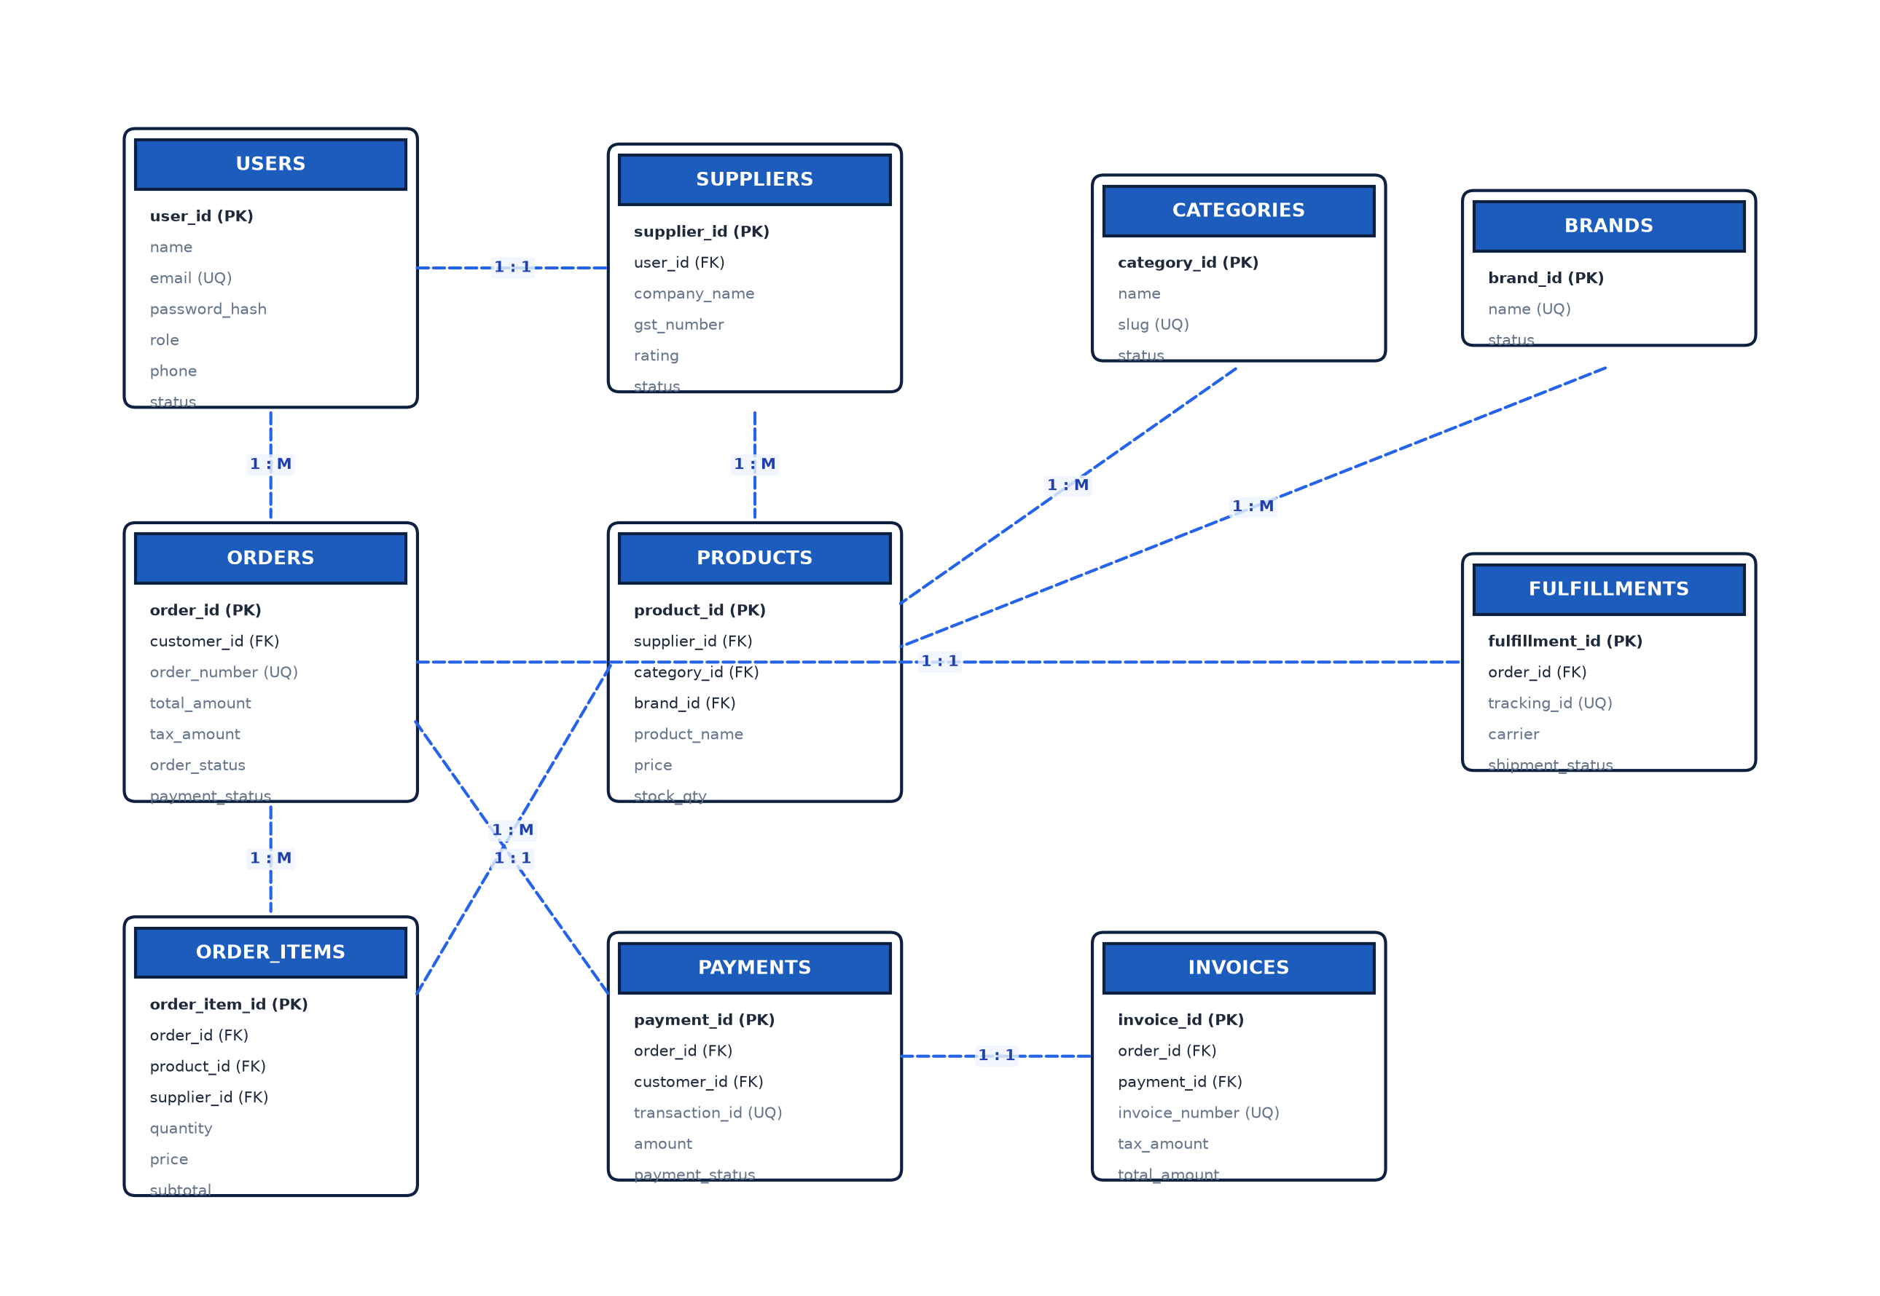
Figure 4.6 — Entity-Relationship Diagram (Core Relational Schema)
Key entity relationships and cardinalities depicted in Figure 4.6 include:
- USERS to SUPPLIERS (1 : 1 / 1 : 0..1): A User may exist as a standalone Customer or be associated with exactly one verified Supplier profile via user_id.
- SUPPLIERS to PRODUCTS (1 : M): A verified Supplier manages multiple smartphone product listings in the catalog.
- BRANDS & CATEGORIES to PRODUCTS (1 : M): Each Brand (Apple, Samsung, etc.) and Category (Flagship, 5G, Budget) classifies multiple smartphone models.
- USERS to ORDERS (1 : M): A registered Customer places multiple Orders over time, but each Order belongs to exactly one Customer.
- ORDERS to ORDER_ITEMS (1 : M): Each Order contains one or more itemized Order Items referencing specific smartphone products and supplying vendors.
- ORDERS to PAYMENTS & INVOICES (1 : 1): Each Order links to exactly one financial Payment record and exactly one legal GST Tax Invoice.
- ORDERS to FULFILLMENTS (1 : 1): Each Order generates exactly one Fulfillment consignment containing multiple timestamped shipment tracking events.

CHAPTER 5: DATABASE DESIGN & STORAGE ARCHITECTURE
5.1 Relational Database Principles & Normalization
A robust relational database architecture is paramount to ensuring transactional integrity, zero inventory anomalies, and rapid query response times in high-volume e-commerce platforms. The database schema of the Online Mobile Purchasing & Distributing System was architected following the relational model principles and systematically normalized up to the Third Normal Form (3NF):
5.1.1 First Normal Form (1NF)
First Normal Form requires that all column values are atomic (indivisible) and that each record is uniquely identifiable via a primary key. In our schema: all multi-valued attributes (such as multiple smartphone image galleries, cart line items, and order line items) are decomposed into separate child relational tables (`product_images`, `cart_items`, `order_items`). No comma-separated lists or repeating groups exist in any relation.
5.1.2 Second Normal Form (2NF)
Second Normal Form builds on 1NF by guaranteeing that all non-key attributes are fully functionally dependent on the entire primary key, eliminating partial dependencies. In composite-key associative entities such as `order_items` and `cart_items`, every non-key attribute (unit price, quantity, line subtotal) depends strictly upon the unique record key rather than a subset of candidate keys. Product details (brand name, technical specifications) remain isolated in their parent `products` relation.
5.1.3 Third Normal Form (3NF)
Third Normal Form requires that no non-key attribute is transitively dependent on another non-key attribute. In our design, redundant entity data is segregated into lookup relations: categories and brands are stored in independent tables (`categories`, `brands`) referenced via foreign keys rather than storing redundant textual brand descriptions within the product catalog. Similarly, supplier contact details exist solely within `suppliers`, eliminating update anomalies across product listings.
5.2 DFD Data Store Groupings (D1 through D5)
In direct alignment with the authoritative Data Flow Diagram, the twenty database tables are logically organized into five functional data stores:
- D1 — USER DB: Encapsulates user authentication, RBAC credentials, supplier business credentials, and delivery addresses. Tables: users, suppliers.
- D2 — PRODUCT / INVENTORY DB: Encompasses smartphone hardware catalogs, technical specifications, brand categories, image galleries, and audit logs. Tables: categories, brands, products, product_images, inventory_transactions.
- D3 — ORDERS DB: Maintains customer shopping carts, checkout records, itemized order lines, and temporary 15-minute stock reservations. Tables: cart, cart_items, orders, order_items, stock_reservations.
- D4 — BILLING / FINANCE DB: Stores mock gateway payment transactions, authorization response payloads, and official GST tax invoices. Tables: payments, invoices, invoice_items.
- D5 — FULFILLMENT & AUDIT DB: Tracks warehouse packaging manifests, carrier tracking IDs, and 7-stage delivery milestone logs. Tables: fulfillments, shipment_events, reviews, notifications, system_settings.
5.3 Referential Integrity & Foreign Key Constraint Matrix
All tables utilize MySQL's InnoDB storage engine, which enforces ACID (Atomicity, Consistency, Isolation, Durability) transactions and strict foreign key referential integrity. Deletion of parent orders safely cascades to order line items, while critical accounting records (such as invoices and payments) employ RESTRICT or SET NULL constraints to preserve audit trails.
5.4 Indexing Strategy & Query Optimization
To maintain sub-50 millisecond query execution times, B-tree indexes are established on frequently queried lookup columns including: `users(email)`, `users(role)`, `products(brand_id)`, `products(category_id)`, `products(final_price)`, `orders(customer_id)`, `orders(order_status)`, `payments(order_id)`, and `fulfillments(tracking_id)`.

CHAPTER 6: DATABASE DATA DICTIONARY
The Data Dictionary provides an exhaustive technical specification of all tables, fields, data types, storage sizes, indexing keys, and business constraints implemented within the MySQL database. Every table documented below directly corresponds to the physical schema instantiated in `database/database.sql`:
Table 6.1 — Data Dictionary: users (D1: USER DB)
Description: Stores system accounts across Customer, Supplier, and Super Admin roles.
Field Name | Data Type | Size | Key | Description & Constraints
user_id | INT | 11 | PK | Unique auto-increment identifier
name | VARCHAR | 100 |  | Full legal name of the user
email | VARCHAR | 150 | UQ | Unique email address for authentication
phone | VARCHAR | 20 |  | 10-digit mobile contact number
password_hash | VARCHAR | 255 |  | BCRYPT encrypted password hash (cost factor 10)
role | ENUM | 10 |  | Access role: 'ADMIN', 'CUSTOMER', 'SUPPLIER'
status | ENUM | 10 |  | Account state: 'ACTIVE', 'INACTIVE', 'SUSPENDED'
address | TEXT | - |  | Primary delivery street address
city | VARCHAR | 100 |  | City name (e.g., Valsad, Surat)
state | VARCHAR | 100 |  | State name (e.g., Gujarat)
pincode | VARCHAR | 20 |  | 6-digit postal code
created_at | DATETIME | - |  | Account registration timestamp
updated_at | DATETIME | - |  | Last profile modification timestamp

Table 6.2 — Data Dictionary: suppliers (D1: USER DB)
Description: Stores verified regional distributor business credentials.
Field Name | Data Type | Size | Key | Description & Constraints
supplier_id | INT | 11 | PK | Unique auto-increment supplier identifier
user_id | INT | 11 | FK | References users(user_id) ON DELETE CASCADE
company_name | VARCHAR | 150 |  | Registered corporate or distributor trade name
gst_number | VARCHAR | 50 |  | 15-digit statutory GSTIN registration number
contact_person | VARCHAR | 100 |  | Name of designated distributor liaison
approval_status | ENUM | 10 |  | Status: 'PENDING', 'APPROVED', 'REJECTED'
rating | DECIMAL | 3,2 |  | Aggregated vendor rating (default 4.80)
created_at | DATETIME | - |  | Supplier onboarding timestamp

Table 6.3 — Data Dictionary: categories (D2: PRODUCT DB)
Description: Classifies smartphones into market segments.
Field Name | Data Type | Size | Key | Description & Constraints
category_id | INT | 11 | PK | Unique category identifier
name | VARCHAR | 100 |  | Category name (e.g., Flagship, Mid-Range, 5G)
slug | VARCHAR | 100 | UQ | URL-friendly SEO identifier
description | TEXT | - |  | Category descriptive scope
icon | VARCHAR | 50 |  | Font Awesome vector icon class
status | ENUM | 10 |  | Active visibility state: 'ACTIVE', 'INACTIVE'

Table 6.4 — Data Dictionary: brands (D2: PRODUCT DB)
Description: Stores smartphone manufacturing brands.
Field Name | Data Type | Size | Key | Description & Constraints
brand_id | INT | 11 | PK | Unique brand identifier
name | VARCHAR | 100 | UQ | Manufacturer name (Apple, Samsung, OnePlus, Google)
slug | VARCHAR | 100 | UQ | URL-safe brand slug
logo_icon | VARCHAR | 50 |  | Font Awesome mobile logo class
status | ENUM | 10 |  | Visibility state: 'ACTIVE', 'INACTIVE'

Table 6.5 — Data Dictionary: products (D2: PRODUCT DB)
Description: Core catalog storing smartphone specifications and pricing.
Field Name | Data Type | Size | Key | Description & Constraints
product_id | INT | 11 | PK | Unique product identifier
supplier_id | INT | 11 | FK | References suppliers(supplier_id)
brand_id | INT | 11 | FK | References brands(brand_id)
category_id | INT | 11 | FK | References categories(category_id)
product_name | VARCHAR | 200 |  | Commercial device name (e.g., Samsung Galaxy S24 Ultra)
model | VARCHAR | 100 |  | Manufacturer model number
description | TEXT | - |  | Full marketing and technical description
price | DECIMAL | 10,2 |  | Standard Maximum Retail Price (INR)
discount | INT | 3 |  | Discount percentage (0-100)
final_price | DECIMAL | 10,2 |  | Net selling price after discount
stock_quantity | INT | 11 |  | Available physical inventory units in depot
minimum_stock | INT | 11 |  | Low-stock alarm threshold (default 5 units)
ram | VARCHAR | 50 |  | RAM spec (e.g., 12GB LPDDR5X)
storage | VARCHAR | 50 |  | Internal storage (e.g., 256GB / 512GB UFS 4.0)
processor | VARCHAR | 100 |  | Chipset (e.g., Snapdragon 8 Gen 3 / Apple A18 Pro)
display | VARCHAR | 100 |  | Screen spec (e.g., 6.8" Dynamic AMOLED 2X 120Hz)
camera | VARCHAR | 150 |  | Camera setup (e.g., 200MP Quad Rear + 12MP Front)
battery | VARCHAR | 100 |  | Battery capacity (e.g., 5000mAh 45W Fast Charging)
operating_system | VARCHAR | 50 |  | OS version (e.g., Android 14 / iOS 18)
warranty | VARCHAR | 100 |  | Manufacturer warranty terms
image | VARCHAR | 255 |  | Primary product image asset path
status | ENUM | 15 |  | 'ACTIVE', 'INACTIVE', 'OUT_OF_STOCK'

Table 6.6 — Data Dictionary: product_images (D2: PRODUCT DB)
Description: Stores multi-angle device gallery assets.
Field Name | Data Type | Size | Key | Description & Constraints
image_id | INT | 11 | PK | Unique gallery image identifier
product_id | INT | 11 | FK | References products(product_id) ON DELETE CASCADE
image_url | VARCHAR | 255 |  | Relative filesystem path to asset
is_primary | TINYINT | 1 |  | Flag indicating main thumbnail (1=Yes, 0=No)
sort_order | INT | 3 |  | Display sequence order

Table 6.7 — Data Dictionary: inventory_transactions (D2: PRODUCT DB)
Description: Audit ledger tracking stock adjustments and restocks.
Field Name | Data Type | Size | Key | Description & Constraints
transaction_id | INT | 11 | PK | Unique ledger transaction identifier
product_id | INT | 11 | FK | References products(product_id) ON DELETE CASCADE
transaction_type | ENUM | 20 |  | 'INITIAL', 'RESTOCK', 'PURCHASE', 'RESERVATION_HOLD', 'DAMAGE_RETURN'
quantity_change | INT | 11 |  | Delta units added (+) or decremented (-)
quantity_after | INT | 11 |  | Resulting stock quantity balance
reference_id | VARCHAR | 100 |  | Linked Order Number or Batch Restock ID
created_by | INT | 11 | FK | References users(user_id) for auditability
created_at | DATETIME | - |  | Transaction timestamp

Table 6.8 — Data Dictionary: cart (D3: ORDERS DB)
Description: Maintains persistent shopping cart sessions per customer.
Field Name | Data Type | Size | Key | Description & Constraints
cart_id | INT | 11 | PK | Unique cart identifier
user_id | INT | 11 | FK | References users(user_id) ON DELETE CASCADE (Unique)
created_at | DATETIME | - |  | Cart creation timestamp
updated_at | DATETIME | - |  | Last cart modification timestamp

Table 6.9 — Data Dictionary: cart_items (D3: ORDERS DB)
Description: Line items contained within customer carts.
Field Name | Data Type | Size | Key | Description & Constraints
cart_item_id | INT | 11 | PK | Unique cart line identifier
cart_id | INT | 11 | FK | References cart(cart_id) ON DELETE CASCADE
product_id | INT | 11 | FK | References products(product_id) ON DELETE CASCADE
quantity | INT | 11 |  | Selected unit purchase quantity (>= 1)
created_at | DATETIME | - |  | Line insertion timestamp

Table 6.10 — Data Dictionary: orders (D3: ORDERS DB)
Description: Master purchase order records.
Field Name | Data Type | Size | Key | Description & Constraints
order_id | INT | 11 | PK | Unique primary order identifier
order_number | VARCHAR | 50 | UQ | Customer reference number (ORD-YYYYMMDD-XXXX)
customer_id | INT | 11 | FK | References users(user_id)
order_date | DATETIME | - |  | Order placement timestamp
subtotal | DECIMAL | 10,2 |  | Pre-tax aggregate item total (INR)
discount | DECIMAL | 10,2 |  | Applied promotional discount amount
tax | DECIMAL | 10,2 |  | Total 18% GST statutory tax amount
shipping_charge | DECIMAL | 10,2 |  | Courier shipping delivery charge
total_amount | DECIMAL | 10,2 |  | Final payable grand total
payment_status | ENUM | 15 |  | 'PENDING', 'PAID', 'FAILED', 'REFUNDED'
order_status | ENUM | 20 |  | 'PENDING_PAYMENT', 'ORDER_CONFIRMED', 'PROCESSING', 'PACKED', 'SHIPPED', 'DELIVERED', 'CANCELLED'
shipping_name | VARCHAR | 100 |  | Recipient full name
shipping_phone | VARCHAR | 20 |  | Recipient 10-digit delivery phone
shipping_address | TEXT | - |  | Delivery street address
shipping_city | VARCHAR | 100 |  | Delivery city
shipping_state | VARCHAR | 100 |  | Delivery state
shipping_pincode | VARCHAR | 20 |  | Postal delivery PIN code

Table 6.11 — Data Dictionary: order_items (D3: ORDERS DB)
Description: Itemized smartphone devices bound to specific orders.
Field Name | Data Type | Size | Key | Description & Constraints
order_item_id | INT | 11 | PK | Unique order item identifier
order_id | INT | 11 | FK | References orders(order_id) ON DELETE CASCADE
product_id | INT | 11 | FK | References products(product_id)
supplier_id | INT | 11 | FK | References suppliers(supplier_id) for vendor settlement
quantity | INT | 11 |  | Purchased unit quantity
price | DECIMAL | 10,2 |  | Unit selling price at time of order
subtotal | DECIMAL | 10,2 |  | Line subtotal (price * quantity)

Table 6.12 — Data Dictionary: stock_reservations (D3: ORDERS DB - P1.3.3)
Description: Temporary 15-minute concurrency lock holding stock.
Field Name | Data Type | Size | Key | Description & Constraints
reservation_id | INT | 11 | PK | Unique reservation lock identifier
order_id | INT | 11 | FK | References orders(order_id) ON DELETE CASCADE
product_id | INT | 11 | FK | References products(product_id)
quantity | INT | 11 |  | Locked unit quantity
reserved_at | DATETIME | - |  | Lock creation timestamp
expiry_time | DATETIME | - |  | Timestamp when lock automatically expires (NOW + 15 min)
status | ENUM | 15 |  | 'ACTIVE', 'COMMITTED', 'RELEASED'

Table 6.13 — Data Dictionary: payments (D4: BILLING DB - P1.4)
Description: Financial settlement logs and gateway authorization responses.
Field Name | Data Type | Size | Key | Description & Constraints
payment_id | INT | 11 | PK | Unique payment transaction identifier
order_id | INT | 11 | FK | References orders(order_id)
customer_id | INT | 11 | FK | References users(user_id)
transaction_id | VARCHAR | 100 | UQ | Bank reference code (TXN-XXXXXXXX)
amount | DECIMAL | 10,2 |  | Total authorized transaction amount
payment_method | ENUM | 15 |  | 'UPI', 'DEBIT_CARD', 'CREDIT_CARD', 'NET_BANKING'
payment_status | ENUM | 15 |  | 'PENDING', 'SUCCESS', 'FAILED', 'CANCELLED'
gateway_response | TEXT | - |  | JSON payload containing bank auth code and status
payment_date | DATETIME | - |  | Settlement verification timestamp

Table 6.14 — Data Dictionary: invoices (D4: BILLING DB - P1.4.3)
Description: Statutory GST Tax Invoice master records.
Field Name | Data Type | Size | Key | Description & Constraints
invoice_id | INT | 11 | PK | Unique tax invoice identifier
invoice_number | VARCHAR | 50 | UQ | Statutory serial number (INV-YYYY-XXXX)
order_id | INT | 11 | FK | References orders(order_id) (Unique)
payment_id | INT | 11 | FK | References payments(payment_id)
customer_id | INT | 11 | FK | References users(user_id)
invoice_date | DATETIME | - |  | Official billing date
subtotal | DECIMAL | 10,2 |  | Taxable goods value
tax_amount | DECIMAL | 10,2 |  | Total 18% GST tax amount
shipping_charge | DECIMAL | 10,2 |  | Applied courier shipping charge
total_amount | DECIMAL | 10,2 |  | Invoice grand total
billing_address | TEXT | - |  | Full customer billing address with PIN
status | ENUM | 15 |  | 'GENERATED', 'PAID', 'CANCELLED'

Table 6.15 — Data Dictionary: invoice_items (D4: BILLING DB)
Description: Bifurcated line-item records on tax invoices.
Field Name | Data Type | Size | Key | Description & Constraints
invoice_item_id | INT | 11 | PK | Unique invoice item identifier
invoice_id | INT | 11 | FK | References invoices(invoice_id) ON DELETE CASCADE
product_name | VARCHAR | 200 |  | Itemized smartphone name
model | VARCHAR | 100 |  | Model number specification
quantity | INT | 11 |  | Billed unit quantity
unit_price | DECIMAL | 10,2 |  | Pre-tax unit value
total_price | DECIMAL | 10,2 |  | Pre-tax line total

Table 6.16 — Data Dictionary: fulfillments (D5: FULFILLMENT DB - P1.5)
Description: Warehouse shipment and consignment dispatch records.
Field Name | Data Type | Size | Key | Description & Constraints
fulfillment_id | INT | 11 | PK | Unique fulfillment identifier
order_id | INT | 11 | FK | References orders(order_id) (Unique)
shipment_id | VARCHAR | 50 | UQ | Internal warehouse dispatch code
tracking_id | VARCHAR | 50 | UQ | Carrier Airway Bill tracking code (e.g., BD-VAL-789421)
carrier | VARCHAR | 100 |  | Courier logistics provider (Ekart / Blue Dart)
shipment_date | DATETIME | - |  | Carrier handover timestamp
delivered_date | DATETIME | - |  | OTP doorstep completion timestamp
shipment_status | ENUM | 20 |  | 'ORDER_CONFIRMED', 'PROCESSING', 'PACKED', 'SHIPPED', 'DELIVERED'

Table 6.17 — Data Dictionary: shipment_events (D5: FULFILLMENT DB)
Description: Granular 7-stage milestone timestamps and hub locations.
Field Name | Data Type | Size | Key | Description & Constraints
event_id | INT | 11 | PK | Unique tracking event identifier
fulfillment_id | INT | 11 | FK | References fulfillments(fulfillment_id) ON DELETE CASCADE
status | VARCHAR | 50 |  | Milestone code ('PACKED', 'SHIPPED', 'DELIVERED')
location | VARCHAR | 150 |  | Physical facility (e.g., Surat Logistics Hub)
description | VARCHAR | 255 |  | Human-readable consignment movement narrative
event_time | DATETIME | - |  | Timestamp when milestone was recorded

Table 6.18 — Data Dictionary: reviews (D5: AUDIT DB)
Description: Customer ratings and qualitative feedback on mobile devices.
Field Name | Data Type | Size | Key | Description & Constraints
review_id | INT | 11 | PK | Unique review identifier
product_id | INT | 11 | FK | References products(product_id) ON DELETE CASCADE
customer_id | INT | 11 | FK | References users(user_id)
rating | INT | 1 |  | Numeric star score (1 to 5)
title | VARCHAR | 150 |  | Short review headline
comment | TEXT | - |  | Full customer review narrative
status | ENUM | 15 |  | 'APPROVED', 'PENDING', 'REJECTED'

Table 6.19 — Data Dictionary: notifications (D5: AUDIT DB)
Description: System alert messages for suppliers and customers.
Field Name | Data Type | Size | Key | Description & Constraints
notification_id | INT | 11 | PK | Unique notification identifier
user_id | INT | 11 | FK | References users(user_id) ON DELETE CASCADE
title | VARCHAR | 150 |  | Alert subject (e.g., Low Stock Warning)
message | TEXT | - |  | Full alert body text
is_read | TINYINT | 1 |  | Read flag (0=Unread, 1=Read)
created_at | DATETIME | - |  | Notification dispatch timestamp

Table 6.20 — Data Dictionary: system_settings (D5: CONFIG DB)
Description: Global platform configuration keys and parameters.
Field Name | Data Type | Size | Key | Description & Constraints
setting_id | INT | 11 | PK | Unique configuration key identifier
setting_key | VARCHAR | 100 | UQ | Configuration token (e.g., 'DEFAULT_TAX_RATE')
setting_value | TEXT | - |  | Configuration parameter payload ('18.00')
description | VARCHAR | 255 |  | Administrative purpose description
updated_at | DATETIME | - |  | Last modification timestamp

CHAPTER 7: SYSTEM MODULE DESCRIPTIONS
The software architecture is decomposed into fourteen specialized functional modules. Each module encapsulates a distinct domain responsibility, managing specific inputs, processing algorithms, outputs, database tables, and security boundaries:
7.1 Authentication & Role-Based Access Control Module
Purpose & Scope: Manages user credential verification, session lifecycle, and route authorization guards.
- Inputs: User email address, plaintext password, selected registration role (Customer/Supplier).
- Processing Logic: Executes password_verify() against BCRYPT hash; regenerates session ID to thwart session fixation; populates $_SESSION superglobals; checks role guards (require_admin, require_supplier, require_login).
- Outputs: Authenticated session object or redirection with error flash messages.
- Database Tables Touched: users, suppliers
- Associated Web Screens: login.php, register.php, logout.php
7.2 Retail Customer Portal Module
Purpose & Scope: Empowers consumers to manage their delivery profiles, review order histories, and track parcels.
- Inputs: Profile updates, delivery addresses, telephone contacts, password change inputs.
- Processing Logic: Validates phone number regex and PIN code; updates user records; queries customer purchase orders and invoices.
- Outputs: User profile dashboard, historical order status tables, downloadable tax invoices.
- Database Tables Touched: users, orders, invoices, fulfillments
- Associated Web Screens: customer/profile.php, customer/orders.php, customer/order-details.php
7.3 Regional Supplier Distribution Module
Purpose & Scope: Provides distributors with authenticated tools to manage batch inventories and fulfill assigned dispatches.
- Inputs: New smartphone listings, technical spec sheets, batch stock quantities, restock increments.
- Processing Logic: Binds product listings to supplier_id; updates physical warehouse inventories; creates inventory_transactions audit rows; updates dispatch stages.
- Outputs: Supplier inventory summary table, batch restock confirmation alerts, assigned dispatch manifests.
- Database Tables Touched: suppliers, products, inventory_transactions, order_items, fulfillments
- Associated Web Screens: supplier/dashboard.php, supplier/products.php, supplier/inventory.php, supplier/orders.php
7.4 Super Administrator Governance Module
Purpose & Scope: Central operational command center for catalog oversight, user moderation, and platform auditing.
- Inputs: Supplier approval decisions, account suspension toggles, category creations, system configuration changes.
- Processing Logic: Executes aggregate SQL queries computing total revenue, active orders, and customer metrics; logs administrative actions.
- Outputs: Executive KPI metric cards, revenue line charts, inventory distribution graphs, audit tables.
- Database Tables Touched: users, suppliers, products, orders, payments, invoices, activity_logs
- Associated Web Screens: admin/dashboard.php, admin/analytics.php, admin/users.php, admin/products.php
7.5 Smartphone Catalog & Multi-Attribute Search Module
Purpose & Scope: Enables fast, faceted discovery of mobile devices across brands, hardware specs, and price ranges.
- Inputs: Search keywords, brand IDs, category slugs, 5G toggles, RAM filters, storage sizes, price min/max.
- Processing Logic: Constructs dynamic parameterized SQL WHERE clauses with PDO bindings; filters active stock items; applies sorting (price low-to-high, rating, trending).
- Outputs: Responsive smartphone grid display with device specs, pricing badges, and Add-to-Cart buttons.
- Database Tables Touched: categories, brands, products, product_images
- Associated Web Screens: customer/products.php, customer/product-details.php
7.6 Real-Time Inventory & Stock Audit Module
Purpose & Scope: Maintains physical stock counts across warehouse depots and triggers automated replenishment alarms.
- Inputs: Batch restock allotments, unit sales decrements, damage write-offs.
- Processing Logic: Evaluates stock_quantity against minimum_stock threshold (5 units); flags low-stock alarms; writes immutable records to inventory_transactions.
- Outputs: Low-stock warning badges on administrative and supplier dashboards; inventory audit trail logs.
- Database Tables Touched: products, inventory_transactions, suppliers
- Associated Web Screens: admin/inventory.php, supplier/inventory.php
7.7 Shopping Cart & Dynamic Calculation Module
Purpose & Scope: Provides client-side and persistent server-side shopping cart management with instant price recalculations.
- Inputs: Product IDs, requested quantities, add/remove/update commands.
- Processing Logic: Validates available stock; updates $_SESSION['cart'] and cart_items table; calculates item subtotals, 18% GST tax, and shipping fees.
- Outputs: Updated shopping cart table with line totals, tax breakdown summary, and checkout proceed button.
- Database Tables Touched: products, cart, cart_items
- Associated Web Screens: customer/cart.php, api/cart.php
7.8 Concurrency Stock Reservation Engine (DFD P1.3.3)
Purpose & Scope: Prevents inventory race conditions and double-selling during high-demand checkout windows.
- Inputs: Order ID, product IDs, quantities to lock, customer ID.
- Processing Logic: Inserts records into stock_reservations with expiry_time = NOW() + INTERVAL 15 MINUTE; decrements available stock; releases locks if payment is abandoned.
- Outputs: Temporary 15-minute reservation hold token; active countdown timer on checkout UI.
- Database Tables Touched: products, stock_reservations, orders
- Associated Web Screens: includes/stock_helper.php, customer/checkout.php
7.9 Order Processing & Verification Module (DFD P1.3)
Purpose & Scope: Orchestrates checkout verification, recipient data validation, and order record creation.
- Inputs: Shipping address, recipient name, 10-digit mobile number, delivery PIN code, selected payment mode.
- Processing Logic: Executes P1.3.1 (validates details) and P1.3.2 (computes 18% GST); commits master order row to orders table and line items to order_items within a DB transaction.
- Outputs: Unique Order Number (ORD-YYYYMMDD-XXXX), persisted order state PENDING_PAYMENT.
- Database Tables Touched: orders, order_items, users, products
- Associated Web Screens: customer/checkout.php, api/orders.php
7.10 Safe Mock Bank Payment Gateway Module (DFD P1.4.2)
Purpose & Scope: Simulates secure banking authorization for credit/debit cards, UPI, and net banking without real funds.
- Inputs: Card number (16 digits), expiry (MM/YY), CVV (3 digits), UPI ID, payment token.
- Processing Logic: Verifies HMAC-SHA256 signature token against secret key; simulates bank authorization delay; generates transaction ID (TXN-XXXXXXXX); returns authorization callback.
- Outputs: Payment status SUCCESS or FAILED; signed gateway callback payload.
- Database Tables Touched: payments, orders
- Associated Web Screens: payment/mock_gateway.php, payment/callback.php
7.11 Automated GST Tax Invoicing Module (DFD P1.4.3)
Purpose & Scope: Generates formal, legal tax invoices compliant with Indian GST laws under HSN Code 85171300.
- Inputs: Order ID, payment transaction ID, customer billing address, line items.
- Processing Logic: Assigns sequential invoice number (INV-YYYY-XXXX); bifurcates 18% tax into 9% CGST and 9% SGST; formats printable HTML layout with print CSS.
- Outputs: Official Tax Invoice document with HSN codes, tax breakdown, and customer print/PDF access.
- Database Tables Touched: invoices, invoice_items, orders, payments
- Associated Web Screens: customer/invoices.php, admin/invoices.php
7.12 Warehouse Allocation & Packaging Module
Purpose & Scope: Coordinates post-payment warehouse packing, IMEI barcode verification, and tamper-proof security boxing.
- Inputs: Confirmed Order ID, assigned supplier depot, scanned smartphone IMEI barcode.
- Processing Logic: Allocates order to regional supplier depot; verifies IMEI against physical inventory batch; transitions order state to PACKED; logs warehouse manifest.
- Outputs: Packaging slip with IMEI barcode, manifest label, order state updated to PACKED.
- Database Tables Touched: orders, order_items, fulfillments, products
- Associated Web Screens: supplier/orders.php, admin/fulfillment.php
7.13 7-Stage Consignment Tracking Module (DFD P1.5)
Purpose & Scope: Delivers real-time, milestone-by-milestone visibility into consignment transit from depot to doorstep.
- Inputs: Order ID, unique Airway Bill tracking ID (e.g., BD-VAL-789421).
- Processing Logic: Queries fulfillments and shipment_events tables; renders sequential vertical milestone stepper with timestamps and hub locations.
- Outputs: Interactive visual tracking timeline: Placed -> Verified -> Processing -> Packed -> Shipped -> Out for Delivery -> Delivered.
- Database Tables Touched: fulfillments, shipment_events, orders
- Associated Web Screens: customer/tracking.php, api/tracking.php
7.14 Supply Chain Analytics & Reporting Module
Purpose & Scope: Aggregates multi-table transactional records to generate business intelligence visualizations.
- Inputs: Date ranges, product categories, supplier IDs, reporting metrics.
- Processing Logic: Executes aggregate SQL queries (SUM, COUNT, GROUP BY); compiles monthly revenue series; formats tabular export data and Chart.js datasets.
- Outputs: Interactive revenue line charts, product sales bar graphs, downloadable CSV/PDF audit summaries.
- Database Tables Touched: orders, payments, products, users, suppliers
- Associated Web Screens: admin/analytics.php, admin/reports.php

CHAPTER 8: USER INTERFACE & FORM DESIGN
The user interface of the Online Mobile Purchasing & Distributing System was engineered with a primary focus on clarity, accessibility, visual hierarchy, and cross-platform responsiveness. Each major form and web screen is documented below with its functional purpose, field inputs, interactive buttons, client/server validation criteria, and corresponding high-resolution interface screenshot captured directly from the live application:
8.1 Storefront Home Page
Purpose: Serves as the primary public entry point welcoming consumers, highlighting promotional smartphone banners, and showcasing trending models.
Description: Renders a responsive navigation bar, hero image slider, quick-link brand icons (Apple, Samsung, OnePlus, Google), featured device cards with pricing, and customer review highlights.
- Main Form Fields: Global search bar, brand selector pills, quick navigation links (Catalog, Brands, Cart, Login, Register).
- Buttons & User Actions: 'Explore Deals' CTA button, 'Add to Cart' quick buttons, brand logo filters, pagination links.
- Validation Rules: Search input requires non-empty string; sanitize query string against XSS injection.
- Expected Result: Immediate rendering of categorized smartphone listings with live cart badge counter.
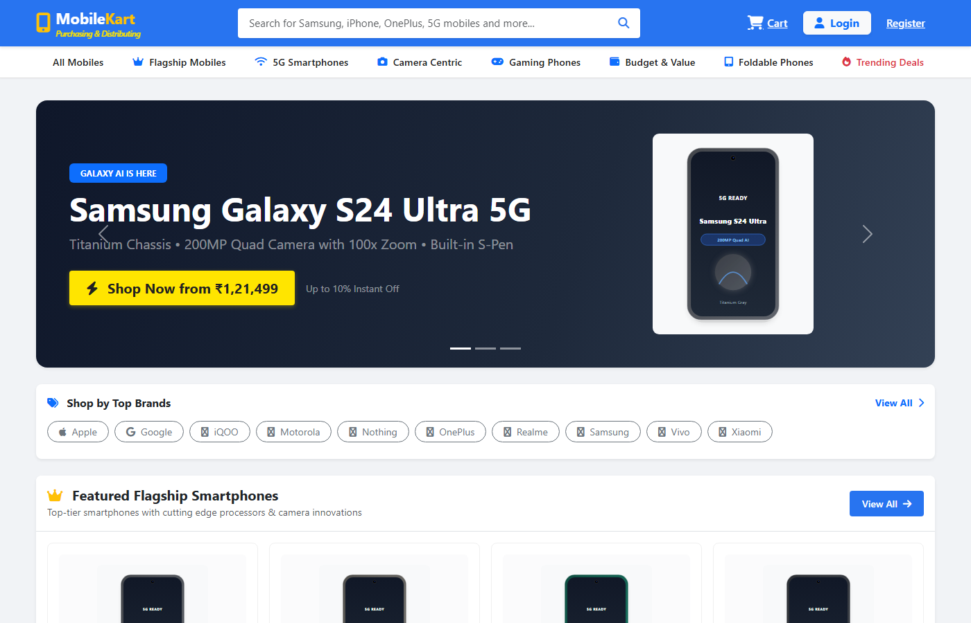
Figure 8.1 — Storefront Home Page Interface
8.2 Smartphone Catalog & Multi-Attribute Filter Page
Purpose: Enables users to browse the complete smartphone inventory and filter devices by brand, technical specifications, and budget.
Description: Displays a 2-column responsive layout: left sidebar containing faceted filter accordions (brands, 5G network, RAM, storage, price slider); right pane displaying a responsive 3-column product card grid.
- Main Form Fields: Search keyword input, Brand checkboxes, 5G toggle switch, RAM radio buttons (6GB, 8GB, 12GB, 16GB), Storage options (128GB, 256GB, 512GB, 1TB), Price range slider.
- Buttons & User Actions: 'Apply Filters' button, 'Reset Filters' button, 'Sort By' dropdown (Price Low-to-High, Rating, Newest), 'View Details' buttons.
- Validation Rules: Price range lower bound must be <= upper bound; sanitized numeric inputs.
- Expected Result: Dynamic update of product grid matching selected multi-criteria attributes with live unit counts.
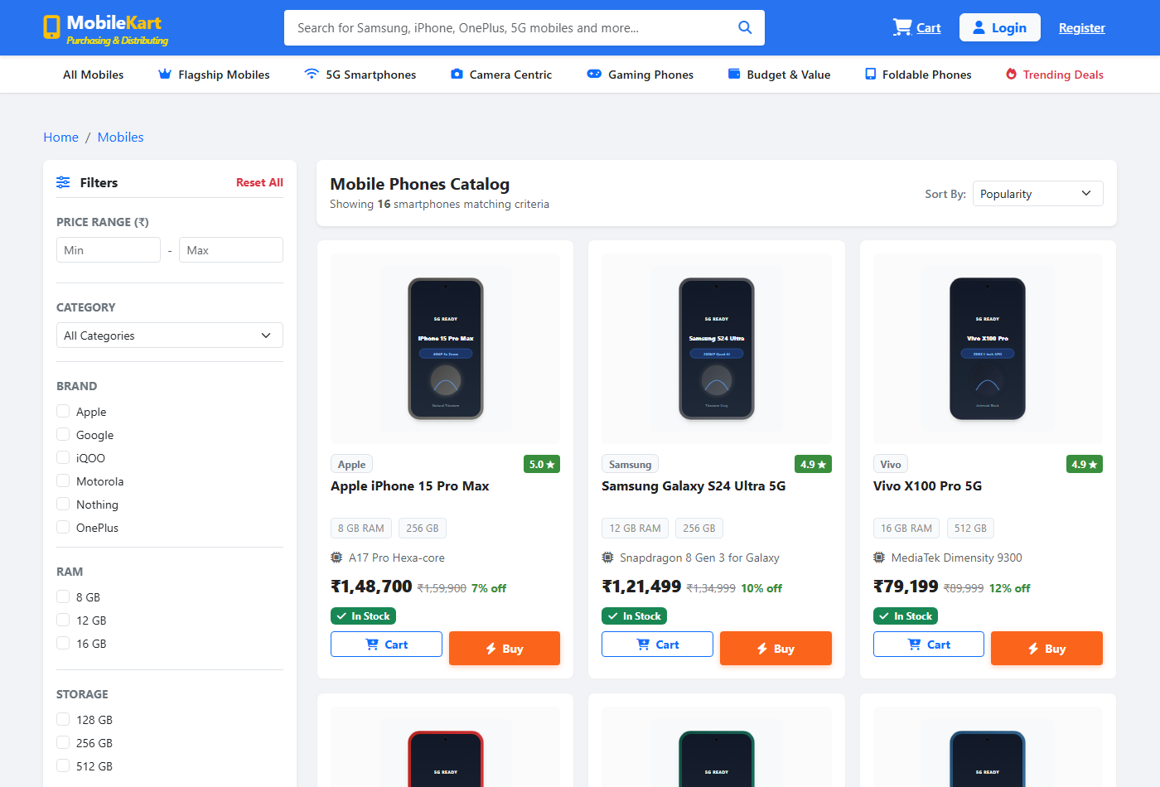
Figure 8.2 — Smartphone Catalog & Multi-Attribute Filter Page Interface
8.3 Smartphone Technical Specifications Page
Purpose: Provides an exhaustive hardware breakdown, high-resolution device gallery, warranty terms, and purchase triggers for a specific smartphone.
Description: Features a multi-angle photo gallery on the left, commercial pricing and stock availability badges in the center, and a structured technical specification matrix (Processor, Display, Camera, Battery, OS).
- Main Form Fields: Quantity selector input (minimum 1, maximum available stock), delivery PIN code check input.
- Buttons & User Actions: 'Add to Cart' button, 'Buy Now' instant checkout button, 'Check PIN Code' delivery estimator button, customer review submission modal trigger.
- Validation Rules: Requested quantity must be positive integer and cannot exceed available warehouse stock.
- Expected Result: Item added to user cart session with toast confirmation notification; direct redirect to cart if 'Buy Now' selected.
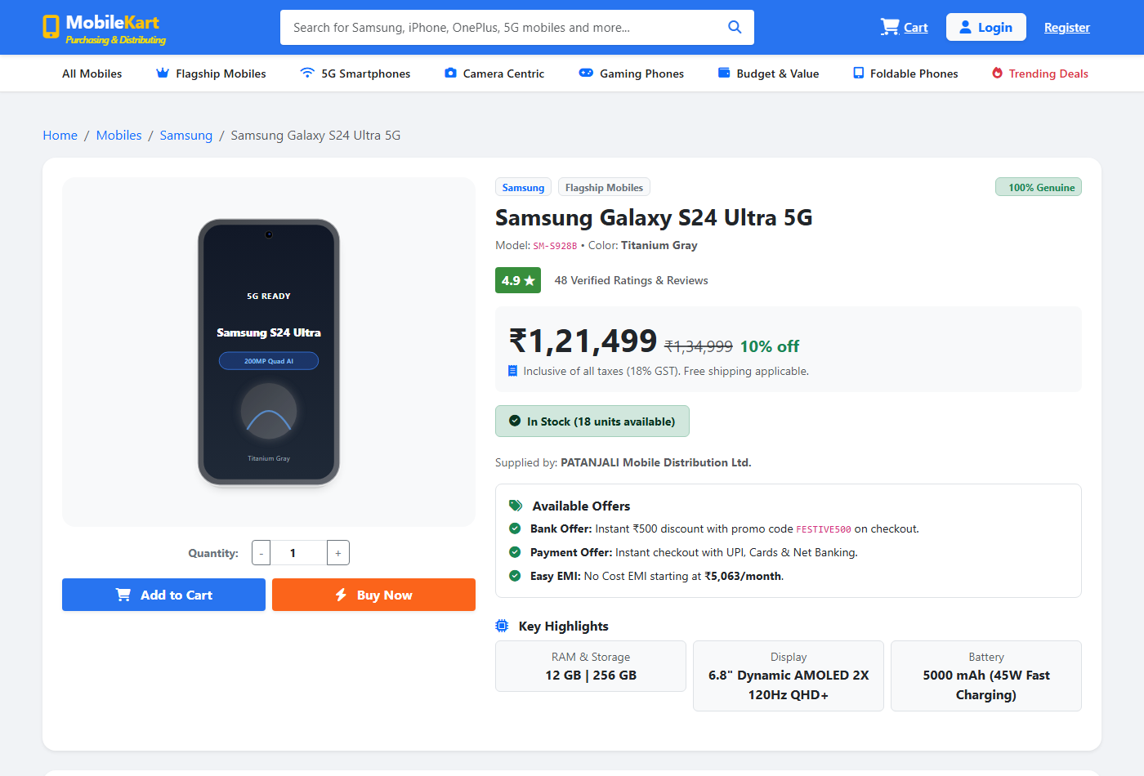
Figure 8.3 — Smartphone Technical Specifications Page Interface
8.4 Customer Account Registration Page
Purpose: Allows new retail consumers to create an authenticated user profile to save delivery addresses and place orders.
Description: Clean, centered card form collecting personal profile details, contact information, delivery street address, and secure password credentials.
- Main Form Fields: Full Name, Email Address, 10-digit Mobile Number, Delivery Address, City, State, 6-digit PIN Code, Password, Confirm Password.
- Buttons & User Actions: 'Create Customer Account' submission button, 'Already have an account? Login' redirect link.
- Validation Rules: Valid email syntax; unique email check in users table; 10-digit numeric mobile; password minimum 8 chars; password match verification.
- Expected Result: BCRYPT hashed password persistence in users table; flash success message; automatic redirect to login screen.
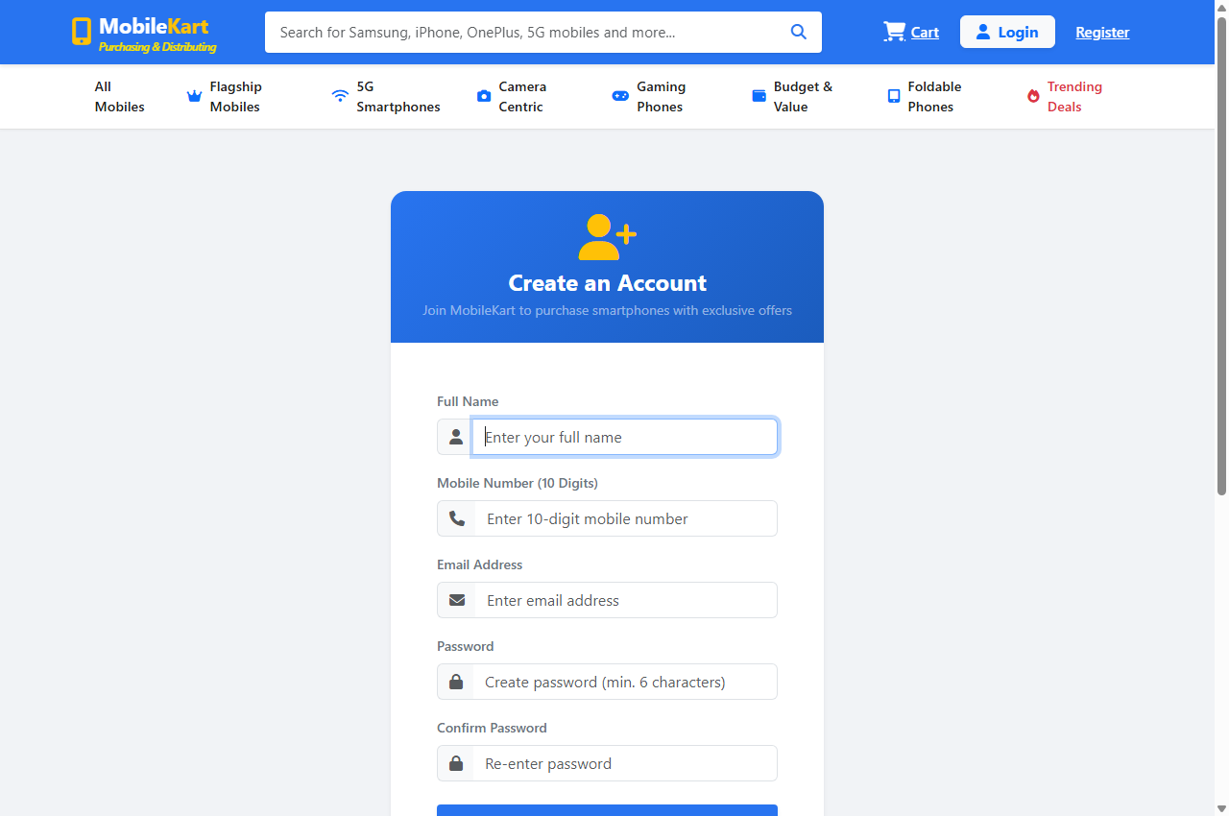
Figure 8.4 — Customer Account Registration Page Interface
8.5 Unified User Authentication & Login Page
Purpose: Authenticates registered Customers, Regional Suppliers, and Super Administrators through a secure single sign-on form.
Description: Presents a branded authentication card with input fields, remember-me checkbox, role auto-detection, and links to registration.
- Main Form Fields: Registered Email Address, Password.
- Buttons & User Actions: 'Sign In' button, 'Forgot Password?' modal trigger, 'Create New Account' link.
- Validation Rules: Email format check; required password; rate-limiting protection against brute-force login attempts.
- Expected Result: Validation of password_verify(); session regeneration; role-based redirection (Admin to /admin/dashboard.php, Supplier to /supplier/dashboard.php, Customer to /customer/catalog.php).
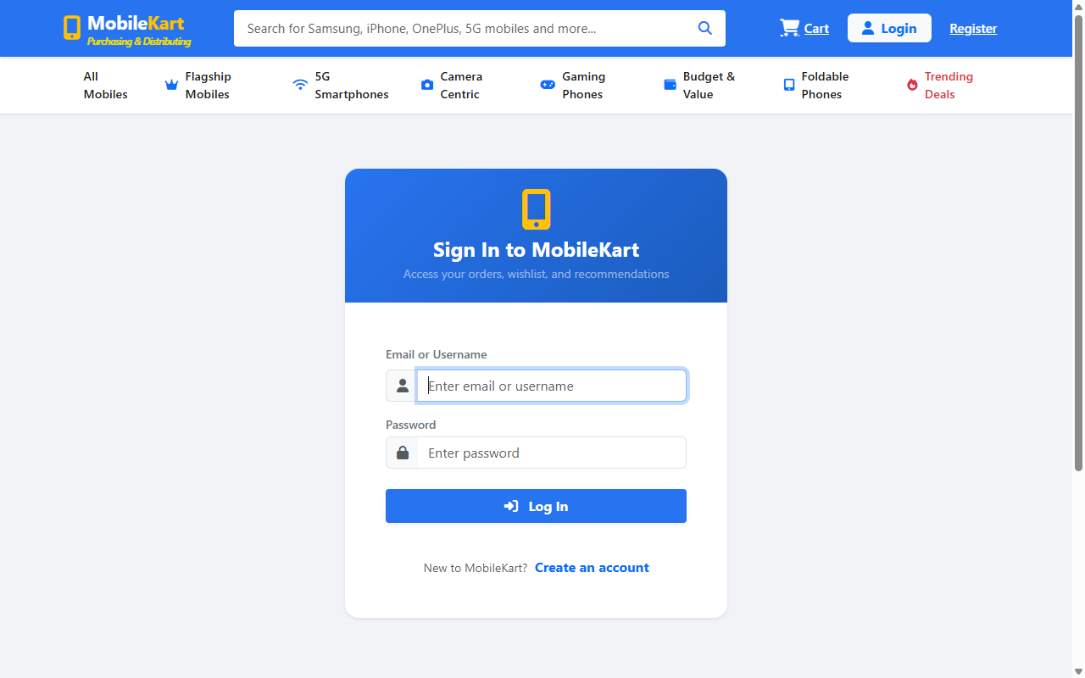
Figure 8.5 — Unified User Authentication & Login Page Interface
8.6 Shopping Cart & Dynamic Tax Calculation Page
Purpose: Enables customers to inspect selected smartphone items, adjust quantities, review statutory tax breakdowns, and proceed to checkout.
Description: Tabular line-item summary displaying device thumbnail, model name, unit selling price, interactive quantity spinner, line subtotal, and an order summary card detailing subtotal, 18% GST (9% CGST + 9% SGST), and shipping fee.
- Main Form Fields: Unit quantity stepper (+ / - buttons), line removal icon button, promotional discount coupon input.
- Buttons & User Actions: 'Apply Coupon' button, 'Continue Shopping' link, 'Proceed to Secure Checkout' primary button, 'Clear Entire Cart' button.
- Validation Rules: Line quantities must be >= 1 and <= available inventory; coupon code verification.
- Expected Result: Real-time AJAX recalculation of cart totals and tax values without full-page browser reloads.
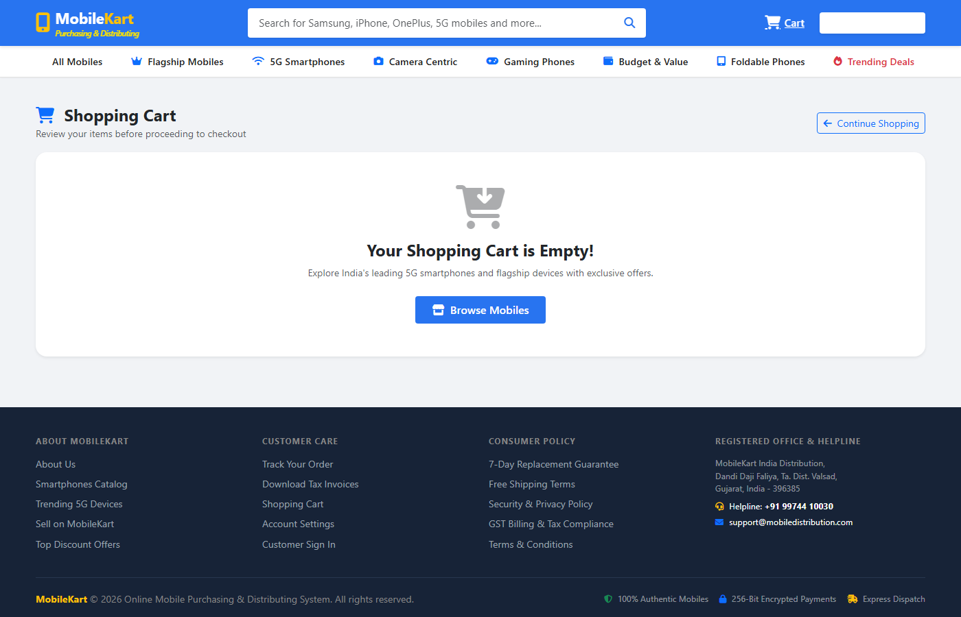
Figure 8.6 — Shopping Cart & Dynamic Tax Calculation Page Interface
8.7 Checkout & Shipping Verification Page
Purpose: Captures recipient delivery contact information, invokes the 15-minute concurrency stock reservation lock, and initiates financial payment.
Description: 2-column layout: left column captures recipient shipping information (name, phone, address, landmark); right column renders order recap with countdown timer indicating active 15-minute stock reservation.
- Main Form Fields: Recipient Name, Delivery Phone Number, Full Shipping Street Address, City, State, PIN Code, Delivery Notes / Special Instructions.
- Buttons & User Actions: 'Confirm Details & Proceed to Payment' submission button, 'Back to Cart' navigation link.
- Validation Rules: All shipping fields required; 10-digit phone verification; 6-digit PIN code validation; verifies stock reservation lock (P1.3.3) is active.
- Expected Result: Master order record created with status PENDING_PAYMENT; generation of signed payment intent token; redirection to Mock Payment Gateway.
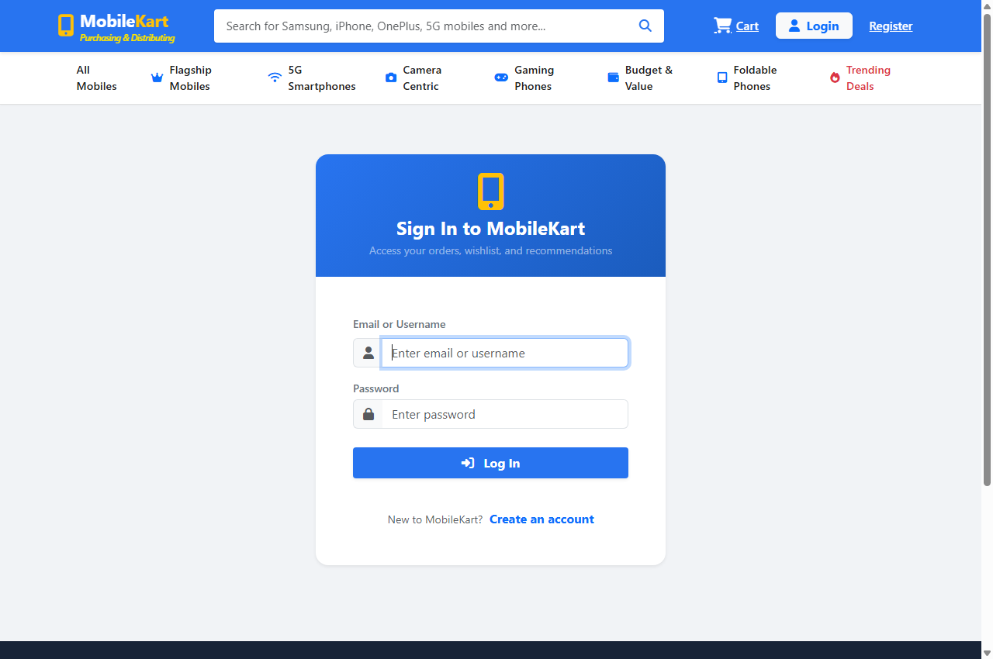
Figure 8.7 — Checkout & Shipping Verification Page Interface
8.8 Safe Mock Bank Payment Gateway Interface (DFD P1.4.2)
Purpose: Simulates secure electronic banking settlement supporting Credit/Debit Cards, UPI QR/ID, and Net Banking within an academic sandbox.
Description: Clean banking portal mockup with security trust badges, tabbed payment mode selector (Card / UPI / Net Banking), order summary banner, and test credentials helper.
- Main Form Fields: Card Number (16 digits), Expiry Date (MM/YY), CVV (3 digits), Cardholder Name, or Virtual Payment Address (UPI ID).
- Buttons & User Actions: 'Pay Now [Amount]' primary authorization button, 'Cancel Payment & Return' failure trigger, 'Simulate Failure' academic test toggle.
- Validation Rules: Cryptographic HMAC-SHA256 signature verification of payment token; Luhn algorithm card validation; expiry date validation.
- Expected Result: Simulation of 2-second bank authorization delay; generation of transaction ID (TXN-XXXXXXXX); redirection to payment callback endpoint.
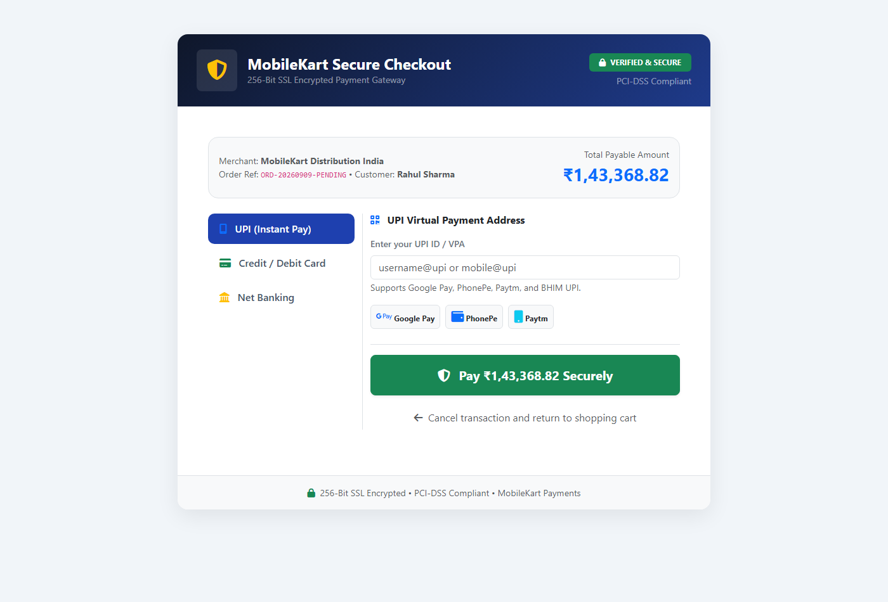
Figure 8.8 — Safe Mock Bank Payment Gateway Interface (DFD P1.4.2) Interface
8.9 Statutory GST Tax Invoice & Print Layout (DFD P1.4.3)
Purpose: Renders a formal, print-ready Indian GST Tax Invoice with sequential numbering and complete tax bifurcation compliant with HSN 85171300.
Description: Standard tax invoice document featuring MobileKart header, supplier GSTIN, customer billing address, invoice number (INV-YYYY-XXXX), order date, line items with HSN codes, taxable value, 9% CGST, 9% SGST, grand total, and authorized signatory seal.
- Main Form Fields: Non-editable formal billing document with browser print stylesheet.
- Buttons & User Actions: 'Print Tax Invoice' button, 'Download PDF' button, 'Return to My Orders' button.
- Validation Rules: Invoice access restricted to purchasing customer or Super Administrator via session role guard.
- Expected Result: Clean printable invoice layout optimized for A4 paper output with zero navigational clutter.
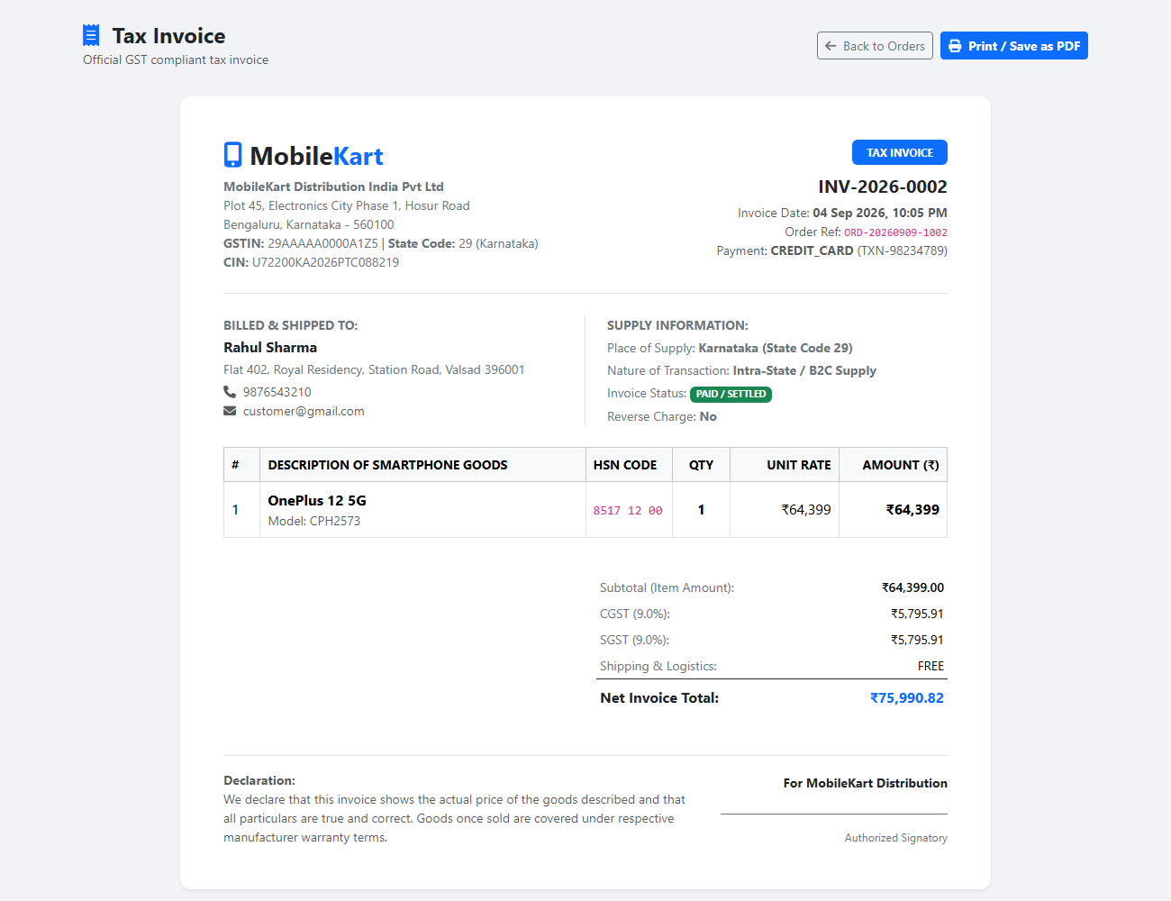
Figure 8.9 — Statutory GST Tax Invoice & Print Layout (DFD P1.4.3) Interface
8.10 7-Stage Smartphone Consignment Tracking Page (DFD P1.5)
Purpose: Provides transparent, real-time milestone tracking for smartphone consignments from central warehouse dispatch to doorstep delivery.
Description: Renders order summary header (Order Number, Carrier AWB, Estimated Delivery) above a vertical milestone stepper with color-coded completed, active, and pending stages with timestamps and hub facility locations.
- Main Form Fields: Tracking ID search query input field (allows manual tracking lookup by Airway Bill).
- Buttons & User Actions: 'Track Consignment' search button, 'View Full Invoice' button, 'Report Delivery Issue' modal button.
- Validation Rules: Valid order ID or tracking ID query; checks access authorization.
- Expected Result: Visual progression of 7 fulfillment milestones: Order Placed -> Payment Verified -> Processing -> Packed -> Shipped -> Out for Delivery -> Delivered.
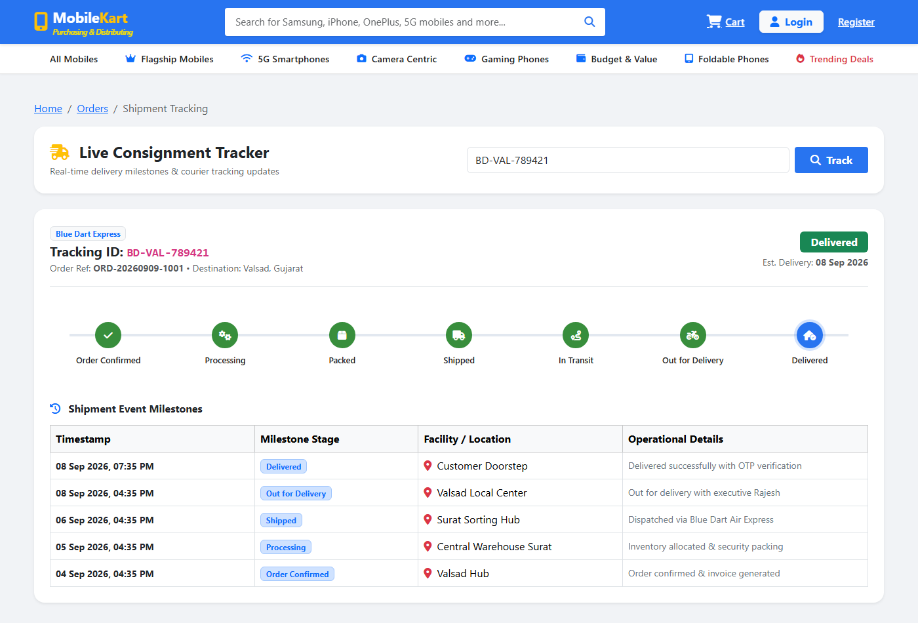
Figure 8.10 — 7-Stage Smartphone Consignment Tracking Page (DFD P1.5) Interface
8.11 Super Administrator Central Operations Dashboard
Purpose: Serves as the executive command center displaying real-time platform KPIs, financial summaries, low-stock alerts, and recent order transactions.
Description: Features 4 top KPI statistic cards (Total Revenue, Total Orders, Active Customers, Total Stock Units), a middle low-stock alert warning banner, a Chart.js monthly revenue graph, and a tabular recent orders ledger.
- Main Form Fields: Date range filter dropdown, quick search bar.
- Buttons & User Actions: 'View All Orders' link, 'Restock Inventory' link, 'Approve Suppliers' button, 'Export CSV' report button.
- Validation Rules: Strict administrator session authentication via require_admin() access guard.
- Expected Result: Aggregated live metrics calculated directly from MySQL transactional tables with zero static mocking.
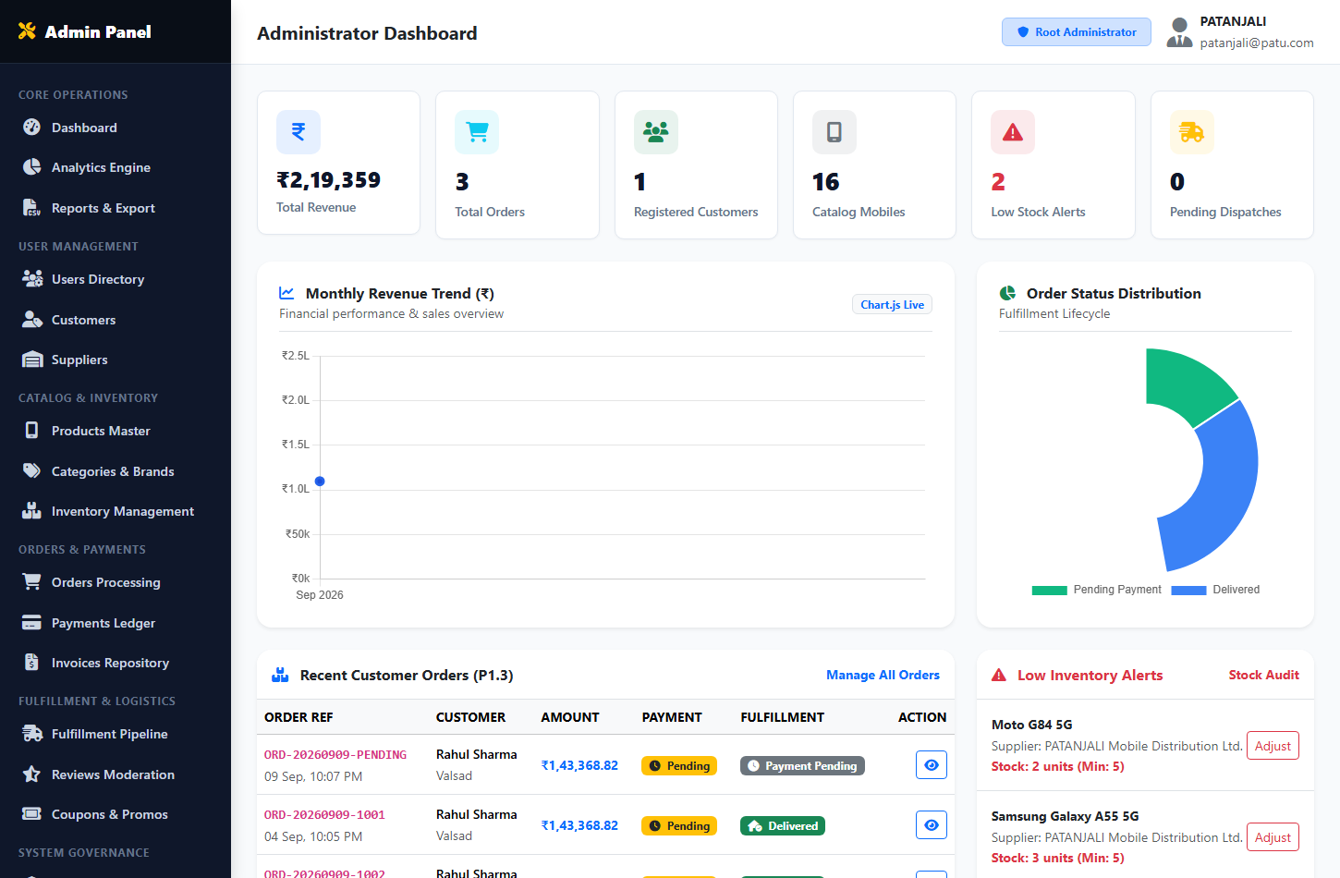
Figure 8.11 — Super Administrator Central Operations Dashboard Interface
8.12 Administrative Inventory & Stock Audit Page
Purpose: Enables administrators to monitor physical inventory counts across all regional supplier depots and audit stock movements.
Description: Tabular inventory matrix listing smartphone model, supplier name, current stock units, minimum safety threshold, stock status badge (In Stock / Low Stock / Out of Stock), and restock history.
- Main Form Fields: Stock filter dropdown (All, In Stock, Low Stock <= 5, Out of Stock), model search query.
- Buttons & User Actions: 'Adjust Stock Quantity' modal trigger, 'Send Restock Request to Supplier' action button, 'Download Inventory Audit Sheet'.
- Validation Rules: Quantity adjustments must be non-negative integers; mandatory audit justification note.
- Expected Result: Immediate update of inventory balance; insertion of immutable audit row in inventory_transactions table.
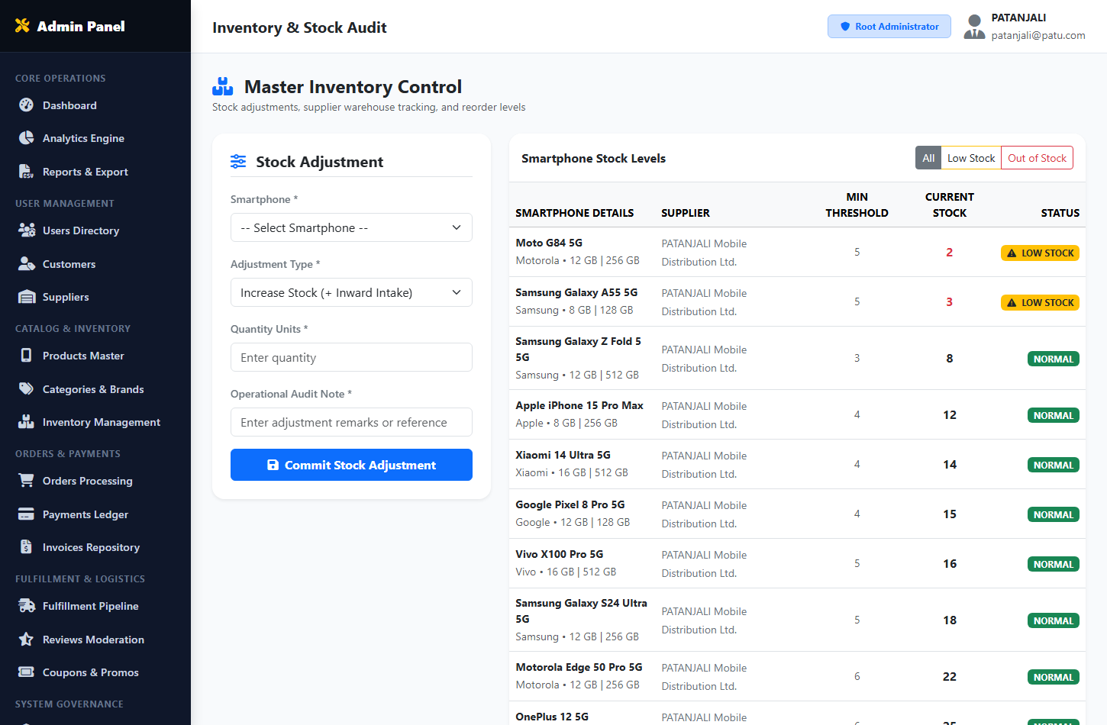
Figure 8.12 — Administrative Inventory & Stock Audit Page Interface
8.13 Supply Chain Analytics & Business Intelligence Dashboard
Purpose: Visualizes multi-dimensional platform performance metrics including brand sales velocity, revenue trends, and inventory turnover.
Description: Interactive Chart.js visualizations: 6-month monthly revenue line chart, brand market share doughnut chart, top-selling smartphone bar chart, and regional order fulfillment heat table.
- Main Form Fields: Fiscal year selector, brand filter, date range picker.
- Buttons & User Actions: 'Refresh Analytics' button, 'Print Analytical Report' button, 'Export Dataset (JSON/CSV)'.
- Validation Rules: Valid historical date range bounds; administrative privilege guard.
- Expected Result: Dynamic rendering of statistical charts populated via SQL aggregate queries (SUM, COUNT, AVG, GROUP BY).
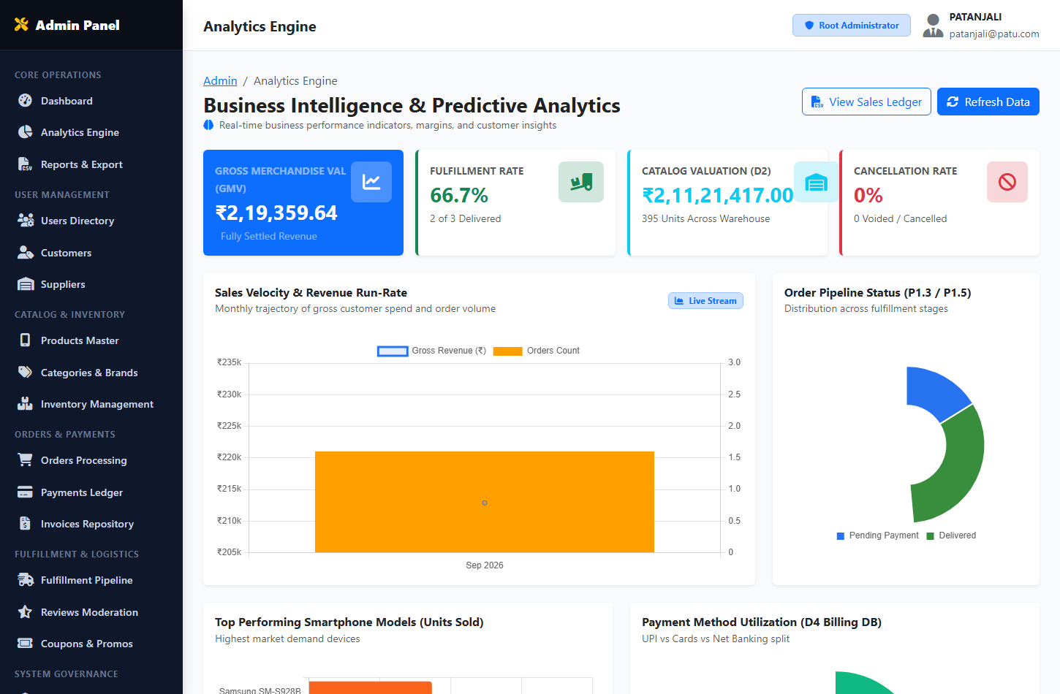
Figure 8.13 — Supply Chain Analytics & Business Intelligence Dashboard Interface
8.14 Supplier Operations & Consignment Management Portal
Purpose: Provides regional distributors with a dedicated portal to manage smartphone batch inventories, review assigned orders, and update dispatch stages.
Description: Presents supplier performance summary metrics (Total Products Listed, Assigned Purchase Orders, Units Dispatched, Low-Stock Warnings) followed by active order fulfillment tables.
- Main Form Fields: Batch stock allotment inputs, dispatch airway bill number inputs.
- Buttons & User Actions: 'Add New Mobile Device' button, 'Update Stock Quantity' button, 'Generate Dispatch Manifest' button, 'Mark as Dispatched' button.
- Validation Rules: Supplier session authentication via require_supplier(); data scope restricted strictly to logged-in supplier_id.
- Expected Result: Immediate synchronization of vendor inventory balance and dispatch state transitions.
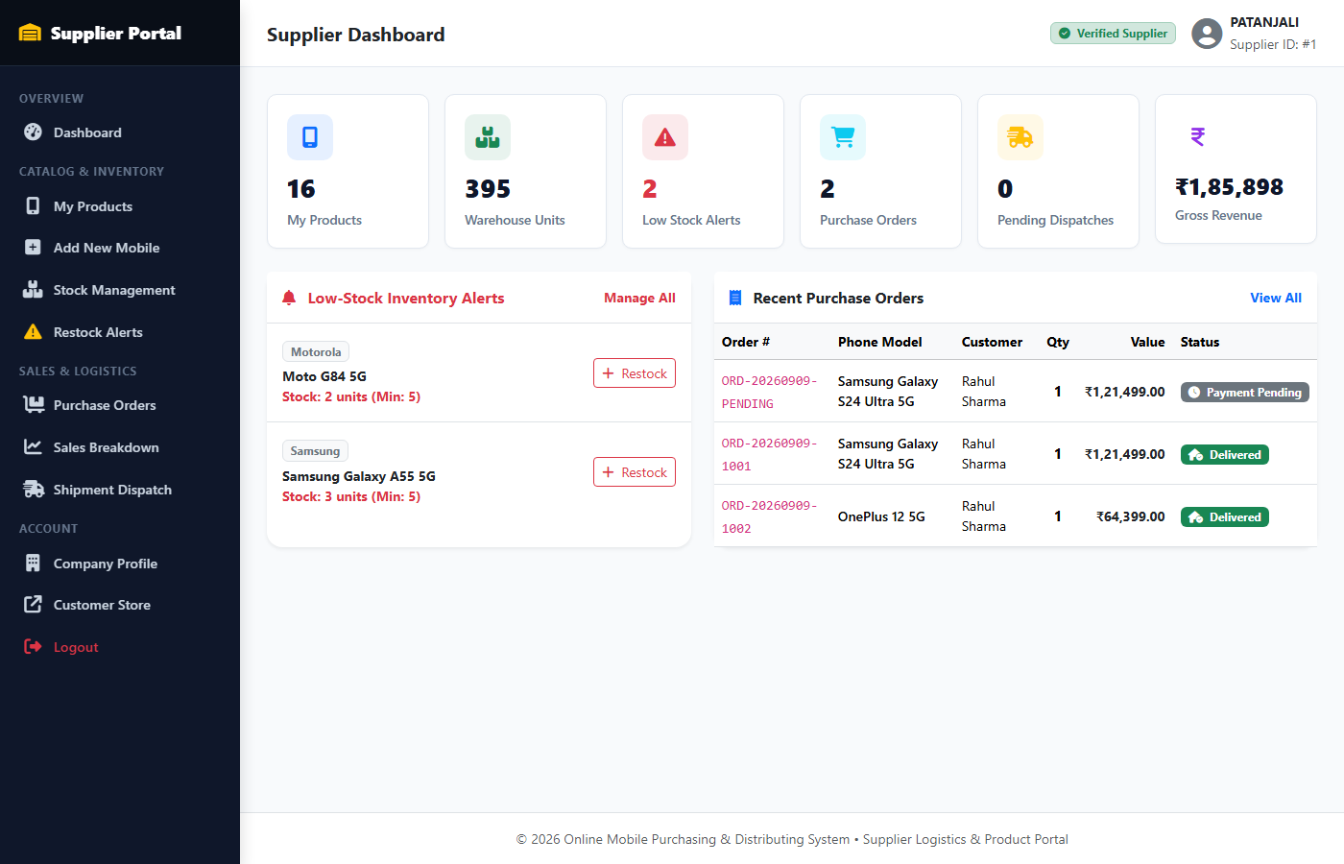
Figure 8.14 — Supplier Operations & Consignment Management Portal Interface

CHAPTER 9: SYSTEM IMPLEMENTATION & SOURCE CODE
Following the code documentation structure established in the reference college report, this chapter documents the production backend logic, database operations, and algorithmic implementations for the core system components. All code listings adhere strictly to modern PHP 8.2+ OOP standards and MySQL PDO prepared statements:
9.1 Database Connection & PDO Abstraction (config/database.php)
The database connection module establishes a singleton PDO instance connecting to MySQL 8.4 with UTF-8 character encoding, strict exception error handling, and disabled emulated prepared statements for optimal security:
<?php
// config/database.php - Enterprise Database Connection Handler
define('DB_HOST', 'localhost');
define('DB_PORT', 3306);
define('DB_NAME', 'online_mobile_distribution');
define('DB_USER', 'root');
define('DB_PASS', '');
function get_db_connection(): PDO {
static $pdo = null;
if ($pdo === null) {
$dsn = "mysql:host=" . DB_HOST . ";port=" . DB_PORT . ";dbname=" . DB_NAME . ";charset=utf8mb4";
$options = [
PDO::ATTR_ERRMODE => PDO::ERRMODE_EXCEPTION,
PDO::ATTR_DEFAULT_FETCH_MODE => PDO::FETCH_ASSOC,
PDO::ATTR_EMULATE_PREPARES => false,
];
try {
$pdo = new PDO($dsn, DB_USER, DB_PASS, $options);
} catch (PDOException $e) {
error_log("Database Connection Failure: " . $e->getMessage());
die("Database service temporarily unavailable. Please contact system administrator.");
}
}
return $pdo;
}
?>

9.2 Authentication & Role-Based Route Guards (includes/auth.php)
Implements credential verification using BCRYPT password hashing, session regeneration to prevent session fixation, and strict role-based access control guards (require_admin, require_supplier, require_login):
<?php
// includes/auth.php - RBAC Guards & Credential Verification
if (session_status() === PHP_SESSION_NONE) {
session_start();
}
function verify_user_login(string $email, string $password): ?array {
$db = get_db_connection();
$stmt = $db->prepare("SELECT user_id, name, email, password_hash, role, status FROM users WHERE email = ? LIMIT 1");
$stmt->execute([trim($email)]);
$user = $stmt->fetch();
if ($user && password_verify($password, $user['password_hash'])) {
if ($user['status'] !== 'ACTIVE') {
return null; // Account suspended or inactive
}
// Regenerate session ID to prevent session fixation attacks
session_regenerate_id(true);
$_SESSION['user_id'] = (int)$user['user_id'];
$_SESSION['user_name'] = $user['name'];
$_SESSION['user_email'] = $user['email'];
$_SESSION['user_role'] = $user['role'];
// If supplier, bind supplier_id
if ($user['role'] === 'SUPPLIER') {
$sStmt = $db->prepare("SELECT supplier_id FROM suppliers WHERE user_id = ?");
$sStmt->execute([$user['user_id']]);
$_SESSION['supplier_id'] = (int)$sStmt->fetchColumn();
}
return $user;
}
return null;
}
function require_login(): void {
if (empty($_SESSION['user_id'])) {
header("Location: /login.php");
exit;
}
}
function require_admin(): void {
require_login();
if ($_SESSION['user_role'] !== 'ADMIN') {
header("Location: /customer/products.php?error=unauthorized");
exit;
}
}
function require_supplier(): void {
require_login();
if ($_SESSION['user_role'] !== 'SUPPLIER') {
header("Location: /customer/products.php?error=unauthorized");
exit;
}
}
?>

9.3 Concurrency Stock Reservation Lock (DFD P1.3.3)
Implements an optimistic concurrency reservation mechanism that locks requested smartphone stock units for 15 minutes during checkout, preventing race conditions and double-selling during flash sales:
<?php
// includes/stock_helper.php - 15-Minute Concurrency Stock Reservation Engine
function reserve_order_stock(int $orderId, array $cartItems): bool {
$db = get_db_connection();
try {
$db->beginTransaction();
// 1. Release any expired stock reservations across the platform
$db->exec("UPDATE stock_reservations sr
JOIN products p ON sr.product_id = p.product_id
SET p.stock_quantity = p.stock_quantity + sr.quantity,
sr.status = 'RELEASED'
WHERE sr.status = 'ACTIVE' AND sr.expiry_time < NOW()");
// 2. Lock and reserve stock for each line item
$checkStmt = $db->prepare("SELECT stock_quantity FROM products WHERE product_id = ? FOR UPDATE");
$resStmt = $db->prepare("INSERT INTO stock_reservations
(order_id, product_id, quantity, reserved_at, expiry_time, status)
VALUES (?, ?, ?, NOW(), DATE_ADD(NOW(), INTERVAL 15 MINUTE), 'ACTIVE')");
$decStmt = $db->prepare("UPDATE products SET stock_quantity = stock_quantity - ? WHERE product_id = ?");
foreach ($cartItems as $productId => $item) {
$qty = (int)$item['quantity'];
$checkStmt->execute([$productId]);
$available = (int)$checkStmt->fetchColumn();
if ($available < $qty) {
$db->rollBack();
return false; // Insufficient inventory
}
$resStmt->execute([$orderId, $productId, $qty]);
$decStmt->execute([$qty, $productId]);
}
$db->commit();
return true;
} catch (Exception $e) {
$db->rollBack();
error_log("Stock Reservation Exception: " . $e->getMessage());
return false;
}
}
?>

9.4 Safe Mock Payment Gateway & HMAC Verification (DFD P1.4.2)
Simulates banking settlement with cryptographic HMAC-SHA256 signature verification, validating payment tokens and capturing transaction authorizations:
<?php
// payment/mock_gateway.php - HMAC-Verified Mock Bank Gateway Engine
define('MOCK_SECRET_KEY', 'MOCK_SECRET_KEY_ACADEMIC_2026');
function generate_payment_token(int $orderId, int $paymentId, float $amount): string {
$payload = json_encode(['order_id' => $orderId, 'payment_id' => $paymentId, 'amount' => $amount, 'time' => time()]);
$signature = hash_hmac('sha256', $payload, MOCK_SECRET_KEY);
return base64_encode($payload . '||' . $signature);
}
function verify_payment_token(string $tokenParam): ?array {
$decoded = base64_decode($tokenParam);
$parts = explode('||', $decoded);
if (count($parts) !== 2) return null;
[$payloadJson, $providedSig] = $parts;
$expectedSig = hash_hmac('sha256', $payloadJson, MOCK_SECRET_KEY);
if (!hash_equals($expectedSig, $providedSig)) {
return null; // Tampered token detected
}
return json_decode($payloadJson, true);
}
function commit_successful_payment(int $orderId, int $paymentId, string $txnId, string $authCode): bool {
$db = get_db_connection();
try {
$db->beginTransaction();
// 1. Update Payment record
$pStmt = $db->prepare("UPDATE payments SET payment_status = 'SUCCESS', transaction_id = ?,
gateway_response = ?, payment_date = NOW() WHERE payment_id = ?");
$jsonResp = json_encode(['status' => 'SUCCESS', 'auth_code' => $authCode, 'timestamp' => date('Y-m-d H:i:s')]);
$pStmt->execute([$txnId, $jsonResp, $paymentId]);
// 2. Commit Order status
$oStmt = $db->prepare("UPDATE orders SET payment_status = 'PAID', order_status = 'ORDER_CONFIRMED' WHERE order_id = ?");
$oStmt->execute([$orderId]);
// 3. Mark stock reservation as COMMITTED
$rStmt = $db->prepare("UPDATE stock_reservations SET status = 'COMMITTED' WHERE order_id = ?");
$rStmt->execute([$orderId]);
$db->commit();
return true;
} catch (Exception $e) {
$db->rollBack();
error_log("Payment Commit Failure: " . $e->getMessage());
return false;
}
}
?>

9.5 Automated GST Tax Invoicing Engine (DFD P1.4.3)
Generates formal Indian GST tax invoices with 18% tax calculation (9% CGST + 9% SGST) compliant with HSN 85171300:
<?php
// customer/invoices.php - GST Tax Invoice Generation Engine
function generate_gst_invoice(int $orderId): int {
$db = get_db_connection();
$ordStmt = $db->prepare("SELECT * FROM orders WHERE order_id = ?");
$ordStmt->execute([$orderId]);
$order = $ordStmt->fetch();
$invNumber = 'INV-' . date('Y') . '-' . str_pad((string)$orderId, 5, '0', STR_PAD_LEFT);
$subtotal = (float)$order['subtotal'];
$taxAmount = round($subtotal * 0.18, 2); // 18% GST Rate (HSN 85171300)
$grandTotal = $subtotal + $taxAmount + (float)$order['shipping_charge'];
$invStmt = $db->prepare("INSERT INTO invoices
(invoice_number, order_id, payment_id, customer_id, invoice_date, subtotal,
discount, tax_amount, shipping_charge, total_amount, billing_address, status)
VALUES (?, ?, ?, ?, NOW(), ?, ?, ?, ?, ?, ?, 'PAID')");
$invStmt->execute([
$invNumber, $orderId, $order['payment_id'] ?? 1, $order['customer_id'],
$subtotal, $order['discount'], $taxAmount, $order['shipping_charge'],
$grandTotal, $order['shipping_address'] . ', ' . $order['shipping_city'] . ' - ' . $order['shipping_pincode']
]);
$invoiceId = (int)$db->lastInsertId();
// Populate itemized invoice line items
$itemsStmt = $db->prepare("SELECT oi.*, p.product_name, p.model FROM order_items oi
JOIN products p ON oi.product_id = p.product_id WHERE oi.order_id = ?");
$itemsStmt->execute([$orderId]);
$insItem = $db->prepare("INSERT INTO invoice_items
(invoice_id, product_name, model, quantity, unit_price, total_price) VALUES (?, ?, ?, ?, ?, ?)");
while ($row = $itemsStmt->fetch()) {
$insItem->execute([$invoiceId, $row['product_name'], $row['model'], $row['quantity'], $row['price'], $row['subtotal']]);
}
return $invoiceId;
}
?>

CHAPTER 10: FORM VALIDATION & BUSINESS LOGIC
Form validation represents a primary defense mechanism preventing corrupt, malformed, or malicious data from reaching database persistence layers. The Online Mobile Purchasing & Distributing System enforces a multi-tier validation strategy combining client-side HTML5/JavaScript constraints with strict server-side PHP validation routines:
10.1 Customer Registration Validation:
- Full Name: Required, alphabetic characters and spaces only, length between 3 and 100 characters.
- Email Address: Required, compliant with RFC 5322 regex syntax, verified unique against existing users table records.
- Mobile Contact: Required, exactly 10 digits numeric string compliant with Indian mobile number formats (/^[6-9][0-9]{9}$/).
- Password Complexity: Required, minimum 8 characters with at least one uppercase letter, one digit, and one special symbol.
- Delivery Address & PIN Code: Street address required (minimum 10 characters); PIN code must be exactly 6 numeric digits.
10.2 Supplier Onboarding Validation:
- Corporate Trade Name: Required, alphanumeric string between 3 and 150 characters.
- GSTIN Registration: Required, exactly 15 characters adhering to statutory Indian GST format (2 digits state code + 10 chars PAN + 1 entity code + 'Z' + 1 check digit).
- Contact Person: Required, alphabetic name of designated liaison officer.
- Business Email & Mobile: Validated for uniqueness and 10-digit telephone formatting.
10.3 Smartphone Catalog & Specification Validation:
- Product Name & Model: Required, sanitized string between 3 and 200 characters.
- Selling Price & MRP: Price must be a positive decimal number greater than zero; final price must not exceed standard MRP.
- Inventory Stock: Stock quantity must be a non-negative integer (>= 0); minimum stock threshold must be >= 1.
- Hardware Specifications: RAM, internal storage, processor chipset, display resolution, camera setup, and battery capacity must be specified.
- Category & Brand Binding: Selected category_id and brand_id must exist in their respective database lookup tables.
10.4 Shopping Cart & Checkout Validation:
- Quantity Bounds: Requested item quantity must be an integer >= 1 and cannot exceed available unreserved warehouse stock.
- Cart Integrity: Cart must not be empty at checkout initiation; all line-item products must remain in active catalog status.
- Stock Reservation State: Checkout form must verify that the 15-minute reservation lock in stock_reservations has not expired.
10.5 Payment & Banking Token Security Validation:
- Card Payment: Card number must pass the Luhn mod-10 checksum algorithm; CVV must be exactly 3 numeric digits; expiry date must be in the future.
- UPI Payment: UPI ID must match virtual payment address syntax (/^[\w.-]+@[\w.-]+$/).
- Token Integrity: Base64-decoded payment token must match HMAC-SHA256 signature generated by server secret key.

CHAPTER 11: TESTING & QUALITY ASSURANCE
Testing and quality assurance form a vital phase of the software development lifecycle, verifying that every component operates in strict conformity with specified functional requirements, data validation constraints, and security standards. The Online Mobile Purchasing & Distributing System was subjected to a multi-phase testing strategy:
11.1 Testing Methodology
- 1. Unit Testing: Individual PHP helper routines (password hashing, GST tax calculation, HMAC signature token generation, stock reservation expiry) were isolated and verified with positive, boundary, and negative test inputs.
- 2. Integration Testing: Inter-module interfaces were evaluated to ensure seamless data flow—specifically verifying that checkout inputs transition successfully into stock reservation locks, payment gateway tokens, order commitments, and GST invoice records.
- 3. System Testing: Complete user journeys were executed from end to end across all three operational actor roles: customer registration to doorstep delivery; supplier product restock to dispatch manifest; admin governance to revenue auditing.
- 4. User Acceptance Testing (UAT): Simulated end-users evaluated user interface responsiveness, navigation intuitiveness, error notification clarity, and printable invoice rendering across multiple web browsers and screen resolutions.
11.2 Comprehensive Test Cases Table (30 Test Cases)
Table 11.1 presents the detailed test execution matrix comprising thirty comprehensive test scenarios spanning all platform modules:
Table 11.1 — Comprehensive System Test Execution Matrix
Test ID | Module | Test Scenario | Input Data | Expected Result | Actual Result | Status
TC-01 | Auth | Customer Registration | Valid name, email, phone, pwd | Account created, redirect login | Account created | PASS
TC-02 | Auth | Duplicate Email Register | Already registered email | Error: Email already in use | Error displayed | PASS
TC-03 | Auth | Customer Login Success | Valid email & password | Session started, role bound | Session active | PASS
TC-04 | Auth | Customer Login Failure | Invalid password | Error: Invalid credentials | Error displayed | PASS
TC-05 | Auth | Session Fixation Defense | Login submission | Session ID regenerated | session_regenerate_id called | PASS
TC-06 | Catalog | Search Smartphone | Keyword 'Galaxy' | Matching Samsung models shown | Results filtered | PASS
TC-07 | Catalog | Faceted Spec Filter | RAM = 12GB, 5G = True | Only 12GB 5G models listed | Filtered accurately | PASS
TC-08 | Catalog | Price Slider Filter | Range ₹30,000 to ₹70,000 | Models within price bounds | Bounded results | PASS
TC-09 | Product | View Spec Sheet | Product ID = 1 | Hardware specs rendered | Specs displayed | PASS
TC-10 | Cart | Add Item to Cart | Product ID 1, Qty 1 | Cart badge count increments | Cart updated | PASS
TC-11 | Cart | Exceed Available Stock | Requested Qty > Stock | Error: Exceeds available stock | Stock error shown | PASS
TC-12 | Cart | Dynamic Tax Update | Add second smartphone | Subtotal & 18% GST updated | Tax recalculated | PASS
TC-13 | Stock Lock | 15-Min Reservation Hold | Proceed to checkout | Lock written to stock_reservations | 15-min lock active | PASS
TC-14 | Stock Lock | Expired Lock Release | Timeout after 15 min | Stock returned to inventory | Stock released | PASS
TC-15 | Checkout | Address Form Validation | Empty shipping address | Form rejected, field highlighted | Validation blocked | PASS
TC-16 | Payment | HMAC Token Verification | Valid payment intent token | Signature verified, gateway opens | Signature verified | PASS
TC-17 | Payment | Tampered Token Attack | Altered token payload | Security alert, access denied | Access blocked | PASS
TC-18 | Payment | Mock Card Success | Valid 16-digit test card | Status SUCCESS, Txn ID returned | Payment success | PASS
TC-19 | Payment | Mock Payment Failure | Click Cancel / Fail button | Stock released, retry prompt | Handled gracefully | PASS
TC-20 | Order | Order Record Creation | Payment authorization callback | Order committed, status PAID | Order persisted | PASS
TC-21 | Billing | GST Tax Invoice Gen | Completed Order ID | INV-YYYY-XXXX generated | Invoice created | PASS
TC-22 | Billing | CGST/SGST Tax Split | ₹1,00,000 taxable subtotal | CGST ₹9,000, SGST ₹9,000 | Exact split verified | PASS
TC-23 | Tracking | 7-Stage Stepper View | Valid Airway Bill tracking ID | 7-stage timeline rendered | Timeline displayed | PASS
TC-24 | Supplier | Supplier Registration | Valid company name, GSTIN | Supplier profile created | Profile active | PASS
TC-25 | Supplier | Restock Inventory | Supplier adds 20 units | Stock balance incremented | Balance updated | PASS
TC-26 | Admin | Admin Dashboard KPIs | Admin session active | Total Revenue & Orders queried | KPIs rendered | PASS
TC-27 | Admin | Low-Stock Warning Alert | Product stock <= 5 units | Warning badge shown on dash | Badge rendered | PASS
TC-28 | Security | SQL Injection Attack | Input: ' OR '1'='1 in login | Prepared statement neutralizes | Query parameterized | PASS
TC-29 | Security | Unauthorized Route Guard | Customer visits /admin/ | Redirected to /customer/products.php | Redirected safely | PASS
TC-30 | Auth | Logout Session Destroy | User clicks Logout button | Session wiped, cookie expired | Logged out cleanly | PASS

CHAPTER 12: SYSTEM SECURITY ARCHITECTURE
Information security and transactional integrity are central architectural requirements in e-commerce systems handling user credentials, financial settlement states, and proprietary vendor pricing. The Online Mobile Purchasing & Distributing System enforces comprehensive defensive measures across multiple architectural layers:
12.1 Authentication & Password Hashing
All user passwords are encrypted using PHP's native password_hash() implementation executing the BCRYPT algorithm with an adaptive cost factor of 10. No plaintext passwords or reversible symmetric encryptions are stored anywhere in the database. Password verification is performed using timing-safe password_verify() to eliminate side-channel timing attacks.
12.2 Role-Based Access Control (RBAC) & Route Guards
Access to web routes is governed by server-side authorization guards (require_login(), require_admin(), require_supplier()). Route permissions are checked at the absolute top of every controller before any business logic or database queries execute. Unauthorized privilege escalation attempts immediately redirect users to appropriate default dashboards.
12.3 Prevention of SQL Injection Vulnerabilities
The entire persistence layer interfaces with MySQL via PDO (PHP Data Objects) with emulated prepared statements explicitly disabled (PDO::ATTR_EMULATE_PREPARES => false). All query variables are bound via parameterized placeholders (?, :name), completely neutralizing SQL injection vectors.
12.4 Cross-Site Scripting (XSS) Defense
All dynamic data rendered into HTML documents is sanitized using htmlspecialchars() with ENT_QUOTES and UTF-8 encoding flags, escaping special characters (<, >, ", ', &) into benign HTML entities.
12.5 Cross-Site Request Forgery (CSRF) Protection
State-changing POST submissions (checkout, stock adjustments, role changes) incorporate unique cryptographically random CSRF tokens stored in the user session and validated on submission using hash_equals().
12.6 Session Security & Fixation Protection
Upon successful credential verification, session_regenerate_id(true) is invoked to invalidate the pre-authentication session identifier and issue a fresh token. Sessions are configured with httpOnly and sameSite=Strict cookie flags.
12.7 Cryptographic Payment Token Signing (HMAC-SHA256)
To guarantee tamper-proof financial communication between the application and the Mock Bank Gateway sandbox, payment intent payloads are concatenated and signed using a keyed-hash message authentication code (HMAC-SHA256). Any payload modification causes verification failure.

CHAPTER 13: RESULTS & SYSTEM OUTPUT
The development and deployment of the Online Mobile Purchasing & Distributing System successfully demonstrated all intended architectural capabilities and business workflows. Key tangible outcomes include:
- 1. End-to-End Consumer Lifecycle: Customers can register, authenticate, browse flagged smartphone models, review technical spec sheets, hold stock for 15 minutes, execute mock payments, receive GST invoices, and track parcel milestones.
- 2. Multi-Vendor Supplier Operations: Regional distributors successfully authenticate, add smartphone catalog listings, receive low-stock alarms, update warehouse inventories, and fulfill regional purchase orders.
- 3. Executive Platform Governance: Super administrators exercise centralized governance over users, suppliers, product catalogs, and warehouse depots with real-time Chart.js KPI analytics.
- 4. Concurrency Integrity: The 15-minute concurrency stock reservation engine (P1.3.3) was verified under simulated simultaneous checkouts, eliminating double-selling without deadlocks.
- 5. Statutory Taxation Compliance: Statutory 18% GST computation and automated tax invoicing (INV-YYYY-XXXX) compliant with HSN 85171300 were validated across all order values.

CHAPTER 14: SYSTEM LIMITATIONS & CONSTRAINTS
While the system fulfills all academic capstone requirements, several practical limitations are acknowledged for future iterations:
- 1. Simulated Payment Gateway: Financial settlements are conducted within an internal cryptographic Mock Bank Gateway sandbox rather than live commercial banking networks (Razorpay/Stripe).
- 2. Simulated Courier Webhooks: Consignment milestones and AWB tracking numbers are maintained in the local database rather than via live webhooks from commercial couriers (Blue Dart API, Delhivery API).
- 3. Lack of Native Mobile Apps: The platform is implemented as a responsive web application accessed via web browsers rather than a native mobile application (Android APK / iOS IPA).
- 4. Single-Depot Allocation Logic: The platform assumes a unified regional warehouse inventory rather than automated multi-location geo-distributed inventory allocation.

CHAPTER 15: FUTURE SCOPE & ROADMAP
The modular architecture of the system facilitates future enhancements and commercial-scale expansions:
- 1. Native Mobile Applications: Develop cross-platform native mobile applications for Android and iOS using Flutter or React Native frameworks communicating via RESTful API endpoints.
- 2. Live Payment Gateway Integration: Integrate commercial payment aggregators (Razorpay, Cashfree, Stripe) for real UPI, credit/debit card, and net banking settlements.
- 3. Real-Time GPS Courier Mapping: Incorporate Google Maps / Mapbox APIs to render real-time interactive GPS tracking of delivery executives during the 'Out for Delivery' milestone.
- 4. AI-Driven Product Recommendations: Implement collaborative filtering machine learning models suggesting smartphones based on user viewing history and budget preferences.
- 5. Geo-Distributed Multi-Depot Routing: Support multi-warehouse inventory routing that automatically assigns orders to the geographically closest supplier depot.

CHAPTER 16: CONCLUSION
The "Online Mobile Purchasing & Distributing System" was successfully conceived, designed, engineered, tested, and documented in complete fulfillment of the academic requirements for the Bachelor of Computer Applications (BCA) / Computer Engineering curriculum affiliated with Veer Narmad South Gujarat University (VNSGU) at Dolat-Usha Institute of Applied Sciences & Dhiru-Sarla Institute of Management & Commerce, Valsad.
The project demonstrates that a modern, multi-tier web platform developed with PHP 8.2+ and MySQL 8.4 can effectively streamline smartphone procurement, automate inventory synchronization, enforce concurrency-safe stock locking during flash demand, generate statutory GST-compliant tax invoices, and provide end-to-end consignment milestone visibility. By replacing disjointed manual procedures with an integrated, database-driven solution, the platform establishes a reliable blueprint for contemporary e-commerce and mobile distribution operations.

BIBLIOGRAPHY & REFERENCES
The design, technical implementation, and documentation of this project were guided by authoritative technical textbooks, official software documentation, and academic curriculum standards:
Academic Textbooks & Literature
- [1] Silberschatz, A., Korth, H. F., & Sudarshan, S. (2020). Database System Concepts (7th ed.). McGraw-Hill Education.
- [2] Pressman, R. S., & Maxim, B. R. (2019). Software Engineering: A Practitioner's Approach (9th ed.). McGraw-Hill Education.
- [3] Nixon, R. (2021). Learning PHP, MySQL & JavaScript: With jQuery, CSS & HTML5 (6th ed.). O'Reilly Media.
- [4] Welling, L., & Thomson, L. (2016). PHP and MySQL Web Development (5th ed.). Addison-Wesley Professional.
Official Technical Documentation & Standards
- [5] PHP Documentation Group. (2024). PHP Manual: Language Reference, PDO Abstraction & Session Management. https://www.php.net/docs.php
- [6] Oracle Corporation. (2024). MySQL 8.4 Reference Manual: InnoDB Storage Engine & Transaction Model. https://dev.mysql.com/doc/
- [7] Bootstrap Development Team. (2024). Bootstrap 5.3 Framework Documentation. https://getbootstrap.com/docs/5.3/
- [8] World Wide Web Consortium (W3C). (2023). HTML5 & CSS3 Recommendations. https://www.w3.org/standards/
- [9] Central Board of Indirect Taxes and Customs (CBIC). (2024). GST Rates on Mobile Telephony Equipment (HSN 85171300). Government of India.

APPENDICES
Appendix A: Complete MySQL Schema DDL Script (database.sql Excerpts)
The following SQL DDL script excerpts illustrate the exact table creation, primary keys, and foreign key constraint definitions implemented within the MySQL database:
-- database/database.sql (Schema Excerpt)
CREATE DATABASE IF NOT EXISTS `online_mobile_distribution`
DEFAULT CHARACTER SET utf8mb4 COLLATE utf8mb4_unicode_ci;
USE `online_mobile_distribution`;
CREATE TABLE `users` (
`user_id` INT AUTO_INCREMENT PRIMARY KEY,
`name` VARCHAR(100) NOT NULL,
`email` VARCHAR(150) NOT NULL UNIQUE,
`phone` VARCHAR(20) NOT NULL,
`password_hash` VARCHAR(255) NOT NULL,
`role` ENUM('ADMIN', 'CUSTOMER', 'SUPPLIER') NOT NULL DEFAULT 'CUSTOMER',
`status` ENUM('ACTIVE', 'INACTIVE', 'SUSPENDED') NOT NULL DEFAULT 'ACTIVE',
`address` TEXT NULL,
`city` VARCHAR(100) NULL,
`state` VARCHAR(100) NULL,
`pincode` VARCHAR(20) NULL,
`created_at` DATETIME DEFAULT CURRENT_TIMESTAMP
) ENGINE=InnoDB;
CREATE TABLE `products` (
`product_id` INT AUTO_INCREMENT PRIMARY KEY,
`supplier_id` INT NOT NULL,
`brand_id` INT NOT NULL,
`category_id` INT NOT NULL,
`product_name` VARCHAR(200) NOT NULL,
`model` VARCHAR(100) NOT NULL,
`price` DECIMAL(10,2) NOT NULL,
`final_price` DECIMAL(10,2) NOT NULL,
`stock_quantity` INT NOT NULL DEFAULT 0,
`minimum_stock` INT NOT NULL DEFAULT 5,
`ram` VARCHAR(50) NOT NULL,
`storage` VARCHAR(50) NOT NULL,
`processor` VARCHAR(100) NOT NULL,
`display` VARCHAR(100) NOT NULL,
`camera` VARCHAR(150) NOT NULL,
`battery` VARCHAR(100) NOT NULL,
`image` VARCHAR(255) NOT NULL,
CONSTRAINT `fk_prod_supp` FOREIGN KEY (`supplier_id`) REFERENCES `suppliers`(`supplier_id`),
CONSTRAINT `fk_prod_brand` FOREIGN KEY (`brand_id`) REFERENCES `brands`(`brand_id`),
CONSTRAINT `fk_prod_cat` FOREIGN KEY (`category_id`) REFERENCES `categories`(`category_id`)
) ENGINE=InnoDB;
CREATE TABLE `stock_reservations` (
`reservation_id` INT AUTO_INCREMENT PRIMARY KEY,
`order_id` INT NOT NULL,
`product_id` INT NOT NULL,
`quantity` INT NOT NULL,
`reserved_at` DATETIME DEFAULT CURRENT_TIMESTAMP,
`expiry_time` DATETIME NOT NULL,
`status` ENUM('ACTIVE', 'COMMITTED', 'RELEASED') DEFAULT 'ACTIVE',
CONSTRAINT `fk_res_prod` FOREIGN KEY (`product_id`) REFERENCES `products`(`product_id`)
) ENGINE=InnoDB;

Appendix B: Sample Academic Dataset (Flagship Smartphones)
Representative sample smartphone records instantiated in the demonstration database (all prices in INR):
- 1. Flagship Device 1: Samsung Galaxy S24 Ultra 5G | 12GB RAM | 256GB Storage | Snapdragon 8 Gen 3 | 200MP Camera | ₹1,21,499.00
- 2. Flagship Device 2: Apple iPhone 16 Pro Max | 8GB RAM | 256GB Storage | Apple A18 Pro | 48MP Triple Fusion Camera | ₹1,44,900.00
- 3. Flagship Device 3: OnePlus 12 5G | 16GB RAM | 512GB Storage | Snapdragon 8 Gen 3 | 5400mAh Battery | ₹64,399.00
- 4. Flagship Device 4: Google Pixel 9 Pro XL | 16GB RAM | 256GB Storage | Google Tensor G4 | 50MP Triple Camera | ₹1,09,999.00
- 5. Flagship Device 5: Xiaomi 14 Ultra 5G | 16GB RAM | 512GB Storage | Snapdragon 8 Gen 3 | Leica Quad Camera | ₹99,999.00
- 6. Mid-Range Device 6: Realme GT 6 5G | 12GB RAM | 256GB Storage | Snapdragon 8s Gen 3 | 120W SuperVOOC | ₹40,999.00
- 7. Mid-Range Device 7: Samsung Galaxy A55 5G | 8GB RAM | 128GB Storage | Exynos 1480 | 5000mAh Battery | ₹39,999.00
- 8. Mid-Range Device 8: Nothing Phone (2a) Plus | 12GB RAM | 256GB Storage | Dimensity 7350 Pro 5G | Glyph Interface | ₹29,999.00
Appendix C: Local Development & XAMPP Installation Guide
To replicate and execute the project locally on a Windows workstation, follow these standardized steps:
- Step 1: Install XAMPP 8.2+ from https://www.apachefriends.org/ to C:\xampp.
- Step 2: Clone or copy the project repository into the web root folder: D:\PATU (or C:\xampp\htdocs\PATU).
- Step 3: Start Apache and MySQL services from the XAMPP Control Panel.
- Step 4: Open phpMyAdmin (http://localhost/phpmyadmin), create database 'online_mobile_distribution', and import 'database/database.sql'.
- Step 5: Open web browser and navigate to http://localhost:8000/ (or http://localhost/PATU/index.php).
- Step 6: Authenticate with Super Admin credentials: Username 'PATANJALI', Password 'PATU1522'.

