n1 = int(input("Enter start number: "))

n2 = int(input("Enter end number: "))

result = sum(range(n1, n2+1))

print("n1 =", n1)

print("n2 =", n2)

print("sum of all number from n1 to n2 is : ", result)

OUTPUT:

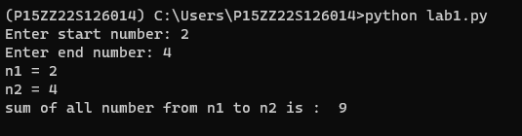

p=[]

n=[]

num = int(input("Enter the array size: "))

arr = [int(input("Enter the elements: ")) for j in range(num)]

for i in arr:

if i >= 0:

p.append(i)

else:

n.append(i)

print("All elements:", arr)

print("Positive array elements:", p)

print("Negative array elements:", n)

print("Sum of positive elements:", sum(p))

print("Sum of negative elements:", sum(n))

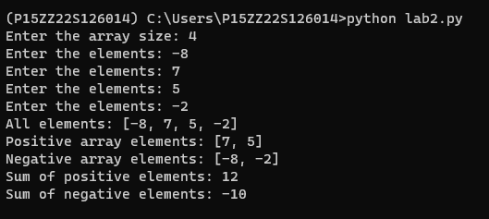

def linear_search(a, n, x):

for i in range(n):

if a[i] == x:

return i

return -1

n = int(input("enter length of list: "))

a = [int(input("Enter the elements: ")) for i in range(n)]

print(a)

x = int(input("Enter element to be searched: "))

r = linear_search(a, n, x)

if r == -1:

print("Element not found")

else:

print("Element is found at at position: ", r + 1)

def binary_search(a, l, h, x):

if h >= l:

m = (h + l) // 2

if a[m] == x:

return m

elif a[m] > x:

return binary_search(a, l, m - 1, x)

else:

return binary_search(a, m + 1, h, x)

else:

return -1

n = int(input("Enter the length of the list: "))

a = [int(input("Enter the elements: ")) for _ in range(n)]

print(a)

x = int(input("Enter the element to be searched: "))

result = binary_search(a, 0, n - 1, x)

if result == -1:

print("Element not found")

else:

print("Element is found at position:", result + 1)

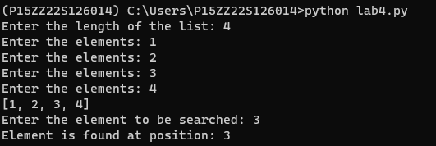

print("Stack operations")

a = []

n = int(input("Enter limit of array: "))

i = 1

while i:

ch = int(input("Select your choice given below\n 1.Insertion\n 2.Deletion\n 3.Display\nEnter Choice: "))

if ch == 1:

if len(a) >= n:

print("Stack is overflow")

else:

a.append(int(input("Enter an element: ")))

elif ch == 2:

if a:

print("Deleted element is ", a.pop())

else:

print("Stack is empty")

elif ch == 3:

print("Stack elements are: ", a)

else:

print("Invalid choice")

i = int(input("Do you want to continue press 1 or press 0: "))

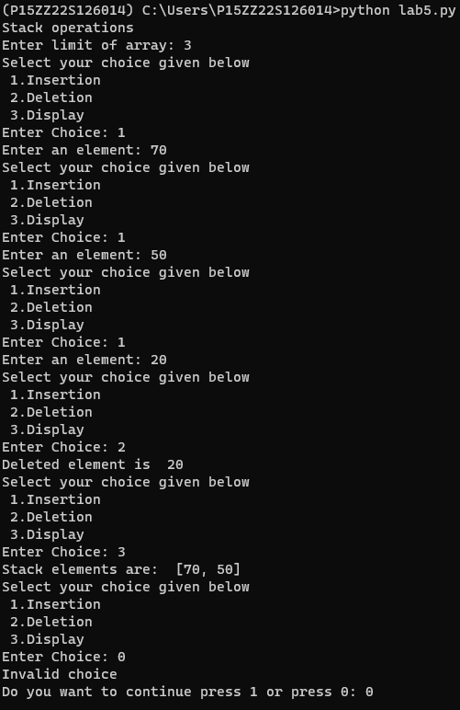

def evaluate_expression(expression):

operand = []

operator = []

precedence = ['+', '-', '*', '/']

for token in expression:

if token.isdigit():

operand.append(int(token))

elif token in precedence:

operator.append(token)

while operator:

right_operand = operand.pop(0)

left_operand = operand.pop(0)

opr = operator.pop(0)

if opr == '+':

result = left_operand + right_operand

elif opr == '-':

result = left_operand - right_operand

elif opr == '*':

result = left_operand * right_operand

elif opr == '/':

result = left_operand / right_operand

operand.append(result)

print(eval(expression.replace(' ','')))

return operand.pop()

expression = input("Enter an expression: ")

result = evaluate_expression(expression)

OUTPUT:

