THE COUNTRY-LIFE-READERS

**FLOWERS**

**OF THE**

**FARM**

BY ARTHUR O. COOKE

FLOWERS OF THE FARM

o

# CONTENTS

Introduction 1 In the Coppice 5

Flowers on the Walls 9 Three Handsome Weeds 17 Clover 21

In “Ashmead” 25

In The Hay-Field 31

In the Hay-Field *(continued) 37*

In the Corn-Field 41

In the Corn-Field *(continued) 45*

On the Chase 51 In the Lanes 55

Chap ter I o

# INTRODUCTION

I

think that some of you have been with me at Willow Farm before to-day. When we were there we went into the farmer’s fields in early spring, and saw the men and horses at work with ploughs and harrows. A little later on we saw some of the crops sown, such as barley and turnips. In summer we were in the hay-

and corn-fields, and later still we saw the ricks being made.

To-day we are at Willow Farm again, and I want to show you some of the flowers that grow there. I do not mean those which Mrs. Hammond, the farmer’s wife, grows in her garden, pretty as they are. We will look rather at the wild flowers in the fields, the hedges, and by the road-side in the lane. No one sows their seed nor takes care of them in any way; yet they grow and blossom year after year, and nearly all of them are beautiful.

Before we begin to look at them we must make sure that we quite understand just what a flower is. Even those of you who live in large towns and have perhaps never been in the country, see flowers

of some sort, I feel sure; you see them in shop windows and they are also often sold in the streets. You have seen wallflowers and daffodils in the spring, roses in the summer, violets in winter, as well as other kinds. You do not need to be told that these are flowers. What about the grass on lawns, and in such places as Battersea Park and Hyde Park in London? “Oh,” you say, “that is not a flower at all – that is just grass.” Yes, it is grass, but the grass has a flower as well as a rose bush or a violet-plant. It is only because the grass is kept cut short that you do not see its flower on a lawn. If grass is not cut, or eaten by animals, it grows tall in spring; then in May or June you would see the flowers on tall straight stems which stand among the blades of grass. Many of these grass flowers are very beautiful and we will look presently at some of them in one

of the farmer’s fields.

Perhaps some of you have gardens or grass plots at your own homes. If you see some dandelions in the lawn, or groundsel among the flowers or vegetables in the garden beds, you say, “Those weeds must be pulled up.” You call the Dandelion and the Groundsel weeds, but they have flowers all the same; the Dandelion is perhaps one of the most lovely yellow flowers that we have.

They are weeds certainly in your lawn or garden beds, for they ought not to be there. Weeds are plants in the wrong place. By and by, in the farmer’s fields, we shall see many pretty flowers which he calls weeds. We speak of the Nettle as a weed, and do not usually admire it; yet the Nettle has a flower, as we shall see.

Then what do you think of a tree having a flower? That is perhaps a new idea to you. Yet if you look at a Horse-chestnut tree in June you will see at once the large spikes of beautiful white flowers with which it is covered. Apple trees have a beautiful pink, or pink and white flower, and the Almond tree bears a lovely pink flower. All other trees have flowers too, but they are often small. The flowers of

*Introduction*

the Oak and the Beech are small, but, though you may not notice them, they are on the tree each spring.

Almost all plants, including large trees, have flowers – they are flowering plants. Just a few plants have no flower; ferns have none, nor have the mosses and lichens which grow on walls and rocks and on the stems of trees. Fungi, too, such as the mushroom, have no flowers. Nearly all other plants have flowers. It is by the flower or blossom that a plant is reproduced. After the flower has faded comes the fruit and seed; the seed falls into the ground or is sown, and from it springs another plant. Without the flower there would be no seed.

You see that there are rather more flowers than you had thought. Still, while we are strolling in the fields and lanes at Willow Farm, we shall look most at what are generally called flowers; we shall look at comparatively small plants in which the flower or blossom is easily noticed because it is large, or bright-coloured, or sweet- scented. But while we are admiring a Daisy or a Dandelion in the spring, we must not forget that the great Oak-tree above it also has a flower of its own – we must remember that the Oak-tree also is a flowering plant.

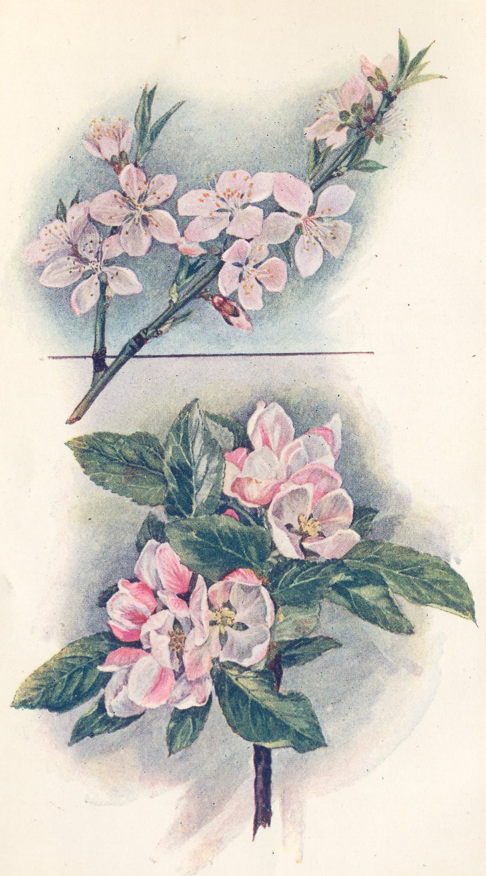

Chap ter II o

# IN THE COPPICE

O

utside the front door of Willow Farm is a broad curving gravel drive, at the far end of which a white gate opens into

the lane. On one side of this drive is a narrow strip of ground planted with flowers and shrubs, and close to the front door there is a patch of grass on which stands a large old mulberry tree.

On the other side of the drive is a lawn. Beyond that are more flowers and then the vegetable garden; further on still is a little wood or coppice of nut bushes. On this March morning we shall find some wild flowers in this little wood.

Between the vegetable garden and the wood is a low grassy bank. It is bright to-day with yellow primroses. The Primrose always blossoms early here, for the bank is sunny and is sheltered from cold winds.

I daresay most of you have seen a Primrose before to-day. Each pale yellow blossom is made up of five petals, which are joined together forming a tube or corolla. The petals are notched or

*Primrose*

indented on the outer edge. At the centre of the blossom, where the petals meet, each petal is marked with a spot of darker yellow. Each flower grows alone on a long slender stem. At the top of the

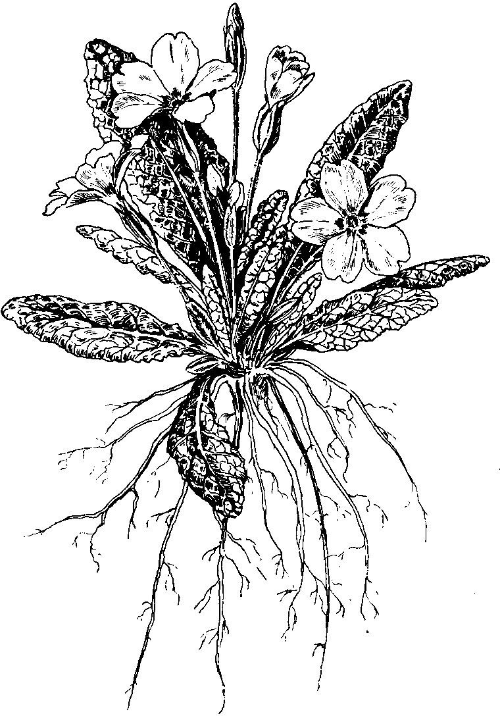stem is a kind of green tube out of which the yellow blossom appears. The Primrose blos- soms have a scent; not strong, but very sweet and pleasant.

The leaves are called “radical” or “root” leaves. They are so called because each leaf appears to grow direct from the root. But the leaves really grow from a short stem at the top of the root – a stem so short that it does not appear above the ground at all.

Among the bushes of the coppice itself we will notice the flowers which first catch our eye – the pretty blossoms of the Wood

Anemone. The whole coppice is starred with the beautiful white flowers. We pick one and see that it has six – six what? “Six petals,” you say. No, these are not petals, for the Anemone has none. They are sepals. The sepals of a plant generally enclose the blossom before it is opened, and they are usually green. In the Anemone the petals are absent; the sepals take their place and are white instead of green. Their under side is often not pure white, but is streaked with pale pink.

Several blossoms which we pick have six of these sepals. That is the usual number, but sometimes there are only five, and sometimes more than six.

The blossoms of the Anemone grow on longer and stronger stalks than those of the Primrose, and on each stalk are three leaves. These leaves grow round the stalk in a ring. Each leaf is “tri-partite”– in three parts or divisions; the edges of these divided leaves are deeply

*In the Coppice*

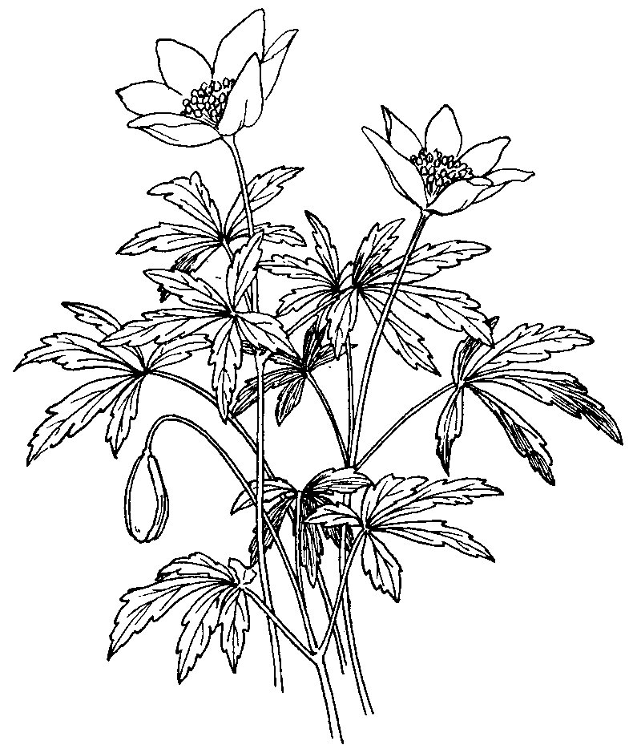serrated. Besides the three leaves on each flower-stalk similar leaves grow from underground stems which creep along not far below the surface of the soil. Such creeping underground stems are usually called “rhizomes.”

At the further side of the coppice, where a hedge separates it from the little meadow called Home Close, are Sweet Violets. We catch their fragrant scent before we see them, for the tiny flowers are half hidden among broad green leaves. Each blossom has five petals of a dark purple colour; there are white Sweet Violets too, but none are growing in our little wood to-day.

At the base of the blossom – the part

where it joins the stem – one of the

petals has a little spur which points back towards the stem. The blossom is therefore said to be spurred; we may presently see other plants with spurred flowers.

There is another violet which grows wild in England – the Dog

*Anenome*

Violet. It is larger than our Sweet Violets here, but it has no scent. While we have been examining the flowers on the ground, the nut bushes above our heads are waiting to remind us of what we said just now – that trees also have flowers. The flowers of the nut bush or hazel are easily seen, for they appear before the leaves are open. What we see to-day are often called catkins, but the name which country children give them is lambs’-tails. It is a very good name, too, for they are more like the tail of some tiny lamb than

anything else.

These catkins are yellowish-white in colour, and soft and almost woolly to the touch. They hang in clusters from the hazel twigs,

and in the strong March wind which blows to-day, they shake and flutter like the tails of lambs at play. Some of them leave a dusty powder on our fingers when we handle them; that is the pollen of the flower.

It is not where these yellow “catkins” are dancing on the twigs to-day that the hazel nuts will appear in autumn. The nuts will grow on twigs where there are very small red flowers – something like tiny paint-brushes. These are the female flowers; they will be fertilized by the yellow pollen of the catkins, and will produce the nuts.

Chap ter III o

# FLOWERS ON THE WALLS

B

ehind the narrow strip of ground with flowers and shrubs on the other side of the drive there is a low stone wall. A piece

of the lawn on which the mulberry tree stands has been cut away, and a flight of steps leads down to a little gate into the foldyard.

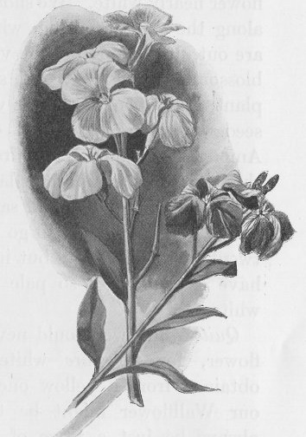This wall between the garden and the foldyard is very old and rough – not like the smooth brick walls you see

in towns. The stones are of different shapes and sizes, the mortar has fallen out of it in many places, and here and there are holes and crevices. Yet it is a very beautiful old wall, for many things grow on it; mosses and grasses, and other flowers too, are there.

On this May morning we not only see, but also smell, one of the flowers which grow upon the wall – it is the beautiful sweet-scented Wallflower.

It grows here and there along the top of the wall, *Wallflower*

and a few plants of it are even springing from the sides. Some of the plants are quite large and their stems are tough. These have grown here for a long time. The Wallflower is a perennial plant; unless it is killed or torn up by the roots it will live and grow for many years. Others are quite young and only a few inches high. These have grown from seeds dropped last autumn by the older plants. You very likely wonder how the Wallflower or any other plant can grow upon the wall, for there is no earth to be seen – nothing but stones and crumbling mortar. But if we pull up one of the smaller plants we shall find earth clinging to its roots. Dry dusty earth has been blown upon the wall by wind, and has lodged in chinks and holes. Dust and soil, too, were mixed with the mortar when the wall was built; and dead leaves falling on it and decaying have produced a little more – for decayed leaves make earth or “soil.”

Wallflowers and other plants which grow on walls and rocks find very little soil sufficient for their needs.

Most of the blossoms of the wallflowers upon this wall are of a golden yellow colour and are very sweet. Some of the blossoms are, however, a darker yellow than others, and here and there are petals which are quite brown.

If we look at the garden behind us we shall see that Mrs. Hammond has several beds of Wallflower this year; it is a flower of which she is very fond. There are wallflowers of two different colours in her beds. One kind has bright golden blossoms, rather deeper in colour than any of those upon the wall; the other has flowers that are a rich dark brown.

These plants are sturdier and more bushy than those upon the wall, and there are more flowers on each plant. The flowers are finer, too, and have a stronger scent. If Mrs. Hammond had wished she could have sown seed to produce many different shades of brown and yellow Wallflowers. She might also have had a purple Wallflower,

and even a Wallflower of so pale a yellow as to be almost white.

If you and I were clever gardeners and had plenty of time and patience, we could get purple or nearly white wallflowers from these yellow-flowered plants upon the wall. It would perhaps take us many years, but we should succeed at last. This is how we should set about it.

Suppose that we wished to have a Wallflower nearly white. We should look carefully along the wall in spring, when the blossoms are out, until we found the very palest yellow blossom we could see. We should mark that plant, and when the flower was over and the seed was ripe, we should collect the seed. Among the plants grown from this seed we should choose again the plant that had the palest flowers, and should save the seed from that. We might have to go on doing this for twenty years or more, but in time we should have a Wallflower so pale as to be almost white.

Quite white we should never get our Wallflower, for no pure white flower can be obtained from a yellow one. However pale our Wallflower might be there would still always be just a tinge of yellow or cream colour in it.

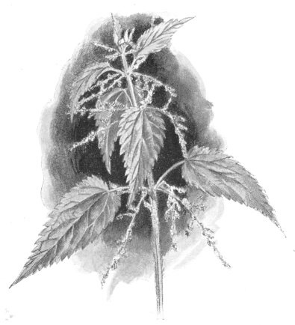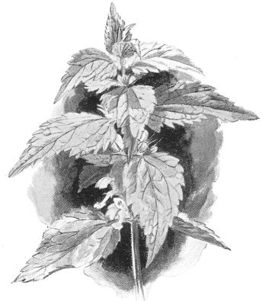If, on the other hand, we wanted a purple or a very dark brown Wallflower, we should save seed from those blossoms which were nearest to the colour we wanted – dark brown or with a tinge of purple in them. We should sow seed from the darkest blossoms again and again, and at last we should get what we wished to have.

*Stinging Nettle White Dead Nettle*

Besides choosing seed from the lightest or darkest blossoms, we should tend our plants very carefully and well, giving them plenty of good rich soil. This would make them grow bushy and with many flowers, as we see them in Mrs. Hammond’s garden beds.

Many of our garden flowers have been produced in this way, by selecting and improving wild flowers. Of course all flowers grow wild somewhere; some in England, but many more in foreign coun- tries, where the air is warmer and the soil richer and better. The Pansy is a little English wild flower with yellow, blue, and red petals. From this little flower gardeners have produced large and beauti- ful pansies of many different colours and shades of colours – white, yellow, blue, and brown. This has been done by careful selection, just as we spoke of doing with the wallflowers.

But if the large single-coloured pansies of which I have told you, or Mrs. Hammond’s dark brown wallflowers, were allowed to seed themselves – that is, were allowed to drop and sow their own seed year after year – do you know what would happen? They would gradually revert or turn back to their original form and colour. The flowers would become mixed in colour and less fine in size; at last

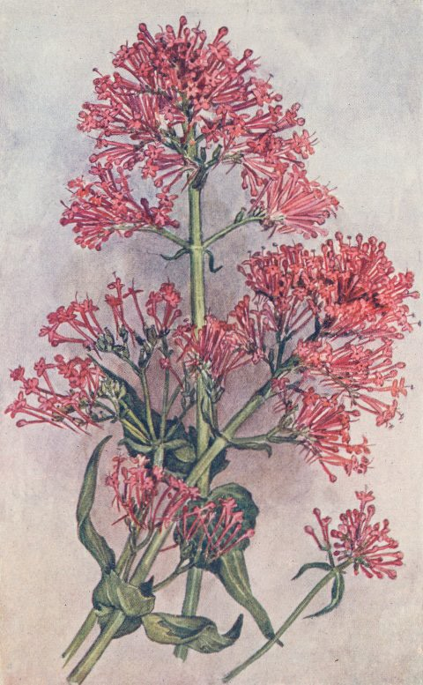they would be simple wild flowers again.

Now it is June, and the blossoms of the Wallflower have faded and fallen. The old wall is, however, growing gay with another plant – the Red Valerian. We must be careful to remember that it is the Red Valerian, for there are other valerians. There is the Great Valerian which does not grow on walls or rocks, but in damp and shady places; its flowers are pale pink.

The blossoms of the Red Valerian on the wall are bright crimson, and they grow in rows on small

*Red Valerian*

stems which spring from a stout stalk a foot or

two in height. Each blossom of five petals forms a little tube or corolla. The base or foot of each little tube appears as a point on the under side of the flower stem; the Red Valerian, like the Violet, is a spurred flower.

The leaves are long and pointed, and they grow in pairs, on oppo- site sides of the stalk. Sometimes the edges of the leaves are quite smooth; sometimes they are serrated, or toothed, like the edge of a saw. If we pulled a plant of Red Valerian from the wall we should find the roots very long and branching; they need to be so, for the plant often grows on rocks and other places where it is exposed to wind. If the roots had not a firm hold the tall stems laden with blossoms might be blown down.

The Red Valerian flowers all through the summer. Its clusters of crimson flowers are as great an ornament to the old wall as were the wallflowers in May.

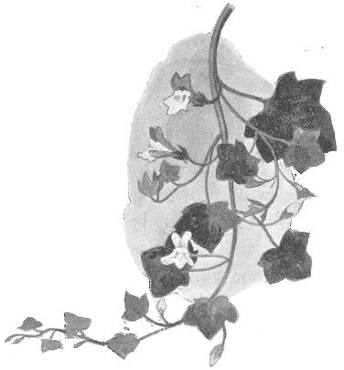Now let us go down the steps into the foldyard; there is a wall on either side of us as we descend. The wall which faces the north is nearly always in shadow, and there are ferns growing but of it between the stones. One of these is a beautiful Hartstongue fern, with large and shining leaves. We said just now, however,

that ferns have no flowers, so we will turn to something that grows on the wall opposite.

This is the ivy-leaved Toadflax. It grows on walls and rocks, as the Red Valerian does, but it is a very different plant in appearance. The stems of the Red Valerian are tall and upright; those of the Toadflax are slender and drooping. There is a large mass of it on the side of the wall, and we find that

the root is at the highest point of the whole mass. The stems with the flowers

and leaves hang down below the root;

*Ivy-Leaved Toadflax*

it is a trailing plant.

There are, however, other roots clinging to the wall here and there below the main root. The plant, like several others, is able to throw out fresh roots from the joints of its stems, and these give it a firmer hold.

The flowers are small, and their colour is a pale lilac-blue with a bright yellow spot in the centre. These flowers too are spurred. The leaves are smooth and thick – what is called fleshy. They are divided into five lobes or divisions, and are not unlike an ivy-leaf in shape. When we turn a leaf or two over we see that the under side of some is dark purple.

This little plant is usually said to prefer a damp situation, and to blossom from May till October. This wall beside the steps is certainly rather damp, for the moisture from the garden above soaks down to it. In my own garden, however, the ivy-leaved Toadflax grows on some very dry old walls, and I have found it in flower in the middle of December.

Neither the Toadflax nor the Red Valerian are really natives of England. They were brought to our country many hundreds of years ago. They have spread so much that they have now become wildflowers. In the same way many others of our wild flowers were once unknown in England.

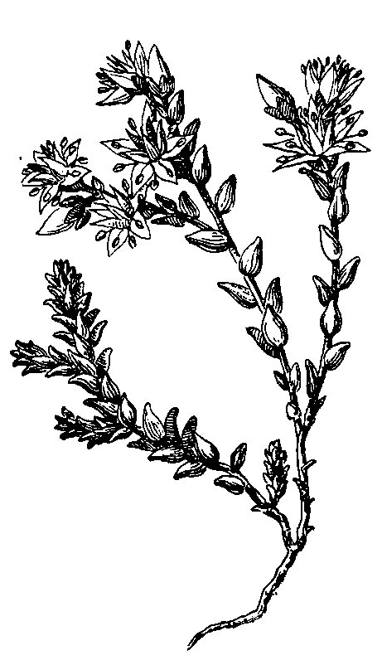

*Common Stonecrop*

Now that we have come down the steps into the foldyard we see that it lies a good deal below the house and garden. Built round the foldyard are the stables for the cart-horses, the cowhouses, and the great barn. Behind the stables is the rickyard. That, like the garden, is above the foldyard; from it there are only two

or three steps to the door of the loft or “tallet” above the stables. It is there that we will go now.

The wall of the tallet is of stone and is very old; the roof is tiled. There is a little hole cut in the bottom of the door, and you will see one like it in the door of the granary. It is made so that old Tib and the other cats can go in and catch mice. Growing between the stones of the wall just by the tallet door is the plant I want to show you now.

It is the Stonecrop. Some of the stems grow upright, while others are trailing. At the top of each upright stem is a cluster of bright yellow flowers. Some of these are fully open, and we see that each blossom has five pointed petals. The trailing stems have no flowers at all, they are barren; but the leaves on the barren stems are much more numerous and closer together than those on the upright flowering stems.

These leaves are very curious. They are not flat like the leaves of the Red Valerian, the Toadflax, and most other flowers; they are very thick and fleshy – something like a short round pointed stick. They grow close against the stalk, not in pairs, but alternately, first a leaf on one side of the stalk, then a leaf on the other. They are erect too; that is, they point in the same direction as the stalk.

On the barren stems the leaves grow so closely that they quite cover the stalk. They have a hot sharp taste, and the plant is some- times called “Wall-Pepper.” The roots are very thin and can spread easily through narrow chinks of the wall.

We will see one more plant of the walls before we look for flowers elsewhere. Our next plant is not very common at Willow Farm; still I know where to look for it. Built against one side of the big barn in the foldyard is a little lean-to shed. Often there are calves in it; but just now we are more interested in something that is on the roof. Standing close to the wall of the shed is a cattle crib – a kind of

big square box or trough on legs, in which hay or chaff is put for the cattle. The shed is not very high, and by standing on the crib we can scramble on to the roof. Here is the plant we want to see.

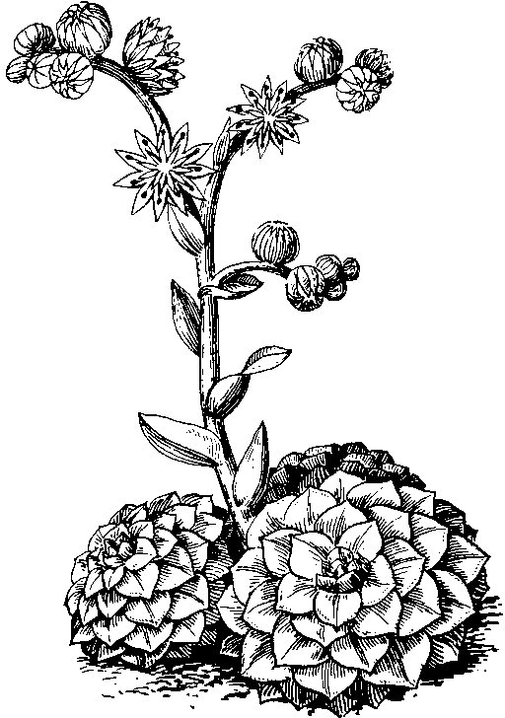It is the Houseleek, of which a clump is growing between the tiles. Almost flat on the tiles is a dense mass of large green fleshy leaves. These leaves are ever- green, they do not die and fall off in winter. From this cluster of leaves rise straight thick stems nearly a foot high. The stems are thickly covered with erect leaves which grow smaller towards the top of the stem.

At the top of the stem is a cluster of very handsome

*House Leek*

rosy-red flowers. Each blossom is star-shaped when fully open, and generally has twelve petals.

If we could see the roots we should find them very thread-like or

fibrous, like those of other flowers we have been looking at to-day. I do not think I can very well show you the roots, however; we should have to pull up a plant, and that would not please Ben, the cowman, at all. There is a belief in country places that it is bad luck to disturb the Houseleek – that someone in the house on which it grows is sure to die soon afterwards. Certainly the plant is not growing on a house here – only on the calves’ cot. Still, if any misfortune should happen to the calves we might be blamed by Ben. Besides, it would be a pity to disturb so handsome a plant, would it not?

We have spent some time in looking at these flowers on the walls and roof because we think them very wonderful. We see how little soil they can have in which to grow, and how, in dry weather, they can have very little moisture either. Yet the leaves of several of them are thick and fleshy, and the flowers of some are large and beautiful. What could be more handsome than the blossoms of the Wallflower, the Red Valerian, and the Houseleek?

Chap ter IV o

# THREE HANDSOME WEEDS

A

t the end of the drive, near the front door, another white gate leads to the “nag” stables, where Mr. Hammond keeps

the two horses which he rides and drives. Billy, the old brown pony, has a little stable of his own close by, and further on are the granary and the poultry yard.

Perhaps you have heard the saying, “Ill weeds grow apace.” It is certainly a true one, for most of the plants which we call weeds grow quickly and well wherever they are allowed to remain. We shall not have far to look for the three weeds which I want to show you this morning. The first of them is the Stinging Nettle. It grows round the wood-pile in the middle of the poultry-yard, and there are great clumps of it beside the hedge which divides the poultry- yard from the kitchen garden.

It is really a very handsome plant, though you may not have thought so before. Look how tall and straight the stems are, and how evenly and regularly the dark green pointed leaves grow from it.

They grow in pairs, on opposite sides of the stem, and are serrated. There is something rather unusual about the stem of the Nettle which we will notice at once. I have brought out a pair of thick leather gloves, so that we can pick a stem without being stung.

You know what shape the trunks of trees are. Round? Yes; round or nearly so. So are the stems of most plants; the stems of the Red Valerian are round. The stem of the Nettle, however, is square, or if not perfectly square, it has four distinct sides. Perhaps you had never noticed this before, for the Nettle is certainly not a plant with which one cares to have very much to do.

Both the stems and leaves are covered with tiny hairs. These hairs are really small hollow tubes ending in a sharp point. When the Nettle stings you it first pricks the skin with these sharp points, and then a drop of poison falls from the tube into the wound the point has made.

If you happen to get stung by a nettle do not bathe your hand with cold water; that will only make the pain worse. While you are waiting for the pain to pass off remember that in India there are nettles whose sting causes great pain which lasts for several days. You might be much worse off, you see!

The small greenish-yellow flowers of the Stinging Nettle grow in long feathery clusters on stalks which spring from the main stem close to a pair of leaves.

The young leaves of the Nettle are said to be very nice boiled as vegetables; I cannot say that I have ever eaten them myself. Years ago country people used to take a great deal of nettle tea as medicine in spring. Nowadays they seem to prefer patent medicines from the chemist’s shop. A dye is made from the roots of the Nettle, and another dye from the stem and leaves. The young leaves or tops, when chopped up, are good for poultry, especially for turkeys. So nettles are useful, you see – not merely stinging weeds. The Nettle,

*Three Handsome Weeds*

too, is a relation of the hemp plant from which we get our string and ropes.

You may sometimes see or hear of the White, Red, and Yellow Dead Nettle, but these are not really nettles at all. Their leaves are somewhat similar, but they are quite different plants.

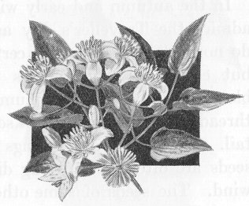Hanging over this great patch of nettles by the hedge there is another weed, the Traveller’s Joy, or Old Man’s Beard. Its stem has climbed not only up the hedge, but high into a hawthorn bush which stands there. It has many small white feathery flowers with a pleasant scent. On each leaf stem there are

usually five leaflets, one at the end of the stem and two pairs lower down. These leaf stems

*Traveller’s Joy*

are long and tough, and it is chiefly by them that the plant can climb as it does; they twine round any branch or twig they touch, and give the Traveller’s Joy a firm support. I have seen trees in woods covered with this plant to a height of twenty feet from the ground. In the autumn and early winter you would admire the Traveller’s Joy as much as you do now. The flowers will certainly be gone, but each seed which takes the place of a blossom will have a little plume of silky white threads attached to it – a sort of feathery tail. These serve as wings by which the seeds are often carried long distances by the wind. The seeds of some other plants which we shall see

have something of the same kind.

There is another climbing plant in the hedge, the Large Bindweed or Convolvulus. To look at it, however, we will go round into the garden where there is more of it than Mrs. Hammond cares to see. It is certainly a beautiful plant, with its large three-sided pointed leaves, and its great pure white bell-shaped flowers – something like the mouth of a trumpet.

In the farmhouse garden, however, it is certainly a weed – a plant in the wrong place. We see that at once. Close to the hedge are some gooseberry and currant bushes, and into these the Bindweed has climbed. The Bindweed’s stems are twined round the stems and branches of the bushes till they are almost hidden by it, and are bent down by the weight.

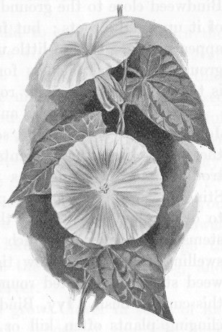The Bindweed climbs, as we see, by twisting its stem round the tree to which it clings; but though it is a climb- ing plant its stems can grow for a foot or more from the ground without support. Some of the shoots of the Bindweed are two or three feet away from the stems of the fruit bushes, but they have grown unsupported till they could reach an overhanging bough and cling to that.

*Large Bindweed*

Every now and then, Dan, who looks after the garden when he has time, cuts oft all the Bindweed close to the

ground, and pulls some of it up by the roots; but fresh shoots soon appear again. It is of little use to dig up the ground near the bushes, for the Bindweed is twisted all among their roots.

You think the Bindweed and the Traveller’s Joy beautiful flowers, and so they are. At the same time these plants are far more trouble- some and dangerous weeds than the Stinging Nettle. Nearly all plants that cling to other plants do harm; they prevent the stems and boughs to which they cling from swelling freely. See how tightly the Bindweed stems are twisted round the boughs of this currant bush. Ivy, Bindweed, and other clinging plants often kill or seriously injure valuable trees in this way.

Chap ter V o

# CLOVER

I

said all I could to make you admire the Nettle, and to see what a handsome and even useful plant it is. I am afraid, however, that you do not care much for it; I do not see that any of you have gathered a handful to take home. When we go in to dinner pres- ently, if Mrs. Hammond were to say, “Will you have green peas or nettle-tops?” I believe you would all say, “Peas, if you please!” So we had better look for a flower that you may like better. We will go to Ashmead, where the cows are grazing, and will find some Clover. Mr. Hammond grows Clover in some of his fields every year.

Those of you who have been at Willow Farm before, and have walked about the farmer’s fields, know this, for we saw the bailiff sowing Clover broadcast. Besides the fields of Clover, however, there is always plenty of it growing among the meadow grass. We find some directly we go through the gate into Ashmead. It is a plant with a bright purplish-red blossom. Let us sit down and examine it carefully.

The blossom is a little knob, or ball of colour, almost round. It is made up of a great many little purple stalks, standing upright and very close together. Pull a few of these stalks from the blossom and put their lower ends between your lips. They are quite sweet like sugar. Nearly all flowers contain honey, or rather nectar of which the bees make honey. Some flowers have much nectar, some less, and some have none at all; the Clover contains a great deal.

Now look at the leaves; each has three leaflets. If you can find a leaf with four of these leaflets, the country children will think you very fortunate, for a four-leaved Clover is said to bring good luck, just as a four-leaved Shamrock does in Ireland. A four-leaved Clover is, however, rather rare; I hope you may find one, but I am rather afraid you will not.

Here is another Clover, not quite so handsome as the Red Clover at which we have just been looking; the flowers are white, and are rather smaller. This is White or Dutch Clover. It is a perennial plant, and one which spreads over a great deal of ground if it is allowed to do so. We saw, you remember, that the ivy-leaved Toadflax on the wall by the foldyard steps sent out fresh roots from its stems as it grew. The White Clover does the same. The stems creep along the ground, send out fresh roots, and in this way the plant spreads quickly.

Keeping a few stems of both these clovers in our hands we will go a little further up the lane. There, in a field, we shall see something that even country people cannot see every day. The Clover which farmers usually sow is either the Red Clover or the White, or else another kind called Alsike. This year Mr. Hammond has sown a field with a fourth kind – Crimson Clover.

Did you ever see a more beautiful sight? The whole field is a blaze of rich crimson colour. I shall never forget the day I first saw a field of Crimson Clover. I was so delighted that I asked the farmer – not

*Clover*

Mr. Hammond, but another friend – if he would have a field of it for me to admire every year! He said he would tell me by and by. At the end of the year he said he did not find it such a useful food for his animals as the Red and White Clovers, and he should not sow it again – at least not very soon. You see pretty things are not always the most useful.

Let us see what differences we can find between the three clovers we have gathered. We look first at the blossoms. That of the Red Clover is, as we have said, like a little round ball, or knob. The flower of the White Clover is of much the same shape, but is less fine. The flower of the Crimson Clover is altogether different in shape. It has indeed many small crimson stems, but these do not form a round ball. They are arranged in the form of a little circular cone or pyramid which is large at the bottom and pointed at the top.

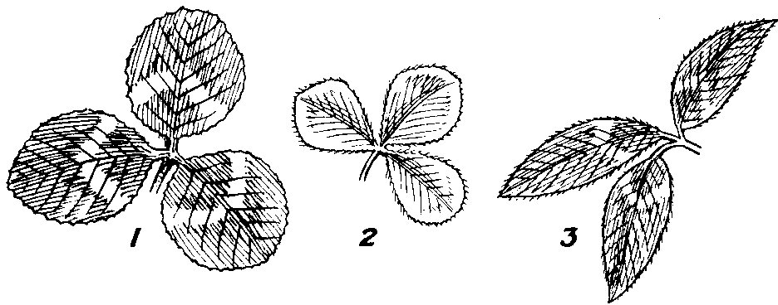

*Clover Leaves. 1. White; 2. Crimson; 3. Red.*

There are other differences. Immediately below the flower of the Red Clover is a pair of leaves; the blossom is said to be “sessile” or seated on these leaves. Other leaves, and also other blossoms, grow on the same stem. Now look at the White Clover. The blossom grows on a stalk without any leaves or other blossoms on it – only the single blossom at the top of the stalk. The blossom of the Crimson Clover has leaves below it.

To-day we easily distinguish one clover from the others by the flowers. Supposing, however, that we looked at them some day

before the flowers were out; what then? Are there any differences in the leaves? All three have leaves formed of three leaflets – they are trefoils – but the leaves are otherwise different.

Those of the Red Clover grow on stems branching from the flower stem, and sometimes on the flower stem itself. Both leaves and stems are hairy, and on the leaves there is generally a white mark, something the shape of a horseshoe.

The leaves of the White Clover grow, like the flower, at the top of the stem – a single leaf on each stem. The under sides of the leaves are smooth and glossy. The leaves of the Crimson Clover grow on the flower stems like those of the Red Clover; but the leaflets are broader and rounder than the Red Clover leaflets. The Crimson Clover is an annual, while the others are perennials.

All these clovers are good food for the farmer’s animals or stock. The Red Clover is, perhaps, the most useful. Bees, however, prefer the White Clover, for they can more easily get at its nectar.

Sheep are exceedingly fond of Clover, but Mr. Hammond is always careful not to turn them into a field of Clover when they are very hungry, or to let them stray in by accident. If they got in they would eat it ravenously, and many would very likely die. Too hearty a meal of Clover has the same effect on them as a great quantity of new bread would have on you or me.

We have spent so much time this morning looking at the clovers that we have only a minute or two to stand at the gate of a field of beans. The blossoms are pretty – white with dark spots – and they are very fragrant. A field of beans in flower gives us one of the most delightful of all country scents.

Chap ter VI o

# IN “ASHMEAD”

T

here are many other flowers besides the Clover in Ashmead to-day, and this afternoon we will look at some that grow among the grass. One of these you may perhaps call a weed, yet it is one of the most beautiful wild flowers in England. I mean the

golden Dandelion.

On a lawn or in a garden bed it would certainly be a weed, and a very troublesome one. Here among the grass we need only think of it as a very lovely flower. See what a rich golden yellow the little florets of the blossom are. Plants like the Dandelion, in which the blossom is composed of a number of florets, are called “composite” plants.

If we examine the plant closely we shall find that each stalk which bears a blossom, and each long deeply indented leaf, grows, like the flower-stem and leaf of the Primrose, from a very short underground stem. It is from the indented leaves that the Dandelion gets its name. The leaves have something the appearance of the teeth of a

lion. Now the French name for lion’s tooth is dent de lion, and we English have corrupted this into dandelion.

Each flower-stem is round and, when we pull one, we see that it is a hollow tube. We bite a piece of the stalk as we did with the Clover blossom. What a difference! The Clover was quite sweet, but the Dandelion is very bitter. You may not like the taste perhaps, but the white milky-looking juice is quite wholesome. Dandelion tea and Dandelion beer are often made by country people, and the leaves give a pleasant flavour to a salad.

Shall we pull up a plant and examine the root? I am afraid we cannot, unless you care to go back to the house for a fork or a trowel. The Dandelion has a very long strong root – tap-root – which goes deep into the ground; and there is no tall main stem of which we can take hold – the leaves and flower stalks only break off in our hands. Here is a stalk from which the flower has fallen, leaving only the seed. Of what does it remind you? Of the Traveller’s Joy in autumn? Yes; the Dandelion has what is called a “pappus” attached to its seed, rather similar to the feathery tail of the Traveller’s Joy. This makes the Dandelion a troublesome weed; the seeds are easily carried by the wind and, if a patch of dandelions is allowed to go to seed, it will produce fresh plants quite far away. Before the seeds are scat-

tered each head is like a round white fluffy ball.

Here are daisies, with their dainty white florets often tinged with pink. In the centre of each blossom is a yellow spot. Every night the white florets fold up over the yellow centre, and do not open until the morning. This fact explains to us the Daisy’s name; it is the Day’s Eye which opens at dawn and shuts at night.

The Daisy is a little flower which everyone knows and loves, yet in the wrong place it is a weed. It is a perennial and it spreads very fast. Of course both perennials and annuals spread by means of their seed, but perennials also spread in other ways as well. We

will see how the Daisy does this.

There; with my pocket knife I have easily dug up a plant. The root is small and compact, not long like that of the Dandelion. But, when I try to lift the Daisy plant from the grass, I find that it is still held down by a stout tough thread branching from the root. This thread is connected with another Daisy plant; from that one there is another thread connected with a third plant. When we have at last got our plant clear away from the ground, three more are hanging to it by these threads.

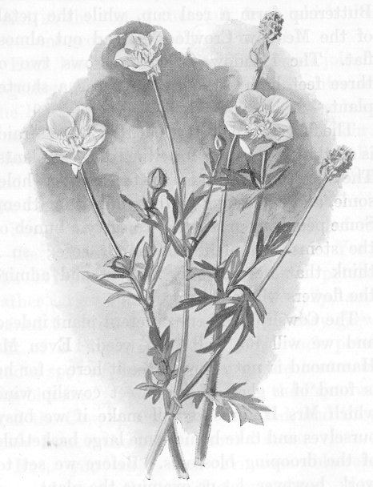That is how the Daisy spreads; it throws out these thread-like shoots from the root, and from these grow another root and plant. I knew only too well what we should find; there are far too many daisies in my lawn at home, and I found out long ago the way in which they spread so fast. If daisies are allowed to increase in this way they form large clumps which smother and kill the grass. We notice that each flower-stem and each leaf of the Daisy springs from a very short underground stem, as those of the

Dandelion do.

*Bulbous Crowsfoot*

Daisies and dandelions are plentiful in Ashmead, and so are the yellow buttercups. There are, however, not quite so many butter- cups as you might think at first. The real name of what we call the Buttercup is the Bulbous Crowfoot, and there is also a Meadow Crowfoot in the field. A third crowfoot is the Corn Crowfoot. To-day we will notice one or two differences between the two plants we see here.

The blossoms of both plants have five smooth shining yellow petals. We see, however, that those of the Bulbous Crowfoot or

Buttercup form a real cup, while the petals of the Meadow Crowfoot spread out almost flat. The Meadow Crowfoot grows two or three feet high; the Buttercup is a shorter plant.

The flowers are pretty, but that, I am afraid, is all that we can say for either of these plants. They are both of them bitter and unwhole- some, and horses and cattle avoid eating them. Some people even say that to carry a bunch of the stems will make the hands sore; so I think that we will only look at and admire the flowers where they grow.

The Cowslip is a very different plant indeed and we will not call it a weed. Even Mr. Hammond is not sorry to see it here; for he is fond of a glass of the sweet cowslip wine which Mrs. Hammond will make if we busy ourselves and take home some large basket- fuls of the drooping blossoms. Before we set to work, however, let us examine the plant.

Looking at a stalk of Cowslip blossoms we see something peculiar about it at once – something unlike the other flowers we have seen. Six or seven drooping blossoms grow from the stalk we have picked, and they all grow from the very top of the stalk. The point at the top of the stalk from which the blossoms grow is called the “umbel.” Each blossom has five yellow petals joined together to form a corolla. In the centre of the blossom, where these petals meet, each is marked with a spot of deep orange-red colour. The yellow petals are comparatively small, and peep out of a long pale green sheath

called the “calyx.”

Surely we have seen a flower like this before – the Primrose in the little coppice. Yes; the Primrose had five pale yellow petals, rather larger than those of the Cowslip, and joined together to form a corolla; they grew out of a long green calyx. Also each petal had a spot of darker yellow in the centre of the blossom. The leaves of both the Primrose and the Cowslip are much wrinkled, and they

grow from a short underground stem.

But, you say, each Primrose blossom grew alone on the top of a long stem. Yes, but if we had dug up a Primrose plant, we should have found that several flower stems grew from the same point – the top of a very short stem which hardly appeared above the ground. They grew from an umbel, and the Primrose is closely related to the Cowslip. The difference is that the blossoms of the Primrose grow on long stems from a short-stemmed umbel. Those of the Cowslip grow on short stems from a long-stemmed umbel.

Chap ter VII o

# IN THE HAY-FIELD

H

ere we are in the hay-field at the end of June. It is not really the hay-field yet, but it will be so as soon as the grass is cut

for hay. This will be done in a few days, so we must lose no time if we wish to look at some of the flowers before they are cut down. We must not stroll all over this field as we did in Ashmead, for the long grass should not be trampled down, or it will be difficult for the machine to cut. Quite near the gate, however, are plenty of flowers, and we shall find others if we step carefully along the

side of the hedge.

We will look first at those flowers which are most important to the farmer, the flowers of the grass. We saw, you remember, that the grass has flowers just as the Rose and the Wallflower have. If you had thought that the flowers of all grass would be alike, you see now that you were quite mistaken; there are many different grass flowers here.

Not only are the flowers different, but so are the stems, and also

the leaves or blades. Mr. Hammond could come into the field in early spring or autumn, when the grass is not in flower, and could tell you to which kind of grass any blade belonged. To-day we shall easily distinguish the different kinds of grasses by their flowers, though we will also notice differences in their stems and leaves.

Let us pick a stem or culm of grass. We see that the greater part of it is hollow; but at intervals there are joints, and here the stem is solid. From each joint grows a leaf-sheath which is wrapped round the stem for a little distance above the joint. Out of each sheath grows a leaf. All grass leaves are long and narrow compared with those of most other plants, but some grass leaves are longer and narrower than others.

Now for a flower. The stem which we have picked is the stem of perennial Rye Grass. The blossom, we see, consists of several small spikelets; there are eighteen on our stem. They grow alternately on two opposite sides of the stem, first one on one side, then one on the other. They have no stalk of their own; they are sessile or seated on the stem. As the spikelets are flat and grow on two sides of the stem only, each stem looks as if it had been pressed in a book, as perhaps you have sometimes pressed flowers.

The leaves are dark green, glossy and shining. On the under side of each leaf there is a prominent rib which extends the whole length. This rib is one of the signs by which Mr. Hammond can tell a blade of Rye Grass at once without seeing the flower.

This is one of the farmer’s most useful grasses. It forms a close thick carpet or sward, and, the more it is trodden on by animals grazing, the better it seems to thrive.

Here is another excellent grass, with a flower quite different in appearance from the last. It is called Timothy Grass. It was first cultivated in America by a man named Timothy Hanson, and it is now always known by his Christian name. Mr. Hammond knows

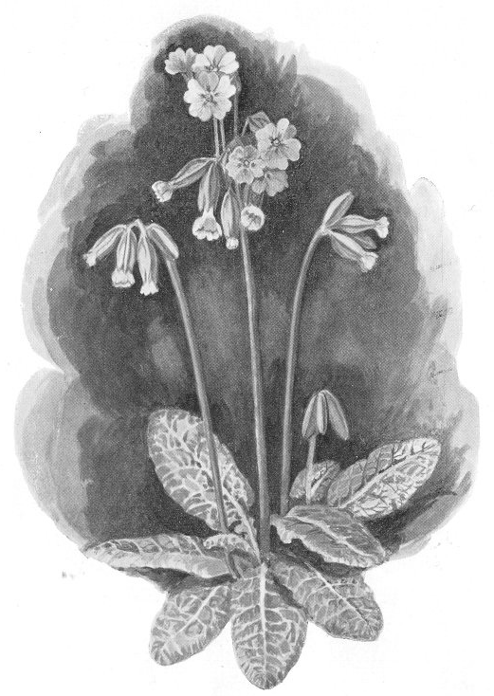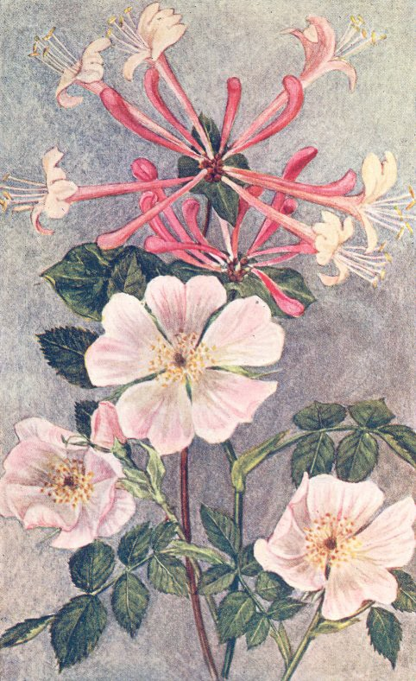this, and now you know it too; but a good many farmers who have plenty of Timothy Grass in their fields do not know the reason of its name.

*Cowslip Honeysuckle and Wild Rose*

The spikelets of Timothy are very small and grow in dense clus- ters at the end of the stem, so that the blossom forms a kind of tail. Indeed Timothy is sometimes called Meadow Catstail, a name which gives a very good idea of its appearance. This cluster or tail of spikelets is green and also rather rough to the touch. Notice these two points about it; we shall see the reason presently. The green leaves have a greyish tint and are broader than many grass leaves. When cut and made into hay, the leaves are rather stiff and hard.

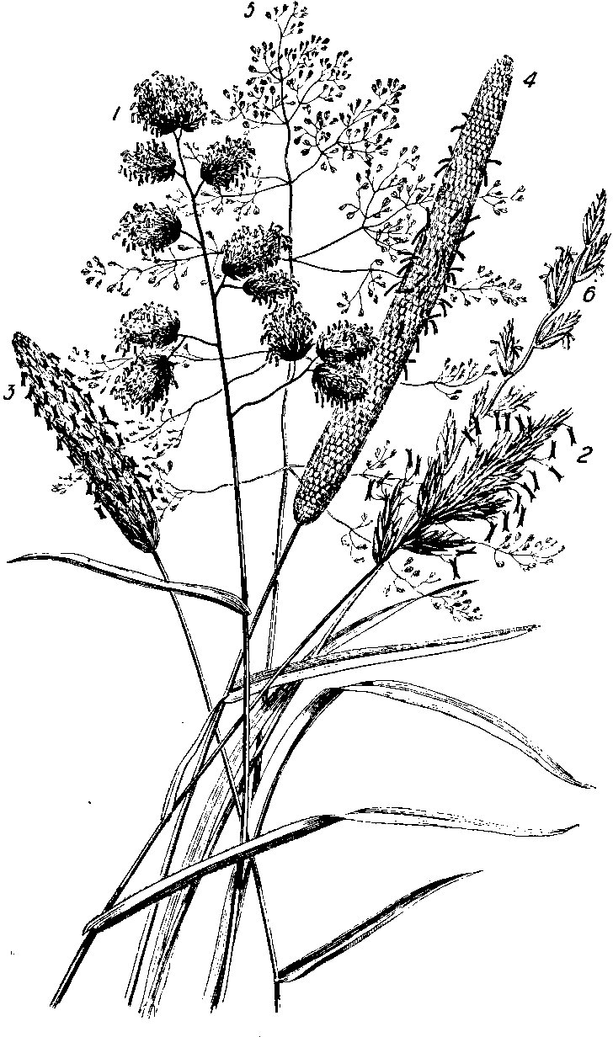

*Grasses. 1. Cocksfoot; 2. Sweet vernal; 3. Meadow foxtail; 4. Common Timothy;*

*5. Tufted hair; 6. Common rye grass.*

Timothy grows in good thick clumps, but does not make a very spreading sward. Moist weather suits it best, though it can stand a dry summer fairly well. It is a late grass. Other grasses in the field are in full flower to-day, but there are only a few ears of Timothy to be seen; its flowering-time is July. In one way it is a valuable grass for hay; it is heavy, and hay is always sold by weight. On the other hand Timothy hay is rather hard.

Now here is a grass something like Timothy, yet different in several ways. It is Meadow Foxtail. The ear formed by the cluster of spikelets is of the same shape as an ear of Timothy, like a round tail slightly pointed. But the ear of Timothy was green, while this is a beautiful silvery grey. Timothy was rough; the ear of Meadow Foxtail is very soft and silky to the touch. The silkiness and the silvery grey colour are given to the ear by a soft hair called the “awn” which grows from each spikelet. The leaves are broad and juicy, and there are many of them.

Meadow Foxtail, unlike Timothy, is an early grass; you may find it in flower in April. An early grass is always valuable to the farmer, who wants herbage for his sheep and cattle after the long winter. The Foxtail, moreover, is a spreading grass. Some of its stems are prostrate; they do not stand upright but creep along the ground. From these prostrate stems fresh roots grow and produce fresh plants. Thus Meadow Foxtail makes a good sward.

Another useful grass is Cocksfoot. Each culm has four or five thick clusters of spikelets growing on small stalks of their own. The clusters grow from the culm in a way which reminds us of the claw of a fowl; that is the reason of the name. Cocksfoot is a tall and quick growing plant, and both the stem and flower feel rough and hard. The blue-green leaves are very juicy. The root goes deep into the soil, so that this grass resists drought well.

We must notice the Sweet Vernal Grass, though there is not much of it in the field; for this grass, when it is dry, gives out much of the sweet scent we smell in or near a hay-field. If we chew a stalk, we notice the scent ourselves, and animals like the pleasant flavour which it gives to hay. Though it is an early grass it also lasts till late in the autumn. The spikelets make a cluster or tail at the end of the stalk, but they do not grow so closely together as those of the Timothy and Meadow Foxtail.

Look at this Tufted Hair Grass. It is very pretty, perhaps one of the prettiest grasses we have seen; but the farmer looks upon it as a weed. It has a large and spreading head of flower; the spikelets grow on stems, and become gradually smaller towards the top of the stalk. The flower is purple, with a shining silvery light upon it. It grows in thick clumps or tussocks, and cattle do not care about the leaves.

Chap ter VIII o

# IN THE HAY-FIELD

## *(continued)*

T

here are many other grasses in the field; some of them are useful, while others the farmer would call weeds. We must now

look at other flowers, and, as the grass is so tall, it will be better to choose tall flowers which can easily be seen. We soon spy a Thistle among the grass near the gate.

There are several kinds of Thistle in England – the Milk Thistle, the Nodding Thistle, and some others. This is the common Field Thistle. It is far too common to please Mr. Hammond or any other careful farmer. It is true that it is only an annual; but, like the Dandelion, it has a pappus attached to its seed. However hard Mr. Hammond tries to get rid of thistles from his fields, fresh seeds are constantly blown into them from thistles on the road-side banks, or in the fields of farmers not so careful as himself. It is very disheartening to a good farmer to have careless neighbours. When

Mr. Hammond hears that a new tenant is coming to a neighbour- ing farm, he always hopes that he will be a “clean” farmer – that he will try to keep his fields free from weeds.

The stiff stem of the Thistle is often three or four feet tall, and divides into smaller branches which bear a flower at the end. These flowers are a little like those of the Red Clover; each blossom has many small upright florets, purplish-red in colour. The leaves are not very tempting to touch, but they are very interesting. They are divided into several lobes or divisions, and each lobe ends in a sharp point. They have no leaf stem to connect them with the stalk of the plant. What is curious about them is that they do not grow from a small point on the stalk. They are “decurrent,” or running along the stalk; a broad strip at the base of each leaf is attached to the stalk. Docks too are far too numerous among the grass. They are very troublesome weeds; they are perennials, and they also scatter a great deal of seed. They have large clusters of small flowers without any true petals. The leaves are very large and pointed, growing on long leaf stems. The stems of the Dock are tough, and they blunt the

mowers’ scythes and the knives of the mowing-machine.

Some people have a good word even for the Dock. They say that a Dock leaf wrapped round the part stung by a nettle will lessen the pain; others advise us to rub the part with Dock seed. I do not think myself that either remedy has much effect; but the leaves of the Sorrel, which is a relative of the Dock, will lessen the pain of nettle stings. Mrs. Hammond always uses Dock leaves to wrap round the pats of butter which she sends to market.

Above us, in the hedge, are two of the sweetest flowers of the farm. The pink Dog Rose is one. The petals of each blossom are five in number – what a number of five-petalled flowers we have seen! The leaves have five, or sometimes seven, serrated leaflets, one of which is always at the end of the leaf stem. These leaflets are not

*In the Hay-Field (continued)*

always perfectly straight; sometimes the pointed end turns a good deal to one side.

Of course we want to gather some of the flowers – who does not want to gather Roses? We want some fully opened blossoms and many of the dainty buds. But the straggling stems of the Rose soon teach us the truth of the proverb: “No Rose without a Thorn.” The stems are thickly covered with thorns; these are not only sharp, but hooked as well, and we do not get our bunch of roses without a scratch or two.

The other beauty of the hedge is the Honey-suckle – a lovely flower which may also be a dangerous weed. The tight grasp of its strong twining stem will soon seriously injure any young tree to which it clings. Here it is doing little harm, and we need only think of the clusters of fragrant flowers. Each cluster grows at the end of a stalk. Some are pale pink, others golden yellow, while some are almost white. After the blossom comes the bright red berry which contains the seed. The leaves grow in pairs. Those low down on the stem have leaf stalks, but the upper ones are sessile on the stem.

Taking care not to trample the grass, we have strolled down the hedge-side till we have reached the other end of the field, where there is a ditch. At once there is a fragrant scent in the air – a scent like that of almonds. It is the Meadow Sweet which grows on the banks of streams or damp ditches.

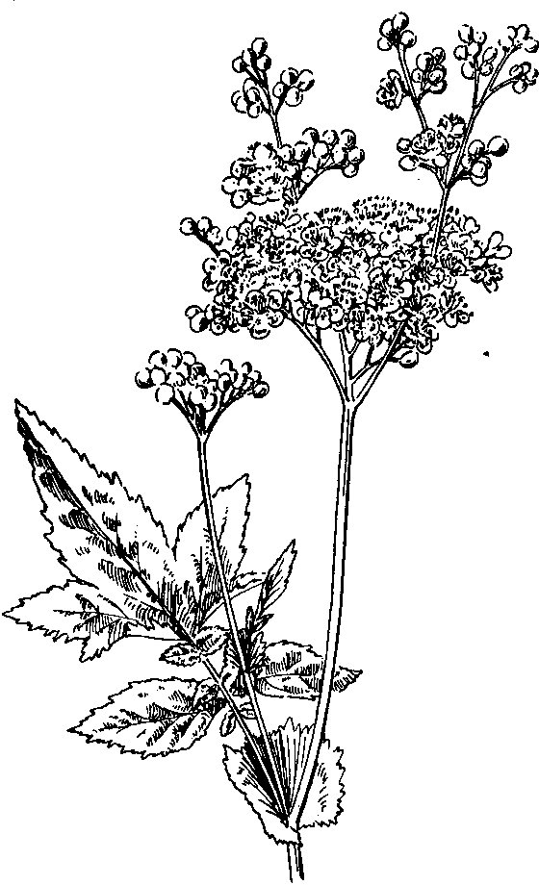

*Meadow Sweet*

It is a beautiful plant, as well as a fragrant one. At the top of the tall stems are large clusters of small five-petalled flowers, creamy- white. The stem itself is handsome; it is often three or four feet high, smooth, stout, and of a reddish colour. The large leaves grow alternately on the stem; they are made up of several pairs of leaf- lets with a single leaflet at the end. The upper surface of the leaves is dark green, but the under side is generally covered with a soft white down.

The scent of Meadow Sweet is very pleasant in the field to-day, but I think we should find it rather too strong if we took a bunch into the house. Yet Queen Elizabeth is said to have loved Meadow Sweet strewn on the floors of her apartments.

Chap ter IX o

# IN THE CORN-FIELD

O

ne morning early in July, while we are having breakfast at Willow Farm, we ask Mr. Hammond if he thinks we shall

find any flowers in his wheat-field. The farmer laughs and says he hopes we shall not, but he is very much afraid that we shall. As we are here on purpose to look for flowers we are glad to find them anywhere. Mr. Hammond thinks more about his crops than about flowers, and does not care to see a single blossom in his corn, however pretty it may be.

We are soon at the field, and there is no mistake about the flow- ers being there too. Close to the gate, where the wheat is not quite so thick as elsewhere, there is a splendid patch of scarlet poppies. This is perhaps the very brightest wild flower that we have.

Some plants, as we have seen, are annuals, others are perennials. An annual only lives for one year. The plant springs up from the seed, grows through the summer, and in the autumn or the winter dies. A perennial lives for many years. The flowers fade and fall as

those of annuals do; even the leaves and stems may droop and die. The roots and lower part of the stem do not die; they live in the ground through the winter, and in the following year fresh stems appear. The White Clover which we found in Ashmead is a peren- nial, the Crimson Clover is an annual.

If you sowed a patch of your garden with Poppy seed you would have the flowers growing there year after year. You might therefore say, “Surely the Poppy is a perennial. I only sowed the seed one year, yet the poppies appear again and again.” That is because the plants sowed their own seed. The flowers faded; then the seed-cases shed their seed upon the ground. Next spring the seeds produced fresh plants. Most annual wild flowers sow their own seed in this way, but we must not mistake them for perennials because year after year they grow in the same place.

In your patch of garden you can easily prevent the poppies from growing more than one year if you wish to do so. All that is neces- sary is to pick off every flower before it fades. Then no seed will fall and you will be rid of the poppies.

Mr. Hammond might do the same, you think, if he wishes to rid his field of poppies. But you see there are many poppies growing among the wheat all through the field. To get at each plant and cut off all the flowers would trample down the wheat and do more harm than good. All that the farmer can do is to have as many weeds as possible hoed up while the wheat is young and short. Even then many more come up later in the spring.

The seeds of the Poppy have no pappus like those of the Thistle and some other plants; they are not blown far away by the wind, but fall close to the plant. There are, however, an immense number of very tiny seeds in each seed-case, as we see by opening the round cup-like case on a stem from which the flower has fallen. This great number of seeds adds to the difficulty of getting rid of poppies.

*In the Corn-Field*

We, I am afraid, are hardly sorry that the poppies are among the corn to-day. The glorious scarlet blossoms give a rich fiery tint to the whole field.

On a Poppy plant close to the gate there are several blossoms. Some of them are fully open, some of them are still only buds. You see a difference between the open flowers and the buds at once. The open flowers stand upright on the stalk; the buds hang down. Here is a bud just opening. The green case, called the calyx, which contains the scarlet petals, is already partly open; it is splitting in

half, and the flower will soon be out. Then the calyx will fall off.

Here is a blossom from which the calyx has just dropped. The four large scarlet petals, two of which are slightly larger than the other two, have lain inside all crumpled up – not neatly folded as is the case with most flowers. Yet in a very short time after the calyx has dropped off, the sap will flow into the petals and will smooth them out. They will be as glossy, smooth, and shining as the other blossoms fully open on the plant.

The brilliant Poppy is more beautiful than useful – to the farmer and the bees at any rate. Most flowers contain nectar, but the Poppy has none at all. If the bees come to it, it is for the dusty yellow pollen to make into wax.

The seed pods of some flowers open when ripe, and the seeds fall out. In others the pod or case does not open but rots away. The Poppy has a different way of scattering its seed. There is a ring of tiny holes in the seed case, and through these holes the seed is shaken out. The leaves are long, but vary a good deal in size and shape. The stems are covered with stiff and bristly hairs.

Chap ter X

# IN THE CORN-FIELD

## *(continued)*

B

esides the poppies there is Charlock in the field; not much, Mr. Hammond will be glad to know, for he has been trying for many years to get rid of this plant altogether. Pretty as the yellow blossoms of the Charlock are, it is one of the most troublesome weeds which the farmer has to fight. It is only an annual certainly, and each seed-pod holds no more than six or seven seeds. The seeds, however, are oily, and this oiliness preserves them. If they are ploughed deep into the ground, they may live there for several years, and will produce a plant when turned up again by the plough

or the scuffle.

Mr. Hammond tells me that some years ago this field was full of Charlock, and in the early summer there would be more Charlock than wheat to be seen. This is how he got rid of it. Every year he ploughed the field and got it ready for the crop as early as possible. Then the Charlock sprang up before the crop of corn or turnips was sown; thus it could be rooted out. Still, as we see to-day, there

is a little left, though it is growing less each year.

Charlock is wild mustard. There is more seed than blossom here to-day, for the flowering time for Charlock is in June. If we chew some seed from a pod, we shall find it hot and biting to the tongue. In some parts of England many farmers grow mustard as one of their crops.

Near Willow Farm some farmers grow mustard as a catch-crop. They sow it in autumn, as soon as another crop has been taken off the field. In the spring it is eaten by sheep, or else it is ploughed in. A catch-crop ploughed in like this enriches the land. Moreover a number of weeds are buried with the catch-crop before they have time to blossom and to shed their seed.

The yellow blossom of the Charlock is pretty, and the Poppy is the finest scarlet wild flower we have. There is a third flower among the wheat to-day, the beautiful blue Corn Flower or Corn Bluebottle. It is no more welcome to the farmer than the Poppy and the Charlock are. It is a perennial, and therefore difficult to get rid of. Moreover when we pull up a stem we find it quite hard work, it is so tough. These tough stems blunt the sickles of the reapers and the knives of the reaping machine.

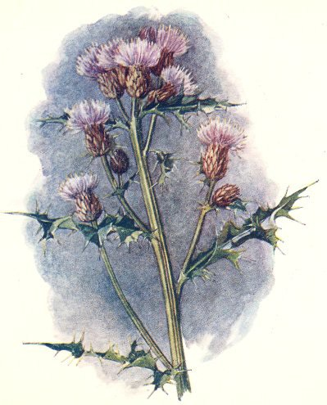

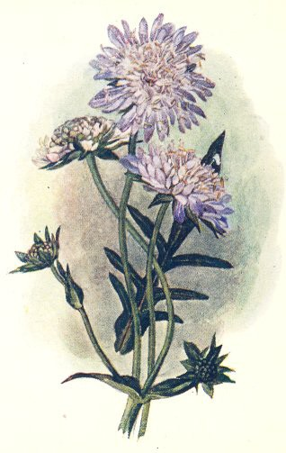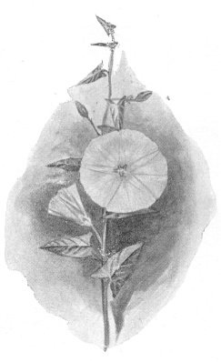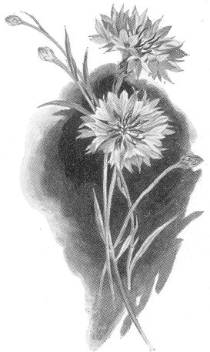*Creeping Thistle Field Scabious*

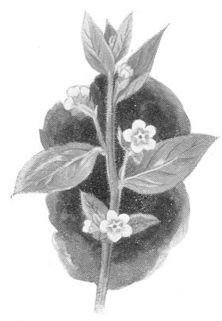*Evergreen Alkanet*

*Cornflower*

*Smaller Bindweed*

To us it is only a very beautiful flower. The florets in the centre of each blossom are dark purple, but the outer ones are of a brighter blue. The leaves are long and narrow; those near the bottom of the stem are rather broader than those higher up. The stems themselves are not round, but angular. We can feel corners or angles as we hold one in our hand. They are also covered with a kind of down. There is another flower which we shall see better if we come to the stubble field after the wheat is cut; but some of it is near the gate to-day. This is the Smaller Bindweed. We see that it is a relation of the Large Bindweed in the garden hedge. It has leaves and flowers of the same shape, but the flowers are smaller, and are

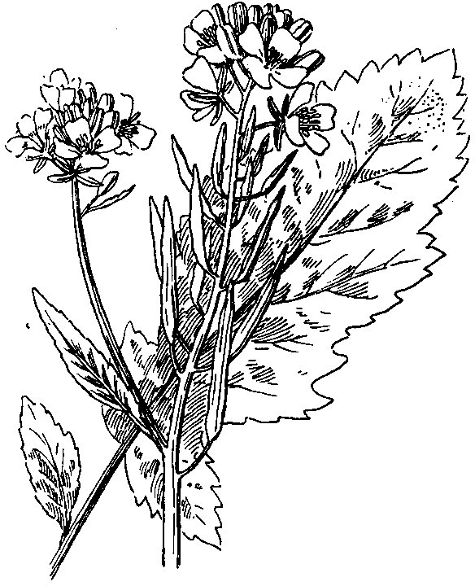pink and white. Those of the Large Bindweed are rarely anything but pure white.

*Charlock*

This is another troublesome weed here. It does not climb, as the Large Bindweed does, but creeps along the ground, twining round everything it meets. In the potato field it is often even more troublesome than here. Corn is cut, but potatoes are dug out of the ground. The Small Bindweed forms

such a thick carpet over the field, and twines round the potato stems so closely, that it is often

very difficult to dig up the potatoes.

Here is another little flower which I am glad to show you now, the Scarlet Pimpernel. This and the Poppy are

the only scarlet wild flowers we have. There are many pink, and also many purple flowers, but only these two are really scarlet.

The Pimpernel differs from the Poppy in almost everything except its colour. The Poppy has a tall stout stem and its blossoms are very large. The Pimpernel trails on the ground and has tiny flowers. The blossoms of the Poppy have four petals, those of the Pimpernel have five. These are a beautiful scarlet, but not quite so bright a scarlet as those of the Poppy.

The leaves grow in pairs, and the small bare stalks which carry a flower at their ends spring from the stem beside the leaves. The leaves are sessile on the stem. Turning a leaf over we find that on its under side are black or dark purple spots.

The blossoms of the Pimpernel close up when rain is near, and it is often called the Poor Man’s Weatherglass. Sometimes, but very rarely, a plant is found which has pink, or even pure white blossoms. There is also a blue Pimpernel. Another Pimpernel is the

Bog Pimpernel; but we shall not find it in this dry field of corn, as you may guess by the name.

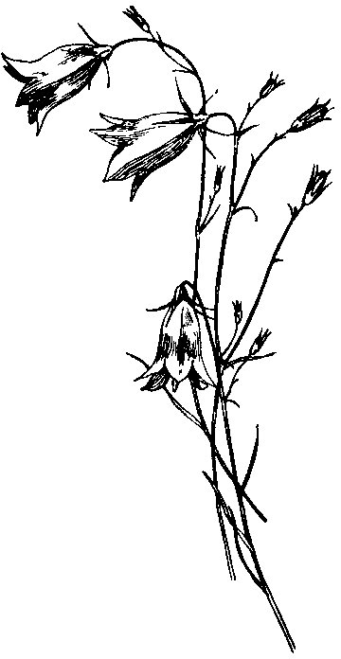One more flower we will look at, and then it will be time to leave our corn-field and to search else- where. Growing on the hedgebank at the side of

the field is a pretty lilac-blue flower on a long bare stalk. It is the Field Scabious.

The blossoms are in shape like a round ball very much flattened – like a round pincushion. There are no large petals here, as with the Poppy, but a great number of small florets. Those on the outer edge of the blossom are larger than those inside. Each floret is a tiny tube or pipe.

The leaves are on separate stalks from those which bear the flowers, and they grow in pairs. They are divided into several

pairs of lobes, with a single lobe at the end of each leaf. Some leaves grow from that part of the

*Pimpernel*

stem which is underground, and these are larger than the others, and are sometimes of a different shape. Both the leaves and the stem are hairy.

Chap ter XI o

# ON THE CHASE

W

e have now seen a good many Flowers of the Farm; we have found them in the coppice, on the garden wall, and

in the fields. To-day we will go a little further off, three miles away. You say, “Surely that is a long way off for the farmer to have a field.” It is not exactly a field. The Chase is a great open common

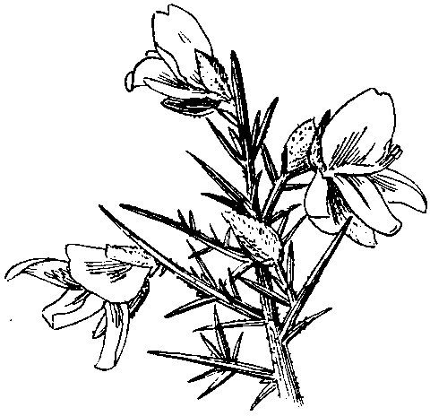or moor, which belongs to the village or parish where Willow Farm is. Nearly all the people of the village have certain rights of pasturage on it; they may let their horses and cattle and sheep graze there. Every now and then Mr. Hammond sends some of his sheep to the Chase to feed there for a few

weeks. It is very high dry ground, and that is good for sheep.

The road runs through the middle of the great common without any hedge or fence on

either side. There are horses and sheep and cattle here on this May

*Gorse*

morning; donkeys too. All the sheep are marked, and we soon see some which belong to Willow Farm; they are stamped on the back in large letters “W.H.” for William Hammond. A farmer easily knows his own horses and cows; sheep are less easy to recognise, and are usually marked.

One of the flowers of the Chase we see at once. In whatever direction we look across the common there is a perfect blaze of gold – the blossoms of the prickly Gorse or Furze. Spring is the time to see its mass of golden yellow blossoms best; but I do not think there is a week, or even a day, in the whole year when some of the flowers are not out. Did you ever hear the saying, “Kissing is out of season when the Gorse is out of bloom.” That is never!

The Gorse flowers are beautiful and their scent is sweet. As to gathering them, however, there is a terrible difficulty. The flowers grow among long sharp spikes which cover the stems closely; you would almost as soon gather nettles! There are very few real leaves, and they are small and not easily seen; but the thorns are beautiful to look at, if not to touch – they are such a rich dark green.

Nor is Gorse a useless plant. If the prickly stems are bruised or mashed a little they form a fodder which animals like. Indeed, a pony near us seems to enjoy them as they are; he is tearing off and eating piece after piece from a Gorse bush. His mouth must be less tender than ours!

Later in the summer we visit the Chase again to find some flow- ers that were not out in May. On our way we pass a potato field in blossom – a very pretty sight. These blossoms are a palish purple, but sometimes the potato flowers are white.

The Hairbell is a flower which we shall now find on the Chase – a great contrast to the stout and thorny bush of Gorse. The Hairbell’s stem is almost as slender as a thread, although it stands upright. Each blossom is a dainty little blue bell of five petals. White

*On the Chase*

blossoms are sometimes found, but not often.

There are leaves as well as flowers on the stem. Growing from the lower part of the stem, close to the ground, we may perhaps find some broader, rounder leaves; perhaps not, however, for these lower leaves soon wither and die away.

The Hairbell loves to grow where there is fresh pure air. Here on the Chase we are high up; it has been a long steep climb from Willow Farm, and we are more than five hundred feet above sea level. Far below us, a few miles away, we see a broad river on which steamers and sailing-ships are passing up and down. Away to the west is the sea, from which a breeze is nearly always blowing across the Chase. No wonder that the little Hairbell loves the spot.

We have found a yellow flower and a blue one on the Chase, and now we have not far to look for something red. Here is a clump of Heath or Ling, and not far off a patch of Heather too. We must be careful to distinguish Heath from Heather; let us look at the Heath first.

On the Heath, as on the Hairbell, we find bell-shaped flowers; but the blossoms of the Heath are very small, and grow from a tough woody stem. They are a reddish-purple. On little side branches growing from the stems are the very tiny leaves. The whole plant is low, bushy, and spreading.

The flowers of the Heather are rather larger, deep crimson in colour, and grow in clusters. On the flower stems grow very small narrow leaves; there are generally three of them together and they do not grow so thickly as the leaves of Heath. Among these leaves are some that are made up of several leaflets.

Gorse, Heather, and Heath are spreading plants, and, if they were allowed to grow unchecked, they would soon smother and destroy the turf. Every few years therefore the Chase is burnt. In winter or spring both Gorse and Heath burn easily, the fire spreading fast

from one patch to another. The smoke of the burning Chase may then be seen from many miles away.

When the fire has burnt out, the Chase looks very black and dismal. But the roots and underground stems of both the Heather and the Gorse are still alive. Fresh shoots will grow, and soon the Gorse will be golden in the spring, the Heather purple in the summer, as they were before.

Chap ter XII o

# IN THE LANES

T

his is the last day that we can spend in looking for wild flowers at Willow Farm. Perhaps some of you already knew something about flowers before this visit. If so, you may have been disappointed that we have not seen some favourite flower of your own. You may think we have passed over many flowers which

deserved to be noticed.

For that matter I think every wild flower deserves to be noticed; but we certainly should not have time for all. I showed you several plants growing on the walls and roof, because it was interesting to see that quite beautiful flowers, such as the Wallflower and the Houseleek, could grow with very little soil. We looked rather closely at the Clovers and at the Grasses in the hay-field, because these plants are important to the farmer; they are part of his crops. Then, too, we noticed several weeds which do him harm.

To-day I am going to take a kind of holiday. I shall show you three flowers, not because they have much to do with the farmer,

but because they are great favourites of my own.

None of these are very common at Willow Farm, although I know where to find each one. We will go first down the little stony lane which leads from near the foldyard gate to the cottages where the shepherd and the bailiff live. Here we shall find the Alkanet. It is a perennial, and it blossoms here year after year. I only know one other place in the village where it grows. Like some other flowers we have seen, it is not really a native of England.

It has a very beautiful blue blossom, a little like the blossom of the Forget-me-not which perhaps you know, but the flower of the Alkanet is of a deeper, richer blue. Here again, as with so many other flowers we have seen, the blossom is formed of the five lobes of a corolla. In the centre of each blue blossom is a small white spot. The blossoms grow in little clusters on a short stalk, and on this stalk there is always one pair of small leaves. The leaves on the main stems of the plant are larger; the lower leaves have stalks, but those on the upper part of the stem are sessile. The leaves are hairy, and

so are the stems, which often grow two or three feet high.

We saw that the Poppy and the Pimpernel were the only two true scarlet wild flowers of our fields. In the same way there is only one other English wild flower which has such a deep blue blossom as the Alkanet. That is the Borage; and the Borage, like the Alkanet, is not really a native of England. For a fine golden yellow flower I do not know anything which can beat the Dandelion. If we have not seen every wild flower which grows at Willow Farm, we have at any rate seen three which have the deepest and richest colours.

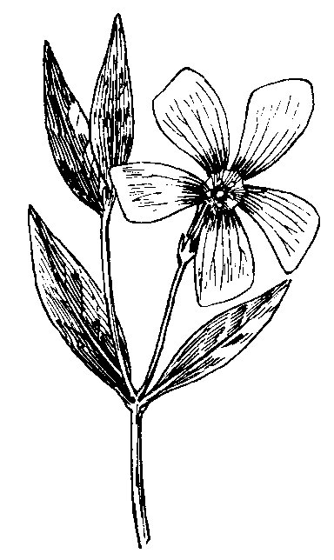

*Lesser Periwinkle*

Now for my next favourite. This time we go

*In the Lanes*

to the shady lane leading from Willow Farm to the church; that is the only place near here where I have found the Lesser Periwinkle. There is also a Larger Periwinkle, very similar to my favourite here, except in size.

To find the Periwinkle in full flower we should have to come in spring, but, though it is July now, we shall still find a blossom here and there, I hope. Even in winter we might do so too.

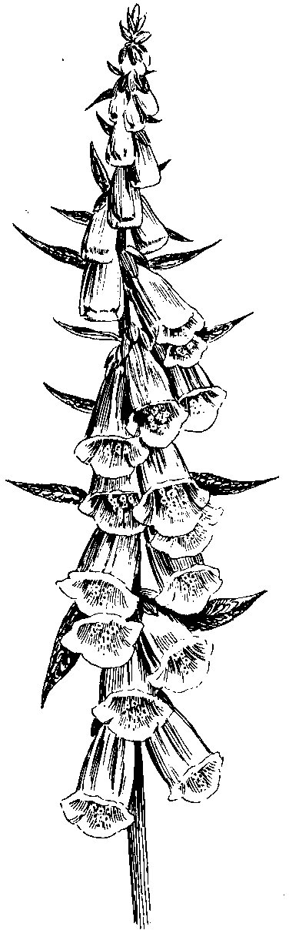The Lesser Periwinkle has a blue flower, but the blue is a pale lilac blue. Here again the petals are really the five spreading lobes of the corolla. There is something curious about these lobes. They are of a peculiar irregular shape that is not easy to describe; they are not exactly pointed, and they are not regular in shape. You could cut the petal of a Buttercup into two equal parts; it would be almost impossible to do this with the lobes of the

Periwinkle blossom.

The leaves are dark green, glossy and pointed, and they grow in pairs. Often, however, we find two pairs of leaves growing so closely together that they seem to grow in fours. The leaves are evergreen; they do not fade and die in autumn.

Some of the Periwinkle stems are erect and are about six inches high; others are creeping. It is only the erect stems which bear flowers; the creeping ones are barren. They do useful work, however, for they form fresh roots, as we have seen the stalks of some other plants do. In this way the whole bank beside the lane has become covered with the pretty plant.

The Periwinkle is a comparatively small plant. The last flower – the Foxglove – that we shall see at Willow

Farm is quite different. It is a very tall plant. It is generally

described as growing from three to five feet high, but

*Foxglove*

I have seen a stem of eight or nine feet. We shall find it growing on the hedgebank in Little Orchard, and it also often grows in woods. Some plants, as we know, are annuals, others are perennials. The Foxglove is neither; it is a biennial – that is a two years’ plant. If you sow Foxglove seed you will have no flowers the first year, only a root and a great bunch of leaves. In the second year tall stems which bear the flowers will appear. In the autumn after it has flowered the Foxglove generally dies, though sometimes it may live for another year, or even two. Foxgloves, of course, will reproduce themselves

by seed, as annuals and perennials do.

The Foxglove is something different from anything that we have seen as yet. The flowers grow on short flower stalks and hang down from the tall stems, a great many on each stem. Here there are no petals, but what we see and admire so much is the bell-shaped corolla, purple-red in colour. This purple bell is spotted with white inside. Bell-shaped is perhaps not a very good description; the flower is more like a large thimble or the finger of a glove.

“A glove for a fox – that is the meaning of the name,” you perhaps say. No, it has nothing to do with a fox. Many years ago nearly everyone believed in Fairies, and the Fairies were often called the Good Folk or Good People. It is they, and not the fox, who were supposed to use the purple blossoms as a glove. If you say “Folk’s Glove” quickly, you will see how easily it comes to sound Foxglove. So our last thought among the flowers is of the Fairies, in whose existence hardly anyone believes to-day.