Q1. Write a Program that contains a string with value “Hello World”. The program should XOR(bitwise) each character in the string with 0 and display the result.

Code:

#include<bits/stdc++.h>

using namespace std;

int main(){

    string s,out, out1;

    cout<<"Enter String\n";

    getline(cin,s); // Input

    for(int i=0;i<s.length();i++){  // Iterating every character

        out.push_back((char)(s[i] ^ 0)); //Taking xor with 0 number and pushing into the output string

        out1.push_back((char)(s[i] ^ '0')); //with '0' character and pushing in output string

    }

    cout<<"XOR with 0 number:\n"<<out<<endl<<"\nXOR with '0' character:\n"<<out1;

}

Output:

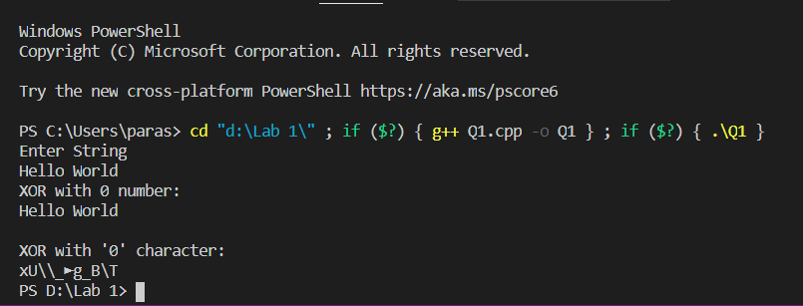

Q2. Write a program that can encrypt and decrypt using the general Caesar cipher.

Code:

#include<bits/stdc++.h>

using namespace std;

int main(){

    string s;

    int inc_val = 3; //Can take any value from 0-25

    cout<<"Enter Text:\n";

    getline(cin,s);   // Taking input

    string ans;    //output string

    for(int i=0;i<s.length();i++){

        if(s[i]==' ') ans.push_back(' ');  //Adding space as it is

        else if(isupper(s[i])){

            ans.push_back(char((s[i]-'A' + 1 + inc_val)%26 + 'A' - 1)); //Incrementing each uppercase character by 3(Increment value)

        }

        else{

            ans.push_back(char((s[i]-'a' + 1 + inc_val)%26 + 'a' - 1)); //Incrementing Each uppercase character by 3(Increment value)

        }

    }

    cout<<"Cipher Test is\n";

    cout<<ans<<endl;

}

Output:

