Verlet vs. Euler approximate time evolution simulation of Oxygen and Nitrogen

# Approximating a true wavenumber value [v_0]

 Using a very small dt gives an accurate value of v_0. I used dt = 10e-5, results as follows. An average of both schemes was used to determine v_0 for oxygen and nitrogen.

# Determining ideal timestep parameter [dt]

A slightly modified *simulate_particle.py* file (*simulate_edited.py*) was made which takes the *sys.argvs* as parameters through the main function such that simulations can be run repeatedly. This was implemented in *test_edited.py*. Using both integration schemes the results are as follows.

From the energy uncertainties we can see the approximations of the verlet scheme far surpasses that of the euler scheme. Although for the wavenumbers the euler scheme proves marginally better for a dt value of 0.01, but for other values their difference is negligible. For the uncertainties within the wavenumbers, there is an unexpected increase for both schemes at a dt value of 0.0001.

For further simulations a dt value of 0.01 was chosen to suffice due to the errors being well below 0.5% and the simulations taking little time to run.

# Results for Nitrogen

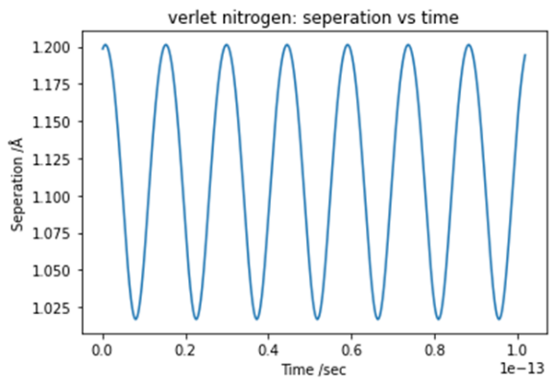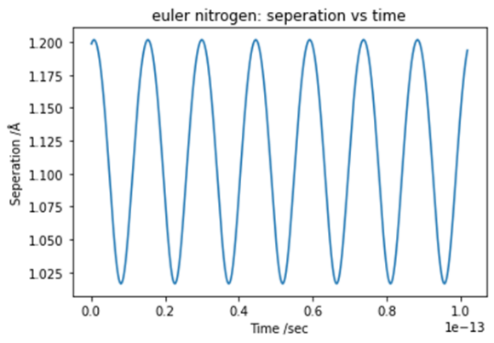



# Results for spin particles

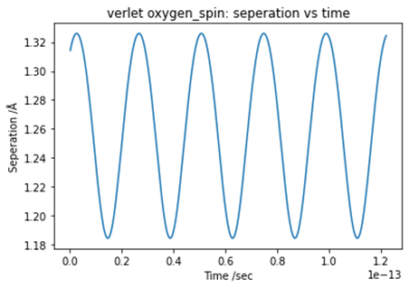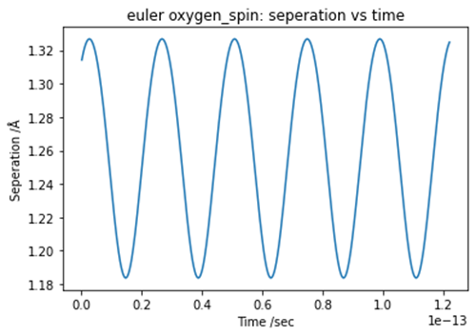



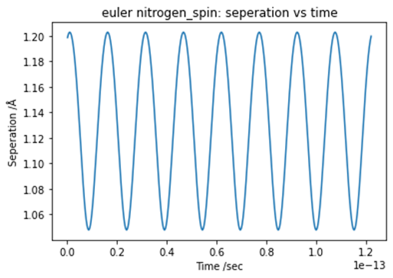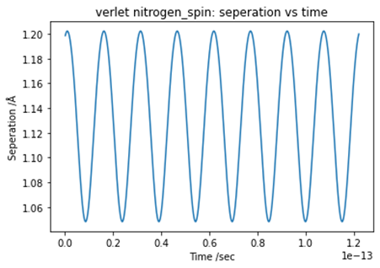



# Comparisons

For the wave numbers both simulations provide very similar values, along most values dt. For dt = 0.01, both simulations provide approximately 1524 /cm which is 3.5% off of the experimental value, although the energy uncertainty for the verlet approximation is smaller by a factor of around 100, this can be observed in the plot titled ‘Energy uncertainties – oxygen’ on page 1.

Due to the energy uncertainties being significantly smaller for the verlet integrated, it can be concluded that this scheme is more accurate although they both prove similar to for wave number approximations.